FAKE NEWS DETECTION USING NLP

**TEAM MEMBERS:**

MADHUMITHAA V – 2021504021

SUDHEKSHA R – 2021504047

ARTHI C – 2021504505

**OBJECTIVE:**

In this, we will building the fake news detection model by applying NLP techniques and training a classification model. Text Preprocessing feature Extraction, Model training are carried out.

Dataset

link:<https://www.kaggle.com/datasets/clmentbisaillon/fake-and-real-news-dataset>

**INTRODUCTION:**

In an era of unprecedented information flow, the proliferation of fake news has emerged as a significant societal concern. Misinformation and disinformation campaigns not only distort public discourse but also have the potential to influence crucial decisions. Addressing this challenge requires innovative solutions that harness the power of cutting-edge technologies.

Natural Language Processing (NLP), a field at the intersection of artificial intelligence and linguistics, offers a promising avenue for combating fake news. By equipping machines with the ability to comprehend, analyze, and contextualize human language, NLP provides a robust framework for distinguishing between credible information and misleading content.

This study delves into the application of NLP techniques in the domain of fake news detection. By leveraging advancements in machine learning and linguistic analysis, we aim to develop a comprehensive approach that goes beyond surface-level analysis, delving into the intricate nuances of language to identify deceptive content. Through this research, we seek to contribute to the ongoing efforts to safeguard the integrity of information dissemination channels in the digital age.

The subsequent sections will delve into the theoretical underpinnings of NLP, explore various methodologies employed in fake news detection, and present empirical findings demonstrating the effectiveness of our proposed approach. Additionally, this research will shed light on the ethical implications and challenges associated with automating the process of discerning factual accuracy in news articles. In doing so, we hope to provide a foundation for future advancements in the field of fake news detection, ultimately bolstering the resilience of society against the pervasive influence of misinformation.

**OVERVIEW OF THE PROJECT:**

**DATA COLLECTION:**

Gather a diverse dataset containing both real and fake news articles. This dataset will be used to train and evaluate the model.

**DATA PREPROCESSING:**

**Text Cleaning**: Remove any irrelevant characters, symbols, or special characters.

**Tokenization:** Break down the text into individual words or tokens.

**Stopword Removal:** Eliminate common, non-informative words (e.g., "the," "and") from the text.

**FEATURE EXTRACTION:**

TF-IDF (Term Frequency-Inverse Document Frequency) or Word Embeddings (e.g., Word2Vec, GloVe) can be used to represent the text in a numerical format that can be fed into a machine learning model.

**MODEL SELECTION:**

Common algorithms include:

* Logistic Regression
* Support Vector Machines (SVM)
* Random Forest
* Deep Learning models like LSTM or Transformer-based models (e.g., BERT).

**TRAINING:**

Use the preprocessed data to train the chosen model. This involves feeding the model with the features (TF-IDF or embeddings) and their corresponding labels (fake or real).

**EVALUATION:**

Split the dataset into training and testing sets. Evaluate the model's performance using metrics like accuracy, precision, recall, F1-score, and ROC-AUC.

**Fine-tuning:**

Adjust hyperparameters, try different algorithms, or consider ensemble methods to improve performance.

**Deployment:**

Once the model performs satisfactorily, it can be integrated into a user-friendly interface. This could be a web application, browser extension, or any other suitable platform.

**Monitoring and Maintenance:**

Continuously monitor the model's performance and update it as needed to adapt to evolving forms of fake news.

**Ethical Considerations:**

Consider the ethical implications of the model, such as biases in the data and its potential impact on free speech.

**PROCEDURE:**

1. **Model Building**:

* Model building involves selecting an appropriate machine learning algorithm or deep learning architecture for your specific problem.
* You'll need to preprocess your data, handle missing values, and perform feature engineering to prepare the data for modeling. Then, you'll split your data into training and testing sets to train and evaluate the model.

STEPS TO BE INVOLVED:

* Building a prediction model: Choose an appropriate model for your task. For fake news detection, you can consider using traditional machine learning models like Random Forest, Logistic Regression, or more advanced models like recurrent neural networks (RNNs) or transformers.
* Import pickle: The pickle module in Python is used to serialize and deserialize Python objects. You can use it to save your trained machine learning models to disk for later use. To import a pickled object, you can use the pickle.load() function to load it back into your Python environment.
* Decision Tree Classifiers are used in fake news detection due to their interpretability and simplicity. They provide insights into key features, handle non-linear relationships, and require minimal assumptions. However, they can overfit and may not capture complex patterns as effectively as more advanced models.
* Long Short-Term Memory (LSTM) is a type of recurrent neural network (RNN) architecture that's particularly well-suited for tasks involving sequential data, like speech recognition, language modeling, and time series analysis. Unlike traditional RNNs, LSTMs have a gating mechanism that helps them capture long-range dependencies in the data. These "gates" control the flow of information through the network, allowing LSTMs to selectively remember or forget information over long sequences. This makes them very effective for tasks where understanding context over extended periods of time is crucial.

1. **Prediction Pipeline**:

* A prediction pipeline is a series of steps used to make predictions on new, unseen data using a trained machine learning model.
* It typically involves data preprocessing, feeding the data into the model, and post-processing the model's output to get meaningful predictions.

1. **Create Word Embeddings**:

* Word embeddings are vector representations of words in a format that machine learning models can understand.
* Common techniques include Word2Vec, GloVe, and more recently, transformer-based models like BERT and GPT.
* You can create word embeddings by training your own models on a large corpus of text or using pre-trained embeddings.

1. **Model Training:**

* Train the selected model on the training data. The model learns to map the features to the binary classification of real or fake news.
* For traditional models like Decision Trees or Random Forests, you can use libraries like Scikit-Learn in Python. For deep learning models, libraries like TensorFlow or PyTorch are common choices.

**PROGRAM**

**1.MODEL BUILDING**

Building a prediction model

from sklearn.tree import DecisionTreeClassifier

model=DecisionTreeClassifier()

model.fit(x_train, y_train)

prediction=model.predict(x_test)

prediction

array([1, 0, 1, ..., 0, 1, 0], dtype=int64)

model.score(x_test, y_test)

Importing pickle:

import pickle

pickle.dump(vect, open('vector.pkl', 'wb'))

pickle.dump(model, open('model.pkl', 'wb'))

vector_form=pickle.load(open('vector.pkl', 'rb'))

load_model=pickle.load(open('model.pkl', 'rb'))

Modelling using LSTM

from keras.layers import LSTM, Dropout, Dense, Embedding

from keras import Sequential

model = Sequential([

Embedding(vocab_size+1, 100, weights=[embedding_matrix], trainable=False),

Dropout(0.2),

LSTM(128),

Dropout(0.2),

Dense(256),

Dense(1, activation='sigmoid')

])

model.compile(loss='binary_crossentropy', optimizer='adam', metrics='accuracy')

model.summary()

**2.PIPELINE PREDICTION**

class Preprocessing:

def __init__(self,data):

self.data = data

def text_preprocessing_user(self):

lm = WordNetLemmatizer()

pred_data = [self.data]

preprocess_data = []

for data in pred_data:

review = re.sub('^a-zA-Z0-9',' ', data)

review = review.lower()

review = review.split()

review = [lm.lemmatize(x) for x in review if x not in stopwords]

review = " ".join(review)

preprocess_data.append(review)

return preprocess_data

**3.CREATE WORD EMBEDDINGS**

from keras.preprocessing.text import Tokenizer

from keras.preprocessing.sequence import pad_sequences

# tokenize text

tokenizer = Tokenizer()

tokenizer.fit_on_texts(df['clean_news'])

word_index = tokenizer.word_index

vocab_size = len(word_index)

# padding data

sequences = tokenizer.texts_to_sequences(df['clean_news'])

padded_seq = pad_sequences(sequences, maxlen=500, padding='post', truncating='post')

# create embedding index

embedding_index = {}

with open('glove.6B.100d.txt', encoding='utf-8') as f:

for line in f:

values = line.split()

word = values[0]

coefs = np.asarray(values[1:], dtype='float32')

embedding_index[word] = coefs

# create embedding matrix

embedding_matrix = np.zeros((vocab_size+1, 100))

for word, i in word_index.items():

embedding_vector = embedding_index.get(word)

if embedding_vector is not None:

embedding_matrix[i] = embedding_vector

**4.MODEL TRAINING:**

from keras.layers import LSTM, Dropout, Dense, Embedding

from keras import Sequential

# model = Sequential([

# Embedding(vocab_size+1, 100, weights=[embedding_matrix], trainable=False),

# Dropout(0.2),

# LSTM(128, return_sequences=True),

# LSTM(128),

# Dropout(0.2),

# Dense(512),

# Dropout(0.2),

# Dense(256),

# Dense(1, activation='sigmoid')

# ])

model = Sequential([

Embedding(vocab_size+1, 100, weights=[embedding_matrix], trainable=False),

Dropout(0.2),

LSTM(128),

Dropout(0.2),

Dense(256),

Dense(1, activation='sigmoid')

])

model.compile(loss='binary_crossentropy', optimizer='adam', metrics='accuracy')

model.summary()

# train the model

history = model.fit(x_train, y_train, epochs=10, batch_size=256, validation_data=(x_test, y_test))

# visualize the results

plt.plot(history.history['accuracy'])

plt.plot(history.history['val_accuracy'])

plt.xlabel('epochs')

plt.ylabel('accuracy')

plt.legend(['Train', 'Test'])

plt.show()

plt.plot(history.history['loss'])

plt.plot(history.history['val_loss'])

plt.xlabel('epochs')

plt.ylabel('loss')

plt.legend(['Train', 'Test'])

plt.show()

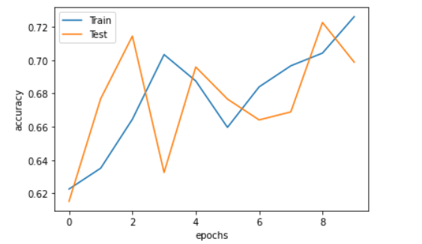

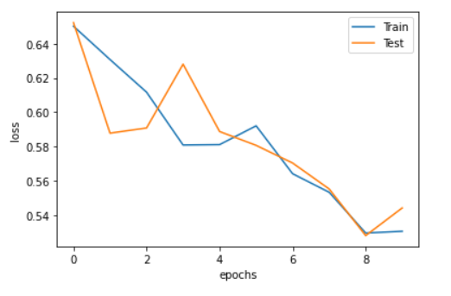

**CONCLUSION**:

Employing Natural Language Processing (NLP) techniques for fake news detection holds significant promise in the ongoing battle against misinformation. By leveraging linguistic patterns, semantic analysis, and contextual cues, NLP models can effectively discern between credible information and fabricated content. However, it's important to acknowledge that this field is constantly evolving, and continued research and development will be crucial to enhance the accuracy and reliability of these detection systems. Additionally, a multi-modal approach, combining NLP with other forms of media analysis, could further bolster the effectiveness of fake news detection efforts. Overall, NLP plays a pivotal role in fortifying the information ecosystem, fostering a more informed and discerning public