INTERNSHIP PROJECT REPORT
CREATION OF AI DRIVEN MULTI-AGENT
NEGOTIATION TRAINING & SIMULATION PLATFORM
Infosys Springboard Virtual Internship 7.0 | Batch-2

Project Details | Information
Project Duration | 8 Weeks
Mentor | Nishyanth
Team Members | Madhugna Yelchuri; Tharungowda N K;  Prasad Chaudhari; Bhagyashree;  Bhoopathi Harshitha; P.M. Sree Priya
Prepared as part of the Infosys Springboard Virtual Internship

Table of Contents

1. Abstract
This project presents the Creation of AI Driven Multi-Agent Negotiation Training & Simulation Platform, implemented as a Disaster Relief Negotiation System (DRNS). The platform models disaster-response resource allocation as a negotiation among multiple role-specific stakeholders rather than as a single automated decision. Three AI stakeholders—Government, NGO and District Administration—can negotiate autonomously in AI-vs-AI mode, while a human participant can join the same environment through Human-vs-AI Practice Mode. The system combines Generative AI, structured proposals, resource constraints, deterministic validation, explicit consensus detection, deadlock handling, concession analysis, outcome analytics and MongoDB-backed history. Groq is used as the primary LLM provider path with Gemini as a fallback path. A React-based frontend communicates with a FastAPI backend using REST APIs and Server-Sent Events for progressive negotiation responses. The resulting platform is intended as an educational and training environment for understanding stakeholder negotiation, resource trade-offs and human-in-the-loop AI interaction.
The supplied implementation contains three disaster-response scenarios: Flood Relief Resource Allocation, Earthquake Emergency Response and Cyclone Relief Coordination. Each scenario defines resources, affected areas, operational objectives and constraints. The platform records negotiation rounds and produces a final allocation, agent performance information and historical replay data. The project therefore demonstrates an end-to-end AI engineering workflow involving frontend design, API orchestration, LLM integration, validation, persistence and analytical reporting.

2. Introduction
Disaster relief operations require rapid coordination between organizations that may have different responsibilities, priorities and constraints. When resources such as rescue teams, medical aid, shelters, food or transport are limited, allocation decisions often involve trade-offs. The project treats this coordination problem as a multi-agent negotiation task in which each stakeholder has its own role, objective, constraints and negotiation personality.
DRNS provides a controlled simulation environment in which these negotiations can be observed, configured and replayed. Instead of allowing a language model to directly control the complete system state, the architecture separates LLM-generated agent behavior from deterministic orchestration and validation. This allows the system to preserve resource limits, track acceptance, detect deadlock and determine when an agreement has actually been reached.

3. Problem Statement
Traditional resource-allocation demonstrations generally produce a final allocation without representing the negotiation process that leads to it. Such an approach does not adequately demonstrate how stakeholders with conflicting priorities communicate, make proposals, respond to counter-proposals and concede over multiple rounds. There is therefore a need for an interactive training platform that can simulate stakeholder negotiation while enforcing resource constraints and maintaining an auditable history of the interaction.
The problem addressed by this project is to design and implement a multi-agent Generative-AI system that can simulate disaster-relief negotiations, support human participation, validate resource proposals, handle agreement and deadlock, and present measurable outcomes through a user-friendly interface.

4. Objectives
- Model multiple disaster-response stakeholders as role-specific agents.
- Represent stakeholder goals, constraints and negotiation personalities.
- Provide realistic multi-round negotiation using Generative AI.
- Support both autonomous AI-vs-AI negotiation and Human-vs-AI Practice Mode.
- Validate all proposals against configured resource quantities and allowed resource names.
- Track proposals, counters, acceptances, rounds and negotiation history.
- Detect explicit consensus and terminate a negotiation when the required participants accept the same proposal.
- Detect stalled negotiations and handle deadlock or maximum-round termination.
- Analyze concessions, objective satisfaction and final resource allocation.
- Persist negotiation sessions in MongoDB and provide historical replay.
- Provide an educational interface for observing and practicing negotiation behavior.

5. Proposed Solution
The proposed solution is a web-based negotiation simulator consisting of a React frontend, FastAPI backend, multi-agent orchestration layer, LLM provider layer, evaluation engine and MongoDB persistence layer. A user first selects a disaster scenario and configures agent personalities and resources. The negotiation can then be executed automatically between AI agents or interactively with a human participant.
- Select a disaster scenario from the scenario catalogue.
- Configure stakeholder personalities, available resources and affected areas.
- Start an AI-vs-AI simulation or enter Human-vs-AI Practice Mode.
- Generate role-aware proposals and responses using the LLM provider layer.
- Normalize and validate proposals before they update negotiation state.
- Record each turn and update the current proposal, acceptance and round state.
- Evaluate consensus, deadlock and maximum-round conditions.
- Generate the final allocation and analytical outcome report.
- Persist the session and expose it through the History interface.

6. System Architecture
The system follows a layered architecture in which presentation, API handling, negotiation orchestration, agent behavior, prompt construction, LLM services, evaluation and persistence have distinct responsibilities.
Layer | Components | Responsibility
Presentation Layer | React 19, Vite, React Router, Tailwind CSS, Lucide React | Scenario selection, configuration, negotiation arena, Practice Mode, Outcome and History
API Layer | FastAPI, Pydantic, Uvicorn | Request validation, session creation, turns, practice actions, suggestions and health checks
Orchestration Layer | NegotiationOrchestrator | Rounds, participants, proposals, consensus, deadlock, termination and final reporting
Agent Layer | BaseAgent; GovernmentAgent; NGOAgent; DistrictAdministrationAgent | Role, goals, constraints, personality and model interaction
Prompt Layer | prompt_builder.py | Structured role/personality-aware prompts using current state and history
LLM Layer | Groq + Gemini | Agent responses, structured outputs and provider fallback
Evaluation Layer | evaluation_engine.py | Consensus, deadlock, concessions, performance and outcome analysis
Persistence Layer | MongoDB Atlas + Motor | Session persistence, history listing and historical retrieval

6.1 Logical Architecture Flow
React Frontend
↓
FastAPI REST / SSE API
↓
Negotiation Orchestrator
↓
Government Agent | NGO Agent | District Administration Agent
↓
Prompt Builder → Groq Primary / Gemini Fallback
↓
Response Normalization + Proposal Validation
↓
Consensus / Deadlock / Max-Round Evaluation
↓
Outcome Analytics → MongoDB Persistence → History / Replay

7. Technology Stack
Area | Technology | Purpose
Frontend | React 19, Vite 8, React Router, Tailwind CSS 4, Lucide React | Interactive web interface and visual analytics
Backend | Python, FastAPI, Uvicorn, Pydantic | REST API, request validation and application services
AI / LLM | Groq primary path, Gemini fallback | Natural-language agent decisions and negotiation responses
Persistence | MongoDB Atlas, Motor | Persistent negotiation sessions and history
Communication | REST APIs, Server-Sent Events (SSE) | Request/response operations and progressive streaming of Practice Mode responses
Testing | Pytest, Python AST/compileall checks | Validation of negotiation logic and source integrity
Development | VS Code, Git/GitHub workflow | Development, version control and team collaboration

8. System Modules
Module | Functionality
Home | Project landing page and entry point showing scenarios, agents, personalities, rounds and major platform features.
Scenario Selection | Provides Flood, Earthquake and Cyclone disaster-response scenarios with resource pools, affected areas and objectives.
Agent Configuration | Allows agent personalities and resource quantities to be configured before a negotiation.
Negotiation Arena | Runs and visualizes AI-vs-AI negotiation turns, proposals, counters, acceptance and current allocation.
Practice Mode | Allows a human participant to submit negotiation actions while AI stakeholders respond.
Outcome | Displays agreement status, rounds, participants, final allocation, resource trajectories and agent performance.
History | Displays persisted sessions and provides visualization and transcript access for replay and analysis.

9. Multi-Agent Architecture
The simulator uses three stakeholder agents with different operational roles. Each agent receives scenario information, its own goal, constraints, personality, available resources, current proposal and negotiation history. The prompt builder creates structured model input, while the orchestrator remains responsible for authoritative state transitions.
Agent | Goal | Example Constraints | Personalities
Government Agent | Direct emergency operations and protect critical infrastructure/public order. | Restricted access, high demand for rescue personnel, multi-agency coordination. | Aggressive / Collaborative / Risk-Averse
NGO Agent | Provide medical support and shelter assistance to displaced families. | Limited medical stockpiles, complex supply-chain disruption, safe transport routes. | Aggressive / Collaborative / Risk-Averse
District Administration Agent | Prioritize local rescue access, shelter placement and infrastructure support. | Damaged roads/utilities, crowded evacuation centres, limited workforce availability. | Aggressive / Collaborative / Risk-Averse

9.1 Scenario Model
Scenario | Resources | Affected Areas
Flood Relief Resource Allocation | Food; Medicine; Rescue Boats; Temporary Shelters; Emergency Supplies | Riverbend; Lakeside; Hillside
Earthquake Emergency Response | Rescue Teams; Medical Aid; Temporary Shelters; Debris Clearance Equipment | North; Central; South Sectors
Cyclone Relief Coordination | Evacuation Transport; Food; Shelter Materials; Communication Equipment | Coastal Region; Inland Valley; Port Authority Zone

10. AI-vs-AI Negotiation
In AI-vs-AI mode, the configured Government, NGO and District Administration agents negotiate autonomously. The frontend starts a session through the negotiation API, after which the NegotiationOrchestrator creates the session and coordinates turns. Each turn includes the scenario, current state, previous proposals, objectives, constraints, personality and available resources.
- The frontend sends a start request to the negotiation API.
- The backend creates a session and initializes the configured agents.
- The orchestrator prepares the context for the active agent.
- The prompt builder creates a role- and personality-aware structured prompt.
- Groq is attempted through the LLM provider path, with Gemini/fallback behavior available.
- The generated response is normalized and its proposal is validated.
- The turn is appended to the negotiation history and state is updated.
- Consensus, deadlock and maximum-round checks determine whether another turn is required.
- When the negotiation ends, the final allocation and outcome metrics are generated.

11. Human-vs-AI Practice Mode
Practice Mode adds a Human Participant to the same negotiation environment. The human can submit structured negotiation actions such as Offer, Counter, Accept or Reject. The backend validates the submitted move, records it in the transcript, and then allows the AI stakeholders to deliberate. Server-Sent Events are used so that AI responses can be received progressively.
This design creates a human-in-the-loop training environment: the participant is not merely observing a simulation but actively negotiating against the AI stakeholders. The Practice Mode interface also exposes scenario details, the participant's role, available resource budget, negotiation progress and acceptance status.

12. Consensus & Deadlock Handling

12.1 Consensus
Consensus is modeled as explicit acceptance rather than inferred similarity. In Practice Mode, the system requires the Human Participant and all three AI participants to accept the same current proposal. The orchestrator compares the accepted proposal objects with the current proposal before marking the negotiation as agreed and producing the final allocation.

12.2 Deadlock
- AI-vs-AI deadlock detection considers repeated responses, repeated/counter proposals and negligible numerical movement.
- A resolution or mediation path can be attempted before breakdown where supported by the negotiation flow.
- Practice Mode uses a separate round-level deadlock detector.
- Maximum-round termination is treated separately from deadlock.
- A negotiation can therefore end because of consensus, deadlock or exhaustion of the configured round limit.

13. Resource Allocation & Proposal Validation
Resource allocation is a constrained part of the negotiation engine. The system does not treat an LLM-generated proposal as authoritative merely because it is syntactically valid JSON. Proposal data is normalized and checked before it is allowed to change the negotiation state.
- Resource names are normalized against the configured resource pool.
- Negative quantities and non-numeric values are rejected.
- An allocation for an individual resource cannot exceed the available quantity.
- The aggregate allocation across affected areas cannot exceed the configured resource pool.
- The prompt explicitly instructs agents to use only permitted resources and to make trade-offs.
- The repository-level resource negotiation test checks that generated responses do not invent resources or exceed configured limits.

14. LLM Integration — Groq + Gemini
The project uses a provider abstraction centered on a Groq-first path with Gemini fallback behavior. The model layer is responsible for generating role-specific negotiation responses while the rest of the application maintains deterministic control over validation and state transitions. The supplied configuration reads the Groq model from GROQ_MODEL and supports Gemini configuration.

14.1 Prompt Engineering
- Persona identity, role, goal, priority and constraints are included.
- The selected personality—Aggressive, Collaborative or Risk-Averse—conditions the negotiation style.
- The current round and latest incoming proposal are included.
- Available resources and quantities are explicitly enumerated.
- Negotiation history and other agents' latest requests are provided as context.
- Prompts impose resource-name and quantity constraints.
- Agents are instructed to speak for their own operational allocation rather than directly dictate other stakeholders' shares.
- The desired response is structured data containing agent speech, proposal information, reasoning and acceptance state.

14.2 AI Usage Metrics
The LLM service maintains aggregate request counts, input/output/total token counts and latency information. These metrics can support transparency and later evaluation of provider usage and negotiation performance.

15. MongoDB Persistence & History
The backend contains a MongoDB persistence implementation using Motor. At startup, the application attempts to connect to MongoDB, verifies the connection and creates the required session index. Serializable negotiation state can be written through to the database when persistence is available. The History routes read stored sessions and make historical negotiations available for visualization and transcript inspection.
The History interface shown in the supplied UI provides session cards containing scenario, mode, round progress and consensus information. Users can open a visualization or transcript for a previous session. This transforms the simulator from a one-time demo into a system where negotiation outcomes can be reviewed after completion.

16. UI/UX and Negotiation Arena
The frontend is designed as a dashboard-style application with a persistent navigation sidebar and dedicated workflow pages. The interface uses React components, Tailwind CSS styling and Lucide icons. The visual workflow follows the sequence Home → Scenarios → Configure → AI Arena/Practice → Outcome → History.
- The Home page presents the purpose of the platform and quick entry points for AI simulation and Practice Mode.
- The Scenario page presents three disaster scenarios as selectable cards.
- The Configuration page presents stakeholder goals, constraints, personality controls, resources and affected areas.
- The AI Arena presents a chronological negotiation transcript, proposal cards, progress indicators and current proposal state.
- Practice Mode presents the human role, available budget, negotiation progress and AI responses.
- Outcome presents agreement status, rounds, participants, resource trajectories, final allocation and agent performance.
- History presents persisted sessions and replay/visualization controls.

17. History Replay & Outcome
The Outcome module summarizes the final state of a negotiation. The demonstrated interface reports agreement status, number of rounds, number of participants and the round in which agreement was reached. It also provides analytical views such as resource trajectory curves, sector resource distribution, final resource allocation and agent performance.
The replay-oriented design is useful for training because the same negotiation can be inspected after completion. Users can compare proposals, review concessions and examine how resource quantities moved toward the final allocation.

18. API Design
Endpoint / Route | Method | Purpose
/ | GET | Root service status message.
/api/health | GET | Backend health check.
/api/negotiation/start | POST | Create an AI-vs-AI negotiation session.
/api/negotiation/turn | POST | Execute the next AI negotiation turn.
/api/negotiation/reset | POST | Create a fresh negotiation session.
/api/practice/start | POST | Initialize Human-vs-AI Practice Mode.
/api/practice/turn | POST | Submit a human move and execute AI responses.
History routes | GET/DELETE | List, retrieve and manage persisted negotiation sessions.

19. Testing & Validation
The repository contains targeted tests covering core negotiation behavior, proposal validation, deadlock, concession calculation, Practice Mode, suggestion generation, orchestrator execution and MongoDB connection behavior.
- Resource quantity and invented-resource validation.
- AI-vs-AI deadlock behavior.
- Practice Mode deadlock behavior.
- Concession calculation and nested proposal comparison.
- Practice roundtable behavior.
- Suggestion generation.
- Negotiation/orchestrator execution and context behavior.
- MongoDB connection checks.

19.1 Verification Snapshot
Check | Result | Interpretation
Python AST parsing | PASS | All supplied Python source files parsed successfully.
python -m compileall backend | PASS | Python source compiled successfully in the analysis environment.
pytest -q | Blocked at collection | Import-path/dependency setup in the analysis environment prevented clean test collection.
Frontend build | Not run | The supplied extracted project did not contain frontend/node_modules; dependency installation is required before the build.

20. Results
The implemented platform demonstrates the complete negotiation workflow from scenario selection through configuration, simulation, outcome analysis and history. The supplied UI screenshots show three available disaster scenarios, three configured stakeholder agents, configurable personalities and resource quantities, AI-vs-AI negotiation, Human-vs-AI Practice Mode, outcome analytics and a persistent History interface.

20.1 Demonstrated Outcome
In the demonstrated outcome screen, the Flood Relief Resource Allocation scenario reaches an agreement after three rounds with four participants. The displayed final resource totals are 40 rescue teams, 300 units of medical aid, 200 temporary shelters and 35 units of debris clearance equipment. The interface also reports agent satisfaction and concession/action counts, allowing the negotiation to be evaluated beyond the final allocation alone.
These values describe the displayed demonstration session and should not be interpreted as a general performance benchmark for all possible scenarios or configurations.

21. Screenshots
The following figures document the implemented user interface and demonstrate the major project modules. Each screenshot is captioned according to its role in the system workflow.
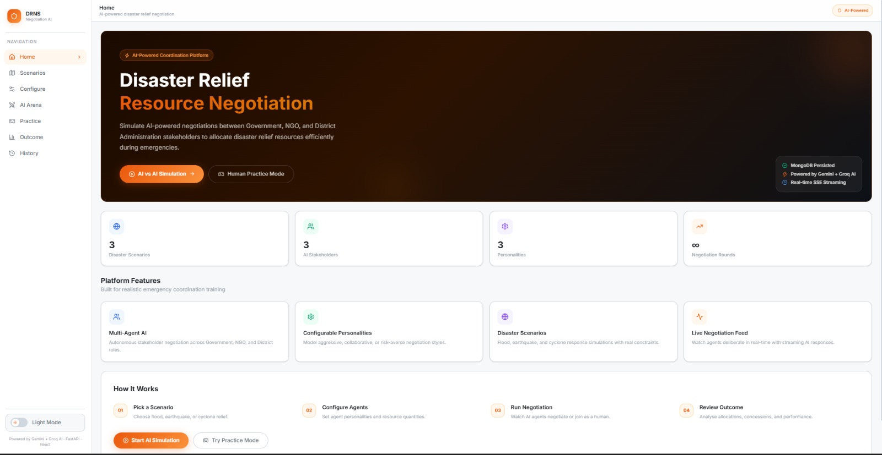
Figure 1. DRNS home page and platform overview.
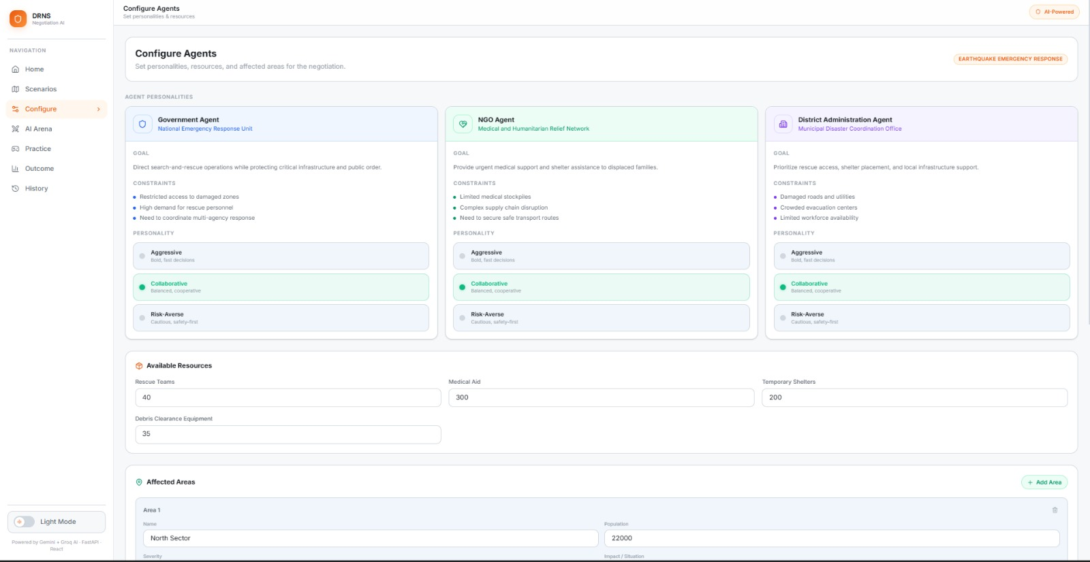
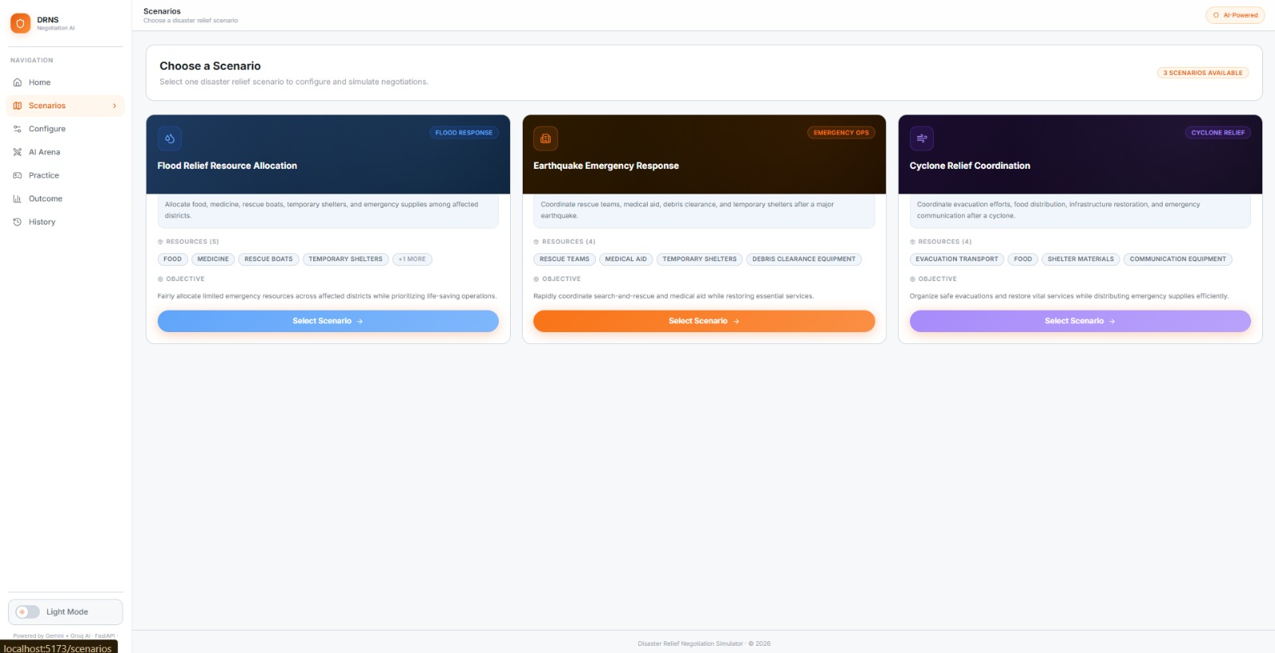
Figure 2. Scenario selection screen.
Figure 3. Agent configuration and resource setup.
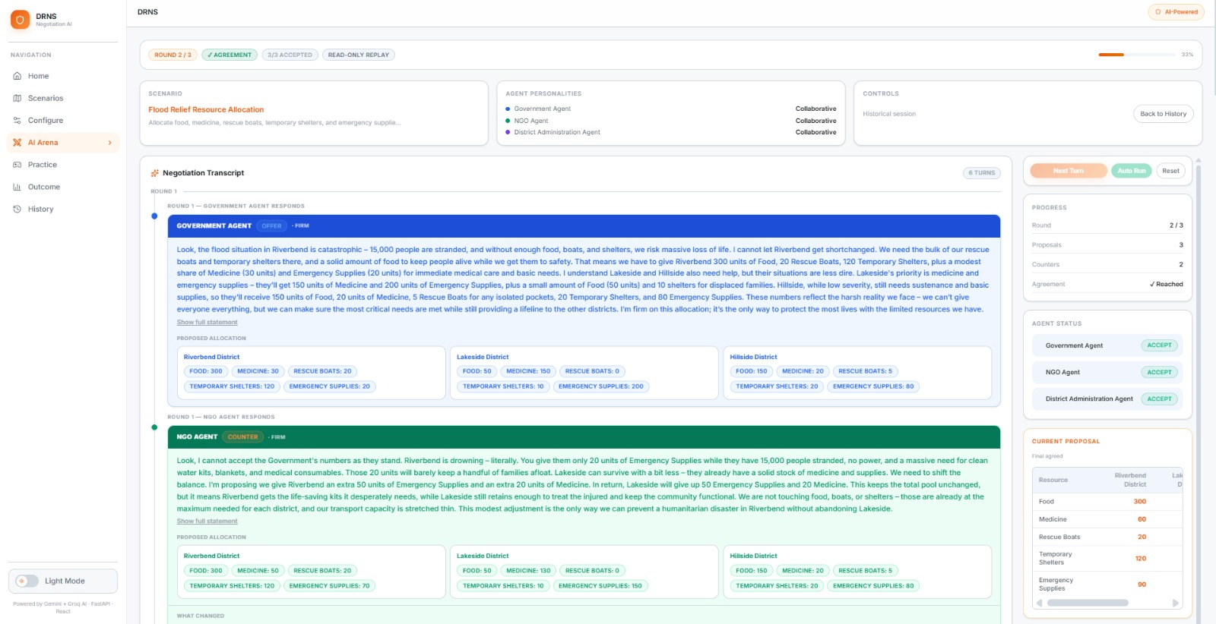
Figure 4. AI-vs-AI negotiation arena and live transcript.
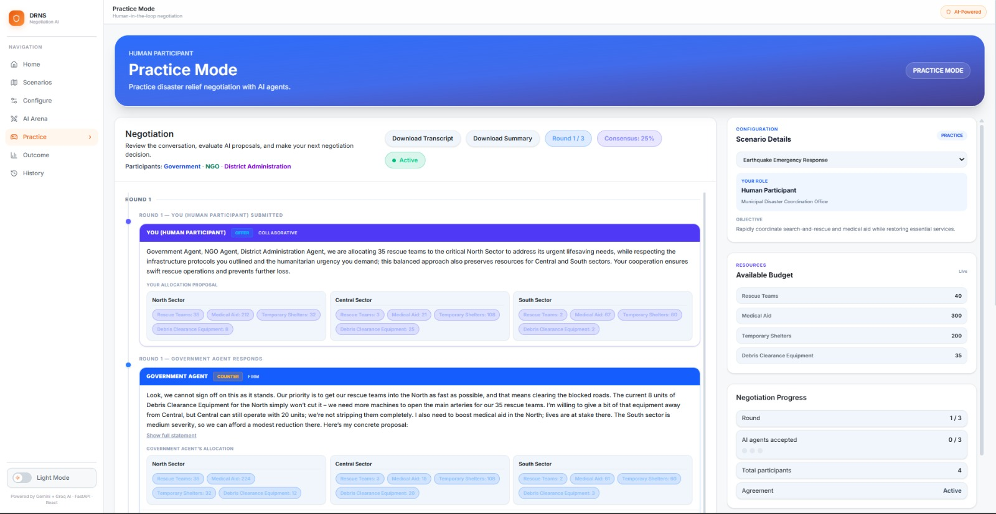
Figure 5. Human-vs-AI Practice Mode.
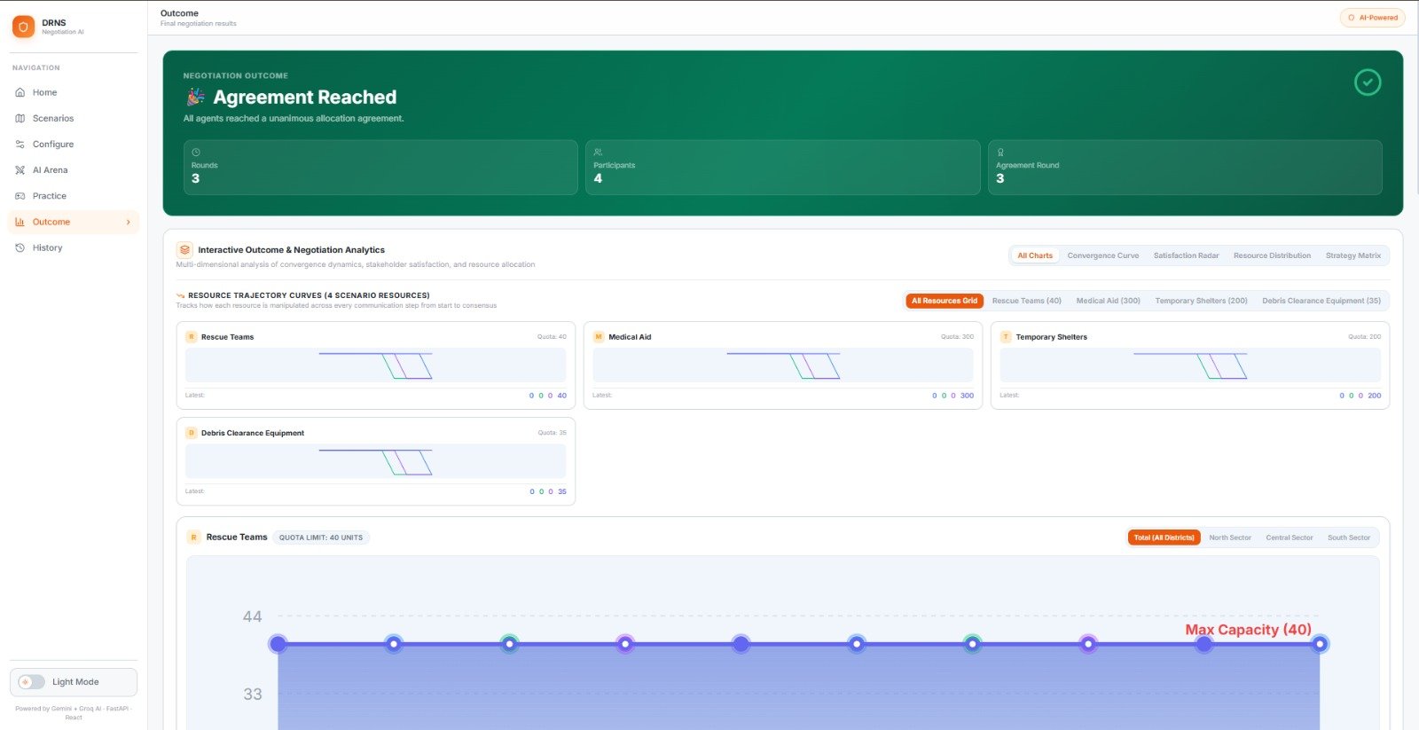
Figure 6. Negotiation outcome and analytics.
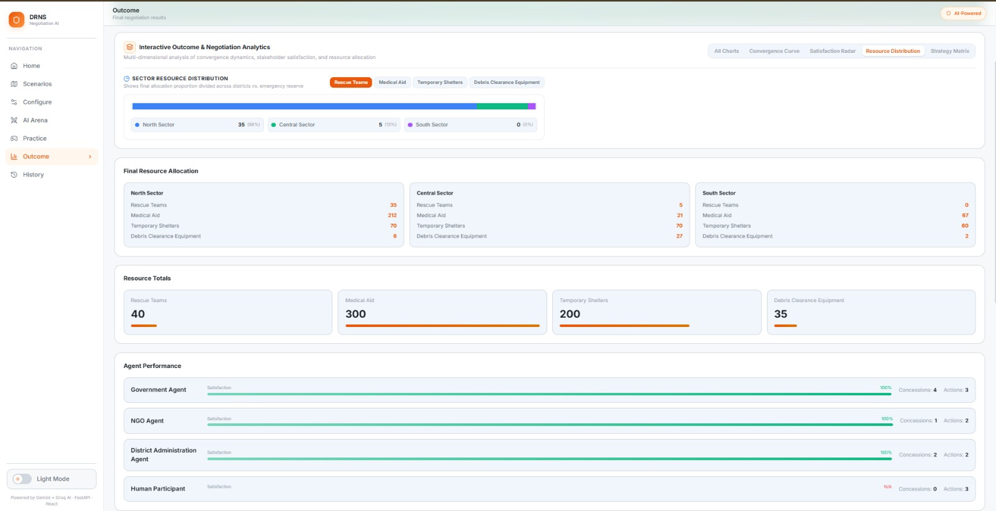
Figure 7. Final resource distribution and agent performance.
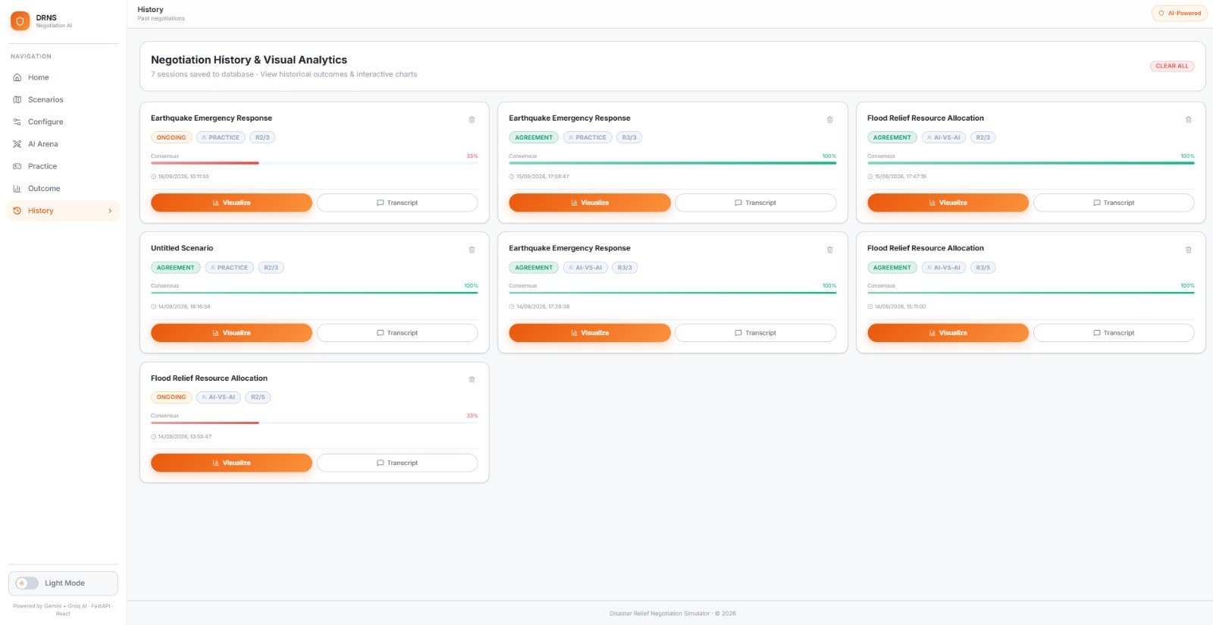
Figure 8. Negotiation history and replay interface.

22. Milestone-wise Contributions
Milestone | Contribution
Milestone 1 – Core Simulation Foundation | Established the initial multi-agent negotiation concept, scenario templates, stakeholder roles and configurable personalities. The foundation supported autonomous negotiation between role-specific agents.
Milestone 2 – Disaster Relief Negotiation | Extended the simulator into disaster-response resource allocation with Government, NGO and District Administration decision-makers, affected areas, constrained resources and disaster-specific scenarios.
Milestone 3 – End-to-End Workflow and Practice Mode | Integrated the Home → Scenario → Configure → Practice/AI Arena workflow, preserved scenario and agent configuration across pages, and introduced Human-in-the-Loop Practice Mode.
Milestone 4 – Outcome, Analytics and History | Implemented the Outcome screen, final allocation reporting, concession/performance analytics and the History/Replay experience. The system also integrates persistent session storage through MongoDB.

23. Limitations
- The current frontend uses a local backend address in the supplied implementation; deployment should externalize the API base URL through environment configuration.
- The repository contains security hardening items such as permissive CORS and diagnostic logging that should be corrected before production deployment.
- History endpoints require authentication and authorization if the system is exposed beyond a trusted local environment.
- Full automated test collection depends on installing the expected backend dependencies and using the intended backend working-directory/PYTHONPATH configuration.
- The LLM-based behavior is dependent on external provider availability and model responses; deterministic validation and fallback behavior reduce, but do not eliminate, this dependency.
- The project is a simulation/training platform and is not intended to replace authorized disaster-response decision makers.

24. Future Enhancements
- Add user authentication, authorization and per-user session isolation.
- Externalize frontend and backend configuration through environment variables.
- Add deterministic/mock LLM mode for repeatable CI and regression testing.
- Expand automated integration tests across all scenarios, personalities, modes and persistence paths.
- Improve model evaluation using repeatability, response validity, latency, token usage and negotiation-quality metrics.
- Add more disaster scenarios and configurable stakeholder types.
- Introduce richer replay controls such as round-by-round timeline navigation and side-by-side proposal comparison.
- Add export options for complete negotiation reports and training summaries.
- Modularize large orchestration and UI files for easier maintenance.
- Add deployment automation and continuous integration for backend tests, frontend linting and frontend builds.

25. SDG Alignment
The project can be aligned with selected United Nations Sustainable Development Goals because it explores the use of digital and AI technologies for coordination, institutional collaboration and resilient communities.
SDG | Alignment
SDG 9 – Industry, Innovation and Infrastructure | Demonstrates applied Generative AI, multi-agent systems, web engineering and data persistence in an integrated software platform.
SDG 11 – Sustainable Cities and Communities | Uses disaster-response scenarios to model coordination of limited emergency resources across affected areas.
SDG 16 – Peace, Justice and Strong Institutions | Supports transparent, reviewable stakeholder interaction and emphasizes human oversight rather than autonomous authority.

26. Conclusion
The Creation of AI Driven Multi-Agent Negotiation Training & Simulation Platform demonstrates how Generative AI can be combined with deterministic software engineering to create an interactive multi-agent negotiation environment. The platform models Government, NGO and District Administration stakeholders, supports configurable personalities and constrained resource allocation, and provides both autonomous AI-vs-AI and Human-vs-AI negotiation.
A key architectural principle is the separation between LLM-generated behavior and authoritative system logic. Proposal validation, consensus, deadlock handling, persistence and outcome analysis remain controlled by the application rather than being delegated entirely to the language model. The resulting system provides a useful educational demonstration of multi-agent AI engineering, human-in-the-loop interaction, constrained decision making and post-negotiation analytics.
The project can be strengthened further through security hardening, environment-based configuration, automated integration testing, modularization and production deployment practices. With these improvements, the platform can serve as a stronger foundation for future work in agentic AI, negotiation simulation and decision-support training.

27. References
- React Documentation. Meta Open Source. https://react.dev/
- Vite Documentation. https://vite.dev/
- FastAPI Documentation. https://fastapi.tiangolo.com/
- Pydantic Documentation. https://docs.pydantic.dev/
- Uvicorn Documentation. https://www.uvicorn.org/
- MongoDB Documentation. https://www.mongodb.com/docs/
- Motor Documentation. https://motor.readthedocs.io/
- Tailwind CSS Documentation. https://tailwindcss.com/docs
- MDN Web Docs – Server-Sent Events. https://developer.mozilla.org/en-US/docs/Web/API/Server-sent_events
- Groq Documentation. https://console.groq.com/docs
- Google Gemini API Documentation. https://ai.google.dev/gemini-api/docs
- Pytest Documentation. https://docs.pytest.org/
- United Nations Sustainable Development Goals. https://sdgs.un.org/goals
- Project source repository and supplied technical report documentation, used as the primary implementation reference.

Appendix A – Security and Responsible AI Considerations
- Keep Groq, Gemini and MongoDB credentials exclusively in server-side environment variables.
- Never log API key values or complete secret-bearing configuration objects.
- Restrict CORS to trusted frontend origins in deployed environments.
- Protect history endpoints with authentication and per-user/session authorization.
- Validate every model-generated proposal before it changes negotiation state.
- Keep a clear distinction between model-generated reasoning and authoritative system decisions.
- Preserve explicit validation, consensus and deadlock checks rather than allowing an LLM to terminate a negotiation directly.
- For real disaster-response use, position the platform as a decision-support and education system rather than an autonomous authority.

Appendix B – Key Implementation Components
Component | Role
backend/main.py | FastAPI application, CORS, lifecycle, request models and primary negotiation/practice endpoints.
backend/services/negotiation_orchestrator.py | Central state machine, participant turns, human participation, consensus/deadlock and persistence triggers.
backend/services/gemini_service.py | LLM provider layer, Groq/Gemini calls, validation/fallback behavior and metrics.
backend/services/evaluation_engine.py | Consensus, deadlock, proposal deltas, concessions, agent performance and outcome analysis.
backend/prompts/prompt_builder.py | Structured prompts using persona, personality, resource constraints, history and negotiation rules.
backend/services/database.py | MongoDB connection, index creation and collection access.
backend/routes/history.py | Persistent negotiation-history listing, retrieval and deletion endpoints.

Update field to generate table of contents.

