INTERNSHIP PROJECT REPORT CREATION OF AI DRIVEN MULTI-AGENT

NEGOTIATION TRAINING & SIMULATION PLATFORM

Infosys Springboard Virtual Internship 7.0 | Batch-2

Project Details | Information
Project Duration | 8 Weeks
Mentor | Nishyanth
Team Members | Madhugna Yelchuri; Tharungowda N K; Prasad Chaudhari; Bhagyashree; Bhoopathi Harshitha; P.M.Sree Priya

Prepared as part of the Infosys Springboard Virtual Internship

ABSTRACT
Negotiation is an important component of decision-making where multiple stakeholders may have different goals, constraints, priorities, and preferences. This project presents a Generative AI-powered multi-agent negotiation training and simulation platform focused on disaster-relief resource allocation. The platform models negotiations between a Government Agent, NGO Agent, and District Administration Agent, each with distinct objectives and negotiation personalities. It supports both AI-vs-AI Simulation Mode and Human-vs-AI Practice Mode. A Negotiation Orchestrator manages turn sequencing, negotiation rounds, context, proposals, consensus, and deadlock handling. The system also provides structured proposal validation, concession analysis, evaluation, outcome reporting, downloadable reports, and history/replay functionality. The current implementation uses a React frontend, FastAPI backend, Groq as the primary LLM provider, Google Gemini as the fallback provider, and MongoDB Atlas for session and history persistence.

INTRODUCTION
The project was developed as an Infosys Springboard Virtual Internship project. Its purpose is to provide an interactive environment for training and studying negotiation using autonomous Generative AI agents. The platform represents different stakeholders as AI agents and allows them to negotiate resource allocations under scenario-specific requirements.
The implemented platform focuses on disaster-relief scenarios. Users can select a scenario, configure the negotiating agents and their characteristics, and then observe or participate in a negotiation. The system maintains the negotiation state across rounds and produces a structured outcome after the negotiation ends.

PROJECT OBJECTIVES
- Develop a multi-agent simulation where autonomous LLM-powered agents negotiate with unique personas, objectives, and negotiation personalities.
- Support Simulation Mode (AI-vs-AI) and Practice Mode (Human-vs-AI) through a chat-style negotiation interface.
- Provide three pre-built disaster-relief scenario templates.
- Provide structured outcome analysis including agreement terms, concession patterns, and per-agent performance.

DISASTER-RELIEF SCENARIOS
The platform includes three pre-built disaster-relief scenarios:

Earthquake Emergency Response
The scenario covers rescue operations, medical response, temporary shelter, and infrastructure recovery.
    - Rescue Teams
    - Medical Aid
    - Temporary Shelters
    - Debris Clearance Equipment

Flood Relief Resource Allocation
The scenario focuses on distributing limited resources across flood-affected districts.
    - Rescue Boats
    - Food
    - Medicine
    - Temporary Shelters
    - Emergency Supplies

Cyclone Relief Coordination
The scenario focuses on evacuation, shelter, food distribution, and emergency communication.
    - Evacuation Transport
    - Food
    - Temporary Shelters
    - Emergency Communication

SYSTEM MODULES
- Scenario Selection and Agent Configuration Module
- Negotiation Orchestrator and Turn Management Module
- LLM-Powered Agent Reasoning and Offer Generation Engine
- Counteroffer Evaluation and Concession Decision Module
- Deadlock Detection and Resolution Module
- Negotiation Arena UI with chat transcript and live metrics
- Human Participant Interface for Practice Mode
- Outcome Evaluation and Report Generation Module
- History and Replay functionality
- MongoDB Atlas persistence for negotiation sessions and history

SYSTEM ARCHITECTURE
The system follows a frontend-backend architecture in which the React frontend communicates with the FastAPI backend. The Negotiation Orchestrator coordinates the agents and the negotiation state. The agent layer connects to the LLM provider layer, while the evaluation layer checks proposals, consensus, deadlock, concessions, and performance. Completed session information is persisted in MongoDB Atlas and can be reviewed through the History and Outcome interfaces.

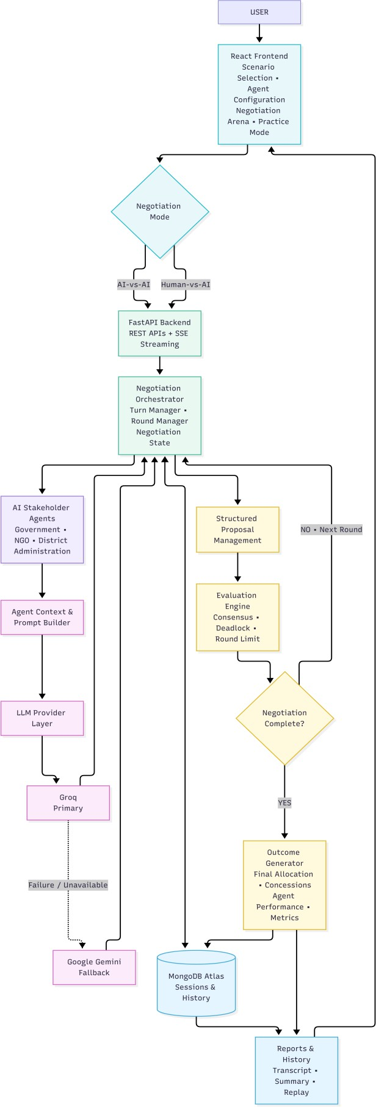
Figure 1: System Architecture of the Multi-Agent Negotiation Platform

NEGOTIATION WORKFLOW
A negotiation begins with scenario selection and agent configuration. The orchestrator initializes the session and manages the sequence of participants. Each agent receives scenario information, negotiation history, current and previous proposals, objectives, constraints, personality, and round information before producing a decision. The negotiation can continue through multiple rounds until consensus, deadlock/breakdown, or the configured maximum number of rounds is reached.
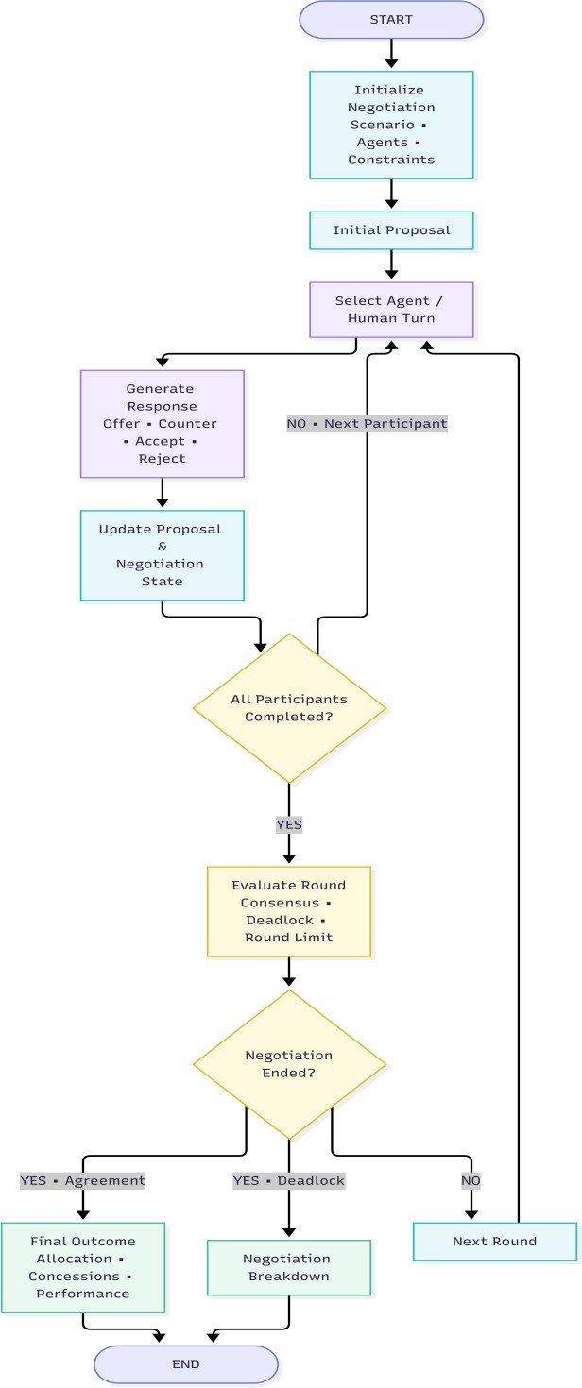
Figure 2: Negotiation Workflow

AGENT ARCHITECTURE
The system models three principal stakeholders: Government Agent, NGO Agent, and District Administration Agent. Each agent has a role, objectives, constraints, resource priorities, and negotiation personality.

Agent | Main Priorities
Government Agent | Public safety; rescue operations; infrastructure; critical regional requirements; essential emergency-response capacity
NGO Agent | Vulnerable communities; medical aid; temporary shelter; humanitarian urgency; protection of affected populations
District Administration Agent | Local operational requirements; infrastructure  recovery; regional emergencies; debris clearance; practical district-level distribution

Agent personalities affect how stakeholders communicate, evaluate proposals, and negotiate. The project statement also defines personality choices including aggressive, collaborative, and risk-averse.

AI-VS-AI SIMULATION MODE
In Simulation Mode, all negotiating participants are autonomous AI agents. The orchestrator controls turn order and passes relevant negotiation context to each agent. Agents can make opening offers, counter-proposals, accept existing proposals, or reject proposals when appropriate.
- Government Agent
- NGO Agent
- District Administration Agent
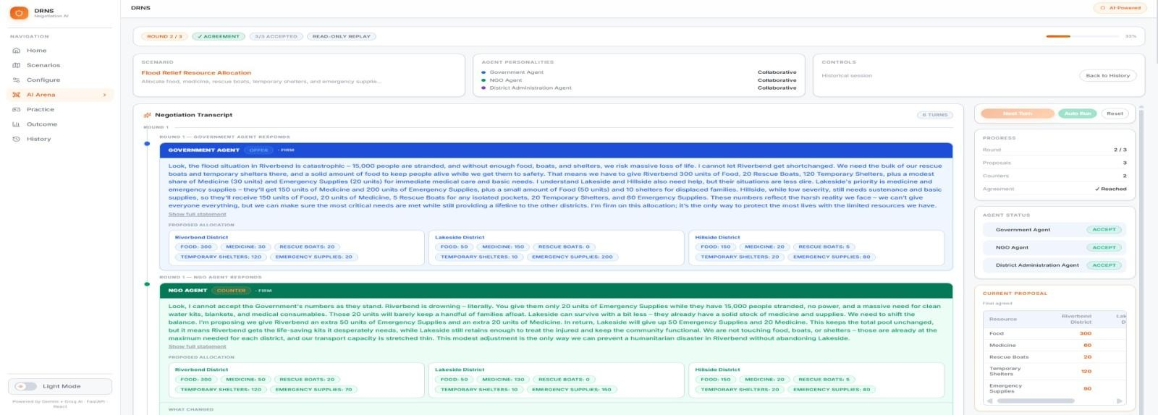
- Negotiation rounds continue until consensus, breakdown/deadlock, or the configured maximum number of rounds.

AI-vs-AI Negotiation Arena

HUMAN-VS-AI PRACTICE MODE
Practice Mode introduces a human participant into the negotiation. The human starts with an opening proposal and reviews the responses of the AI stakeholders. Human actions are incorporated into the same negotiation state used by the AI agents.
- Offer
- Counter
- Accept
- Reject
- Reset
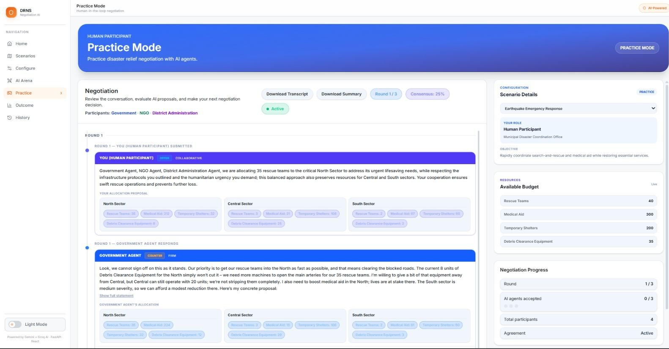

Practice Mode

NEGOTIATION ORCHESTRATOR
The Negotiation Orchestrator coordinates the complete negotiation lifecycle. It manages turn sequencing, negotiation rounds, current and previous proposals, agent and human responses, accepted proposals, consensus state, maximum rounds, deadlock detection, termination, final allocation, and outcome report generation.

STRUCTURED PROPOSAL MANAGEMENT
Resource allocations are represented using structured district/resource data. The system tracks current and previous allocations, resource totals, increases, decreases, concessions, and the final allocation.
Proposals are validated against the available resource quantities.

CONSENSUS DETECTION
Consensus is based on exact proposal agreement. In AI-vs-AI negotiation, all configured AI agents must accept the same current proposal. In Practice Mode, the Human Participant, Government Agent, NGO Agent, and District Administration Agent are all required to accept the same valid proposal.
The proposer is not automatically counted as having accepted.

DEADLOCK AND MAXIMUM-ROUND HANDLING
The system includes deadlock handling for stalled negotiations. AI-vs-AI deadlock detection considers repeated identical messages, repeated counter-proposals with unchanged allocations, and negligible numerical movement. Practice Mode uses a four-participant unchanged-allocation rule across consecutive completed rounds. If the negotiation reaches its configured maximum number of rounds without consensus, it ends without consensus.

LLM INTEGRATION
The project uses a multi-provider LLM architecture. Groq is the primary provider and the current configured model is openai/gpt-oss-120b. Google Gemini is configured as the fallback provider when the primary provider is unavailable or a request fails, subject to valid credentials.

Provider | Role | Current Model / Use
Groq | Primary | openai/gpt-oss-120b
Google Gemini | Fallback | Used when the primary provider is unavailable or a  request fails

AGENT REASONING AND CONTEXT
Before making a negotiation decision, each agent receives a structured context containing the scenario, negotiation history, current round, maximum rounds, available resource quantities, current proposal, previous proposals, objectives, constraints, priorities, personality, and Practice Mode context when applicable. The agent's role and negotiation style are also included to provide context for decision-making.
The system uses Groq as the primary LLM provider with Google Gemini as a fallback provider. The current Groq model is openai/gpt-oss-120b. LLM responses are structured into an action (OFFER, COUNTER, ACCEPT, or REJECT), natural-language message, reasoning, stance, and resource allocation/proposal. The response is validated before being incorporated into the negotiation state.
Three agent personalities are supported: Aggressive, Collaborative, and Risk-Averse. Personality and objective information are provided to the LLM so that agents can adopt different negotiation styles. Personality and objectives influence the agent's negotiation behavior, while concession analysis evaluates changes between proposals.
Human Practice Mode also supports natural-language negotiation input. Human messages are added to the negotiation history and provided to subsequent agents as part of their context, allowing agents

to respond to statements such as "I can't give you any more medical aid." Structured numerical allocations are still used when an explicit resource proposal is required.
The system also includes response-uniqueness and repeated-proposal handling to reduce repetitive negotiation behavior. If an LLM request fails or produces an invalid response, fallback mechanisms provide a valid response so that the negotiation can continue. This includes the Groq-to-Gemini provider fallback and deterministic fallback handling for unavailable or invalid LLM responses.

EVALUATION AND CONCESSION ANALYSIS
The Evaluation Engine analyzes the negotiation state and evaluates the quality of agent decisions throughout the negotiation. It evaluates agent satisfaction, objective alignment, resource allocation fit, actions, proposal changes, concession patterns, consensus progress, contribution to agreement, and final allocation changes.
The engine compares the opening proposals with subsequent proposals and the final allocation to identify how resource distributions changed during negotiation. It also calculates per-agent performance information, including objective satisfaction, action statistics, acceptance behavior, proposal stability, concession count, quantity conceded, and contribution to the final agreement.

OUTCOME AND REPORTING
After completion, the system provides the final negotiation status, agreement terms, rounds elapsed, agreement round, participants, consensus status, final allocation, resource totals, concession timeline, concession patterns, per-agent objective satisfaction, per-agent performance, negotiation summary, and LLM metrics.
A decrease in an agent's previously proposed resource quantity is treated as a concession, while an increase represents a request for additional resources and is not counted as a concession.

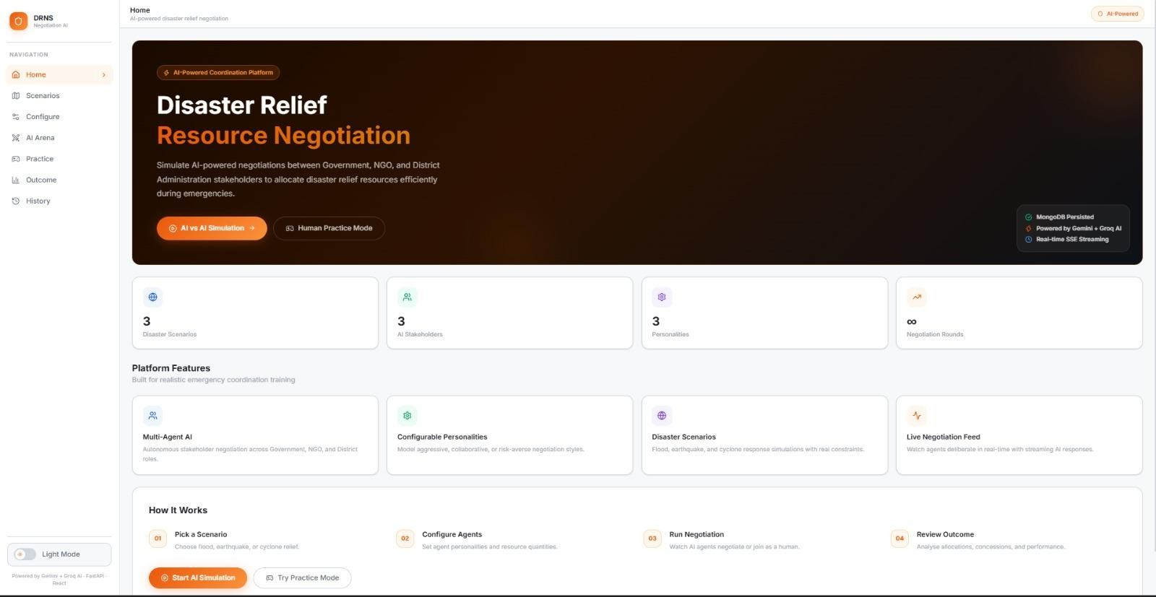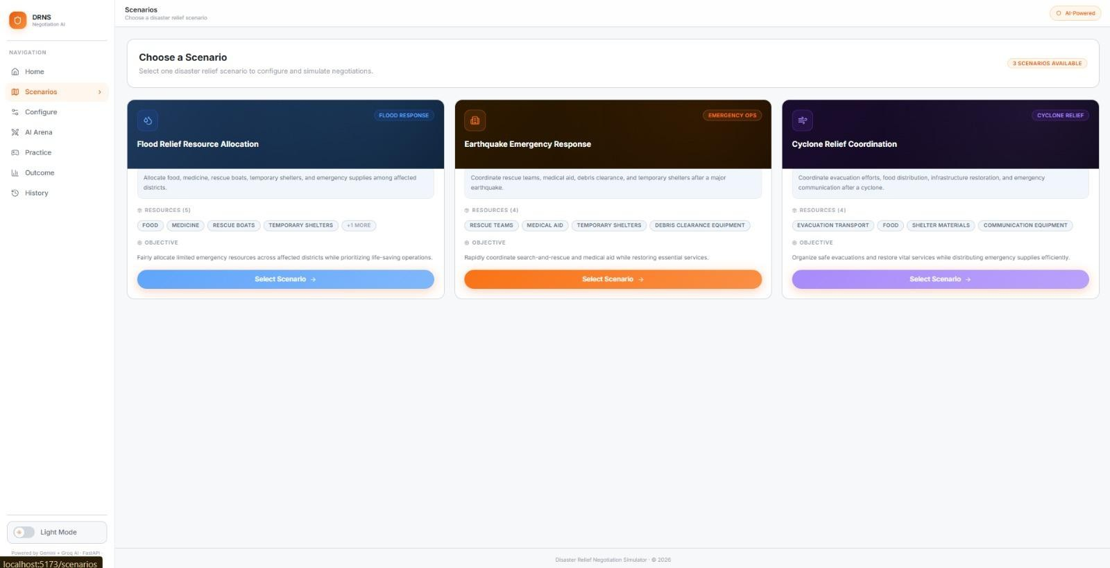

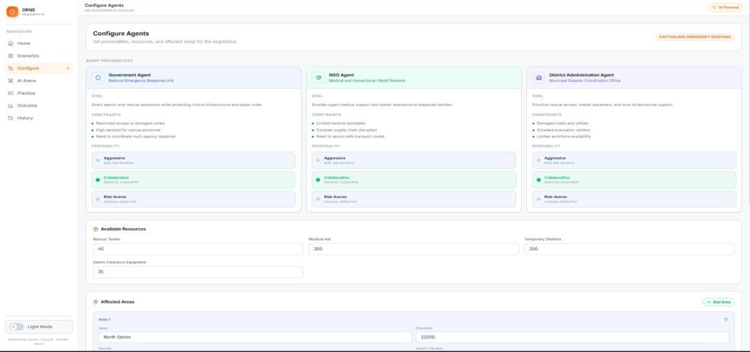

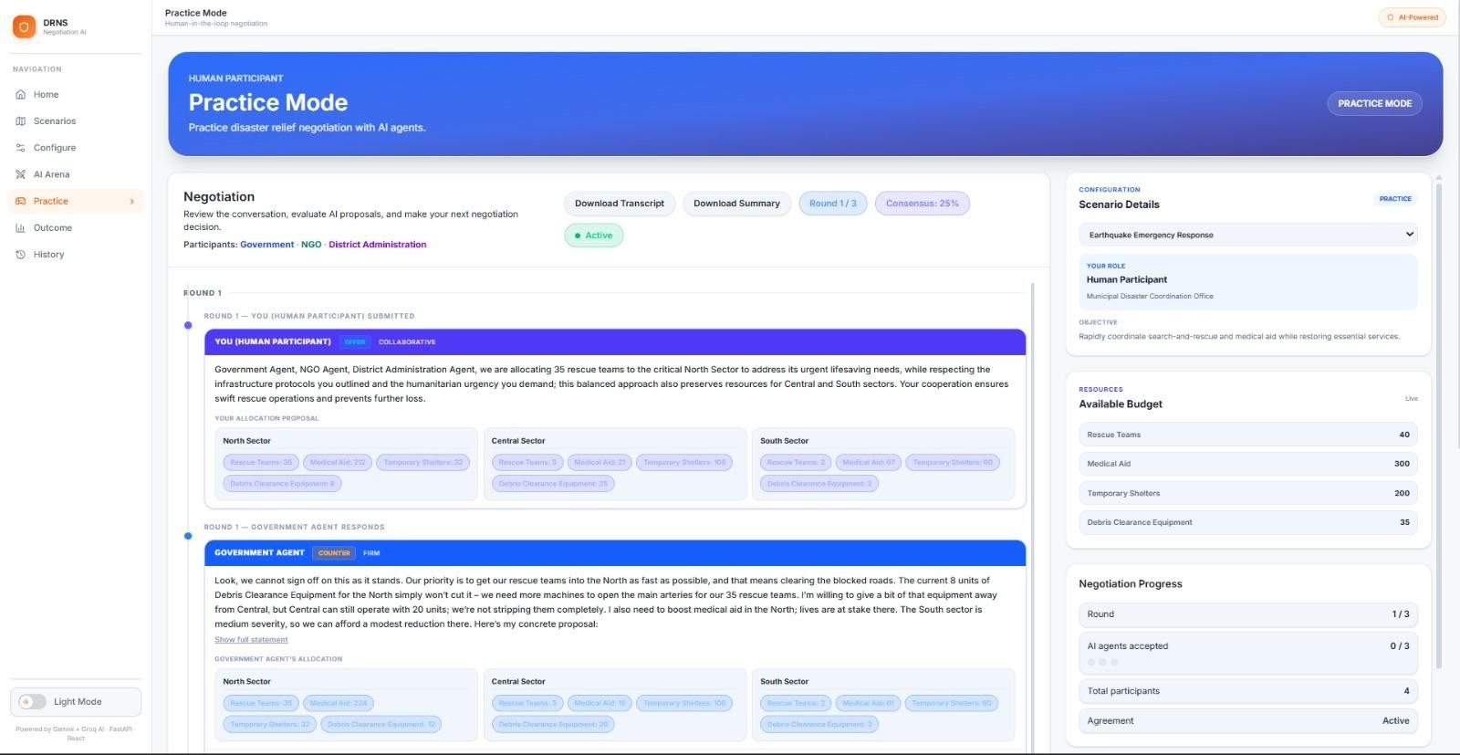

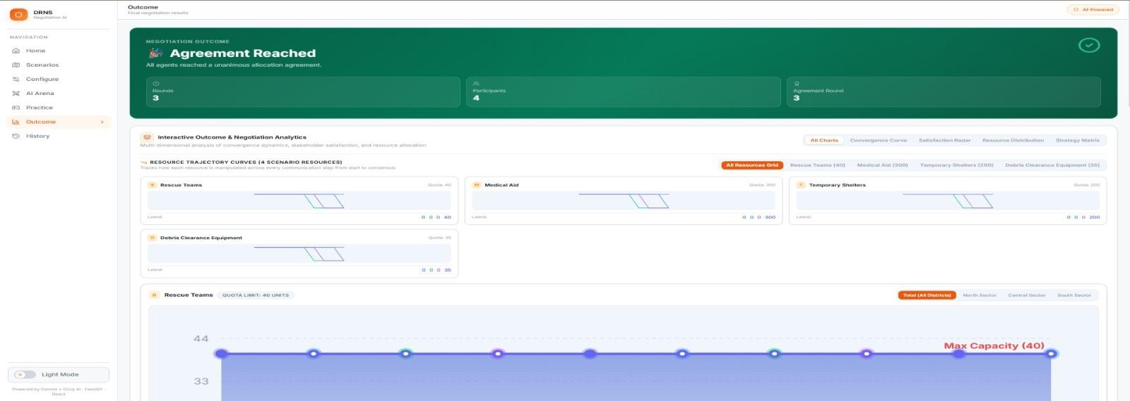

HISTORY, REPLAY AND DOWNLOADS
After a negotiation is completed, the Outcome Screen presents a structured summary of the final negotiation result. The screen provides the final negotiation status, agreement terms, rounds elapsed, agreement round, participants, consensus status, final resource allocation, per-resource totals, concession timeline, concession patterns, per-agent objective satisfaction, per-agent performance, and negotiation summary.
The Outcome Screen allows users to review how the negotiation progressed from the initial proposals to the final result and understand the contribution and concession behavior of each participant.
Historical sessions can also be opened in their corresponding Outcome view. The system provides downloadable historical negotiation summaries and final reports from stored session information.
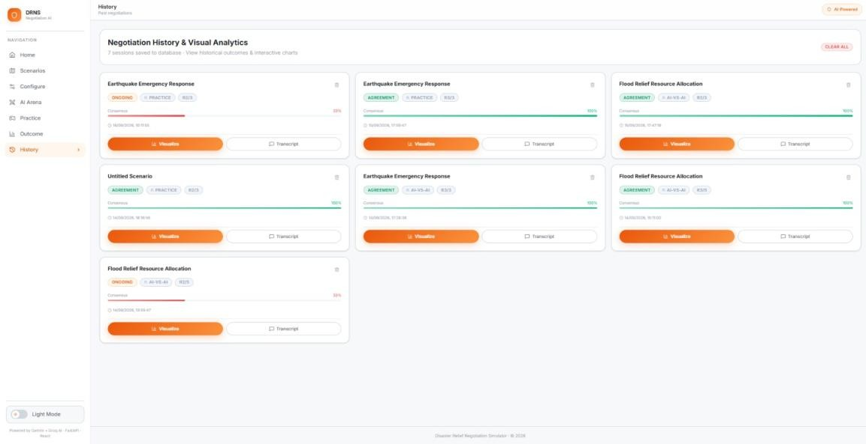

History Page

Read-Only Negotiation Replay

DATA PERSISTENCE
MongoDB Atlas is used to persist negotiation session information and history. Stored session information can include scenario configuration, agents, negotiation turns, proposals, consensus state, final allocation, outcome information, and related session status. This supports retrieval through the History interface.

FRONTEND AND BACKEND

Layer | Technologies / Components
Frontend | React, Vite, JavaScript, CSS
Backend | Python, FastAPI, Uvicorn
AI / LLM | Groq, Google Gemini
Communication | REST APIs, Server-Sent Events (SSE)
Database | MongoDB Atlas
Testing | Pytest, Python py_compile, npm build
Version Control | Git, GitHub

API OVERVIEW
The backend exposes REST endpoints for negotiation, Practice Mode, history, and health checking.

Method | Endpoint | Purpose
GET | /api/health | Health check
POST | /api/negotiation/start | Create a new AI-vs-AI negotiation session
POST | /api/negotiation/turn | Execute the next AI-vs-AI negotiation turn
POST | /api/negotiation/reset | Reset a negotiation session
POST | /api/practice/start | Create a Practice Mode session
POST | /api/practice/turn | Process a human Practice Mode action
POST | /api/practice/stream-turn | Process a Practice Mode action with streamed AI responses
POST | /api/practice/decision | Process the human final decision
POST | /api/practice/suggest | Provide a Practice Mode suggestion
GET | /api/history | Retrieve negotiation history
GET | /api/history/{session_id} | Retrieve a specific session
DELETE | /api/history/{session_id} | Delete a specific session
DELETE | /api/history | Delete negotiation history

TESTING AND VALIDATION
The project was validated through focused automated tests, backend checks, API testing, frontend build validation, and manual end-to-end testing of the implemented flows.

Area Tested | Validation

Backend compilation | Passed
MongoDB connection and read/write | Passed
AI-vs-AI negotiation | Passed
Practice Mode | Passed
Consensus handling | Validated
Maximum-round handling | Validated
AI-vs-AI deadlock handling | Validated
Practice Mode deadlock handling | Validated
Concession evaluation | Focused regression tests passed
History retrieval | Passed
Individual history deletion | Passed
Frontend production build | Passed

Focused regression testing covered negotiation evaluation, concession handling, Practice Mode deadlock behavior, and related negotiation logic. Manual API validation was performed for health, negotiation, Practice Mode, history, and history deletion flows.

MILESTONE PROGRESS

Milestone 1 — Foundation
    - Study of negotiation theory, multi-agent design patterns, and LLM-based agent reasoning
    - System architecture, orchestration flow, agent persona model, and UI wireframes
    - Scenario selection with three pre-built templates
    - Agent configuration with roles, goals, constraints, and personality selection

Milestone 2 — Negotiation System
    - Negotiation Orchestrator
    - Turn order, negotiation history, state, and round management
    - LLM-powered agent reasoning and offer generation
    - Counteroffer evaluation and accept/counter/reject decisions
    - End-to-end AI-vs-AI negotiation loop

Milestone 3 — Human Interaction and Deadlock Handling
    - Negotiation Arena
    - Human-vs-AI Practice Mode
    - Human-to-orchestrator integration
    - Structured human proposals
    - Consensus and maximum-round handling
    - AI-vs-AI and Practice Mode deadlock detection
    - LLM provider fallback
    - Server-Sent Events streaming
    - Practice Mode UI improvements

Milestone 4 — UI, History, Replay, Outcome and Integration
    - Improved overall UI/UX
    - Cleaner Current Proposal and Available Resources presentation
    - History page improvements
    - History-to-Negotiation-Arena read-only replay
    - Historical Outcome view for the selected session
    - Historical summary and final-report downloads
    - Gemini + Groq provider branding
    - MongoDB Atlas persistence validation
    - Individual history-session deletion
    - API validation and frontend build validation
    - Focused regression testing
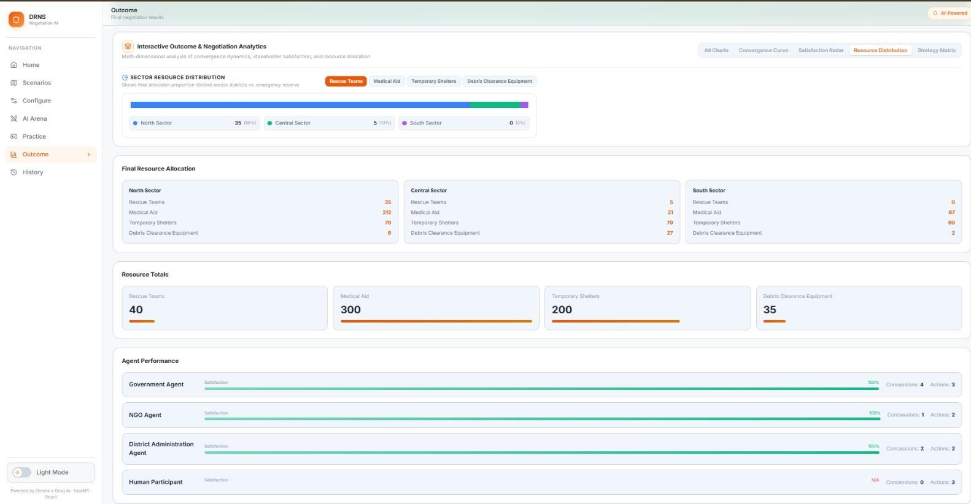

Final Milestone 4 UI

LIMITATIONS
The current platform is a simulation and training environment for negotiation. Its scenarios and stakeholder roles are predefined, and the available scenarios are limited to the three implemented disaster-relief templates. The platform is intended to demonstrate negotiation dynamics rather than replace real-world emergency-response decision-making.

FUTURE ENHANCEMENTS
- Additional disaster scenarios
- Additional stakeholder agents
- Advanced negotiation analytics
- Long-term agent performance tracking

- User accounts and saved workspaces
- Cloud deployment
- Authentication and authorization

SDG ALIGNMENT

SDG 11 — Sustainable Cities and Communities
The project supports disaster-response coordination and resource allocation to improve community resilience.

SDG 13 — Climate Action
The project models disaster-response scenarios and supports coordinated resource planning for climate-related emergencies.

SDG 16 — Peace, Justice and Strong Institutions
The system promotes structured, transparent, and coordinated decision-making between multiple stakeholders.

CONCLUSION
The Creation of AI Driven Multi-Agent Negotiation Training & Simulation Platform demonstrates a complete multi-agent negotiation workflow for disaster-relief resource allocation. The platform combines Generative AI, autonomous stakeholder agents, human-in-the-loop interaction, structured resource proposals, consensus handling, deadlock detection, evaluation, and outcome reporting.
The completed implementation supports AI-vs-AI Simulation Mode and Human-vs-AI Practice Mode, provides a Negotiation Arena for interactive negotiation, and allows completed sessions to be reviewed through History, read-only replay, and Outcome views. The project also integrates Groq and Google Gemini through a primary/fallback provider design and uses MongoDB Atlas for session and history persistence.

REFERENCES
- Infosys Springboard Virtual Internship 7.0, Batch-2 project statement and milestone requirements.
- Project source repository and project README provided for this report.

