**We can see that credit_data is imbalance data set we resolve this issue by using imbalanced-learn.** 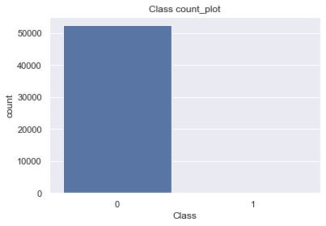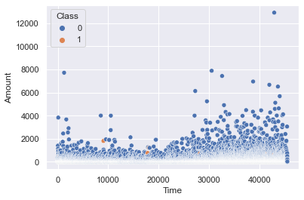

**-Madhvendra Singh and Akanksha**

Revision Number 1.3

Last date of revision – 26-May-23

WIREFRAME DOCUMENT

**FRAUD DETECTION PROJECT**

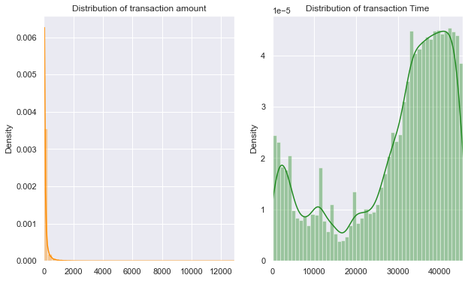

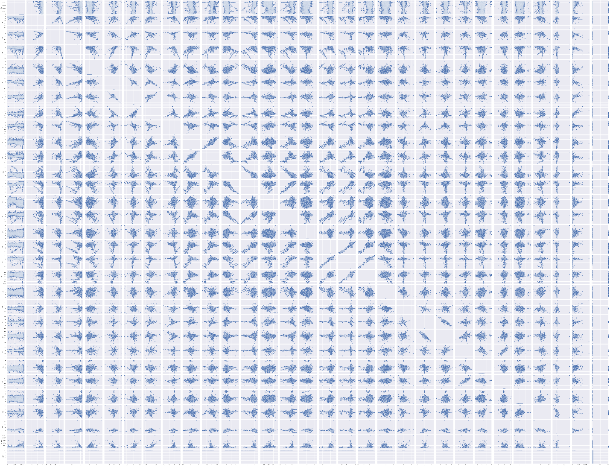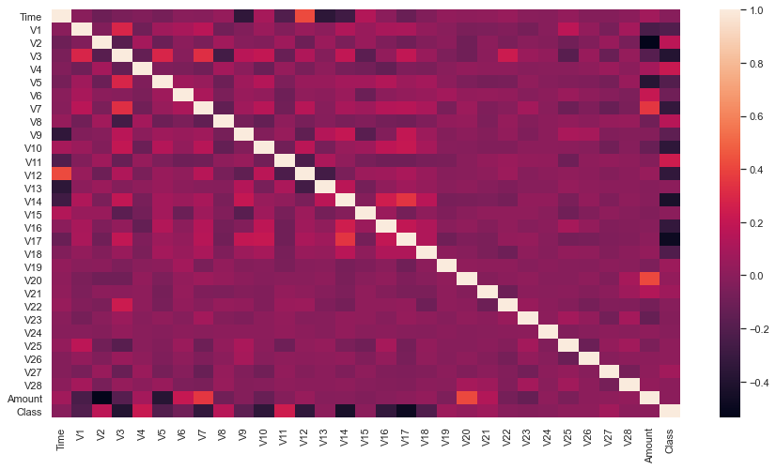

**Plotting a heatmap to visualize the correlation between the variables**

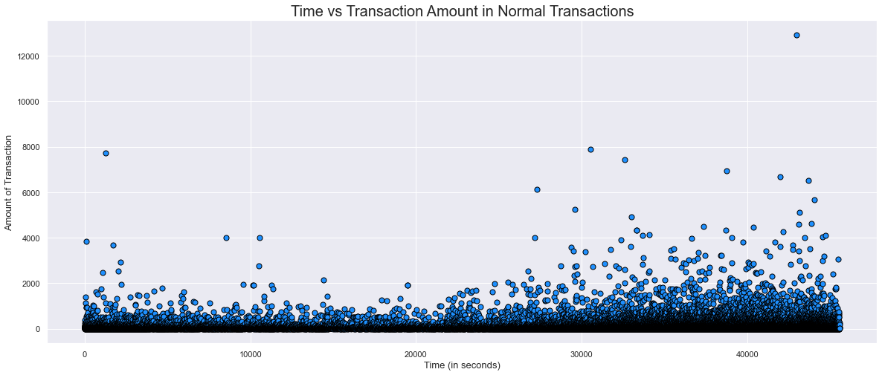

**Scatter plot of Class vs Amount and Time for Normal Transactions**

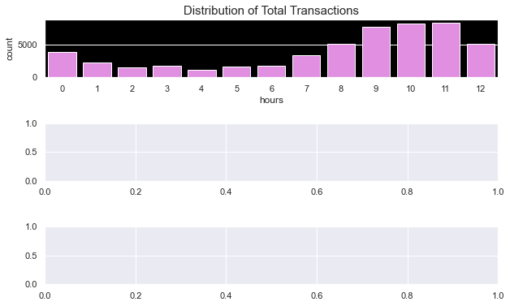

**FRAUDULENT** - There are much more outliers as compared to normal transactions.

The plot seems to not have any inherent pattern.

**NORMAL** - There are a less number of outliers as compared to fraudulent transactions.

There are a lot of transactions with amount less than 5000.

