target

Disease No_Disease

Heart Disease

138

(45.54%)

target

Disease

No_Disease

165

(54.46%)

Gender Distribution

sex Female Male

 | 100
of sex
Count | 50
 | 0 | No_Disease
 | Disease | No_Disease
 | target
Healthcare Analysis
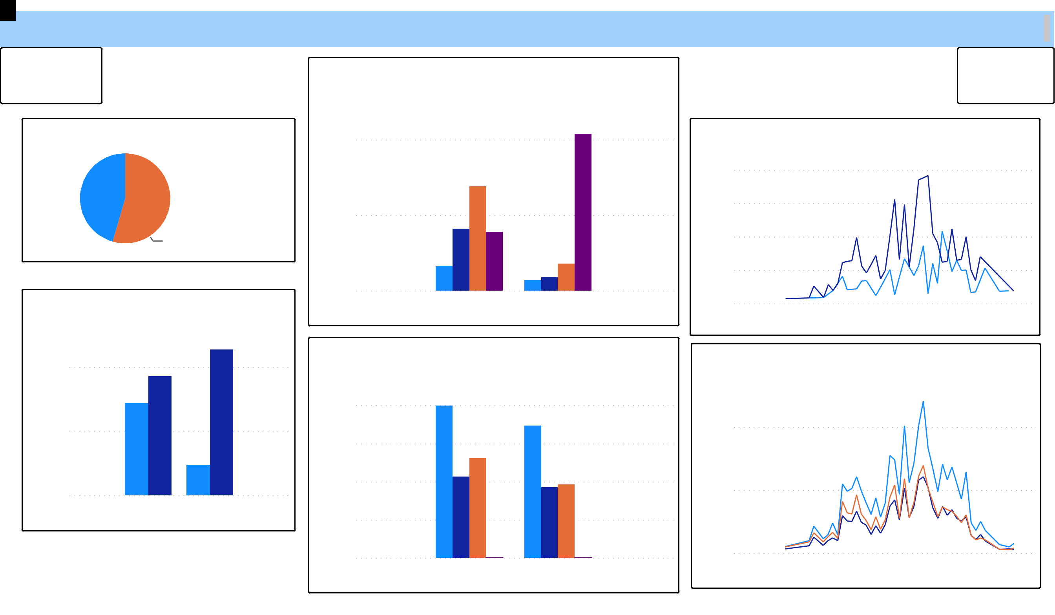

Chest Pain Distribution

cp Asymtomatic Atypical_Angina Non-Anginal … Typical_An…

 | 100
of cp
Count | 50
 | 0 | No_Disease
 | Disease | No_Disease
 |  | target

Cholestrol,Blood Pressure,Heart Rate and Fasting Blood Sugar by Heart Disease

chol trestbps thalach Count of fbs

and … | 40K
and … | 30K
thalach | 30K
thalach | 20K
trestbps, | 20K
trestbps, | 10K
chol, | 0K
 | 0K | No_Disease
 | Disease | No_Disease
 |  | target

sex

Female

Male

Age Distribution

sex Female Male

800

 | 600
age | 400
 | 200
 | 0 | 40 | 60 | 80
 | 20 | 40 | 60 | 80
age

Cholestrol,Blood Pressure and Hear Rate by Age

chol trestbps thalach

andthalach | 4K
chol,trestbps | 4K
chol,trestbps | 2K
 | 0K | 40 | 60 | 80
 | 20 | 40 | 60 | 80
age

