Horizon Infrastructure Demonstrator
Table of Contents
Horizon Infrastructure Demonstrator 1
Technical Documentation 3
Introduction 3
Architecture 3
End-User Documentation 5
Introduction to GeoTagger 5
Installation of the Android Client 5
System Requirements 5
Using the Android Client 6
Appendix A 12

Technical Documentation

Introduction
The Horizon infrastructure demonstrator is an implementation of a very simple multi-user geo-tagging application. This class of applications typically allows a user to perform some action at a location, for example taking a photo, and then sharing that action with other users who are 'in' that location. This particular application allows a user to either take a photo or make a text note and leave it to be found at a location. Whilst there is nothing novel about geo-tagging, it is a very simple to use and easy to understand example that can be used to test or demonstrate other technologies.
In the case of the Horizon infrastructure demonstrator, we want to demonstrate how it might be possible to use a Personal Container to mediate privacy aspects in publishing and storage of personal information. A Personal Container in it's simplest terms is an electronic repository in which is responsible for storing all of a users electronic personal information such as emails, Facebook posts, digital photos, and which is responsible for maintaining privacy whilst mediating access to the stored information by third parties. If you wish to know more about personal containers please read more about the Horizon Digital Economy project at http://www.horizon.ac.uk.

Architecture
The demonstrator is a typical client-server application. The server, running on Google App Engine, is responsible for storing 'tags' and serving them up to the client application when requested. The client application runs on the Android mobile phone operating system. Where the architecture differs from a traditional client-server application is in the use of the Personal Container service for publishing. Typically, data would be pushed in a closed loop between the client and the server, in the demonstrator however, data is pushed through the personal container service running on the mobile phone. This service in turn pushes the data to the cloud personal container service which then pushes the data to the server application. Image 1 below shows the demonstrator architecture and the flow of data through the system.
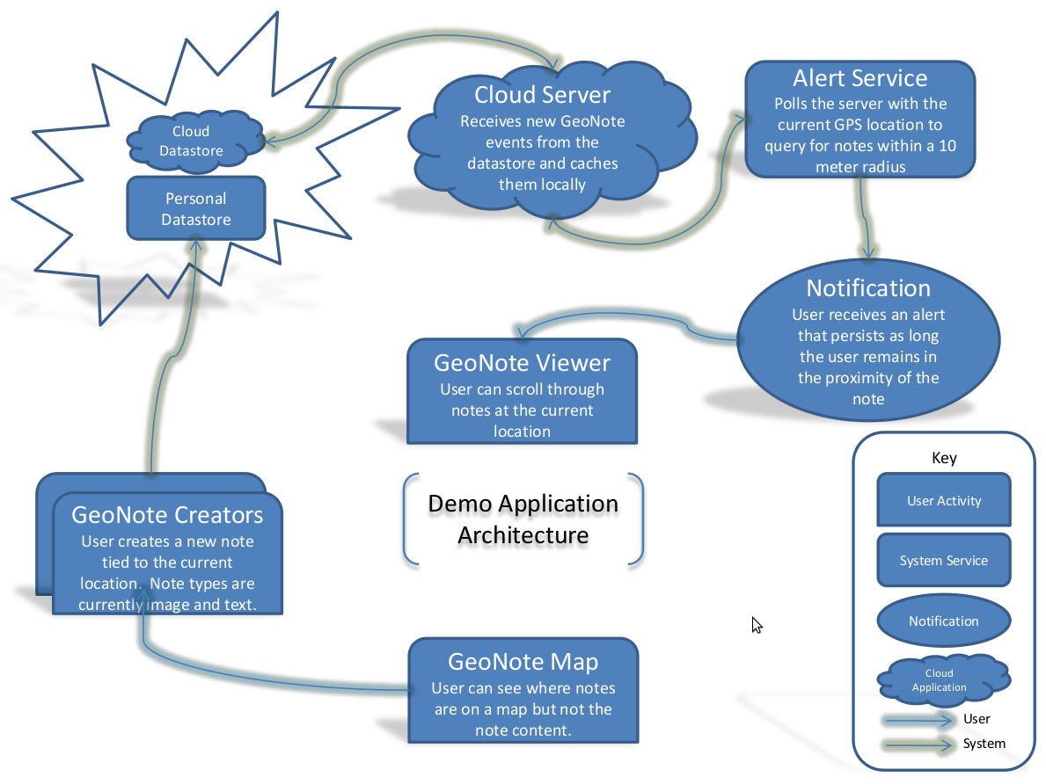Image 1: Infrastructure Demonstrator Architecture

End-User Documentation

Introduction to GeoTagger
GeoTagger is a very basic application for Android mobile phones that makes it possible to leave small 'notes' (photos or text notes) at a location so that they can be found later by anybody who has installed the GeoTagger application. Users can view on a map where to find notes but they cannot see the content of the note until they actually make their way to that location.
GeoTagger is intended as a demonstrator for an application that makes use of a prototype personal data store, whilst the exact nature of a personal data store is outside of the scope of this document, it is essentially a container in which your digital information is stored in a secure way and that you have complete control over. If you wish to know more please visit http://www.horizon.ac.uk for more information.

Installation of the Android Client
Unfortunately, due to the nature of the Android operating system, installing applications from sources other than the Android Marketplace is not a straightforward task and outside of the scope of this document. If you are aware of how to install non-marketplace applications, or are able to gain the help of someone who is, you will need to install two separate applications on your Android phone. The first is contained in the installer person.apk which can be downloaded from http://bit.ly/dntn6D, this is the personal container background service. The second installation package is GeoTagger.apk which contains the GeoTagger demonstrator application and can be downloaded from http://bit.ly/9qKFyP.

System Requirements
The GeoTagger application will run on any Android phone running Android version 1.5 or greater that includes a GPS device. You must also have data connectivity for the application to work correctly.

Using the Android Client
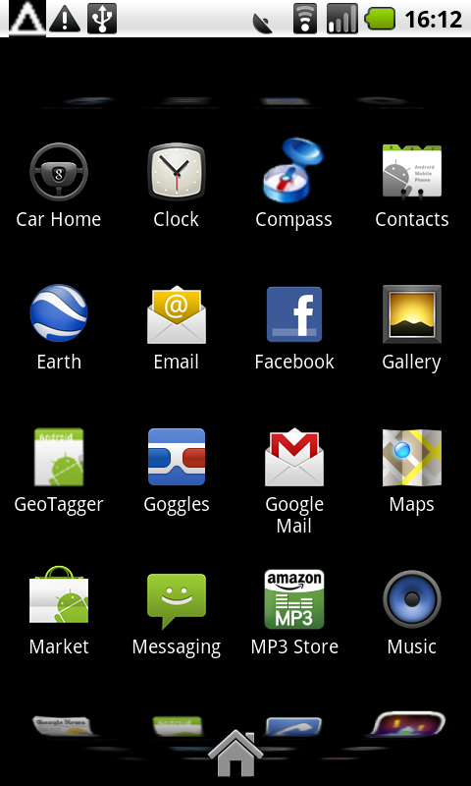Step 1: From the home screen, select the GeoTagger application.
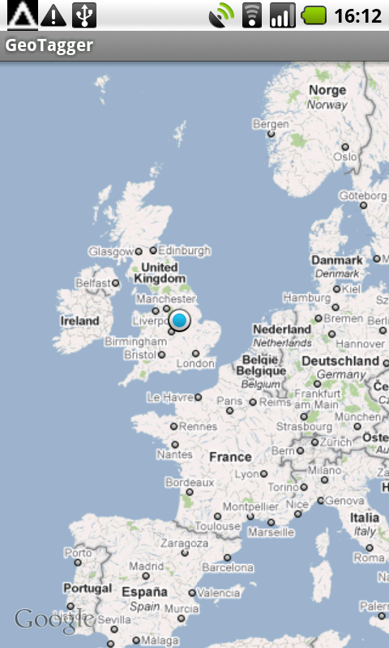Step 2: The first time you run the application, you will be shown a map that is zoomed out. The flashing blue dot shows your location (you must enable GPS for this to work correctly).
0.90
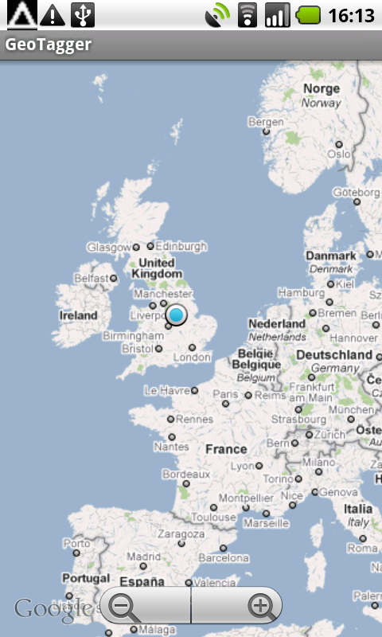Step 3: Touch on the map screen to be shown the zoom buttons.
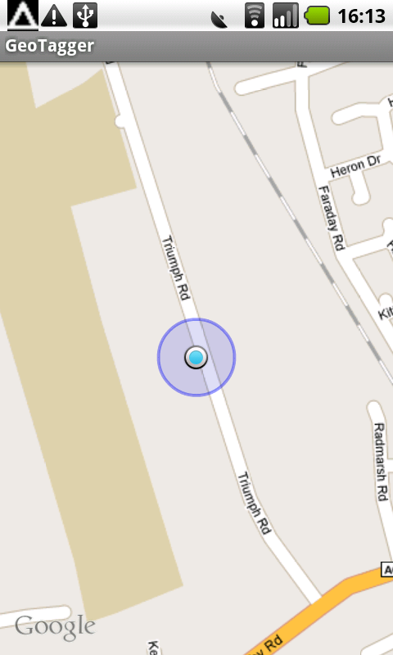Step 4: Zoom in to be shown clearer your location, the transparent blue circle around the blue dot shows the level of inaccuracy in the reported position.
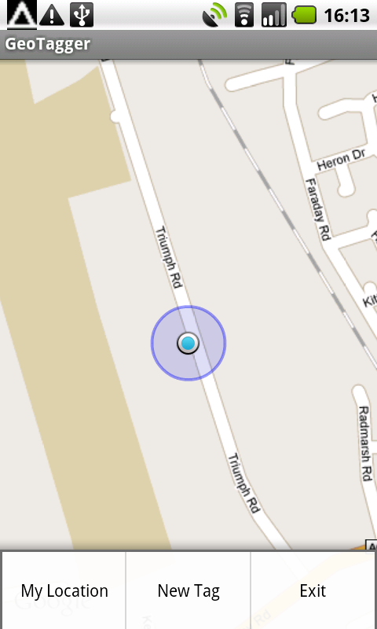Step 5: Press the menu button to bring up the application menu. Selecting My Location will centre the map view on your location. New Tag will bring up the view for creating a new tag at your current location. Exit will cause the application to quit.
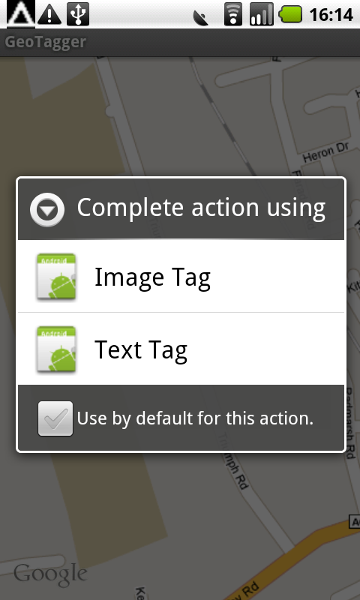Step 6: Selecting the 'New Tag' option from the menu will bring up options for the different types of tags you can create. At present you can create image or text tags.
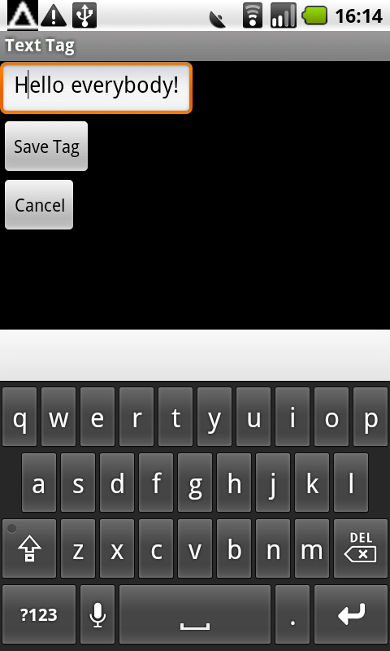Step 7: You can type any text you want to create a text tag.
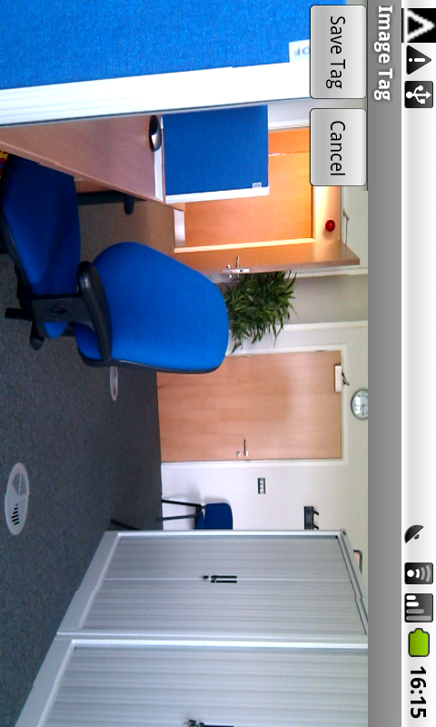Step 8: To create an image tag, you are shown a preview image from the camera before you select save.
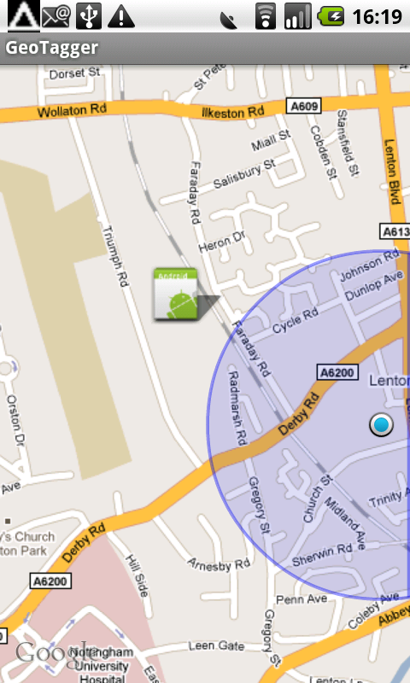Step 9: The position of tags are shown by the application logo on the map.
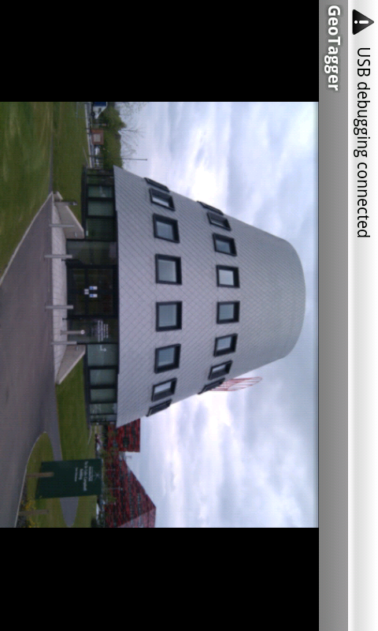Step 10: If you go to a location where a tag is stored, you are able to view that tag.
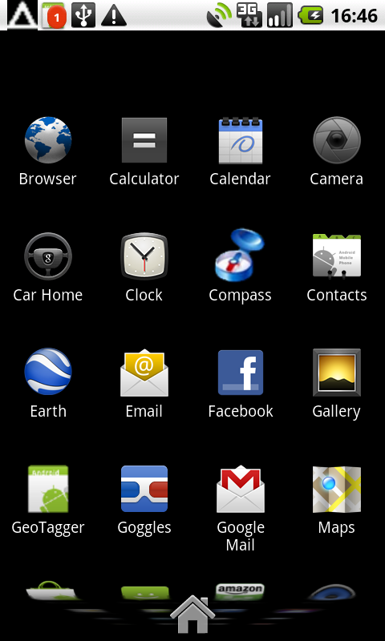Step 11: If you cross into a tag location whilst the application is closed, you will be alerted with a notification that there are tags you can view.
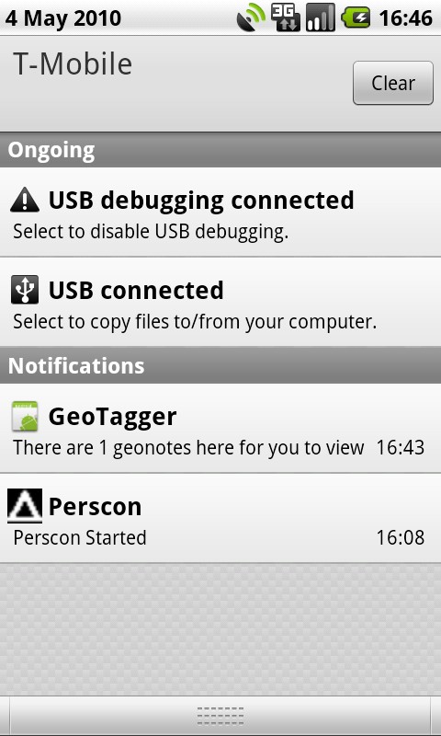Step 12: Selecting the notification will launch the application in tag viewing mode.

Appendix A
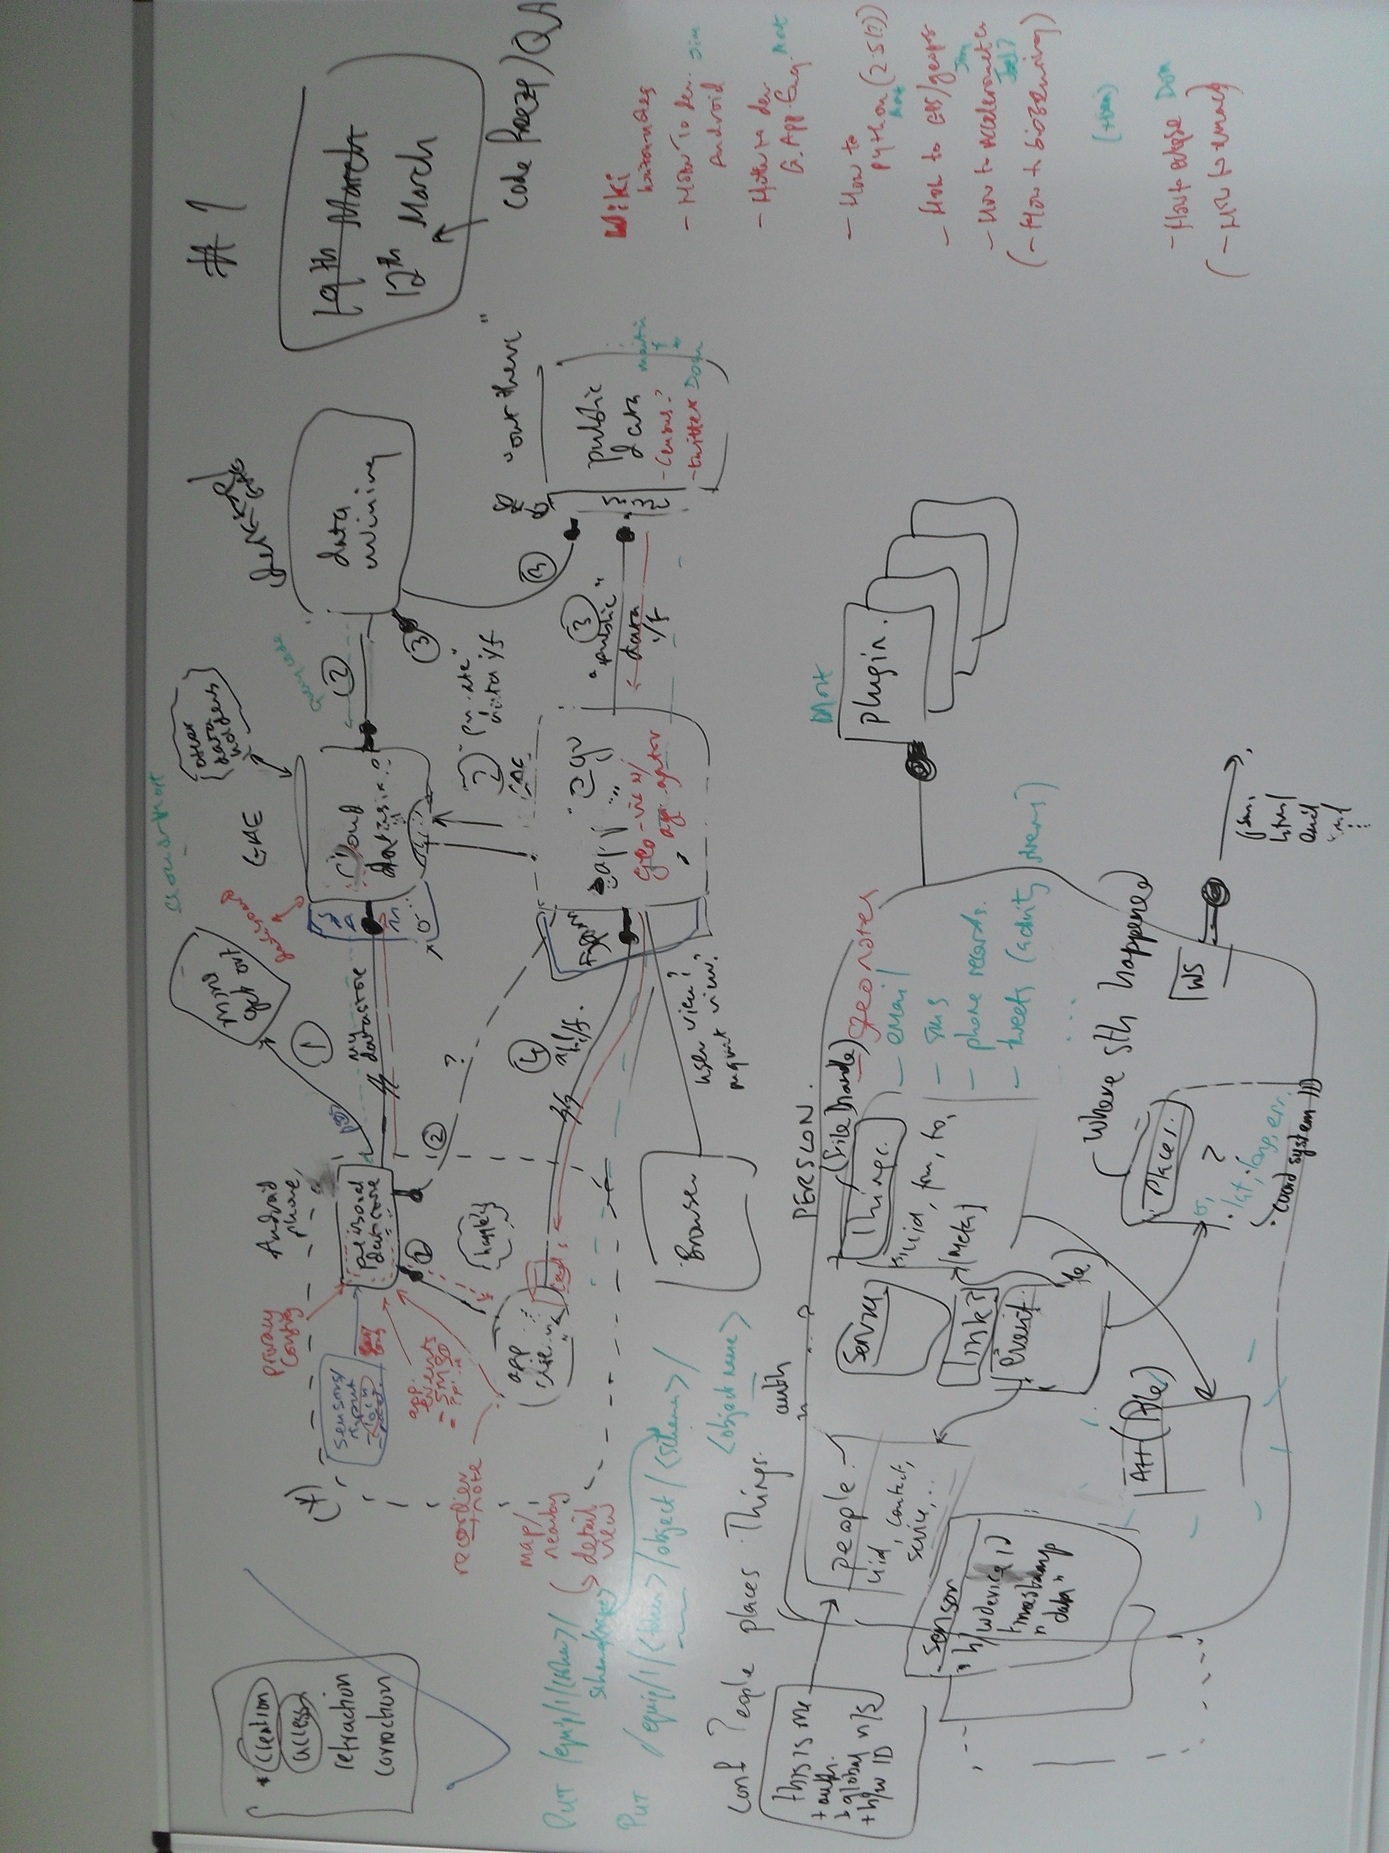Image 2: Brainstorming of the architecture for the infrastructure demonstrator.

