**PROJECT REPORT**

**Soccer League**

**Contents**

* **Definition of the problem**
* **Requirement analysis**
* **Architecture of web application**
* **Project tracking and monitoring activities**
* **Source code**
* **User guide**
* **Sitemap**
* **Task Sheet**
* **Our Journey**

1. **Definition of the Problem:**

**Soccer is a sport that’s played with a round black and white ball that player’s pass to each other using**

**their feet. To win a soccer match, your side has to kick the ball into the goal more time then your**

**rivals do. Go team!**

**.**

**In most part of the world , soccer is known as football which make sense since player(expect the goalie)**

**Can’t touch the ball with their hands –then mainly control and move it with their feet. In the U.S.A, however , soccer is the completely different sport one that’s know as American soccer everywhere else, soccer comes from socca , slang for Assoc , which is a shortened version of association soccer**

1. **Requirement Analysis:**

* **List of inputs to the system**
* Feedback
* **List of output from to the system**
* Feedback show (admin panel)
* Order placed show (user & admin both)

**3.** **Architecture of web Application:**

***Logo***

***Power-bots Home Galleries Top Players Feedback Contact Us***

***FIFA WORLD CUP MATCH 2026 UPCOMING***

***COUNTER***

***GALLERY***

***OWL - CAROUSEL***

***COUNTER***

**Soccer League Soccer League world cup Contacts**

Aptech Garden Center

[Hanz666@gmaill.com](mailto:Hanz666@gmaill.com)

+ 01 234 567 88

+ 01 234 567 89

FIFA WORLD CUP

COPA AMERICAN

AFC ASIAN CUP

CONCACAF GOLD CUP

"Welcome to our soccer league website, your ultimate destination for all things related to the beautiful game. Ouprlatform is dedicated to providing comprehensive information about soccer leagues, tournaments.

1. **PROJECT TRACKING & MONITORING:**

**FAIZA AND MUHAMMAD HANZELA: Covered the Homepage (Frontend).**

**SHAFIA AND MADIHA: Covered the Top 10 players Pages.**

**KHIZRA NAZ: Covered the Contact us Page.**

**UM E AIMUN: Covered the Footer Page.**

**MADIHA: Covered the JSON File.**

**5. SOURCE CODE.**

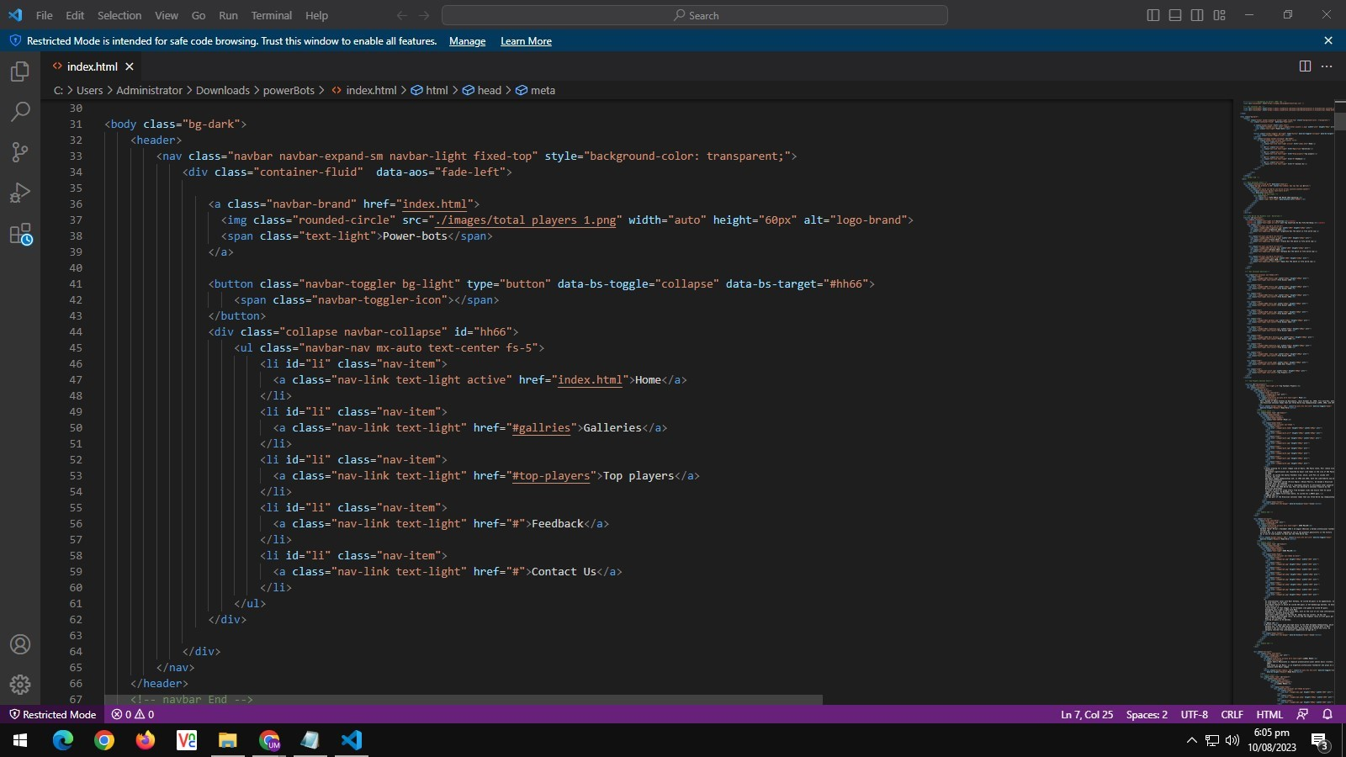

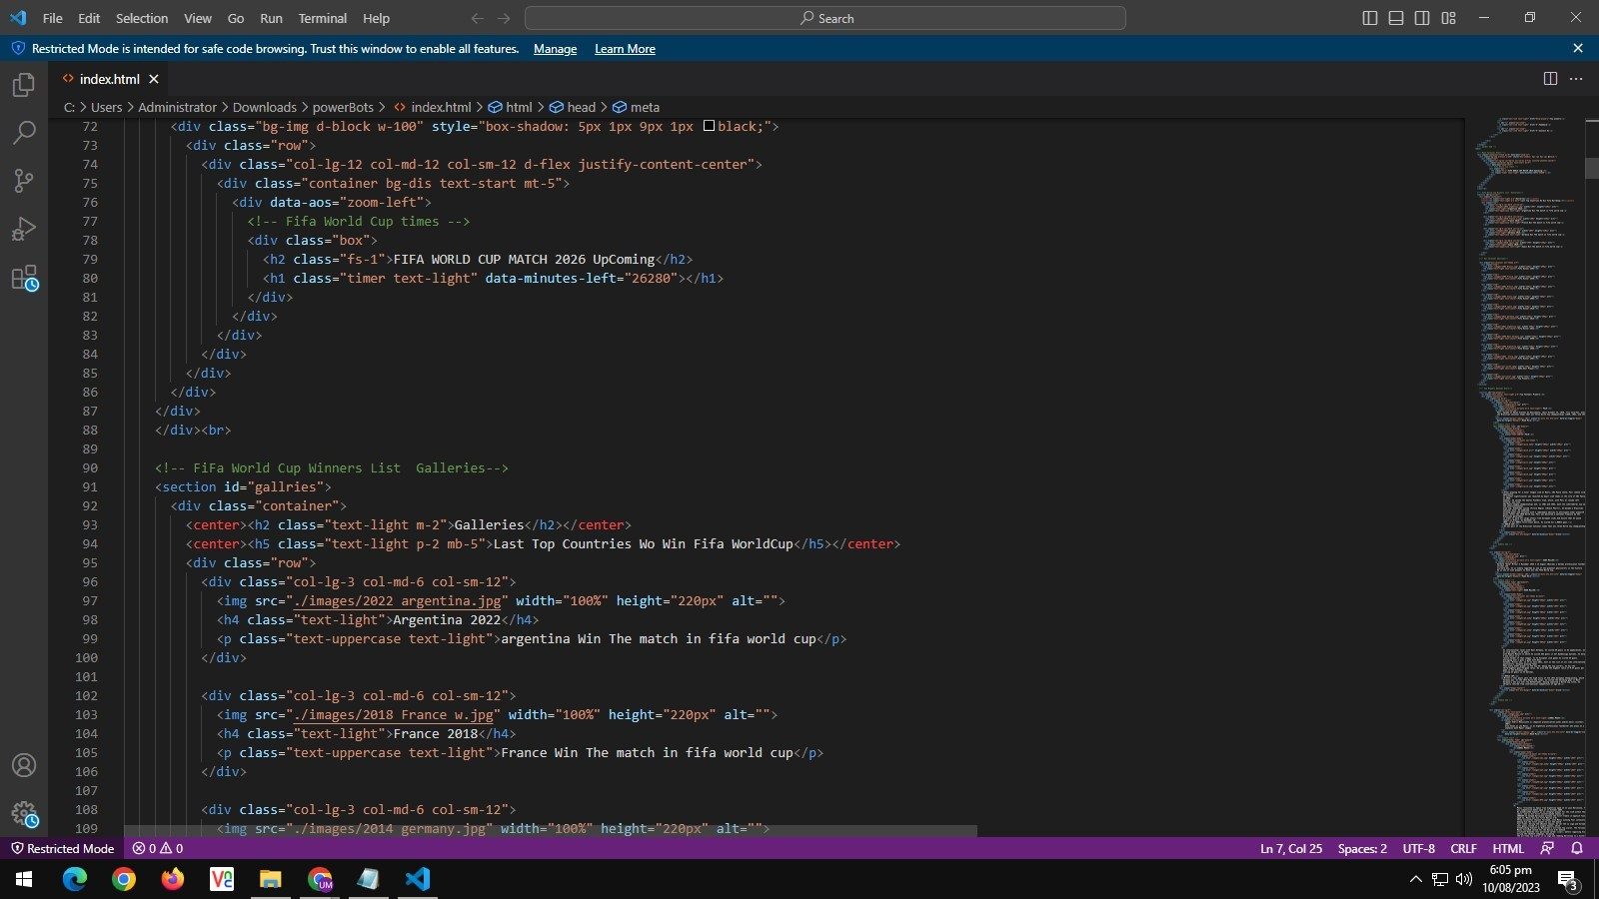

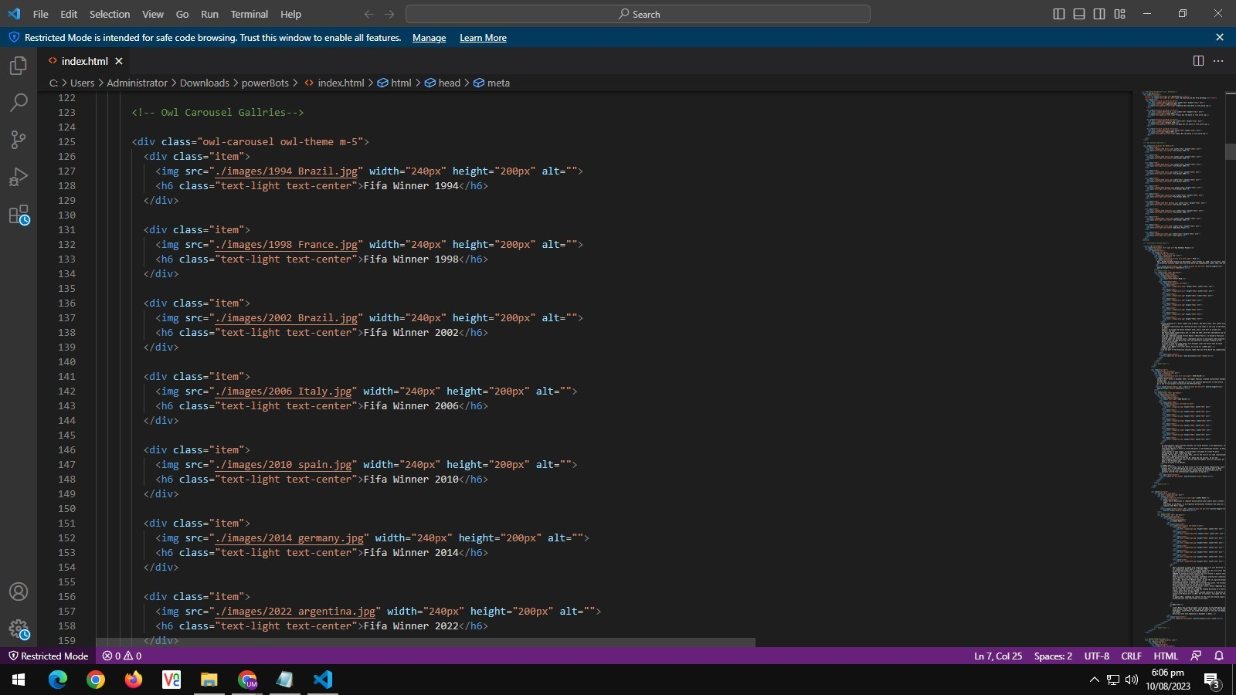



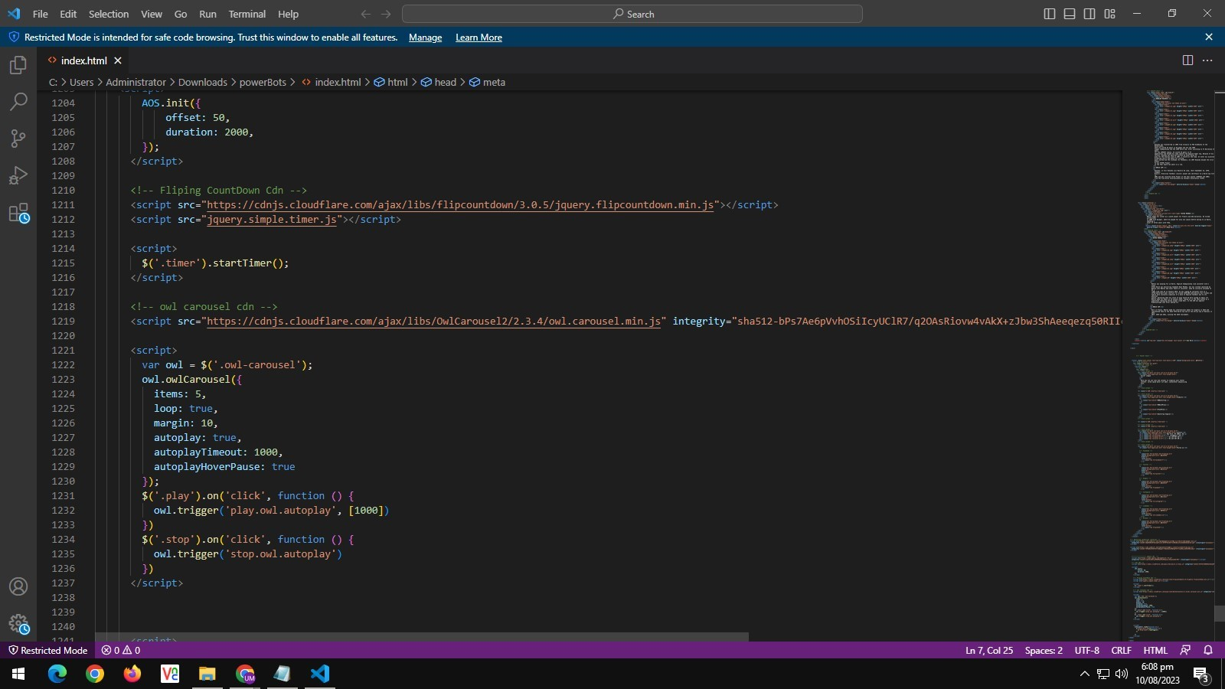

**6. USER GUIDE.**

1. **System Requirements:**
2. **Operating System || Microsoft Windows 8.1, 19. or higher.**
3. **Software || Visual Studio Code.**

**B) Execution Of Web App:**

**1) Install a browser example chrome.**

**2) Run the website by double clicking it.**

**7. SITEMAP:**

**8. TASK SHEET:**

|  |  |  |  |  |  |  |
| --- | --- | --- | --- | --- | --- | --- |
| **Project Ref No.**  **Techwiz/**  **Advertisement**  **Portal Management**  **System/o1** | | **Project**  **Title** | **Date of preparation of Activity**  **Plan** | | | |
| **NO.** | **Task** | **C**  **H**  **A**  **M**  **P**  **L**  **E**  **A**  **G**  **U**  **E** | **Actual Date**  **Start** | **Actual Date**  **End** | **Team-Mate Name** | **Status** |
| **01** | **Home page** | **0**  **8**    **A**  **U**  **G**  **U**  **S**  **T**  **2**  **0**  **2**  **3** | **1**  **1**  **A**  **U**  **G**  **U**  **S**  **T**  **2**  **0**  **2**  **3** | **MUHAMMAD**  **HANZELA** |  |
| **02** | **Matches** | **FAIZA** |  |
| **03** | **Contact Page** | **KHIZRA**  **NAZ** |  |
| **04** | **Gallery** | **MUHAMMAD**  **HANZELA**  **&**  **FAIZA** |  |
| **05** | **Top**  **Players** | **SHAFIA**  **&**  **MADIHA** |  |
| **06** | **Read ME** | **UM E AIMUN** |  |
| **07** | **JSON**  **File** | **MADIHA** |  |
| **08** | **Prototyping** | **KHIZRA NAZ** |  |

**9. DOCUMENTATION**

|  |  |  |  |  |  |  |
| --- | --- | --- | --- | --- | --- | --- |
| **Documentation** |  |  |  |  | **KHIZRA NAZ**  **SHAFIA**  **UM E AIMUN**  **FAIZA**  **MADIHA**  **M.HANZELA** |  |

**8. OUR JOURNEY:**

**Aptech has been one of the front runners in the I.T, education**

**Space.**

**At the 4 days Techwiz competition we got to learn extra-ordinary. The projects assigned were challenging and fun. Another good point is we were grouped with the students of other batches and got to learn from each other. Our faculty members guided us throughout the project and monitored our tasks.**

**Concluding, we would like to thanks Aptech for coming up with this great idea.**

**At TECHWIZ,**