Subject: Proposal for a Future-Ready Employability and Industry Connect Programs

Dear Respected Dean (XXXXX, YYYYY)

I am writing to propose a strategic partnership with XXXXX University, YYYYY, to enhance student employability and align educational outcomes with evolving industry needs. XXXXX has earned a well-deserved reputation as a premier institution that instils critical thinking, problem-solving, and holistic development through its emphasis on case-based learning and practical exposure. This strong foundation prepares students well for real-world challenges and has contributed immensely to their success across diverse sectors.

Yet, in today’s rapidly changing job market, even top institutions face unique challenges. A recent report from the World Economic Forum projects that over 50% of employees will require reskilling by 2025 as technological advancements redefine job roles. Positions that exist today may look entirely different in a year, and some may even become obsolete. With these shifts, it’s essential that XXXXX’s curriculum not only prepares students for today’s jobs but also equips them with adaptable, future-oriented skills to navigate an unpredictable landscape.

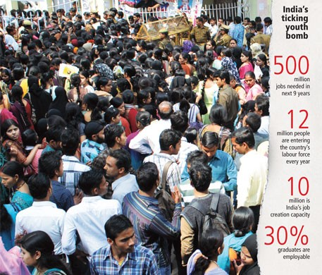

The Current Skills Gap and Why XXXXX Stands to Benefit

Globally, the gap between academic training and job-readiness is a pressing issue. McKinsey & Company reports that this discrepancy in job readiness can limit career growth and success, particularly for recent graduates. Additionally, NACE (National Association of Colleges and Employers) found that nearly 65% of employers believe graduates lack essential skills for entry-level positions, especially in areas such as communication, problem-solving, and technology. This concern is echoed across industries, highlighting the need for graduates who can seamlessly adapt to a fast-paced, technologically driven job market.

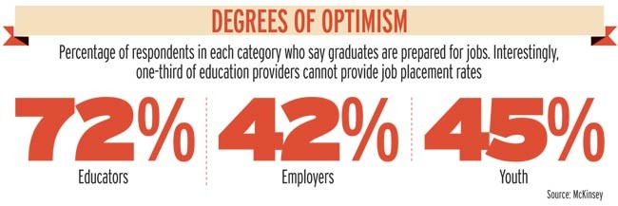

LinkedIn’s Workforce Report further supports this, showing that underprepared graduates face a 40% higher turnover rate within their first 18 months due to skill mismatches, leading to performance struggles and job insecurity. By proactively addressing this skills gap, XXXXX can give its students a significant competitive advantage and help them succeed in long-term, fulfilling careers.

Around 31% is illiterate, only 13% had a primary education, and only 6% were college graduates. Further, only about 2% of the workforce had formal vocational training, and only 9% had non-formal, vocational training.

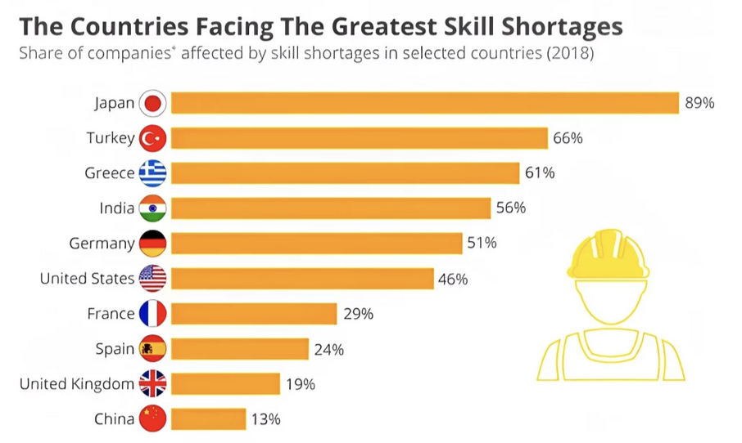

Proposed Guardrails-Based Roadmap for Industry Alignment

To address these challenges, every educational institution needs a “guardrails-based roadmap” that imparts an ongoing connection with industry trends, innovations, and research. This roadmap can help XXXXX anticipate changes in the job market, adjust curricula in real time, and ensure that students graduate with the skills needed for emerging roles.

The proposed program will serve as a bridge between XXXXX’s academic strengths and the demands of the workforce. This initiative will build upon XXXXX’s achievements, ensuring that students stay relevant by:

- Expanding Exposure to Emerging Technologies: According to the World Economic Forum’s Future of Jobs Report, 85% of jobs expected by 2030 require skills not emphasized in traditional curriculums. By introducing XXXXX students to rapidly advancing fields such as AI, data analytics, and digital transformation, we can provide them with a critical edge.

- Enhancing Industry-Specific, Hands-On Training: Studies by the National Center for Education Statistics indicate that students with experiential learning opportunities have a 30% higher job placement rate within six months of graduation. Tailored workshops, labs, and simulations will help XXXXX students translate theoretical knowledge into practical skills that are directly applicable in the workforce.

- Career-Readiness Planning from Early Stages: OECD research shows that students who engage in early career planning are twice as likely to secure stable employment by age 25. This program will offer structured career-planning modules to guide XXXXX students from their first academic year, empowering them to identify their unique strengths and career aspirations early on.

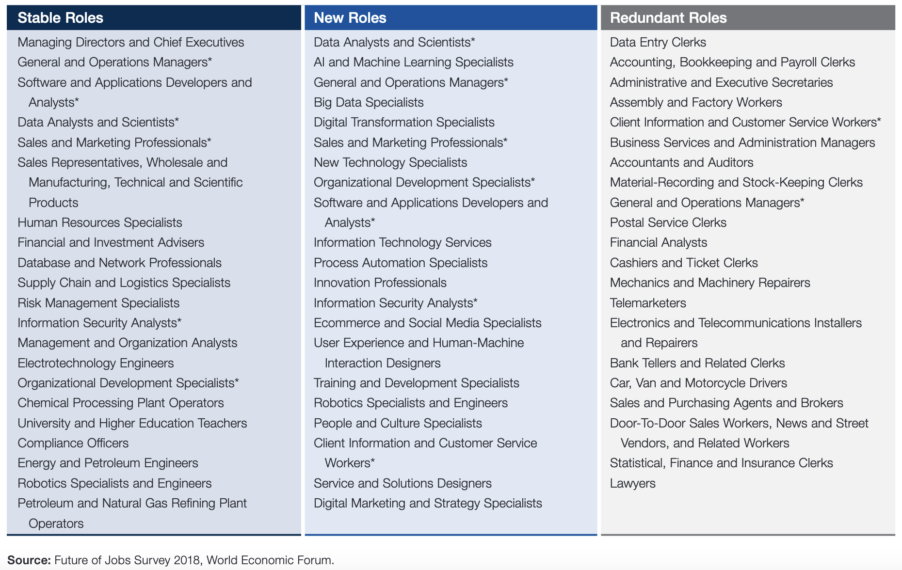

Future-Proofing XXXXX’s Graduates for the Job Market

To truly prepare XXXXX students for an evolving global job market, it’s essential to reduce the likelihood of “unpleasant surprises” when they seek employment. Without direct exposure to current industry demands and emerging technologies, graduates risk entering the workforce with skills that may already be outdated. By establishing a direct pipeline to industry leaders, we can continuously align XXXXX’s offerings with real-world expectations.

CognAILabs: Bridging Campuses with the Future
Empowering Students. Connecting Campuses. Driving Innovation
CognAILabs is a virtual-first innovation ecosystem designed to minimize the gap between academic learning and industry demands. We partner with universities, colleges, and educational institutions to bring cutting-edge technology, mentorship, and real-world application into classrooms—preparing students to thrive in the ever-evolving digital economy.

Service Portfolio
1. Tech Empowerment Workshops
Interactive, hands-on workshops in high-demand domains like AI, Machine Learning, Data Science, Cybersecurity, DevOps, Cloud, and Blockchain.
2. Guest Professorship Series
Talks and sessions delivered by senior professionals and subject matter experts from leading global industries.
3. Online IT Subject Tutoring
Live and recorded tutoring sessions for core computer science and IT subjects, aligned with university curriculums.
4. University Capstone Projects with Deployment
End-to-end mentorship for academic projects with a focus on hands-on tools, deployment, and real-time tech stacks.
5. One-on-One Mentorship and Career Counselling
Personalized support for students to build their career roadmap, improve portfolios, and prepare for tech careers.
6. Industry Problem Solving Projects
Real-time industry challenges turned into student projects, guided by experts from respective industries.
7. Campus Industry Connect Hubs
Setting up dedicated spaces within campuses to facilitate workshops, ideation, mentoring, and prototype development.
8. Faculty Development and Full-Time Professors
Deployment of experienced IT educators and industrial mentors as visiting or full-time academic staff.
9. Virtual Internships through CognAILabs
Structured online internships through our Virtual Innovation Lab simulating real workplace experiences.
10. Industrial Exposure and Tech Tours
Facilitated visits to tech firms, R&D labs, and innovation centers to give students practical exposure.
11. Hackathons, Ideathons, and Innovation Sprints
Campus-hosted events where students build fast, iterate, and learn through problem-solving aligned with current industry themes.
12. Future-Ready Talent Transformation Program
From soft skills to technical mastery, a comprehensive transformation journey to make students ready for next-gen careers.
13. Curriculum Co-Design with Industry
Assistance in aligning university curriculum with the latest industry needs, certifications, and emerging domains.
14. Certification Programs in Niche Technologies
Credentialed programs with industry-recognized certificates in specialized tracks like AI ethics, Prompt Engineering, RPA, and more.
15. Student Startup Incubation Support
Support for student-led innovations and startups with pitch guidance, MVP mentorship, and funding connections.
About iREAD Foundation
iREAD (Innovation, Research, Education, and Development) is a purpose-driven NGO dedicated to bridging the digital divide for underprivileged students and institutions. At iREAD, we believe that talent is universal, but opportunity is not—and we work every day to change that.
We closely collaborate with rural and underfunded educational institutions, especially those serving students from financially constrained and marginalized backgrounds, to ensure they are not left behind in the rapidly transforming digital era. Our mission is to empower every learner with access to technology, tools, mentorship, and real-world exposure, enabling them to become contributors in a future driven by innovation.
Through a combination of grassroots training, tech-literacy programs, and industry-aligned educational initiatives, iREAD supports students in becoming career-ready, confident, and capable of participating in the global digital economy.

Our Vision: Education That Meets Industry Standards
As the world advances at an unprecedented pace in fields like AI, Automation, Cybersecurity, Data Science, Machine Learning, and Cloud, iREAD stands committed to ensuring that unprivileged students and institutions are not left behind. Our programs are designed to:
- Introduce high-demand skills in university curriculums and local institutions
- Provide workshops and mentoring led by industry professionals
- Offer project-based learning modelled after real-world challenges
- Enable digital infrastructure support where needed
- Guide career development through hands-on internships and soft skill training

We partner with forward-thinking universities, colleges, and edtech platforms to upgrade their offerings, align with industry expectations, and most importantly—bring inclusion and accessibility to the forefront of education.

iREAD is not just an NGO. It’s a movement to democratize access to industry-relevant education, so that no student is left behind—regardless of where they come from.

This program aims to ensure that XXXXX graduates are equipped to confidently adapt, succeed, and thrive in a variety of industries, even as job descriptions and roles evolve. By setting new standards in career readiness, XXXXX can distinguish itself as a university that not only educates but also transforms students into resilient, forward-thinking professionals ready to meet future challenges.

Thank you for considering this opportunity to enhance the employability and career readiness of XXXXX students. I am confident that, together, we can empower XXXXX students to lead successful, prosperous careers and make meaningful contributions in their chosen fields. I look forward to the possibility of discussing this proposal in more detail and collaborating to bring this vision to life.

Warm regards,
Meer Ahmed, Ex-IBM & HP
+91 9900058138
B-Tech(JNTUH), MS (SUNY Buffalo, NY), MSc (Amrita, School of Business)
Founder & Director of CogniLABS
Managing Trustee of iREAD

