**REGRESSION:**

from keras.models import Sequential

from keras.layers import Dense

import numpy

numpy.random.seed(7)

dataset = numpy.loadtxt("data.csv", delimiter=",")

X = dataset[:,0:8]

Y = dataset[:,8]

model = Sequential()

model.add(Dense(12, input_dim=8, activation='relu'))

model.add(Dense(8, activation='relu'))

model.add(Dense(1, activation='sigmoid'))

model.compile(loss='binary_crossentropy', optimizer='adam', metrics=['accuracy'])

model.fit(X, Y, epochs=150, batch_size=10)

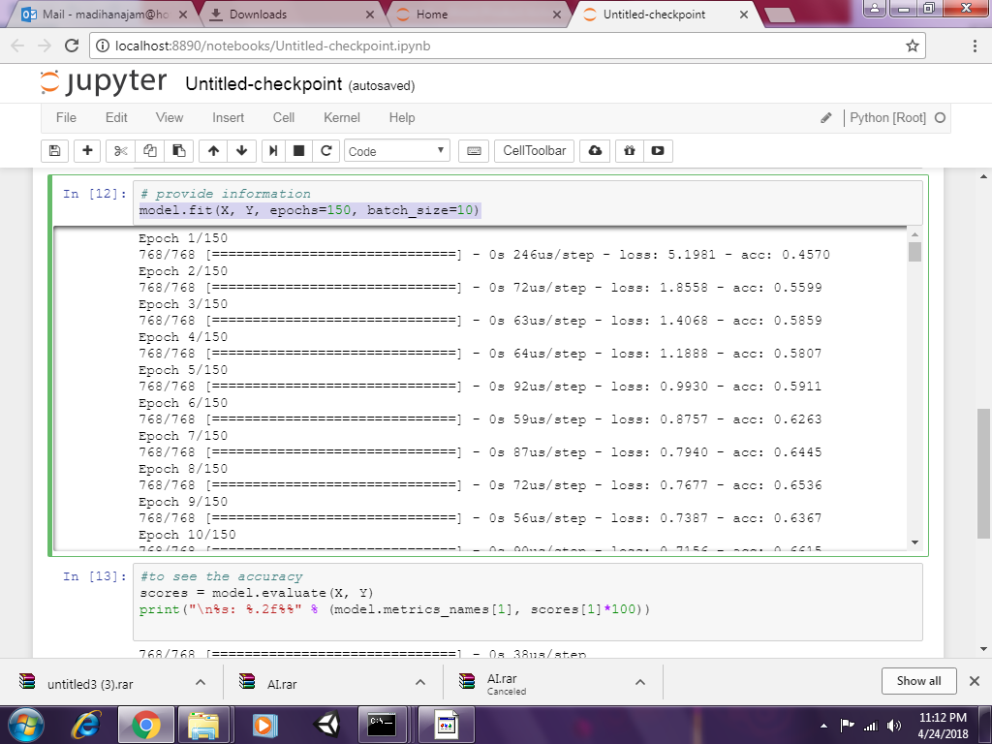

scores = model.evaluate(X, Y)

print("\n%s: %.2f%%" % (model.metrics_names[1], scores[1]*100))

768/768 [==============================] - 0s 38us/step

acc: 89.6%

# Do predictions

import numpy as np

x=np.array([[2,130,79,3,1,42,0.5,80]])

predictions = model.predict(x)

# round predictions

rounded = [round(x[0]) for x in predictions]

print(rounded)

[0.0]