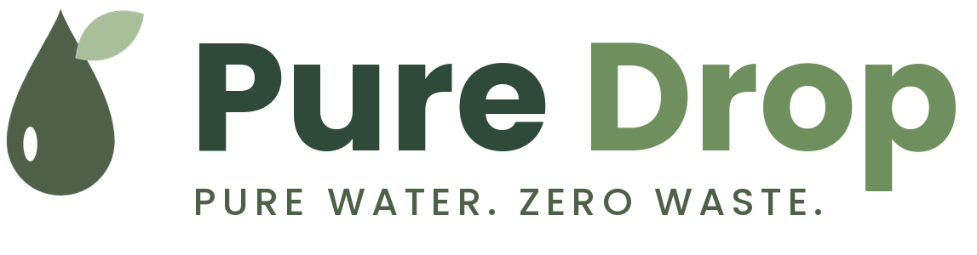
Custom-Branded Eco Bottle Proposal
Prepared for: [Client Name], [Company]
Prepared by: Pure Drop | Date: October 2026 | Valid for 30 days

1. Our pitch
Pure Drop makes reusable stainless steel water bottles with a soft silicone base and a carry loop, designed to replace single-use plastic bottles. For [Company], we propose a custom-branded bottle your team, clients or event guests will use every day, carrying your logo and your sustainability message.
Why Pure Drop
- A clean, modern design that people choose to keep, not leave in a drawer.
- Your logo printed on the silicone base, with optional gift-box packaging.
- Three sizes (350, 500 and 750 ml) so each group gets the right fit.
- A complete launch kit: mockups, social content and a landing page if you need them.

2. Brand and product mockups
The visuals below show the Pure Drop range, the launch social posts and the website. Your logo and colors will replace the Pure Drop mark on the base for custom orders.
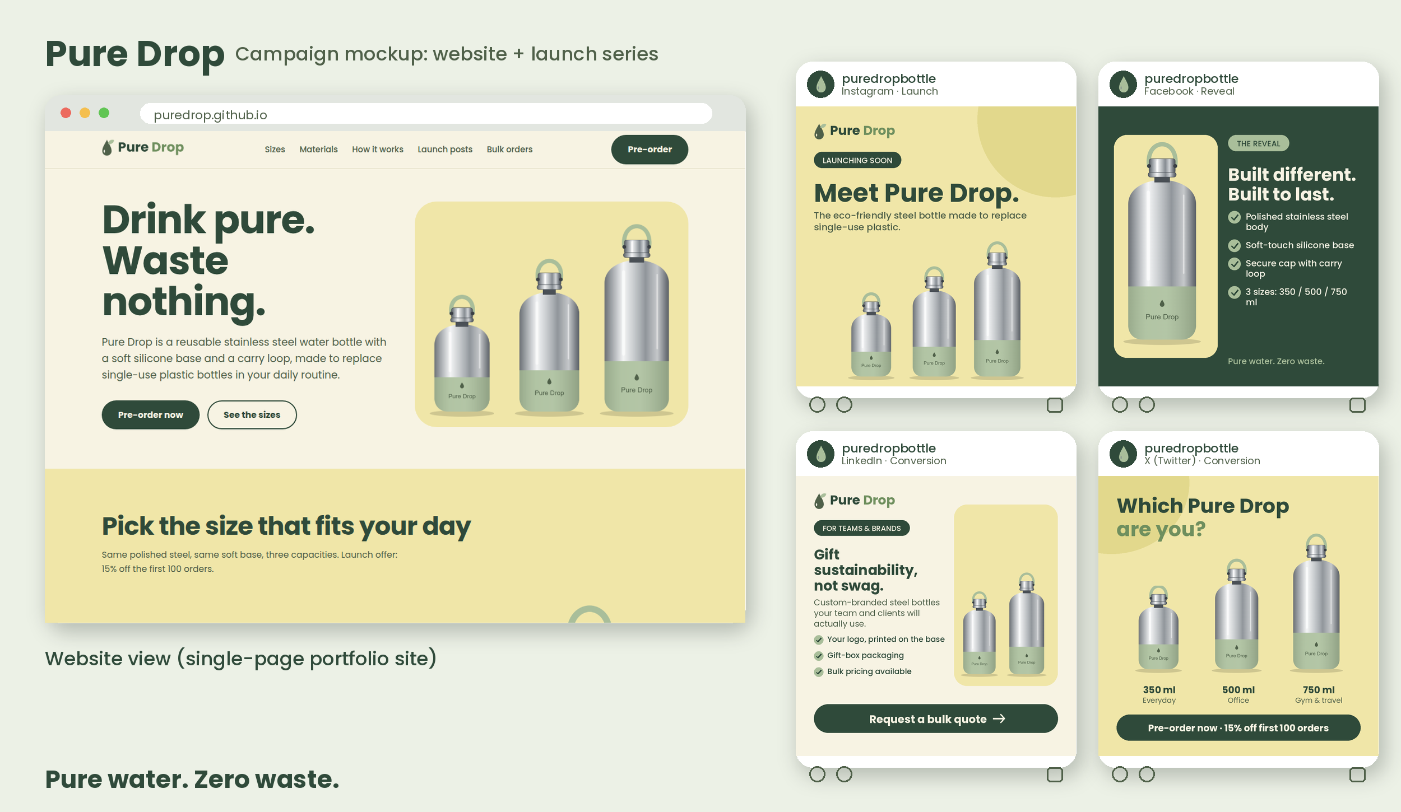
Figure 1: Launch campaign mockup (website and four social posts).

3. Scope of work
Item | What is included
Custom bottle design | Logo placement on the base, color matching, digital mockup for approval
Sample | 1 physical sample per size for approval before production
Production | Stainless steel bottles with silicone base, secure cap and carry loop
Packaging | Recyclable card box, with optional gift-box upgrade
Launch content (optional) | 4 social posts, captions, infographic and a one-page website

4. Schedule
The timeline below starts when the proposal and deposit are approved.
Week | Milestone
Week 1 | Kick-off, finalize sizes, quantities and logo files
Week 2 | Design mockups sent for approval
Week 3 | Physical samples produced and shipped for approval
Weeks 4-5 | Approved bottles go into production and quality check
Week 6 | Packing, shipping and delivery
Week 6 (optional) | Launch content and landing page delivered
Shipping times depend on destination and courier. Samples and production dates assume timely approvals.

5. Costing
All prices are indicative estimates in USD, excluding shipping and taxes, and will be confirmed with final manufacturer quotes.

Custom-branded bottles (logo on base, standard box)
Quantity | Price per bottle | Subtotal
100 units | $12.50 | $1,250
300 units | $10.90 | $3,270
500 units | $9.80 | $4,900

One-time and optional costs
Item | Cost
Design mockups and logo setup | $150
Physical samples (3 sizes) | $120
Gift-box packaging upgrade | $1.50 per unit
Launch content package (4 posts, captions, infographic) | $350
One-page website, hosted on GitHub Pages | $400
Estimated total for 300 bottles + mockups + samples | $3,540

Payment terms
- 50% deposit to start, 50% before shipping.
- Prices are valid for 30 days from the date of this proposal.
- Changes to quantity or design after sample approval may affect price and schedule.

6. Next steps
- Reply to confirm the quantity and sizes you would like.
- Send your logo files (SVG or PNG) and brand colors.
- Approve the proposal and pay the deposit, and we will begin the mockups straight away.
Contact: hello@puredrop.example | @puredropbottle

