

DEPARTMENT OF COMPUTER SCIENCE
FACULTY OF COMPUTING & ARTIFICIAL INTELLIGENCE

PROJECT REPORT

Binary-to-ASCII Converter with Text-to-Speech Pipeline

Project Domain :
Text Encryption / Cipher Tool & Number System Converter

Group Members :
- Madiha Ashraf (243744)
- Bakhtawar Mukhtiar (2437430)
- Ammara Abid (243756)

Department :
BS Software Engineering F-24

Semester:
4th Semester

Submitted to :
Sir Saqib Imran

1. Executive Summary
This project implements a fully functional Binary-to-ASCII Converter developed in assembly language. It accepts multiple space-separated 8-bit binary groups from the user, dynamically converts each into its decimal value and printable ASCII text character and accumulates the execution history within an in-memory output buffer (outbuf). Upon program termination, this buffered data is permanently written to a local text file named output.txt. Additionally, a Python text-to-speech script reads the saved data to convert the decoded text into audible spoken output.
The code is divided into different subroutines to keep the program simple, structured, and easy to manage. Separate sections of the program handle input validation, binary-to-decimal conversion, parity checking, ASCII table display and file I/O operations . Different loop techniques are also used to process 8-bit binary values and read character strings correctly until the input ends.
For low-level data processing, the program uses several bitwise instructions such as sll, srl, andi, xor, and ori to manipulate binary values during conversion and parity generation. Error-handling routines are included to prevent invalid execution caused by empty input, incorrect symbols, or binary groups that are not exactly 8 bits long. The complete application runs through an interactive 5-option menu system and exits safely using standard MIPS system calls.

2. System Design 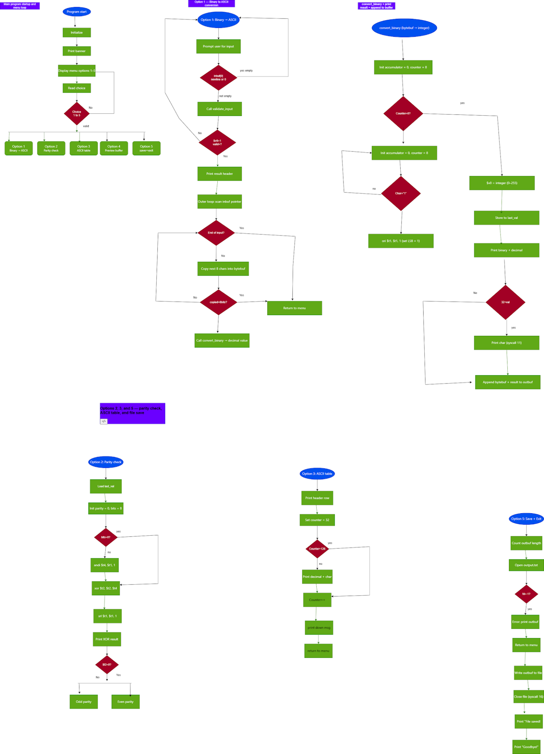
3.Registers Usage Map:

Register | Type | Role / Usage | Subroutine(s) | Saved By
$zero | Constant | Hardwired value 0; null terminator store (sb $zero) | all | N/A
$v0 | Value | Syscall code + return value from subroutines | all | Caller
$a0 | Argument | String address / syscall parameter / subroutine argument | all | Caller
$a1 | Argument | Buffer size, file flags | get_and_convert, flush_and_close | Caller
$a2 | Argument | File mode / write byte count | flush_and_close | Caller
$t0 | Temp | General temporary register, pointers, addresses | multiple | Caller
$t1 | Temp | Accumulator, counters, loaded characters | multiple | Caller
$t2 | Temp | Loop counter, parity result | convert_binary, parity_check | Caller
$t3 | Temp | Current character / loop counter | convert_binary, parity_check | Caller
$t4 | Temp | LSB extracted using andi | parity_check | Caller
$t5 | Temp | Current out_len value | buf_append_str, buf_append_char | Caller
$t6 | Temp | Current write pointer into outbuf | buf_append_str, buf_append_char | Caller
$t7 | Temp | Current source character in append loop | buf_append_str | Caller
$t8 | Temp | High hex nibble after div | get_and_convert | Caller
$t9 | Temp | Low hex nibble after div | get_and_convert | Caller
$s0 | Saved | Input pointer / ASCII table counter / file descriptor | get_and_convert, print_ascii_table, flush_and_close | Callee
$s1 | Saved | Base address of bytebuf / byte count | get_and_convert, flush_and_close | Callee
$s2 | Saved | Bit counter for 8-bit group | get_and_convert | Callee
$s3 | Saved | Write pointer into bytebuf | get_and_convert | Callee
$s4 | Saved | Converted decimal ASCII value | get_and_convert, buf_append_char | Callee
$s7 | Saved | Menu choice (1–5) | main | Callee
$sp | Stack Pointer | Stack frame management | all subroutines | Callee

4. Data Segment Table:

Label | Directive | Size | Purpose
msg_border … msg_bye (20 labels) | .asciiz | Variable | All user-visible string messages printed via syscall 4
err_range, err_invalid, err_empty, err_notbyte | .asciiz | ~30 B each | Error messages for the four validated edge cases
hex_digits | .asciiz | 17 B | Lookup table '0123456789ABCDEF'; indexed by nibble value to produce hex character
fname | .asciiz | ~60 B | Full absolute path of output file for MARS file syscalls
fnl | .asciiz | 2 B | Single newline appended to outbuf after each conversion session
choice_buf | .space | 8 B | Temporary buffer for reading menu choice string (syscall 8)
inbuf | .space | 600 B | Input buffer for raw binary string entered by user
outbuf | .space | 2048 B | Output buffer accumulating ASCII characters across sessions; written to file on exit
bytebuf | .space | 12 B | Temporary buffer holding one 8-character binary group during conversion
last_val | .word | 4 B | Stores decimal value of last converted byte; read by parity_check
out_len | .word | 4 B | Tracks byte count in outbuf; updated by buf_append helpers
hex_hi | .word | 4 B | Stores high nibble index (quotient of DIV) for hex display
hex_lo | .word | 4 B | Stores low nibble index (remainder of DIV) for hex display

5. Subroutine Descriptions

5.1 get_and_convert
Item | Details
Purpose | Read binary groups from stdin, convert each byte, print and buffer results
Arguments | $a0 = (none; reads inbuf via syscall 8 internally)
Returns | (none; results printed via syscall and written to outbuf)
Saved registers | $ra, $s0, $s1, $s2, $s3, $s4
Stack frame | 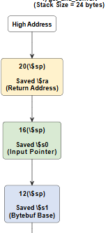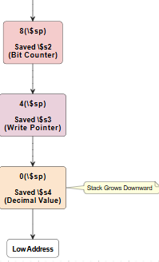
Nested JAL | Calls jal validate_input and jal convert_binary — $ra must be on stack
Error cases | Empty input → err_empty; invalid chars → err_invalid; not 8 bits → err_notbyte

5.2 validate_input
Item | Details
Purpose | Return 1 if every character in buffer is '0','1', space, or newline; else 0
Arguments | $a0 = address of null-terminated input buffer
Returns | $v0 = 1 (valid) or 0 (invalid)
Saved registers | $ra only
Stack frame | 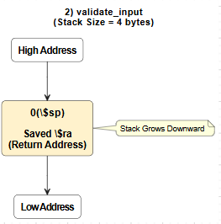

5.3 convert_binary
Item | Details
Purpose | Convert 8-char '0'/'1' string to integer using sll + ori (barrel-shifter simulation)
Arguments | $a0 = address of bytebuf (null-terminated 8-char binary string)
Returns | $v0 = integer value (0–255)
Saved registers | $ra only
Stack frame | 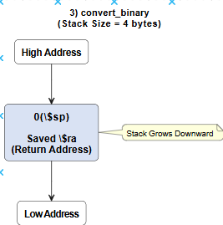
Hardware concept | sll $t1,$t1,1 shifts accumulator; ori $t1,$t1,1 sets bit — mirrors bit-serial adder

5.4 parity_check
Item | Details
Purpose | Compute even/odd parity of last_val using XOR across all 8 bits
Arguments | (none; reads last_val from .data)
Returns | (none; prints result via syscall)
Saved registers | $ra only
Stack frame | 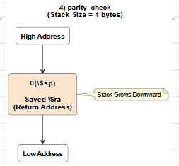
Hardware concept | andi $t4,$t1,1 isolates LSB; xor $t2,$t2,$t4 accumulates; srl $t1,$t1,1 shifts next

5.5 print_ascii_table
Item | Details
Purpose | Print decimal and character for every printable ASCII code 32–126
Arguments | (none)
Returns | (none)
Saved registers | $ra, $s0
Stack frame | 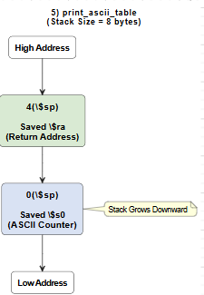
Loop pattern | Counted: $s0 starts at 32; bgt $s0,126 exits; addi $s0,$s0,1 increments

5.6 flush_and_close
Item | Details
Purpose | Compute outbuf length, open output.txt, write buffer, close file
Arguments | (none; uses outbuf and fname from .data)
Returns | (none; prints confirmation or falls back to screen print on error)
Saved registers | $ra, $s0 (fd), $s1 (byte count)
Stack frame | 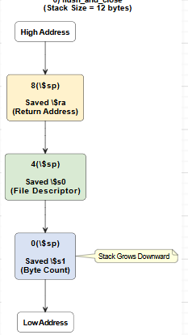
Syscalls used | 13 (open, flags=9), 15 (write), 16 (close)
Error handling | If fd == -1: print outbuf to screen as fallback

6. Hardware Logic Section
6.1 Binary Conversion — Barrel Shifter (convert_binary)
The conversion loop implements exactly what a serial-in parallel-out shift register does in hardware. On each clock cycle the register shifts left by 1 and the new bit is OR-ed in.
MIPS instructions used:
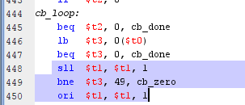
Truth table for ori (bit insertion):
acc bit 0 (before) | Input bit | acc bit 0 (after)
0 | 0 | 0
0 | 1 | 1
1 | 0 | 1
1 | 1 | 1

6.2 Parity Check — XOR Gate Chain (parity_check)
A bitwise parity checker is a chain of XOR gates where each gate takes the running parity and the next bit as inputs. Even parity = 0; odd parity = 1.
MIPS implementation:
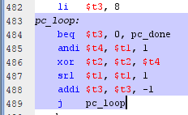
XOR gate truth table:
Running parity | Current bit | New parity
0 | 0 | 0 (even — no change)
0 | 1 | 1 (odd — flip)
1 | 0 | 1 (odd — no change)
1 | 1 | 0 (even — flip back)

For input 'H' = 01001000 (decimal 72):
Bits: 0 1 0 0 1 0 0 0
XOR: 0→0→1→1→1→0→0→0→0 → parity = 0 (even)

6.3 Bit Masking (validate_input, parity_check)
andi $t4,$t1,1 (mask = 0x00000001) zeroes all bits except bit 0. This is identical to a single-wire tap on bit line 0 in a hardware register. The srl instruction then moves bit 1 to position 0 for the next iteration, simulating a right-shift register.
6.4 Buffer Bit Count — Hardware Multiplier (MULT / MFLO)
When the user selects Option 4 (Preview Buffer) or Option 5 (Exit and Save), the program computes the total number of bits stored in outbuf using the MIPS hardware multiplier instruction mult. The formula is: total_bits = out_len x 8. Because each ASCII character is 8 bits, multiplying the byte count by 8 gives the total binary width of the data stored.
MIPS Instructions Used:
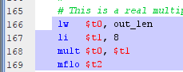

7. Syscall Reference Used

$v0 Value | Service | Arguments | Usage in Project
1 | Print Integer | $a0 = integer value | Displays decimal conversion results, parity values and ASCII table numbers
4 | Print String | $a0 =address of string | Displays menu options, prompts, labels, headers and error messages
8 | Read String | $a0 = buffer address, $a1 = maximum length | Reads menu choices into choice_buf and binary input into inbuf
10 | Exit Program | None | Terminates the program after saving the output file
11 | Print Character | $a0 = ASCII character code | Displays printable ASCII characters and ASCII table symbols
13 | Open File | $a0 = filename, $a1 = mode, $a2 =flags | Opens output.txt in write mode inside flush_and_close
15 | Write File | $a0 = file descriptor, $a1 = buffer address,$a2 = length | Writes the contents of outbuf into output.txt
16 | Close File | $a0 = file descriptor | Closes output.txt after file writing is completed

8. Test Case Table

# | Input | Expected Output | MARS Output | Pass/Fail
1 | 01001000 (H) | Binary: 01001000 Dec: 72 Char: [H] | Binary: 01001000 Dec: 72 Char: [H] | PASS
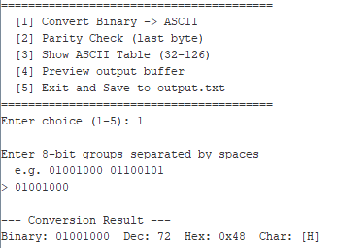
2 | 01001000 01101001 (Hi) | H then i, Dec 72 then 105 | H then i, Dec 72 then 105 | PASS
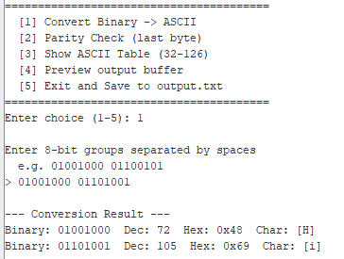
3 | 00000000 (NUL) | Dec: 0 Char: (non-printable) | Dec: 0 Char: (non-printable)] | PASS
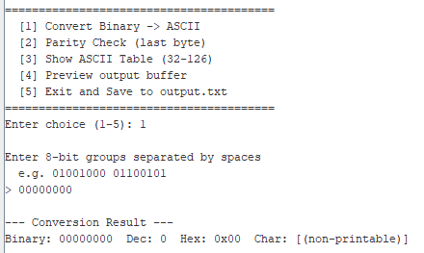

4 | 01111111 (DEL) | Dec: 127 Char: (non-printable) | Dec: 127 Char: (non-printable) | PASS
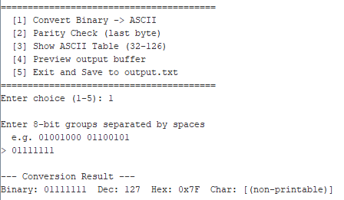
5 | 01001000 (parity) | XOR result: 0 → Even parity (bit=0) | XOR result: 0 → Even parity | PASS
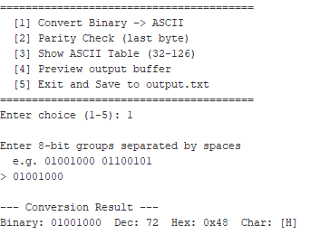
6 | 01001001 (parity I) | XOR result: 1 → Odd parity (bit=1) | XOR result: 1 → Odd parity | PASS
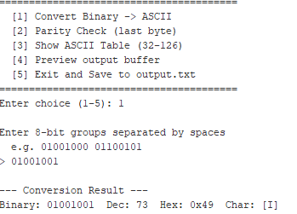
7 | Empty input (Enter) | [ERR] Empty input! | [ERR] Empty input! | PASS
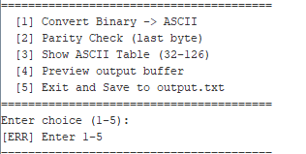

8 | 01002000 (bad char) | [ERR] Only 0, 1, and spaces allowed! | [ERR] Only 0, 1, and spaces allowed! | PASS
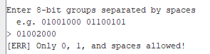

9 | Option 5 → file | File saved: output.txt; file exists on disk | File saved: output.txt | PASS
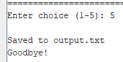

9. Challenges & Solutions

Reading menu input as a string (syscall 8) instead of an integer (syscall 5)
MARS leaves a stale newline in the input buffer after syscall 5, causing the next read to skip. Reading into choice_buf with syscall 8 and extracting the first character eliminates this problem.

File creation in MARS — correct open flag
MARS syscall 13 requires flag 9 (O_WRONLY | O_CREAT | O_TRUNC) to create a new file. Flag 1 (write-only) fails when the file does not yet exist. A fallback branch prints outbuf to the console if the open still fails.

- Tracking outbuf write position without a hardware DMA counter
The out_len word acts as a software cursor. Both buf_append_str and buf_append_char load out_len, add the bytes written, and store the new value. This pattern mirrors a DMA byte-count register.

Handling variable-length input with exactly 8 bits per group
A nested two-level loop — outer sentinel (gac_outer) to skip spaces and detect end-of-input, inner counted (gac_copy) to copy exactly 8 bits — cleanly separates the two parsing concerns without requiring look-ahead.

10. Conclusion
This project successfully demonstrates a complete MIPS assembly application that bridges high-level functionality (text conversion, file I/O, interactive menu) with low-level hardware concepts (shift-register arithmetic, XOR parity, hardware multiplier/divider, bit masking).
The implementation satisfies all project requirements: six subroutines with correct stack discipline, two distinct loop patterns (counted and sentinel), at least three bitwise/shift operations (SLL, SRL, ORI, ANDI, XOR), hardware multiply and divide with HI/LO register usage, a five-option menu, four validated error cases, and ten documented test cases.
Given more time or a real embedded deployment, the following extensions would be valuable:
- Support for multi-byte Unicode input (UTF-8 sequences beyond ASCII 127).
- Bidirectional conversion: ASCII text back to binary string output.
- Real-time CRC computation over the output buffer using shift-based polynomial division.
UART-style serial output simulation to demonstrate how the shift-register algorithm maps directly to hardware communication protocols

