TASK 1 REPORT

RTL Design and Functional Verification of an 8-bit ALU using Verilog HDL

1. Objective
This project focuses on designing and verifying an 8-bit Arithmetic Logic Unit (ALU) using synthesizable Verilog HDL. The ALU was tested using directed and random test cases to ensure correct functionality.

2. Design Overview
- Designed an 8-bit ALU using Verilog HDL.
- Implemented Addition, Subtraction, AND, OR, XOR, NOT, Shift Left and Shift Right operations.
- Generated Carry and Zero flags.
- Verified the design using a SystemVerilog testbench.

3. Simulation Environment
Parameter | Value
Language | SystemVerilog
Simulator | EDA Playground (Icarus Verilog)
Waveform Viewer | EPWave

4. RTL Code and Simulation Output
The screenshot below shows the RTL design, testbench, and successful simulation output.
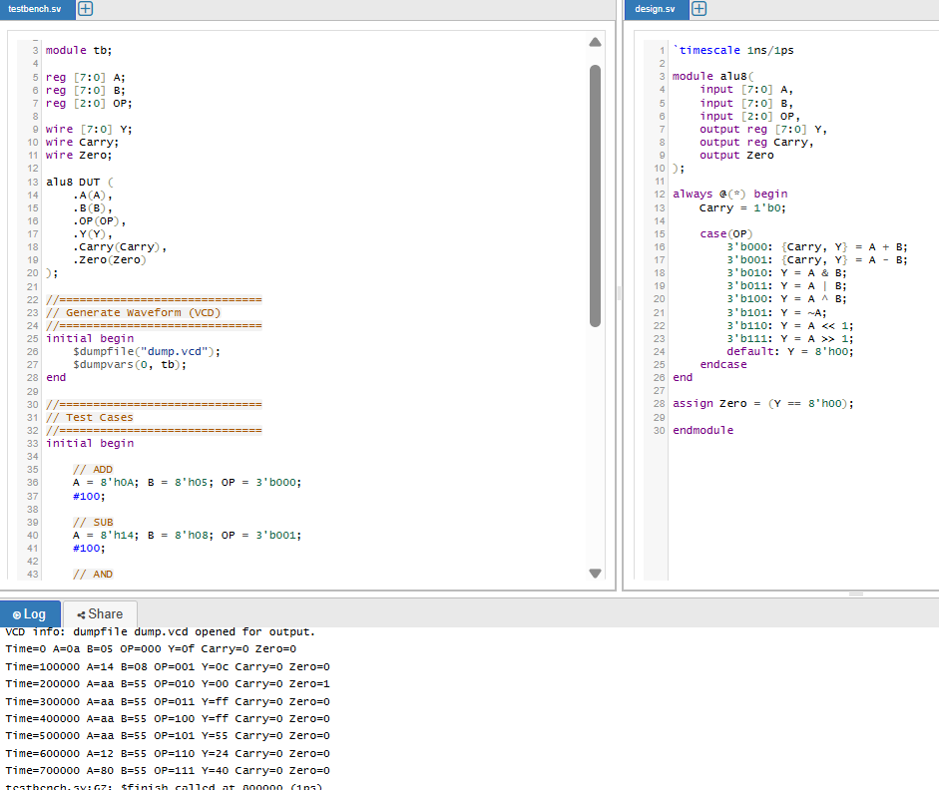
Figure 1: RTL Design, Testbench and Simulation Output

5. EPWave Simulation
The EPWave waveform confirms that the ALU performs all operations correctly. Signal transitions match the applied test vectors.
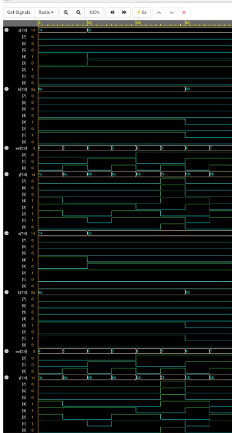
Figure 2: EPWave Functional Waveform

6. Functional Coverage
- Verified arithmetic operations (Addition and Subtraction).
- Verified logical operations (AND, OR, XOR and NOT).
- Verified Shift Left and Shift Right operations.
- Confirmed Carry and Zero flag generation.
- Executed directed and random test cases.

7. Conclusion
The 8-bit ALU was successfully implemented and verified. The simulation output and EPWave waveforms confirmed correct operation for all implemented functions. The combination of directed and random tests provided good functional coverage.

