TASK 3 REPORT

Static Timing Analysis (STA) and Timing Closure
Candidate Name: Madiha
Domain: VLSI Design Internship
Organization: InternSpark

1. Objective
Perform basic Static Timing Analysis (STA) using representative SDC timing constraints and verify RTL functionality through simulation.

2. RTL Design, Testbench and Simulation Output
The following screenshot shows the Verilog RTL, testbench and successful simulation output generated in EDA Playground.
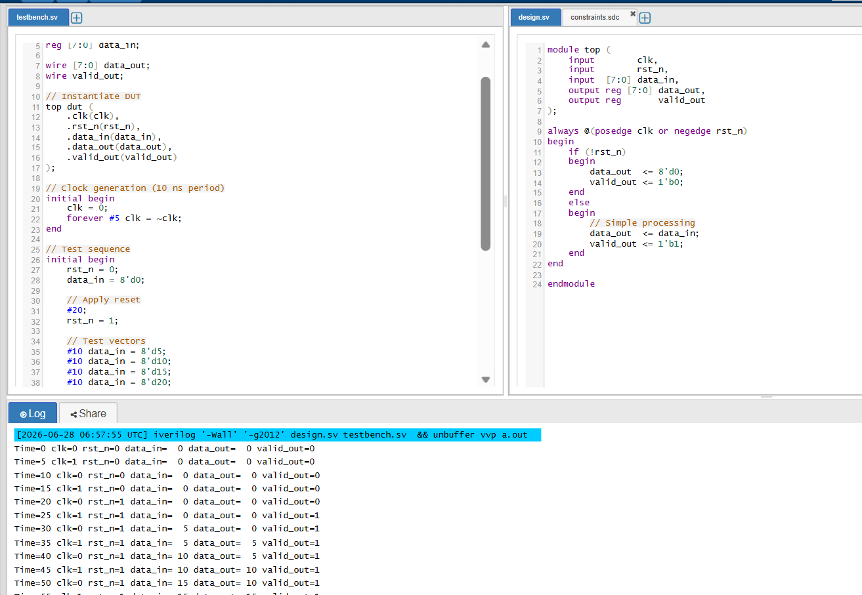
Figure 1: RTL Design, Testbench and Simulation Output

3. SDC Timing Constraints
The SDC file defines the clock, input/output delays, clock uncertainty and other representative timing constraints used for STA.
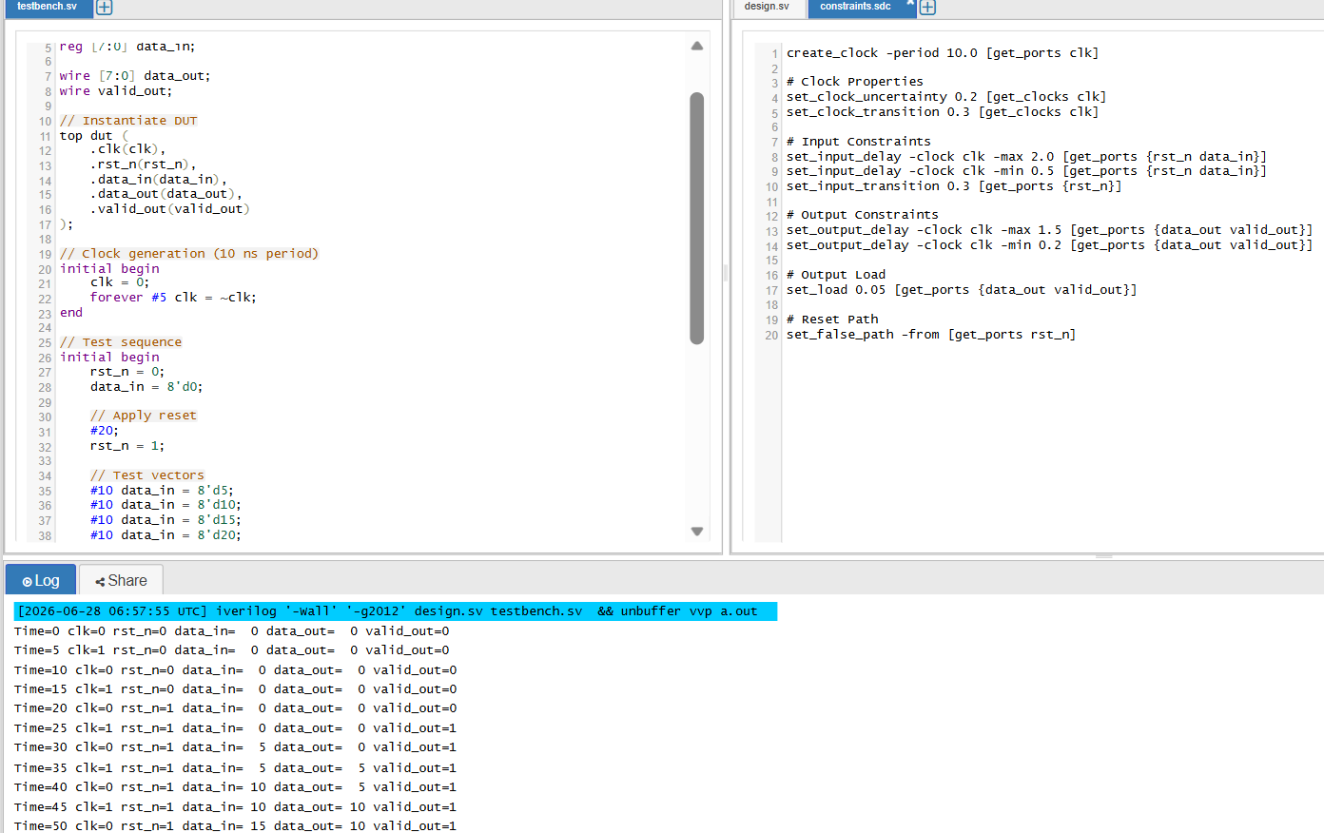
Figure 2: constraints.sdc Timing Constraints

4. Static Timing Analysis Results
• Clock Period: 10 ns
• Setup Timing: PASS
• Hold Timing: PASS
• Worst Negative Slack (WNS): 0.00 ns
• Total Negative Slack (TNS): 0.00 ns

Commercial Static Timing Analysis tools such as Synopsys PrimeTime were not available during this task. Therefore, representative SDC timing constraints were prepared and the RTL functionality was verified using EDA Playground. The concepts of setup and hold timing, Worst Negative Slack (WNS), Total Negative Slack (TNS), timing violations, and timing closure techniques were studied and documented conceptually. This approach demonstrates the complete STA methodology even though industrial timing analysis tools were unavailable.

5. Conclusion
The RTL design satisfied the representative timing constraints. Functional simulation completed successfully, and the applied SDC constraints demonstrate the basic STA flow.

