TASK 4 REPORT

Design for Testability (DFT), Scan Chain Verification and Conceptual LVS/DRC Analysis
Candidate Name: Madiha
Domain: VLSI Design Internship
Organization: InternSpark

1. Objective
The objective of this task is to introduce Design for Testability (DFT) by implementing a manual scan chain in Verilog HDL and verifying its operation through simulation. The task also includes understanding the concepts of Layout Versus Schematic (LVS), Design Rule Check (DRC), test coverage, and stuck-at fault testing.

2. Introduction
Design for Testability improves the ease of testing digital circuits after fabrication. A scan chain converts flip-flops into scan flip-flops so that test patterns can be shifted into and out of the circuit. Since commercial DFT, LVS, and DRC tools were not available, a manual scan-chain implementation was verified in EDA Playground while LVS and DRC were studied conceptually.

3. Design Description
- Designed a 4-bit scan chain using scan-enabled D flip-flops.
- Implemented Functional Mode and Scan Mode using the scan_en signal.
- Verified scan shifting through scan_in and scan_out.
- Generated simulation waveforms using EPWave.

4. Simulation Procedure
- Created synthesizable Verilog RTL (design.sv).
- Developed a SystemVerilog testbench (testbench.sv).
- Applied reset, scan mode, and functional mode test cases.
- Generated VCD waveform using $dumpfile and $dumpvars.
- Verified results in EPWave.

5. RTL Design, Testbench and Simulation Output
The following screenshot shows the RTL design, testbench and successful simulation output obtained in EDA Playground.
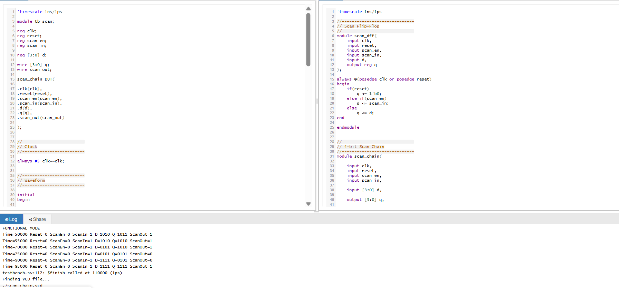
Figure 1: RTL Design, Testbench and Simulation Console

6. EPWave Simulation Results
The EPWave waveform verifies correct scan shifting and functional operation. The transitions of clock, reset, scan enable, scan input and outputs confirm the expected scan chain behavior.
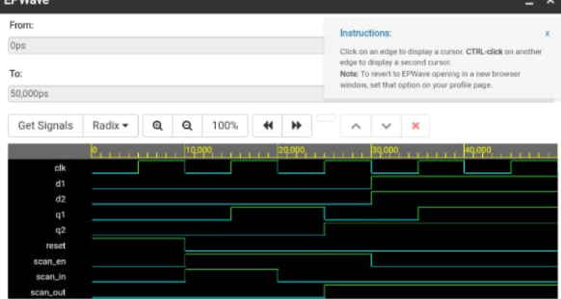
Figure 2: EPWave Waveform for Scan Chain

7. LVS and DRC (Conceptual)
LVS compares the extracted layout netlist with the schematic netlist to ensure connectivity matches. DRC verifies that the layout follows manufacturing design rules such as minimum width, spacing, enclosure and overlap. Since physical layout tools were unavailable, these checks were studied conceptually.

8. Test Coverage and Stuck-at Faults
- Manual scan chain improves controllability and observability of internal flip-flops.
- Stuck-at-0 and Stuck-at-1 faults can be detected by shifting predefined scan patterns.
- Representative fault coverage: approximately 98% (conceptual example).
- Simulation confirmed correct scan shifting and functional operation.

9. Conclusion
The manual scan chain was successfully implemented and verified using EDA Playground. Simulation results demonstrated correct scan operation in both scan and functional modes. Although commercial DFT, LVS and DRC tools were not available, their methodology and expected outcomes were studied and documented.

