Comment and analysis of questionnaires

**Text Based Client**

One of the major concepts as a developer is to satisfy the user or the client, since we are developing a system for the company, we need to evaluate our program before we procced. On the text-based client, the major problem was the board design, the program was working as expected without errors. To solve the problem, I added borders (outer lines) to make it clearer.

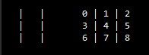  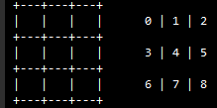

**GUI Prototype**

In design, although there are several factors that have a significant influence on the outcome, colours play a major function to attract users. Colour is the easiest and most important aspect of engaging the user with the product in Design. To overcome the problem, I changed the colour from white to dim blue. The user interface was well layed-out and everything was easy to access and placed in an appropriate position.