1a.

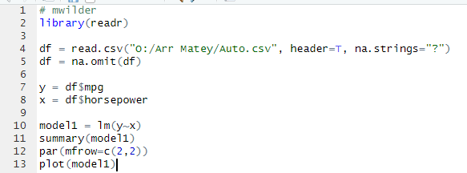

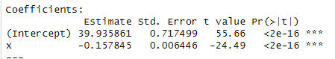

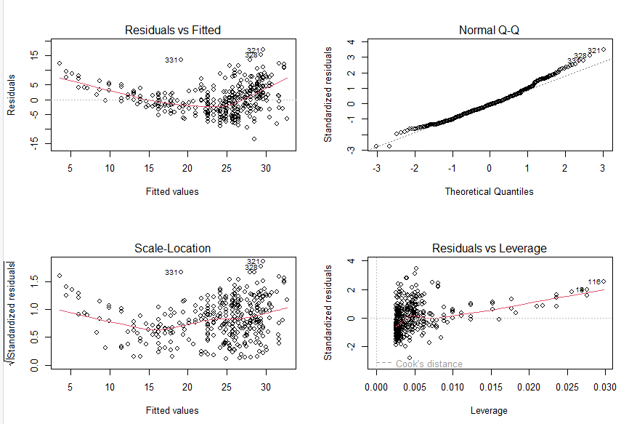

b.) There are issues with the fit. The residual fits on the left increasingly deviate from the predictive curve. The plots suggest 321, 328, and 331 are outliers. The Normal Q-Q splitting at the tails indicates a non-normal distribution. There are also points with a large amount of leverage such as 18 and 116.

c.)

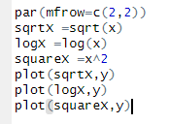

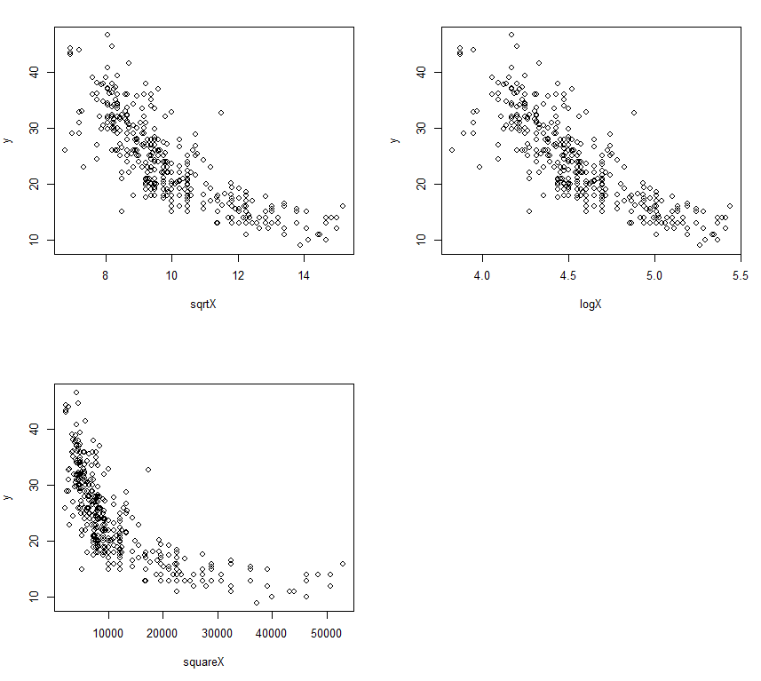

The logarithmic transformation gives the most-linear graph. The others look too much like 1/x.

d.)

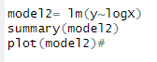

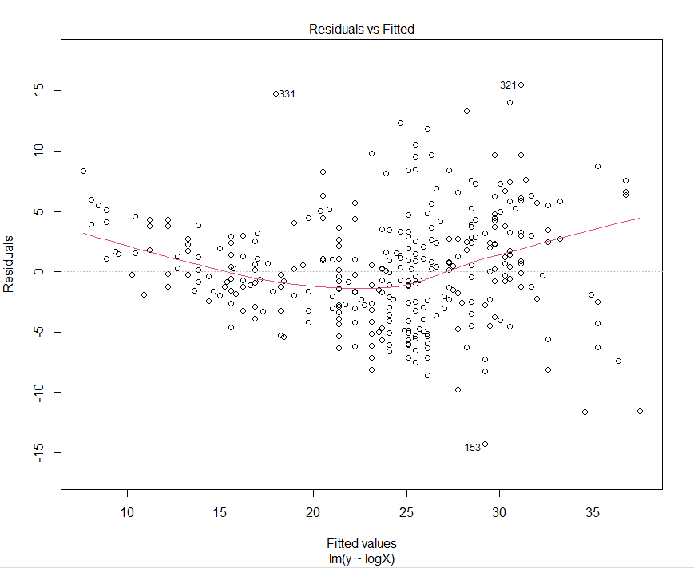

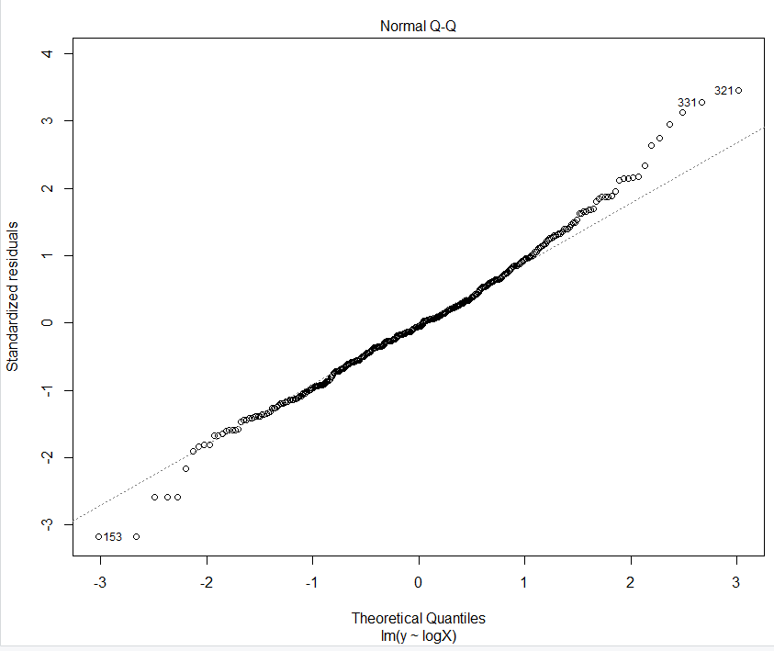

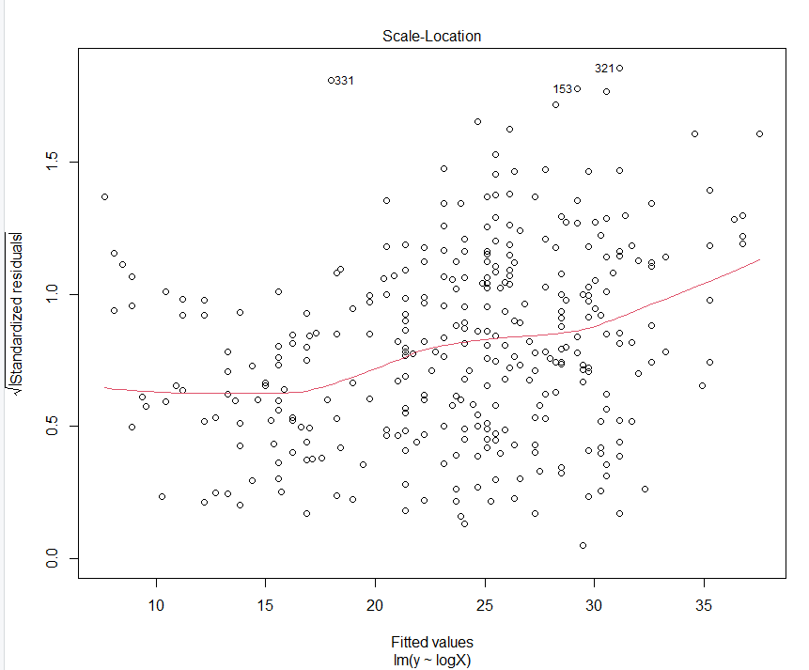

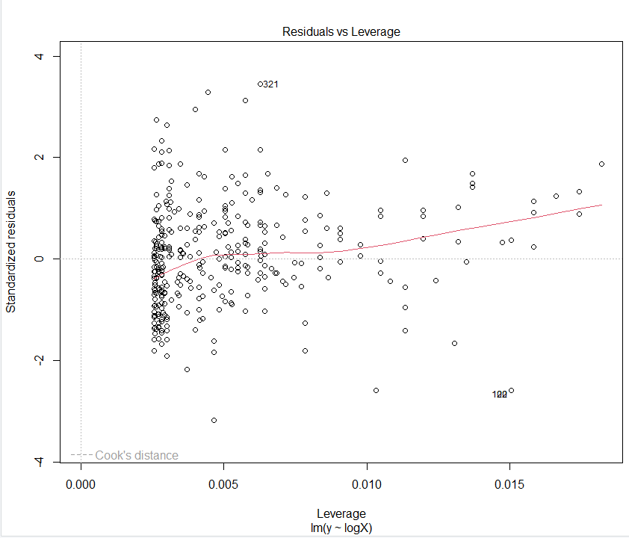

The residuals now seem to be better and don't seem to trend off to infinity anymore (which makes sense since it was the most linear). The Q-Q plot still makes the tails look non=normal. The spread of the leverage also is more spread, making each datapoint way less relative to the others.

e.)



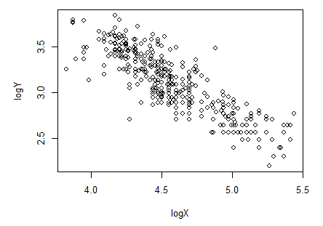

f.)

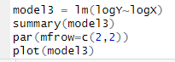

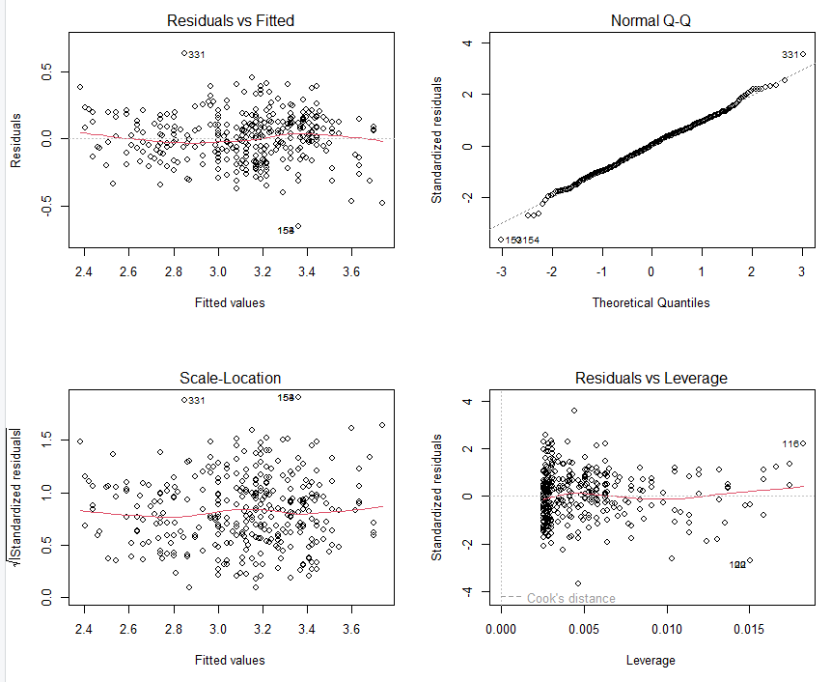

This does seem to give a good improvement on the residuals since now they average out to be very flat. The leverage is about the same as (d)'s, which is good. The Q-Q has small bumps at the ends, but they're centered around the expected line so it seems to be normal. The graph in part (e) also makes a massive improvement to its visual linearity.