Student Perceptions of ChatGPT and Traditional Search Engines for Educational Information Retrieval: A Survey and Experimental Study
Author: Madina Madmusayeva
Country: Uzbekistan

Research Area: Computer Science / Educational Technology
Date: July 2026

Table of Contents
Abstract
1. Introduction
2. Literature Review
3. Methodology
4. Results
5. Discussion
6. Limitations
7. Conclusion
8. References

Abstract

The rapid development of artificial intelligence has transformed the way students access and process information. Among AI-powered tools, ChatGPT has become increasingly popular for educational purposes due to its ability to provide instant explanations, answer questions, and assist with learning tasks. However, traditional search engines such as Google remain widely used as primary sources of information.
This study investigates students’ perceptions of ChatGPT and traditional search engines in the context of educational information retrieval. The research employed a mixed-methods approach, including a survey of 75 participants, an experimental comparison of ChatGPT and Google Search using five academic questions, and qualitative analysis of user feedback collected from 15 respondents.
The survey results indicated that 45.3% of participants considered ChatGPT the best overall tool for educational information retrieval, while 40.0% viewed ChatGPT and search engines as equally useful. The experimental comparison demonstrated that ChatGPT provided responses significantly faster than Google Search, with an average response time of 5.17 seconds compared to 45.54 seconds. ChatGPT also received higher ratings for clarity, ease of understanding, and completeness of explanations. Nevertheless, many participants reported verifying information through search engines due to concerns regarding the accuracy of AI-generated responses.
The findings suggest that ChatGPT serves as an effective educational assistant that improves learning efficiency and accessibility of information. However, traditional search engines continue to play an important role in information verification and source reliability. The study concludes that the most effective educational strategy may involve combining both AI-based and traditional information retrieval tools.
Keywords: ChatGPT, Artificial Intelligence, Education, Information Retrieval, Search Engines, Student Perceptions
- Introduction
The emergence of artificial intelligence has significantly changed the educational landscape. Students increasingly rely on digital technologies to access information, complete assignments, and support independent learning. Among recent AI innovations, ChatGPT has attracted considerable attention due to its ability to generate human-like responses, explain complex concepts, and provide personalized assistance across a wide range of subjects.
Traditional search engines such as Google have long been the dominant tools for information retrieval. They provide access to vast collections of websites, articles, and educational resources. However, unlike search engines, ChatGPT offers direct answers and interactive explanations without requiring users to navigate multiple sources. This difference has raised questions regarding the effectiveness, reliability, and educational value of AI-powered systems compared to traditional search methods.
The increasing adoption of ChatGPT in educational settings has generated both enthusiasm and concern. Supporters argue that AI tools improve learning efficiency, simplify complex topics, and provide immediate assistance. Critics, however, emphasize the risks of misinformation, overreliance on AI, and the potential decline of critical thinking skills.
The purpose of this study is to compare students’ perceptions of ChatGPT and traditional search engines for educational information retrieval. Specifically, the research aims to examine which tool students prefer, which tool they trust, and how each tool influences learning outcomes.
The study addresses the following research questions:
RQ1: Which tool do students consider more useful for educational information retrieval?
RQ2: What advantages and disadvantages do students associate with ChatGPT and traditional search engines?
RQ3: How does ChatGPT compare with Google Search in terms of response speed, clarity, completeness, and accuracy?
RQ4: How do students perceive the impact of ChatGPT on their learning process?
To answer these questions, a mixed-methods research design was employed, combining quantitative survey data, experimental comparison, and qualitative user feedback.

- Literature Review

  - Artificial Intelligence in Education
Artificial intelligence has become one of the most influential technological developments in modern education. AI-powered systems are increasingly used to support teaching, learning, assessment, and information retrieval. These technologies provide students with immediate access to information, personalized feedback, and adaptive learning experiences.
Recent advances in large language models have further expanded the educational applications of artificial intelligence. AI tools can explain complex concepts, answer questions, assist with writing, and provide learning support across various academic disciplines. As a result, students are increasingly integrating AI technologies into their daily learning activities.
Researchers have suggested that AI can improve learning efficiency by reducing the time required to search for information and by providing explanations that are tailored to individual needs. However, concerns remain regarding the reliability and accuracy of AI-generated content.
2.2 ChatGPT as an Educational Tool
ChatGPT, developed by OpenAI, is one of the most widely used generative AI systems. Unlike traditional search engines, ChatGPT generates direct responses in conversational form, allowing users to ask follow-up questions and receive personalized explanations.
Several studies have reported positive educational outcomes associated with ChatGPT. Students often describe the system as helpful for understanding difficult concepts, generating ideas, improving writing skills, and completing assignments. The ability to receive immediate feedback and explanations makes ChatGPT particularly attractive for self-directed learning.
Another advantage frequently mentioned in the literature is accessibility. Students can interact with ChatGPT using natural language without needing advanced search skills. This may reduce barriers to information access and increase engagement with learning materials.
Despite these benefits, researchers have identified several limitations. ChatGPT may occasionally generate inaccurate or misleading information, a phenomenon often referred to as “hallucination.” Furthermore, excessive reliance on AI tools may reduce opportunities for independent problem-solving and critical thinking.
2.3 Traditional Search Engines in Education
For decades, search engines such as Google have been the primary tools for educational information retrieval. Search engines allow users to access a wide variety of sources, including academic articles, websites, books, and multimedia content.
One major advantage of search engines is transparency. Users can examine multiple sources, compare information, and evaluate the credibility of websites. This process supports the development of information literacy and critical evaluation skills.
However, traditional search engines also present challenges. Students often need to navigate multiple websites before locating relevant information. This process can be time-consuming and may require advanced search strategies. As the volume of online information continues to grow, finding reliable and understandable content becomes increasingly difficult for many learners.
2.4 Comparing ChatGPT and Search Engines
The growing popularity of ChatGPT has led researchers to compare AI-powered conversational systems with traditional search engines.
Existing studies suggest that ChatGPT offers advantages in speed, accessibility, and ease of understanding. Because the system generates direct explanations, users can obtain answers without reviewing multiple websites. This may improve efficiency, particularly for students seeking quick explanations of academic concepts.
In contrast, search engines remain important for verifying information and accessing original sources. While ChatGPT provides convenient summaries and explanations, search engines offer greater transparency and allow users to evaluate evidence independently.Consequently, many researchers argue that ChatGPT and search engines should be viewed as complementary rather than competing technologies. AI systems may support rapid learning and understanding, while search engines continue to play a crucial role in verification and source evaluation.

2.5 Research Gap

Although numerous studies have examined the educational applications of ChatGPT, relatively few have combined survey data, experimental comparison, and qualitative user feedback within a single study.
Most previous research has focused either on student attitudes toward AI tools or on technical evaluations of AI performance. Limited attention has been given to comparing students’ perceptions with actual user experiences and performance measures.
Therefore, this study aims to address this gap by combining:
a survey of 75 participants,
an experimental comparison of ChatGPT and Google Search,
qualitative feedback from 15 users.
This mixed-methods approach provides a more comprehensive understanding of how students perceive and use AI-powered educational tools.

- Methodology

  - Research Design

This study employed a mixed-methods research design, combining quantitative and qualitative approaches to investigate students’ perceptions of ChatGPT and traditional search engines for educational information retrieval.
The research consisted of three components:
1. A survey of 75 participants.
2.An experimental comparison between ChatGPT and Google Search.
3.Qualitative analysis of open-ended user responses.
This approach allowed the researcher to collect both numerical data and personal
experiences, providing a more comprehensive understanding of the topic.
3.2 Survey Participants
A total of 75 participants completed the online survey.
Age Distribution
- Under 15 years old: 1 participant (1.3%)
- 15–17 years old: 25 participants (33.3%)
- 18–20 years old: 32 participants (42.7%)
- 21–25 years old: 7 participants (9.3%)
- Over 25 years old: 10 participants (13.3%)
Most respondents (76%) were between the ages of 15 and 20, representing the primary student population.
Gender Distribution

- Female: 40 participants (53.3%)
- Male: 29 participants (38.7%)
- Prefer not to say: 6 participants (8.0%)
Educational Background
Participants represented different educational levels, including:

- High School Students
- College Students
- University Students
- Other educational backgrounds
The majority of respondents were high school and university students.
3.3 Survey Instrument
Data were collected using an online questionnaire created through Google Forms.
The survey included questions related to:
- Frequency of ChatGPT usage
- Preferred tool for educational information retrieval
- Trust in ChatGPT and search engines
- Perceived accuracy of information
- Learning efficiency
- Ease of use
- Recommendation of ChatGPT as a learning tool

Most questions used multiple-choice response formats.
3.4 Experimental Comparison
To evaluate the practical performance of ChatGPT and traditional search engines, an experimental comparison was conducted.
Five educational questions were selected from different academic disciplines:
1. History
2. Biology
3. Geography
4. Computer Science
5. Mathematics

The same question was entered into both ChatGPT and Google Search.
The following criteria were evaluated:

- Response Time
- Detail
- Completeness
- Ease of Understanding
- Accuracy
Response quality was rated using a five-point scale, where:

- 1 = Very Poor
- 2 = Poor
- 3 = Average
- 4 = Good
- 5 = Excellent
Experimental Results Summary
ChatGPT achieved:

- Average Response Time: 5.17 seconds
- Average Detail Score: 4.6
- Average Completeness Score: 4.4
- Average Ease of Understanding Score: 4.8
- Average Accuracy Score: 4.8
Google Search achieved:
- Average Response Time: 45.54 seconds
- Average Detail Score: 4.0
- Average Completeness Score: 3.6
- Average Ease of Understanding Score: 3.0
- Average Accuracy Score: 4.2
3.5 Qualitative Data Collection
To gain deeper insight into students’ experiences, additional open-ended responses were collected from 15 participants.
Participants were asked three questions:
1. Why do you prefer ChatGPT or search engines for learning?
2. What disadvantages of ChatGPT have you experienced?
3. How has ChatGPT affected your learning process?
Responses were collected in multiple languages, including Russian, Uzbek, and Korean.
The responses were translated and analyzed to identify recurring themes and patterns.
3.6 Data Analysis
Quantitative survey data were analyzed using descriptive statistics, including frequencies and percentages.Experimental results were compared using average scores across the evaluation criteria.Qualitative responses were analyzed through thematic analysis. Similar responses were grouped into categories such as:

- Speed and convenience
- Ease of understanding
- Information accuracy
- Learning support
- Concerns about dependency on AI
The combination of quantitative and qualitative analysis provided a comprehensive evaluation of ChatGPT and traditional search engines in educational information retrieval.

4. Results
4.1 Survey Results
The survey was completed by 75 participants from various educational backgrounds. The findings reveal that ChatGPT has become a widely used educational tool among students.
Frequency of ChatGPT Usage
The majority of respondents reported using ChatGPT regularly for educational purposes. More than half of the participants indicated that they use ChatGPT either often or very often when studying.
This finding demonstrates the growing integration of artificial intelligence into students’ learning processes.

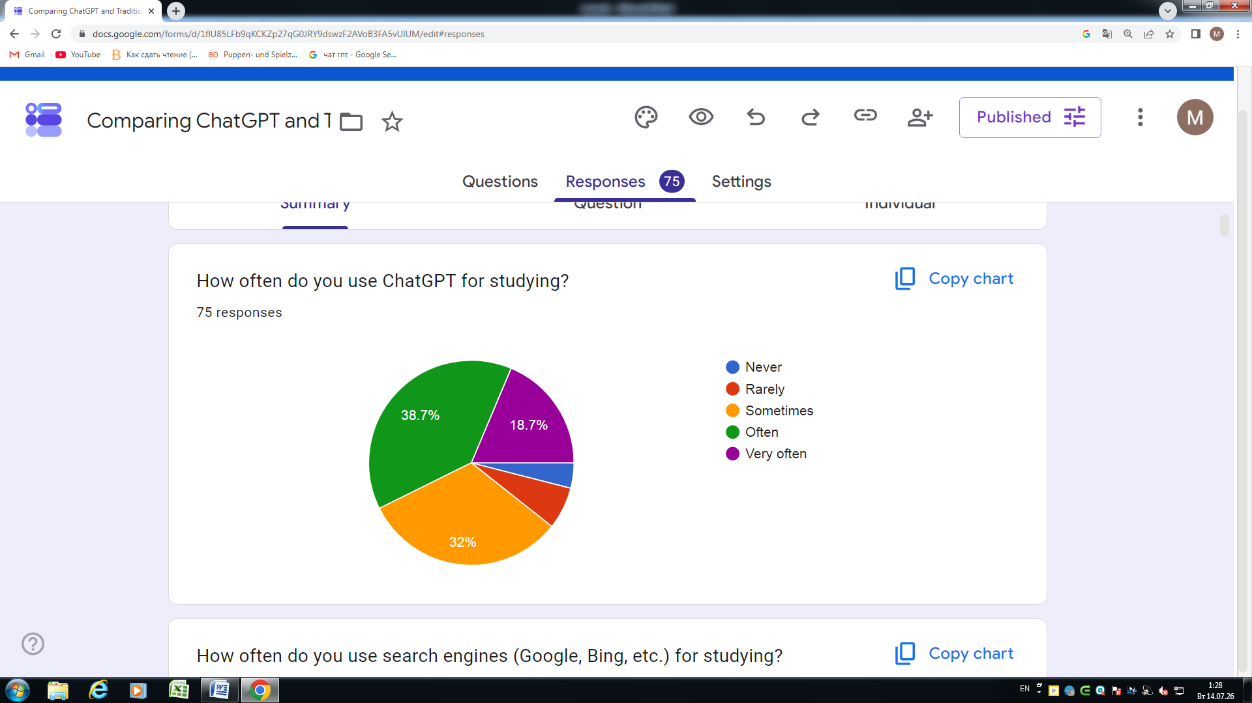
Figure 1. Frequency of ChatGPT Usage for Studying

Preferred Tool for Educational Information Retrieval
Participants were asked which tool they considered more useful for educational information retrieval.
The results showed:
- ChatGPT: 34 participants (45.3%)
- Search Engines: 11 participants (14.7%)
- Both Equally Useful: 30 participants (40.0%)
These findings suggest that students generally prefer ChatGPT or view both tools as equally valuable. Only a small minority considered traditional search engines to be superior.

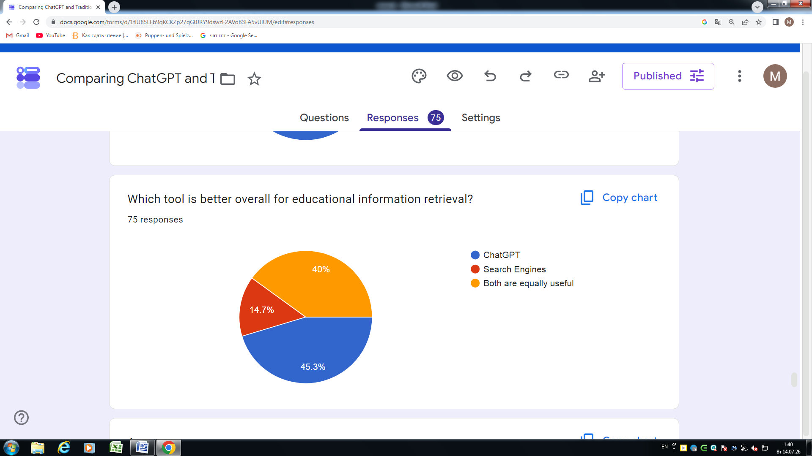
Figure 2. Overall Preference Between ChatGPT and Search Engines

Trust in Information Sources
Participants were also asked which tool they trusted more.
The results were:
- Search Engines: 30 participants (40.0%)
- ChatGPT: 24 participants (32.0%)
- Both Equally: 21 participants (28.0%)
Although ChatGPT was preferred for learning, traditional search engines were trusted more frequently. This indicates that students often use search engines to verify information obtained through AI systems.
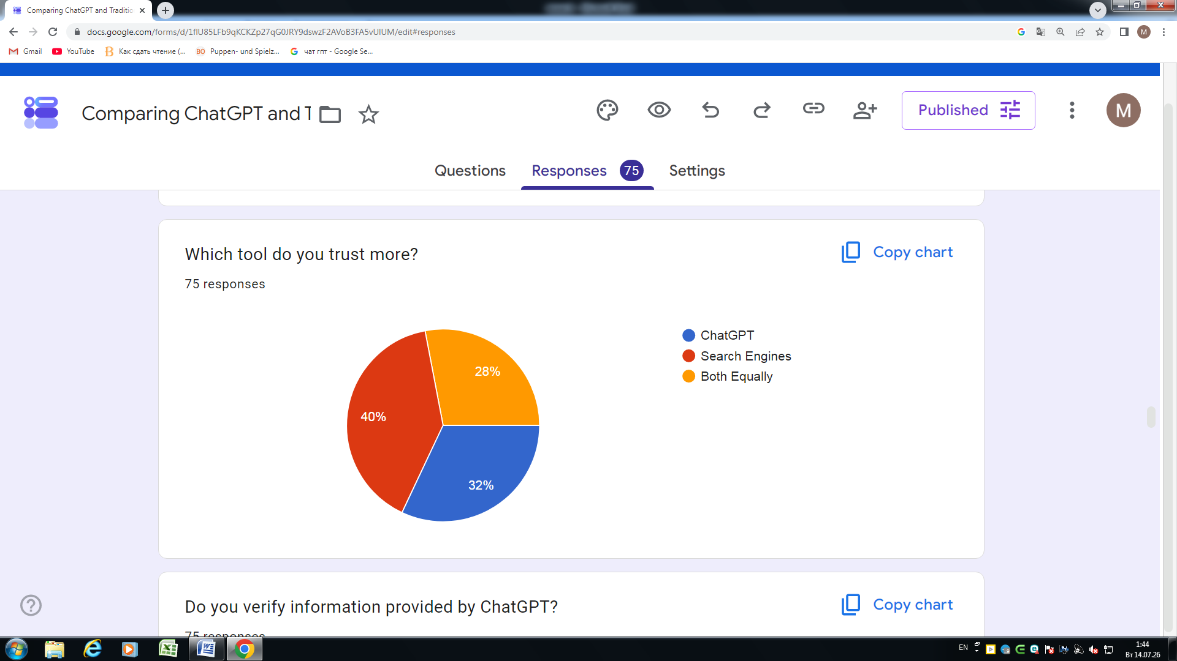
Figure 3. Trust in Information Sources

Perceived Speed of Information Retrieval
When asked which tool provides information more quickly:
- 65.3% selected ChatGPT.
- 34.7% selected Search Engines.
This result highlights one of the most significant advantages of AI-powered systems: immediate access to direct answers.

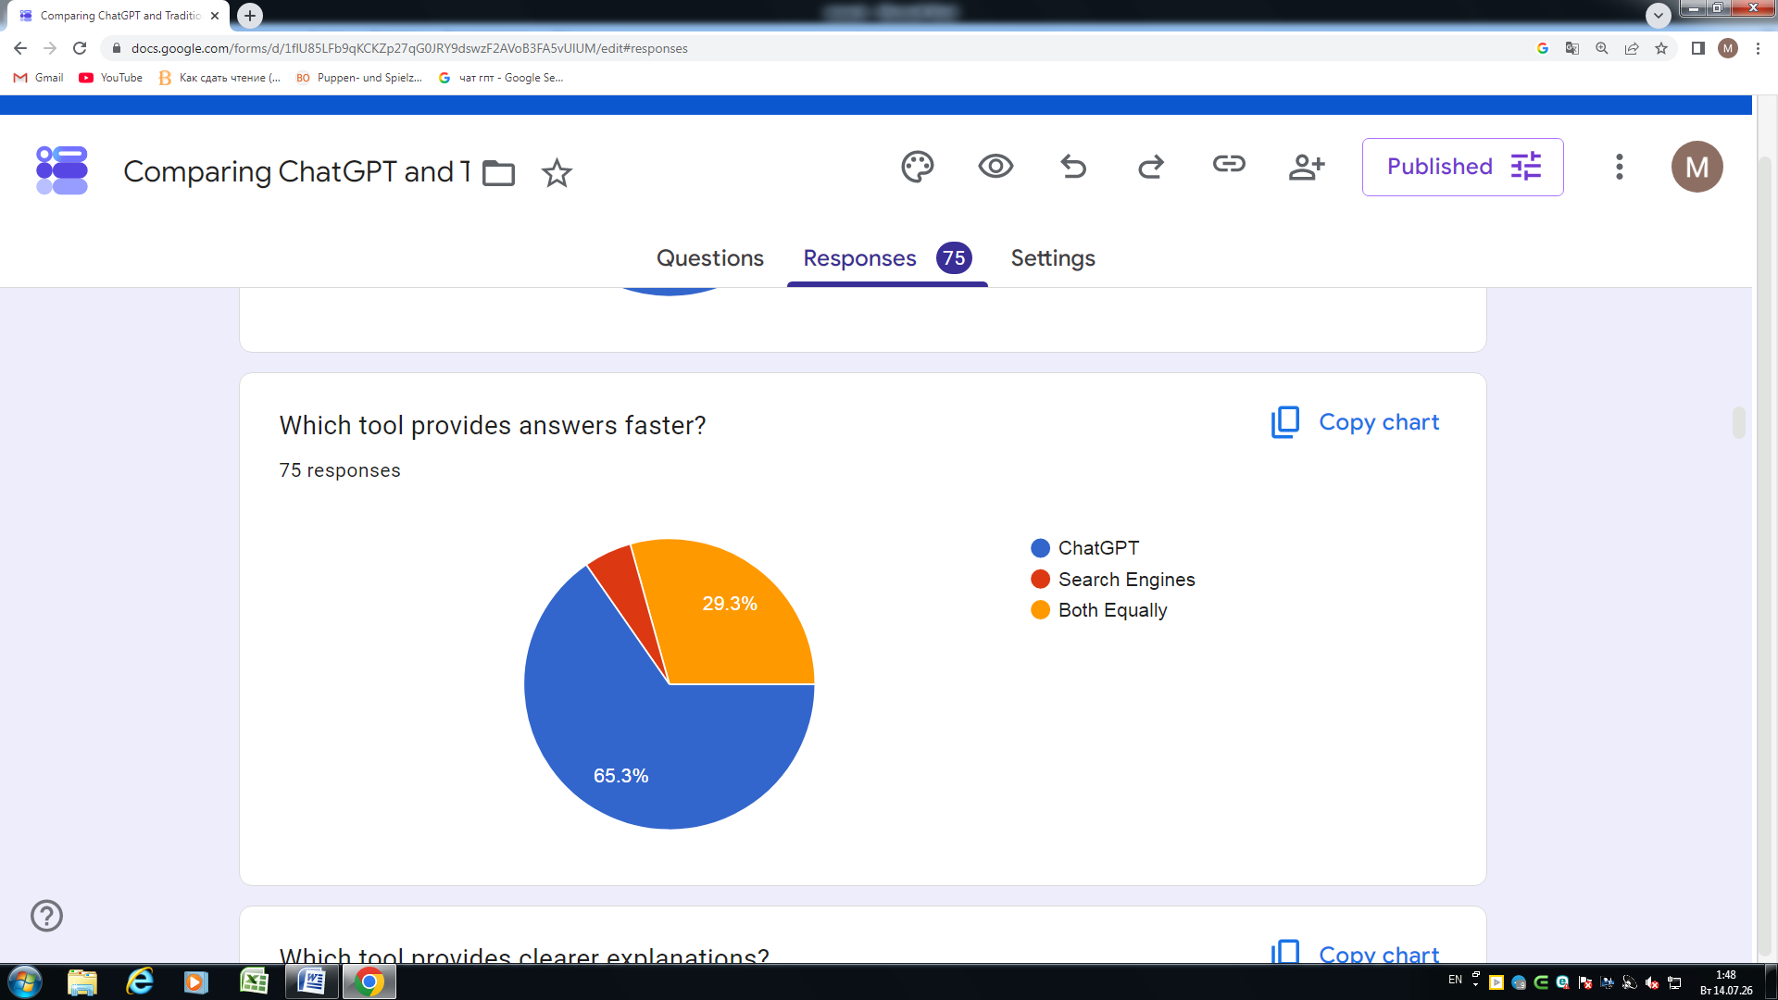
Figure 4. Perceived Speed of Information Retrieval

Ease of Understanding
Participants were asked which tool provides explanations that are easier to understand.
The majority of respondents selected ChatGPT, indicating that AI-generated explanations are generally perceived as more accessible and student-friendly than information retrieved through traditional search methods.
Learning Efficiency
A substantial proportion of participants agreed that ChatGPT improved their learning efficiency and helped them understand difficult concepts more effectively.
Furthermore, 68% of respondents stated that they would recommend ChatGPT as a learning tool to other students.
These findings suggest a generally positive perception of AI-assisted learning.

4.2 Experimental Comparison Results
An experimental comparison was conducted using five academic questions from History, Biology, Geography, Computer Science, and Mathematics.
The same questions were entered into ChatGPT and Google Search.
Response Time
Table 1. Average Response Time Comparison Between ChatGPT and Google Search

Tool | Average Response Time
ChatGPT | 5.17 seconds
Google Search | 45.54 seconds
ChatGPT provided answers approximately nine times faster than Google Search.
Quality Evaluation

. Table 2. Quality Evaluation of ChatGPT and Google Search Responses

Criterion | ChatGPT | Google Search
Detail | 4.6 | 4.0
Completeness | 4.4 | 3.6
Ease of understanding | 4.8 | 3.0
Accuracy | 4.8 | 4.2
Across all criteria, ChatGPT received higher average scores than Google Search.
The largest difference was observed in ease of understanding, where ChatGPT significantly outperformed traditional search methods.
4.3 Qualitative Results
To better understand students’ experiences, open-ended responses from 15 participants were analyzed.
Several recurring themes emerged.
Theme 1: Speed and Convenience
The most common reason for preferring ChatGPT was its speed and convenience.
Participants frequently described ChatGPT as:
- faster;
- easier to use;
- more efficient than searching multiple websites.
One participant stated:
"ChatGPT helps me learn faster, understand difficult topics better, and save time."
Another participant commented:
"It saves a significant amount of time compared to search engines.”
Theme 2: Easy-to-Understand Explanations
Many participants appreciated ChatGPT’s ability to explain difficult concepts using simple language.
Respondents reported that the system:

- simplifies complex topics;
- adapts explanations to different levels;
- provides personalized assistance.
These characteristics were identified as major advantages for educational use.
Theme 3: Concerns About Accuracy
The most frequently mentioned disadvantage was inaccurate information.
Participants reported that ChatGPT occasionally:

- provides incorrect facts;
- generates misleading information;
- gives inconsistent answers.
Several respondents emphasized that they verify important information using search engines.
One participant stated:
"Sometimes ChatGPT provides inaccurate information, so I check important facts."
Theme 4: Positive Educational Impact
Most respondents described a positive influence on their learning.
Participants reported that ChatGPT:

- improves understanding of difficult concepts;
- assists with homework;
- helps generate ideas;
- supports language learning;
- increases motivation.
One participant explained:
"It helped me find the right learning path."
Theme 5: Dependency and Reduced Critical Thinking
A smaller but notable group of respondents expressed concerns regarding overreliance on AI.
Some participants reported becoming:
- less independent;
- more reliant on quick answers;
- less likely to search for information independently.
One respondent commented:
"It made studying easier, but I also became a little lazy."
This theme suggests that while ChatGPT offers significant educational benefits, excessive dependence on AI may have unintended consequences.

- Discussion

The findings of this study provide valuable insights into the growing role of artificial intelligence in education. By combining survey data, experimental comparison, and qualitative feedback, the research offers a comprehensive perspective on how students perceive and use ChatGPT for educational purposes.
One of the most significant findings is that students generally prefer ChatGPT over traditional search engines for educational information retrieval. Survey results showed that 45.3% of participants considered ChatGPT the best overall tool, while an additional 40.0% believed that ChatGPT and search engines are equally useful. These findings suggest that AI-powered conversational systems have become an important part of modern learning environments.
The experimental comparison further supports this conclusion. ChatGPT demonstrated significantly faster response times than Google Search, requiring an average of only 5.17 seconds compared to 45.54 seconds for traditional search methods. In addition, ChatGPT received higher scores for detail, completeness, ease of understanding, and accuracy. These results indicate that AI systems can provide students with faster and more accessible access to educational information.
Another important finding concerns ease of understanding. Both survey participants and interview respondents repeatedly emphasized that ChatGPT explains complex topics in a simple and understandable manner. Many users reported that they preferred ChatGPT because it provides direct answers and allows follow-up questions. This interactive nature may contribute to more effective learning experiences, particularly for students who struggle with difficult academic concepts.
Despite these advantages, the study also revealed important concerns regarding information accuracy. Although many participants preferred ChatGPT, a larger proportion trusted traditional search engines when verifying information. Furthermore, qualitative responses showed that inaccurate information was the most frequently mentioned disadvantage of ChatGPT. These findings are consistent with previous research that highlights the risk of AI-generated misinformation and hallucinations.
The results suggest that students do not view ChatGPT as a complete replacement for search engines. Instead, many participants reported using both tools together. ChatGPT is often used to obtain quick explanations and understand concepts, while search engines are used to verify information and access original sources. This complementary relationship indicates that the future of educational information retrieval may involve the integration of AI systems with traditional search technologies.
An additional finding concerns the potential impact of AI on learning habits. While most participants described positive educational outcomes, several respondents expressed concerns about becoming overly dependent on AI tools. Some reported relying on ChatGPT too frequently, which may reduce opportunities for independent problem-solving and critical thinking. This issue represents an important area for future educational research.
Overall, the findings demonstrate that ChatGPT offers significant educational benefits, including speed, accessibility, and improved understanding of academic content. However, the results also emphasize the continuing importance of critical evaluation, source verification, and responsible AI usage in educational settings.

6.Limitations

Like all research studies, this study has several limitations that should be considered when interpreting the results.
First, the sample size was limited to 75 survey participants and 15 qualitative respondents. Although the findings provide useful insights, a larger sample would improve the generalizability of the results.
Second, most participants were between 15 and 20 years old. As a result, the findings primarily reflect the perspectives of younger students and may not fully represent older learners or professionals.
Third, the experimental comparison was conducted by a single researcher. The evaluation of response quality, including detail, completeness, and ease of understanding, involved subjective judgment. Future studies could involve multiple evaluators to improve reliability.
Fourth, the research focused primarily on educational information retrieval and did not examine other applications of ChatGPT such as programming, creative writing, or professional work.
Despite these limitations, the study provides valuable evidence regarding students’ perceptions and experiences with AI-powered educational tools.

7. Conclusion

The purpose of this study was to compare ChatGPT and traditional search engines in the context of educational information retrieval.
Using a mixed-methods approach that combined survey data, experimental comparison, and qualitative feedback, the study explored how students perceive and utilize these technologies for learning.
The findings indicate that ChatGPT is widely viewed as a useful educational tool due to its speed, accessibility, and ability to provide easy-to-understand explanations. The experimental comparison demonstrated that ChatGPT delivered responses significantly faster than Google Search while also receiving higher ratings across several quality criteria.
At the same time, the study found that many students continue to trust traditional search engines for information verification. Concerns regarding inaccurate AI-generated information remain an important challenge. As a result, students frequently combine ChatGPT with search engines to balance efficiency and reliability.
The research suggests that artificial intelligence is likely to play an increasingly important role in future education. However, effective learning requires not only access to AI tools but also the development of critical thinking skills and the ability to evaluate information from multiple sources.
In conclusion, ChatGPT should not be viewed as a replacement for traditional search engines. Instead, the most effective educational strategy may be the combined use of both technologies, allowing students to benefit from the strengths of each while minimizing their limitations.

8. References

OpenAI. (2023). GPT-4 Technical Report. OpenAI. https://arxiv.org/abs/2303.08774
Kasneci, E., Sessler, K., Küchemann, S., Bannert, M., Dementieva, D., Fischer, F., ... & Kasneci, G. (2023). ChatGPT for good? On opportunities and challenges of large language models for education. Learning and Individual Differences, 103, 102274.
Lo, C. K. (2023). What is the impact of ChatGPT on education? A rapid review of the literature. Education Sciences, 13(4), 410.
Tlili, A., Shehata, B., Adarkwah, M. A., Bozkurt, A., Hickey, D. T., Huang, R., & Agyemang, B. (2023). What if the devil is my guardian angel: ChatGPT as a case study of using chatbots in education. Smart Learning Environments, 10(1), 15.
Zhai, X. (2023). ChatGPT user experience: Implications for education. International Journal of Educational Technology in Higher Education, 20(1), 57.
Dwivedi, Y. K., Kshetri, N., Hughes, L., Slade, E. L., Jeyaraj, A., Kar, A. K., ... & Wright, R. (2023). “So what if ChatGPT wrote it?” Multidisciplinary perspectives on opportunities, challenges, and implications of generative conversational AI. International Journal of Information Management, 71, 102642.
Cotton, D. R. E., Cotton, P. A., & Shipway, J. R. (2023). Chatting and cheating? Ensuring academic integrity in the era of ChatGPT. Innovations in Education and Teaching International, 61(2), 228–239.
Lund, B. D., Wang, T., Mannuru, N. R., Nie, B., Shimray, S., & Wang, Z. (2023). ChatGPT and a new academic reality: Artificial Intelligence-written research papers and the ethics of the large language models in scholarly publishing. Journal of the Association for Information Science and Technology, 74(5), 570–581.
Sallam, M. (2023). ChatGPT utility in healthcare education, research, and practice: Systematic review. Healthcare, 11(6), 887.
UNESCO. (2023). Guidance for generative AI in education and research. UNESCO Publishing.
UNESCO. (2021). AI and education: Guidance for policy-makers. UNESCO Publishing.
Luckin, R., Holmes, W., Griffiths, M., & Forcier, L. B. (2016). Intelligence unleashed: An argument for AI in education. Pearson Education.
Holmes, W., Bialik, M., & Fadel, C. (2019). Artificial Intelligence in education: Promises and implications for teaching and learning. Center for Curriculum Redesign.
Mayer, R. E. (2020). Multimedia learning (3rd ed.). Cambridge University Press.

