COVENTRY UNIVERSITY
MSc Business Analytics
7015SOM – Postgraduate Business Project

Quantified and Financially Connected Climate Disclosure in Climate-Sensitive FTSE 350 Firms: Determinants and Reporting Gaps Ahead of UK SRS S2

Student: Vasu Deva Rao Madireddy
Student ID: 16814044
Route: Research-based Dissertation
Date: October 2026
Word count: 6,533 (Chapters 1–6 including in-chapter tables; references, appendices and front matter excluded)

A dissertation submitted in partial fulfilment of the requirements of the MSc Business Analytics programme.

Abstract
This dissertation examines the depth of quantified and financially connected climate disclosure among 40 climate-sensitive Financial Times Stock Exchange 350 Index (FTSE 350) non-financial firms immediately before the United Kingdom Sustainability Reporting Standards (UK SRS) transition. A researcher-developed Climate Financial Connectivity and Quantification Index (CFCQI) was applied to 80 verified annual reports spanning two consecutive reporting cycles, creating 960 item-level coding decisions supported by a frozen codebook and evidence audit. The analysis combined descriptive statistics, pooled ordinary least squares regression with firm-clustered robust standard errors, reliability testing and paired within-firm analysis. Mean CFCQI was 51.77, indicating moderate but uneven financial connectivity. Disclosure was strongest for financial-planning integration, quantified scenario analysis and asset valuation/impairment, while current financial position, performance and cash-flow effects remained the largest gaps. Firm size was positively associated with CFCQI in the pooled model, although the relationship weakened in a latest-cycle-only sensitivity. External sustainability assurance was not independently significant. Board-level sustainability or climate oversight showed the largest and most stable positive association, at approximately 24 CFCQI points. No systematic improvement occurred between reporting cycles. The findings suggest that the principal pre-UK SRS challenge is not the presence of climate narrative but its conversion into decision-useful financial connectivity, supported by governance, finance processes and auditable evidence.
Keywords: climate disclosure; UK SRS S2; IFRS S2; FTSE 350; financial connectivity; CFCQI; corporate governance

Table of Contents
Chapter 1: Introduction 6
1.1 Chapter Introduction 6
1.2 Background and Regulatory Context 6
1.3 Research Problem and Rationale 6
1.4 Research Aim and Objectives 7
1.5 Research Questions 7
1.6 Significance and Scope of the Study 7
1.7 Chapter Summary 8
Chapter 2: Literature Review and Theoretical Framework 9
2.1 Chapter Introduction 9
2.2 Literature Review Approach and Source Boundaries 9
2.3 Evolution of Climate-Related Financial Disclosure 9
2.4 From Narrative Disclosure to Quantified Financial Connectivity 9
2.5 Determinants of Climate-Disclosure Quality 10
2.6 Triple Bottom Line and Conceptual Framework 11
2.7 Research Gap and Contribution 12
2.8 Chapter Summary 12
Chapter 3: Methodology and Ethics 13
3.1 Chapter Introduction and Research Onion 13
3.2 Research Philosophy – Pragmatism 14
3.3 Research Approach – Deductive 14
3.4 Methodological Choice and Strategy 14
3.5 Time Horizon, Sample and Data Collection 14
3.6 CFCQI Scoring, Variables and Hypotheses 15
3.7 Statistical Analysis 16
3.8 Reliability, Validity and Reproducibility 16
3.9 Ethics and Responsible Data Use 16
3.10 Chapter Summary 16
Chapter 4: Results and Findings 17
4.1 Chapter Introduction 17
4.2 Data Quality and Reliability 17
4.3 CFCQI Descriptive Results 17
4.4 Determinants of CFCQI 19
4.5 Regression Diagnostics and Robustness 20
4.6 Paired Reporting-Cycle Results 21
4.7 Chapter Summary 22
Chapter 5: Discussion 23
5.1 Chapter Introduction 23
5.2 Discussion of RQ1 – Level and Pattern of Financially Connected Climate Disclosure 23
5.3 Discussion of RQ2 – Organisational Determinants 24
5.4 Discussion of RQ3 – Change Across Reporting Cycles 25
5.5 Triple Bottom Line Interpretation 25
5.6 Chapter Summary 26
Chapter 6: Conclusion, Recommendations and Limitations 27
6.1 Chapter Introduction 27
6.2 Overall Conclusion and Contribution 27
6.3 Answers to the Research Questions 27
6.4 Practical Recommendations 28
6.5 Policy and Professional Implications 29
6.6 Research Limitations 29
6.7 Future Research 30
6.8 Final Chapter Summary 30
AI Use Acknowledgement 31
References 32
Appendix A: Final Sample and Reporting Cycles 35
Appendix B: CFCQI Codebook Summary 36
Appendix C: Reliability by CFCQI Item 37
Appendix D: Regression Diagnostics and Influential Observations 37
Appendix E: Item-Level Paired Change 38
Appendix F: Technical Reproducibility Summary 39
Appendix G: CFCQI Item-Score Distribution 40

List of Tables
Table 3.1. Research Onion decisions and justification. 13
Table 3.2. Variables and operational definitions. 15
Table 3.3. Null and alternative hypotheses. 15
Table 4.1. CFCQI descriptive statistics by cycle and TCFD group. 17
Table 4.2. Pooled OLS regression with firm-clustered robust standard errors. 19
Table 4.3. Robustness of the three main predictors. 21
Table 6.1. Evidence-based implementation priorities. 28

List of Figures
Figure 2.1. Conceptual pathway from climate risk to financially connected disclosure. 12
Figure 3.1. Research Onion and methodological choices used in this study. 13
Figure 4.1. Mean CFCQI item scores across the 80 firm-year observations. 19
Figure 4.2. Mean CFCQI by sector group and reporting cycle. 19
Figure 4.3. Main RQ2 coefficients and 95% confidence intervals. 20
Figure 4.4. Prior-cycle versus latest-cycle CFCQI by firm. 22
Figure D1. Regression residual and influence diagnostics. 38

List of Abbreviations
Abbreviation | Meaning
CFCQI | Climate Financial Connectivity and Quantification Index
FCA | Financial Conduct Authority
FRC | Financial Reporting Council
FTSE | Financial Times Stock Exchange
HC3 | Heteroskedasticity-consistent covariance estimator type 3
IFRS S2 | IFRS S2 Climate-related Disclosures
ISSB | International Sustainability Standards Board
OLS | Ordinary least squares
ROA | Return on assets
TCFD | Task Force on Climate-related Financial Disclosures
TBL | Triple Bottom Line
UK GDPR | United Kingdom General Data Protection Regulation
UK SRS | United Kingdom Sustainability Reporting Standards
VIF | Variance inflation factor

Chapter 1: Introduction

1.1 Chapter Introduction
This chapter defines the Business Analytics problem: climate-sensitive listed companies increasingly report climate risks, but the financial specificity of those disclosures remains uneven. It establishes the regulatory context, research gap, approved aim, objectives, questions, scope and contribution. Method and results are reserved for later chapters.

1.2 Background and Regulatory Context
Climate-related reporting has moved from voluntary sustainability narrative towards information intended to support capital allocation and financial decision-making. The Task Force on Climate-related Financial Disclosures (TCFD) established a widely adopted architecture around governance, strategy, risk management, and metrics and targets (Task Force on Climate-related Financial Disclosures, 2017). The International Sustainability Standards Board (ISSB) subsequently issued IFRS S2 Climate-related Disclosures, which requires information about both current and anticipated effects of climate-related risks and opportunities on financial position, financial performance and cash flows, together with the way those matters enter financial planning (IFRS Foundation, 2023).
The UK Government finalised United Kingdom Sustainability Reporting Standards (UK SRS) S1 and S2 on 25 February 2026, adapting the ISSB baseline for the UK. On 30 September 2026, the Financial Conduct Authority (FCA) confirmed a comply-or-explain regime for listed companies for accounting periods beginning on or after 1 January 2027 (Department for Business and Trade, 2026; Financial Conduct Authority, 2026). The annual reports used in this study therefore form a pre-implementation baseline: the evidence was limited to reports publicly available by 31 August 2026, before the new listing rules became operative.

1.3 Research Problem and Rationale
The problem is incomplete financial connectivity rather than absent climate disclosure. Companies routinely describe governance, emissions, transition risks and scenario analysis, yet users also need to understand effects on assets, liabilities, earnings, cash flows, investment and accounting estimates. Deloitte (2025) found that 77% of reviewed Financial Times Stock Exchange 100 Index (FTSE 100) reporters discussed potential climate-related financial impacts, but nearly three-quarters were qualitative. KPMG UK (2026) likewise identifies a quantification gap between established TCFD processes and the financial-effects information expected under ISSB-aligned reporting. Academic evidence similarly suggests that quantitative content can be more decision-useful than broad narrative (Bingler et al., 2022; Keeley et al., 2026).
Existing studies have examined TCFD alignment, the determinants of climate reporting, governance, assurance and the consequences of mandatory disclosure (Alqudwa et al., 2025; Gebhardt et al., 2024; Gupta, 2026; Moses et al., 2025). However, a narrower UK gap remains: how far climate-sensitive FTSE 350 firms connect climate matters to recognised financial effects and financial planning, and which organisational characteristics are associated with deeper disclosure. The dissertation addresses this gap through the Climate Financial Connectivity and Quantification Index (CFCQI), a research instrument measuring disclosure depth rather than regulatory compliance or environmental performance.

1.4 Research Aim and Objectives
The research aim is to measure and explain variation in the quantification and financial connectivity of climate-related disclosure among climate-sensitive FTSE 350 firms ahead of the transition to UK SRS S2.
- Develop and pilot a transparent CFCQI grounded in current and anticipated financial-effects concepts in IFRS S2/UK SRS S2 and the climate-reporting literature.
- Construct a paired firm-year dataset from two consecutive reporting cycles for 40 climate-sensitive FTSE 350 non-financial firms.
- Describe CFCQI overall, by item, reporting cycle and TCFD sector group.
- Test whether firm size, external sustainability assurance and board-level sustainability/climate oversight are associated with CFCQI after controlling for leverage, profitability, sector and cycle.
- Test within-firm change across the two cycles and evaluate reliability, limitations and practical implications ahead of UK SRS S2 implementation.

1.5 Research Questions
- RQ1: What is the level and pattern of quantified and financially connected climate disclosure among climate-sensitive FTSE 350 firms across two consecutive reporting cycles?
- RQ2: Which firm characteristics – particularly firm size, external sustainability assurance and dedicated board-level sustainability/climate oversight – are associated with higher CFCQI scores after controlling for leverage, profitability, sector and reporting cycle?
- RQ3: How does CFCQI change within firms between the two reporting cycles, and which disclosure dimensions show the largest remaining gaps ahead of UK SRS S2 implementation?

1.6 Significance and Scope of the Study
The study narrows analysis from broad Environmental, Social and Governance (ESG) reporting to the financial depth of climate disclosure. Climate-sensitive non-financial FTSE 350 firms are relevant because transition regulation, physical exposure, carbon costs, asset revaluation and decarbonisation investment can create material financial consequences. Its Business Analytics contribution is the conversion of heterogeneous, unstructured annual-report evidence into reproducible variables with page-level provenance, followed by descriptive, regression, reliability and paired analysis. This creates a transparent measurement and decision-support framework for preparers, boards, assurers, investors and regulators. Higher CFCQI is not treated as better environmental performance or regulatory compliance.

1.7 Chapter Summary
This chapter established the regulatory context, the quantification/connectivity problem and the approved research focus. Chapter 2 critically reviews the literature and develops the theoretical and conceptual logic used to explain variation in disclosure depth.

Chapter 2: Literature Review and Theoretical Framework

2.1 Chapter Introduction
This chapter explains why financially connected climate disclosure remains uneven. It moves from the Task Force on Climate-related Financial Disclosures (TCFD) and International Sustainability Standards Board (ISSB) reporting to the distinction between narrative alignment and quantified connectivity, then synthesises organisational determinants. Triple Bottom Line (TBL) is retained as a contextual lens linking environmental risk, governance/accountability and financial reporting. The chapter concludes with the research gap and contribution.

2.2 Literature Review Approach and Source Boundaries
The review combines peer-reviewed accounting, sustainability and finance literature with authoritative standard-setting and practitioner evidence. Priority was given to work from 2015 onwards, retaining earlier foundational sources where necessary. Searches covered climate-related financial disclosure, TCFD, IFRS S2, financial effects, disclosure quality, assurance, board oversight and firm determinants. Sources were synthesised thematically by measures, mechanisms and unresolved gaps.

2.3 Evolution of Climate-Related Financial Disclosure
TCFD shifted climate reporting towards investor-oriented governance, strategy, risk and metrics, but its recommendations still allowed substantial discretion in the depth and quantification of disclosure. Research therefore distinguishes formal framework alignment from substantive information content. Bingler et al. (2022) show that corporate climate disclosure can contain selective or symbolic language, while Braasch and Velte (2023) demonstrate material variation in TCFD reporting quality. More recent evidence continues this distinction: Keeley et al. (2026) find that quantitative climate disclosures have stronger financial associations than qualitative disclosures, supporting the idea that disclosure type matters rather than disclosure volume alone.
IFRS S2 raises the analytical bar by explicitly requiring information on current and anticipated financial effects. The standard links climate risks and opportunities to financial position, financial performance and cash flows, and connects anticipated effects to financial planning (IFRS Foundation, 2023). This creates a useful boundary for the present study. CFCQI is not an IFRS S2 compliance checklist; instead, it isolates the depth of the financial connections that are increasingly expected under ISSB-aligned reporting.

2.4 From Narrative Disclosure to Quantified Financial Connectivity
The literature identifies a recurring gap between climate narrative and monetary/accounting connectivity. Deloitte (2025) reports near-universal scenario analysis and board responsibility among early FTSE 100 reporters, yet quantified financial effects remain limited. KPMG UK (2026) similarly finds mature climate processes but weaker quantification, traceability and controls over financial-effects information. Investors require information linking climate risk to enterprise value, not simply evidence that a climate process exists (Phang, 2025).
Academic reviews also show that “quality” is not consistently operationalised. Alqudwa et al. (2025) identify heterogeneous measures across climate-disclosure studies, while Mashhadi Rajabi et al. (2026) argue for stronger integration between accounting, governance and climate-risk perspectives. IFRS Foundation implementation material further clarifies that current and anticipated financial effects may require a combination of quantitative and qualitative information and that proportionality and measurement uncertainty matter when quantification is difficult (IFRS Foundation, 2025). This is analytically important: absence of a quantified amount is not automatically non-compliance, while generic narrative does not provide the same decision-useful depth as a traceable financial connection. A financial-connectivity index can therefore add value by measuring disclosure depth without pretending to be a compliance score.

2.5 Determinants of Climate-Disclosure Quality
Variation in disclosure depth is unlikely to be random. The literature points to organisational capacity, external credibility mechanisms, governance accountability, financial characteristics and sector exposure as plausible determinants.

2.5.1 Organisational Capacity, Visibility and Firm Size
Larger firms face greater investor scrutiny and typically possess more specialised finance, sustainability, risk and reporting resources. The FCA’s earlier review of TCFD reporting found that disclosure detail often varied with size, sector and climate-risk assessment (Financial Conduct Authority, 2022). Gupta (2026) also finds that the effects of mandatory TCFD disclosure differ by firm characteristics, with larger UK non-financial firms showing stronger outcomes. These arguments support a positive size–CFCQI expectation, but the mechanism is probabilistic: scale may enable better reporting without guaranteeing it.

2.5.2 Governance and Credibility Mechanisms
External assurance and board oversight represent different accountability mechanisms, and the literature does not imply that they should operate identically. Assurance may improve discipline and credibility, yet sustainability assurance frequently covers selected greenhouse-gas or operational metrics rather than climate-related financial effects. Al-Shaer and Zaman (2018) associate governance and assurance structures with reporting credibility, while KPMG UK (2026) shows that scope can remain narrow. Assurance presence is therefore theoretically ambiguous unless scope reaches the financial-connectivity construct being measured. Board structures may be more directly related to internal integration: environmental committees and climate-related governance arrangements have been associated with stronger disclosure (Liao et al., 2015; Gebhardt et al., 2024). Even here, reverse causality is plausible because organisationally mature reporters may both create stronger governance structures and disclose more deeply. These competing mechanisms justify testing assurance and board oversight separately rather than treating them as interchangeable signals of reporting quality.

2.5.3 Financial Structure, Profitability and Sector Context
Profitability and leverage may influence disclosure incentives and capacity, while sector shapes the materiality and visibility of climate risk. Energy, mining, transport and food-related value chains face distinct combinations of carbon cost, physical exposure, asset stranding and transition investment. Sector therefore needs to be controlled rather than treated as background noise. Return on assets (ROA) and leverage are included as financial controls because stronger profitability may expand reporting capacity, while financing structure may affect risk sensitivity and stakeholder scrutiny. These controls reduce the risk that the main governance and size relationships merely proxy for basic financial differences.

2.6 Triple Bottom Line and Conceptual Framework
Elkington’s (1997) Triple Bottom Line frames organisational performance across economic, environmental and social dimensions, although later critiques warn against treating the three dimensions as mechanically commensurable (Norman & MacDonald, 2004). In this dissertation, TBL is therefore a contextual lens rather than a scoring formula. Climate risk represents the environmental pressure; governance and accountability mechanisms help determine whether that pressure enters strategic and financial processes; and financial connectivity makes the economic consequences visible to users of corporate reports. The social dimension appears through accountability to investors and other stakeholders rather than as a separate CFCQI component.
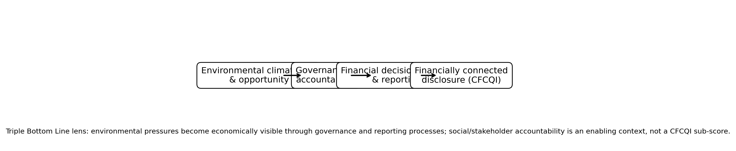
Figure 2.1. Conceptual pathway from climate risk to financially connected disclosure.
The framework predicts that financial connectivity should be strongest where organisations have the capacity to integrate climate information, credible reporting processes and formal governance oversight. CFCQI is the observable reporting outcome of that pathway, not a measure of the firm’s sustainability performance.

2.7 Research Gap and Contribution
Three gaps follow. First, much research measures TCFD alignment or general climate disclosure rather than current and anticipated financial effects. Second, assurance and governance studies often examine broad ESG reporting rather than ISSB-style financial connectivity. Third, UK evidence immediately before UK SRS implementation is limited. The study therefore makes three linked contributions: a measurement contribution through a transparent 12-item index with evidence-level provenance; an explanatory contribution by testing organisational correlates while controlling for financial and sector differences; and a temporal contribution through a paired pre-implementation baseline. The value is not another disclosure-volume score, but an auditable analytical framework for distinguishing procedural climate maturity from financially connected reporting.

2.8 Chapter Summary
The literature shows that climate reporting has matured procedurally faster than it has matured financially. Quantification and connectivity remain uneven, while firm capacity, assurance, governance and sector context provide plausible explanations for variation. Chapter 3 translates these arguments into the research design, variables, hypotheses and statistical procedures.

Chapter 3: Methodology and Ethics

3.1 Chapter Introduction and Research Onion
This chapter translates the conceptual framework into a coherent Business Analytics methodology using the Research Onion of Saunders et al. (2019). The onion moves from philosophy through approach, methodological choice, strategy and time horizon to data collection and analysis. This structure clarifies the link between research questions, hypotheses, variables and statistical procedures. Figure 3.1 and Table 3.1 summarise the selected choices.
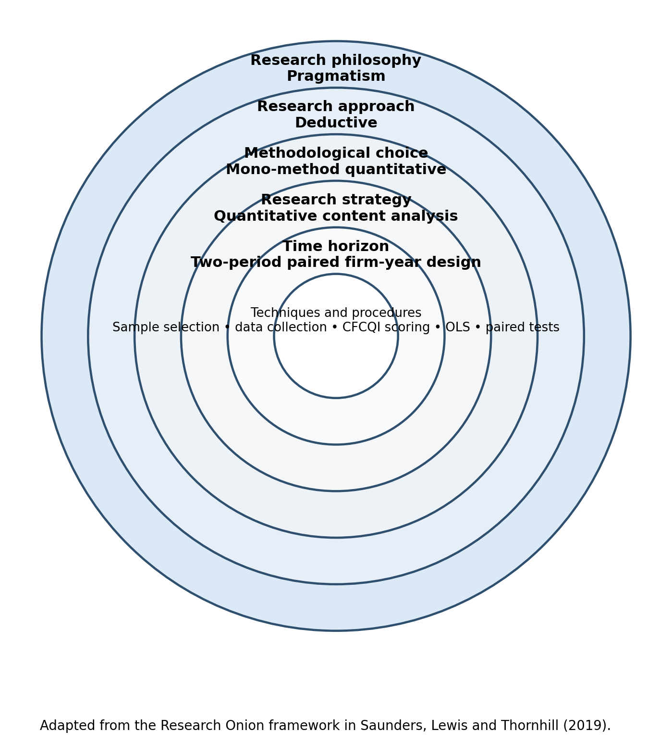
Figure 3.1. Research Onion and methodological choices used in this study. Adapted from Saunders et al. (2019).
Table 3.1. Research Onion decisions and justification.
Layer | Selected choice | Justification
Philosophy | Pragmatism | Addresses an applied Business Analytics problem while making measurement assumptions explicit.
Approach | Deductive | Literature informs hypotheses and variables before testing.
Methodological choice | Mono-method quantitative | Final evidence is represented as numerical firm-year variables; thematic analysis is not used.
Strategy | Quantitative content analysis | Predefined rules convert annual-report evidence into comparable 0–2 scores.
Time horizon | Two consecutive reporting cycles | Supports pooled analysis and within-firm comparison.
Techniques/procedures | Sample selection, data collection, CFCQI scoring, OLS and paired tests | Connects documentary evidence directly to reproducible statistical analysis.
Source: Author, adapted from Saunders et al. (2019).

3.2 Research Philosophy – Pragmatism
Pragmatism is appropriate because the study addresses a practical measurement problem: converting heterogeneous climate-reporting evidence into a transparent indicator and relating it to organisational characteristics. It permits documentary judgement while prioritising methods that answer the research problem (Saunders et al., 2019). The project remains mono-method quantitative because the evidence is transformed into numerical variables and analysed statistically.

3.3 Research Approach – Deductive
The approach is deductive. Chapter 2 identifies expected relationships between organisational capacity, external assurance, board accountability and disclosure depth. Those expectations are converted into pre-specified hypotheses and operational variables before regression analysis. Likewise, the 12 CFCQI dimensions and 0–2 decision rules are defined in advance rather than generated inductively from themes in the annual reports.

3.4 Methodological Choice and Strategy
The methodological choice is mono-method quantitative and the strategy is quantitative content analysis. No themes are generated inductively; a frozen scoring scheme classifies annual-report evidence into predetermined categories and produces numerical variables. This is consistent with quantitative content analysis, which systematically classifies communication using explicit, replicable rules (Neuendorf, 2017).

3.5 Time Horizon, Sample and Data Collection
The study uses two consecutive reporting cycles for each firm. The sampling frame is non-financial Financial Times Stock Exchange 350 Index (FTSE 350) firms mapped to the four climate-sensitive Task Force on Climate-related Financial Disclosures (TCFD) groups. Eligible firms were ranked by market capitalisation, producing a supervisor-reviewed 40-firm sample. The ranking was frozen on 7 October 2026, while report eligibility ended on 31 August 2026; this boundary-timing limitation is disclosed in Chapter 6.
Two reports per firm produced 80 firm-years. Each document was checked for company identity, financial year (FY), consolidated-group status and completeness; Secure Hash Algorithm 256-bit (SHA-256) hashes confirmed 80 unique files. Mobico’s 15-month latest period and Tesco’s 53-week latest year were retained and tested through exclusion sensitivities.

3.6 CFCQI Scoring, Variables and Hypotheses
The Climate Financial Connectivity and Quantification Index (CFCQI) contains 12 items covering current and anticipated financial effects, capital allocation, valuation/impairment, provisions, carbon/regulatory costs, financial-planning integration and quantified scenario analysis. Scores are 0 (no qualifying financial connection after full-report review), 1 (explicit but unquantified connection) or 2 (quantified or strongly specific financial link). Equal weighting is used because no defensible ex ante basis exists for differential weights and unweighted disclosure indices are established in disclosure research (Tsalavoutas et al., 2010). CFCQI = (raw score / 24) × 100 and measures disclosure depth, not compliance or environmental performance.
Firm size is ln(total assets in Pound Sterling (GBP) millions). External sustainability assurance equals 1 for qualifying independent assurance and 0 otherwise; the statutory financial audit alone does not qualify. Board oversight equals 1 where a board-level committee has an explicit sustainability/climate remit. Leverage and Return on Assets (ROA) are financial controls, while TCFD group and cycle are categorical controls. Table 3.2 summarises the definitions.
Table 3.2. Variables and operational definitions.
Variable | Operationalisation | Role
CFCQI | 12-item score, 0–100 | Dependent variable
Firm size | ln(total assets in GBP millions) | Primary predictor
External assurance | 1 = qualifying independent assurance; 0 = otherwise | Primary predictor
Board oversight | 1 = board committee with explicit sustainability/climate remit; 0 = otherwise | Primary predictor
Leverage | Interest-bearing debt / total assets | Control
ROA | Profit after tax / average total assets | Control
TCFD group; cycle | Categorical indicators | Controls
Source: Study codebook and locked data dictionary.
The supervisor requested both null and alternative hypotheses. Each pair is assessed through the sign, 95% confidence interval and p-value of the corresponding OLS coefficient. A non-significant result is described as failure to reject the null, not acceptance of it.
Table 3.3. Null and alternative hypotheses.
Test | Null hypothesis | Alternative hypothesis
Size | H01: Firm size has no statistically significant association with CFCQI after controls. | H11: Firm size is positively associated with CFCQI after controls.
Assurance | H02: External sustainability assurance has no statistically significant association with CFCQI after controls. | H12: Firms with qualifying external sustainability assurance have higher CFCQI after controls.
Board oversight | H03: Board-level sustainability/climate oversight has no statistically significant association with CFCQI after controls. | H13: Firms with qualifying board-level oversight have higher CFCQI after controls.

3.7 Statistical Analysis
Analysis begins with CFCQI descriptives by cycle, TCFD group and item. Determinants are estimated using pooled ordinary least squares (OLS) with firm-clustered standard errors because each company contributes two observations (Cameron & Miller, 2015; Wooldridge, 2010). OLS is retained because the 0–100 index is quasi-continuous and coefficients are interpretable in CFCQI points. Variance Inflation Factors (VIFs), Breusch–Pagan testing, residual checks, leverage and Cook’s distance assess model behaviour. Robustness checks cover influential observations, atypical periods, the borderline Drax classification and a latest-cycle-only Heteroskedasticity-Consistent type 3 (HC3) model.
For reporting-cycle change, ΔCFCQI is defined as Latest (T) − Prior (T1). Normality of paired differences determines the primary test; where normality is not supported, the Wilcoxon signed-rank test is used, with a paired t-test and exact sign test as sensitivities. Item-level change is also calculated, and Mobico/Tesco exclusion tests assess whether their atypical reporting periods drive the conclusion.

3.8 Reliability, Validity and Reproducibility
A blind second-pass scoring exercise covered 12 reports (15% of the corpus) using a separate workflow that had not produced their first-pass scores. It is treated as a scoring-stability check, not proof of human inter-coder agreement. Exact agreement and weighted Cohen’s kappa assess the ordinal 0–2 scores (Cohen, 1968; Milne & Adler, 1999). Content and construct validity are supported by predefined financially connected disclosure concepts and evidence requirements. Criterion validity is not claimed because no accepted external benchmark exists. Page-level evidence, hashes, decision logs, locked datasets and automated checks strengthen reproducibility.

3.9 Ethics and Responsible Data Use
Ethical approval was granted through Coventry University’s research ethics process. The project uses public corporate reports, recruits no human participants and does not collect personal or special-category data for analysis. Handling follows university governance and United Kingdom General Data Protection Regulation (UK GDPR) principles. Source provenance, hashes, decision logs and locked datasets protect integrity; no evidence or result is fabricated, CFCQI is not presented as legal compliance, and regression coefficients are interpreted as associations.

3.10 Chapter Summary
Following the Research Onion layer by layer, this chapter establishes a coherent mono-method quantitative design based on pragmatism, deduction, quantitative content analysis, predefined CFCQI scoring and reproducible statistical testing. Chapter 4 reports the empirical results; Chapters 5 and 6 provide interpretation and direct answers to the research questions.

Chapter 4: Results and Findings

4.1 Chapter Introduction
This chapter reports results from the locked dataset: data quality and reliability, CFCQI patterns, determinant regression, diagnostics/robustness and paired change. Literature-based interpretation is reserved for Chapter 5.

4.2 Data Quality and Reliability
The final dataset contains 80 firm-years from 40 firms: 10 Energy, 9 Transportation, 11 Materials and Buildings, and 10 Agriculture, Food and Forest Products firms, with two cycles per firm and no missing CFCQI items or model variables. All 960 item decisions were valid, raw scores reconciled to item totals and CFCQI formulas, and all 80 source reports had unique hashes.
The blind 12-report second-pass scoring check produced 66.7% exact agreement and pooled weighted Cohen’s κ = 0.631, above the pre-specified 0.60 threshold. Item-level κ ranged from −0.286 (current financial performance) to 0.757 (asset valuation/impairment), with several other weak items. Appendix C reports the full table. Aggregate reliability is acceptable, but individual boundary judgements require caution.

4.3 CFCQI Descriptive Results
Across all 80 observations, mean CFCQI was 51.77 (SD = 18.65), with a median of 54.2 and a range from 16.7 to 95.8. Latest-cycle and prior-cycle means were almost identical (51.76 and 51.77 respectively). Energy recorded the highest group mean (62.91), followed by Materials and Buildings (49.80), Transportation (48.38) and Agriculture, Food and Forest Products (45.82). Figure 4.2 shows that these sector differences are much larger than the aggregate latest–prior movement.
Table 4.1. CFCQI descriptive statistics by cycle and TCFD group.
Group | n | Mean | SD | Median | Range
Overall | 80 | 51.77 | 18.65 | 54.2 | 16.7–95.8
Latest cycle (T) | 40 | 51.76 | 18.02 | 58.3 | 16.7–91.7
Prior cycle (T1) | 40 | 51.77 | 19.49 | 54.2 | 16.7–95.8
Energy | 20 | 62.91 | 20.23 | 68.75 | 16.7–91.7
Materials & Buildings | 22 | 49.80 | 17.27 | 52.1 | 25.0–95.8
Transportation | 18 | 48.38 | 14.60 | 52.1 | 20.8–66.7
Agriculture/Food/Forest | 20 | 45.82 | 18.27 | 50.0 | 16.7–70.8
Source: author’s analysis of the locked CFCQI dataset.
The item profile reveals a sharper distinction than the total score alone. Financial-planning integration (I11) had the highest mean (1.81), with 83.8% of observations scoring 2. Quantified scenario analysis (I12) averaged 1.60 and asset valuation/impairment (I8) 1.50. In contrast, current financial position (I2) averaged 0.34, current financial performance (I1) 0.44 and current cash flows (I3) 0.51; 77.5%, 68.8% and 72.5% of observations respectively scored zero. Figure 4.1 therefore identifies the principal connectivity gap: planning and scenario processes are widely reported, but direct current-period financial effects are much less frequently evidenced.
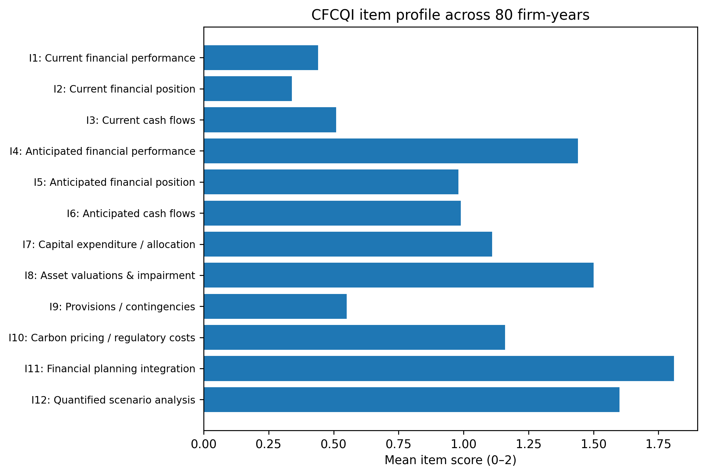
Figure 4.1. Mean CFCQI item scores across the 80 firm-year observations.
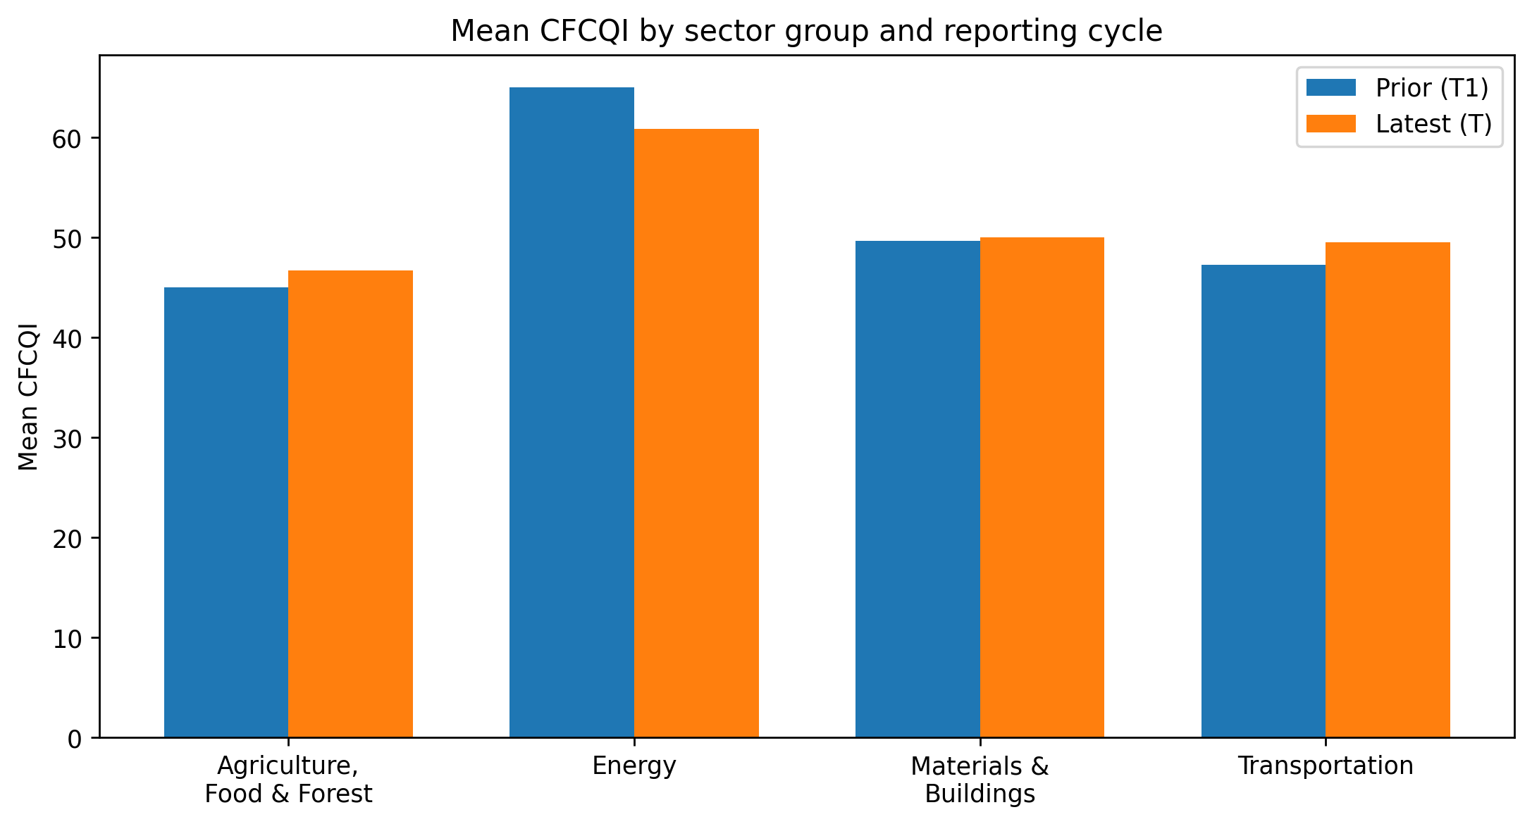
Figure 4.2. Mean CFCQI by sector group and reporting cycle.

4.4 Determinants of CFCQI
The pooled ordinary least squares (OLS) model explained 47.8% of CFCQI variation (adjusted R² = 0.410; n = 80; 40 firm clusters). For firm size, the null hypothesis of no statistically significant association (H01) was rejected in the primary specification and the positive alternative (H11) was supported: β = 4.60, 95% CI [0.78, 8.42], p = .018. For external assurance, H02 was not rejected and H12 was not supported because the coefficient was positive but imprecise (β = 11.17, 95% CI [−5.36, 27.70], p = .185). For board-level oversight, H03 was rejected and H13 was strongly supported: qualifying board oversight was associated with 23.76 additional CFCQI points (95% CI [13.48, 34.05], p < .001).
Among controls, ROA was positive and significant (β = 49.57, p = .042); because ROA is a proportion, a 0.10 increase corresponds to about 4.96 CFCQI points. Energy firms scored 11.86 points above the Agriculture/Food/Forest baseline (p = .040). Materials/Buildings, Transportation, leverage and cycle were non-significant. Table 4.2 reports the complete model.
Table 4.2. Pooled OLS regression with firm-clustered robust standard errors.
Predictor | β | Robust SE | p | 95% CI
Energy group | 11.86 | 5.78 | 0.040 | [0.53, 23.19]
Materials & Buildings | 1.16 | 5.91 | 0.844 | [-10.42, 12.75]
Transportation | 6.07 | 6.76 | 0.369 | [-7.17, 19.31]
Prior cycle (T1) | 0.67 | 1.93 | 0.730 | [-3.12, 4.45]
Firm size | 4.60 | 1.95 | 0.018 | [0.78, 8.42]
External assurance | 11.17 | 8.43 | 0.185 | [-5.36, 27.70]
Board oversight | 23.76 | 5.25 | 0.000 | [13.48, 34.05]
Leverage | 8.47 | 15.77 | 0.591 | [-22.45, 39.38]
ROA | 49.57 | 24.33 | 0.042 | [1.88, 97.27]
Notes: n = 80 firm-years; 40 firm clusters; R² = 0.478; adjusted R² = 0.410. Reference sector: Agriculture/Food/Forest. Source: author’s Python analysis.
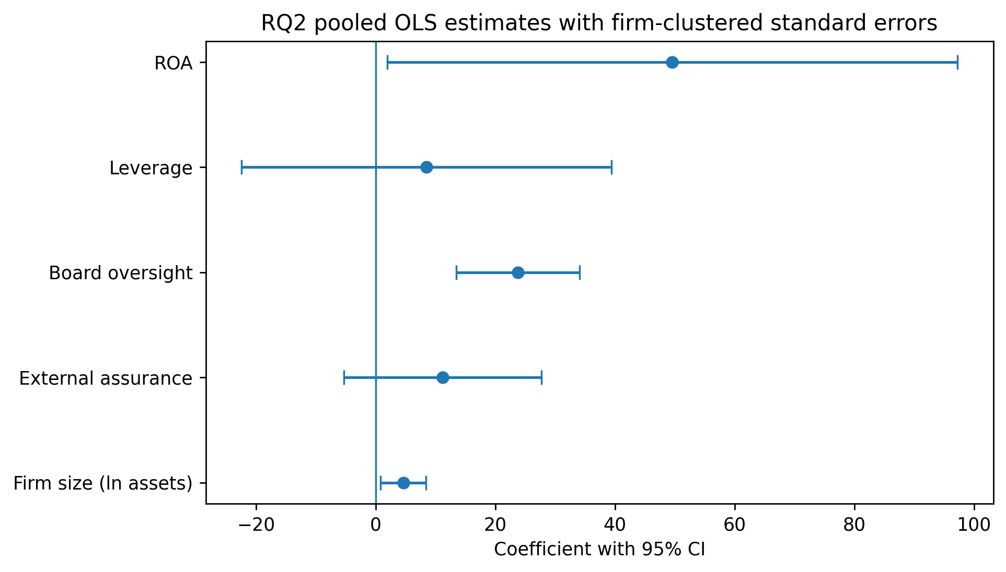
Figure 4.3. Main RQ2 coefficients and 95% confidence intervals.

4.5 Regression Diagnostics and Robustness
Multicollinearity was not problematic: the maximum VIF was 1.93. The Breusch–Pagan test indicated mild heteroscedasticity (p = .044), supporting the use of robust/clustered inference, while residual normality was not rejected (Shapiro p = .292). Six firm-years exceeded the Cook’s-distance threshold of 4/n: BP in both cycles, Ithaca Energy in the latest cycle, easyJet in the prior cycle, Rio Tinto in the prior cycle and Diageo in the prior cycle. Excluding those observations strengthened H1, left H2 non-significant and left H3 strongly significant.
Sensitivity tests addressed period and classification concerns. Excluding Mobico, Tesco, or both did not change the substantive conclusions. Reclassifying Drax Group’s borderline board-oversight indicator from 1 to 0 reduced H3 to 20.34 points but it remained significant (p < .001). In the latest-cycle-only HC3 model, H1 remained positive but weakened to p = .076, H2 remained non-significant (p = .751), and H3 remained positive and significant (β = 25.34, p = .002). H1 is therefore supported but sample-size-sensitive; H3 is the most stable result.
Table 4.3. Robustness of the three main predictors.
Specification | n | H1 size β (p) | H2 assurance β (p) | H3 board β (p)
Base pooled | 80 | 4.60 (0.018) | 11.17 (0.185) | 23.76 (0.000)
Exclude Mobico | 78 | 4.56 (0.023) | 11.09 (0.191) | 23.95 (0.000)
Exclude Tesco | 78 | 4.82 (0.017) | 11.28 (0.185) | 24.32 (0.000)
Exclude Mobico + Tesco | 76 | 4.79 (0.021) | 11.18 (0.191) | 24.51 (0.000)
Drax oversight recoded 1→0 | 80 | 4.13 (0.042) | 11.69 (0.172) | 20.34 (0.000)
Latest cycle only (HC3) | 40 | 4.61 (0.076) | 3.65 (0.751) | 25.34 (0.002)
Source: author’s robustness analysis. Drax Group is firm F009.

4.6 Paired Reporting-Cycle Results
Paired differences were non-normal (Shapiro p < .001), so the Wilcoxon signed-rank test was the primary inferential procedure. Defining change as Latest (T) − Prior (T1), mean change was −0.003 CFCQI points and the median was 0. The Wilcoxon statistic was W = 101.5 (p = .896), providing no evidence of systematic change. Twelve firms improved, 20 were unchanged and eight declined. Complementary tests reached the same conclusion: paired t = −0.002 (p = .999) and the exact sign test excluding ties gave p = .503.
The null result was robust to excluding Mobico’s 15-month latest period, Tesco’s 53-week period, or both. Item-level movement was also small. Current performance, current position and current cash flows each increased by 0.075 points on average, and capital expenditure/allocation increased by 0.075. By contrast, asset valuation/impairment declined by 0.10 and anticipated financial performance by 0.075. Most item scores were unchanged for 80–97.5% of firms. The largest remaining gaps therefore remained the current financial-effects items rather than scenario or planning disclosure. Full item-level change results are reported in Appendix E.
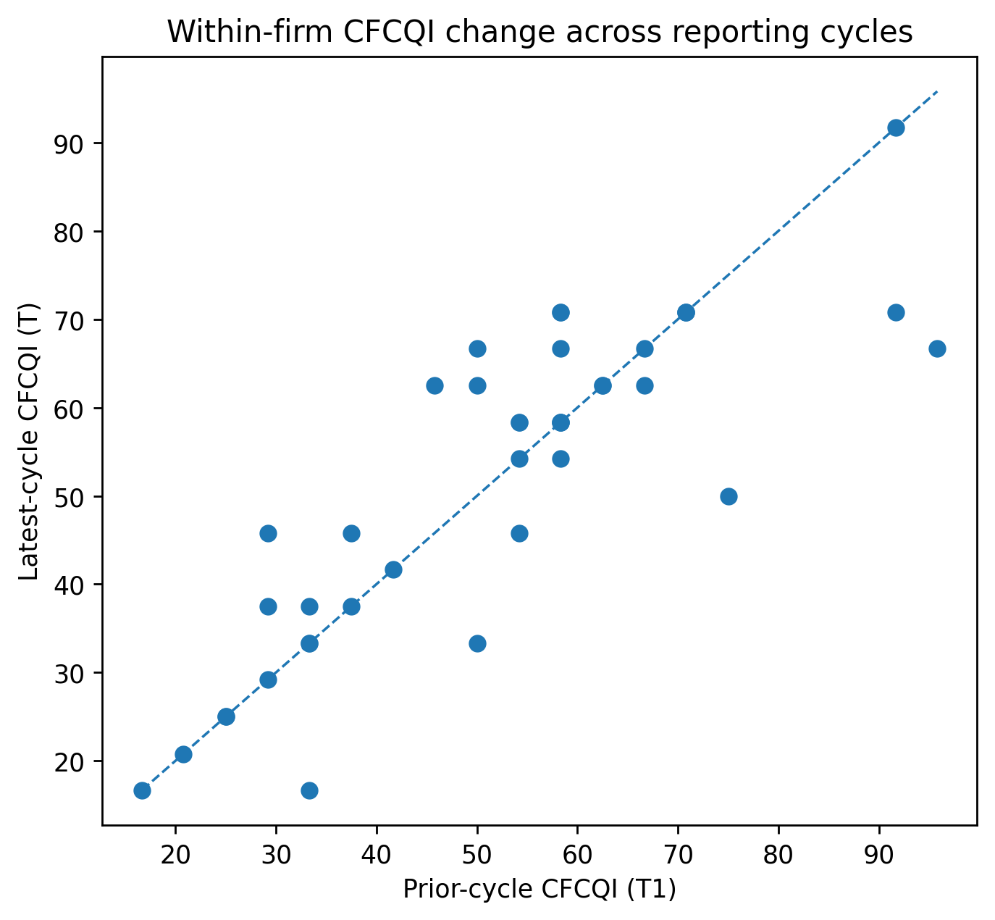
Figure 4.4. Prior-cycle versus latest-cycle CFCQI by firm.

4.7 Chapter Summary
The results show moderate but highly uneven financial connectivity. Planning, scenario and impairment disclosure are comparatively developed, whereas current financial effects remain weak. Firm size is positively associated with CFCQI in the pooled model but becomes weaker in the latest-only specification; assurance is not independently significant; board oversight is large and robust. There is no systematic aggregate improvement across the two reporting cycles. Chapter 5 interprets these findings against the literature, UK SRS/IFRS S2 expectations and the TBL-based conceptual framework.

Chapter 5: Discussion

5.1 Chapter Introduction
This chapter interprets the findings against the research questions, literature and conceptual framework. It distinguishes statistical from practical significance, considers alternative explanations and links the evidence to the transition from TCFD-style reporting towards UK SRS S2.

5.2 Discussion of RQ1 – Level and Pattern of Financially Connected Climate Disclosure
RQ1 asked how developed quantified and financially connected climate reporting is. The mean CFCQI of 51.77 indicates a middle position: climate processes are established, but financial connectivity is incomplete. This distinction is visible within the index. Items linked to financial planning, scenario analysis and impairment receive comparatively high scores, while direct current-period effects on financial position, performance and cash flows remain uncommon. The pattern aligns closely with Deloitte’s (2025) finding that climate-related financial implications are widely discussed but frequently remain qualitative, and with KPMG UK’s (2026) conclusion that quantification and evidence trails remain major UK SRS-readiness gaps.
The result clarifies “readiness” under IFRS S2. The standard requires current and anticipated financial effects, not only governance or scenario-process disclosure (IFRS Foundation, 2023). IFRS implementation guidance also recognises that useful anticipated-effects disclosure may combine quantitative and qualitative information and that quantification can be constrained by measurement uncertainty, identifiability and available capabilities (IFRS Foundation, 2025). The study therefore should not be read as treating every unquantified disclosure as deficient or non-compliant. Instead, CFCQI shows that firms can have sophisticated scenarios and governance while still offering less traceable information about recognised or expected financial consequences. Keeley et al. (2026) similarly show that quantitative disclosure differs from qualitative disclosure in financial relevance. The remaining transition challenge is increasingly finance integration rather than climate-policy awareness.
Sector variation is also meaningful. Energy’s mean CFCQI of 62.91 is materially above the other groups, consistent with greater exposure to carbon pricing, asset impairment, transition investment and investor scrutiny. However, the sector-cycle figure shows no common upward step between the two reporting periods. The sector result therefore appears structural rather than evidence of a uniform pre-UK SRS acceleration.

5.3 Discussion of RQ2 – Organisational Determinants
RQ2 examined whether organisational characteristics are associated with disclosure depth after financial, sector and cycle controls. The results distinguish capacity, external credibility and internal governance mechanisms.

5.3.1 Firm Size – H1
The pooled model supports H1: a one-unit increase in log assets is associated with 4.60 additional CFCQI points. This accords with the resource and visibility mechanisms developed in Chapter 2: larger firms can support specialist reporting, scenario modelling and finance–sustainability integration, and is consistent with FCA evidence and Gupta (2026). However, H1 weakens to p = .076 in the latest-cycle-only model. The direction is stable, but inference is sensitive to the smaller cross-section; H1 is therefore supportive rather than definitive.

5.3.2 External Assurance – H2
H2 is not supported. The assurance coefficient is positive but imprecise, and 67 of 80 observations already have qualifying assurance, leaving limited variation. This qualifies literature linking assurance with reporting credibility (Al-Shaer & Zaman, 2018). Deloitte (2025) and KPMG UK (2026) show that assurance commonly covers emissions or selected metrics rather than current and anticipated financial effects. Assurance may therefore strengthen metric credibility without automatically producing deeper climate–financial connectivity.

5.3.3 Board-Level Oversight – H3
H3 is the strongest result. Qualifying board-level sustainability/climate oversight is associated with about 24 additional CFCQI points and remains above 20 after the conservative Drax recode. This is statistically and practically large and is consistent with evidence linking environmental committees and governance structures to stronger disclosure (Liao et al., 2015; Gebhardt et al., 2024). It also fits IFRS S2’s emphasis on governance and integration into decision-making.
The result should not be read causally. More mature reporters may be more likely both to establish formal committees and to produce financially connected disclosure, so governance could partly proxy for wider organisational capability. The magnitude is nevertheless practically important: the pooled association of 23.76 points is almost half of the sample’s mean CFCQI, far larger than the estimated size effect for a typical one-unit change in log assets. Even with the endogeneity caution, H3 is stable across atypical-period exclusions, influential-observation removal, the Drax classification sensitivity and the latest-only HC3 model. It is therefore the most credible organisational marker identified by this study, while remaining an association rather than evidence that creating a committee will itself raise disclosure quality.
Two control results add context. ROA is positively associated with CFCQI, which may reflect greater capacity to fund reporting systems or a broader relationship between organisational quality and profitability, but the design cannot distinguish these explanations. Energy remains positive relative to the Agriculture/Food/Forest baseline after controls, suggesting that sector exposure has an independent relationship with disclosure depth. Neither finding should be interpreted as evidence that disclosure causes profitability or that one sector is intrinsically “better”.

5.4 Discussion of RQ3 – Change Across Reporting Cycles
RQ3 finds no systematic improvement. The conclusion is unchanged after excluding Mobico’s 15-month period or Tesco’s 53-week year. A plausible interpretation is a reporting plateau: TCFD governance and scenarios are established, but converting climate risk into auditable financial effects and accounting assumptions is harder. Bingler et al. (2022) likewise show that formal climate commitments do not automatically produce substantive disclosure.
The item-level evidence is more informative than the near-zero total change. Small improvements occur in current financial performance, position and cash-flow items and in capital allocation, while impairment and anticipated-performance items decline slightly. Because 20 firms show no total-score change and most individual items are unchanged for at least 80% of firms, the pattern is one of incremental movement rather than convergence towards full financial connectivity. This strengthens the case for treating the two cycles as a pre-implementation baseline rather than evidence of rapid market adjustment.

5.5 Triple Bottom Line Interpretation
TBL helps interpret why governance matters. Environmental climate risks become economically visible when they enter budgets, asset assumptions, capital allocation and financial reporting. Governance/accountability is the transmission mechanism, while the social dimension concerns decision-useful accountability to stakeholders. The strong H3 result is consistent with this pathway, whereas assurance alone is not. CFCQI remains a disclosure measure, not an environmental-performance metric.
Reliability results also qualify the discussion. Pooled κ of 0.631 supports aggregate use of the index, but weak kappas for several individual items show that boundaries between absent, qualitative and quantified connectivity can be difficult to apply consistently. Conclusions about the overall CFCQI pattern and the robust governance association deserve more confidence than fine-grained claims about any single low-reliability item.

5.6 Chapter Summary
The discussion shows that the central UK SRS-readiness gap is financial integration rather than the presence of climate processes. Larger firms tend to disclose more deeply, assurance alone does not explain CFCQI, and formal board oversight is the strongest organisational correlate. Reporting does not improve systematically across the two observed cycles. Chapter 6 converts these findings into direct answers to the research questions, contributions, recommendations, limitations and future research priorities.

Chapter 6: Conclusion, Recommendations and Limitations

6.1 Chapter Introduction
This final chapter consolidates the conclusions, answers each research question, states the study’s contribution and translates the evidence into recommendations, limitations and future research.

6.2 Overall Conclusion and Contribution
The dissertation examined financially connected climate disclosure among climate-sensitive FTSE 350 firms before UK SRS implementation. The market is procedurally mature but financially uneven: scenario analysis, planning and impairment disclosure are common, while direct current-period financial connections remain weak. Academically, the study sharpens the distinction between climate-reporting presence and financial connectivity; methodologically, it contributes a transparent 12-item CFCQI, verified paired corpus and evidence-level audit trail; practically, it identifies where boards, finance teams and assurance functions need stronger integration. It also provides a reproducible pre-implementation benchmark against which later UK SRS reporting can be compared. The strongest explanatory result is not assurance status alone but formal board-level oversight, although the observational design prevents causal inference.

6.3 Answers to the Research Questions

6.3.1 RQ1 – Level and Pattern of Disclosure
Financial connectivity is moderate and heterogeneous. Mean CFCQI is 51.77, with Energy the highest-scoring sector group. The largest strengths are financial-planning integration, quantified scenario analysis and asset valuation/impairment. The largest gaps are current financial position, current financial performance and current cash flows, where most observations score zero. The findings therefore identify incomplete connection to current financial outcomes as the main pre-UK SRS weakness.

6.3.2 RQ2 – Organisational Determinants
The pooled model rejects H01 and supports the positive firm-size alternative H11, although the relationship weakens in the latest-cycle-only specification. H02 is not rejected, so the study does not find independent support for H12 that externally assured firms have higher CFCQI after controls. H03 is rejected and H13 is supported: board-level sustainability/climate oversight is the largest and most robust positive association. Return on assets (ROA) and Energy-sector membership are also positive secondary findings, although the observational design does not support causal interpretation.

6.3.3 RQ3 – Change Across Reporting Cycles
There is no statistically significant systematic change between the two consecutive cycles. The Wilcoxon, paired t-test and exact sign test all support the same conclusion, and Mobico/Tesco sensitivities do not alter it. Small item-level movements occur, but the principal current-financial-effects gaps remain. The sample therefore provides a stable pre-implementation baseline rather than evidence of rapid convergence before UK SRS S2.

6.4 Practical Recommendations
Recommendations follow directly from the observed gaps and should be treated as implementation priorities rather than claims of causal effect.
Table 6.1. Evidence-based implementation priorities.
Evidence issue | Recommended action | Primary owner | Timing | Success indicator
Current-effects gap | Map material climate risks to financial-statement lines, assumptions and supportable amounts | CFO / reporting | Next cycle | % material risks with financial linkage
Governance integration | Make climate-financial connectivity a standing board/committee control responsibility | Board / CoSec | Immediate | Documented board review
Assurance scope | Extend readiness beyond emissions to material climate-financial data and controls | Audit committee | 12–24 months | Broader assured scope
Scenario translation | Link scenarios to capex, impairment, cash flow and planning ranges | Finance / risk | 12 months | Scenario outputs reconciled to plans
UK SRS readiness | Run requirement-level gap assessment and retain traceable evidence | Reporting team | Before first UK SRS period | Gap-closure rate
Recommendations are evidence-based implementation priorities; the observational design does not establish causal effects.

6.5 Policy and Professional Implications
For boards and preparers, the findings support stronger integration between sustainability, finance, risk and audit functions. For assurance providers, the non-significant H2 result suggests that assurance scope matters: expanding beyond selected emissions metrics towards financial-effect data, assumptions and control processes may be more relevant to UK SRS readiness. For regulators and standard setters, the persistence of current-financial-effects gaps indicates that practical guidance should continue to emphasise connectivity, proportionality and traceable quantitative evidence. Investors should distinguish between the existence of climate governance processes and the depth of financially decision-useful disclosure.

6.6 Research Limitations
Several limitations constrain interpretation. CFCQI is researcher-developed and item-level reliability is uneven despite acceptable pooled κ. The sample covers 40 large climate-sensitive FTSE 350 firms, limiting generalisability. The sample ranking was frozen on 7 October 2026, after the 31 August report-eligibility cut-off, creating modest look-ahead risk near selection boundaries. Only two cycles are observed, including Mobico’s 15-month and Tesco’s 53-week periods.
Assurance and board oversight are binary measures that do not capture quality, expertise, frequency or scope. The observational regression may omit factors influencing both governance and disclosure, so coefficients are not causal. Some financial variables required foreign-exchange (FX) conversion and public-report extraction. Finally, CFCQI measures disclosure rather than climate-management quality or environmental performance. These limitations define the boundaries of the conclusions rather than invalidating the baseline.

6.7 Future Research
Future research should extend the panel into the first years of mandatory UK SRS reporting to test whether current and anticipated financial-effects disclosure improves after implementation. Larger samples could examine smaller listed companies and financial institutions. Governance measures could incorporate committee expertise, meeting frequency and board skills; assurance research could distinguish provider, standard, scope and level of assurance. A multi-coder design with larger reliability samples would strengthen item-level measurement. Finally, future studies could connect disclosure scores to realised investment, impairment, financing costs or market responses to test whether financially connected reporting corresponds with substantive corporate action.

6.8 Final Chapter Summary
The study concludes that UK climate reporting is moving from narrative maturity towards financial integration, but that transition is incomplete. The most persistent weakness is the connection between climate matters and current financial outcomes. Governance appears more closely associated with deeper connectivity than assurance status alone, and no broad improvement is visible across the two pre-implementation cycles. The resulting baseline provides a transparent benchmark against which post-UK SRS reporting can be assessed.

AI Use Acknowledgement
In accordance with the module brief and the supervisor guidance followed during this project, the use of artificial intelligence is declared below. The student remains responsible for source checking, calculations, interpretation, academic integrity and the final submitted work.
Tool | How used in this assignment
OpenAI ChatGPT (GPT-5.6 Sol) | Used under supervisor guidance for drafting and language support, structural consolidation, summarising researcher notes and quality checking. The annual-report corpus, CFCQI coding, evidence audit and statistical results were derived from the retained source files and reproducible Python/Excel workflow. The student is responsible for verifying and approving the final text and cited evidence.

References

Alqudwa, A., Parhi, M., & Nguyen, T. T. (2025). Quality, determinants and financial consequences of climate change disclosures: A structured review. Cogent Business & Management, 12(1), 2579663. https://doi.org/10.1080/23311975.2025.2579663
Al-Shaer, H., & Zaman, M. (2018). Credibility of sustainability reports: The contribution of audit committees. Business Strategy and the Environment, 27(7), 973–986. https://doi.org/10.1002/bse.2046
Bingler, J. A., Kraus, M., Leippold, M., & Webersinke, N. (2022). Cheap talk and cherry-picking: What ClimateBERT has to say on corporate climate risk disclosures. Finance Research Letters, 47, 102776. https://doi.org/10.1016/j.frl.2022.102776
Braasch, A., & Velte, P. (2023). Climate reporting quality following the recommendations of the Task Force on Climate-related Financial Disclosures: A focus on the German capital market. Sustainable Development, 31(2), 926–940. https://doi.org/10.1002/sd.2430
Cameron, A. C., & Miller, D. L. (2015). A practitioner’s guide to cluster-robust inference. Journal of Human Resources, 50(2), 317–372. https://doi.org/10.3368/jhr.50.2.317
Cohen, J. (1968). Weighted kappa: Nominal scale agreement with provision for scaled disagreement or partial credit. Psychological Bulletin, 70(4), 213–220. https://doi.org/10.1037/h0026256
Deloitte. (2025). Corporate Reporting Insights 2025: Climate-related reporting. https://www.deloitte.com/uk/en/services/audit-assurance/content/corporate-reporting-insights-2025.html
Department for Business and Trade. (2026). UK Sustainability Reporting Standards: UK SRS S1 and UK SRS S2. https://www.gov.uk/government/publications/uk-sustainability-reporting-standards-uk-srs-s1-and-uk-srs-s2
Elkington, J. (1997). Cannibals with forks: The triple bottom line of 21st century business. Capstone.
Financial Conduct Authority. (2022). Review of TCFD-aligned disclosures by premium listed commercial companies. https://www.fca.org.uk/publications/multi-firm-reviews/tcfd-aligned-disclosures-premium-listed-commercial-companies
Financial Conduct Authority. (2026). PS26/19: Aligning listed issuers’ sustainability disclosures with international standards. https://www.fca.org.uk/publications/policy-statements/ps26-19-aligning-listed-issuers-sustainability-disclosures-international-standards
Gebhardt, M., Schneider, A., Siedler, F., Ottenstein, P., & Zülch, H. (2024). Climate reporting in the fast lane? The impact of corporate governance on the disclosure of climate-related risks and opportunities. Business Strategy and the Environment, 33(7), 7253–7272. https://doi.org/10.1002/bse.3852
Gupta, P. (2026). Mandatory TCFD disclosure and corporate financial performance: Evidence from UK non-financial firms. Business Strategy and the Environment, 35(3), 3826–3842. https://doi.org/10.1002/bse.70374
IFRS Foundation. (2023). IFRS S2 Climate-related Disclosures. https://www.ifrs.org/issued-standards/ifrs-sustainability-standards-navigator/ifrs-s2-climate-related-disclosures/
IFRS Foundation. (2025). Disclosing information about anticipated financial effects of sustainability-related risks and opportunities. https://www.ifrs.org/news-and-events/news/2025/08/disclosing-information-anticipated-financial-effects/
Keeley, A. R., Xie, J., Li, C., Nagamura, M., & Managi, S. (2026). Does disclosure type matter? Climate-related financial disclosures and corporate performance. Business Strategy and the Environment. Advance online publication. https://doi.org/10.1002/bse.71121
KPMG UK. (2026). ISSB readiness: The UK market’s moment of truth. https://kpmg.com/uk/en/insights/audit/issb-readiness.html
Liao, L., Luo, L., & Tang, Q. (2015). Gender diversity, board independence, environmental committee and greenhouse gas disclosure. The British Accounting Review, 47(4), 409–424. https://doi.org/10.1016/j.bar.2014.01.002
Mashhadi Rajabi, M., Shen, Y., Linnenluecke, M., Sidhu, B., Nguyen, H., & Smith, T. (2026). Climate-related financial disclosures: A meta-theoretical synthesis for accounting research and practice. Meditari Accountancy Research, 34(1), 328–361. https://doi.org/10.1108/MEDAR-10-2025-3345
Milne, M. J., & Adler, R. W. (1999). Exploring the reliability of social and environmental disclosures content analysis. Accounting, Auditing & Accountability Journal, 12(2), 237–256. https://doi.org/10.1108/09513579910270138
Moses, O., Bui, B., Houqe, M. N., & Borghei, Z. (2025). Readiness for mandatory climate-related disclosures: A tri-jurisdictional analysis of governance attributes in Australia, New Zealand and the United Kingdom. Business Strategy and the Environment, 34(3), 3739–3763. https://doi.org/10.1002/bse.4154
Neuendorf, K. A. (2017). The content analysis guidebook (2nd ed.). SAGE Publications.
Norman, W., & MacDonald, C. (2004). Getting to the bottom of “triple bottom line”. Business Ethics Quarterly, 14(2), 243–262. https://doi.org/10.5840/beq200414211
Phang, S.-Y. (2025). Investor reactions to climate change disclosures: Joint effects of disclosure focus and controllability. Contemporary Accounting Research. https://doi.org/10.1111/1911-3846.13037
Saunders, M. N. K., Lewis, P., & Thornhill, A. (2019). Research methods for business students (8th ed.). Pearson.
Task Force on Climate-related Financial Disclosures. (2017). Recommendations of the Task Force on Climate-related Financial Disclosures. Financial Stability Board.
Tsalavoutas, I., Evans, L., & Smith, M. (2010). Comparison of two methods for measuring compliance with IFRS mandatory disclosure requirements. Journal of Applied Accounting Research, 11(3), 213–228. https://doi.org/10.1108/09675421011088143
Wooldridge, J. M. (2010). Econometric analysis of cross section and panel data (2nd ed.). MIT Press.
Appendices
The appendices contain the detailed evidence needed to audit the study without overloading the 6,000-word main report. The complete 960-decision evidence register and verified annual-report corpus are retained in the accompanying technical project files.
Appendix A: Final Sample and Reporting Cycles
ID | Firm | TCFD group | Latest (T) | Prior (T1)
F001 | Shell plc | Energy | FY2025 (Dec YE) | FY2024 (Dec YE)
F002 | BP plc | Energy | FY2025 (Dec YE) | FY2024 (Dec YE)
F003 | National Grid plc | Energy | FY2025/26 (Mar YE) | FY2024/25 (Mar YE)
F004 | SSE plc | Energy | FY2025/26 (Mar YE) | FY2024/25 (Mar YE)
F005 | Centrica plc | Energy | FY2025 (Dec YE) | FY2024 (Dec YE)
F006 | DCC plc | Energy | FY2025/26 (Mar YE) | FY2024/25 (Mar YE)
F007 | Ithaca Energy plc | Energy | FY2025 (Dec YE) | FY2024 (Dec YE)
F008 | Harbour Energy plc | Energy | FY2025 (Dec YE) | FY2024 (Dec YE)
F009 | Drax Group plc | Energy | FY2025 (Dec YE) | FY2024 (Dec YE)
F010 | Energean plc | Energy | FY2025 (Dec YE) | FY2024 (Dec YE)
F011 | International Consolidated Airlines Group SA | Transportation | FY2025 (Dec YE) | FY2024 (Dec YE)
F012 | easyJet plc | Transportation | FY2025 (Sep YE) | FY2024 (Sep YE)
F013 | Inchcape plc | Transportation | FY2025 (Dec YE) | FY2024 (Dec YE)
F014 | Clarkson plc | Transportation | FY2025 (Dec YE) | FY2024 (Dec YE)
F015 | Wizz Air Holdings plc | Transportation | FY2025/26 (Mar YE) | FY2024/25 (Mar YE)
F016 | Zigup plc | Transportation | FY2025/26 (Apr YE) | FY2024/25 (Apr YE)
F017 | FirstGroup plc | Transportation | FY2025/26 (Mar YE) | FY2024/25 (Mar YE)
F018 | Aston Martin Lagonda Global Holdings plc | Transportation | FY2025 (Dec YE) | FY2024 (Dec YE)
F019 | Mobico Group plc | Transportation | 15m to 31 Mar 2026 (year-end change) | FY2024 (Dec YE)
F020 | Rio Tinto plc | Materials and Buildings | FY2025 (Dec YE) | FY2024 (Dec YE)
F021 | Glencore plc | Materials and Buildings | FY2025 (Dec YE) | FY2024 (Dec YE)
F022 | Anglo American plc | Materials and Buildings | FY2025 (Dec YE) | FY2024 (Dec YE)
F023 | Antofagasta plc | Materials and Buildings | FY2025 (Dec YE) | FY2024 (Dec YE)
F024 | Fresnillo plc | Materials and Buildings | FY2025 (Dec YE) | FY2024 (Dec YE)
F025 | Endeavour Mining plc | Materials and Buildings | FY2025 (Dec YE) | FY2024 (Dec YE)
F026 | Diploma plc | Materials and Buildings | FY2025 (Sep YE) | FY2024 (Sep YE)
F027 | Smiths Group plc | Materials and Buildings | FY2025 (Jul YE) | FY2024 (Jul YE)
F028 | IMI plc | Materials and Buildings | FY2025 (Dec YE) | FY2024 (Dec YE)
F029 | Weir Group plc | Materials and Buildings | FY2025 (Dec YE) | FY2024 (Dec YE)
F030 | Spirax-Sarco Engineering plc | Materials and Buildings | FY2025 (Dec YE) | FY2024 (Dec YE)
F031 | Diageo plc | Agriculture Food and Forest Products | FY2026 (Jun YE) | FY2025 (Jun YE)
F032 | Tesco plc | Agriculture Food and Forest Products | FY2025/26 (Feb YE) | FY2024/25 (Feb YE)
F033 | Coca-Cola HBC AG | Agriculture Food and Forest Products | FY2025 (Dec YE) | FY2024 (Dec YE)
F034 | Associated British Foods plc | Agriculture Food and Forest Products | FY2025 (Sep YE) | FY2024 (Sep YE)
F035 | Marks and Spencer Group plc | Agriculture Food and Forest Products | FY2025/26 (Mar YE) | FY2024/25 (Mar YE)
F036 | J Sainsbury plc | Agriculture Food and Forest Products | FY2025/26 (Mar YE) | FY2024/25 (Mar YE)
F037 | Mondi plc | Agriculture Food and Forest Products | FY2025 (Dec YE) | FY2024 (Dec YE)
F038 | Cranswick plc | Agriculture Food and Forest Products | FY2025/26 (Mar YE) | FY2024/25 (Mar YE)
F039 | Tate & Lyle plc | Agriculture Food and Forest Products | FY2025/26 (Mar YE) | FY2024/25 (Mar YE)
F040 | Ocado Group plc | Agriculture Food and Forest Products | FY2025 (Nov YE) | FY2024 (Nov YE)
Appendix B: CFCQI Codebook Summary
Item | Dimension | Score 0 | Score 1 | Score 2
I1 | Current financial performance | No qualifying financial connection after full-report review | Explicit qualitative/specific connection | Quantified effect or strongly specific financial/planning link
I2 | Current financial position | No qualifying financial connection after full-report review | Explicit qualitative/specific connection | Quantified effect or strongly specific financial/planning link
I3 | Current cash flows | No qualifying financial connection after full-report review | Explicit qualitative/specific connection | Quantified effect or strongly specific financial/planning link
I4 | Anticipated financial performance | No qualifying financial connection after full-report review | Explicit qualitative/specific connection | Quantified effect or strongly specific financial/planning link
I5 | Anticipated financial position | No qualifying financial connection after full-report review | Explicit qualitative/specific connection | Quantified effect or strongly specific financial/planning link
I6 | Anticipated cash flows | No qualifying financial connection after full-report review | Explicit qualitative/specific connection | Quantified effect or strongly specific financial/planning link
I7 | Capital expenditure / allocation | No qualifying financial connection after full-report review | Explicit qualitative/specific connection | Quantified effect or strongly specific financial/planning link
I8 | Asset valuations & impairment | No qualifying financial connection after full-report review | Explicit qualitative/specific connection | Quantified effect or strongly specific financial/planning link
I9 | Provisions / contingencies | No qualifying financial connection after full-report review | Explicit qualitative/specific connection | Quantified effect or strongly specific financial/planning link
I10 | Carbon pricing / regulatory costs | No qualifying financial connection after full-report review | Explicit qualitative/specific connection | Quantified effect or strongly specific financial/planning link
I11 | Financial planning integration | No qualifying financial connection after full-report review | Explicit qualitative/specific connection | Quantified effect or strongly specific financial/planning link
I12 | Quantified scenario analysis | No qualifying financial connection after full-report review | Explicit qualitative/specific connection | Quantified effect or strongly specific financial/planning link
Appendix C: Reliability by CFCQI Item
Item | Dimension | n | Exact agreement | Weighted κ
I1 | Current financial performance | 12 | 50.0% | -0.286
I2 | Current financial position | 12 | 75.0% | -0.091
I3 | Current cash flows | 12 | 91.7% | 0.625
I4 | Anticipated future financial performance | 12 | 75.0% | 0.438
I5 | Anticipated future financial position | 12 | 41.7% | 0.200
I6 | Anticipated future cash flows | 12 | 66.7% | 0.351
I7 | Capital expenditure / allocation | 12 | 83.3% | 0.556
I8 | Asset valuations & impairment | 12 | 75.0% | 0.757
I9 | Provisions, contingencies & commitments | 12 | 58.3% | 0.368
I10 | Carbon pricing / ETS / regulatory costs | 12 | 58.3% | 0.500
I11 | Financial planning integration | 12 | 75.0% | 0.250
I12 | Quantified scenario analysis | 12 | 50.0% | 0.000
ALL | pooled across items | 144 | 66.7% | 0.631
Pooled result: 144 item decisions, 66.7% exact agreement, weighted κ = 0.631.
Appendix D: Regression Diagnostics and Influential Observations
Diagnostic | Result | Interpretation
Maximum VIF | 1.93 | No material multicollinearity
Breusch–Pagan p | .0438 | Mild heteroscedasticity; robust/clustered SEs used
Residual Shapiro p | .2918 | Residual normality not rejected
Cook’s D threshold | 4/n = .050 | Six firm-years exceed threshold
Firm | Cycle | Cook’s D
BP plc | T | .0911
BP plc | T1 | .1272
Ithaca Energy plc | T | .0525
easyJet plc | T1 | .0606
Rio Tinto plc | T1 | .0685
Diageo plc | T1 | .0577
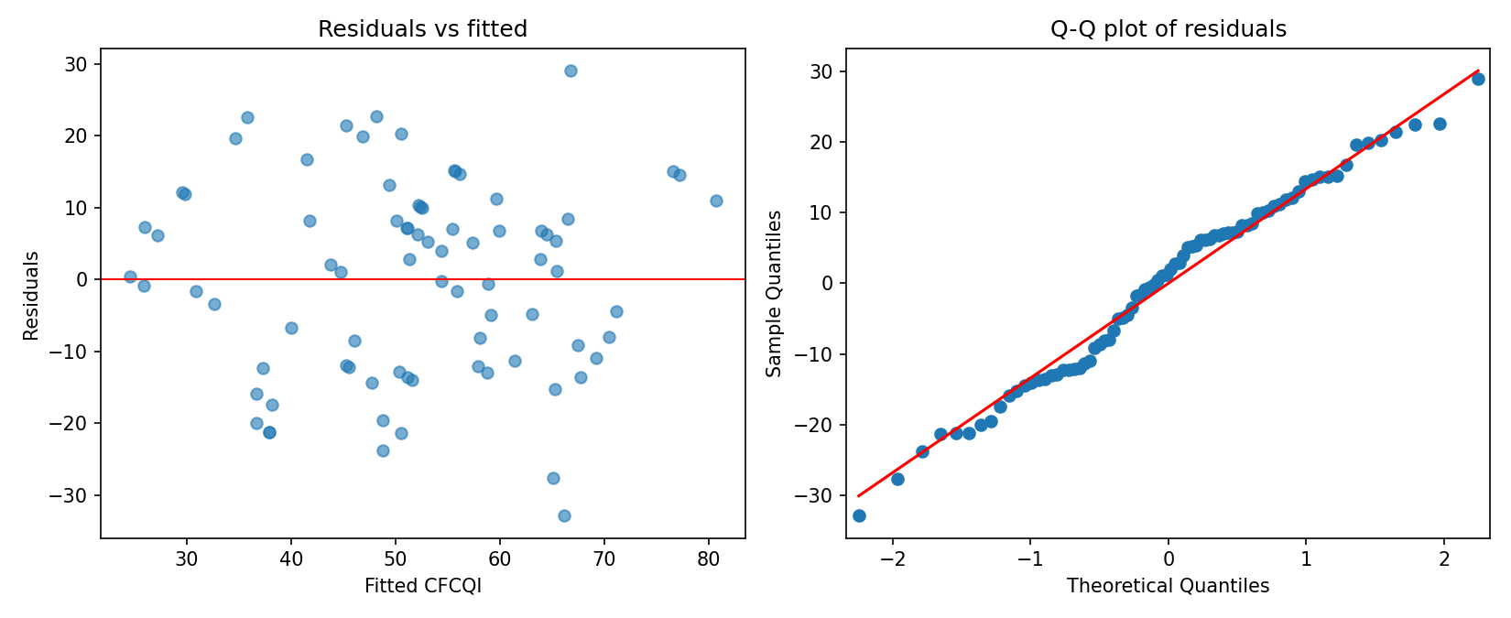
Figure D1. Regression residual and influence diagnostics.
Appendix E: Item-Level Paired Change
Item | Dimension | Latest | Prior | Δ | Improved | Unchanged | Declined
I1 | Current financial performance | 0.47 | 0.40 | +0.07 | 12.5% | 80.0% | 7.5%
I2 | Current financial position | 0.38 | 0.30 | +0.07 | 5.0% | 95.0% | 0.0%
I3 | Current cash flows | 0.55 | 0.47 | +0.07 | 12.5% | 80.0% | 7.5%
I4 | Anticipated financial performance | 1.40 | 1.48 | -0.07 | 2.5% | 87.5% | 10.0%
I5 | Anticipated financial position | 0.95 | 1.00 | -0.05 | 5.0% | 85.0% | 10.0%
I6 | Anticipated cash flows | 0.97 | 1.00 | -0.03 | 2.5% | 92.5% | 5.0%
I7 | Capital expenditure / allocation | 1.15 | 1.07 | +0.07 | 10.0% | 85.0% | 5.0%
I8 | Asset valuations & impairment | 1.45 | 1.55 | -0.10 | 0.0% | 92.5% | 7.5%
I9 | Provisions / contingencies | 0.53 | 0.57 | -0.05 | 0.0% | 95.0% | 5.0%
I10 | Carbon pricing / regulatory costs | 1.18 | 1.15 | +0.03 | 7.5% | 90.0% | 2.5%
I11 | Financial planning integration | 1.80 | 1.82 | -0.03 | 0.0% | 97.5% | 2.5%
I12 | Quantified scenario analysis | 1.60 | 1.60 | +0.00 | 7.5% | 85.0% | 7.5%
Appendix F: Technical Reproducibility Summary
Control | Final status
Verified annual reports | 80
Unique source hashes | 80/80
Firms / observations | 40 / 80
CFCQI item decisions | 960
Missing model variables | 0
Pooled blind-recode weighted κ | 0.631
Primary RQ2 model | Pooled OLS; firm-clustered robust SE
Primary RQ3 test | Wilcoxon signed-rank
Auditable layers | Source register; codebook; evidence files; locked CSV; Python scripts; Excel outputs

Appendix G: CFCQI Item-Score Distribution
This appendix reports the complete score distribution for all 12 Climate-related Financial Connectivity and Quantification Index (CFCQI) dimensions across the 80 firm-year observations. It complements the selected item-level results reported in Chapter 4 and allows the full disclosure profile to be inspected without expanding the main-text word count.
Item | Dimension | Mean | Score 0 (%) | Score 1 (%) | Score 2 (%)
I1 | Current financial performance | 0.44 | 68.8 | 18.8 | 12.5
I2 | Current financial position | 0.34 | 77.5 | 11.2 | 11.2
I3 | Current cash flows | 0.51 | 72.5 | 3.8 | 23.8
I4 | Anticipated future financial performance | 1.44 | 0.0 | 56.2 | 43.8
I5 | Anticipated future financial position | 0.97 | 27.5 | 47.5 | 25.0
I6 | Anticipated future cash flows | 0.99 | 28.7 | 43.8 | 27.5
I7 | Capital expenditure / allocation | 1.11 | 20.0 | 48.8 | 31.2
I8 | Asset valuations & impairment | 1.50 | 3.8 | 42.5 | 53.8
I9 | Provisions / contingencies & commitments | 0.55 | 57.5 | 30.0 | 12.5
I10 | Carbon pricing / regulatory costs | 1.16 | 22.5 | 38.8 | 38.8
I11 | Financial planning integration | 1.81 | 2.5 | 13.8 | 83.8
I12 | Quantified scenario analysis | 1.60 | 2.5 | 35.0 | 62.5

