**BIOL_EN 8180**

There are SEVEN questions. You must answer Questions 1-5 and select ONE from 6 and 7.

*Question 1 (100 points), Question 2 (200 points), Question 3 (150), Question 4 (150), Question 5 (300), and Question 5 or 6 (300).*

Include all R scripts in the relevant section in the R script “*Exam_support_script_v1.R*”

**Q1)** Create a map with the following information.

The csv file “*MO_weather_stations.csv*” contains locations of weather stations within the state of Missouri. Create a map of the State of Missouri showing the weather station locations. Your map should include (i) county boundaries, (ii) locations of the weather stations and (iii) proper title and subtitles.

---- Upload the map as a PDF file (*Missouri.pdf*) with your submission ----

**Q2)** Create user-defined functions for the following equations and plot curves corresponding to the functions within the limits given.

|  |  |
| --- | --- |
| Where, is the natural exponent. Consider the following range . | Equation 1 |

|  |  |
| --- | --- |
| Where, is the natural exponent. Consider the following range . | Equation 2 |

|  |  |
| --- | --- |
| Where, is the natural exponent. Consider the following range . | Equation 3 |

|  |  |
| --- | --- |
| Where, is the natural exponent. Consider the following range . | Equation 4 |

---- Combine all the plots into a single PDF file (*Q2-curves.pdf*), and upload the file with your submission ----

**Q3)**

Schematic diagram of a cannon is shown in Figure 1. When the cannon is fired, the chemical burn produces high pressure gasses that accelerate the projectile inside barrel to a high-speed discharge. This reaction would push the barrel in the opposite direction, which, if not dampened, could cause oscillations. In order minimize the oscillation, a spring-damper system called the recoil mechanism is introduced.

In this particular case, the recoil distance at given time is given by the following formula:

|  |  |
| --- | --- |
| Where, is the natural exponent, and are recoil velocity and the natural frequency of the recoil mechanism, respectively, and is the time. | Equation 5 |

If the recoil distance is 0.2 m when m/s, and rad/s, find the time .

1. Write the function in terms of time by substituting values for , and .

recoil_function <- function(t) {

v * exp(-omega * t) - x / t

}

1. Create the graphical representation of the function in terms of within the range of -1 and +5.
2. Find the time corresponding to the recoil distance of 0.2 m
   1. Time corresponding to the recoil distance of 0.2 m: 0.616568 seconds

(Tip: refer the Engineering Example I handout and the R script “*Engineering_problem_I.R*”)

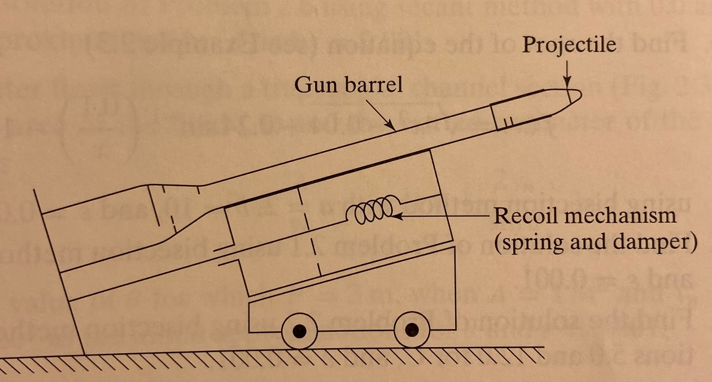

|  |  |
| --- | --- |
| Please review Equation 5 in Question 3. The function should be of the form f (t) = 0. Thus, if you rearrange equation 5, . Assuming time t≠0, this can be written as | Equation 5 |

Figure 1 cannon with a projectile (adapted from Rao, 2002)

---- include graphical representation of the function as a PDF (*Q3-cannon-curve.pdf*) with your submission ----

**Q4)**

Density of Water as a Function of Temperature is given in Table 1.

Table 1 Density of water v. temperature (Source: National Institute of Standards and Technology)

|  |  |
| --- | --- |
| **Water Density (kg/m^3)** | **Temperature (deg. C)** |
| 999.972 | 4 |
| 999.699 | 10 |
| 999.100 | 15 |
| 998.205 | 20 |
| 997.045 | 25 |
| 995.649 | 30 |
| 994.033 | 35 |
| 992.215 | 40 |

1. Create a dot plot and add a first-order polynomial fit (y ~ x) that can be used to predict density of water based on its temperature. Your plot must include axes and main titles.
2. Create a dot plot and add a second order polynomial fit ( y ~ (x + x2) ) that can be used to predict density of water based on its temperature. Your plot must include axes and main titles.
3. Which one of the fitted curved (A or B) would you recommend for predicting the density of water, and why?
   1. Plot B, with the second-order polynomial fit, aligns more closely with the plot points and exhibits better visual alignment with the data, that is a strong indication of a good fit

**Q5)**

The US Geological Survey has an extensive network of river flow monitoring locations in the US. The instruments installed in many locations measure depth of water at a river location and uses a rating curve to estimate the flow rate. The relationship between the amount of water flowing at a location and the corresponding depth of water is known as depth-discharge relationship or rating curve. Data to develop such a rating curve for the Hinkson Creek in Columbia, Missouri are provided in the CSV file “*gage_height_and_discharge_relationship.csv*”.

The gage height is in feet and the discharge is in cubic feet per second (ft3/s).

1. Use the data to create a **first order** polynomial to predict flow rate based on gage height.
2. Use the data to create a **second order** polynomial to predict flow rate based on gage height.
3. Use the data to create a **third order** polynomial to predict flow rate based on gage height.
4. Predict the discharge rate at gage heights 4.5 ft, 5.5 ft and 6.5 ft using the functions developed in (A), (B) and (C).

**Gage_Height Model_1 Model_2 Model_3**

**1 4.5 -0.9845431 14.11705 14.47132**

**2 5.5 171.8376412 125.30008 125.30008**

**3 6.5 344.6598255 359.76142 359.40714**

1. Which rating curve would you recommend to US Geological Survey, and why? Please include a table comparing the observation and predicted values.

**Gage_Height Observation Model_1 Model_2 Model_3**

**1 4.5 15.63 -0.9845431 14.11705 14.47132**

**2 5.5 124.09 171.8376412 125.30008 125.30008**

**3 6.5 360.49 344.6598255 359.76142 359.40714**

**The second order and third order appear to give an equal effectiveness in predicting the data trend. Both appear to be a good fit and the predicted values are equally as close to the observed values**

**Q6)**

Figure 2 shows three carts, interconnected by springs, subjected to horizontal loads , and . The displacement , and (in meters) are governed by the following equilibrium equations:

Figure 2 Carts connected by springs (adapted from Rao, 2002)

|  |  |
| --- | --- |
| Where are spring constants (N/m). | Equation 6 |

The following data for and, , and are given in Figure 2.

Table 2 Spring constants and loads

|  |  |  |  |  |
| --- | --- | --- | --- | --- |
| Spring constants |  |  |  |  |
|  |  |  |  |
| Load |  |  |  |  |

1. Rewrite the equations (Equation 6) in the form
2. Substitute the values for the “spring constants” and “load” and create THREE system of linear equations.
3. Find the displacements by solving the system of linear equations.

(Hint: review “*Systems_of_Equations_II_scaffolding_problem.R*” and “*Systems_of_Equations_III_crane-truss.R*” scripts)

---- include graphical representation of the 3-D plot with your submission ----

**Q7)**

Average annual atmospheric Carbon Dioxide (CO2) concentrations measured at the Mona Loa Observatory in Hawaii are provided in the CSV file “*mona_loa_CO2_measurements.csv*” for the period 1963-2022. The CO2 concentration values are expressed as a mole fraction in dry air, micro mol/mol, abbreviated as *ppm*.

Additional information about the data can be found at the National Oceanic and Atmospheric Administration (NOAA) Global Monitoring Laboratory (<https://gml.noaa.gov/ccgg/>).

Figure 3 Mona Loa Observatory, Hawaii

Use the data CO2 concentration data to answer the following questions.

**<<< Show all your work by updating the R script provided >>>>**

1. Create a **line plot** using the *ggplot* package to show the annual concentration of CO2 for the period 1963-2022. You plot must include proper axes and main plot titles.
2. Fit a linear model to using the data for the period 1963-1982
3. Fit a linear model to using the data for the period 1983-2002
4. Fit a linear model to using the data for the period 2003-2022
5. Fit a linear model to using the data for the period 1963-2022
6. Fill out the following table.

Table 3 Annual Average CO2 concentrations and growth rates

|  |  |  |
| --- | --- | --- |
| Period | Mean concentration (ppm) | Slope of the linear trend |
| 1963-1982 | 328.9405 | 1.197977 |
| 1983-2002 | 357.8245 | 1.549030 |
| 2003-2022 | 396.3250 | 2.270541 |
| 1963-2022 | 361.0400 | 1.683271 |

1. Describe the rate of change during the three 20-year periods and the entire 60-year period. Are the rates of change different from year to year? Which 20-year period shows the heighted rate of change? In your opinion, what is the reason for this?
   1. 1963-1982: The mean concentration increased at an average rate of approximately 1.20 ppm per year during this period.
   2. 1983-2002: The mean concentration increased at an average rate of approximately 1.55 ppm per year during this period.
   3. 2003-2022: The mean concentration increased at an average rate of approximately 2.27 ppm per year during this period.
   4. 1963-2022: The mean concentration increased at an average rate of approximately 1.68 ppm per year over the entire 60-year period.
   5. The rates of change vary across these periods, with the highest rate observed in the most recent 20-year period (2003-2022). This could be due to several factors, including increased industrialization, deforestation, and human activities contributing to higher CO2 emissions during this period. The increased awareness of climate change during the 21st century may have led to efforts to monitor and reduce carbon emissions, but the impact on CO2 levels is still evident.