Ecology of Freshwater Fish

Mr. Mom: Nocomis embryo-burying effectively increases embryo survival amidst predation by all mutualism participants
Madison M. Betts¹, David C. Haak², Eric M. Hallerman¹, Eugene G. Maurakis³, Emmanuel A. Frimpong^{1*}
APPENDIX S3
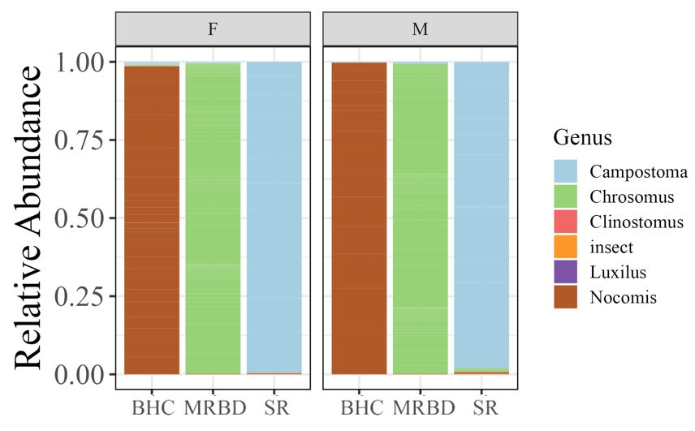
Figure S1. Relative abundance of other-DNA to self-DNA found within the guts of female (F) and male (M) bluehead chub (BHC), mountain redbelly dace (MRBD), and stoneroller (SR) from gut samples collected from Toms Creek near Blacksburg, VA, in summer 2022. Genera should be interpreted as: Nocomis – bluehead chub (Nocomis leptocephalus), Campostoma – central stoneroller (Campostoma anomalum) embryo, Chrosomus – mountain redbelly dace (Chrosomus oreas) embryo, and Clinostomus – rosyside dace (Clinostomus funduloides) embryo. Luxilus may include crescent shiner (Luxilus cerasinus) and/or white shiner (Luxilus albeolus) as both are present in this system and frequently spawn with chubs.

