1. State your main research question
   * Can I predict the ratio of average cost of food to income for different regions in California based on socio-economic and demographic features?
2. Brief summary of where your data came from
   * This data is from the California Department of Public Health, but I downloaded it from the data.gov website. On their website, data.gov indicates that this data is “intended for public access and use” and was last updated March 30th, 2024.
3. Explanation/description (in words) of all the variables in your data
   * My target variable is affordability_ratio (float)
     1. This is a ratio of food cost to income for female-headed families with children under 18
   * Other features:
     1. Ind_id: Indicator ID
     2. Ind_definition: definition of indicator (description)
     3. Reportyear: years that the indicator was reported
     4. Race_eth_code: the numeric code for a race/ethnic group
     5. Race_eth_name: name of above group
     6. Geotype: type of geographic unit
     7. Geotypevalue & geoname: geographic unit info
     8. County_name: name of county that the geotype is in
     9. County_fips: probably won’t use
     10. Region_name: region name
     11. Region_code
     12. Cost_yr: annual food costs
     13. Median_income
     14. LL_95CI & UL_95CI: upper and lower limit confidence intervals
     15. Se_food_afford & rse_food_afford: standard error of percent
     16. CA_decile: California decile
     17. CA_RR: rate ratio to California rate
     18. Ave_fam_size: average family size for a female-headed household with children under 18, specific to a geography
     19. Version: timestamp of version data
4. Summary statistics for all variables

1. Two or three interesting graphs that start to address your main question of interest

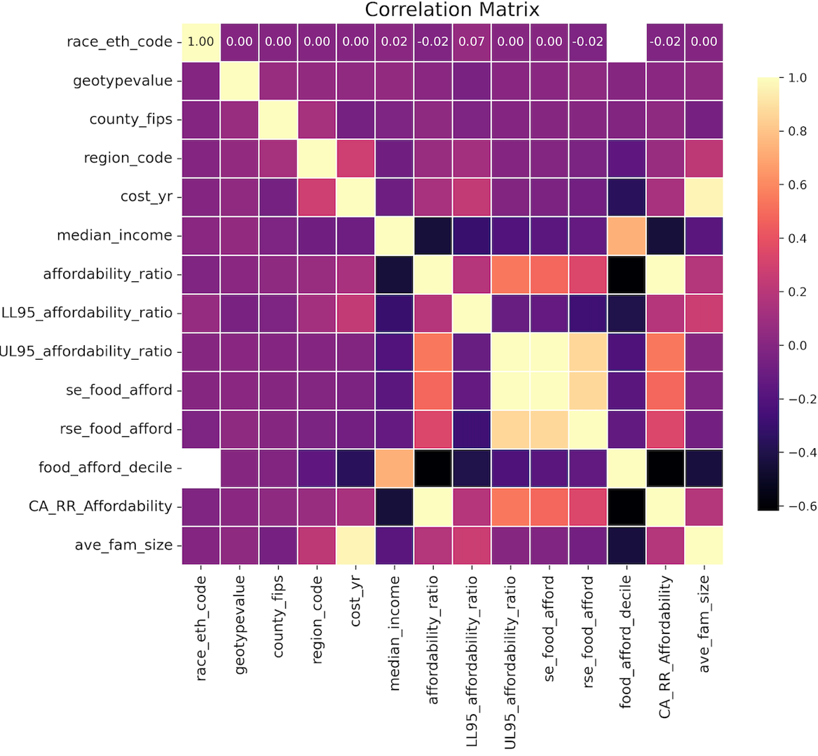

* very interesting that the affordability ratio and annual income ethnic groups are almost exactly opposite, which makes me wonder if White, Asian, NHOPI etc. may be buying more expensive groceries than necessary?

1. Answer these questions:
   * Were there any challenges or obstacles in finding the right dataset for your project?
     1. No, data.gov was a really good source to use
   * Are there any other problems, concerns, or challenges that you are facing regarding your project?
     1. No challenges yet