Homework5_Markdown

Madison Russell

2022-11-29

library(readr)  
library(tidyverse)

## ── Attaching packages ─────────────────────────────────────── tidyverse 1.3.2 ──  
## ✔ ggplot2 3.3.6 ✔ dplyr 1.0.9  
## ✔ tibble 3.1.8 ✔ stringr 1.4.1  
## ✔ tidyr 1.2.1 ✔ forcats 0.5.2  
## ✔ purrr 0.3.4   
## ── Conflicts ────────────────────────────────────────── tidyverse_conflicts() ──  
## ✖ dplyr::filter() masks stats::filter()  
## ✖ dplyr::lag() masks stats::lag()

homicides <- read.csv(url("https://raw.githubusercontent.com/washingtonpost/data-homicides/master/homicide-data.csv"))

Choice 1: Pick one city in the data. Create a map showing the locations of the homicides in that city, using the sf framework discussed in class. Use tigris to download boundaries for some sub-city geography (e.g., tracts, block groups, county subdivisions) to show as a layer underneath the points showing homicides. Use different facets for solved versus unsolved homicides and different colors to show the three race groups with the highest number of homicides for that city (you may find the fct_lump function from forcats useful for this).

library(dplyr)  
library(tidyverse)  
library(sf)

## Linking to GEOS 3.10.2, GDAL 3.4.2, PROJ 8.2.1; sf_use_s2() is TRUE

library(tigris)

## To enable caching of data, set `options(tigris_use_cache = TRUE)`  
## in your R script or .Rprofile.

library(ggplot2)  
library(purrr)  
library(scales)

##   
## Attaching package: 'scales'

## The following object is masked from 'package:purrr':  
##   
## discard

## The following object is masked from 'package:readr':  
##   
## col_factor

library(ggthemes)  
library(broom)  
library(forcats)

library(geofacet)  
library(tidyr)  
library(dplyr)  
homicides2 <- unite(homicides, city_name,  
sep = ", ", remove = FALSE, c(city, state))  
  
milwaukee_tracts <- tracts("WI", "Milwaukee", cb = TRUE, class = "sf") %>% st_as_sf(milwaukee_tracts, coords = c("lon", "lat")) %>%   
 st_set_crs(4269)

## Retrieving data for the year 2020

## | | | 0% | |= | 1% | |= | 2% | |== | 2% | |== | 3% | |== | 4% | |=== | 4% | |=== | 5% | |==== | 5% | |==== | 6% | |===== | 7% | |====== | 8% | |====== | 9% | |======= | 10% | |======== | 11% | |========= | 12% | |========= | 13% | |========== | 14% | |============= | 18% | |============== | 20% | |=============== | 21% | |================ | 23% | |================= | 24% | |================= | 25% | |================== | 25% | |================== | 26% | |=================== | 27% | |=================== | 28% | |==================== | 29% | |====================== | 31% | |============================= | 42% | |=============================== | 44% | |=================================== | 50% | |==================================== | 52% | |===================================== | 53% | |======================================== | 57% | |============================================= | 64% | |======================================================================| 100%

class(milwaukee_tracts)

## [1] "sf" "data.frame"

class(milwaukee_tracts$geometry)

## [1] "sfc_MULTIPOLYGON" "sfc"

library(ggplot2)  
ggplot() +   
 geom_sf(data = milwaukee_tracts)

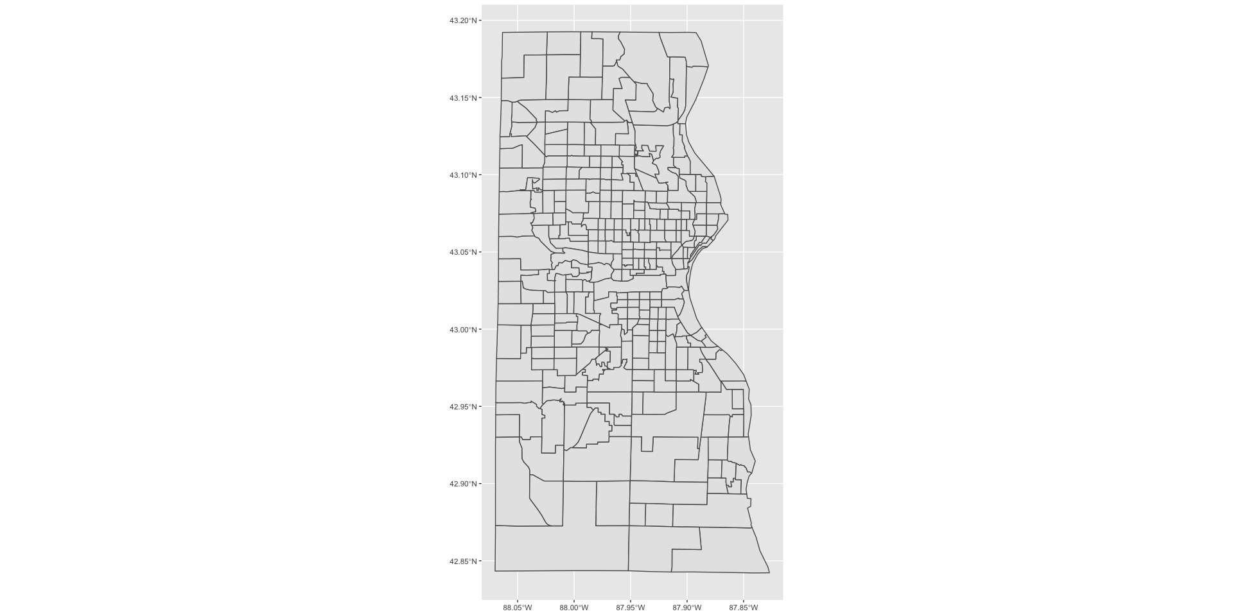

milwaukee_homicides <- homicides2 %>%   
 filter(city == "Milwaukee") %>%   
 select(victim_race, uid, city, disposition, lat, lon) %>% dplyr::mutate(victim_race = forcats::fct_lump(victim_race, n = 3)) %>%   
mutate(unsolved_homicides = as.numeric(disposition != "Closed by arrest"))  
  
library(ggplot2)  
ggplot() +   
 geom_point(data = milwaukee_homicides, aes(x = lon, y = lat))

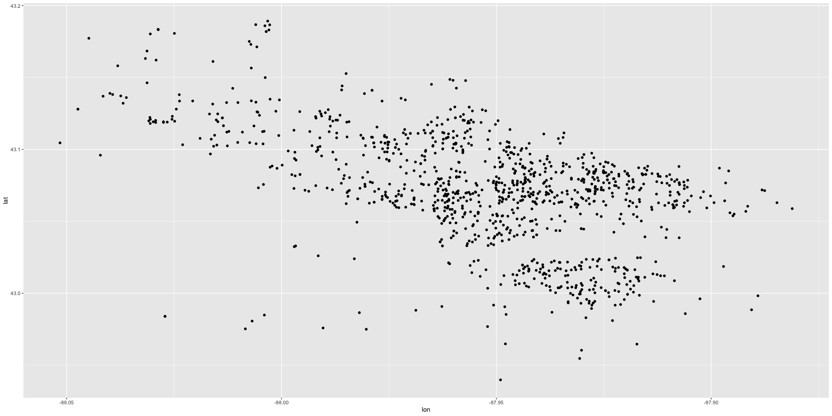

plottybaby2 <- ggplot() +   
 geom_sf(data = milwaukee_tracts, color = "black") +   
 geom_point(data = milwaukee_homicides, aes(x = lon, y = lat, col = victim_race), size =.36) + labs(x = "Longitude", y = "Latitude", title = "Homicides in Milwaukee, WI", col = "Victim Race") + theme_few()   
  
plottybaby2

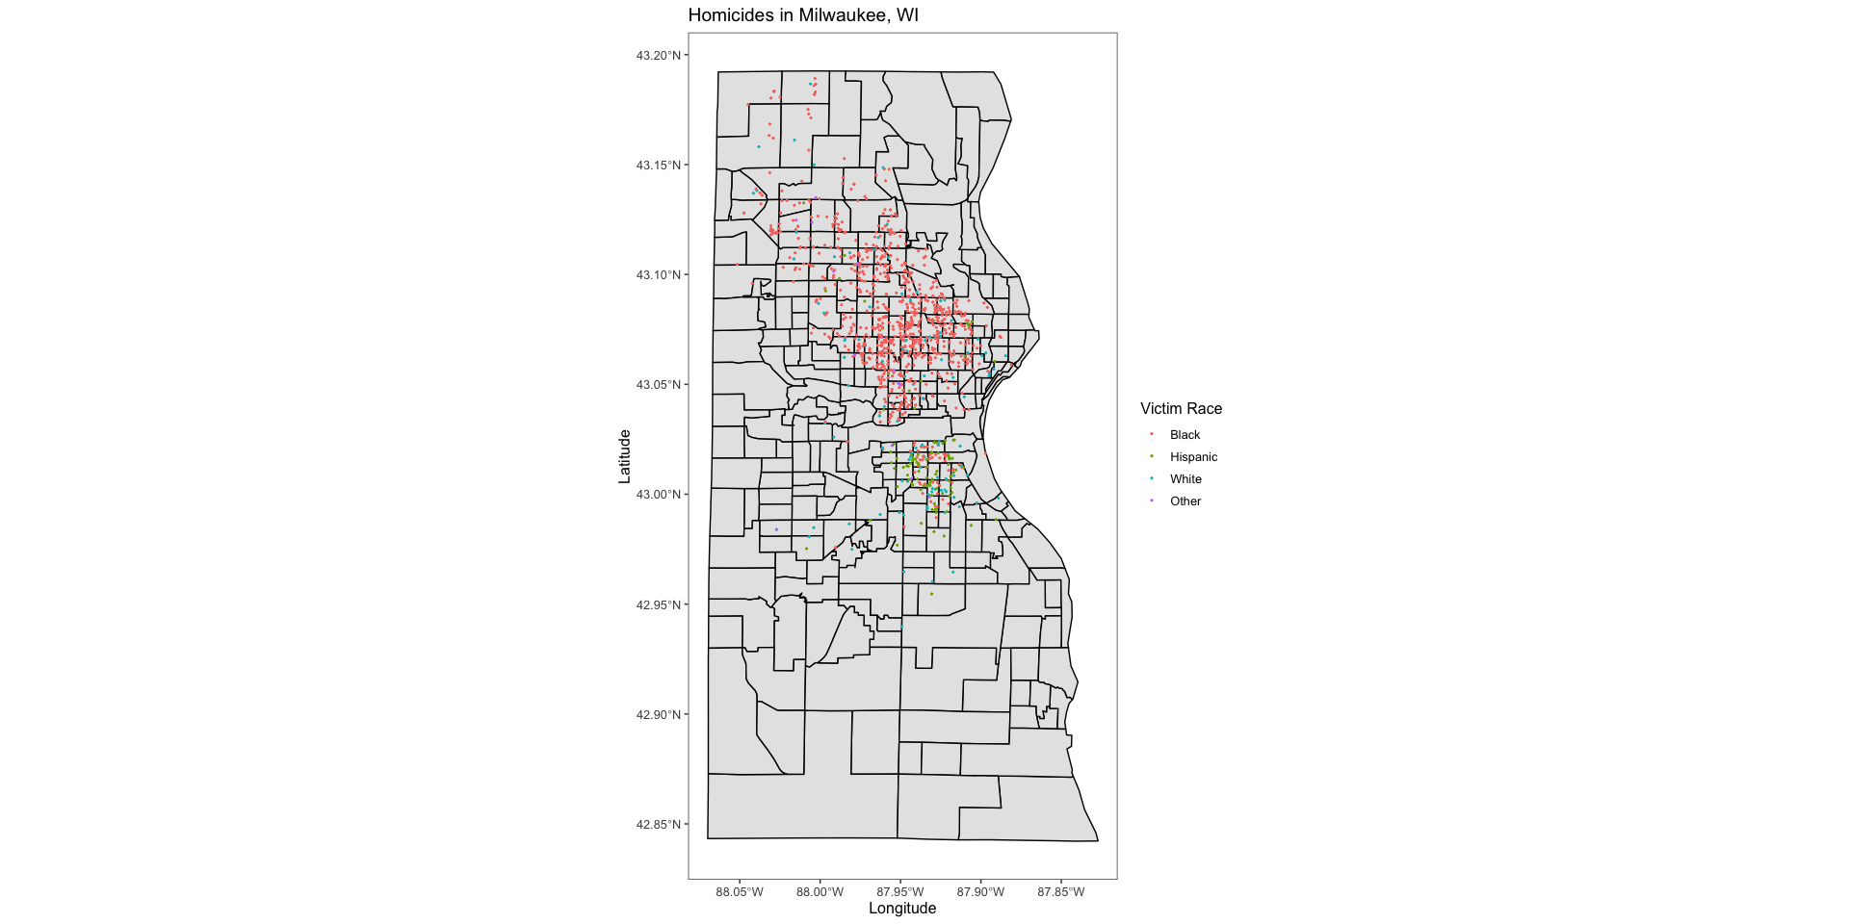

milwaukee_labels <- as_labeller(c('0' = "Solved",  
 '1' = "Unsolved"))  
  
plottybaby2 + facet_wrap(~unsolved_homicides, ncol = 1, labeller = milwaukee_labels)

