## Module 4 Missing Data Assignment

### Madison West

Load in libraries and read in data.

library(tidyverse)

##

## v ggplot2 3.2.1 v purrr 0.3.3  
## v tibble 2.1.3 v dplyr 0.8.3  
## v tidyr 1.0.0 v stringr 1.4.0  
## v readr 1.3.1 v forcats 0.4.0

##   
## x dplyr::filter() masks stats::filter()  
## x dplyr::lag() masks stats::lag()

library(VIM)

## Warning: package 'VIM' was built under R version 3.6.2

## Loading required package: colorspace

## Loading required package: grid

## Loading required package: data.table

##   
## Attaching package: 'data.table'

## The following objects are masked from 'package:dplyr':  
##   
## between, first, last

## The following object is masked from 'package:purrr':  
##   
## transpose

## VIM is ready to use.   
## Since version 4.0.0 the GUI is in its own package VIMGUI.  
##   
## Please use the package to use the new (and old) GUI.

## Suggestions and bug-reports can be submitted at: https://github.com/alexkowa/VIM/issues

##   
## Attaching package: 'VIM'

## The following object is masked from 'package:datasets':  
##   
## sleep

library(mice)

## Warning: package 'mice' was built under R version 3.6.2

## Loading required package: lattice

## Registered S3 methods overwritten by 'lme4':  
## method from  
## cooks.distance.influence.merMod car   
## influence.merMod car   
## dfbeta.influence.merMod car   
## dfbetas.influence.merMod car

##   
## Attaching package: 'mice'

## The following object is masked from 'package:tidyr':  
##   
## complete

## The following objects are masked from 'package:base':  
##   
## cbind, rbind

grades <- read_csv("class-grades.csv")

## Parsed with column specification:  
## cols(  
## Prefix = col_double(),  
## Assignment = col_double(),  
## Tutorial = col_double(),  
## Midterm = col_double(),  
## TakeHome = col_double(),  
## Final = col_double()  
## )

Task 1: How much data is missing and in what variables?

str(grades)

## Classes 'spec_tbl_df', 'tbl_df', 'tbl' and 'data.frame': 99 obs. of 6 variables:  
## $ Prefix : num 5 8 8 7 8 7 8 7 8 7 ...  
## $ Assignment: num 57.1 95 83.7 81.2 91.3 ...  
## $ Tutorial : num 34.1 105.5 83.2 96.1 93.6 ...  
## $ Midterm : num 64.4 67.5 30 49.4 95 ...  
## $ TakeHome : num 51.5 99.1 63.1 105.9 107.4 ...  
## $ Final : num 52.5 68.3 48.9 80.6 73.9 ...  
## - attr(*, "spec")=  
## .. cols(  
## .. Prefix = col_double(),  
## .. Assignment = col_double(),  
## .. Tutorial = col_double(),  
## .. Midterm = col_double(),  
## .. TakeHome = col_double(),  
## .. Final = col_double()  
## .. )

summary(grades)

## Prefix Assignment Tutorial Midterm   
## Min. :4.000 Min. : 28.14 Min. : 34.09 Min. : 28.12   
## 1st Qu.:7.000 1st Qu.: 80.88 1st Qu.: 83.93 1st Qu.: 52.50   
## Median :8.000 Median : 89.94 Median : 93.37 Median : 69.38   
## Mean :7.313 Mean : 85.49 Mean : 89.79 Mean : 67.70   
## 3rd Qu.:8.000 3rd Qu.: 95.00 3rd Qu.:100.56 3rd Qu.: 81.56   
## Max. :8.000 Max. :100.83 Max. :112.58 Max. :110.00   
## NA's :1 NA's :3   
## TakeHome Final   
## Min. : 16.91 Min. : 28.06   
## 1st Qu.: 69.91 1st Qu.: 52.91   
## Median : 88.42 Median : 66.11   
## Mean : 81.12 Mean : 68.23   
## 3rd Qu.: 99.07 3rd Qu.: 83.61   
## Max. :108.89 Max. :108.89   
## NA's :3 NA's :4

**We have missing data in variables Tutorial, Midterm, TakeHome, and Final. We have 11 total values that are missing, 1 of which is from Tutorial, 3 in Midterm, 3 in TakeHome, and 4 in Final.**

Task 2: Use the VIM package to visualize missingness. Does there appear to be systematic missingness? In other words, are there students that are mising multiple pieces of data?

vim_plot = aggr(grades, numbers = TRUE, prop = c(TRUE, FALSE),cex.axis=.7)

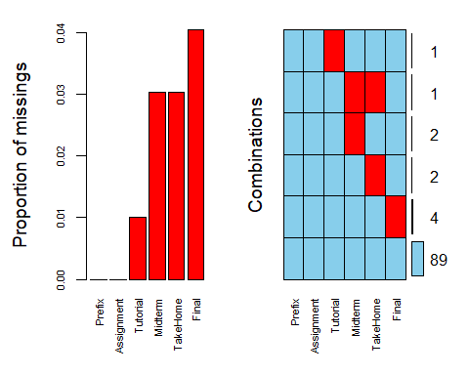

**It appears that there is one student that is missing multiple pieces of data, with the remaining missing data coming from different students.**

Task 3: Use row-wise deletion of missing values to create a new data frame. How many rows remain in this data frame?

gradesrow = grades %>% drop_na()

**There are 89 records remaining in grades after deleting rows with missing data. This makes since based on our previous observations, since 10 records were deleting, one of which had 2 entries missing, accounting for all 11 missing values.**

Task 4: Use column-wise deletion of missing values to create a new data frame (from the original data frame not from the data frame created in Task 3). How many columns remain in this data frame?

gradescol = grades %>% select(-Tutorial, -Midterm, -TakeHome, -Final)

**After dropping the columns with missing data, we have 2 columns remaining.**

Task 5: Which approach (Task 3 or Task 4) seems preferable for this dataset? Briefly discuss your answer.

**The task that seems preferable for this dataset is row-wise deletion. Since there are only 10 records of our 99 total that are missing data, we essentially only lose 10 rows*6 columns of missing data, versus losing 4 columns*99 rows in column-wise deletion. We want to retain the most useful data in order to predict data, and row-wise does that here.**

Task 6 Use the code below to impute the missing values in the dataset using the mice package.

grades_imp = mice(grades, m=1, method = "pmm", seed = 12345)

##   
## iter imp variable  
## 1 1 Tutorial Midterm TakeHome Final  
## 2 1 Tutorial Midterm TakeHome Final  
## 3 1 Tutorial Midterm TakeHome Final  
## 4 1 Tutorial Midterm TakeHome Final  
## 5 1 Tutorial Midterm TakeHome Final

#in line above: m=1 -> runs one imputation, seed sets the random number seed to get repeatable results   
summary(grades_imp)

## Class: mids  
## Number of multiple imputations: 1   
## Imputation methods:  
## Prefix Assignment Tutorial Midterm TakeHome Final   
## "" "" "pmm" "pmm" "pmm" "pmm"   
## PredictorMatrix:  
## Prefix Assignment Tutorial Midterm TakeHome Final  
## Prefix 0 1 1 1 1 1  
## Assignment 1 0 1 1 1 1  
## Tutorial 1 1 0 1 1 1  
## Midterm 1 1 1 0 1 1  
## TakeHome 1 1 1 1 0 1  
## Final 1 1 1 1 1 0

densityplot(grades_imp)

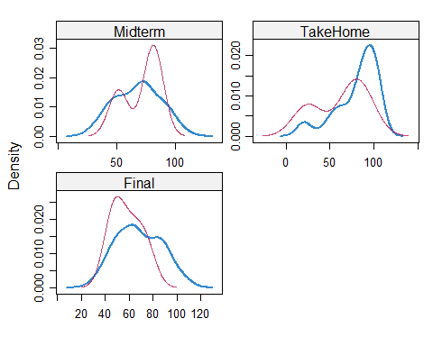

#red imputed, blue original, only shows density plots when more than 1 value the variable was imputed  
#note that the density plots are fairly uninteresting given the small amount of missing data  
grades_complete = complete(grades_imp)  
summary(grades_complete)

## Prefix Assignment Tutorial Midterm   
## Min. :4.000 Min. : 28.14 Min. : 34.09 Min. : 28.12   
## 1st Qu.:7.000 1st Qu.: 80.88 1st Qu.: 84.69 1st Qu.: 52.50   
## Median :8.000 Median : 89.94 Median : 93.10 Median : 69.38   
## Mean :7.313 Mean : 85.49 Mean : 89.76 Mean : 67.80   
## 3rd Qu.:8.000 3rd Qu.: 95.00 3rd Qu.:100.55 3rd Qu.: 81.88   
## Max. :8.000 Max. :100.83 Max. :112.58 Max. :110.00   
## TakeHome Final   
## Min. : 16.91 Min. : 28.06   
## 1st Qu.: 67.96 1st Qu.: 52.09   
## Median : 87.96 Median : 65.56   
## Mean : 80.54 Mean : 67.81   
## 3rd Qu.: 98.42 3rd Qu.: 83.19   
## Max. :108.89 Max. :108.89

Task 7: Briefly discuss potential issues that could be encountered when working with missing data. Describe situations where imputation may not be advisable.

**Potential isses that could be encountered include deleting useful data in rows/columns that had some missing data, as well as imputing inaccurate data when using imputation as a technique to deal with missing data. Some situations where imputation may not be advisable include working with highly variable data, or data with frequent outliers. Additionally, if missing data was orginially meant to mean 0, imputing could greatly skew results. Ensuring that the context of the data is understand is crucial before deciding how to handle missing data.**