Initial windows:

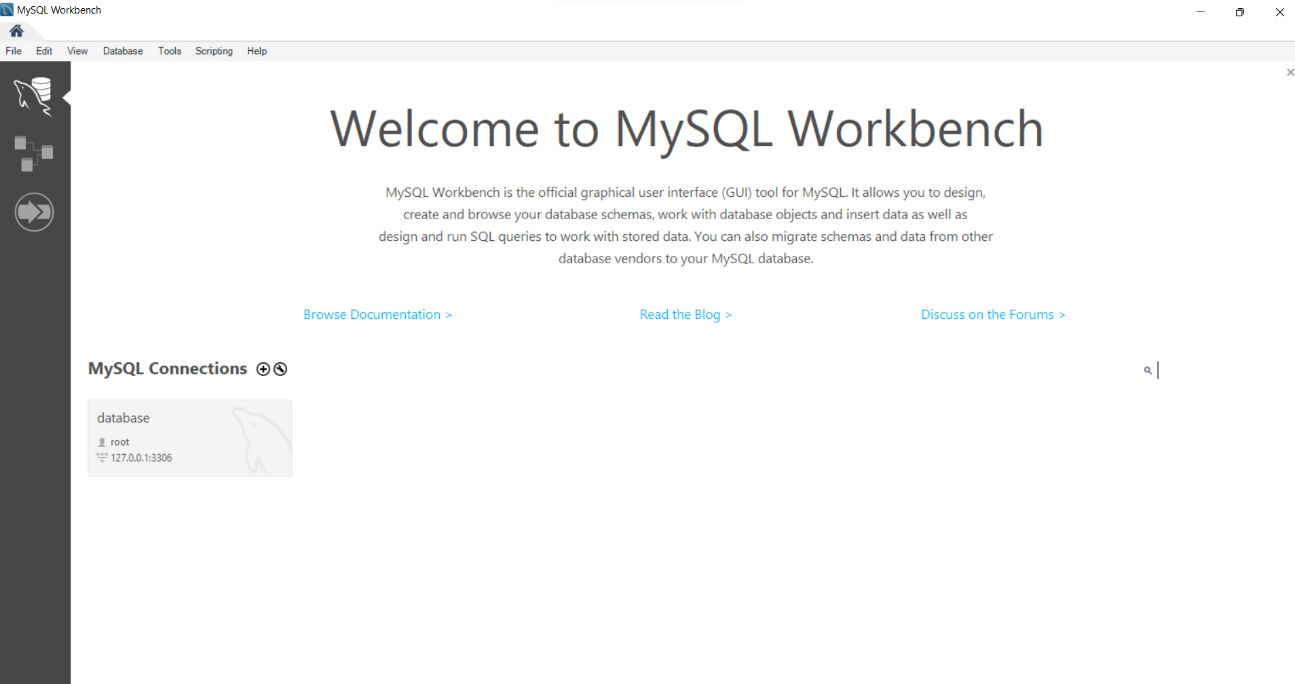

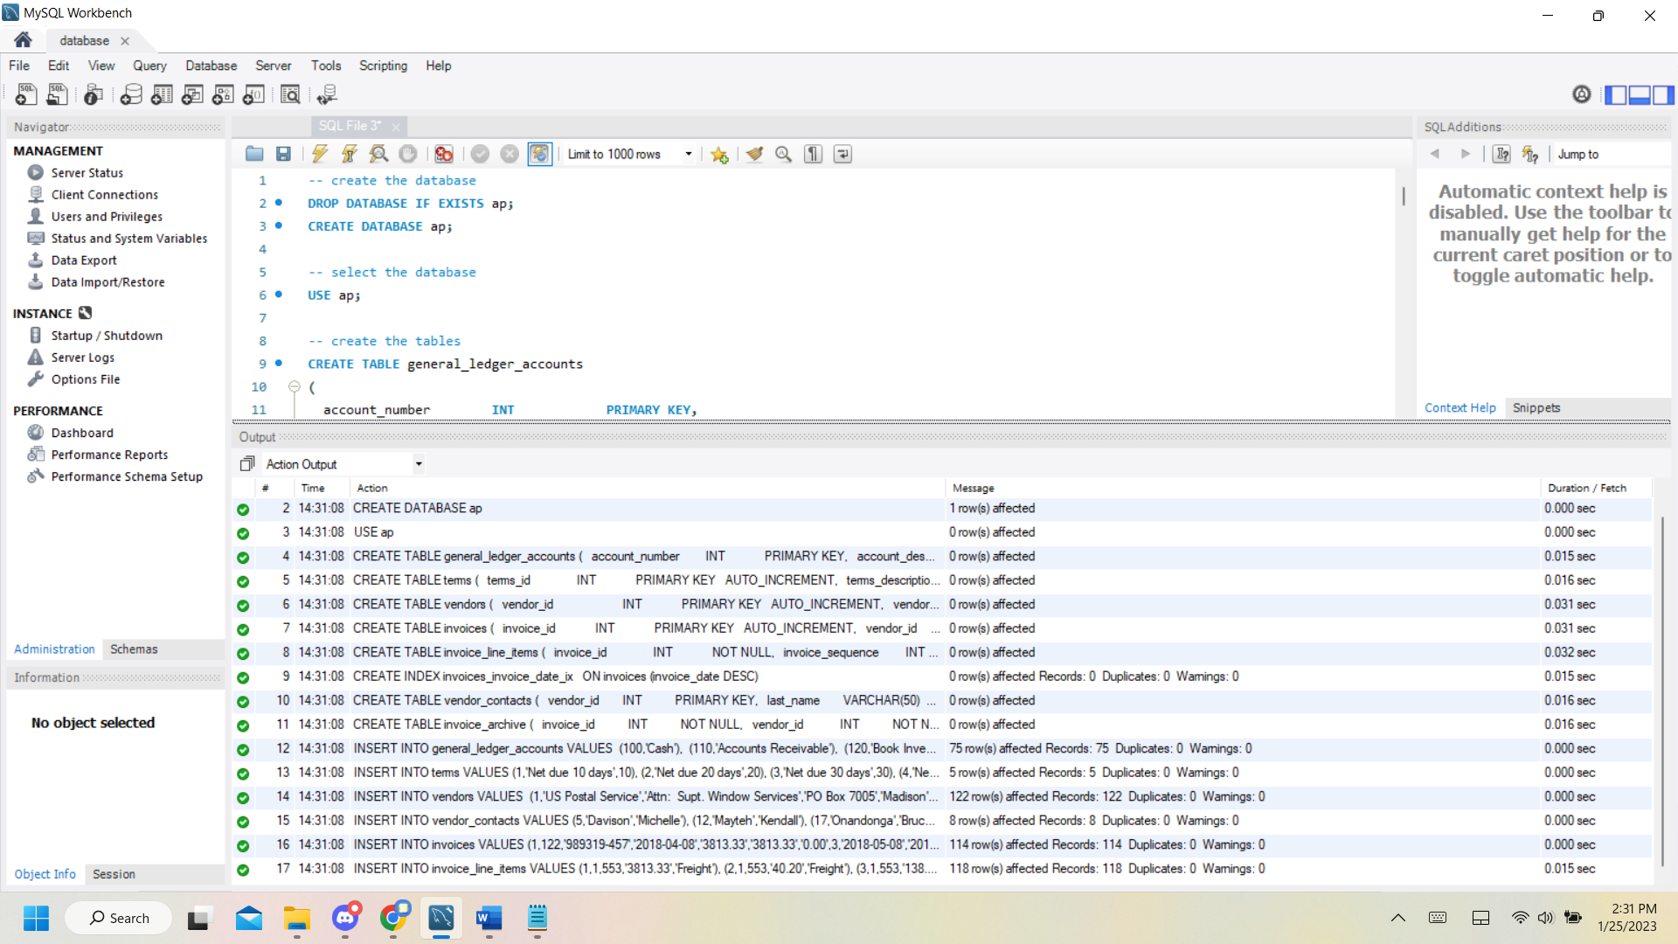

-query SELECT NOW()

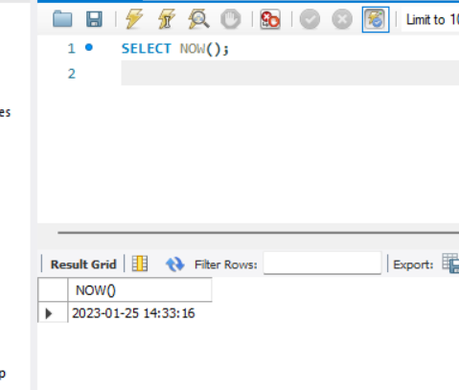

Query SHOW DATABASES

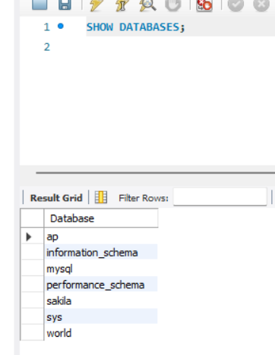

Query USE ap

Query SELECT * FROM vendors

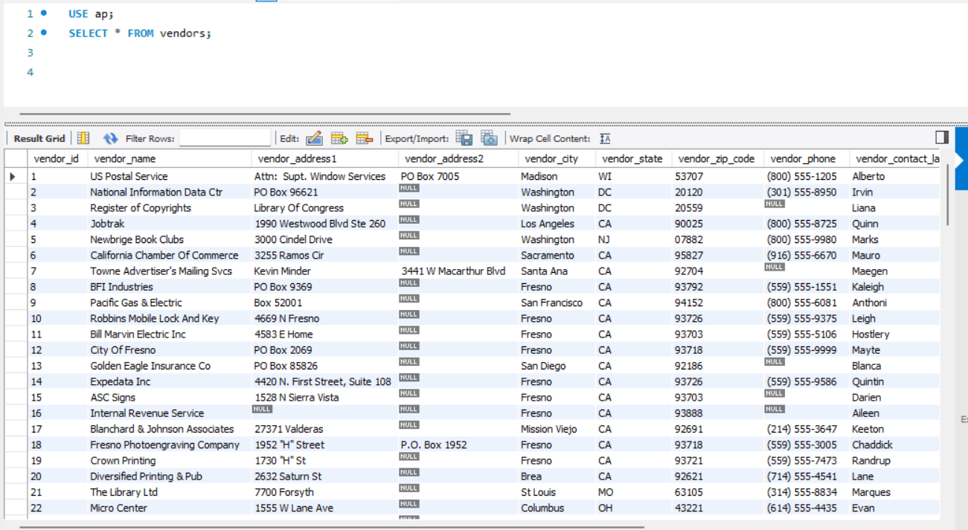

Query USE ap

Query SELECT * FROM invoices

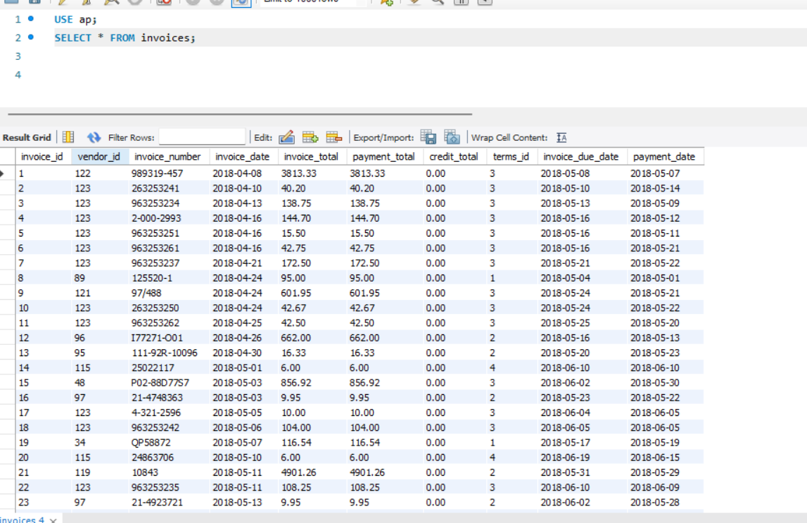

Query

SELECT vendor_name, invoice_id, payment_total

FROM invoices, vendors

WHERE vendors.vendor_id = invoices.vendor_id

ORDER BY vendor_name;

:

