Initial window

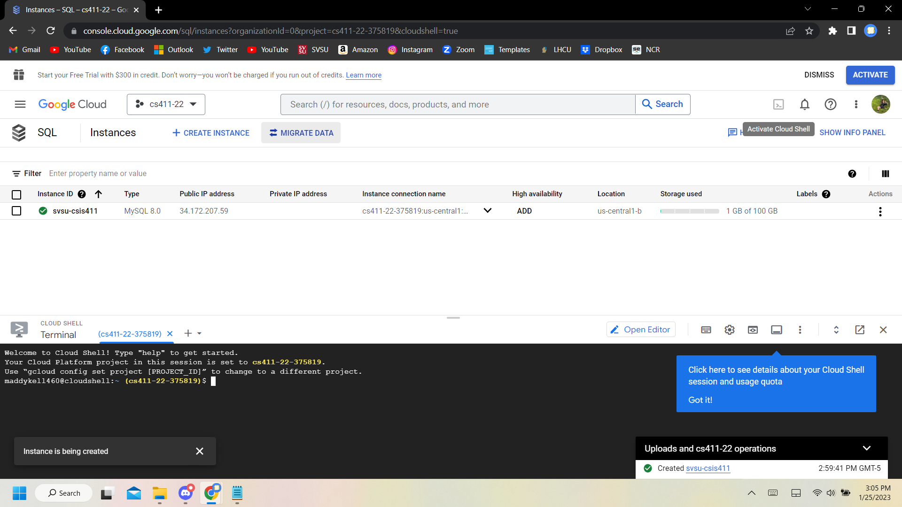

Select now

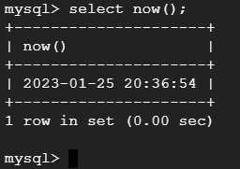

Show databases

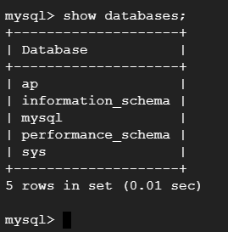

Use ap

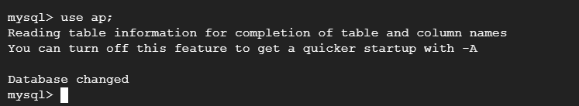

Select * from vendors

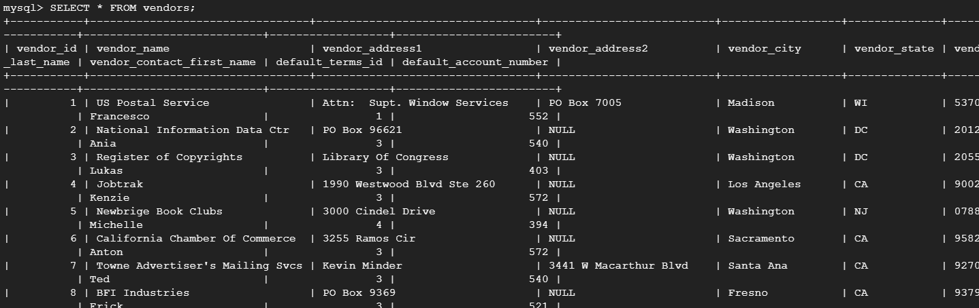

Select * from invoices

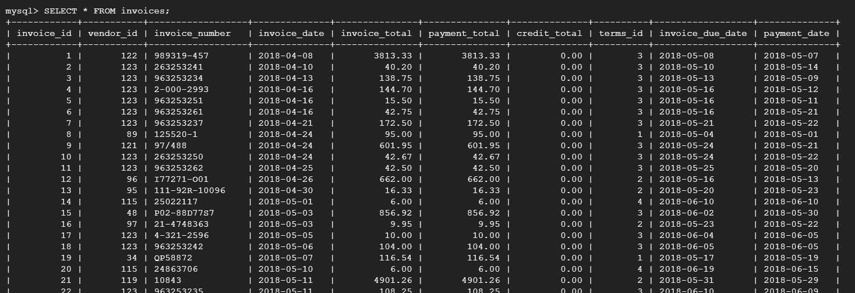

SELECT vendor_name, invoice_id, payment_total

FROM invoices, vendors

WHERE vendors.vendor_id = invoices.vendor_id

ORDER BY vendor_name;

