**CS411, Winter 2023, Homework 3– ch4, 5, 6, and 7.**

1. **(5) Write a SELECT statement that returns these four columns where the balance due is less than 200 and greater than 0.**

**vendor_name The vendor_name column from the Vendors table**

**invoice_number The invoice_number column from the Invoices table**

**invoice_date The invoice_date column from the Invoices table**

**balance_due The invoice_total column minus the payment_total and credit_total columns from the Invoices table**

**Sort the result by balance_due.**

USE ap;

SELECT vendor_name, invoice_number, invoice_date, invoice_total-payment_total - credit_total

AS balance_due

FROM vendors INNER JOIN invoices

ON vendors.vendor_id = invoices.vendor_id

WHERE invoice_total - payment_total - credit_total < 200

AND invoice_total - payment_total - credit_total > 0

ORDER BY invoice_total - payment_total - credit_total

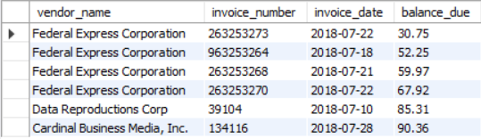



1. **(5) Write a SELECT statement that returns three columns:**

**vendor_id The vendor_id column from the Vendors table**

**vendor_name The vendor_name column from the Vendors table**

**contact_name A concatenation of the vendor_contact_first_name and vendor_contact_last_name columns with a space between**

**Return one row for each vendor whose contact has the same last name as another vendor’s contact. Sort the result set by vendor_contact_last_name.**

USE ap;

SELECT v1.vendor_id, v2.vendor_name,

CONCAT(v1.vendor_contact_first_name, "",v1.vendor_contact_last_name) AS contact_name

FROM vendors AS v1 JOIN vendors AS v2

ON v1.vendor_id != v2.vendor_id

AND v1.vendor_contact_first_name = v2.vendor_contact_first_name

ORDER BY v1.vendor_contact_first_name

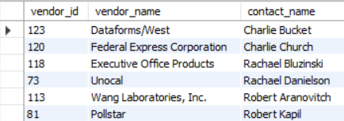



1. **(5) Show the vendor name, line_item_description, and account number for each line item. Show vendors which use just one account number.**

USE ap;

SELECT distinct v.vendor_name, k.line_item_description, k.account_number

FROM vendors v

JOIN invoices i ON v.vendor_id = i.vendor_id

JOIN invoice_line_items k ON k.invoice_id = i.invoice_id

WHERE vendor_name IN (

SELECT v.vendor_name

FROM vendors v

JOIN invoices i ON v.vendor_id = i.vendor_id

JOIN invoice_line_items k ON k.invoice_id = i.invoice_id

GROUP BY vendor_name

HAVING COUNT(DISTINCT k.account_number) = 1)

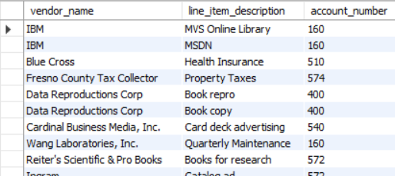



1. **(5) Show two columns from the Vendors table: vendor_name and vendor_phone. If the vendor has a phone number, the vendor_phone value should be its phone number. Otherwise, the vendor_phone value should be “No Phone.” Just show the vendors whose initial starts with ‘A’ through ‘K’ and sort the result set by vendor_name.**

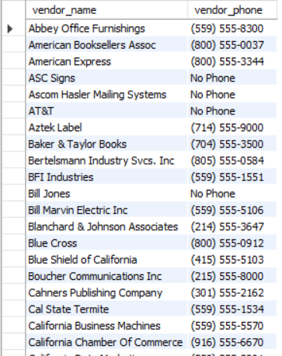

USE ap;

SELECT vendor_name, vendor_phone

FROM vendors

WHERE vendor_phone is not null

AND vendor_name >= 'A'

AND vendor_name < 'L'

UNION

SELECT vendor_name, vendor_phone

FROM vendors

WHERE vendor_phone is null

AND vendor_name >= 'A'

AND vendor_name < 'L';

****UPDATE vendors

SET vendor_phone = 'No Phone'

WHERE vendor_phone is null

ORDER BY vendor_name

1. **(40) Consider the following ER diagram.**
2. **(10) Show the account_description and the number of invoices for each account_description. Show the top five results in terms of the number of invoices.**

USE ap;

SELECT account_description, COUNT(invoice_id) AS number_of_invoices

FROM general_ledger_accounts g

JOIN vendors v ON g.account_number = v.default_account_number

JOIN invoices i ON v.vendor_id = i.vendor_id

GROUP BY account_description

ORDER BY COUNT(invoice_id) DESC

LIMIT 5

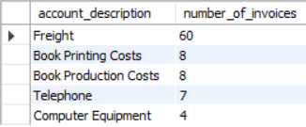

1. **(10) What is the total invoice for the account from the above question? Show the query that finds the answer. The result should show the account_number, account_description, the number of invoices, and the total invoice for each account_number.**

USE ap;

SELECT account_number, account_description, COUNT(invoice_id) AS number_of_invoices, SUM(invoice_id) AS total_invoice

FROM general_ledger_accounts g

JOIN vendors v ON g.account_number = v.default_account_number

JOIN invoices i ON v.vendor_id = i.vendor_id

GROUP BY account_description, account_number

ORDER BY COUNT(invoice_id) DESC

LIMIT 5

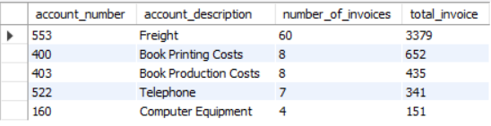

1. **(10) Find the vendor which has the biggest amount of total invoices. Show the query that shows the vendor name and the total invoice amount.**

USE ap;

SELECT v.vendor_name, SUM(invoice_total) AS total_invoices

FROM vendors v

JOIN invoices i ON v.vendor_id = i.vendor_id

GROUP BY v.vendor_name

ORDER BY total_invoices DESC

LIMIT 1



1. **(10) Find the vendor which has the single most expensive order for an item. Show the query that shows the vendor name, the item description, and the amount.**

USE ap;

SELECT vendor_name, line_item_description, line_item_amount

FROM vendors v

JOIN invoices i ON v.vendor_id = i.vendor_id

JOIN invoice_line_items k ON k.invoice_id = i.invoice_id

ORDER BY line_item_amount DESC

LIMIT 1



1. **5) Create a table called “new_terms” from the terms table. Then, write an INSERT statement that adds this row to the new_terms table:**

**terms_id: 6terms_description: Net due 120 days**

**terms_due_days: 120**

**Then, show the result of the following query: SELECT * FROM new_terms;**

USE ap;

CREATE TABLE new_terms AS

SELECT *

FROM terms;

INSERT INTO new_terms

(terms_id, terms_description, terms_due_days)

VALUES (6, 'Net due 120 days', 120)

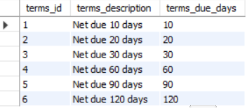

1. **(5) Then, write an UPDATE statement that modifies the row you just added to the Terms table. This statement should change the terms_description column to “Net due 100 days”, and it should change the terms_due_days column to 100.**

**Then, show the result of the following query: SELECT * FROM new_terms;**

USE ap;

SELECT terms_description, terms_due_days

FROM new_terms

WHERE terms_id = 6;

UPDATE new_terms

SET terms_description = 'Net due 100 days',

terms_due_days = 100

WHERE terms_id = 6

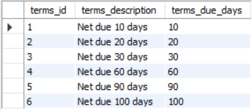

1. **(5) Then, write a DELETE statement that deletes the row you added to the new Terms table (that is with the terms_id 6).Then, show the result of the following query: SELECT * FROM new_terms;**

USE ap;

DELETE FROM new_terms

WHERE terms_id = 6;

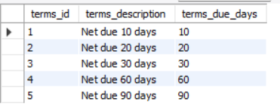

1. **(5) Write a query that displays the vendor name, the number of invoices, and the sum of invoice totals for each vendor, sorted by the sum of invoice totals. Show only those vendors whose invoice totals are less than the average invoice totals.**

USE ap;

SELECT v.vendor_name, COUNT(invoice_id) AS number_of_invoices, MAX(i.invoice_total)

FROM invoices i JOIN vendors v

ON i.vendor_id = v.vendor_id

GROUP BY v.vendor_id

HAVING SUM(invoice_total) < (SELECT AVG(invoice_total)

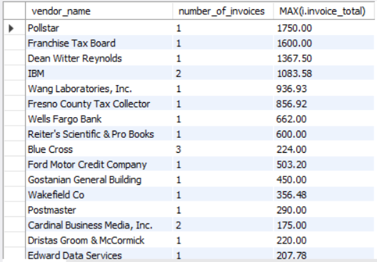 FROM invoices i

WHERE vendor_id = i.vendor_id

)

ORDER BY SUM(invoice_total) DESC



1. **(5) Consider the following database. Show a query that displays the employee ids, employee names and their manager names, ordered by the employee_id. Also, show the query result.  
   Note: You should make this table first.**

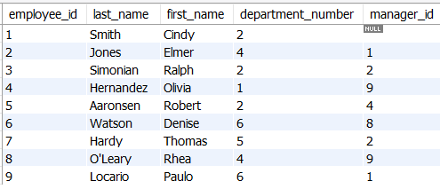

CREATE TABLE employees(

employee_id INT PRIMARY KEY AUTO_INCREMENT,

last_name VARCHAR(20) NOT NULL,

first_name VARCHAR(20) NOT NULL,

department_number INT NOT NULL,

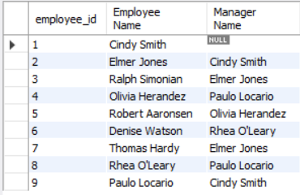manager_id INT

);

USE ap;

INSERT INTO employees

VALUES

(1, 'Smith', 'Cindy', 2, null),

(2, 'Jones', 'Elmer', 4, 1),

(3, 'Simonian', 'Ralph', 2, 2),

(4, 'Herandez', 'Olivia', 1, 9),

(5, 'Aaronsen', 'Robert', 2, 4),

(6, 'Watson', 'Denise', 6, 8),

(7, 'Hardy','Thomas',5,2),

(8, "O'Leary",'Rhea',4,9),

(9, 'Locario', 'Paulo',6,1);

USE ap;

SELECT e.employee_id, CONCAT(e.first_name, " ", e.last_name) AS 'Employee Name', CONCAT(f.first_name, " ", f.last_name) AS 'Manager Name'

FROM employees e LEFT JOIN employees f

ON e.manager_id = f.employee_id

ORDER BY e.employee_id

1. **(5) From the above question, show a query that displays employees who manage more than one employee.**

SELECT f.employee_id, CONCAT(f.first_name, " ", f.last_name) AS 'Manager Name'

FROM employees e LEFT JOIN employees f

ON e.manager_id = f.employee_id

GROUP BY e.manager_id

HAVING count(*) > 1

ORDER BY employee_id

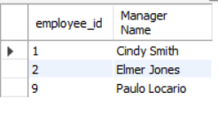

1. 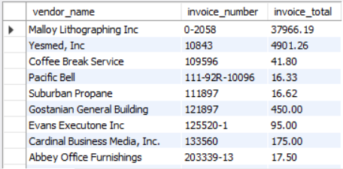**(5) Use a correlated subquery to return one row per vendor, representing the vendor’s oldest invoice (the one with the earliest date). Each row should include these three column: vendor_name, invoice_number, and invoice_total. Sort the result by the invoice_number column.**

USE ap;

SELECT vendor_name, invoice_number, invoice_total

FROM vendors v JOIN invoices i

ON v.vendor_id = i.vendor_id

WHERE invoice_date =

(SELECT MIN(invoice_date)

FROM invoices sub

WHERE v.vendor_id = sub.vendor_id)

****ORDER BY invoice_number

1. **(5) Rewrite the query for the above problem that does not use a correlated query.**

SELECT v.vendor_name, i.invoice_number, i.invoice_total

FROM vendors v JOIN invoices i

ON v.vendor_id = i.vendor_id

WHERE (v.vendor_name, i.invoice_date) IN

(SELECT v.vendor_name, MIN(i.invoice_date)

FROM vendors v JOIN invoices i

WHERE v.vendor_id = i.vendor_id

GROUP BY v.vendor_name

ORDER BY invoice_date)

ORDER BY invoice_number;

