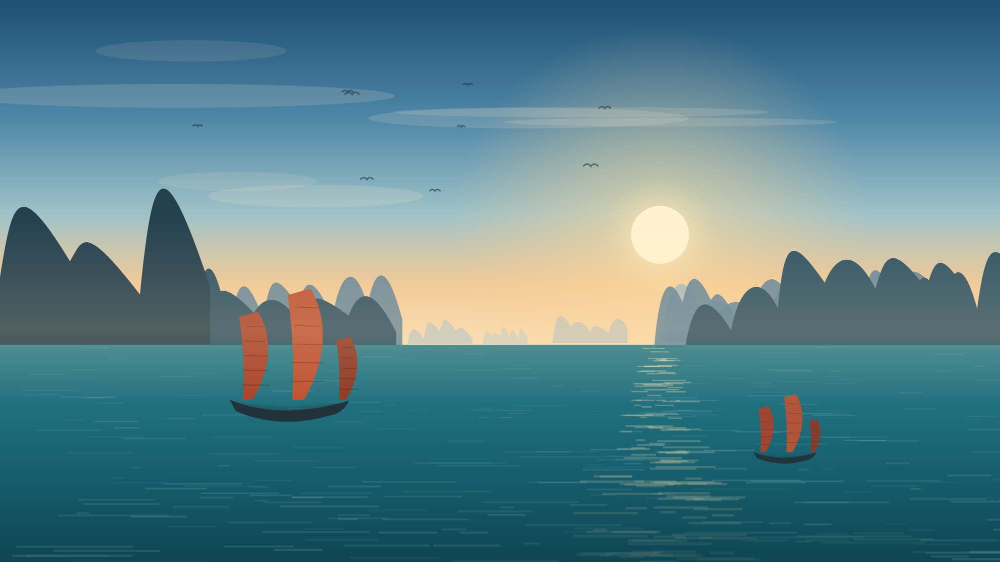
Sail Into a Postcard: Ha Long Bay, Vietnam
[THESIS STATEMENT]
There are places you look at in photographs and places you feel the moment you arrive. Ha Long Bay in northern Vietnam is the second kind. Almost two thousand limestone islands rise straight out of emerald water, and a boat is the only way through them. If you are choosing one destination in Southeast Asia, choose the one that has been shaped for millions of years and can still be crossed in an afternoon.
[SUPPORTING EVIDENCE]
Ha Long Bay is a UNESCO World Heritage Site, recognised for limestone karsts that took roughly 500 million years to form. Visitors cruise between the islands on traditional wooden junks, kayak into hidden lagoons that open only at low tide, and climb into caves such as Sung Sot, whose chambers are large enough to hold hundreds of people. Floating fishing villages still work the same waters, so the bay is a living community and not only a view. Meals are served on deck as the islands slide past, and an overnight cruise lets you watch the sun set and rise over the same horizon.
[COUNTERARGUMENT]
Some travellers worry that Ha Long Bay has become too crowded, or that a cruise costs more than the rest of their trip. It is a fair concern in peak season. The answer is simply to choose well: routes through Lan Ha Bay and Bai Tu Long carry a fraction of the traffic and show the same limestone scenery, and cruises run at every price level, from shared day trips to small overnight boats. Travelling outside the summer months gives you quieter water and softer light for photographs.
[CALL TO ACTION]
Do not leave Ha Long Bay on a list of places you meant to see. Fly into Hanoi, take the two-and-a-half-hour transfer to the coast, and book at least one night on the water. Stand on the deck at sunrise while the mist lifts off the islands, and you will understand why the photographs never quite manage it. Book your cruise and let Ha Long Bay do the rest.
Illustration by the author. Information: UNESCO World Heritage Centre. (n.d.). Ha Long Bay. https://whc.unesco.org/

