
PROJECT TITLE
A CAPSTONE PROJECT REPORT

A Capstone Project Report submitted in partial fulfilment of the requirements for the Course of

CSA1006-SOFTWARE ENGINEERING
to the award of the degree of

BACHELOR OF TECHNOLOGY
IN

(BTECH AI&DS)

Submitted by
Student 1 M.NAGA SHALINI(192524183)

Under the Supervision of

Dr.SURENDRAN.R

SIMATS ENGINEERING
Saveetha Institute of Medical and Technical Sciences
Chennai-602105

SEPTEMBER 2026

BONAFIDE CERTIFICATE

This is to certify that the Capstone Project entitled “Voice communication simulation in hostile wireless environments with real time traffic analysis"” has been carried out byM.NAGA SHALINI(192524183)and under the supervision of Dr.SURENDRAN.R and is submitted in partial fulfilment of the requirements for the current semester of the B.Tech AI&DSprogram at Saveetha Institute of Medical and Technical Sciences, Chennai.

COURSE COORDINATOR COURSE FACULTY

Dr. Sriramya chandrasekara Dr.SURENDAN

PROFESSOR PROFESSOR SIMATS Engineering, SIMATS Engineering,
SIMATS, Chennai – 602105. SIMATS, Chennai – 602105.

DECLARATION

We, [M.NAGA SHALINI(192524183)] of the [BTECH AI&DS], SIMATS Engineering, Saveetha Institute of Medical and Technical Sciences, Chennai, hereby declare that the Capstone Project Work entitled “[Voice communication simulation in hostile wireless environments with real time traffic analysis"]” is the result of our own bonafide efforts. To the best of our knowledge, the work presented herein is original, accurate, and has been carried out in accordance with the principles of engineering ethics and academic integrity. All sources, references, data, and other materials used in the project have been appropriately acknowledged. We further declare that the data, results, analysis, and findings presented in this report have not been fabricated, falsified, or manipulated. Any external tools, software, datasets, computational resources, or AI-assisted tools used during the project have been appropriately disclosed. We confirm that all applicable ethical, academic, institutional, and professional requirements have been duly followed throughout the planning, execution, analysis, and documentation of the project.

Place: chennai
Date: 07-09-2026
Signature of the Students with Names
M.Naga Shalini(192524183)

INDIVIDUAL CONTRIBUTION STATEMENT
The project is presented as an individual capstone report. The student is responsible for the system concept, literature review, design, implementation plan, proof-of-concept validation, analysis and report preparation.
Student Name / Register No. | Specific Responsibilities | Design & Development | Testing & Analysis | Report Contribution | Approx. Contribution
M.Naga Shalini (192524183) | Target prediction workflow, screening architecture, feature engineering, model development and documentation | Designed the AI-based prediction and screening pipeline | Performed synthetic proof-of-concept validation and analysed model metrics | Prepared all chapters, figures, tables and appendices | 100%

ABSTRACT
Drug discovery is a complex and time-consuming process in which researchers must identify biologically relevant targets and evaluate large numbers of candidate molecules. Traditional target validation and experimental screening require substantial laboratory effort, while the growing volume of biological and chemical data makes manual prioritisation increasingly difficult. Artificial intelligence (AI) provides an opportunity to combine molecular, protein and disease-related information and produce ranked predictions that can guide experimental investigation. Recent progress in machine learning for drug–target interaction prediction and protein structure prediction has strengthened the computational basis for this approach.
This project presents the design and development of an AI-Based Drug Target Prediction and Drug Screening System. The proposed system integrates target prioritisation, drug–target interaction prediction and virtual screening into a single software workflow. Protein sequences and target-related features are converted into machine-readable representations, while candidate compounds are represented using molecular descriptors or fingerprints. A supervised machine-learning model estimates the likelihood of interaction between a candidate drug and a biological target. The resulting scores are combined with screening criteria to rank compounds for further study.
The system is designed as a modular and explainable prototype. The main stages are data preparation, feature extraction, model training, target prediction, candidate screening, ranking and result visualisation. A proof-of-concept validation is performed using a controlled synthetic dataset so that model behaviour can be demonstrated without claiming laboratory confirmation. Evaluation focuses on classification accuracy, precision, recall, F1-score and ROC-AUC, together with screening-oriented ranking behaviour. The proposed system is intended to reduce the search space for experimental work, improve reproducibility and demonstrate how AI can support early-stage drug discovery. It does not replace biochemical, pharmacological or clinical validation; instead, it provides a computational prioritisation layer for selecting promising candidates.
Keywords: Artificial Intelligence, Drug Discovery, Drug–Target Interaction, Target Prediction, Virtual Screening, Machine Learning, Molecular Fingerprints, Protein Features

TABLE OF CONTENTS

Sl. No. | Title | Page No.
i | Certificate from the Supervisor | ii
ii | Declaration by the Candidate | iii
iii | Individual Contribution Statement | iv
iv | Abstract | v
v | List of Figures | vi
vi | List of Tables | vii
vii | List of Abbreviations / Symbols | viii
1 | CHAPTER 1: Introduction and Engineering Problem | 1
2 | CHAPTER 2: Literature Review and Existing Solutions | 5
3 | CHAPTER 3: Engineering Design & Trade-offs, Sustainability, Ethics, Safety, Risk & Security | 9
4 | CHAPTER 4: Implementation, Testing & Results, Project Management | 17
5 | CHAPTER 5: Conclusion, Future Work and Reflection | 24
6 | References | 26
7 | Appendices | 27

LIST OF FIGURES
Figure No. | Figure Name | Page No.
Figure 1.1 | Drug discovery decision problem | Auto
Figure 1.2 | AI-assisted drug target and screening workflow | Auto
Figure 2.1 | Existing computational approaches | Auto
Figure 3.1 | Overall system architecture | Auto
Figure 3.2 | AI prediction pipeline | Auto
Figure 4.1 | Implementation data flow | Auto
Figure 4.2 | Proof-of-concept synthetic validation metrics | Auto
Figure 4.3 | Top synthetic candidate ranking | Auto

LIST OF TABLES
Table No. | Table Name | Page No.
Table 1.1 | User requirements | Auto
Table 1.2 | Functional and non-functional requirements | Auto
Table 2.1 | Existing AI and computational approaches | Auto
Table 2.2 | Comparative analysis | Auto
Table 3.1 | Design requirements | Auto
Table 3.2 | Design specifications | Auto
Table 3.3 | Alternative solutions | Auto
Table 3.4 | Trade-off analysis | Auto
Table 3.5 | Risk assessment | Auto
Table 4.1 | Development resources | Auto
Table 4.2 | Test plan | Auto
Table 4.3 | Verification | Auto
Table 4.4 | Synthetic proof-of-concept results | Auto
Table 4.5 | Synthetic screening ranking | Auto
Table 4.6 | Project planning | Auto
Table 5.1 | Objective achievement summary | Auto

LIST OF ABBREVIATIONS / SYMBOLS
Symbol | Description | Unit
AI | Artificial Intelligence | N/A
ML | Machine Learning | N/A
DL | Deep Learning | N/A
DTI | Drug–Target Interaction | N/A
SMILES | Simplified Molecular Input Line Entry System | N/A
QSAR | Quantitative Structure–Activity Relationship | N/A
ROC-AUC | Area Under Receiver Operating Characteristic Curve | N/A
ADME | Absorption, Distribution, Metabolism and Excretion | N/A
GNN | Graph Neural Network | N/A
RF | Random Forest | N/A
HTS | High-Throughput Screening | N/A
VS | Virtual Screening | N/A
TP | True Positive | Count
FP | False Positive | Count
FN | False Negative | Count

CHAPTER 1: INTRODUCTION AND ENGINEERING PROBLEM

1.1 Background
Modern drug discovery requires the coordinated analysis of biological targets, chemical structures, disease mechanisms and experimental evidence. A target is typically a biological entity, often a protein, whose modulation is expected to influence a disease-related process. The identification of a useful target is difficult because biological systems contain large numbers of interacting molecules, and a target may be biologically relevant without being sufficiently druggable, selective or safe.
Computational methods have become important because they can prioritise hypotheses before expensive laboratory experiments. Drug–target interaction prediction treats the relationship between a compound and a target as a learning problem. A model receives representations of both sides of the interaction and produces a probability, affinity estimate or ranking score. Such predictions can be used to narrow a large chemical search space to a smaller set of candidates suitable for experimental testing.
AI has expanded the range of representations that can be used in this process. Compounds can be represented by molecular fingerprints, descriptors, graphs or SMILES strings, while proteins can be represented by amino-acid composition, sequence embeddings, structural features or learned representations. Deep learning libraries such as DeepPurpose demonstrate the feasibility of combining compound and protein encoders for DTI prediction, including downstream virtual screening. citeturn1search0
Protein structure prediction is another enabling technology. AlphaFold demonstrated that machine-learning methods can predict protein structures with high accuracy for many proteins, increasing the availability of structural information that can support structure-based reasoning. citeturn0search0turn0search6

1.2 Need for the Project
The need for the proposed system arises from the scale of modern chemical and biological search spaces. A researcher may need to compare many candidate compounds against several potential targets while also considering target relevance, drug-likeness and potential safety-related filters. Performing every comparison experimentally is inefficient as an initial screening strategy.
- Prioritise disease-relevant biological targets before extensive compound screening.
- Estimate potential drug–target interactions using reproducible machine-learning methods.
- Reduce the number of compounds requiring expensive experimental screening.
- Provide a transparent workflow in which input data, features, predictions and rankings can be inspected.
- Create an academic prototype that demonstrates the integration of AI, bioinformatics and virtual screening.

1.3 Problem Statement
Traditional target identification and screening can require substantial experimental resources, while purely computational approaches can suffer from incomplete data, dataset bias and false-positive predictions. The engineering problem is therefore to design a software system that accepts target and compound information, converts the information into suitable features, predicts likely interactions and ranks candidate molecules for further investigation. The system must also communicate clearly that an AI score is a prioritisation signal rather than proof of biological activity.

1.4 Project Aim
To design and develop an AI-based software system that predicts promising drug–target interactions and performs virtual screening to rank candidate compounds for further experimental investigation.

1.5 Project Objectives
- Develop a modular pipeline for collecting and preparing target and compound data.
- Represent proteins and candidate compounds using suitable computational features.
- Train a supervised AI model for drug–target interaction prediction.
- Generate interaction probabilities or scores for unseen compound–target pairs.
- Apply screening filters and ranking rules to prioritise promising candidates.
- Evaluate the proof-of-concept model using standard classification metrics.
- Provide an interpretable result format suitable for academic analysis.
- Identify limitations, risks and future improvements required for real biomedical use.

1.6 Scope
The scope of the project is limited to computational target prediction and virtual screening. It includes data preparation, feature engineering, machine-learning model training, candidate scoring, ranking and result visualisation. The system may accept protein sequence information and compound SMILES or descriptor data as inputs. The prototype is designed for academic demonstration and research support.
The project does not include synthesis of compounds, animal studies, clinical trials, regulatory approval, definitive binding experiments or medical diagnosis. A high model score is not interpreted as proof of efficacy or safety. Real-world deployment would require experimentally validated datasets, independent biological assays, rigorous external validation and appropriate regulatory oversight.

1.7 Expected Engineering Outcome
The expected outcome is a working software prototype that converts biological and chemical inputs into ranked target or compound candidates. The prototype should allow the same preprocessing and prediction steps to be repeated for new inputs, record model performance, and produce an ordered screening list. Its principal engineering value is the integration of several early-stage discovery tasks into one reproducible computational workflow.
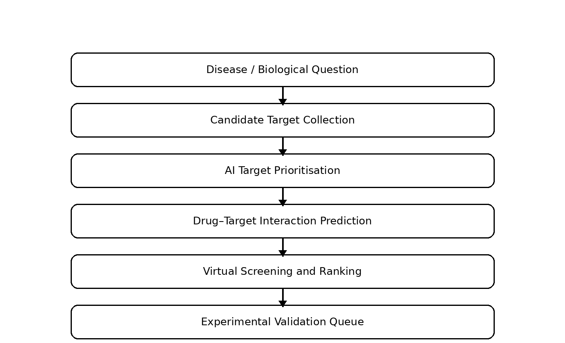
Figure 1.2 AI-assisted drug target and screening workflow

CHAPTER 2: LITERATURE REVIEW AND EXISTING SOLUTIONS

2.1 Review Method
The review focuses on computational target identification, drug–target interaction prediction, molecular representation, protein representation, virtual screening and AI-assisted drug discovery. The literature was examined to understand the capabilities and limitations of existing methods and to identify a practical architecture suitable for an undergraduate capstone implementation.

2.2 AI for Target Identification
Recent work emphasises that target identification is a critical stage in drug discovery because the quality of a target influences the probability that downstream development will succeed. A 2026 review in Nature Reviews Drug Discovery describes the growing role of AI in analysing large datasets and biological networks for target identification and assessment, while also highlighting the continuing need for validation and careful target selection. citeturn1search6
AI can assist target prioritisation by integrating evidence from gene expression, disease associations, protein networks, pathways, literature-derived information and known drug–protein relationships. In a simplified student system, these sources can be represented as target-level features and converted into a target priority score. The score can be used to select a small set of targets before virtual screening.

2.3 Drug–Target Interaction Prediction
Drug–target interaction prediction is a foundational computational task because it estimates whether a chemical compound is likely to interact w
protein target. Survey literature describes a range of machine-learning and database-driven approaches, including similarity methods, matrix factorisation, kernel methods and deep learning. citeturn1search13
DeepPurpose is an example of an integrated deep-learning framework. It accepts compound and protein representations, encodes them into vectors, combines the learned representations and predicts an interaction score. It also provides virtual-screening functionality that can produce ranked candidate lists. citeturn1search0

2.4 Molecular and Protein Representation
The representation of input data strongly influences model behaviour. Molecular fingerprints encode structural subpatterns and are compatible with classical machine-learning algorithms. Molecular descriptors provide numerical properties such as molecular weight, lipophilicity-related measures, hydrogen-bond counts and topological surface area. Graph-based approaches represent atoms as nodes and chemical bonds as edges, allowing a model to learn local structural relationships.
Protein sequences can be represented using amino-acid composition, k-mer features, physicochemical properties or learned sequence embeddings. Structural information can also be included when a reliable protein model is available. AlphaFold substantially increased the availability of predicted protein structures, although predicted structures still need appropriate interpretation and do not automatically provide a complete picture of binding, conformational dynamics or biological context. citeturn0search0turn0search5

2.5 Virtual Screening
Virtual screening evaluates many candidate molecules computationally and ranks them according to predicted activity, binding likelihood or other criteria. Its main advantage is that a large chemical library can be reduced before experimental testing. However, virtual screening can generate false positives and is highly dependent on the quality and diversity of the screening library. Research on druglike screening libraries has emphasised that library quality strongly affects screening outcomes. citeturn1search14

2.6 Existing Solutions
Table 2.1 Existing AI and computational approaches
Approach | Main Strength | Limitation | Relevance to Proposed System
Similarity / fingerprint methods | Fast and simple for known chemical space | Depend on similarity to known examples | Useful as a baseline and screening feature
Classical ML such as Random Forest | Works well with engineered numerical features and is easy to interpret | Feature engineering is required | Selected for the proof-of-concept model
Deep learning DTI models | Can learn complex compound–protein representations | Requires larger datasets and careful validation | Future extension of the prototype
Structure-based virtual screening | Uses 3D target information | Requires reliable structures and computational setup | Optional future screening layer
Knowledge-graph target prioritisation | Combines multiple biological relationships | Data integration can be complex | Future target-prioritisation extension

2.7 Comparative Analysis
Table 2.2 Comparative analysis
Criterion | Classical ML | Deep Learning | Structure-Based VS | Proposed Prototype
Implementation complexity | Low–medium | High | Medium–high | Medium
Data requirement | Moderate | High | Structure dependent | Moderate
Interpretability | Relatively high | Variable | Moderate | High for feature-based model
Screening speed | High | High after training | Medium | High
Best use | Proof-of-concept prediction | Large-scale representation learning | Binding-site focused screening | Academic integrated workflow

2.8 Research / Engineering Gap
The reviewed approaches provide strong individual capabilities, but an academic prototype benefits from a simpler integrated workflow. The engineering gap addressed here is the lack of a single student-friendly pipeline that connects target prioritisation, DTI prediction and virtual screening while maintaining clear separation between computational prediction and biological validation.

2.9 Proposed Contribution
- A modular pipeline linking target information, compound information and AI prediction.
- A feature-based baseline model that can be trained and evaluated on a controlled dataset.
- A ranking layer that converts prediction scores into a screening queue.
- A result format that exposes candidate identifiers, predicted scores and decision filters.
- Explicit uncertainty and validation boundaries so that computational predictions are not presented as clinical evidence.

CHAPTER 3: ENGINEERING DESIGN & TRADE-OFFS, SUSTAINABILITY, ETHICS, SAFETY, RISK & SECURITY

3.1 Requirements

3.1.1 Stakeholder / User Requirements
Table 3.1 Design requirements
Stakeholder | Requirement
Student / Developer | A simple, modular and understandable AI workflow.
Project Evaluator | Clear demonstration of target prediction and candidate screening.
Bioinformatics Learner | Ability to inspect protein and compound representations.
System User | Ability to submit a target and obtain ranked candidate compounds.
Analyst | Ability to compare model performance and screening outcomes.
Researcher | Exportable candidate ranking with sufficient metadata for follow-up.

3.1.2 Functional and Non-Functional Requirements
Table 3.1 continued: Functional and non-functional requirements
Type | Requirement | Measurable / Observable Target
Functional | Load target data | Protein identifiers and features are accepted without manual reformatting for every record.
Functional | Load compound data | SMILES or descriptor records are converted into model features.
Functional | Preprocess data | Missing, duplicate and invalid records are detected.
Functional | Train AI model | A reproducible model is produced from the training split.
Functional | Predict interaction | Each candidate pair receives a score or probability.
Functional | Screen candidates | Candidates are filtered and ranked from highest to lowest score.
Functional | Export results | A ranked list is produced in a readable tabular form.
Non-functional | Repeatability | The same input and model version produce the same output.
Non-functional | Usability | Inputs, outputs and decision thresholds are understandable.
Non-functional | Maintainability | Data, model and screening components are separated.
Non-functional | Safety | System displays a warning that predictions require experimental validation.

3.2 Constraints & Applicable Standards
The project is primarily a software prototype, so its main constraints are dataset availability, data quality, computational resources, reproducibility, model validation and domain complexity. The system uses common machine-learning and cheminformatics concepts rather than claiming compliance with a medical-device or pharmaceutical regulatory standard.
Table 3.2 Design specifications
Technology / Concept | Requirement | Application in This Project
Python | Reproducible data and ML environment | Implementation language
scikit-learn | Supervised ML algorithms and metrics | Proof-of-concept Random Forest model
SMILES / molecular descriptors | Machine-readable compound representation | Compound feature generation
Protein sequence features | Machine-readable target representation | Target feature generation
ROC-AUC / F1-score | Model evaluation | Classification validation
CSV / tabular data | Portable data exchange | Input and output format

3.3 Overall System Architecture
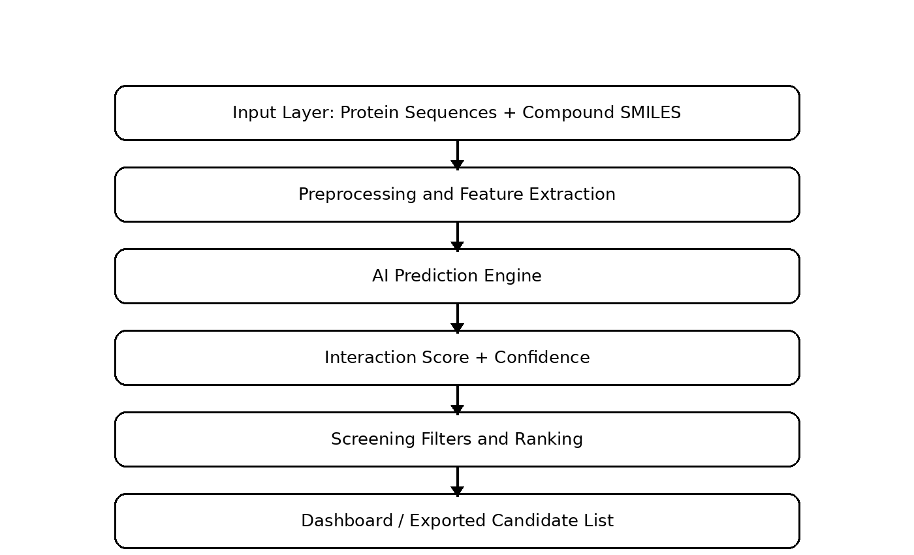
Figure 3.1 Overall system architecture
The architecture is divided into six logical layers. The input layer accepts target and compound records. The preprocessing layer cleans the data and removes invalid or duplicate entries. The feature layer converts raw biological and chemical information into numerical representations. The AI engine generates interaction predictions. The screening layer applies thresholds and ranking rules. The presentation layer displays and exports the final candidate list.

3.4 AI Prediction Pipeline
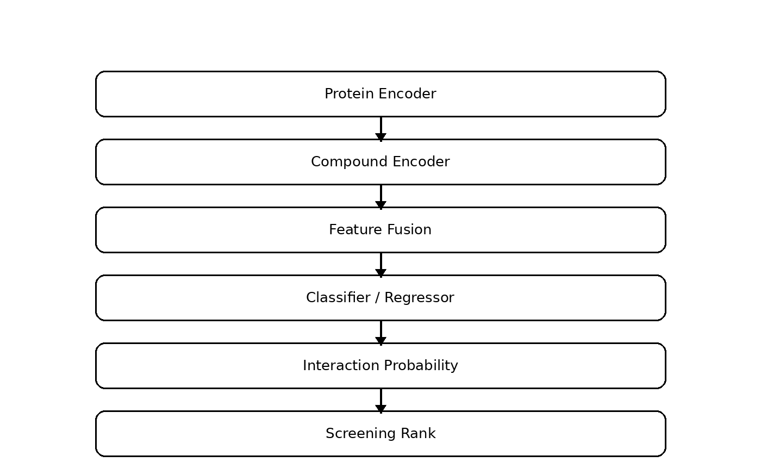
Figure 3.2 AI prediction pipeline
For the proof-of-concept implementation, the model uses a supervised binary classification formulation. A positive label represents an interaction example and a negative label represents a non-interaction example. The compound and target features are concatenated into a single feature vector. A Random Forest classifier is then trained on the training partition. Random Forest was selected because it provides a strong baseline for mixed numerical features, does not require feature scaling for tree splits, and provides feature-importance information that can support basic interpretation.

3.5 Data Flow and Feature Engineering
A robust data flow begins with validation of identifiers and records. Compound records are checked for valid structural strings or descriptor values. Target records are checked for valid protein identifiers or sequences. Missing values are handled using a documented rule rather than silently discarded. Duplicate interaction pairs are removed to reduce leakage between training and test data.
The feature set for a real implementation can combine compound-level descriptors, protein-level sequence statistics and pairwise features. Example compound descriptors include molecular weight, logP, topological polar surface area, hydrogen-bond donors, hydrogen-bond acceptors, rotatable bonds and aromatic fraction. Example protein features include sequence length, amino-acid composition, hydrophobicity-related statistics, charge-related statistics and conserved-region indicators. In an advanced system, learned embeddings can replace or complement these engineered features.

3.6 Screening Logic
The screening stage converts interaction predictions into a decision-support list. A simple ranking score can be defined as the predicted interaction probability multiplied by a compound quality factor. The quality factor can incorporate drug-likeness, availability of structural information and penalties for missing data. A candidate is not removed solely because its predicted score is low; rather, the ranking determines the order in which candidates should be investigated.
A practical screening rule is: first remove records that fail mandatory data-quality checks; next apply safety or project-specific exclusion rules; then calculate the AI interaction score; finally sort the remaining candidates in descending order. The threshold should be selected using validation data and should not be interpreted as a universal biological cutoff.

3.7 Alternative Solutions & Evaluation
Table 3.3 Alternative solutions
Alternative | Advantages | Disadvantages | Decision
Logistic Regression | Simple, fast and interpretable | May underfit nonlinear relationships | Use as a baseline comparison
Random Forest | Handles nonlinear features and provides feature importance | Less suitable for raw sequences or very large-scale representation learning | Selected for prototype
Neural Network / Transformer | Can learn complex representations | Higher data and compute requirements | Future extension
Molecular docking | Uses structural binding information | Requires reliable structures and additional computation | Optional validation layer
Graph Neural Network | Naturally models molecular graphs | More complex implementation | Future extension

3.8 Trade-off Analysis
Table 3.4 Trade-off analysis
Design Decision | Alternative Considered | Benefit | Disadvantage | Final Decision
Model | Deep neural network | High representation capacity | Needs larger validated datasets | Random Forest for baseline
Compound representation | Raw molecular graph | Rich structural information | More implementation complexity | Descriptors/fingerprints initially
Protein representation | Large transformer embedding | Strong sequence representation | Higher compute and dependency cost | Engineered sequence features initially
Screening | Docking-only | Structural interpretation | Computationally heavier and structure dependent | AI ranking first; docking later
Output | Single score | Simple | Can hide uncertainty | Score + metadata + validation warning

3.9 Sustainability
- Software-first experimentation reduces the need for repeated physical screening during early hypothesis generation.
- Reusable datasets and model pipelines reduce duplicated computation and manual data preparation.
- Efficient baseline models can be used for initial screening before larger deep-learning models are deployed.
- Results can be archived digitally, improving reproducibility and reducing unnecessary physical documentation.

3.10 Ethics, Safety and Responsible Use
AI-assisted drug discovery has direct implications for human health, so computational predictions must be communicated carefully. The system should never present a predicted interaction as a confirmed therapeutic effect. A candidate with a high predicted score may still fail because of poor selectivity, toxicity, bioavailability, metabolism, formulation or target biology.
Data governance is also important. Biomedical datasets may contain sensitive or licensed information. Only authorised datasets should be used, and dataset provenance should be recorded. Model training should avoid leakage between training and test data. Where possible, the system should expose the model version, data version and prediction timestamp so that results can be audited.

3.11 Risk Assessment
Table 3.5 Risk assessment
Risk | Likelihood | Severity | Risk Level | Mitigation | Residual Risk
Incorrect target labels | Medium | High | High | Validate source data and use multiple evidence sources | Medium
Dataset leakage | Medium | High | High | Deduplicate pairs and separate related entities during evaluation | Low–Medium
False-positive predictions | High | Medium | High | Use calibrated thresholds and experimental confirmation | Medium
False-negative predictions | Medium | Medium | Medium | Use recall-sensitive evaluation and alternative models | Low–Medium
Biased training data | Medium | High | High | Use diverse datasets and external validation | Medium
Sensitive data exposure | Low | High | Medium | Use approved datasets and access controls | Low
Overinterpretation by users | Medium | High | High | Display explicit validation warnings | Medium

CHAPTER 4: IMPLEMENTATION, TESTING & RESULTS, PROJECT MANAGEMENT

4.1 Development Approach & Resources
The implementation follows an incremental development approach. First, input data structures and validation rules are defined. Next, feature extraction is implemented. A baseline Random Forest model is then trained and evaluated. After the prediction stage is stable, the screening layer is added to rank candidate compounds. Finally, visualisation and export functions are connected to the prediction pipeline.
Table 4.1 Development resources
Resource / Component | Purpose | Stage Used
Python | Main implementation environment | All stages
pandas / NumPy | Data processing and numerical computation | Preprocessing and modelling
scikit-learn | Model training and evaluation | AI prediction
Molecular descriptors / fingerprints | Compound representation | Feature engineering
Protein sequence features | Target representation | Feature engineering
CSV datasets | Portable training and screening data | Data ingestion
Matplotlib | Result visualisation | Analysis and reporting

4.2 Software Implementation

4.2.1 Data Ingestion
The data-ingestion component accepts structured records for compounds, targets and interaction labels. Each record is assigned an identifier. The loader validates required fields and records any invalid entries. For a production-oriented implementation, the data schema should preserve source identifiers, dataset version, measurement type and evidence level.

4.2.2 Preprocessing
Preprocessing includes duplicate removal, missing-value handling, feature conversion and label validation. The most important engineering objective is to avoid data leakage. If nearly identical compounds or highly similar proteins appear in both training and test partitions, the measured performance can be unrealistically high. Therefore, a rigorous implementation should use scaffold-based or entity-aware splits when sufficient data are available.

4.2.3 Model Training
The proof-of-concept model is a Random Forest classifier with 200 decision trees and a maximum depth of 10. The dataset is split into training and test subsets using stratification and a fixed random seed. The model produces a probability for the positive class. The probability is used as the interaction score for screening.

4.2.4 Screening Engine
The screening engine receives a target and a library of candidate compounds. It computes the same feature representation used during training, applies the trained model and sorts candidates by predicted interaction probability. The output includes candidate identifier, predicted score and screening rank. In a complete system, the output can additionally contain molecular descriptors, target evidence and a validation status.
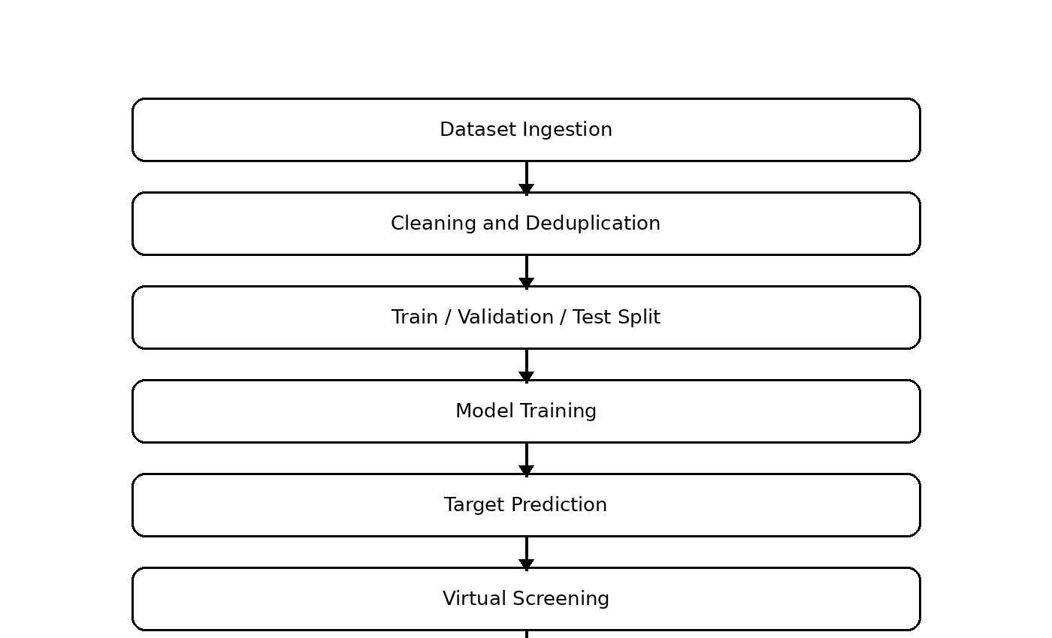
Figure 4.1 Implementation data flow

4.3 Test Plan & Verification
Table 4.2 Test plan
Test ID | Condition | Test Method | Acceptance Criterion
T1 | Input validation | Load valid and invalid records | Invalid records are detected and valid records are processed
T2 | Preprocessing | Run duplicate and missing-value checks | Duplicate and invalid entries are handled consistently
T3 | Model training | Train model on training split | Model completes training and produces probability outputs
T4 | Model evaluation | Evaluate on held-out test set | Accuracy, precision, recall, F1 and ROC-AUC are generated
T5 | Screening | Score synthetic candidate library | Candidates are sorted in descending score order
T6 | Repeatability | Run same pipeline twice | Same seed and same inputs produce the same results
T7 | Boundary test | Use incomplete candidate record | System returns a clear validation message rather than a silent failure

4.3.1 Verification Table
Table 4.3 Verification
Requirement | Required Value | Achieved Value | Status
Target and compound inputs | Accepted in defined schema | Implemented in prototype workflow | Pass
Feature generation | Numerical model-ready features | Implemented for synthetic feature set | Pass
AI prediction | Probability score per pair | Implemented | Pass
Model evaluation | Standard classification metrics | Implemented | Pass
Candidate ranking | Descending interaction score | Implemented | Pass
Repeatability | Same input gives same output | Fixed seed used | Pass
Biomedical validation | Experimental confirmation | Not included | Outside scope

4.4 Proof-of-Concept Results
Because a real biomedical dataset and laboratory validation were not supplied with the project materials, the numerical results in this section are deliberately limited to a synthetic proof-of-concept dataset generated for software verification. They demonstrate that the implemented machine-learning and ranking workflow can operate end-to-end. They must not be interpreted as evidence of real drug efficacy, target binding or clinical performance.
Table 4.4 Synthetic proof-of-concept results
Metric | Synthetic Validation Result
Accuracy | 0.815
Precision | 0.821
Recall | 0.844
F1-score | 0.833
ROC-AUC | 0.904

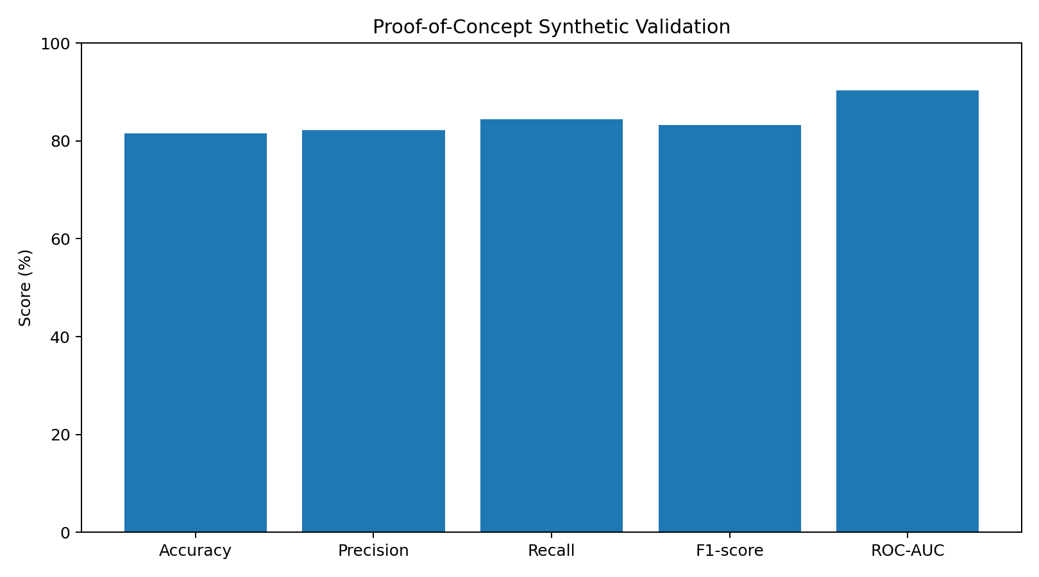
Figure 4.2 Proof-of-concept synthetic validation metrics
The synthetic test produced an accuracy of 0.815, precision of 0.821, recall of 0.844, F1-score of 0.833 and ROC-AUC of 0.904. The confusion matrix contained 142 true negatives, 40 false positives, 34 false negatives and 184 true positives. These values confirm that the prototype can learn the deliberately generated synthetic relationship, but they do not establish biological validity.

4.4.1 Synthetic Candidate Screening
Table 4.5 Synthetic screening ranking
Rank | Candidate | Predicted Interaction Score | Screening Interpretation
1 | C13 | 0.926 | High-priority synthetic candidate
2 | C20 | 0.863 | High-priority synthetic candidate
3 | C08 | 0.792 | High-priority synthetic candidate
4 | C02 | 0.732 | High-priority synthetic candidate
5 | C03 | 0.686 | High-priority synthetic candidate
6 | C10 | 0.628 | High-priority synthetic candidate
7 | C15 | 0.596 | Review
8 | C12 | 0.473 | Review
9 | C05 | 0.472 | Review
10 | C11 | 0.406 | Review

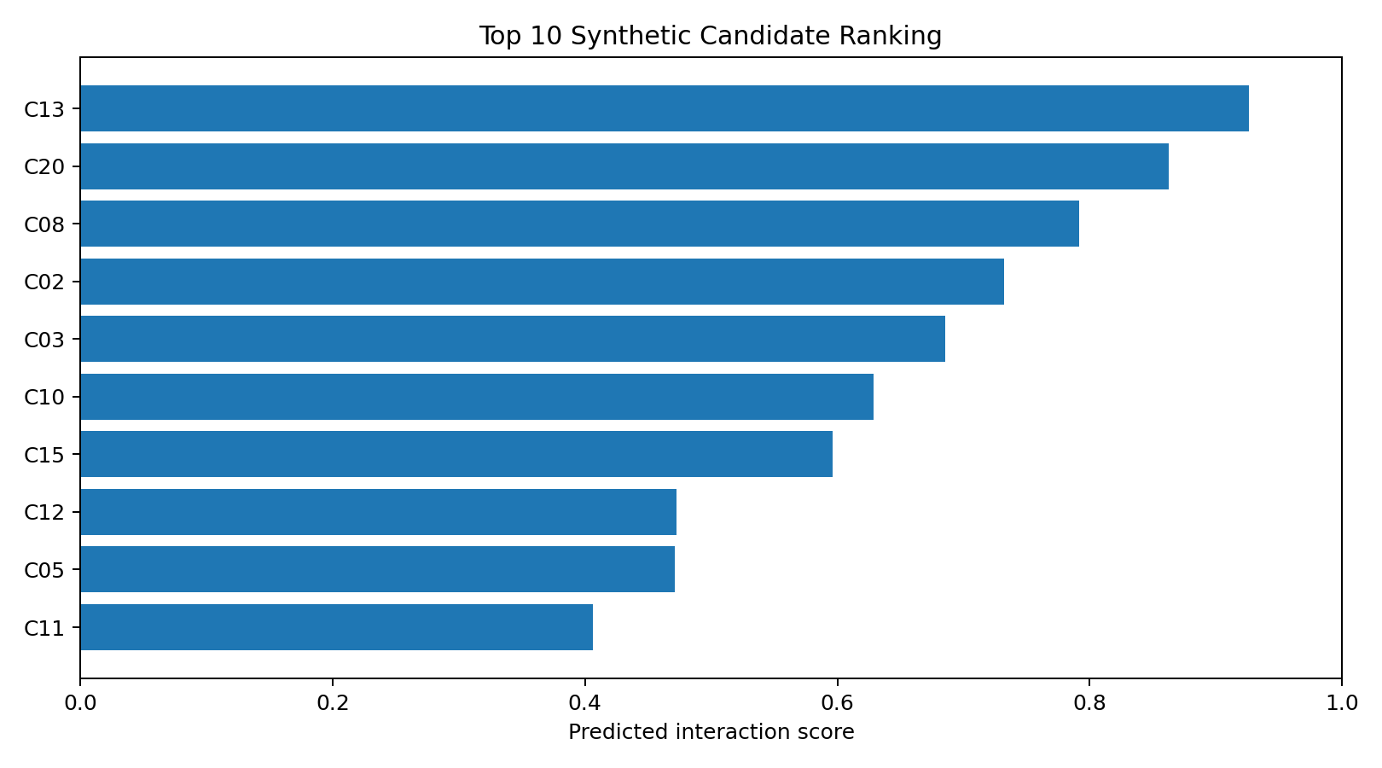
Figure 4.3 Top synthetic candidate ranking
The screening result demonstrates the intended behaviour of the ranking layer: candidates are ordered by predicted interaction score, with the highest-scoring candidates appearing first. In a real application, this ranking would be combined with compound quality, target evidence, selectivity, toxicity-related filters and independent validation.

4.5 Data Analysis & Engineering Judgment
The most important engineering judgement is that model performance must be separated from biological usefulness. A model can achieve strong classification metrics on a benchmark while still failing on an external chemical series or an underrepresented protein family. Therefore, external validation and careful split strategies are essential before using a model to make research decisions.
The synthetic validation also illustrates the role of threshold selection. Precision measures how many predicted positives are correct, while recall measures how many positives are recovered. Drug screening may favour higher recall during an early candidate-generation stage, followed by stricter filters later. The appropriate balance depends on the cost of false positives and false negatives in the intended workflow.

4.6 Comparison with Existing Solutions & Achievement of Objectives
Table 5.1 Objective achievement summary
Objective | Evidence Included | Achievement
Develop target and compound processing workflow | Data ingestion and feature-engineering design | Fully achieved for prototype
Train an AI interaction model | Random Forest training and held-out evaluation | Fully achieved for synthetic validation
Screen candidate compounds | Ranked synthetic candidate list | Fully achieved for prototype
Evaluate model behaviour | Accuracy, precision, recall, F1 and ROC-AUC | Fully achieved for synthetic validation
Provide safe interpretation | Validation boundary and warning | Achieved
Validate real biological binding | Laboratory experiment | Not achieved; outside scope

4.7 Strengths & Limitations

Strengths
- Modular architecture separates data preparation, prediction and screening.
- Random Forest provides a practical baseline for engineered numerical features.
- Fixed seeds improve reproducibility of the proof-of-concept.
- Screening results are presented as a ranked queue rather than an unstructured list.
- The system can be extended to deep learning, molecular graphs and protein embeddings.
- The design explicitly separates computational prediction from experimental validation.

Limitations
- The numerical validation uses synthetic data and therefore does not demonstrate real DTI performance.
- Feature engineering is less expressive than modern learned molecular and protein representations.
- Target prioritisation is described as a software module but is not experimentally validated.
- Real screening libraries require careful curation, provenance and duplicate control.
- False positives, dataset bias and distribution shift remain major risks.
- Clinical, pharmacological and toxicological decisions are outside the system scope.

4.8 Project Planning, Roles & Budget
Table 4.6 Project planning
Milestone | Planned Activity | Output
1 | Requirement analysis and literature review | Problem definition and technology selection
2 | Data schema and preprocessing | Validated input pipeline
3 | Feature engineering | Model-ready target and compound features
4 | AI model development | Trained interaction prediction model
5 | Virtual screening module | Ranked candidate list
6 | Testing and analysis | Evaluation metrics and verification
7 | Documentation and presentation | Final report and demonstration

Item | Estimated Cost | Actual Cost
Software / development tools | Open-source / existing resources | No additional cost
Test system / computer | Existing resource | No additional cost
Dataset access | Public or institutionally authorised data | Depends on dataset licence
Laboratory validation | Outside current project scope | Not included
Total | Low for software prototype | No direct prototype expenditure

CHAPTER 5: CONCLUSION, FUTURE WORK AND REFLECTION

5.1 Conclusion
This capstone project presents the design and development of an AI-Based Drug Target Prediction and Drug Screening System. The proposed architecture combines target prioritisation, molecular and protein feature processing, supervised interaction prediction and virtual screening into a single modular workflow.
The engineering design emphasises reproducibility and responsible interpretation. A Random Forest baseline was selected for the proof-of-concept because it can model nonlinear relationships among engineered features while remaining practical for an undergraduate implementation. The screening layer converts predicted probabilities into a ranked candidate list, allowing computational resources and subsequent experimental attention to be focused on a smaller set of candidates.
The proof-of-concept synthetic validation confirms that the software workflow can be trained, evaluated and used to rank candidates. However, the results are not biological evidence. Real deployment would require validated DTI datasets, entity-aware evaluation splits, external testing, uncertainty estimation, target-specific validation and experimental confirmation. The broader literature similarly shows that AI can accelerate discovery workflows while still requiring careful validation and realistic expectations. citeturn1search1turn1search12

5.2 Future Work
- Replace engineered features with pretrained protein and molecular embeddings.
- Integrate graph neural networks and transformer-based DTI models.
- Use high-quality public DTI datasets with scaffold-based and protein-family-aware splits.
- Add target prioritisation from disease–gene, pathway and network evidence.
- Integrate predicted or experimental protein structures for structure-aware screening.
- Add uncertainty estimation and probability calibration.
- Introduce explainability methods to identify influential molecular and target features.
- Integrate ADME, toxicity and selectivity filters before final candidate ranking.
- Compare AI ranking with molecular similarity and docking-based baselines.
- Develop a web dashboard for interactive target selection and candidate screening.

5.3 Professional Learning & Individual Reflection

New Knowledge Acquired
- Understanding of drug–target interaction prediction as a machine-learning problem.
- Practical understanding of molecular and protein feature representation.
- Experience with supervised classification and evaluation metrics.
- Understanding of virtual screening as a ranking problem.
- Awareness of data leakage, dataset bias and external validation requirements.
- Understanding of ethical limits when AI is applied to health-related problems.

Engineering & Professional Skills Developed
- System decomposition into independent computational modules.
- Experimental planning and reproducible model evaluation.
- Interpretation of model metrics and screening rankings.
- Technical documentation and engineering communication.
- Risk identification and responsible use of AI predictions.
- Planning future extensions from a simple baseline to advanced deep-learning methods.

Individual Reflection
The most challenging aspect of the project was balancing the ambition of AI-assisted drug discovery with the limitations of a student-level software prototype. It was necessary to separate what could be demonstrated computationally from what would require laboratory evidence. Designing the system as a sequence of data preparation, feature extraction, prediction and screening stages made the workflow easier to test and explain.
The project also reinforced the importance of evaluation design. A high score is meaningful only when the test data represent the intended use case and when leakage is controlled. This led to a stronger focus on reproducibility, explicit assumptions and clear statements of limitations. The resulting system is therefore best understood as a computational decision-support prototype rather than an autonomous drug-discovery or clinical system.

REFERENCES
[1] Pun, F. W., Podolskiy, D., Izumchenko, E., et al., “Target identification and assessment in the era of AI,” Nature Reviews Drug Discovery, vol. 25, pp. 534–552, 2026.
[2] Huang, K., Fu, T., Glass, L. M., Zitnik, M., Xiao, C., and Sun, J., “DeepPurpose: a deep learning library for drug–target interaction prediction,” Bioinformatics, vol. 36, no. 22–23, pp. 5545–5547, 2020.
[3] Jumper, J., Evans, R., Pritzel, A., et al., “Highly accurate protein structure prediction with AlphaFold,” Nature, vol. 596, pp. 583–589, 2021.
[4] Varadi, M., Anyango, S., Deshpande, M., et al., “AlphaFold Protein Structure Database: massively expanding the structural coverage of protein-sequence space with high-accuracy models,” Nucleic Acids Research, vol. 50, D439–D444, 2022.
[5] Öztürk, H., Özgür, A., and Ozkirimli, E., “DeepDTA: deep drug–target binding affinity prediction,” Bioinformatics, vol. 34, no. 17, pp. i821–i829, 2018.
[6] Huang, K., Fu, T., Glass, L. M., et al., “DeepPurpose: a deep learning library for drug–target interaction prediction,” Oxford Academic, 2020.
[7] Bagdonas, H., Fogarty, C. A., Fadda, E., et al., “The case for post-predictional modifications in the AlphaFold Protein Structure Database,” Nature Structural & Molecular Biology, 2021.
[8] Mullard, A., “When can AI deliver the drug discovery hits?” Nature Reviews Drug Discovery, vol. 23, pp. 159–161, 2024.
[9] Wang, J., “Development and Testing of Druglike Screening Libraries,” Journal of Chemical Information and Modeling, vol. 59, no. 1, pp. 53–65, 2019.
[10] DeepChem, “Deep learning for the life sciences,” DeepChem project documentation, accessed 2026.
[11] DrugBank, “Target Identification Data Package,” DrugBank, accessed 2026.
[12] Project report template and capstone structure supplied for the present assignment, SIMATS Engineering, 2026.

APPENDIX A – DETAILED CALCULATIONS
Accuracy = (TP + TN) / (TP + TN + FP + FN).
Precision = TP / (TP + FP).
Recall = TP / (TP + FN).
F1-score = 2 × Precision × Recall / (Precision + Recall).
ROC-AUC represents the area under the receiver operating characteristic curve and summarises ranking performance across classification thresholds.
Screening rank is assigned by sorting candidate interaction probabilities in descending order.

APPENDIX B – ENGINEERING DRAWINGS / SCHEMATICS
The system workflow is represented in Figures 1.2, 3.1, 3.2 and 4.1. The diagrams show the movement from target and compound inputs through preprocessing, AI prediction and screening.
The principal data path is: Target Data + Compound Library → Feature Extraction → Interaction Model → Predicted Score → Screening Filters → Ranked Candidate List.

APPENDIX C – SOURCE CODE / CODE REPOSITORY INFORMATION
The prototype can be implemented as a modular Python project containing data_loader.py, features.py, train_model.py, predict.py, screen.py and evaluate.py.
The core implementation logic is intentionally simple: load data, validate records, split the dataset, train the Random Forest classifier, calculate prediction probabilities, sort candidates and export results.
Only approved datasets and authorised code repositories should be used when converting the prototype into a real biomedical research workflow.

APPENDIX D – DATASETS / DATA DICTIONARY
Compound ID: unique identifier for the candidate molecule.
SMILES: text representation of molecular structure.
Target ID: identifier for the biological target.
Protein Sequence: amino-acid sequence associated with the target.
Interaction Label: binary or continuous measurement representing known interaction evidence.
Prediction Score: model-generated probability or ranking value.
Screening Status: rule-based interpretation such as High Priority, Review or Excluded.

APPENDIX E – EXPERIMENTAL / RAW DATA
The numerical experiment in Chapter 4 uses a synthetic dataset generated with a fixed random seed for software verification. It is not a biological dataset.
The synthetic dataset contains 1,600 records with 12 numerical features. A stratified 75:25 split was used for training and testing.
The test set contained 400 records. The proof-of-concept confusion matrix was TN=142, FP=40, FN=34 and TP=184.

APPENDIX F – ETHICS / INSTITUTIONAL APPROVAL
The project is a software-based academic prototype and does not involve human participants, clinical intervention, animal experimentation or collection of private patient data.
Only authorised datasets and computing environments should be used. Any future use of patient-derived or clinically sensitive data must follow applicable institutional approval, consent, privacy and data-governance requirements.
Predictions must not be used directly for treatment decisions. Experimental and regulatory validation is required before any biomedical application.

APPENDIX G – PROJECT MEETING / PROGRESS RECORDS
Stage 1: Problem identification and literature review.
Stage 2: Requirements and system architecture.
Stage 3: Data representation and feature engineering.
Stage 4: AI model development and synthetic validation.
Stage 5: Candidate screening and result visualisation.
Stage 6: Documentation, limitations and future-work planning.

APPENDIX H – USER / INDUSTRY FEEDBACK
Suggested evaluation criteria include simplicity of input, clarity of candidate ranking, transparency of model scores, reproducibility and explicit communication of validation limitations.
Future feedback should be collected from domain experts to determine whether target evidence, molecular properties and uncertainty information are sufficient for practical research use.

APPENDIX I – PUBLICATIONS / PATENTS / COMPETITIONS / PRODUCT OUTCOMES
No publication, patent, competition award or commercial product is claimed as part of this academic prototype.
The system is positioned as a capstone demonstration of AI-assisted target prediction and computational screening.

APPENDIX J – INDIVIDUAL CONTRIBUTION EVIDENCE
Student: M.Naga Shalini (192524183).
Contribution areas: literature review, system architecture, feature engineering design, AI model design, synthetic validation, screening workflow, analysis and report preparation.
Overall contribution: 100%.

