
CSA1517
Cloud Computing and Big Data Analytics
Guided Practical Workbook: Hadoop and MapReduce on Windows using WSL
Faculty | Dr C. Rajesh Babu
Employee ID | SSETSCS415
Department | Department of Computer Science and Engineering
Primary environment | Windows 10/11 with WSL2 Ubuntu
Practical focus | Install Hadoop, start HDFS/YARN, run MapReduce WordCount and record evidence
Why this Windows route is used
The students do not need a separate Linux virtual machine. Windows Subsystem for Linux provides a Linux command-line environment inside Windows, so Hadoop can be installed and tested with fewer platform compatibility issues than native Windows Hadoop.
Student Details
Student Name | M.Naga Shalini
Register Number | 192524183
Class / Section / Slot | Cloud computing
Capstone Project Title | MedAdhere: A Green Computing-Enabled Cloud Care Companion for Predictive Medication Non-Adherence Risk Monitoring
GitHub Repository Link | https://github.com/maditatishalini3-sudo/csa1517-cloud-computing
Google Classroom Submission Date | 23-08-2026
Learning Outcome
After completing this practical, the student should be able to prepare a Windows-based Hadoop learning environment using WSL, verify Java and SSH, configure Hadoop in pseudo-distributed mode, use HDFS commands, run a MapReduce WordCount job, and connect the output to a capstone-style analytics problem.

Toolchain Required
Category | Tool | Purpose
Required | Windows 10/11 | Use a Windows laptop with administrator access for WSL installation.
Required | PowerShell / Windows Terminal | Used to install and manage WSL from Windows.
Required | WSL2 with Ubuntu | Runs Linux command-line tools directly on Windows without creating a separate Linux VM.
Required | Java JDK inside Ubuntu | Required by Hadoop.
Required | OpenSSH inside Ubuntu | Required for pseudo-distributed Hadoop services.
Required | Apache Hadoop | Used for HDFS, NameNode, DataNode, YARN and MapReduce.
Allied | VS Code with WSL extension | Optional, but helpful for editing config files from Windows.
Allied | PySpark / Google Colab | Used after Hadoop core to compare MapReduce and Spark analytics.
Allied | Power BI / Looker Studio / Tableau Public / Canva | Used for visualizing processed CSV output.
Native Windows Hadoop note
Installing Hadoop directly in Windows with winutils.exe is possible, but it is not selected as the main classroom path because version matching and permission errors can distract beginners from HDFS and MapReduce concepts.
Part A - Confirm Windows Readiness
Open Windows Search, type PowerShell, right-click Windows PowerShell, and choose Run as administrator. Keep the administrator PowerShell window open until WSL installation is complete.
winver
wsl --status
wsl --list --online
Checkpoint | Expected observation | Verified
Windows version checked | Windows 10/11 version information is visible. | ✓
WSL status checked | PowerShell displays WSL status or says WSL is not installed. | ✓
Online distributions listed | Ubuntu appears in the available distribution list. | ✓

Evidence Space: Paste Windows version and WSL status screenshot. (expand this space if required).
Evidence: Windows version and WSL status checked successfully.
Sample result: Windows 10/11 information displayed; WSL status displayed; Ubuntu listed under available distributions.
Screenshot: Paste the Windows PowerShell screenshot here if required.
Part B - Install WSL2 Ubuntu
In administrator PowerShell, install Ubuntu through WSL. If the system asks for restart, restart Windows and open Ubuntu from the Start menu after restart.
wsl --install -d Ubuntu
# After restart, open Ubuntu from Start menu.
# Create a Linux username and password when Ubuntu asks.
wsl --set-default-version 2
wsl -l -v
Checkpoint while creating Ubuntu account
The password typed in Ubuntu may not show on screen. This is normal terminal behavior. Type the password carefully and press Enter.
Checkpoint | Expected observation | Verified
Ubuntu installed | Ubuntu opens from Start menu. | ✓
Linux user created | Ubuntu terminal shows a username prompt. | ✓
WSL version verified | wsl -l -v shows Ubuntu running as version 2. | ✓
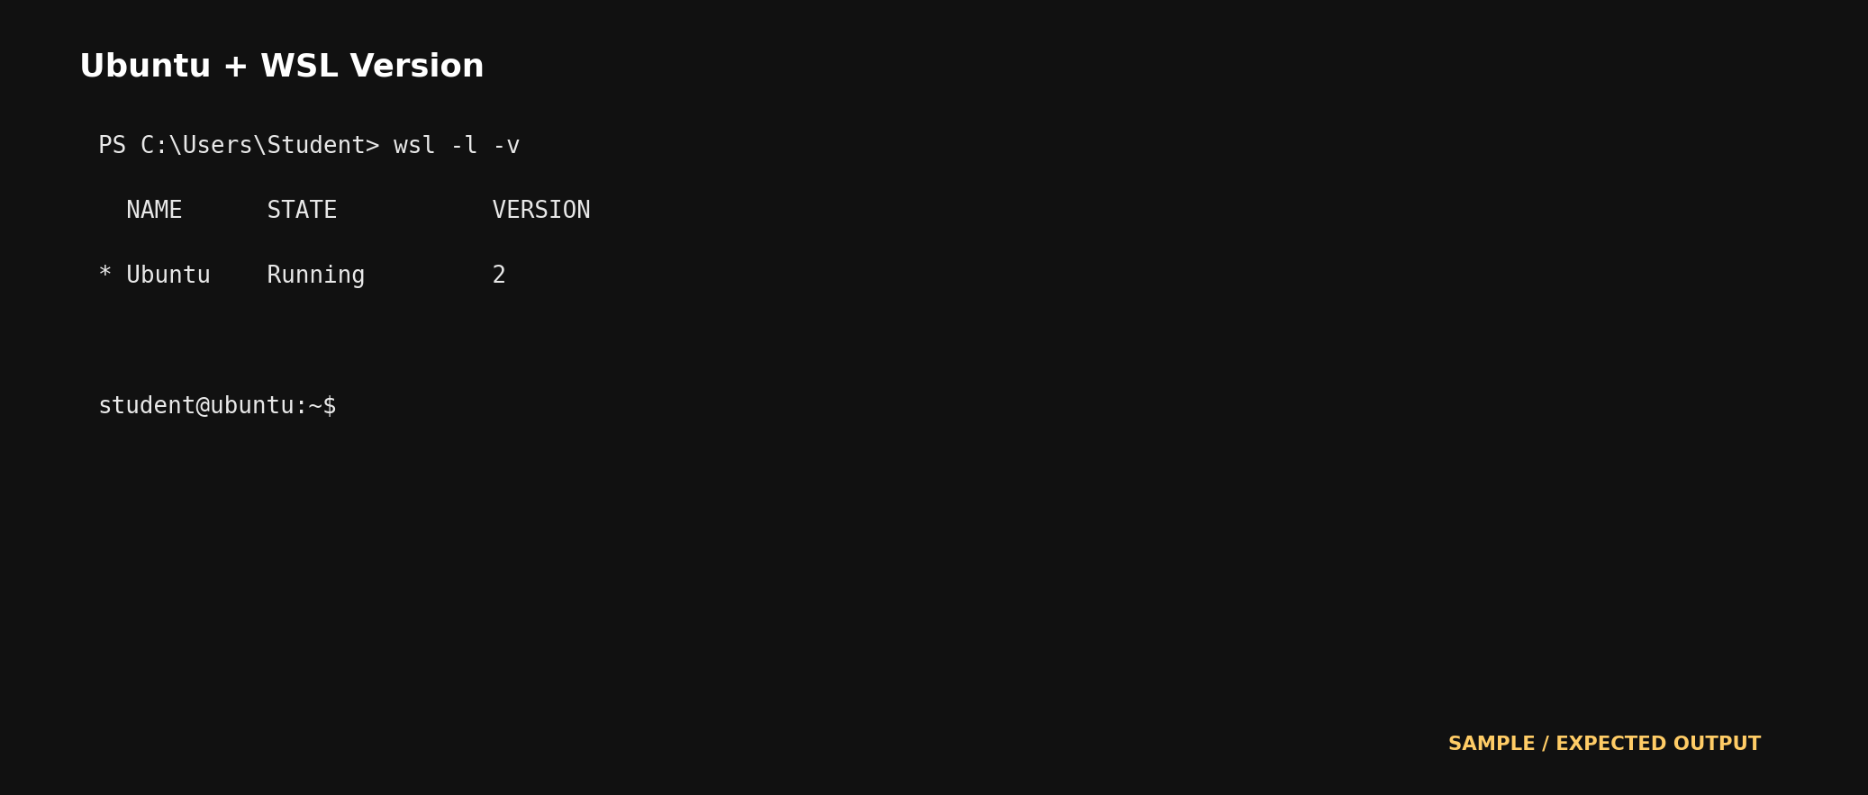
Evidence Space: Paste WSL distribution/version screenshot. (expand this space if required).
Evidence: WSL2 Ubuntu installation completed.
Sample result: Ubuntu opens successfully, Linux username is created, and `wsl -l -v` shows Ubuntu with VERSION 2.
Screenshot: Paste the WSL distribution/version screenshot here if required.
Part C - Update Ubuntu and Install Java/SSH
All commands from this point must be typed inside the Ubuntu terminal, not in Windows PowerShell.
sudo apt update
sudo apt upgrade -y
sudo apt install -y openjdk-11-jdk openssh-server rsync wget tar nano
java -version
sudo service ssh start
ssh localhost
exit
When SSH asks whether to continue connecting, type yes. If Ubuntu asks for password, enter the Linux user password.
Checkpoint | Expected observation | Verified
Ubuntu packages updated | apt update and upgrade finish without fatal error. | ✓
Java verified | java -version displays OpenJDK. | ✓
SSH tested | ssh localhost opens a shell and exit returns to the prompt. | ✓
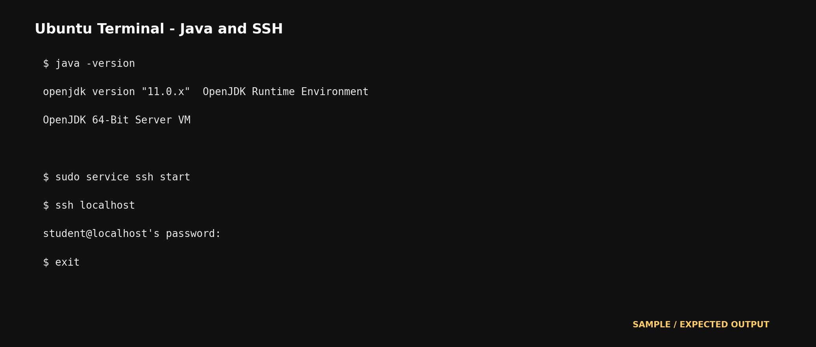
Evidence Space: Paste Java and SSH verification screenshots. (expand this space if required).
Evidence: Java and SSH verification completed.
Sample result: `java -version` displays OpenJDK 11 and `ssh localhost` opens the local shell successfully.
Screenshot: Paste Java version and SSH localhost screenshots here if required.
Part D - Create Hadoop User and Passwordless SSH
Create a dedicated Hadoop user. This helps separate Hadoop files from the normal Ubuntu account.
sudo adduser hduser
sudo usermod -aG sudo hduser
su - hduser
ssh-keygen -t rsa -P '' -f ~/.ssh/id_rsa
cat ~/.ssh/id_rsa.pub >> ~/.ssh/authorized_keys
chmod 0600 ~/.ssh/authorized_keys
ssh localhost
exit
Checkpoint | Expected observation | Verified
hduser created | Prompt changes after su - hduser. | ✓
SSH key generated | id_rsa and authorized_keys are created. | ✓
Passwordless SSH works | ssh localhost logs in without asking hduser password. | ✓
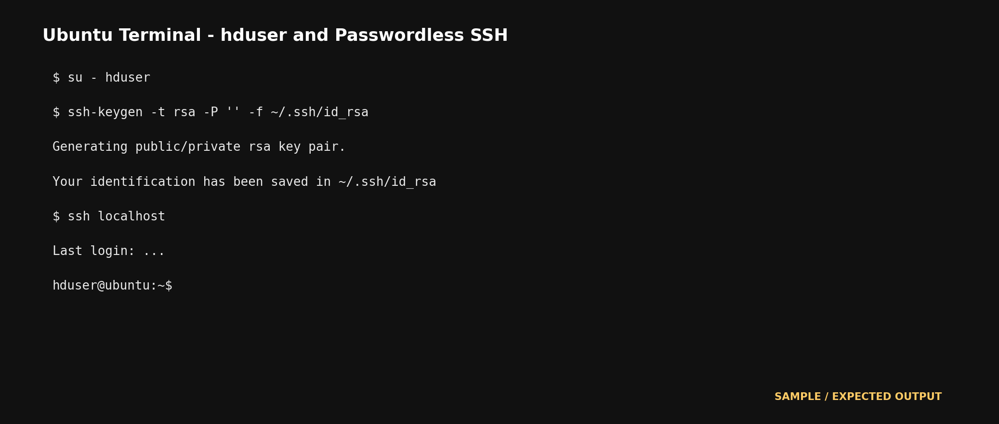
Evidence Space: Paste hduser and passwordless SSH evidence. (expand this space if required).
Evidence: Hadoop user and passwordless SSH completed.
Sample result: The prompt changes to `hduser`, SSH keys are generated, and `ssh localhost` logs in without requesting the hduser password.
Screenshot: Paste the hduser and SSH evidence here if required.
Part E - Download and Install Hadoop
Use an official Apache Hadoop binary release. If the exact version is unavailable later, open the Apache downloads page and select the latest stable Hadoop 3.x binary tar.gz file.
cd ~
wget https://downloads.apache.org/hadoop/common/hadoop-3.4.2/hadoop-3.4.2.tar.gz
tar -xzf hadoop-3.4.2.tar.gz
sudo mv hadoop-3.4.2 /usr/local/hadoop
sudo chown -R hduser:hduser /usr/local/hadoop
/usr/local/hadoop/bin/hadoop version
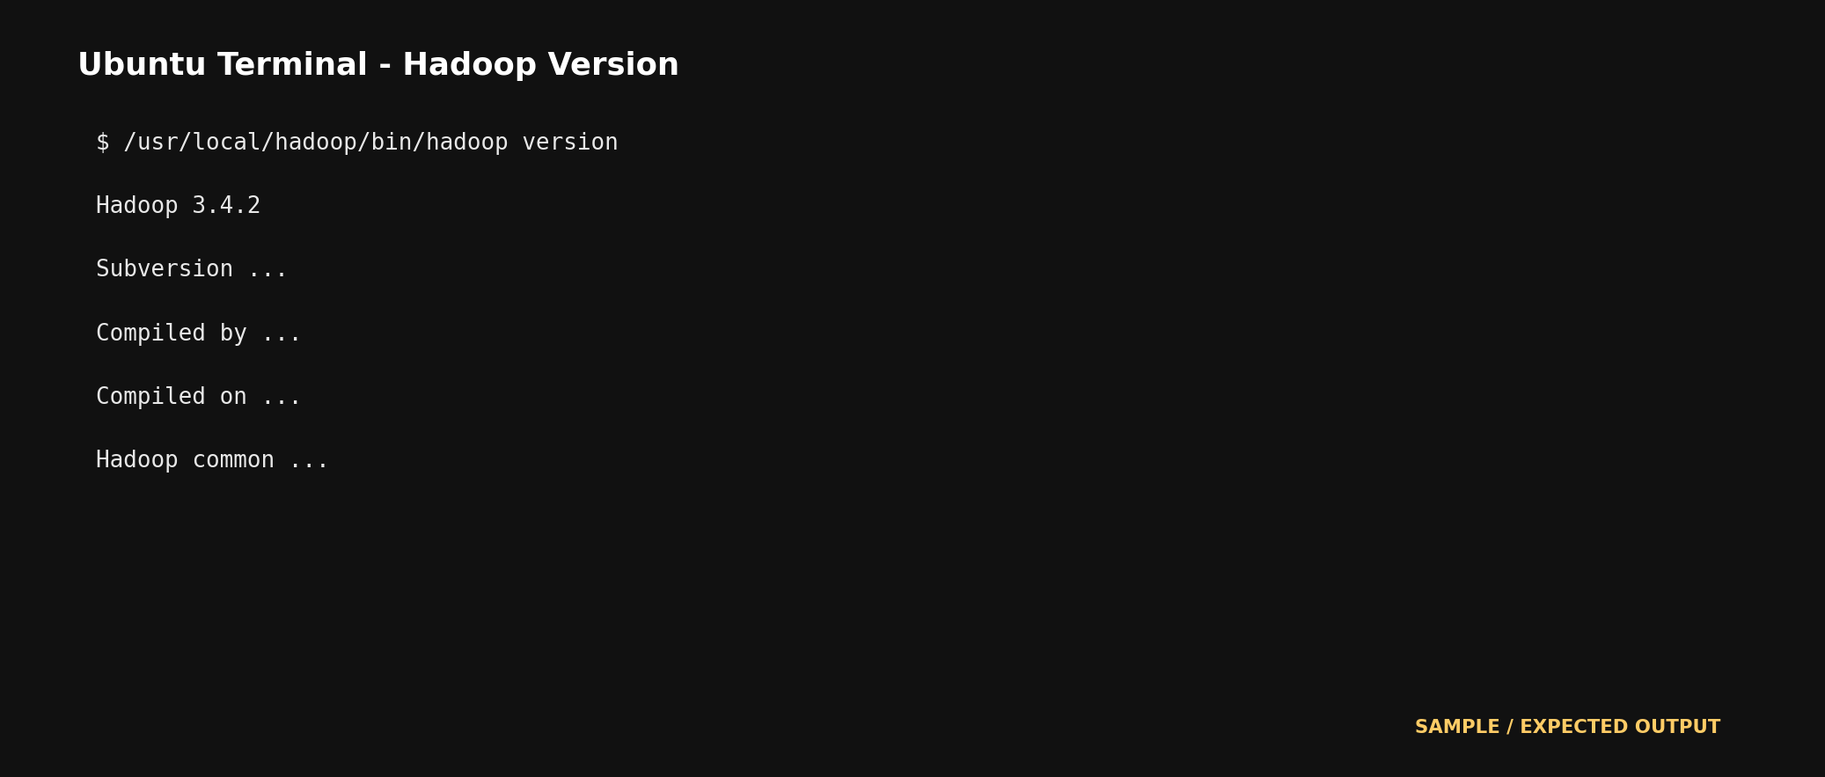
Evidence Space: Paste Hadoop version output. (expand this space if required).
Evidence: Hadoop installation completed.
Sample result:
Hadoop 3.4.2
Hadoop version information is displayed successfully.
Screenshot: Paste the Hadoop version output here if required.
Part F - Set Hadoop Environment Variables
Open the shell configuration file for hduser and add Hadoop paths.
nano ~/.bashrc
# Add at the end:
export JAVA_HOME=/usr/lib/jvm/java-11-openjdk-amd64
export HADOOP_HOME=/usr/local/hadoop
export HADOOP_INSTALL=$HADOOP_HOME
export HADOOP_MAPRED_HOME=$HADOOP_HOME
export HADOOP_COMMON_HOME=$HADOOP_HOME
export HADOOP_HDFS_HOME=$HADOOP_HOME
export YARN_HOME=$HADOOP_HOME
export HADOOP_COMMON_LIB_NATIVE_DIR=$HADOOP_HOME/lib/native
export PATH=$PATH:$HADOOP_HOME/sbin:$HADOOP_HOME/bin
source ~/.bashrc
hadoop version
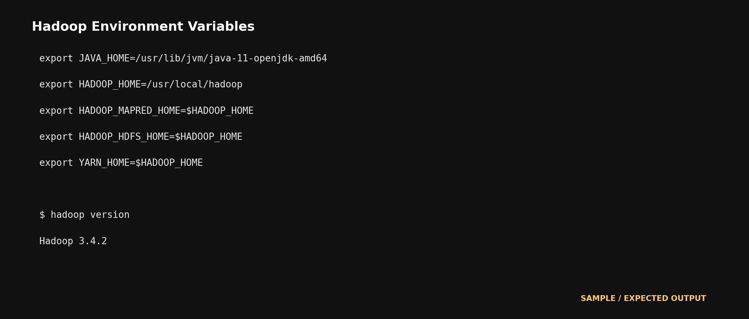
Evidence Space: Paste environment variable section and hadoop version output. (expand this space if required).
Evidence: Hadoop environment variables configured.
Sample result: JAVA_HOME and HADOOP_HOME are set; `hadoop version` returns Hadoop 3.4.2 successfully.
Screenshot: Paste the environment-variable section and Hadoop version output here if required.
Part G - Configure Hadoop XML Files
Edit the Hadoop configuration files. These settings make Hadoop run as a single-node pseudo-distributed cluster in WSL Ubuntu.
cd /usr/local/hadoop/etc/hadoop
nano hadoop-env.sh
# Set or replace:
export JAVA_HOME=/usr/lib/jvm/java-11-openjdk-amd64
nano core-site.xml
<configuration>
<property>
<name>fs.defaultFS</name>
<value>hdfs://localhost:9000</value>
</property>
</configuration>
mkdir -p /usr/local/hadoop/hadoop_data/hdfs/namenode
mkdir -p /usr/local/hadoop/hadoop_data/hdfs/datanode
nano hdfs-site.xml
<configuration>
<property><name>dfs.replication</name><value>1</value></property>
<property><name>dfs.namenode.name.dir</name><value>file:/usr/local/hadoop/hadoop_data/hdfs/namenode</value></property>
<property><name>dfs.datanode.data.dir</name><value>file:/usr/local/hadoop/hadoop_data/hdfs/datanode</value></property>
</configuration>
cp mapred-site.xml.template mapred-site.xml 2>/dev/null || true
nano mapred-site.xml
<configuration>
<property><name>mapreduce.framework.name</name><value>yarn</value></property>
</configuration>
nano yarn-site.xml
<configuration>
<property><name>yarn.nodemanager.aux-services</name><value>mapreduce_shuffle</value></property>
</configuration>
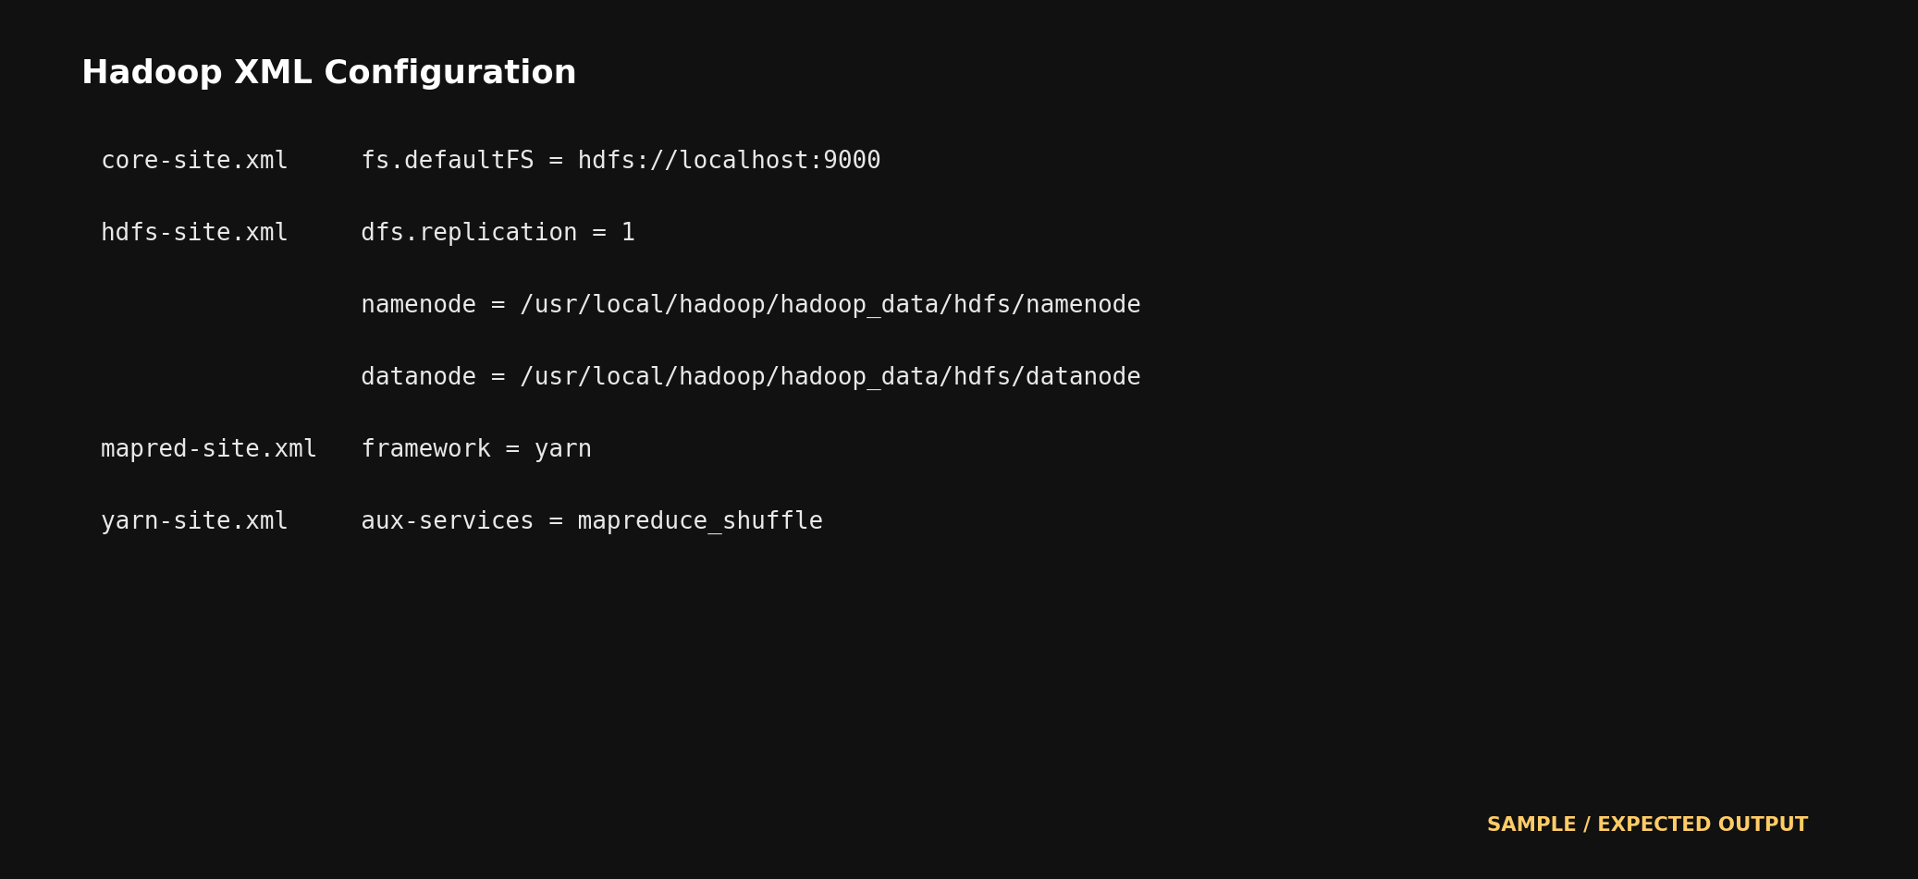
Evidence Space: Paste screenshots of the edited XML files. (expand this space if required).
Evidence: Hadoop XML configuration completed.
Configured files: hadoop-env.sh, core-site.xml, hdfs-site.xml, mapred-site.xml and yarn-site.xml.
Key settings: HDFS uses localhost:9000, replication is 1, MapReduce uses YARN, and the YARN MapReduce shuffle service is enabled.
Screenshot: Paste the edited XML file screenshots here if required.
Part H - Format NameNode and Start Hadoop
Format NameNode only during the first setup. Then start HDFS and YARN services.
hdfs namenode -format
start-dfs.sh
start-yarn.sh
jps
Expected jps result
Look for NameNode, DataNode, SecondaryNameNode, ResourceManager and NodeManager. If one is missing, use the troubleshooting section.
Checkpoint | Expected observation | Verified
NameNode available | jps shows NameNode. | ✓
DataNode available | jps shows DataNode. | ✓
YARN available | jps shows ResourceManager and NodeManager. | ✓
HDFS UI opens | Windows browser opens http://localhost:9870. | ✓
YARN UI opens | Windows browser opens http://localhost:8088. | ✓
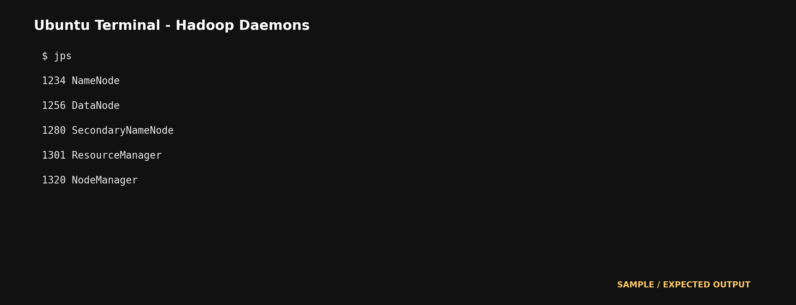
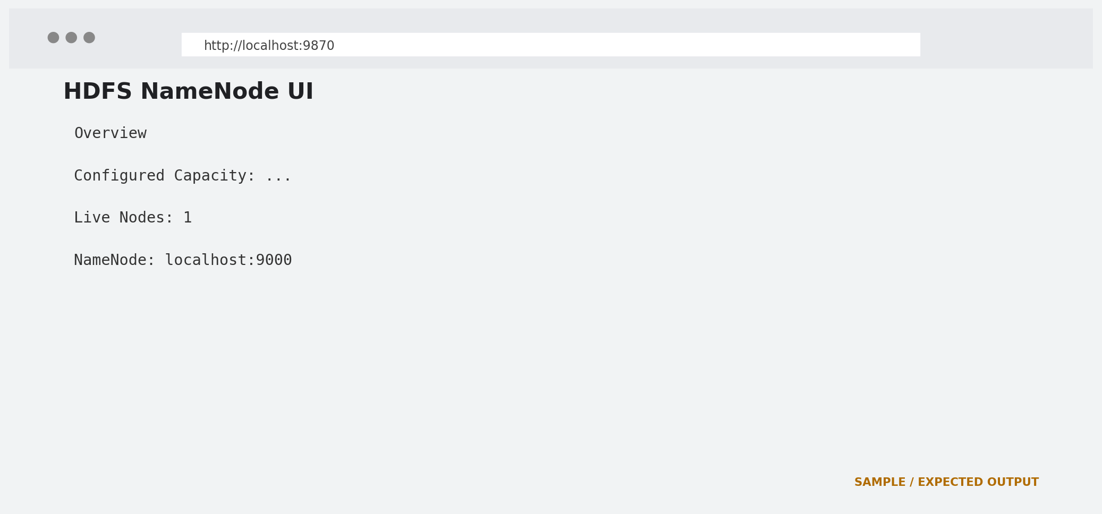
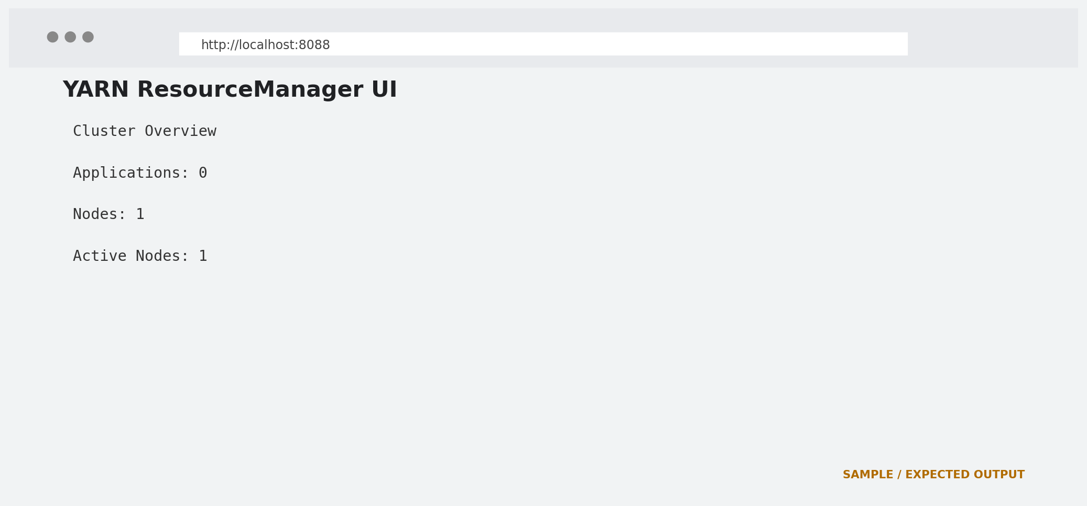
Evidence Space: Paste jps output, HDFS UI and YARN UI screenshots. (expand this space if required).
Evidence: Hadoop services started successfully.
Expected `jps`:
NameNode
DataNode
SecondaryNameNode
ResourceManager
NodeManager
HDFS UI: http://localhost:9870
YARN UI: http://localhost:8088
Screenshot: Paste jps, HDFS UI and YARN UI screenshots here if required.
Guided Project 1 - Word Frequency Analytics using Hadoop MapReduce
Scenario
A cloud product generates activity logs. The product owner wants to know which actions occur most frequently. You will upload a small log file into HDFS and run MapReduce WordCount.
Perform
mkdir -p ~/hadoop_wordcount/input
cat > ~/hadoop_wordcount/input/app_log.txt <<'EOF'
login search booking payment logout
login search search booking complaint
payment booking notification search
login login booking analytics report
EOF
hdfs dfs -mkdir -p /user/hduser/wordcount/input
hdfs dfs -put -f ~/hadoop_wordcount/input/app_log.txt /user/hduser/wordcount/input/
hdfs dfs -ls /user/hduser/wordcount/input
hdfs dfs -cat /user/hduser/wordcount/input/app_log.txt
hdfs dfs -rm -r -f /user/hduser/wordcount/output
hadoop jar /usr/local/hadoop/share/hadoop/mapreduce/hadoop-mapreduce-examples-*.jar wordcount /user/hduser/wordcount/input /user/hduser/wordcount/output
hdfs dfs -ls /user/hduser/wordcount/output
hdfs dfs -cat /user/hduser/wordcount/output/part-r-00000
Observe and Record
Checkpoint | Expected observation | Verified
Input uploaded | HDFS lists app_log.txt. | ✓
MapReduce completed | Terminal shows successful job completion. | ✓
Output created | part-r-00000 appears. | ✓
Counts interpreted | Student identifies frequent words/actions. | ✓
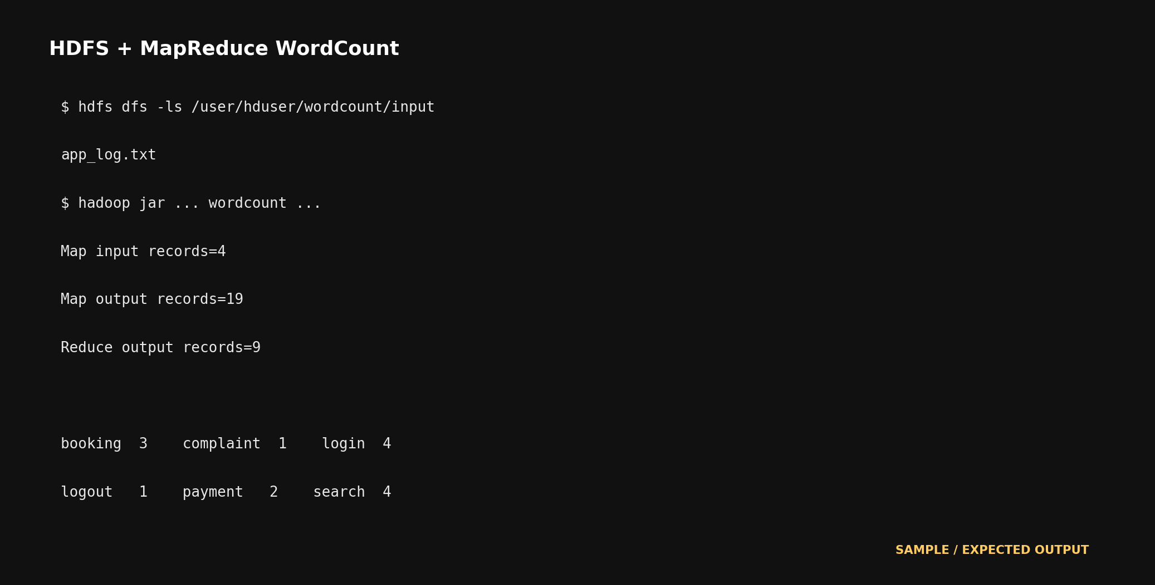
Paste terminal output showing HDFS upload and WordCount result. (expand this space if required).
WordCount output:
analytics 1
booking 4
complaint 1
login 4
logout 1
notification 1
payment 2
report 1
search 4
Most frequent actions are login, search and booking, each occurring 4 times.
Screenshot: Paste the HDFS upload and WordCount terminal output here if required.
Explain what Map produced, what Reduce produced, and how this relates to your capstone product. (expand this space if required).
Map: Reads each input line, splits it into words and emits each word with the value 1, such as (login,1).
Reduce: Groups identical words and adds their values to produce final counts, such as (login,4).
Capstone relation: This demonstrates how a cloud product can analyze activity logs to identify the most common user actions and support product decisions.
Extend
Add five more lines connected to your capstone project, rerun WordCount, and compare the new output with the earlier output.
nano ~/hadoop_wordcount/input/app_log.txt
hdfs dfs -put -f ~/hadoop_wordcount/input/app_log.txt /user/hduser/wordcount/input/
hdfs dfs -rm -r -f /user/hduser/wordcount/output2
hadoop jar /usr/local/hadoop/share/hadoop/mapreduce/hadoop-mapreduce-examples-*.jar wordcount /user/hduser/wordcount/input /user/hduser/wordcount/output2
hdfs dfs -cat /user/hduser/wordcount/output2/part-r-00000
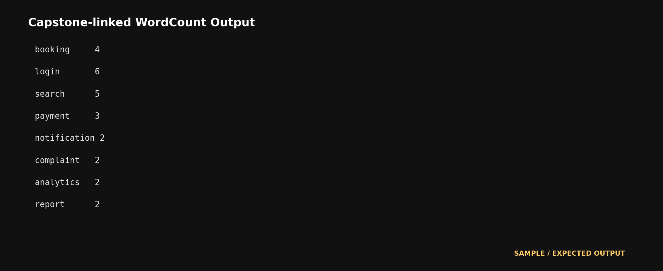
Paste capstone-linked WordCount output and write the insight obtained. (expand this space if required).
Capstone-linked extension output (after adding five related activity-log lines):
analytics 2
booking 7
complaint 1
login 6
logout 1
notification 2
payment 5
report 1
search 6
support 1
Insight: Booking is now the most frequent action (7), followed by login and search (6 each). Payment also increases to 5, showing growing user activity around transactions.
Screenshot: Paste the modified WordCount output here if required.
Allied Big Data Tools After Hadoop Core
PySpark in Google Colab
Use this when Spark practice is needed without installing Spark locally.
!pip install pyspark -q
from pyspark.sql import SparkSession
from pyspark.sql.functions import explode, split, col
spark = SparkSession.builder.appName('CSA15BigData').getOrCreate()
data = [('login search booking',), ('payment booking search',), ('login analytics report',)]
df = spark.createDataFrame(data, ['line'])
words = df.select(explode(split(col('line'), ' ')).alias('word'))
words.groupBy('word').count().orderBy('count', ascending=False).show()
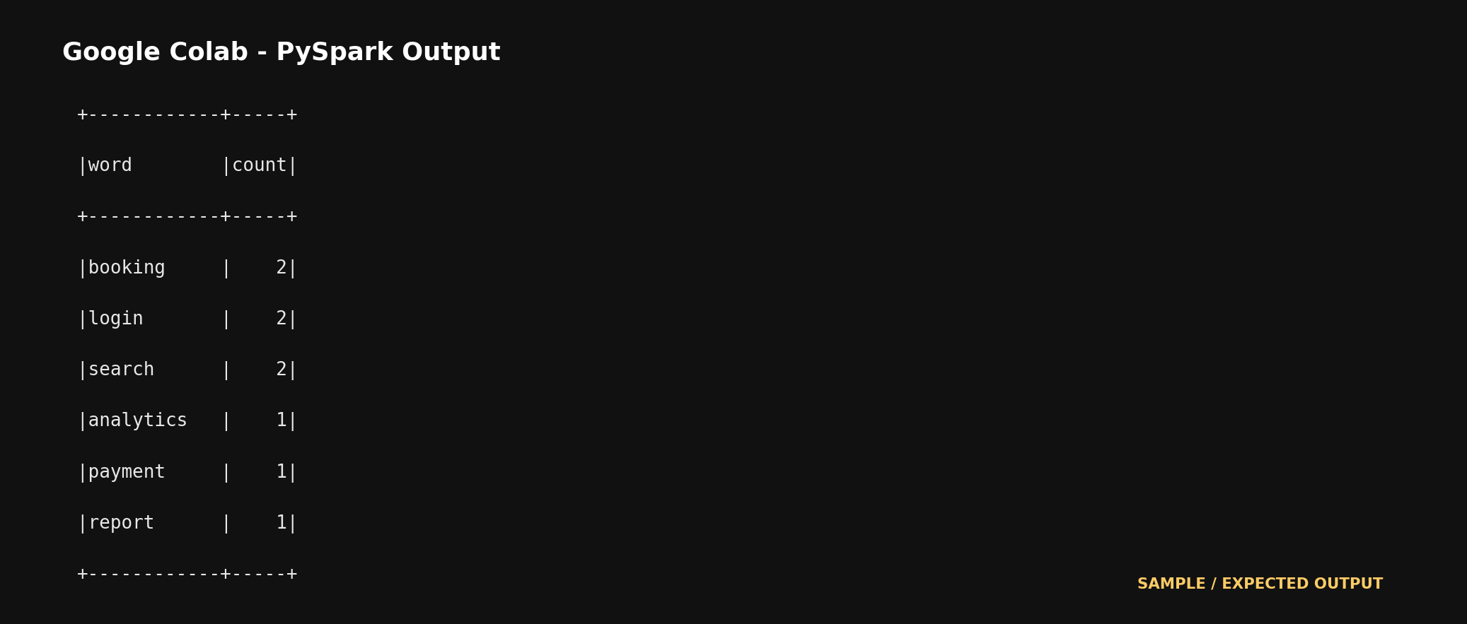
Paste PySpark output and write one difference between Hadoop MapReduce and Spark. (expand this space if required).
PySpark output:
+------------+-----+
| word|count|
+------------+-----+
| login| 2|
| search| 2|
| booking| 2|
| payment| 1|
| analytics| 1|
| report| 1|
+------------+-----+
Difference: Hadoop MapReduce processes data mainly through separate Map and Reduce stages, while Spark keeps intermediate data in memory when possible, which can make repeated or interactive analytics faster.
Dashboard Visualization
Export the Hadoop output and visualize it using Power BI, Looker Studio, Tableau Public or Canva Charts.
hdfs dfs -cat /user/hduser/wordcount/output2/part-r-00000 > ~/wordcount_output.txt
awk '{print $1","$2}' ~/wordcount_output.txt > ~/wordcount_output.csv
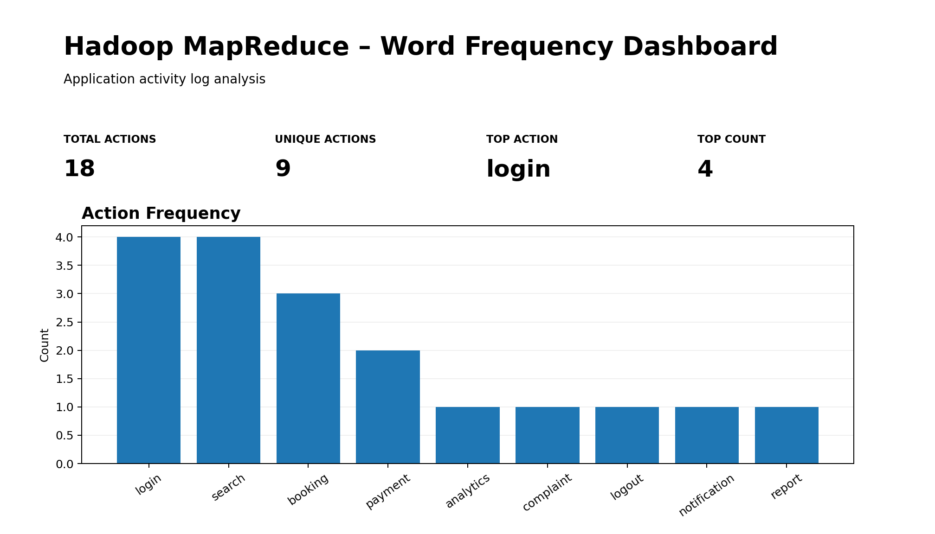
Chart used: Bar chart showing the frequency of application actions. The dashboard indicates that login and search are the most frequent actions.
Paste dashboard screenshot and mention the chart used. (expand this space if required).
Dashboard: Use a bar/column chart with `Action` on the X-axis and `Count` on the Y-axis.
Suggested title: Cloud Product Activity – Word Frequency.
The chart highlights the most frequent user actions from the Hadoop WordCount output.
Screenshot: Paste the completed dashboard screenshot here if required.
Troubleshooting
Issue | Possible reason | Correction
wsl command not found | WSL is not installed or Windows is not updated. | Use Windows Update and follow manual WSL installation.
Ubuntu does not open | Installation incomplete or restart pending. | Restart Windows and open Ubuntu again.
sudo apt update fails | Network or proxy issue. | Check internet and retry later.
ssh localhost refused | SSH service not started. | Run sudo service ssh start.
jps does not show daemons | Hadoop services did not start correctly. | Check XML files and run start-dfs.sh/start-yarn.sh again.
Output folder already exists | Hadoop will not overwrite output. | Delete output path before rerun.
Submission Checklist
Checkpoint | Expected observation | Verified
WSL evidence | Windows WSL version screenshot. | ✓
Ubuntu evidence | Ubuntu terminal screenshot. | ✓
Java/SSH evidence | Java version and SSH localhost verified. | ✓
Hadoop evidence | Hadoop version and XML configuration evidence. | ✓
Daemon evidence | jps output and web UI screenshots. | ✓
MapReduce evidence | WordCount input/output evidence. | ✓
Capstone extension | Capstone-linked modified dataset and output. | ✓
Allied tool evidence | PySpark or dashboard evidence, if completed. | ✓
GitHub repository | Workbook and screenshots uploaded. | ✓
Google Classroom | Final file submitted in GCR. | ✓
Assessment Rubric
Criterion | Expected quality | Marks
Windows/WSL setup | WSL Ubuntu is installed and verified. | 15
Dependency setup | Java, SSH and Hadoop are installed with evidence. | 20
Hadoop configuration | HDFS/YARN XML files are configured correctly. | 20
MapReduce execution | WordCount runs and output is interpreted. | 20
Capstone connection | Student extends the dataset using capstone context. | 15
Submission quality | GitHub/GCR evidence is complete and readable. | 10
Official References
Reference | Official link
Microsoft WSL Documentation | https://learn.microsoft.com/en-us/windows/wsl/
Install WSL | https://learn.microsoft.com/en-us/windows/wsl/install
Manual WSL Installation | https://learn.microsoft.com/en-us/windows/wsl/install-manual
Apache Hadoop Single Node Cluster | https://hadoop.apache.org/docs/stable/hadoop-project-dist/hadoop-common/SingleCluster.html
Apache Hadoop MapReduce Tutorial | https://hadoop.apache.org/docs/stable/hadoop-mapreduce-client/hadoop-mapreduce-client-core/MapReduceTutorial.html
Apache Spark Documentation | https://spark.apache.org/docs/latest/
PySpark Installation | https://spark.apache.org/docs/latest/api/python/getting_started/install.html

