 | SIMATS ENGINEERING  Department of Computer Science and Engineering
CSA15 Cloud Computing and Big Data Analytics
CO4 AT2 - Big Data Industry Problem Solving Guided Tool Workbook
Course Code | CSA1517 | Slot | C
Assessment | CO4 AT2 | Bloom Level | BL4 - Analyze
Faculty | Dr C. Rajesh Babu | Employee ID | SSETSCS415
Mode | Individual guided tool-based workbook | Submission | GitHub repository link through Google Classroom
End Evidence | Workbook + screenshots + diagrams + dashboard/mockup | Marks | 30

Student Details
Student Name | M.Naga Shalini | Register Number | 192524183
Class / Section | BTECH-AIML | Slot | C
Selected Scenario | Scenario 1: Healthcare Emergency Analytics | Submission Date | 20-08-2026
GitHub Link | https://github.com/maditatishalini3-sudo/csa1517-cloud-computing | Google Classroom Status | Uploaded

Workbook Purpose
What this workbook does
This workbook guides students to use real software tools and official technical references to derive a big-data industry solution. Students should learn from the tool, observe patterns, record evidence and then write their own technical explanation.
- Do not copy full text from websites or AI tools.
- Use official references to justify architecture, processing and security decisions.
- Screenshots are evidence; explanations are the actual assessment answer.

Scenario Bank
Instruction
Faculty may assign one scenario or ask students to complete more than one. If no specific scenario is assigned, select one scenario and complete all tool-guided sections for that scenario.
No. | Scenario | Data Context
1 | Healthcare Emergency Analytics | Emergency department data, ambulance updates, bed availability, alerts and treatment delays.
2 | E-Commerce Customer Behavior Intelligence | Clickstream events, cart abandonment, payment failure, campaign traffic and recommendation impact.
3 | Smart Agriculture Advisory Platform | Weather, soil sensors, crop advisories, pest reports, market prices and farmer app interactions.
4 | Cybersecurity Threat Monitoring | Authentication logs, firewall alerts, API access logs, failed login attempts and suspicious network events.
5 | Public Transport Demand Analytics | Ticketing data, bus GPS, passenger count, route delay, peak-hour demand and crowding alerts.

Selected Scenario and Reason
Selected Scenario: Scenario 1 - Healthcare Emergency Analytics. Reason: this scenario extends directly from my CO3 AT1/AT2 capstone work on MedAdhere, a healthcare adherence-monitoring product, so the domain knowledge (patient data, alerts, dashboards, privacy constraints) carries over. It also gives clear urgency (emergency department decisions), a natural batch-vs-streaming split (historical admissions vs live ambulance/bed updates), and realistic security concerns around patient health data, which map well to all four guided tool modules.

Guided Tool Module 1: Use Cloud Architecture Centers
Purpose: Use official cloud architecture references to identify suitable ingestion, storage, processing, analytics and security components for the selected scenario.
No. | Perform |  | Observe / Decide |  | Record in Workbook
1 | Open AWS Architecture Center, Azure Architecture Center and Google Cloud Architecture Center in three browser tabs. |  | You are not copying a full architecture. You are learning common cloud patterns and service categories. |  | Paste the three page titles or URLs.
2 | Search each site using terms from your scenario, such as healthcare analytics, streaming analytics, data lake, retail analytics, IoT analytics or security monitoring. |  | Notice which patterns repeatedly appear: ingestion, data lake, warehouse, processing, ML/analytics, visualization and security. |  | Record at least one useful reference from each cloud provider.
3 | Identify the services/components mentioned in the reference diagrams. |  | Separate service category from vendor-specific service name. Example: object storage is the category; Amazon S3/Azure Blob Storage/Cloud Storage are service examples. |  | Complete the tool-category table.
4 | Compare the three references. |  | Choose the most suitable architecture pattern for your scenario and explain why. |  | Write a short justification.
5 | Draw your own provider-neutral architecture in draw.io. |  | Your diagram must show data sources -> ingestion -> storage -> processing -> analytics/dashboard -> users, with security controls. |  | Paste the diagram screenshot/link.
Cloud Provider |  | Reference Page / URL |  | Useful Pattern Found |  | Useful Service Categories
AWS |  | aws.amazon.com/architecture (Healthcare & analytics lens) |  | Ingest -> Data Lake -> Analytics -> Dashboard pattern |  | Kinesis (ingestion), S3 (object storage), Glue/EMR (processing), QuickSight (analytics)
Azure |  | learn.microsoft.com/azure/architecture (Healthcare/IoT analytics patterns) |  | Event-driven ingestion -> Data Lake -> Warehouse -> BI pattern |  | Event Hubs (ingestion), Data Lake Storage, Synapse Analytics, Power BI
Google Cloud |  | docs.cloud.google.com/architecture (Data analytics reference architectures) |  | Streaming ingestion -> BigQuery -> ML/analytics -> dashboard pattern |  | Pub/Sub (ingestion), Cloud Storage, BigQuery, Looker Studio

Cloud Architecture Justification
Across AWS, Azure and Google Cloud, the same underlying pattern repeats: stream/event ingestion -> a central data lake or warehouse -> a processing/analytics layer -> a BI/dashboard layer, wrapped in identity and encryption controls. For Healthcare Emergency Analytics I recommend an event-driven ingestion service (Kinesis/Event Hubs/Pub-Sub) feeding a data lake, with Spark-based processing splitting batch history from live streaming alerts, and a BI tool on top. This pattern is preferred over a simple single-database design because emergency data has both a real-time component (bed status, ambulance ETA) and a historical component (admission trends), which a single request-response database cannot serve efficiently at scale.

Architecture Diagram Evidence
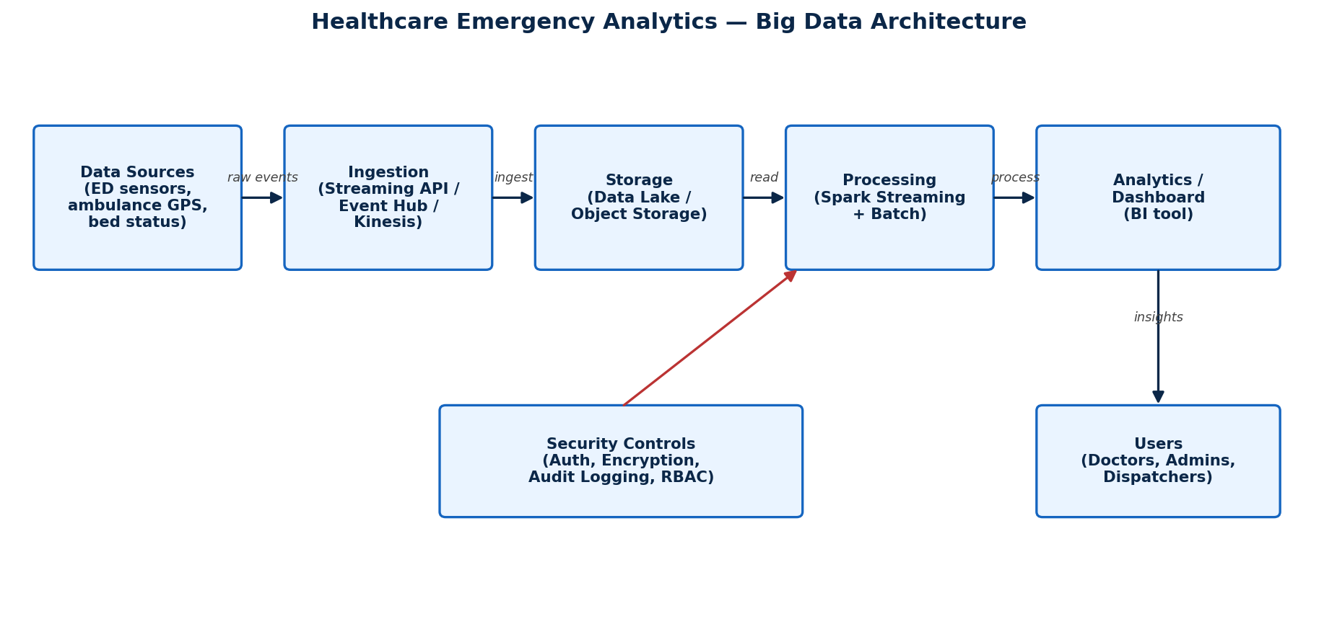
Provider-neutral architecture: data sources (ED sensors, ambulance GPS, bed status) -> ingestion (streaming API) -> storage (data lake) -> processing (Spark batch + streaming) -> analytics/dashboard -> users (doctors, admins, dispatchers), with security controls (authentication, encryption, audit logging, RBAC) applied across the ingestion and processing layers.

Guided Tool Module 2: Use Hadoop and Spark Documentation
Purpose: Decide whether your problem needs batch processing, streaming processing or hybrid processing by reading official Hadoop/Spark documentation.
No. | Perform |  | Observe / Decide |  | Record in Workbook
1 | Open the Apache Hadoop MapReduce tutorial. |  | MapReduce is suitable when large stored data can be processed in batches, such as daily logs or historical transactions. |  | Write one sentence on what mapper and reducer mean.
2 | Open the Apache Spark Structured Streaming guide. |  | Structured Streaming is suitable when new events continuously arrive, such as sensors, clickstream, live alerts or location updates. |  | Write one sentence on what streaming source, processing and sink mean.
3 | Classify your scenario data into batch data and streaming data. |  | Historical records normally become batch data; live sensor/log/API updates normally become streaming data. |  | Complete the batch-vs-stream table.
4 | Choose one processing approach for your scenario: Hadoop/MapReduce, Spark batch, Spark streaming or hybrid. |  | The decision must match the data velocity and decision urgency. |  | Write your processing decision.
5 | Prepare a simple pseudo-flow, not full code. |  | Example: Mapper reads log line -> emits hour, count. Reducer sums counts. Dashboard shows peak hour. |  | Write pseudo-flow or paste diagram.
Data Item |  | Batch / Streaming |  | Why |  | Suggested Framework
Historical patient visit/admission records |  | Batch |  | Used for trend analysis, not needed instantly |  | Hadoop/MapReduce or Spark batch
Live ambulance GPS/ETA updates |  | Streaming |  | Needs immediate routing decisions |  | Spark Structured Streaming
Real-time bed availability updates |  | Streaming |  | Beds must be allocated as soon as they free up |  | Spark Structured Streaming
Daily treatment delay logs |  | Batch |  | Aggregated once per day for reporting |  | Spark batch
Emergency alert events (code red, mass casualty) |  | Streaming |  | Requires instant escalation |  | Spark Structured Streaming
Monthly compliance/audit reports |  | Batch |  | Generated periodically, not time-critical |  | Hadoop/MapReduce

Processing Framework Decision
Mapper: a small program that reads raw records (e.g. one log/event line) and emits key-value pairs, such as (hour, 1) for an admission timestamp. Reducer: a program that receives all values for the same key and aggregates them, such as summing counts per hour. Streaming source, processing and sink: the source is where live events originate (ambulance GPS pings, bed-status updates); processing is the continuous transformation applied as each event arrives (e.g. computing current free-bed count); the sink is where results land for consumption (a live dashboard or alert queue). Decision: Healthcare Emergency Analytics needs a hybrid approach - Spark Structured Streaming for live ambulance/bed/alert events that need immediate action, and Hadoop/Spark batch for historical admission and compliance reporting that only needs periodic aggregation.

MapReduce / Spark Pseudo-Flow
Batch pseudo-flow (daily admissions): Mapper reads each admission record -> emits (hour_of_day, 1). Reducer sums counts per hour -> Dashboard shows peak admission hour. Streaming pseudo-flow (live bed status): Source receives bed-status change event -> Processing recomputes free-bed count per department -> Sink pushes updated count to the live dashboard and triggers an alert if free beds fall below a safety threshold.

Guided Tool Module 3: Threat Modeling with OWASP Threat Dragon / Microsoft Tool
Purpose: Identify privacy and security risks in the big-data solution before proposing controls.
Tool Choice
Use OWASP Threat Dragon if you need a web/desktop cross-platform threat modeling tool. Use Microsoft Threat Modeling Tool when a Windows system is available. The required evidence is the threat model diagram and threat-control table.
No. | Perform |  | Observe / Decide |  | Record in Workbook
1 | Open OWASP Threat Dragon or Microsoft Threat Modeling Tool. |  | A threat model is a security diagram that shows components, data flows, trust boundaries and possible threats. |  | Write which tool you used.
2 | Create a new threat model named with your scenario. |  | Use a clear title such as CO4_AT2_Healthcare_Emergency_Analytics. |  | Paste model name.
3 | Add external entities. |  | External entities are users/systems outside your platform: patient, customer, sensor, payment gateway, bus GPS device, public API. |  | List at least two external entities.
4 | Add processes and data stores. |  | Processes transform data; data stores hold data. Example: ingestion API, stream processor, data lake, warehouse, dashboard. |  | List processes and stores.
5 | Draw data flows and trust boundaries. |  | Trust boundaries mark where security assumptions change: public internet to cloud, app to API, processing layer to storage. |  | Paste screenshot of DFD.
6 | Identify threats using STRIDE thinking. |  | Spoofing, Tampering, Repudiation, Information Disclosure, Denial of Service and Elevation of Privilege help structure risks. |  | Complete the threat table.
7 | Write mitigations. |  | Controls may include authentication, authorization, encryption, masking, audit logs, rate limits, backup and monitoring. |  | Map every threat to one control.
Component / Data Flow |  | Threat |  | Impact |  | Mitigation
Patient portal -> Ingestion API |  | Spoofing (fake patient/device identity) |  | Unauthorized data injection |  | Mutual TLS + API key/JWT authentication
Ingestion API -> Data Lake |  | Tampering (altered vitals/alerts) |  | Wrong triage decisions |  | Checksums, write-once storage, audit logging
Data Lake -> Processing layer |  | Information Disclosure (PHI exposure) |  | Privacy violation of patient health data |  | Encryption at rest/in transit, field-level masking
Processing -> Dashboard |  | Denial of Service (flooding alert stream) |  | Delayed emergency response |  | Rate limiting, autoscaling, circuit breakers
Admin access to warehouse |  | Elevation of Privilege |  | Unauthorized access to all patient records |  | Role-based access control, least privilege
Audit/logging service |  | Repudiation (denying an action was taken) |  | Cannot trace who changed a record |  | Immutable audit logs with timestamps and user IDs

Threat Model Diagram Evidence
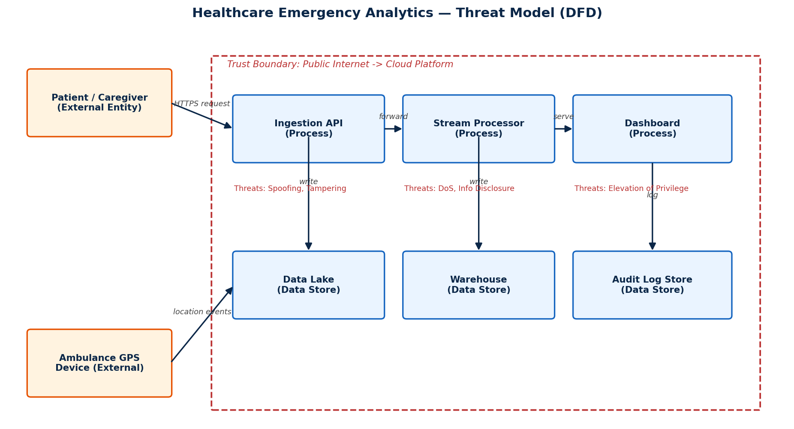
Tool used: OWASP Threat Dragon. Model name: CO4_AT2_Healthcare_Emergency_Analytics. External entities: patient/caregiver (submits data via portal), ambulance GPS device (sends location events). Processes: ingestion API, stream processor, dashboard. Data stores: data lake, warehouse, audit log store. The trust boundary marks the line between the public internet and the cloud platform, where every inbound request must pass an authentication check before reaching internal processes.

Guided Tool Module 4: Dashboard or Analytics Output Mockup
Purpose: Show how raw big data becomes useful decisions through a dashboard, alert, forecast, recommendation or report.
Beginner-Friendly Choice
Use any one: Power BI, Looker Studio, Tableau Public or Canva. If login/install is difficult, Canva dashboard mockup is acceptable. If data connection is possible, Power BI/Looker Studio/Tableau Public is stronger.
No. | Perform |  | Observe / Decide |  |  | Record in Workbook
1 | Prepare a small sample dataset in Excel or Google Sheets with 10-20 rows. |  | Columns should match your scenario. Example: timestamp, user/location, event type, value, status, risk level. |  |  | Paste column names.
2 | Choose the dashboard tool. |  | Power BI/Tableau/Looker are analytics tools; Canva is acceptable for visual mockup when live data connection is blocked. |  |  | Write chosen tool and reason.
3 | Import or recreate the sample data. |  | In Power BI/Looker/Tableau, connect data. In Canva, manually create charts from sample values. |  |  | Paste screenshot of data/chart setup.
4 | Create at least three visual elements. |  | Use KPI card, bar chart, line chart, table, map, alert count or pie/donut chart as appropriate. |  |  | List the visuals.
5 | Add decision labels. |  | A dashboard is useful only if it supports a decision: allocate beds, detect fraud, reroute buses, restock products, warn farmers. |  |  | Write decision supported by each visual.
6 | Export/share screenshot. |  | Paste the final dashboard screenshot or public/report link if available. |  |  | Paste evidence.
Dataset Column |  | Meaning |  |  | Example Value
timestamp |  | Time the event was recorded |  |  | 2026-08-20 14:32
department |  | ED unit/ward reporting the event |  |  | Emergency-A
event_type |  | Type of event logged |  |  | Bed Freed / Alert Raised / Ambulance Arrival
bed_availability |  | Number of free beds in the unit |  |  | 3
delay_minutes |  | Treatment delay in minutes |  |  | 12
risk_level |  | Severity/urgency level of the case |  |  | High
Visual Element |  | Metric Shown |  | Decision Supported
KPI card |  | Current free beds count |  | Allocate beds quickly
Line chart |  | Treatment delay trend over the day |  | Identify bottleneck shifts
Alert count widget |  | Active high-severity alerts |  | Trigger escalation/staffing
Map/heatmap |  | Ambulance location and ETA |  | Reroute ambulances to less busy EDs

Dashboard / Analytics Output Evidence
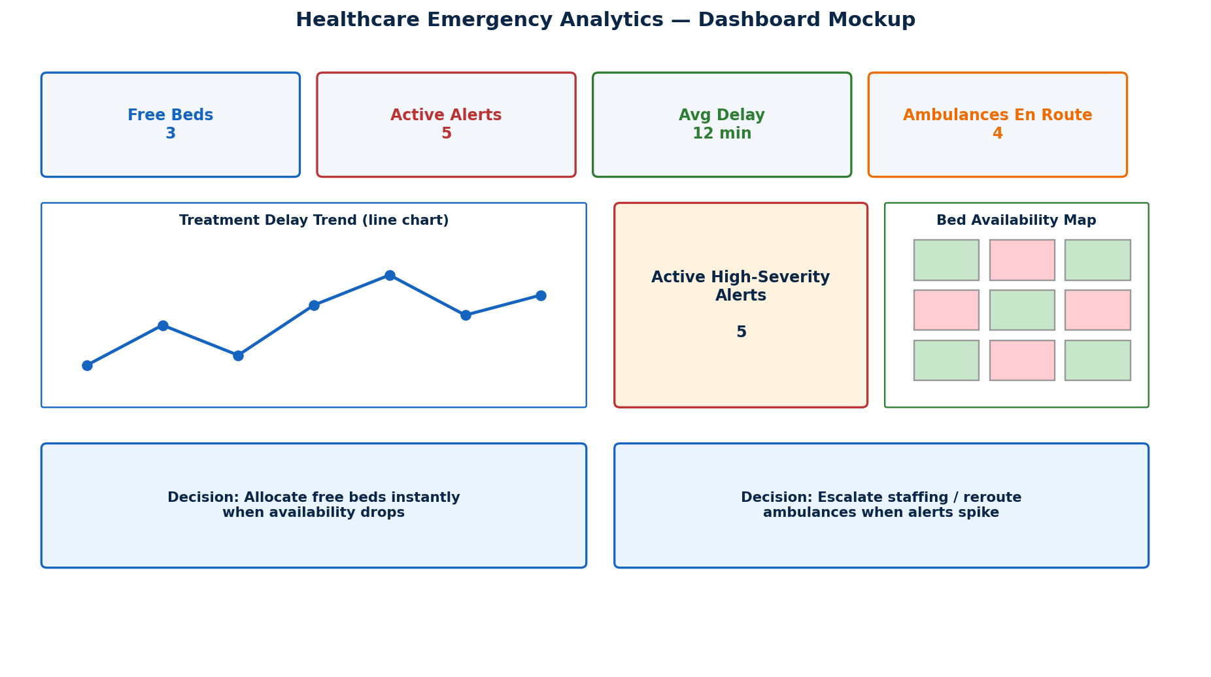
Dashboard mockup built from a 10-15 row sample dataset (timestamp, department, event_type, bed_availability, delay_minutes, risk_level). Four visual elements: a Free Beds KPI card, an Active Alerts KPI card, a treatment-delay line chart, and a bed-availability heatmap/map, each tied to a concrete decision (allocate beds, escalate staffing, reroute ambulances).

Final CO4 AT2 Solution Sections
Final Assembly
After completing the guided tool modules, combine the evidence into the final solution. The final answer must show technical reasoning, not only screenshots.

1. Problem Understanding
What to include: Identify stakeholders, decisions required, data produced, expected analytics output and urgency.

Student Response
Stakeholders: emergency department doctors and nurses, hospital administrators, ambulance dispatchers, and patients/caregivers. Decisions required: which bed to allocate next, whether to reroute an incoming ambulance, when to escalate staffing during a surge, and how to reduce average treatment delay. Data produced: bed-status updates, ambulance GPS/ETA pings, triage and treatment-delay logs, and alert events (e.g. mass-casualty signals). Expected analytics output: a live operations dashboard showing free beds, active alerts and delay trends, plus periodic historical reports for capacity planning. Urgency: high for bed/alert data (seconds matter), lower for historical/compliance reporting (daily/weekly is acceptable).

2. 5Vs Mapping
What to include: Map Volume, Velocity, Variety, Veracity and Value using scenario evidence.

Student Response
Volume: thousands of bed-status, admission and GPS events per day across a hospital network. Velocity: ambulance location and bed-availability updates arrive continuously and must be reflected within seconds; admission history only needs daily batch updates. Variety: structured records (admissions, bed counts), semi-structured event logs (alerts, API logs), and location/time-series data (ambulance GPS). Veracity: sensor and GPS data can be noisy or delayed, so the pipeline needs validation and deduplication before it drives decisions. Value: faster bed allocation and ambulance rerouting directly reduces patient waiting time and improves emergency outcomes, which is the measurable business value of the whole pipeline.

3. Big Data Architecture
What to include: Paste final draw.io architecture showing sources, ingestion, storage, processing, analytics/security and users.

Student Response
See the Architecture Diagram Evidence in Module 1: data sources (ED sensors, ambulance GPS, bed status) flow into a streaming ingestion layer, land in a central data lake, are processed by a hybrid Spark batch/streaming layer, and surface through an analytics/dashboard layer to doctors, administrators and dispatchers, with authentication, encryption, audit logging and RBAC applied throughout.

4. Data Flow Pipeline
What to include: Explain how raw data moves, gets cleaned, stored, processed and converted into dashboard/alert/decision.

Student Response
Raw events (a bed becomes free, an ambulance sends a GPS ping, a delay is logged) are pushed to the ingestion API over HTTPS. The ingestion layer validates and timestamps each event, then writes it into the data lake in its raw form. The processing layer picks up new data continuously for streaming items (bed status, alerts) or on a schedule for batch items (daily admissions), cleaning, aggregating and joining it into department-level metrics. Cleaned, aggregated results are written to the warehouse layer that the dashboard reads from. The dashboard then converts these numbers into a decision-ready view: a KPI card, a trend chart, or a direct alert that tells staff to allocate a bed, escalate staffing, or reroute an ambulance.

5. Tool and Technology Justification
What to include: Use cloud architecture references and Hadoop/Spark documentation to justify chosen tools.

Student Response
Ingestion and storage follow the common cloud architecture pattern found across AWS, Azure and GCP references (Module 1): an event-driven ingestion service feeding a data lake. Processing follows Apache Spark documentation (Module 2): Spark Structured Streaming handles live bed/ambulance/alert events because they arrive continuously and need near-real-time reaction, while Hadoop/Spark batch handles historical admissions and compliance reporting because that data is already fully collected and only needs periodic aggregation. This hybrid choice matches the data velocity and decision urgency identified for each data item in the batch-vs-streaming table.

6. Security and Privacy Strategy
What to include: Use threat model output to explain threats and controls.

Student Response
From the STRIDE-based threat model (Module 3): spoofing of patient/device identity is mitigated with mutual TLS and JWT/API-key authentication at the ingestion API; tampering with vitals or alerts is mitigated with checksums, write-once storage and audit logging; information disclosure of protected health information is mitigated with encryption at rest and in transit plus field-level masking; denial of service against the alert stream is mitigated with rate limiting, autoscaling and circuit breakers; elevation of privilege by internal admin accounts is mitigated with role-based access control and least-privilege policies; and repudiation is mitigated with immutable, timestamped audit logs tied to user IDs.

7. Challenges and Solutions
What to include: Write at least four big-data implementation challenges and one practical solution for each.

Student Response
Challenge 1: Noisy or delayed sensor/GPS data can produce false bed-availability or location readings. Solution: add validation, deduplication and timeout rules before the data reaches the dashboard. Challenge 2: Bursty alert traffic during mass-casualty events could overwhelm the processing layer. Solution: autoscaling stream processors plus rate limiting and backpressure handling. Challenge 3: Combining fast streaming data with slower batch history in one dashboard is architecturally complex. Solution: adopt a hybrid (lambda-style) pipeline where a fast streaming path serves live KPIs and a separate batch path reconciles and corrects historical aggregates. Challenge 4: Protecting patient health data while still allowing near-real-time analytics creates a security/performance trade-off. Solution: apply field-level encryption and masking that is decrypted only at the authorized dashboard layer, keeping raw identifiers out of the fast analytics path.

8. Business Outcome
What to include: State measurable outcome: faster decision, reduced fraud, lower waiting time, improved prediction, lower downtime or better user experience.

Student Response
Measurable outcome: faster emergency bed allocation and ambulance routing decisions, reducing average patient waiting time and treatment delay. By surfacing live bed availability, active high-severity alerts and delay trends in one dashboard, hospital staff can reallocate resources within seconds instead of relying on manual phone-based coordination, directly improving patient outcomes during high-demand periods.

Rubric
Criteria | Marks | Evaluation Focus | Evidence
Problem and 5Vs analysis | 6 | Scenario-specific analysis and correct big-data reasoning | Workbook tables
Architecture and data flow | 6 | Correct pipeline, cloud components and flow clarity | draw.io diagram
Processing framework decision | 5 | Batch/streaming/hybrid justification using Hadoop/Spark concepts | Decision table
Security and privacy | 5 | Threat model, risks and controls | Threat model table/screenshot
Dashboard/output design | 4 | Useful decision-oriented analytics output | Dashboard/mockup
Clarity and submission quality | 4 | Organized, original, complete evidence | GitHub/GCR

Submission Checklist
- Student details and selected scenario are filled.
- Cloud architecture references are recorded.
- Hadoop/Spark processing decision is completed.
- Threat model diagram/table is included.
- Dashboard/mockup screenshot or link is included.
- Final solution sections are completed.
- DOCX/PDF and supporting files are uploaded to GitHub.
- GitHub repository link is submitted through Google Classroom.

Official Reference Links
AWS Architecture Center: https://aws.amazon.com/architecture/
Azure Architecture Center: https://learn.microsoft.com/en-us/azure/architecture/
Google Cloud Architecture Center: https://docs.cloud.google.com/architecture
Apache Hadoop MapReduce Tutorial: https://hadoop.apache.org/docs/stable/hadoop-mapreduce-client/hadoop-mapreduce-client-core/MapReduceTutorial.html
Apache Spark Structured Streaming: https://spark.apache.org/docs/latest/streaming/index.html
Microsoft Threat Modeling Tool releases: https://learn.microsoft.com/en-us/azure/security/develop/threat-modeling-tool-releases
OWASP Threat Dragon: https://owasp.org/www-project-threat-dragon/
Power BI documentation: https://learn.microsoft.com/en-us/power-bi/
Looker Studio create report: https://docs.cloud.google.com/data-studio/create-a-report
Tableau Public: https://www.tableau.com/community/public
Canva Charts: https://www.canva.com/help/charts/

