DAA Assignment 1 — Sorting and Selection Algorithms
- Asymptotic Complexity Analysis
Algorithm | Best Case | Average Case | Worst Case | Reason
MergeSort | Θ(n log n) | Θ(n log n) | Θ(n log n) | The array is divided into halves and merged in linear time.
QuickSort | Θ(n log n) | Θ(n log n) | Θ(n²) | Performance depends on partition balance. Random pivot reduces the chance of bad partitions.
QuickSelect | Θ(n) | Θ(n) | Θ(n²) | It continues only with the partition that contains the required element.
Insertion Sort | Θ(n) | Θ(n²) | Θ(n²) | It is fast for already sorted data, but may shift many elements in other cases.

MergeSort has stable Θ(n log n) complexity because it always divides the array into smaller halves and then merges them. QuickSort has Θ(n log n) average complexity, but its worst case is Θ(n²) when partitions are very unbalanced. In this project, a random pivot and 3-way partition are used to improve its practical performance. QuickSelect has Θ(n) average complexity because after partitioning it continues only on one side. Insertion Sort is used for small subarrays in MergeSort because it has low overhead for small inputs.

- Recurrence Relations
MergeSort
MergeSort divides the array into two equal parts and merging takes linear time.
T(n)=2T(n/2)+\Theta(n)
Using the Master Theorem:
a=2,\quad b=2,\quad f(n)=n n^{\log_b a}=n^{\log_2 2}=n
Therefore:
\boxed{T(n)=\Theta(n\log n)}
QuickSort
For a balanced partition, QuickSort divides the array into two approximately equal parts. Partitioning requires linear time.
T(n)=2T(n/2)+\Theta(n)
Therefore, balanced QuickSort has:
\boxed{T(n)=\Theta(n\log n)}
In our implementation, the pivot is selected randomly. This helps reduce the probability of repeatedly getting very unbalanced partitions. Therefore, the expected running time is \(O(n\log n)\).
QuickSelect
QuickSelect also uses partitioning, but it continues only with the side that contains the required element. For a balanced partition:
T(n)=T(n/2)+\Theta(n)
So:
T(n)=n+n/2+n/4+\dots
This geometric series is bounded by \(2n\). Therefore:
{T(n)=\Theta(n)}

- Experimental Results
The algorithms were tested with four input sizes: 1,000, 10,000, 100,000 and 1,000,000 elements. Three input types were used: random, sorted and duplicate values. For duplicate input, the values were generated in the range from 0 to 9. Each test was executed five times, and the median execution time was used. The benchmark collected execution time, number of comparisons and maximum recursion depth.

Figure 1. Execution time vs input size
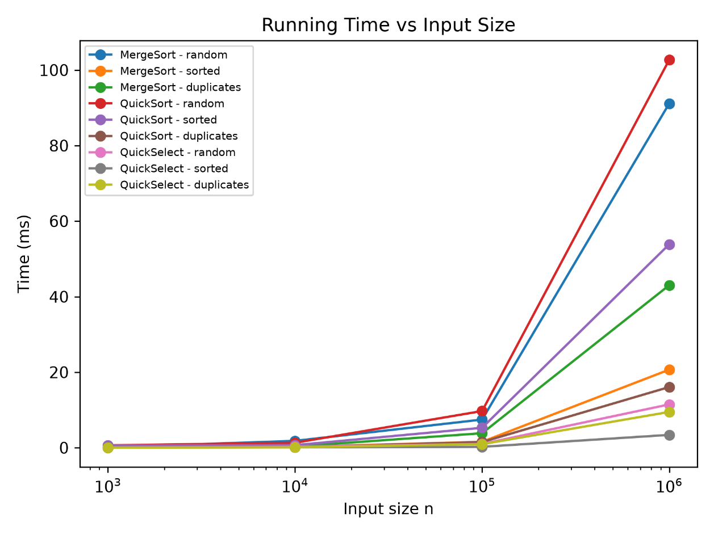
Figure 1. shows how execution time changes when the input size increases. MergeSort and QuickSort require more time for large arrays because their expected complexity is Θ(n log n). QuickSelect is generally faster because it processes only the part of the array that contains the selected element. The results also show that input type can affect practical performance.

Figure 2. Maximum recursion depth vs input size

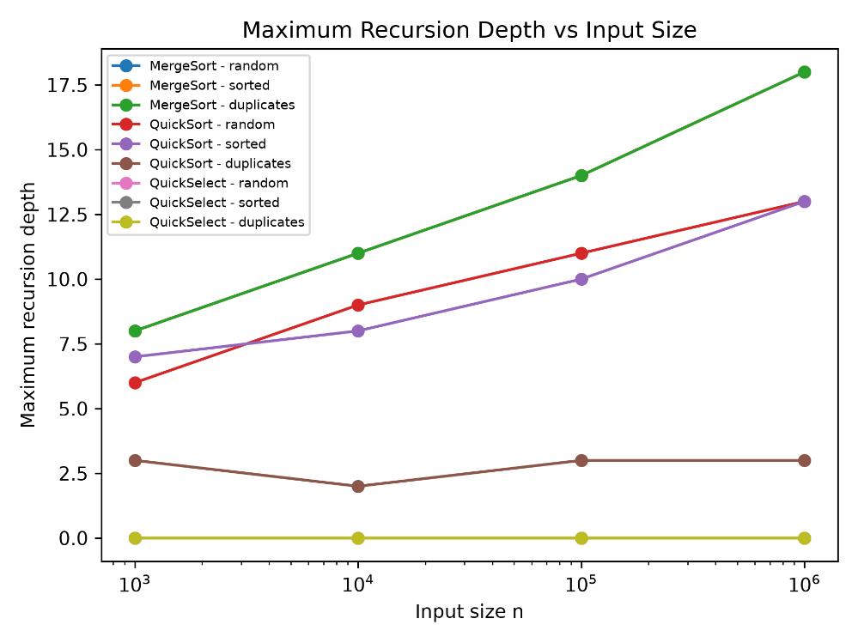
Figure 2 shows the maximum recursion depth. MergeSort depth increases approximately logarithmically because the array is repeatedly divided into two halves. QuickSort keeps a small recursion depth because the implementation recursively processes the smaller partition and handles the larger partition with a loop. QuickSelect has depth 0 in the benchmark because this implementation uses an iterative loop instead of recursion.

Figure 3. Normalized comparison ratios

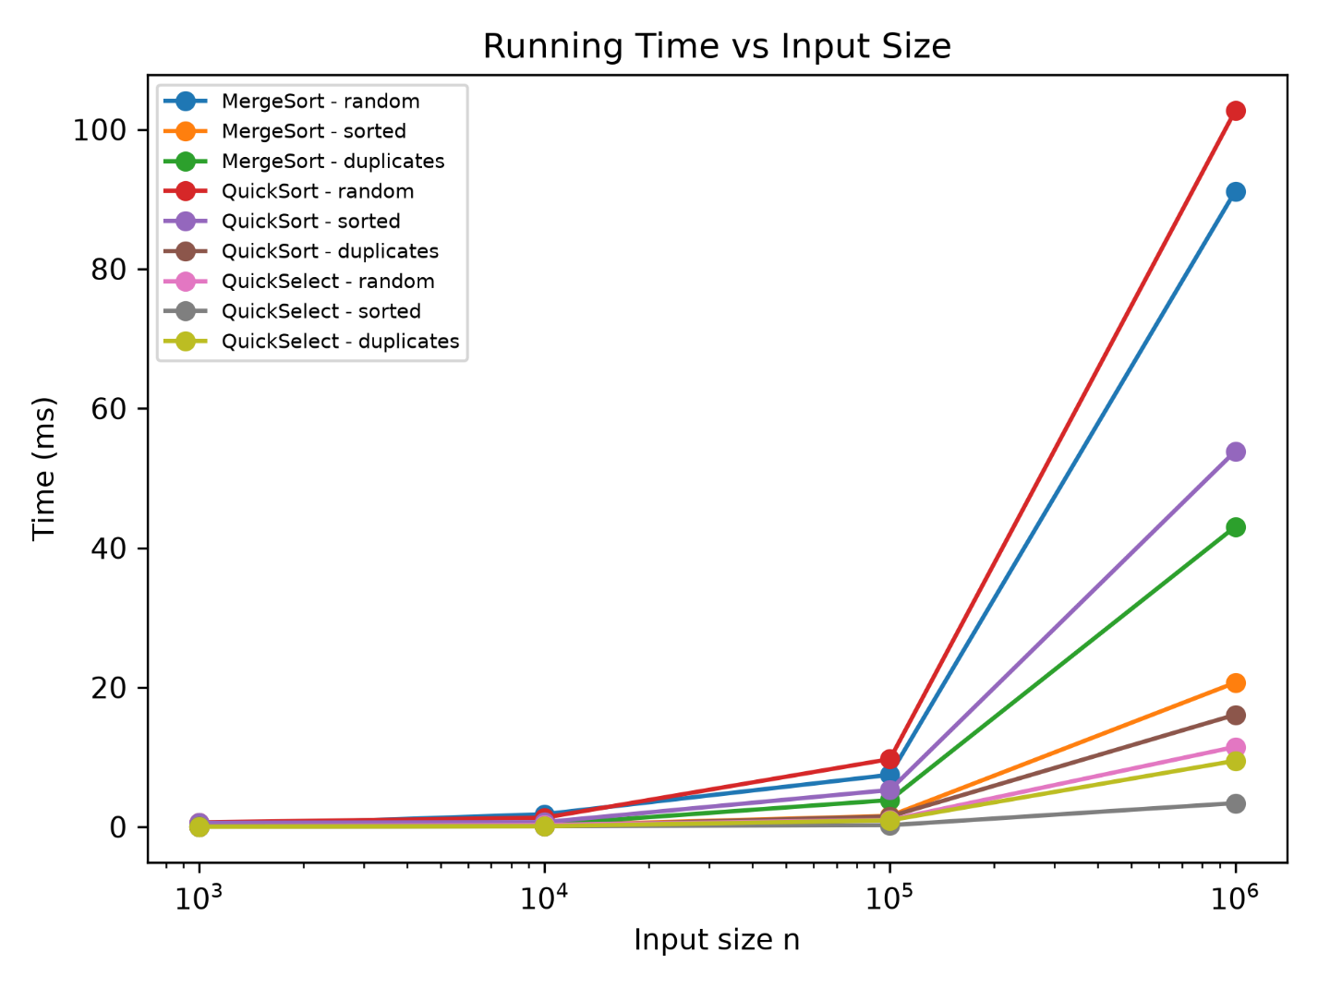

For MergeSort and QuickSort, the number of comparisons is divided by n log₂(n). For QuickSelect, comparisons are divided by n. These normalized ratios help compare the experimental results with the theoretical growth rates. If the ratios stay within a reasonable constant range as n increases, the measurements are consistent with the expected asymptotic complexity.

- Theta Check
To compare the experimental results with the theoretical complexity, normalized comparison ratios were calculated. For MergeSort and QuickSort, I used comparisons / (n log₂n). For QuickSelect, I used comparisons.
For random input, the MergeSort ratio stays approximately between 0.95 and 1.00 as the input size increases. This is consistent with Θ(n log n) growth. For random QuickSort, the ratio is approximately between 1.69 and 1.88, which is also consistent with the expected Θ(n log n) average behavior.

For random input, the QuickSelect comparisons / n ratio varies more because the algorithm uses a random pivot. However, the values remain within a constant range in these experiments. This is consistent with the expected linear average complexity Θ(n).

For example, for MergeSort with random input, we can choose c₁ = 0.95, c₂ = 1.01 and n₀ = 1000 for the measured input sizes. The observed comparison counts satisfy approximately c₁n log₂n ≤ C(n) ≤ c₂n log₂n

5. Discussion
The experimental results are generally consistent with the theoretical complexity of the algorithms. Execution time can be different between runs because the JVM needs time to warm up and optimize the code. Garbage collection can also affect some measurements because Java may spend time cleaning unused objects from memory. CPU cache can make some array operations faster when data is accessed efficiently. In MergeSort, the cutoff value of 15 allows Insertion Sort to process small subarrays with less overhead. QuickSort performs especially well on inputs with many duplicate values because the 3-way partition groups values smaller than, equal to, and greater than the pivot. The random pivot also means that QuickSort and QuickSelect can produce slightly different results between benchmark runs. QuickSelect has a recursion depth of zero in our results because the implementation uses a loop instead of recursive calls. Overall, the benchmark results show behavior that is consistent with the expected average complexities of the implemented algorithms.

Conclusion
In this assignment, I implemented and tested MergeSort, QuickSort and QuickSelect in Java. I collected execution time, comparisons and recursion depth for different input sizes and types. The experimental results were compared with theoretical complexity using plots and normalized comparison ratios. The results generally agree with the expected asymptotic behavior of the algorithms.

