SmartEvent AI: Real-Time Event Management System with Machine Learning
A Project Based Learning Report Submitted in partial fulfilment of the requirements for the award of the degree

of

Bachelor of Technology
in The Department of Electronics and Communication Engineering
Course name with Course code

Submitted by
2510080046: Balaji
2510080056: Ruthvik
2510080054: Krithik Reddy
2510080058-Sharath N
Under the guidance of
Gangamohan Paidi



Department of Electronics and Communication Engineering
Koneru Lakshmaiah Education Foundation, Aziz Nagar
Aziz Nagar – 500075
OCT - 2026.
Abstract
Accurate planning of an event depends on knowing how many people will actually attend, which registration counts alone cannot reveal. This report presents SmartEvent AI, a proposed real-time event management system that combines event creation, registration, ticketing and check-in with four machine learning modules: attendance prediction, personalised event recommendation, no-show prediction and demand forecasting. The reference architecture uses React with Vite, Node.js with Express, PostgreSQL, Socket.IO for live updates, and a Python/FastAPI service built on scikit-learn for model inference. The report describes the problem, the system architecture, the data model, the proposed models and an evaluation plan based on MAE, RMSE, R², precision, recall, F1 and Precision@K. No trained-model results are claimed; evaluation against verified event outcomes is the next stage of the project.
Keywords: event management, attendance prediction, recommendation, no-show prediction, demand forecasting, Random Forest
List of Figures
Figure 1: Reference system architecture of SmartEvent AI 3
Figure 2: Attendance prediction model workflow 4
List of Tables
Table 1: Proposed machine learning modules 4
Table 2: Evaluation plan by module 4
Table of Contents
1. Introduction 3
2. Methodology 3
a. System Architecture and Technology Stack 3
b. User Journeys 3
c. Machine Learning Modules 4
d. Data Model and Real-Time Operations 4
3. Experiments 4
4. Results 4
5. Conclusion and Future Work 5
References 5
SmartEvent AI: Real-Time Event Management System with Machine Learning

Introduction
Events such as conferences, workshops and technical fests depend on decisions made well before the doors open: how many seats to arrange, how much food to order, how many staff to roster, and how much logistics support to book. These decisions are usually based on registration counts, but registrations are only a rough guide. Some registrants never attend, demand shifts as the event date approaches, and attendees faced with a long list of events find it hard to discover the ones that suit them. Manual planning therefore risks both over- and under-provisioning, and follow-up and check-in data are often scattered across separate tools.
SmartEvent AI is a full-stack event platform concept that addresses these problems by combining event operations with machine learning (ML)-assisted planning and discovery. It centralises event creation and registration, tracks registration and check-in activity, and adds four ML modules: attendance prediction, personalised recommendations, no-show prediction and demand forecasting. The overall goal is data-informed event planning, in which forecasts support resource decisions and verified outcomes are fed back to improve later forecasts.
The objectives of the project are to (i) centralise event creation and registration, (ii) track registration and check-in activity in real time, (iii) use forecasts to inform resource planning, (iv) rank events against attendee interests, and (v) surface no-show risk and demand trends to organisers. This report describes the proposed design, the models and the evaluation plan. Components are presented as architectural targets; no trained-model performance is claimed.

Methodology

System Architecture and Technology Stack
The reference architecture (Figure 1) separates the platform into an operational path and an ML inference lane. Attendees and organisers use a React and Vite frontend, which communicates with a Node.js and Express REST API. The API persists data in PostgreSQL, and Socket.IO pushes live updates to connected clients. In the ML lane, event and registration data are preprocessed and passed to the ML models, which a Python FastAPI service (where implemented) exposes to the API and to an ML dashboard built with Recharts. The end-to-end workflow is: create, register, store, predict, review and check-in.
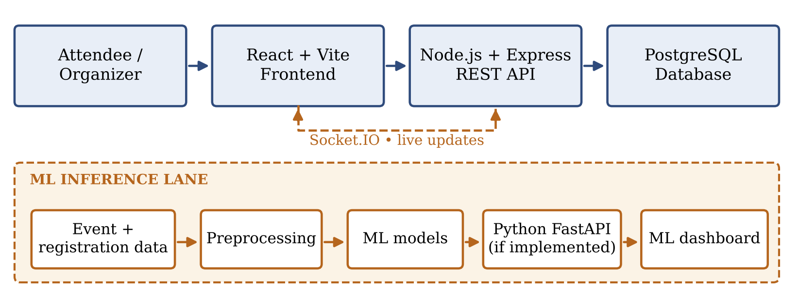
Figure 1: Reference system architecture of SmartEvent AI. Solid components are architectural targets.

User Journeys
Two connected experiences are built around the same event data. Attendees can explore and search events, filter them by category, date and location, register, view their tickets and personal event details, and receive personalised recommendations. Organisers can create and manage events, monitor registrations and capacity, review check-ins and event status, and consult forecasts and ML insights.

Machine Learning Modules
Four modules are proposed, summarised in Table 1. All use scikit-learn [2] and are intended to be served by the FastAPI inference service.
Table 1: Proposed machine learning modules.
Module | Technique / model | Inputs | Output and use
Attendance prediction | Supervised regression; Random Forest Regressor [1] | Confirmed registrations, category, ticket price, capacity, weekday, days remaining | Predicted attendees and attendance rate; plan seating, food, staff, logistics
Recommendations | Content-based filtering with similarity ranking [3] | User interests and interactions; event categories, tags, descriptions | Ranked list of upcoming events per attendee
No-show prediction | Classification; Random Forest Classifier [1] | Lead time, category, RSVP, suitable history | No-show probability or risk band; target reminders
Demand forecasting | Regression or time-series model [4] | Historical registrations, current trend, time remaining | Future registration counts and capacity warnings

For attendance prediction, a registration count is not treated as the answer; the model estimates expected attendees. Training needs historical actual attendance as labels. The data are cleaned and encoded, the model is trained and tested on held-out events, and forecasts are then generated (Figure 2). The recommendation module compares user preference features with event features and ranks events by similarity; for a new user it falls back on popular, upcoming or category-based events until enough preference data exist (cold-start fallback).
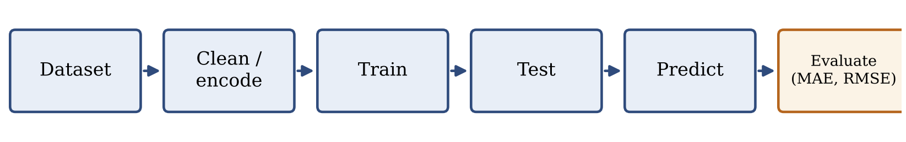
Figure 2: Attendance prediction model workflow, ending in evaluation on held-out data.

Data Model and Real-Time Operations
The conceptual data model has five core entities: users, events, registrations, tickets and check-ins. Supporting tables such as user_preferences, notifications, prediction_history and model_versions can store preferences, alerts, issued forecasts and the model version behind each forecast. Real-time operations include registration counters, seat availability, QR-code check-ins, live event status and capacity alerts, delivered through Socket.IO. The entity design is conceptual and must be confirmed against the actual tables, keys, APIs and event handlers in the repository.

Experiments

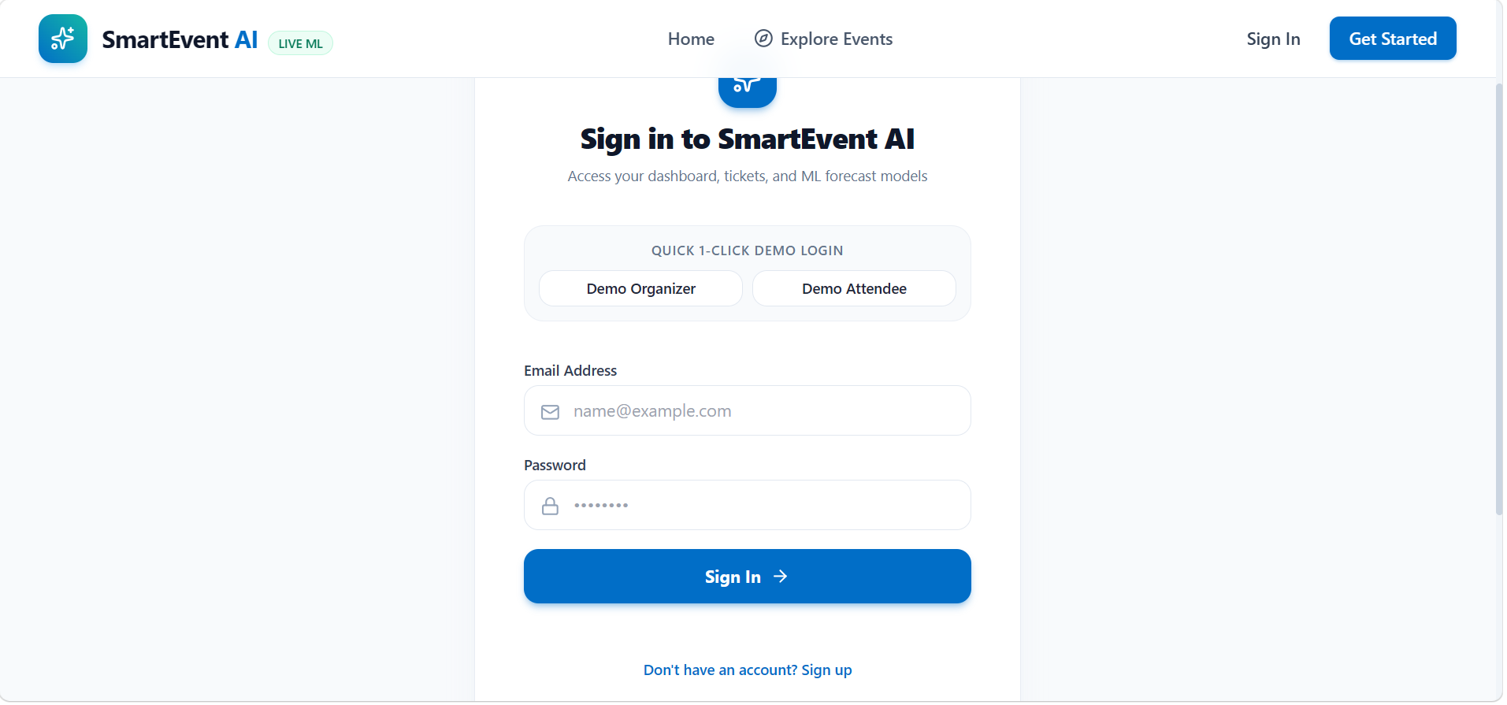
The experimental plan reports measured results only after a reproducible test. Historical events with registration records and verified actual attendance (check-ins) are required for training labels. Data are split so that the models are tested on unseen events, and predictions are compared with held-out actual attendance. Each module is assessed with the metrics in Table 2.
Table 2: Evaluation plan by module.
Module | Metrics | Comparison basis
Attendance regression | MAE, RMSE, R² (optional) | Predicted vs. held-out actual attendance
No-show classifier | Precision, Recall, F1 | Predicted risk vs. recorded no-shows
Recommendations | Precision@K, Recall@K | Ranked list vs. events the user registered for
Demand forecast | MAE, suitable percentage error | Forecast vs. actual registration counts

The website demonstration follows six steps: (1) open the event listing and organiser view; (2) select an event and inspect its registrations; (3) generate or refresh an attendance forecast, if live; (4) review the demand and no-show views, if implemented; (5) complete a check-in workflow, if available; and (6) after the event, compare the forecast with verified check-ins.

Results
At the time of writing, no verified training logs, dataset counts or evaluation scores are available, so the results of all four ML modules are pending and no accuracy figure is reported here. Numbers shown in interface mock-ups or synthetic examples are
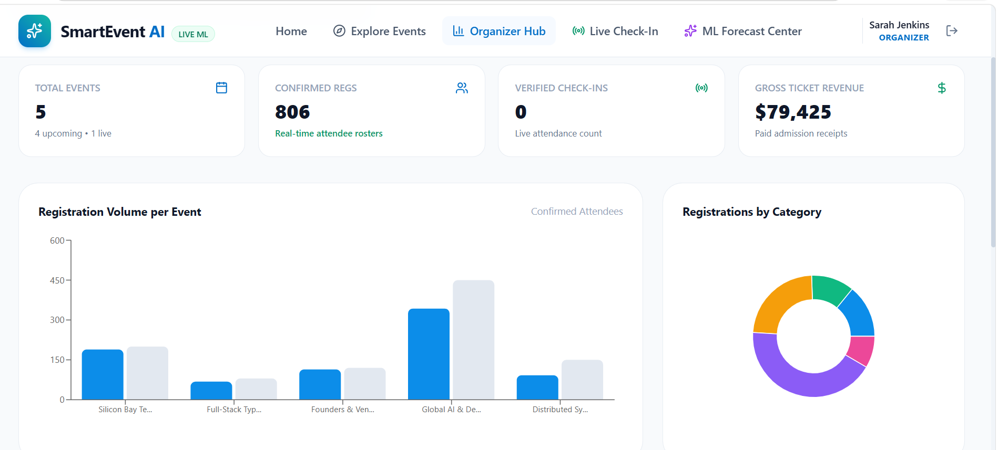

illustrative and are not evidence of a trained model. Each component, including its route, service and UI behaviour, must be verified in the repository before it is described as live. Once the tests in Table 2 are run, the report will give the measured metric for each module together with the dataset size and the train/test split, so that the results can be reproduced.

Conclusion and Future Work
SmartEvent AI aims to unite event management with ML-assisted planning and event discovery. Its value depends on trustworthy data and reliable integration between the web platform and the ML service. Smart event planning is not only prediction; it is a feedback loop between forecasts and verified outcomes. The main limitations are:
• predictions depend on data quality, and new events may have little history;
• behaviour and trends can shift, and models need evaluation on unseen data;
• live ML features depend on reliable service integration.
Future work: collect verified event outcomes; improve forecasting and ranking; add reminder integrations; monitor drift and retrain; and deploy the backend, database and ML service reliably.

References
- L. Breiman, "Random Forests," Machine Learning, 45(1), 5–32 (2001).
- F. Pedregosa et al., "Scikit-learn: Machine Learning in Python," Journal of Machine Learning Research, 12, 2825–2830 (2011).
- P. Lops, M. de Gemmis, and G. Semeraro, "Content-based Recommender Systems: State of the Art and Trends," in Recommender Systems Handbook, Springer, 73–105 (2011).
- R. J. Hyndman and G. Athanasopoulos, Forecasting: Principles and Practice, 3rd ed., OTexts (2021).

