
BUS 101 - Core Course in Business
Final Project Report
AgroKomek
May 2, 2025
Prepared by: Aknur ZhakanovaAlen KazhymukanAiym MadilMadiyar SaduakasAlima NurgaliyevaYersain SarbassovSanzhar Ussin

The problem:
The absence of an online place to communicate with/between farmers is the problem that “Agrokomek” will address by creating a user-friendly online app. Agriculture is an important sphere in Kazakhstan's economic development. It is hard for farmers to find other farmers in order to exchange the cattle. Moreover, people who are willing to buy cattle also suffer from the absence of variability of where they can buy.
Aim of the project:
We are developing a mobile app designed to serve as a networking platform for farm owners. The app will feature an interactive map showing the live locations of other users, similar to the friend-tracking feature in 2GIS. Users will be able to chat with each other, share suggestions with the government, and stay informed through a dedicated news feed focused on agriculture and political developments that may impact farmers.
Additionally, the app will provide a convenient way for individuals interested in purchasing livestock to locate nearby farms, contact owners directly, and negotiate deals online

Value proposition
1. Find neighbours
As was said before, the opportunity to find the position of the neighbouring farms for us is the main aim of the project.
2. Create a market for buying the cattle
All farmers will be able to put their cattle up for sale at the price they wish. People who want to buy cattle will have options and the ability to negotiate with owners, the ability to find the closest farms and so on. People in Kazakhstan may buy cattle for multiple reasons, such as religious reasons (Kurban ait, sacrifice, etc), for personal use (like horses), or to eat?????
3. Stronger Relationship
We will create a community which is united by one common topic: agriculture. People will be able to share their knowledge with each other, providing valuable insights, increasing the overall level of knowledge in this sphere.
4. Scalable tech
We will have a team of developers who will constantly work on updates of the app, based on the feedback of users.
Products and services
The main product that we offer is the innovative mobile app named “Agrokomek”. It will be free to download from all app markets like “Apple App Store”, “Google Play Market” and so on. In this app, users will be provided with numerous services listed below:
- Always-on online map with marked locations of other users (farmers), similar to 2GIS friends. Users, equivalently, farmers will register and verify the existence of the farm, put a fixed marker for their location of the farm, and it will be shown to every user in the app.
- Built-in online catalogue with the ability to talk to owners of cattle, similar to kolesa.kz or kaspi.kz online shop. Users who want to buy from farmers, whether it other owners of a farm or just a person willing to buy cattle, will be able to see tons of offers.
- Users will be provided with everyday news inside the app. All governmental changes, forums and information related to agriculture will be posted regularly.
If a user registers as a farm owner, they should pay a yearly subscription that costs 5000 tenge (approximately 10 dollars), otherwise, the location of their farm will not be visible to others. Users who want to access the market of cattlemarket can do it on a free basis.

The strategy of Getting Our Products to Customers
We use a digital-first approach to successfully reach our target customers who consist of Kazakhstani farmers. Agrokomek will become available on the Apple App Store and Google Play Market platforms during the first annual period. Our product distribution strategy includes digital marketing directed at farmers supported by cooperative organization and agricultural union collaborations.
The app promotion strategy includes online platforms with rural farming events along with national rural development programs. Our primary attention right now targets users from Akmola together with Turkestan and East Kazakhstan regions to establish a critical user mass before we proceed with expanding our service toward every rural area. Local akimats will join forces to host offline workshops and demo sessions to assist farmers on how to use our app.

Gradual Expansion with Growing Market Demand

The expansion strategy of Agrokomek corresponds to Kazakhstan’s digital agriculture direction, while rural residents adopt smartphones in increasing numbers. The expansion will begin by utilizing farmer associations with existing government infrastructure as well as agricultural exhibitions, to gradually develop a dependable user network. We expect customer demand for enhanced functionality to accelerate once trust spreads naturally and broadens its consumer base. Especially from vendors who seek distribution platforms, from agri-tech startups who want to implement their APIs and data tools, and from meat buyers who are interested in direct access to local farms.
The estimated market size
Target Market: 240,720 registered farm entities in Kazakhstan (source: National Statistics).
We assume, at least 35% of farm owners, which is 84,000 farms, have the potential to adopt Agrokomek because they own medium to large farms and use digital technology extensively.
Agrokomer aims to acquire 5,000 active users in Year 1 followed by a continuous expansion of this user base:
Estimated Subscription Sales: 5,000 (total sold, per year).
Average Selling Price: 5,000 tenge (average subscription cost).
Market Size Calculation:
Estimated Subscriptions × Average Selling Price = 5,000 × 5,000 = 25,000,000 tenge per year.

Market Share
It is crucial to analyze and calculate the market share and further plan a market strategy to successfully launch the business. Based on the data above, our goal is to take a stable market share in the Kazakhstani market within five years of operation.
- Market Share Projections.
Market share estimation includes considering our sales objectives and projected industry revenue levels.
We have made annual projections based on steady company advancement and an increasing client base as follows:
- Year 1: Establish presence, targeting a Х% market share.
- Year 2: Expanding marketing and partnerships, aiming for a Х% market share.
- Year 3: Strengthening reputation and customer base, achieving a Х% market share.
- Year 4: Expanding the product line and launching premium goods to increase market share to X%.
- Year 5: Maximizing market penetration through strategic innovations, achieving a Х% market share.
2. Sales Overview

Priorities for Action:
In order to meet our growth goals and generate early momentum, we have the following list of priorities.
- Complete MVP development and UX testing by Q2.
The minimum viable product (MVP) will include core features like live map, chat functionality, cattle listing and profile page. Small focus group of farmers will be invited to test the app on its user friendliness under real conditions and collect feedback on our app.
- Collaborate with regional agricultural departments for implementing the app implementation and its promotional activities.
The partnerships will enable us to establish trust with communities as we acquire their geographical access. Local authorities provide help to schedule educational campaigns together with promotional content distribution and could involve Agrokomek in region-wide digital agricultural projects.
- Launch pilot campaigns in 3 regions by Q3.
We will select target regions with high agricultural activity and a mix of traditional and modern farms such as Akmola, East Kazakhstan, and Turkestan regions. Our marketing approach combines digital ads with public protests alongside famous farmer representatives who will promote the app.
- Design referral incentives to encourage viral user acquisition.
The implementation of incentive plans will stimulate users to refer others through viral acquisition. People who refer new users to join the application will gain benefits including premium account access for free along with additional listing visibility features. The incentive program aims at building our user base through viral growth initiatives at affordable marketing expenses.
- Recruit support reps and devs for onboarding, localization, and technical scalability.
The team requires new hires for support representatives and developers to provide onboarding as well as localization and technical scalability. New users who need assistance obtaining basic understanding of mobile technology will be supported by representatives while developers will work on expanding the backend infrastructure and extending app functionality across different connectivity settings.

These actions will develop a unified system where local farmers establish relationships and deal with each other and collaborate thus transforming the entire agricultural sector of Kazakhstan.
Key assumptions
AgroKomek represents an essential opportunity to solve the problem of the connectivity gap in Kazakhstan’s agricultural sector. We assume that there is a strong demand for a centralized platform that provides farmer networking, livestock trading, and access to agricultural news, because of the inefficiencies of current methods like word-of-mouth or outdated catalogs. It is expected that the interactive map, accessible chat functionality and marketplace will appeal to the farmers who are looking for a comfortable solution. The user-friendly design of the app is created for various levels of digital literacy ,making it accessible.
The business model is assumed to be scalable, with low incremental costs for adding new users. Revenue streams, such as transaction fees from livestock sales or premium subscriptions for advanced features (e.g., analytics or priority listings), are expected to provide high margins. Partnerships with agricultural organizations and government will enrich credibility and trust of the users, which are the most important to adopt the app. The opportunity to share opinions, negotiate deals, and access news will be the main advantage to repeat the use. The long-term goal is to expand further into other agricultural services, such as tools for crop management and equipment trading.
Finally, we consider that the competitive landscape for agricultural networking apps in Kazakhstan is not yet developed sufficiently, giving our platform an advantage of a first-mover.
Summary Financial Projections and Expected Returns to Investors

Prices
Our business model is based on a freemium approach, with optional premium subscription. The pricing structure is based on market research on similar platforms and the purchasing power of farmers in Kazakhstan. Two subscription tiers are proposed:
- Basic (Free): Includes access to the interactive map, basic chat, and catalog. This subscription is intended for cost-conscious farmers.
- Premium (5,000 KZT/month): Offers advanced features like priority listings, analytics on market trends, and access to a dedicated news feed with agricultural insights. This subscription is intended for large companies or regular traders.

Costs
Cost of Goods Sold (COGS)
The Cost of Goods Sold includes expenses of the app’s services, such as server costs and app maintenance. Estimated at about 14 % annually. These costs increase depending on the number of subscribers and are projected as follows:

Years | 1 | 2 | 3 | 4 | 5
Servers | ₸2,845,500 | ₸6,060,801 | ₸8,456,700 | ₸11,223,300 | ₸13,965,000
Maintain of app | ₸3,699,150 | ₸7,879,041 | ₸11,763,270 | ₸15,611,610 | ₸19,425,315
Total | ₸6,544,651 | ₸13,939,844 | ₸20,219,973 | ₸26,834,914 | ₸33,390,320
Table 1.

Expenses
Operating expenses are an essential component of the business’s financial structure. These include salaries, which start at (15,408,000 KZT) in Year 1, rising annually due to team expansion and inflation adjustments, reaching (35,344,304 KZT) by Year 5. Rent expenses begin at (7,200,000 KZT)in Year 1 and increase by 10% yearly, rising to (10,465,063 KZT) in Year 5. Travel expenses, essential for partnership development and customer outreach, grew from (16,560,000 KZT) in Year 1 to (20,114,180 KZT) in Year 5, reflecting increased operational activity. The amortization of app creation costs, a fixed annual expense, remains steady at (24,000,000 KZT) for all five years. Advertising costs start at (5,000,000KZT) in Year 1, increasing with inflation and marketing efforts to (6,553,980 KZT) by Year 5. Combined, total operating expenses rose from (68,192,000 KZT) in Year 1 to (97,861,527 KZT) in Year 5. Capital expenditures (CapEx) include an initial investment of (120,000,000 KZT) in Year 0 for app development and fixed assets. The following years have smaller investments: (120,000 KZT) in Year 1, (3,360,000 KZT) in Year 3 for IT equipment upgrades, and (1,720,000 KZT) annually in Years 4–5 for maintenance. All these expenses are necessary to maintain operations and ensure the functioning of the business.

Initial Capital Requirements
Initial investment required to initiate the business includes capital spending (CapEx) on fixed assets such as a printer purchased in Year 1 for 120,000 KZT. There is no other fixed asset purchase itemized for Year 1. Since the business has no other capital spending in the first year, overall initial investment required to initiate operations totals 120,000 KZT.

Products Number Growth
Agrokomek demonstrates strong and consistent growth in subscriber base, reflecting growing utilization of digital technologies in Kazakhstan's agriculture sector. Starting with 9,485 subscribers in Year 1, our foundation increases nearly two times by Year 2 to 18,881 subscribers. The growth continues steadily to 46,550. This growth trend reflects market demand and trust created through strategic partnerships, continued marketing, and enhanced app functionality as shown in the Table 2. By Year 5, Agrokomek is a vital platform for Kazakhstan farmers as they bring together nearly 47,000 users nationwide.
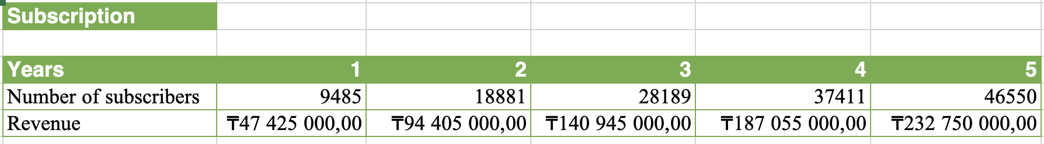
Table 2. Predicted total number of customers provided in Excel Worksheet
Net Income
Agrokomek's finances show a clear transition from initial losses to strong profitability as the business scales. The Year 1 net loss of ₸24,580,486 reflects high up-front spending, namely the ₸24,000,000 amortization of app development and costly operating expenses such as salaries, marketing, and travel (Table 3). The initial loss was intentional, as in the beginning, focus was put on developing the app, obtaining a user base, and marketing in multiple regions.

From Year 2, the business is profitable at a net income of ₸8,081,816. This is driven by a sharp increase in subscribers (9,485 to 18,881) and subsequent revenue growth to ₸94,405,000. The greatest drivers of improved profitability are economies of scale and the relatively fixed nature of some costs (such as app amortization), which do not grow with the number of users.

By Year 5, net income is ₸91,348,338. Key drivers of this performance include consistent revenue growth from a growing subscriber base (46,550 users in Year 5) and the firm's ability to control growth in operational costs. Salaries and travel costs, in particular, grow modestly compared to revenue, enabling margin expansion.

Overall, the shift from loss to profit is largely attributable to a well-executed growth strategy that balances user acquisition with careful cost control. The upfront investment in marketing and technology sets the stage for long-term profitability with positive trends as shown in the Figure 1.

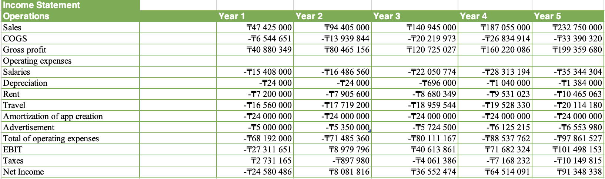
Figure 3. Income statement in Exchel Worksheet
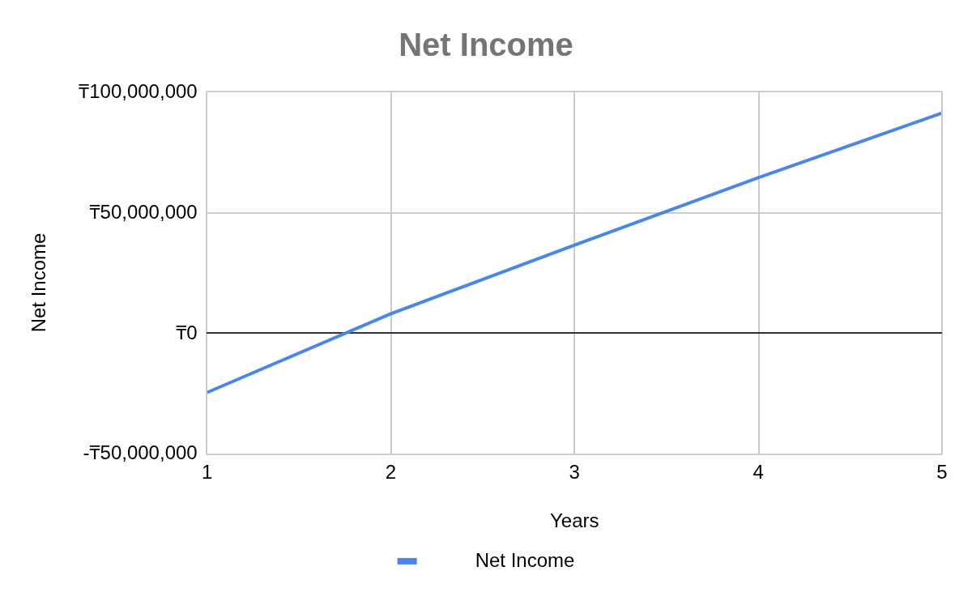
Figure 1. Net Income after taxes
Free Cash Flow

Payback Period
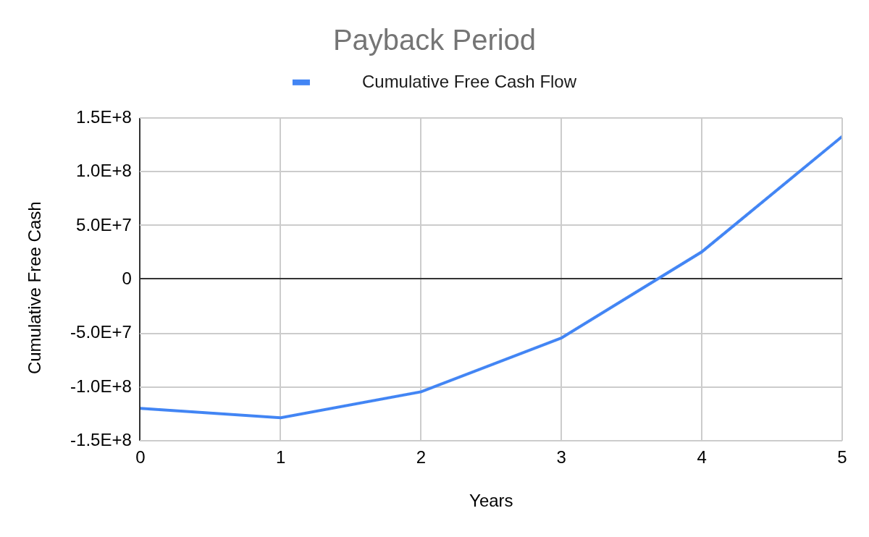
Figure 2. Payback Period

