**Pre-Requisite**

1. Install VSS Server

* download VSS from ISO file

<https://stackoverflow.com/questions/26525189/where-can-i-download-visual->sourcesafe

* Change setting in Ec2 instance for .net frame work as below

go to server manager-> Manage->Add roles and features ->insatllation type-> role based or feature based installation -> next select server -> select file and isics server and click next-> select.net frame work 3.5 and install and close

* Once .Net frame work is done then install ISO file downloaded above to get VSS Repository.

1. After installation Use VSS administrator (Start menu and search for it) to create users to database (VSS Repo)
2. Login with above create credential to VSS Explorer to create VSS repository.
3. Create a project and that is repository for you for now, do check in or check out with file so that history is there.
4. Once above step done, click on project and select Get latest version and click on recursive and get Tree structure and click next.
5. Now your project is ready in VSS.

**Migration Steps:**

1. Download and install VSS2Git application from below url

<https://vss2git.software.informer.com/1.0/>

* 1. <https://vss2git.software.informer.com/download/>

1. Install git <https://git-scm.com/download/win>

1. Launch vss2git and enter the paths to your VSS files and the path where you want your new GIT repository.
   1. Point the Directory in VSS setting to Repository folder as it need (srcsafe.ini) file this will be present in VSS repository
   2. if in single repo multiple project is present mention project name which need to be converted mention in project (VSS setting) (for example project name is sample mention it as $/sample) So Please don’t miss forward slash(/)
   3. Mention the place where u need to get git repo to be created in output setting (directory) or It’s best to make sure the git destination path is empty, or doesn’t exist at all. Vss2git will create it

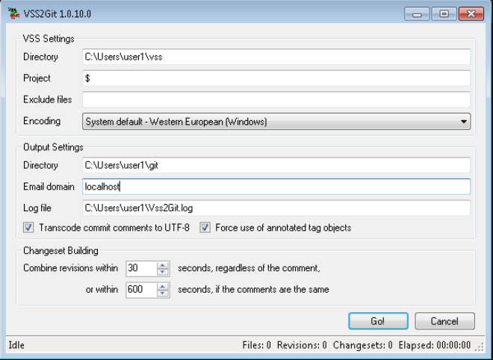

Once you have the paths entered, depending on the size of your VSS project and transaction history, you will have a git repo created with transaction history.

At this point you have a working git repo.

5) Login to “https://github.com” create a new repository

Below are the sample screenshots.

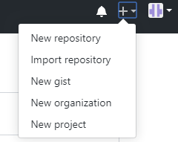

Note: Do NOT Check README file

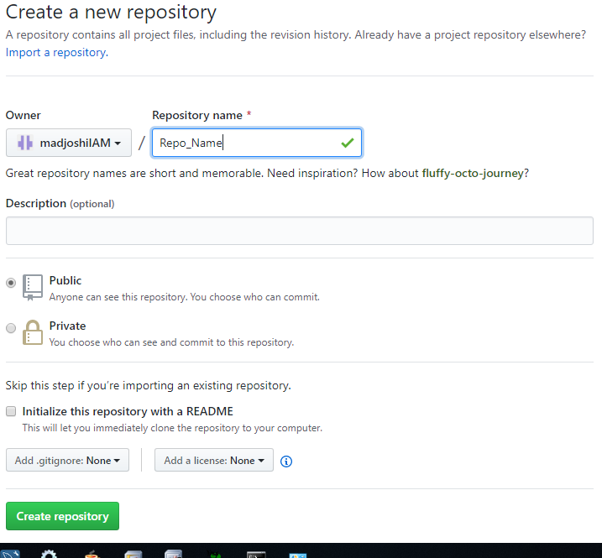

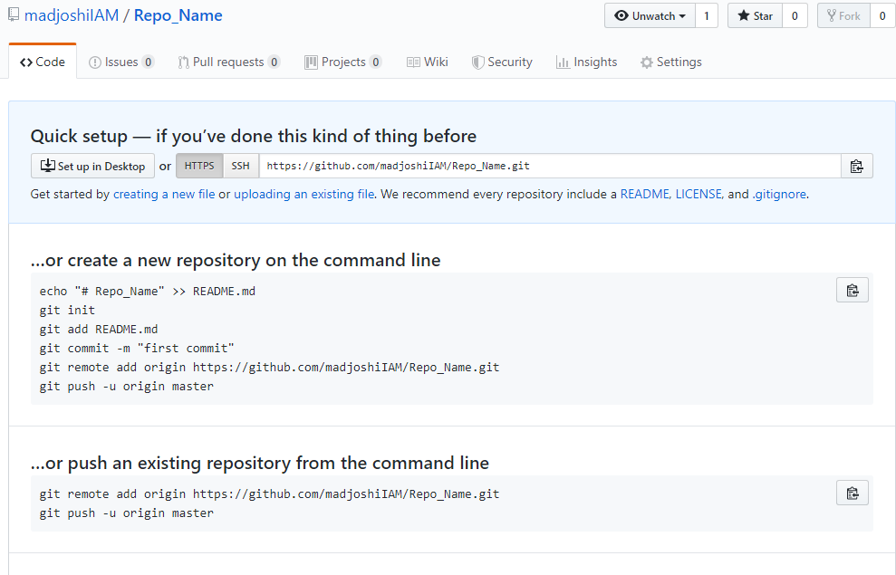

5) Go to the Git repo which VSS has created for the project.

Example:-

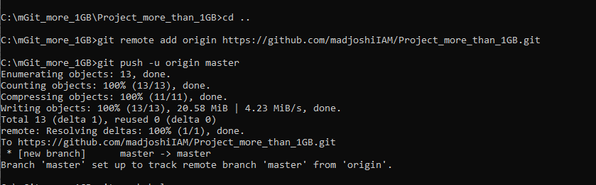

Run below commands

git remote add origin git@host:old_vss_stuff.git

git push –u origin master

Example:-

git remote add origin <https://github.com/madjoshiIAM/Project_more_than_1GB.git>

git push -u origin master

6) Please check the Github.com, with updated folder structure.

