Madison Area
Jugglers
Pattern Book

Version 2.0

DRAFT COPY
1/1/2012

Hello Madison Club Passers and Friends!
Welcome to the Madison Area Jugglers Book of Patterns, a collection of patterns for intermediate to advanced passers. These patterns are part of our repertoire and the book is a good indication of our work and a record of our evolution in club passing at Madison.
Originally we wrote down the patterns just to save time arguing over exactly how we did the pattern last time. (Don't worry...there's still plenty of arguing, even with the book.) We were pleasantly surprised to find other people found our book helpful too! The pattern book can be used as a club passing guide or just a library of the patterns that we originated or find interesting. If you're from Madison, then it's a handbook to what we do twice a week on Thursdays and Sundays, and if you don't know the patterns already then you probably will. This book is not intended to be an encyclopedia of all possible passing patterns (that would be a big book)!
Version 1 of this book edited by Mike Newton and Steve Otteson and the Madison Area Jugglers.
Version 2 edited by Luke Emery and the Madison Area Jugglers.
Our thanks go out to all of the many jugglers who have helped us. Club passing is a social pastime that needs a group of similarly inclined jugglers. Many of these patterns are inspired by other jugglers and patterns or created in collaboration with other jugglers. We hope that these patterns will help inspire new club passing ideas and help more jugglers all over the world enjoy club passing!
All jugglers are welcome to play with, use, extend and otherwise enjoy all of our club passing patterns.
This book may be freely reproduced and distributed for non-commercial use.
We have tried to give credit to the creators of the patterns and have indicated when we didn't know. If we have erred in our credits, please let us know.
This book of patterns is on the web at www.madjugglers.com.
Madison, Wisconsin, October 1999 Version 1.0
Madison, Wisconsin, January 2001 Version 1.1
Madison, Wisconsin, March 2001 Version 1.2
Madison, Wisconsin, January 2012 Version 2.0
If you have any questions, comments or suggestions relating to this book, please send us a line via the e-mail address on the web site.

How To Read Patterns

Standard Feed
Positions
 | B
A | C
 | D

Juggler | 1 | 2 | 3 | 4
A | B | C | D | C
B | A
C |  | A |  | A
D |  |  | A
Right hand counting

When juggling the cascade, each hand takes turns throwing: right, left, right, left, etc. Usually, all of the jugglers in the pattern throw their right hand throws at the same time, and then their left hand throws at the same time. For most patterns, all the participants juggle at the same synchronized rate.
In general, right hand throws are made to the left hand and left hand throws are made to the right hand. This applies to passes and self throws. (Exceptions will be noted when applicable.)
The two graphs above illustrate a standard feed. The position graph shows where the jugglers stand. The left graph shows where and when passes are made.
The label "Right hand counting" means that all of the right hand throws are numbered in the graph. The column under each number lists the jugglers that pass at that time. Since left hand passes are never made in this particular pattern, they are not listed in the graph. Throws that are not in the graph are self throws.
The first column lists the jugglers in the pattern. The row where a juggler is listed shows to whom and when that juggler passes.
For example, if I was juggler C in the above pattern, I would read along the 3rd row to see where I pass. On the first pass (column 1), I have a self throw (the empty box represents a self throw). For the next right hand throw (column 2), I pass to A. For the next two right hand throws, I do a self throw followed by a pass to A. The table rolls over, so that the fifth pass is the same as the first.
Unless otherwise specified, all passes are single spins and do not cross. Doubles and triples to juggler A would be indicated by D-A and T-A respectively and are also straight unless noted.
Special instructions like different counts, double selves, crossing passes or starting instructions may be noted in the graph or underneath it.

Typewriter Extra Club Feed (13 clubs)
Positions
 | B
A | C
 | D

Juggler | 1 | 2 | 3 | 4 | 5 | 6
A | D-D |  | D-C |  | D-B
B |  | D-A
C |  |  |  | D-A
D |  |  |  |  |  | D-A
Both hands counting, right hand passes
A starts with 4 and right hand
B, C and D start with left hand

Here's an example with double straight passes and special instructions. In this case all the passes are right handed passes, but we count both left and right hand throws. A throws right Double pass to D, then left self, then right Double pass to C, then left self, then right Double pass to B.
How to tip: Jugglers C and D should throw a little higher and deeper so A has room to pass underneath to C and B.

Some Funny Left/Right Box
Positions
 | A
C |  | D
 | B

Juggler | 1 | 2 | 3 | 4 | 5 | 6
A | B | C | B |  | D
B | A | D | A |  | C
C |  | A |  | D | B | D
D |  | B |  | C | A | C
Both hands counting

The above pattern has both hands counting, so the column under 1 is a right hand pass, the column under 2 is a left hand pass, etc.
If I was juggler D, I will read the fourth row to see that I start with a right hand self (column under 1), followed by a left hand pass to B (column under 2). The next 4 throws are: right hand self, left hand pass to C, right hand pass to A, and a left hand pass to C. then the pattern repeats.
Any variation to anything said above will be noted as needed when a pattern requires special circumstances.
Site Swaps

Occasionally passing site swaps are used to describe patterns. For example, 7 club 2-count would be 4p 3 | 3 4p (2nd juggler starts with left hand). There are a number of different site swap notations out there for passing. We use whatever seems to make sense to us at the moment and make no guarantee of consistency.

Secret Juggling Code Words (Glossary)

Chocolate Bar | Pass, pass, self, self.
n-count | States the count when passes are made. For example, 2-count means: pass, self, pass, self, etc. Three count means: pass, self, self, pass, self, self, etc. One count means: pass, pass, pass, (no self throws).
Double 3-count | Pass, pass, self. Academics can argue over whether this can be represented as 3/2 count.
Pass | A throw from one juggler to another.
Feed | One juggler passing, in turn, to two or more jugglers.
Feedee | A juggler that is passing with a feeder.
Feeder | The juggler that is passing to two or more jugglers.
Standard Feed | A feeder passes to a group of jugglers feeding back and forth. If A is the feeder and B, C, and D are in line, then A's passing order is B, C, D, C, B, C, D, C, etc. Draw a picture if you are still confused. Also called a windshield wiper feed because it goes back and forth.
Rotating Feed | Every juggler in the pattern has a turn at being a feeder.
Typewriter Feed | A feeder passes to a group starting at one end and starts over when the other end is reached. If A is the feeder and B, C, and D are in line, then A's passing order is B,C,D,B,C,D, etc.
Feast | All of the jugglers in a group are feeders at the same time.
Site-Swap | A string of numbers that tells you where, and how high to throw a prop. A site-swap is valid if it has a whole number as an average, and if it has no collisions. Test a string for collisions by seeing where each number "lands". For 531, we start with the 5, and decrement it by 1 for every space that we move to the right. The 5 becomes a 4 at the 3, and becomes a 3 at the 1. Now we "roll over" and continue the countdown at the start of the string. The 5 becomes a 2 at the 5, a 1 at the 3, and a 0 at the 1. A number lands when it becomes a zero by counting down by the above process. The 5 lands on the 1, and repeating the above method shows that the 3 lands on the 3, and the 1 lands on the 5. Since no two numbers landed on the same spot, there are no collisions. The average of 531 is (5 + 3 + 1)/3 = 9/3 = 3, so 531 is valid.
Turbo | Three weaving jugglers who pass among themselves
Weave | The feedees move in a figure 8 while juggling. The standard (or preverse) weave is back on the ends and forward through the middles. The inverse weave is forward on the ends and back through the middle.
ZOC | Zone of Catchability – Refers to the area around a passer where they can catch passes.
Immaculate Assumption | When you think that a juggler is about to move or pass...maybe they even give you the look...you know, the look...but then they don't!
Phantom | A feedee place holder who isn't really there. A feeder, for example, may feed 2 real feeders and a phantom in a sweep feed: pass, pass, self, pass and repeat.
Sweenish | Completing a pattern with no drops, though not necessarily with no mistakes. A sweet finish.
Mustard | Energy, power, spice, velocity or chi added to throws. As in, your corner passes need more mustard. The opposite of mustard is mayonnaise.
Chalant | To drop a perfectly fine pass due to lack of focus. The opposite of nonchalant.
NFP | Nice Pass.
Wuss | The amount of gentleness, tenderness and love added to a juggling throw. Compare to mayonnaise. The quality of passes you would make to your favorite grandmother. As in, please add some wuss to your middle passes. You're hurting my catching hand!

3 Person Patterns

Feed (for 3 jugglers)
Positions
 | A
B |  | C

The feed for 3 jugglers is the simplest 3 person pattern and likely the first one you tried. Because juggling with 3 is so much different than with 2, it's often a good idea to be comfortable with other patterns in a 3 person feed before trying them in larger patterns.
Juggler | 1 | 2
A | B | C
B | A
C |  | A
Right hand counting

How about left handed, chocolate bar, feeder in double 3-count (and feedees in 3-count), or Tom's (which is 3 passes in a row to each feedee with no selves for the feeder)?

Extra Club Feeds
Then extra club 2-count feeds with 10, 11 and 12 clubs (in singles and doubles and triples). There are 4-count feeds in triples and popcorn feeds in 5-count, 6-count and 7-count. And 7 club double 3-count feeds in pass, pass, pause. And extra club chocolate bar feeds.

4-Count Popcorn Feed
Juggler | 1 | 2
A | C | B
B | A | T-self
C | T-self | A
Right hand counting
B starts with 4

6-Count Popcorn Feed

Juggler | 1 | 2 | 3
A | C | T-self | B
B | A |  | T-self
C | T-self | A
Right hand counting
B starts with 4

This variation makes a nice triangle too.

Note: you can replace any triple self, self, single pass with a triple pass, single self to make things more interesting, or with double straight self, double straight self, pass (533p, 5p33, 443p, 44px3 all work).

5-Count Popcorn Feed (one variation)
Juggler | 1 | 2 | 3 | 4 | 5
A | D-B |  | D-C
B |  | T-self |  | D-A
C |  | D-A |  |  | T-self
Both hands counting, start with right hands
A and C start with 4 clubs
The timing is a bit wonky, B and C should delay slightly at the start.

4.5p:B 3 4.5p:C 3 3 | 3 5 3 4.5p:A 3 | 3 4.5p:A 3 5 3

Extra Clubs Chocolate Bar Feed (one variation)
Juggler | 1 | 2 | 3 | 4
A | Dx-B | Dx-B | Dx-C | Dx-C
B | A | A | D-self | D-self
C | D-self | D-self | A | A
Both hands counting, start with right hands
A and C start with 4 clubs
A throws all crossing doubles
B and C throw chocolate bar, then double self, double self
The double selves are straight

Fast/Slow Feeds, Gorilla Feeds, Site-Swap Feeds...we do all of them in Madison, but they're not really part of the Pattern Book yet. Look them up somewhere else for now and maybe we'll get some of them in a future passing pattern book.

Triangle
Positions
 | A
B |  | C

When 3 jugglers stand in a triangle, three obvious passing formations are the inside triangle (pass to the juggler on the left with a right hand pass), outside triangle (pass to the juggler on the right with a right hand pass), and two jugglers pass with each other while the other does a self.
Those 3 simple building blocks can be repeated in an infinite variety of permutations in many different counts to provide hours of instruction and diversion. You may already be familiar with the Hovey's Nightmare variations. Mastery of such triangle variations is very useful for larger and more complex patterns.
See Extra Club Triangles for variations of the triangle with 3-count, double 3 count and 1-count, 2-count and 4-count.
Rotating Feed
The Rotating Feed Triangle is the simplest rotating feed. For 3 jugglers, a rotating feed is the same as a feast.
Juggler | 1 | 2 | 3
A | B |  | C
B | A | C
C |  | B | A
Right hand counting

Pulsar
Positions
 | A
B |  | C

Juggler | 1 | 2 | 3 | 4 | 5 | 6 | 7 | 8 | 9 | 10 | 11 | 12
A | B | C |  | C |  | B | C | B | C |  | B
B | A |  | C |  | C | A |  | A |  | C | A | C
C |  | A | B | A | B |  | A |  | A | B |  | B
Right hand counting

Rules: Jugglers take turns as feeders: A is first, then C, then B (repeat).
Each feeder feeds the other 2 jugglers.
The next feeder feeds in the opposite order of the previous feeder.

A starts as the feeder and feeds right-left. C is the next feeder and feeds opposite of A, so C feeds left-right. B, the next feeder, feeds opposite of C, namely, right-left. A then feeds left-right, followed by C with right-left, and B finishes the pattern with left-right.
I recommend that feeders call out what they are doing (right-left or left-right) so that the next feeder will know what to do. This will also help every juggler know what is going on.
With the rules and the recommendation, you won't have to memorize all of the passes in the stinking table.
Try this with 1-count, so that both hands pass when you are the feeder.
Pulsar dates to 1993 by Steve Otteson and MAJ.

Three-piece Puzzle (for 2 jugglers)
Right, self, right, self, self, left, self, self, self, left, self, self.

Puzzle Feeder (for 3 jugglers)
Positions
 | A
B |  | C

Juggler | 1 | 2 | 3 | 4 | 5 | 6 | 7 | 8 | 9 | 10 | 11 | 12
A | C |  | C | B |  | C | B |  | B | C |  | B
B |  |  |  | A |  |  | A |  | A |  |  | A
C | A |  | A |  |  | A |  |  |  | A
Both hands counting, right hand starts

A is the feeder, and B and C are doing the Three-piece Puzzle pattern six throws out of phase.

Puzzle Feast
Juggler | 1 | 2 | 3 | 4 | 5 | 6 | 7 | 8 | 9 | 10 | 11 | 12
A | C | B |  | C | B |  | B | C |  | B | C
B | A | C |  | A | C |  | C | A |  | C | A
C | B | A |  | B | A |  | A | B |  | A | B
Both hands counting, right hand starts

In the Puzzle Feast, all 3 jugglers are doing what A did in the Puzzle Feeder pattern.
Three-piece Puzzle and Puzzle Feeder patterns are by Jim Brennen. Puzzle Feast is by Steve Otteson.

Siteswap Feeds
Here are two nice variations related to a Martin's Madness feed.
Juggler | 1 | 2 | 3
A | D-B | D-C | 1
B |  | A
C |  |  | A
Both hands counting, right hand starts
A does 441 (i.e. double pass, double pass, shuffle)
Alternatively, A can throw cross double passes and B and C can throw cross passes too (starting on opposite hands).

Juggler | 1 | 2 | 3
A | T-C | B | 1
B |  | A
C |  |  | A
Both hands counting, right hand starts
A does 5px3px1 (i.e. triple pass, single pass, shuffle)

Alternatively, A can throw straight passes and B and C can throw cross passes (starting on opposite hands).

Reviewers – is that right?

Extra Club Rotating Feed (for 3 jugglers)
There are several versions of the extra club rotating feed, but this is one of my favorites based on an extra club 2 count feed (10 club 2-count). After each feed sweep, the feeder must throw a right to left self double to adjust the timing of the pattern. Also, the old feeder throws 2 passes in a row to the new feeder to transfer the extra club.
Positions
 | A
B |  | C

Juggler | 1 | 2 | 3 | 4 | 5 | 6 | 7 | 8 | 9
A | D-B |  | D-C |  | D-C |  | D-self | Pause
B |  | D-A |  | D-self | Pause |  | D-C |  | D-C
C | D-self | Pause |  | D-A |  | D-B |  | D-B
Both hands counting.
A and C start with right hand.
B starts with left hand

Variations
Once you're comfortable with this pattern, try pirouetting under the double self, or instead of throwing the double self, do two single selves and an early triple straight pass instead (followed by a pause), or both!
By Luke Emery 1999.

Extra Club Triangles
Positions
 | A
B |  | C

There are a lot of nice extra club triangle variations. Here are a few examples to play with.
This pattern is based on the standard 7 club 3-count in double spins and extends it to a triangle. All passes cross (rights to right, lefts to left). This version has 10 clubs, and A starts with 4 clubs.
10 Club 3 Count Triangle
Juggler | 1 | 2 | 3
A | D-C
B |  | D-B
C |  |  | D-A
Both hands counting
All jugglers start in sync with right hand
All passes cross

If that isn't challenging enough. Add more clubs and passes. A and C start with 4.
11 Club 2 of 3 Count Triangle
Juggler | 1 | 2 | 3
A | D-C | D-C
B |  | D-B | D-B
C | D-A |  | D-A

12 Club 1 Count Triangle
Juggler | 1 | 2 | 3
A | D-C | D-C | D-C
B | D-B | D-B | D-B
C | D-A | D-A | D-A

The 10 club version has been around for some time. We learned it from some fellow club passers at a convention, but I don't remember from whom. 11 Club and 12 Club variations by Luke Emery, 2005, although it seems likely that other jugglers have also tried them.
There are corresponding extensions to a 5 person star in the 5 Person Patterns.
10 Club Triangle with Triple-Single-Single
Here's another variation on a 10 club triangle from 4-count 7 with triples.
Juggler | 1 | 2 | 3
A | T-C | B | C
B | C | A | T-A
C | B | T-B | A
Right hand counting

You can skip all the single passes until the triple passes are reliable.

6-Count Popcorn Triangle

Juggler | 1 | 2 | 3
A | C |  | T-self
B |  | T-self | A
C | T-self | B
Right hand counting
A starts with 4

5-Count Popcorn Triangle

Juggler | 1 | 2 | 3 | 4 | 5
A | C |  |  | T-self
B |  |  | T-self |  | A
C | T-self |  | B
Both hand counting
A starts with 4 and right hand
C starts with left
B starts with right
All passes are crossing and alternate hands

Timing is wonky (hands aren't all synced up, so the table is a little misleading...C should wait a bit before the first triple, throw high lofty single crossing passes): 3.3px 3 3 5 3.
The pattern should be possible in 5-count with triple crossing passes too... Hmmm... But fast...

Another 5-Count triangle is to throw crossing triples to the left in 5-count. This timing is also wonky 1 2/3 count or some such difference between each jugger.

10 Club 4-Count Triangle
The juggler with 4 clubs starts with a right hand double to the left and then repeats in 4-count. Each juggler passes a right handed double to the left as the incoming double pass approaches. The timing on this pattern is not symmetric. Each juggler is 1/3 beat out of time with the juggler before. This pattern can be extended to a number of interesting variations, such as the Bubbler of David.

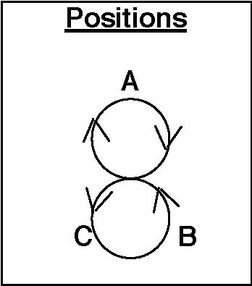
Turbo

Juggler | 1 | 2 | 3 | 4 | 5 | 6 | 7 | 8 | 9
A | B | C | B |  | B |  | C |  | C
B | A |  | A | C | A | C |  | C
C |  | A |  | B |  | B | A | B | A
Right hand counting

A Turbo is a group of 3 weaving jugglers who feed themselves. It is also a Two-leaf Clover or a continuous change sides feed through the middle. Pass every right hand throw when you are feeding, and pass every other when you are not feeding.
When a juggler moves to the other side, he or she cuts across in front of the old feeder, and turns around to pass to the new feeder.
Note: Turbo is similar to Bruno's Nightmare, but with a much shorter cycle (18 throws compared to 30 passes needed for Bruno's Nightmare).

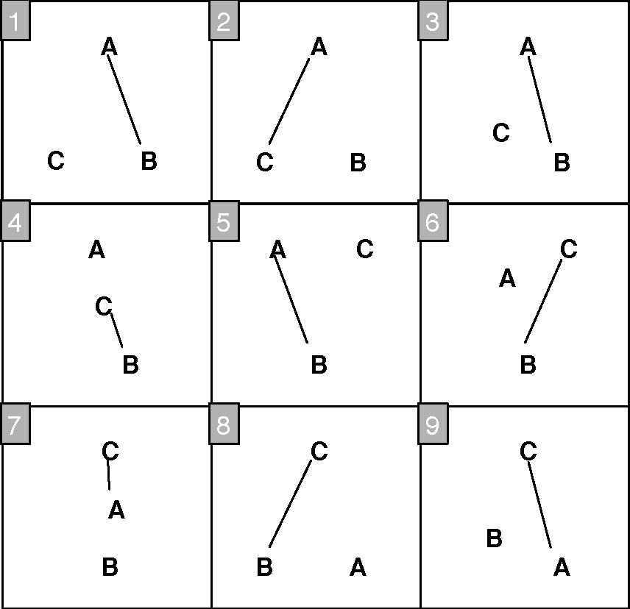
To learn the Turbo, start by practicing a regular feed change sides. Then learn the feed change sides through the middle. Finally, speed up the change side moves until the feedees all move at the earliest possible opportunity.
Variations
There are a lot of Turbo variations. Turbos can be done in almost any count and combined in many different ways.
Left Handed – Same as above, but mirror image.
3-count – Feeder does 3 count, feedees do 6 count.
Chocolate Bar – Fun!
Double 3 count – Tricky. There are 2 different ways to do the transitions. Usually we have the movers stay in 3-count and move on the inside hand throw. You can also do this pattern where the movers transition in 4 count and move on the outside hand throw. Feels a little like the El Nino.
Tom's Turbo – Feeder is in 1-count and does 3 passes in a row to each feeder. Have each juggler start with a different set of clubs. (Created by Tom Pomraning.)
10-Club Turbo – See below.

Also see Interlocking Turbos in 6 person patterns and Strange Attractor in 5 person patterns.

10-Club Turbo
The 10 Club Turbo has the same positions and movement as the Turbo but with an extra club. Usually we throw the passes as doubles (same as in 7 club 2-count). In order to keep the timing the mover must add an extra beat into the pattern. That can be done by throwing a double self (either right or left) to the opposite hand or by throwing an early triple pass and pausing for one beat. The diagram below shows the early triple, but experiment with whatever works best for you (some people think a right to left double is easier).
Juggler | 1 | 2 | 3 | 4 | 5 | 6 | 7 | 8 | 9 | 10 | 11 | 12 | 13 | 14
A | D-B |  | D-C |  | D-C |  |  |  | D-C | Move |  |  | T-B | Pause
B |  | D-A | Move |  |  | T-C | Pause |  |  |  | D-C |  | D-A
C |  |  |  | D-A |  | D-B |  | D-A |  | D-B |  | D-B
Both hands counting
A starts with right hand.
B and C start with left hand.

The table shows 2 transitions. Note that the old feeder (A) passes twice in a row to the new feeder (C). The mover (B) throws a triple to the new feeder at the SAME time as the new feeder throws a double to the mover and then pauses for one beat. The feeder and the 2 feedees are always on opposite timings (the feeder's right is synchronized with the feedees' lefts).
The easiest way to learn is by practicing the change sides feed with transitions on the outside and getting comfortable with the triple or the self double timing transition. Then learn the inside transition and finally rev it up to true turbo speed. Excelsior!
By Luke Emery, 1999.
Variations
Try with single passes instead of double passes in 7 club 2 count singles speed.
We worked out an 11-Club Turbo variation with triple selves on the transitions, but it's too hard for us to run more than a couple transitions at a time. Maybe we'll get it in a future version of the book.

Another 10-Club Turbo
The pattern above will always be the 10-Club Turbo, but here is another version that makes a nice diversion. It's based on an extra club feed too, but the transitions in the middle are made by a half pirouette underneath a right to left double.
The feedee who is moving first steps into the middle of the pattern directly between the feeder and the non-moving feedee. After one pass the moving feedee does a half pirouette underneath a double right to left self throw, Then steps back to complete a single turbo transition. The table below has one complete transition.

Juggler | 1 | 2 | 3 | 4 | 5 | 6 | 7 | 8 | 9 | 10 | 11
A | D-B |  | D-C |  | D-B |  | D-C |  | D-C
B |  | D-A |  |  |  | D-A |  | D-self |  |  | D-C
C |  |  |  | D-A |  |  |  | D-A |  | D-B
Both hands counting
A starts with R
B and C start with L
D-self is a half pirouette

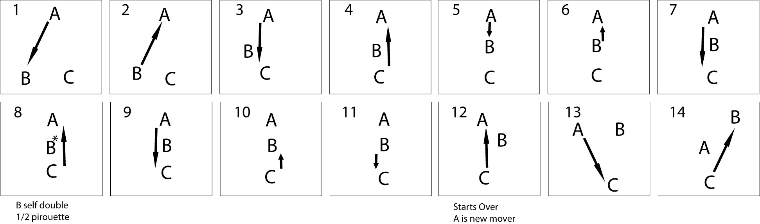
When you do the half pirouette, make sure to throw the double more inside than usual and have the outside passers pass a little on the wide side to reduce collisions.
By Luke Emery, 2002.

Lines
The Line is another classic family of patterns with countless variations. Here are a few we often juggle in Madison.
Mel in the Middle
Positions
A
B
C

A double 3 count pass with a moving juggler in the middle spinning around. If Mel is B (Mel is always B), and starts facing A, then it looks like this.
Juggler | 1 | 2 | 3 | 4 | 5 | 6 | 7 | 8 | 9 | 10 | 11 | 12
A | C | B |  | C |  |  | C | B |  | C
B |  | A |  |  | C |  |  | A |  |  | C
C | A |  |  | A | B |  | A |  |  | A | B
Both hands counting

Peter's Backcrosses
If you replace Mel with Peter, change to 3-count, remove spinning and add backcrosses, you get this pattern.
All jugglers are in 3-count. Use the exact same pass sequence, but B (that's Peter – ok, Mel isn't always B) faces perpendicular to the line from A to B and makes all the passes as backcrosses, alternately to A and C.
Swiftly Tilting Popcorn
Extra club version of Mel in the Middle, except in 4-count instead of 3-count. Inside person whirls with half pirouettes under doubles while outsides do popcorn. All passes are right handed.
Juggler | 1 | 2 | 3 | 4 | 5 | 6 | 7 | 8 | 9 | 10 | 11 | 12 | 13 | 14
A | D-C |  | B |  | D-C |  | T-self |  | D-C |  | D-C |  | B
B |  |  | A |  | D-self | ½ P |  | C |  | D-self | ½ P |  | A
C |  | T-self |  | D-A |  | D-A |  | B |  | D-A |  | D-A |  | T-self
Both hands counting
A starts with 4 clubs, right hand
B starts facing A, right hand
C starts with left hand
½ P marks half pirouette underneath the double

1 is the same as 11. This is just one possible variation of spinning underneath popcorn.

Dropback Line
A passes to B. B drops back to C. C passes to A. You can do a dropback line in any count: 2-count, 4-count, 3-count, chocolate bar. It's a nice pattern to add clubs to as well. Try one two, or 3 extra clubs with doubles or one extra club in 3-count (A and B cross, C throws straight).
Line Feed
You can do any of the feed variations in a line layout instead of a V. Some will be useful for more complex patterns. Also see 4 person Lines.

Extra Club Line
Positions
A
B
C

What do you do if there are 3 club passers and one is more advanced, one is intermediate and the third is a beginner. Here's a nice pattern to accommodate everyone!
A and B face each other. C faces A and B. A starts with 4 clubs.
Juggler | 1 | 2 | 3 | 4
A | D-C |  | B
B |  |  | A
C |  | T |  | D-A
Both hands counting

A alternates right hand doubles to C and singles to B. B does right hand 4-count to A. A alternates right triple selves and doubles to A (fast popcorn).

GDP
Positions
A
B
C

Juggler | 1 | 2 | 3 | 4 | 5 | 6 | 7 | 8 | 9
A | T-C | B | T-C | Move | C | Move |  | T-B
B |  | A | Move |  | T-C |  | T-A | C | T-A
C |  | T-A |  | T-B | A | T-B | Move | B | Move
Right hand counting

A starts with 4 clubs and passes triple to C, single to A. B faces A, starts with a self, and passes every others to A. C starts with a self, then triple every others to A.
The description above is the base pattern without movement. We will follow the pattern of movement by concentrating on B. All jugglers do the following sequence at different times.
Right hand counting:
B: self, single to A, self, self (while replacing A), triple to C, self (A replaces C), triple to A, single to C, triple to A, self, (as B moves to the middle). Start over.
By Luke Emery, 1999.
Variations
Doubles – Throw doubles instead of singles.
A variety of tricks can be done while moving into the center (such as an early triple followed by a pirouette, etc.)
There's a 5 person variation we call Cathedral in the 5 Person Patterns.

Up, Up and Over
Ok, Mike, how do you do this one, exactly?

4 Person Patterns

Box
The box is a classic passing pattern with dozens of variations, many of which have been around for a long time. It's a great foundation for innovating new patterns, though.
Basic 4 Count Box
Positions
 | A
C |  | D
 | B

Juggler | 1 | 2
A | B
B | A
C |  | D
D |  | C
Right hand counting

2 Count Box
Juggler | 1 | 2 | 3 | 4
A | B |  | B
B | A |  | A
C |  | D |  | D
D |  | C |  | C
Both hands counting
A, B start with right
C, D start with left

1 Count Asynchronous Box
Juggler | 1 | 2
A | B | B
B | A | A
C | D | D
D | C | C
Both hands counting

This is a good exercise to practice timing. All jugglers throw at exactly the same time. Wide throws make it a little easier. You can do the same pattern with synchronous ultimates, but that's pretty hard.
Almost any staggered passing pattern will work with a box, and many that are synchronous. A moving variation in 4 count is for C and D to swap places when A and B pass and vice versa. Other variations are Pistons and the Minuet.

Extra Club Boxes
13 Club Box – Throw a double right pass to the juggler on your left in 4-count. Each passer passes on their own beat.
14 Club Box – This can be done with pairs of jugglers synchronized in a 7 club 2-count, but it is easiest if each juggler is ½ beat after each other.
14 Club 4-Count Box – This is a box where each pair of juggler does 7 club 4-count with triples. The two pairs are 1 beat away from each other (A and B's rights are synchronized with C and D's lefts).
16 Club Box – There are several nice 16 club box variations. To reduce collisions, have A and C throw triples while B and D throw singles (½ beat after each other). The overall timing is about the same as 8 doubles (or 7 singles). This is a pretty pattern. You can also do a 16 club box pattern with all the jugglers synchronized in 8 club 2-count singles, doubles or triples. Nice! Pass either straight across, or to the juggler on the left.
18 Club Box – With 9 club triples 2 count and each juggler offset ½ beat. However, if you are doing this pattern, you probably don't need our suggestions on club passing in a box... Very cool, but tricky!
Also see Fireworks.

14 Club Ultimate Box
If the timing is perfect, it is possible to do a 14 club box in 1-count, with right hand doubles across the box and left hand singles along the edges of the box.
Positions
 | A
C |  | D
 | B

Juggler | 1 | 2
A | D-B | C
B | D | D-A
C | D-D | A
D | B | D-C
Both hands counting
A and C start with 4 clubs and right hands
B and D start with 3 clubs and left hands

Throw a little wide on the double passes and make sure that everyone has metronome perfect timing and it actually works!

Pattern by Luke Emery, 2007.

Bermuda Quadrangle
Positions
 | A
D |  | B
 | C

Juggler | 1 | 2 | 3 | 4
A | B | C | D
B | C |  | A | D
C | A | D |  | B
D |  | A | B | C
Both hands counting
Start with R

Bermuda Quadrangle by Laura and Becky Provance, Barry Friedman, and Steve Otteson.

Maya
Positions
 | A
D |  | B
 | C

Juggler | 1 | 2 | 3 | 4 | 5 | 6
A | D |  | B | C |  | B
B | C |  | A | D |  | A
C | B | D |  | A | D
D | A | C |  | B | C
Both hands counting
Start with R

Maya, by Tom Pomraning, was published in Jugglers World. Tom makes incredible chocolates as well as juggling patterns.

Interlocking Triangles
Positions
 | A
D |  | B
 | C

Juggler | 1 | 2
A | B | B
B | D | C
C |  | A
D | A
Right hand counting

Spider Web
Positions
 | A
D |  | B
 | C

This is a variation of the box with 3 extra clubs and all right hand passes.
Juggler | 1 | 2 | 3 | 4
A | T-C |  | D-B
B |  | T-D |  | D-C
C | D-D |  | T-A
D |  | D-A |  | T-B
Both hands counting, all passes with right hand
A and C start with right
B and D start with left
A, B and C start with 4 clubs
Positions
 | A
D |  | B
 | C

Extra Club Rotating Feed (for 4 jugglers)
This is a box pattern with a rotating feed for 4 jugglers and one extra club.
The graph shows a counter clockwise feed but both directions work.

Juggler | 1 | 2 | 3 | 4 | 5 | 6 | 7 | 8 | 9 | 10 | 11 | 12
A | D-C |  | D-B |  | D-self | Pause |  | D-C |  | D-self | Pause
B | D-self | Pause |  | D-D |  | D-C |  | D-self | Pause |  | D-D
C |  | D-A |  | D-self | Pause |  | D-A |  | D-D |  | D-self | Pause
D |  | D-self | Pause |  | D-B |  | D-self | Pause |  | D-B |  | D-A
Both hands counting, all right hand throws are either double passes or double selves
A starts with 4 clubs
A and B start with right hand
C and D start with left hand

The steady state right hand sequence is pass across, pass left, self, pass across, self.
Pattern by Luke Emery, 1999.
Positions
A |  | B
C |  | D

Gustav
This is a double 3-count extra club pattern for four jugglers in a box pattern.
Juggler | 1 | 2 | 3 | 4 | 5 | 6
A | T-D |  | C | T-D |  | C
B | D |  |  | D
C |  |  | A |  |  | A
D | B | T-A |  | B | T-A
Both hands counting
A starts with 4 clubs
A throws triple crosses, B throws triple straights
C and D start slightly after A and B – timing is a bit wonky

Pattern by Luke Emery, 2008 and named after the hurricane.

Switch Sides Feed
The standard Switch Sides Feed is an easy introduction to moving while passing. The extra club version is a fun and spectacular pattern.
The basic idea is that a feeder feeds three feedees, but the feedees on the end move straight across after every pass so that the middle feedee becomes the new feeder after each sweep.
Positions 1
 |  | B
A |  | C
 |  | D

Positions 2
B
A |  | C
D

Windshield Wiper Switch Sides Feed
Juggler | 1 | 2 | 3 | 4 | 5 | 6 | 7 | 8
A | B | C | D | C |  | C |  | C
B | A |  |  |  | C
C |  | A |  | A | B | A | D | A
D |  |  | A |  |  |  | C
Right hands counting
Start with right hand

In this version, weavers move back and forth in an 8-count.
Typewriter Switch Sides Feed
Juggler | 1 | 2 | 3 | 4 | 5 | 6
A | B | C | D |  | C
B | A |  |  | C
C |  | A |  | B | A | D
D |  |  | A |  |  | C
Right hands counting
Start with right hand

Extra Club Switch Sides Feed
In this version, weavers move back and forth in an 6-count. This is a fun one.
Juggler | 1 | 2 | 3 | 4 | 5 | 6 | 7 | 8 | 9 | 10 | 11 | 12 | 13 | 14
A | D-B |  | D-C |  | D-D |  | D-C |  |  |  | D-C
B |  | D-A |  | D-self | ½ P |  |  |  | D-C |  | D-self | ½ P
C |  |  |  | D-A |  |  |  | D-B |  | D-A |  | D-D |  | D-A
D | D-self | ½ P |  |  |  | D-A |  | D-self | ½ P |  |  |  | D-C
Both hands counting, all passes are right handed
A starts with right hand and 4 clubs
B, C and D start with left hand
½ P marks a half pirouette underneath the Right to Left double self throw

Pattern by Luke Emery.

Standard Weave
Here's where the fun really begins! This is a great pattern to master because it leads to many other exciting patterns.
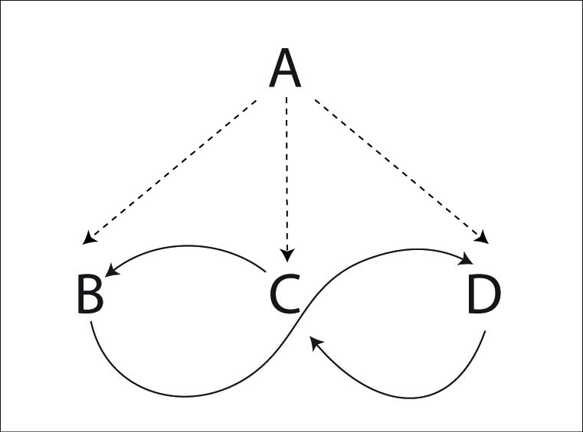
Juggler | 1 | 2 | 3
A | B | C | D
B | A |  | A
C |  | A
D |  |  | C
Right hand counting

Weavers move BACK on the ends and FORWARD in the middle for the standard weave.
A is the feeder who throws to the end, middle, end, middle and then repeats. A will be in a 2-count. That's called a wind-shield wiper field (as opposed to a typewriter feed that only goes in one direction).
Each weaver passes from their current position and then moves to the next position. The weavers pass in a 6-count. Weavers move back on the ends and forward in the middle in a figure 8 pattern.
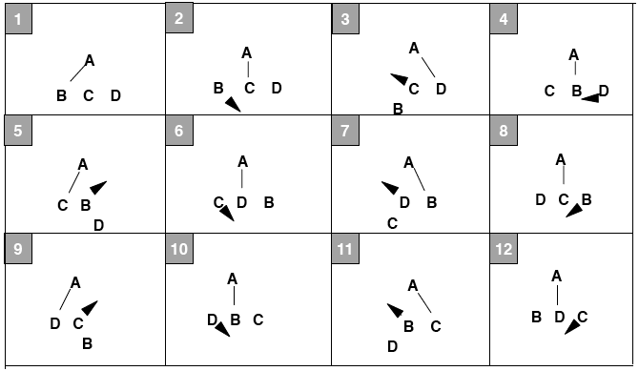
Note: The middle weaver moves towards the end that passes to the feeder first.

Variations
Oh, there are so many variations of the weave! The mind boggles. To start, try with left handed throws in 2-count feeding. Try moving forward on the ends and back in the middle (an inverted weave). Now try with chocolate bar (feeder throws ultimates, Right, and then Left to each feeder.)
You can do this pattern with an extra club, all passes as doubles, or all throws as singles, or feeder throwing singles and weavers throwing triples, or feeder throwing all triples and weavers throwing singles.
Do this pattern with 2 extra clubs and all the passes are triples.
Slow it down and pass twice in a row from the feeder to each weaver.
In general, the weavers can move in many different counts, and the feeder can choose a pattern that makes the weave work as long as two weavers aren't passing at the same time. You can slow the weave down if you want, or speed it up. Here are some examples (all of these in both hands counting):
5-Count Weave (Feeder PSPSP, Feedees 5-Count)

Juggler | 1 | 2 | 3 | 4 | 5 | 6 | 7 | 8 | 9 | 10
A | B |  | C |  | D | B |  | C |  | D
B | A |  |  |  |  | A
C |  |  | A |  |  |  |  | A
D |  |  |  |  | A |  |  |  |  | A

There are other variations that also work out as a 5-count Weave (like the feeder throwing PPPSS instead of PSPSP).
Double 3-Count Weave (Feeders Double 3-Count, Feedees 4 of 5-Count)

Juggler | 1 | 2 | 3 | 4 | 5 | 6 | 7 | 8 | 9
A | B |  | C | D |  | B | C |  | D
B | A |  |  |  |  | A
C |  |  | A |  |  |  | A
D |  |  |  | A |  |  |  |  | A

In this variation, the weavers move in a 5 count to the middle and a 4 count to the outsides. The inverse works too, but is a bit harder.
The variations with a 4-count or 3 of 4-count for the feeders don't work with the standard feed, but see the Iron Cross Weave, Spiral Weave or Twister Weave for more 4-count weave variations.
Hyper -Weave (Feeders 1-Count, Feedees 3-Count)

Juggler | 1 | 2 | 3 | 4 | 5 | 6
A | B | C | D | B | C | D
B | A |  |  | A
C |  | A |  |  | A
D |  |  | A |  |  | A

Ok, this is about as fast as a weave can get. It's really fast and really hard. Throw really high lofty slow passes, move fast and hope for the best. If you can do this weave, make sure you stop by Madison some time and do some fun juggling with us!
Also see Mr. Inside Mr. Outside Weaves, Inside Out Weaves, Twister Weaves, etc.
There are a number of variations floating around where the weavers trade place with the feeder (typically on one end only). Work it out.
The Standard Weave has been around longer than any of us have been juggling.

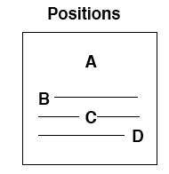
Dresser Drawer Weave
This weave variation has the same passes as the standard weave, but the weavers move back and forth instead of in a figure 8.
Juggler | 1 | 2 | 3
A | B | C | D
B | A |  | A
C |  | A
D |  |  | C

Each juggler has its own slot to move on. Each slot has three positions: left, middle, and right. Weavers move back and forth on their slots. Moves are made to the next position after the pass is made from the current position.
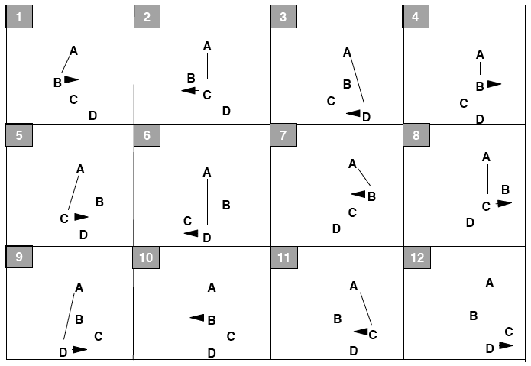
When was this pattern created? We have been doing it since 1992.

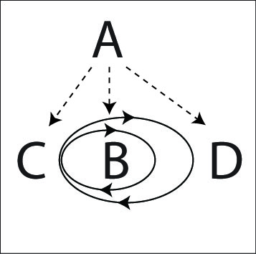
Inside Out Weave
A standard weave is in a figure eight, which is two loops connected by a center. Now imagine warping space so that one of the loops is folded back inside the other. That's the Inside Out Weave.
The count and the passes are exactly the same as the standard weave, but the jugglers move in a small loop from the new center (which is in the middle, but has the count and movement for an end) to the “middle” (which is now on the outside), and then in a large loop back (the other end) . In the loops always move forwards for the “middle” (where C starts) and backwards from the “ends” (where B and D are).
The passing lanes can be somewhat narrow, so be careful, or you might bruise your Zoc.
Pattern by Mike Newton.

Gandini Weave
The Gandini Juggling Project has explored a lot of interesting weaves (see Appendix C for more examples). We call any weave a Gandini Weave if the weavers always pass in the middle of the figure 8 loop, although the Gandini's have innovated many other interesting weaves besides just these variations. I don't know if that is what the Gandini's call them! This is a simple Gandini Weave that is a great foundation for other patterns.
In this weave all the weavers move in a figure 8, but they always pass from the middle instead of the end. To make the weave slow enough to be under control the feeder will pass twice in a row to each mover.
The feeder is in 2-count (every right hand pass), the feedees throw 2 right hand passes in a row, and then 4 right hand selves (PPSSSS).
Juggler | 1 | 2 | 3 | 4 | 5 | 6
A | B | B | C | C | D | D
B | A | A
C |  |  | A | A
D |  |  |  |  | A | A

It's easiest to start with the weavers stacked in a line all facing the feeder.
- The feeder (A) passes twice to the first weaver (B), then that weaver goes to the right.
- The feeder passes twice to the second weaver (C), then that weaver goes to the left.
- The feeder passes twice to the third weaver (D), then that weaver goes right.
- Now repeat where each weaver passes to the feeder and then moves in the opposite direction of the previous weaver.
This weave can be done in many interesting variations.
Try adding an extra club and making all the passes as doubles, or passing chocolate bar.
You can also invert the weave (reverse cascade).
Try this weave in 6-count with only a single pass to each weaver if you want a challenge that will really make you break a sweat.
See the Gandini 5 variations in 6 Person Patterns, the Twister 5 in 7 Person Patterns and other variations in Appendix C.
We learned about this family of weave variations from juggling with Sean Gandini and the Gandini Juggling Project in 2000.

Three Leaf Clover (Standard)
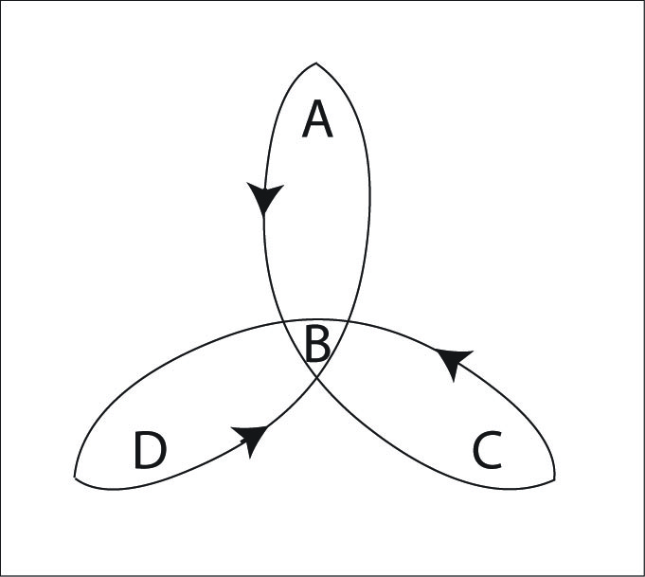
There are lots of variations on a clover pattern, but this one is Madison's favorite. It's a great pattern!
Juggler | 1 | 2 | 3 | 4 | 5 | 6 | 7 | 8
A | D | B | C |  |  | B
B |  | A |  |  | C | A | D
C |  |  | A | D | B |  |  | D
D | A |  |  | C |  |  | B | C
Right hand counting

The idea of a clover leaf is to have a juggler on top of each leaf, and a juggler in the middle. The juggler in the middle trades places with a juggler on a leaf. The juggler who was on the leaf goes to the middle, and then replaces the juggler on the next leaf (follow the arrows in the diagram above). All of this movement occurs while passing.
In this variation, there is a feeder who passes 3 times in a row (once to each of the other jugglers). Then the former feeder has 2 right hand selves to move to the middle, one pass in the middle, and 2 right hand selves to move out of the middle. Then the pattern repeats.
To start, ignore the fact that there is a clover. Just concentrate on the feed, and then moving into the middle of a feed and then moving out and repeating the feed.
Just remember, feed, 2 in and 2 out. In the diagram above, A is the first feeder. In 8 passes, the clover has completed a cycle where every juggler has moved from their leaf to the next leaf.
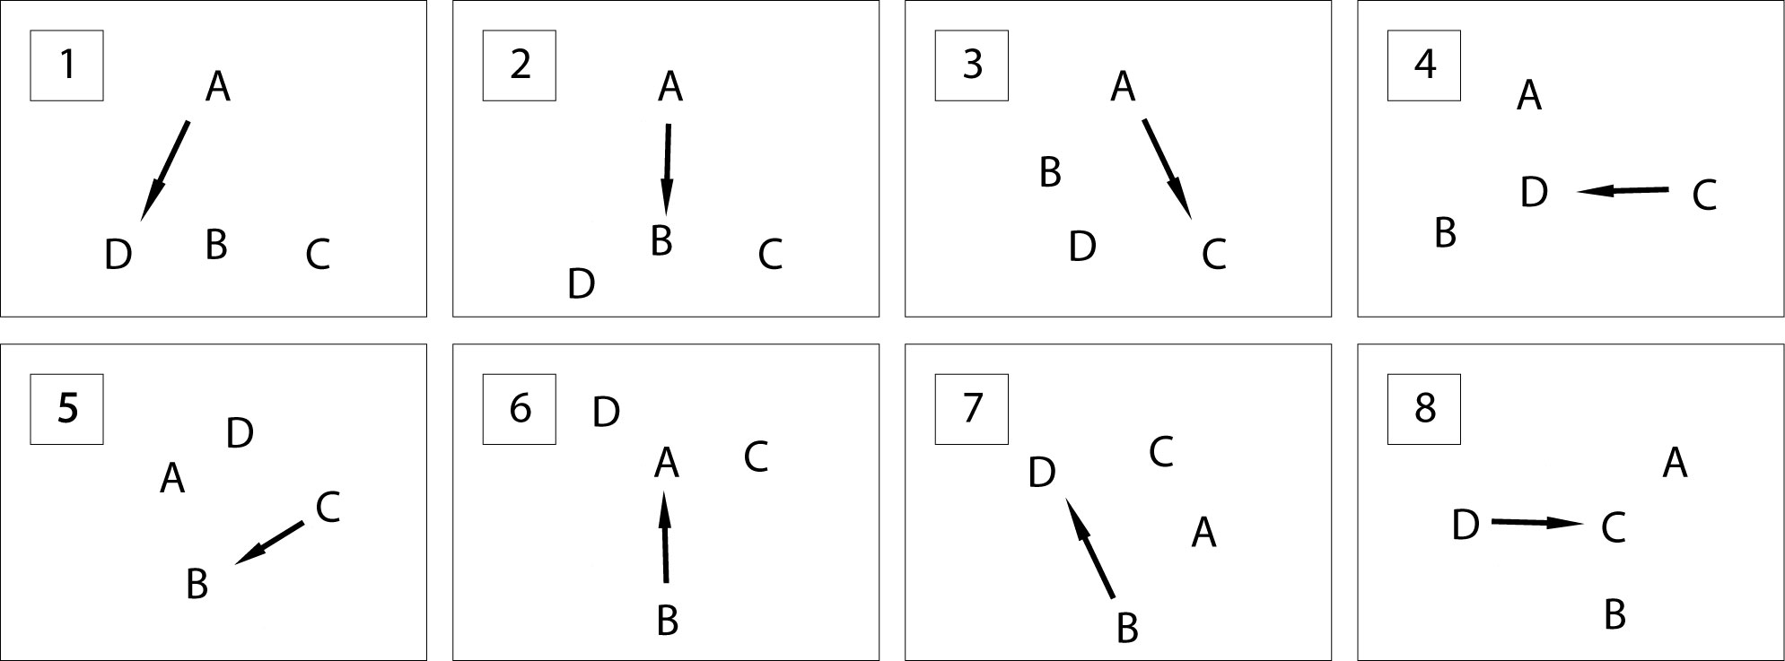
There's a beautiful symmetry to the pattern once it gets going. I hope you enjoy it as much as we do!
Mike Newton created this pattern in 2000.
Variations
Try it in 3-count or chocolate bar. There are straight forward extensions for any number of people and you can also add extra clubs (see Extra Club Clover and Hyper Clover).
Madison passing history has a lot of other clover variations, some of which are described later in the book.
The Run Over Clover is the same pattern with some of the selves replaced with passes.

Run Over Clover
Once you're comfortable with the standard clover, You can add some extra passes. This variation has the same count (8 beats to a cycle) and the same movement, but adds 2 extra passes per cycle. Each person has a “favorite” partner that they pass to in 4-count, while maintaining the clover pattern the rest of the time.
Juggler | 1 | 2 | 3 | 4 | 5 | 6 | 7 | 8
A | D | B | C | B |  | B |  | B
B |  | A |  | A | C | A | D | A
C |  | D | A | D | B | D |  | D
D | A | C |  | C |  | C | B | C
Right hand counting

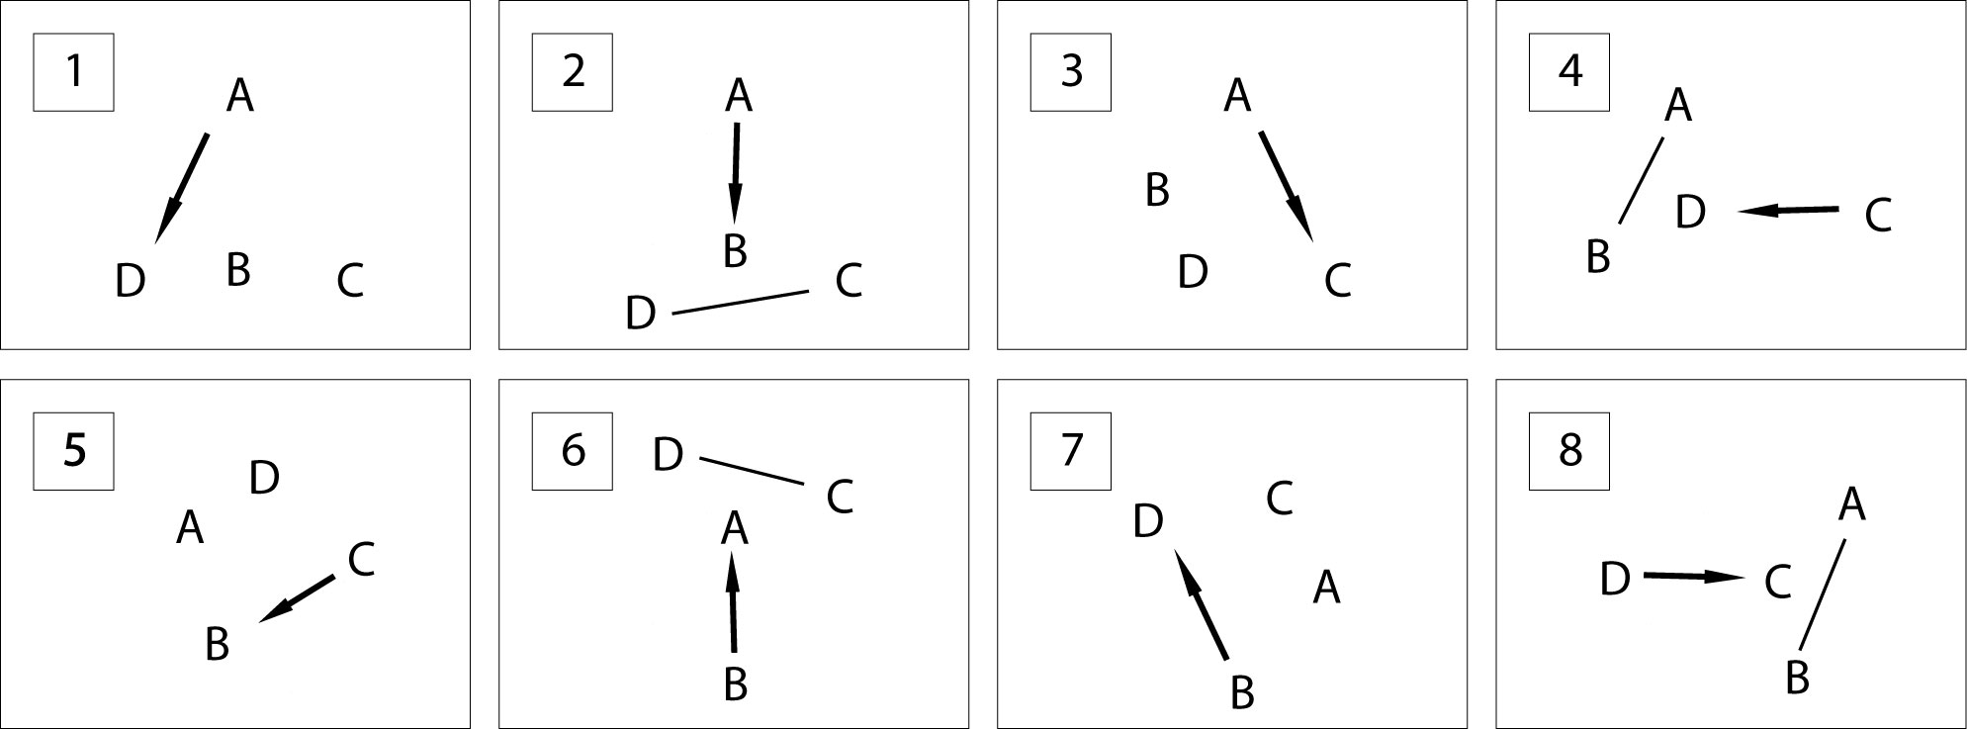
Created in 2001 by Mike Newton and the MAJ.

Extra Club Three Leaf Clover
This is the standard three leaf clover with an extra club added and all passes as doubles. As usual, there are a number of ways to add a club. Here is a slower version that is a little easier. The feeder passes twice to the 2nd and 3rd feedees. The Hyper Clover is a faster and more elegant (but much harder) relation.
All passes are right hand straight doubles. A right to left double self is required to keep the timing.
Juggler | 1 | 2 | 3 | 4 | 5 | 6 | 7 | 8 | 9 | 10 | 11 | 12
A | D-D |  | D-B |  | D-B |  | D-C |  | D-C |  | D-self | Pause
B |  |  |  | D-A |  | D-A |  | D-self | Pause
C | D-self | Pause |  |  |  |  |  | D-A |  | D-D |  | D-D
D |  | D-A |  | D-self | Pause |  |  |  |  |  | D-C
Juggler | 13 | 14 | 15 | 16 | 17 | 18 | 19 | 20 | 21 | 22 | 23 | 24
A |  |  |  |  |  | D-B |  | D-B |  | D-self | Pause
B |  |  | D-C |  | D-A |  | D-A |  | D-D |  | D-D
C |  | D-B |  | D-B |  | D-self | Pause
D | D-C |  | D-self | Pause |  |  |  |  |  | D-B |  | D-C
Juggler | 25 | 26 | 27 | 28
A
B | D-self | Pause
C | D-D |  | D-D
D |  | D-C |  | D-A

Both hands counting, right hand passes only
A and C start with R
B and D start with L

Hmmm...this is the first time that pattern has been written down. It isn't really as complicated as it looks. Let's walk one juggler through it.
- Feed from right to left in doubles. Pass once to the end, twice to the middle, twice to the other end.
- Self double, pause.
- Two right selves to move into the middle, then pass twice
- Self double, pause
- Two right selves to move out of the middle
- Repeat!

It's good fun if you're comfortable weaving while throwing doubles. Make sure your double selves are high enough to maintain the timing of the pattern.
Pattern by Luke Emery, 2001.

Hyper-Clover
Juggler | 1 | 2 | 3 | 4 | 5 | 6 | 7 | 8 | 9 | 10 | 11 | 12
A |  | D-B |  | D-C |  | D-self | Pause |  | D-B |  | D-self | Pause
B | Pause |  | D-A |  | D-self | Pause |  | D-A |  | D-D |  | D-self
C |  | D-self | Pause |  | D-D |  | D-B |  | D-self | Pause |  | D-D
D | D-A |  | D-self | Pause |  | D-C |  | D-self | Pause |  | D-C
Both hands counting, all right hands are double passes or double selves
A starts with left hand
B starts with pause, then left hand (for start, B can just start with right self)
C starts with left hand
D starts with right hand and 4 clubs

It's a great pattern but quite challenging.
This was one of the first extra club clover variations we tried. (The first attempt was me, Peter and Luke and Ilka from Luka Luka at a juggling convention.) Peter, Luke and Ilka are all fantastic club passers, but we discovered that this pattern was actually quite hard to do. That was the motivation to create the slower version described previously. However, after practicing and performing the Extra Club Clover for a few years, we were finally able to learn the original variation too, now renamed to the Hyper-Clover.
Pattern by Luke Emery, 2001.

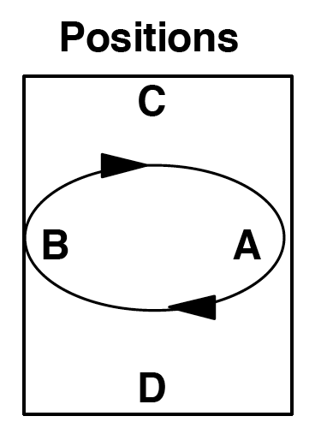
Benzene Ring (for 4 jugglers)
There is a whole family of benzene ring patterns, where movers juggle in a circle between two feeders. The Benzene Ring for Six and for Eight are much easier patterns to start, but Benzene Ring for Four is more fun.
This version is in 3-count.

Juggler | 1 | 4 | 7 | 10
A | C | D | D | C
B | D | C | C | D
C | A | B | B | A
D | B | A | A | B
Both hands counting starting
with the right hand. Numbers
missing are self throws.

After the first pass (throw #1 in the graph, made with the right hand), A and B have 2 self throws to turn around. If C and D make their right hand passes deep, A and B will have an easier time turning.
After the second pass (throw #4 in the graph, made with the left hand), A and B have 2 self throws to switch places. They switch places by moving around each other in a counter clockwise direction.
After the 3rd pass (throw #7 in the graph, made with the right hand), A and B have 2 self throws to turn around.
After the 4th pass (throw #10 in the graph, made with the left hand), A and B have 2 self throws to switch places. The jugglers are at their original positions. At this point, the pattern repeats.
This pattern is fast for the movers A and B because they are passing 3-count while spinning around each other.
This pattern could be considered a 2-seated unicycle without the seats, going backwards. It is a precursor for the Razor juggling pattern.
Pattern created July, 1997 by MAJ.

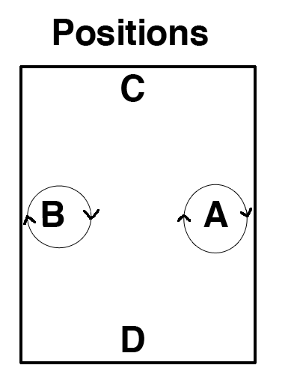
Chocolate Stir
A chocolate bar variation of the 4 person Benzene Ring starts in the same positions as the Benzene Ring. Each juggler is in chocolate bar. The inner jugglers throw right pass, left pass, then right to left single and do a half pirouette underneath, followed by a left self and then repeat.
Juggler | 1 | 2 | 3 | 4 | 5 | 6 | 7 | 8
A | D | D | ½ P |  | C | C | ½ P
B | C | C | ½ P |  | D | D | ½ P
C | B | B |  |  | A | A
D | A | A |  |  | B | B
Both hands counting starting
with the right hand.

The ½ P marks a half pirouette under a single spin right to left self. A and B spin in place. They don't move to both positions like in the Benzene Ring.
Pattern by Luke Emery

Canoe
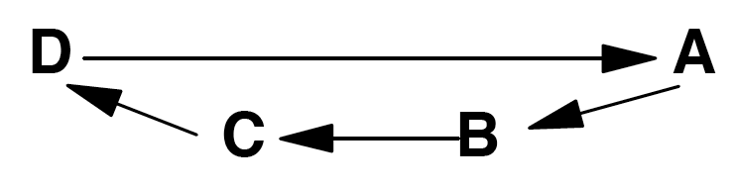
This is basically a line of jugglers where the jugglers in the middle pass drop-backs. A canoe can be performed with 3 or more jugglers.
A is facing B, C, and D.
B, C, and D are facing A.
B and C pass dropbacks.
Use your favorite passing sequence.
Arrows indicate passes.

We don't know who invented this pattern, but we have been doing it since 1993. You can easily add extra clubs or people and use a variety of passing counts.

Death from Above
This is a fun but challenging pattern with 2 extra clubs. It requires two jugglers that are comfortable with 7 clubs 4-count back to back passing and who aren't pansies like some Madison Area Jugglers I could mention.
Positions
A | B | C | D

A faces B, and C faces D.

Juggler | 1 | 2
A | T-D | S-B
B | T-C | S-A
C | S-D | T-B
D | S-C | T-A
Right hand counting

A and B start with 4 clubs each and start passing at the same time. C and D each start with 3 clubs.
A passes triple to D, then single to B.
B passes triple back-to-back to C, single to A.
C passes single to D, triple back-to-back to B.
D passes single to C, triple to A.

Pattern by Luke Emery, 1999.

Two on Two Double 3-Count
Everyone does double 3-count feed, feeding from right to left. This pattern is a prerequisite for El Nino [see later].
Positions
A |  | C
B |  | D

Juggler | 1 | 2 | 3
A | C |  | D
B | D | C
C | A | B
D | B |  | A
Both hands counting
Start with R

This is the standard MAJ double 3-count box, but you might as well learn the opposite version (feeding from left to right) for doing the backwards El-Nino (La Niina).
[dates to 7/97 MAJ]
Positions
 |  | B
A |  | C
 |  | D

Ultimate Feed
This is just a standard typewriter or windshield wiper feed in 1-count, but it's worth extra attention because it is a foundation for so many other patterns, including the very cool El Nino.

Typewriter

Juggler | 1 | 2 | 3
A | B | C | D
B | A
C |  | A
D |  |  | A
Both hands counting
Start with R

Windshield Wiper

Juggler | 1 | 2 | 3 | 4
A | B | C | D | C
B | A
C |  | A |  | A
D |  |  | A
Both hands counting

This is a 3-count feed where A feeds a 1-count carriage return, and B, C, and D are passing 3-count.
This pattern has been around for a long time and is a basis for other patterns. For example, each of the jugglers in the El Nino pattern will take their turn as feeder of the above pattern.
Extra Club Ultimate Feed
Add one extra club to the Ultimate feed by having all the feedees throw crosses. Alternatively (the feeder can throw crosses while the feedees throw straight). The extra club feed can be done with many different spins.
All passes in singles. (Timing is a bit wonky. Throw a little outside, especially on the middle throws.)
Feeder and feedees all in double passes. (Feeder rights synchronized with feedee lefts.) Feels like 7 club 3-count.
Feeder in triples ultimates, feedees in singles. (Feeder rights synchronized with feedee rights.)
Feeder in single ultimates, feedees in triples. (Feeder rights synchronized with feedee rights.)

Two Extra Club Ultimate Feed
To add another club (14 total), throw all passes as doubles and all passes are straight from both feeder and feedees.
Theoretically you could keep adding more clubs and higher throws, and just switching back and forth from straight to cross feedee passes with each extra club, but it gets challenging quickly.

El Nino
El Nino is a rotating 1 count feed and is one of the crown jewels of the MAJ pattern book.
It is a challenging pattern, but quite doable once passers master the 1-count feed and the 2 on 2 double 3-count box. And once you can juggle it, you can join the Madison elite group of Jugglers Who Can Do The El Nino.
Juggler | 1 | 2 | 3 | 4 | 5 | 6 | 7 | 8 | 9 | 10 | 11 | 12 | 13 | 14 | 15 | 16
A | C | D | B | C |  | B |  |  | C |  |  | C |  |  | D
B |  |  | A |  | D | A | C | D |  | C |  |  | D |  |  | D
C | A |  |  | A |  |  | B |  | A | B | D | A |  | D
D |  | A |  |  | B |  |  | B |  |  | C |  | B | C | A | B
Both hands counting
All jugglers start with left hands
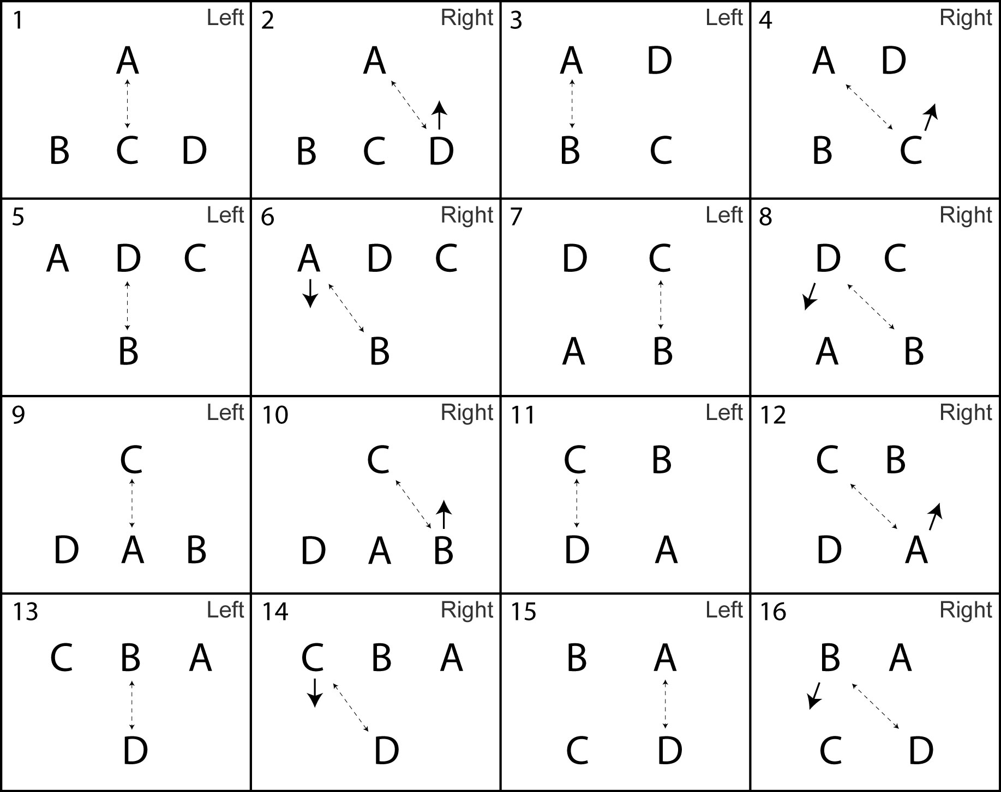
Positions: Lines indicate passes, arrows indicate movement of juggler after the pass.
El Nino is the combination of 2 patterns: Two on Two Double 3-Count, and Ultimate feed. Starting in the positions of the Ultimate Feed pattern, one of the feedees moves across and stands next to the feeder. Now the jugglers are doing Two on Two Double 3-Count.
Then another of the original feedees moves across, following the first mover, and the pattern becomes the Ultimate Feed again.
Now have 2 jugglers move back (one at a time) to join the feeder. See the diagrams above to see how the jugglers move.
The pattern in the graphs above is the fastest version. While learning, it's a good idea to wait a while, until the next juggler is ready, before the next move. Remember to move on a right hand pass.
The mirror image (1-count feeding left to right) is called La Nina. Move on left throws instead of rights and start with a right pass in the middle.
There are other fun ways to rotate a 1-count feed. Tarim demonstrated a pattern similar to 1-count El Nino where the mover transitions in 4-count instead of 3-count (leaving on a left hand throw in the above picture instead of a right, and joining the double three count box on the opposite count. He also goes the wrong direction like La Nina! :)
El Nino dates to August, 1997 by Peter Kaseman and MAJ.

Oogle Boogie
The Oogle Boogie is a rotating Y.
Positions and passing directions
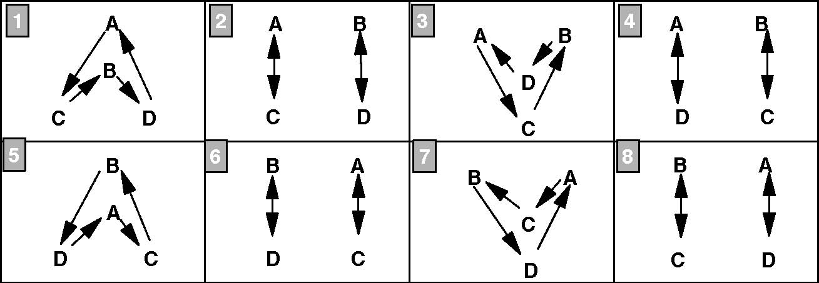
For each box, the jugglers will throw 3 right hand passes (two count) followed by a right hand self throw so they can move to the positions in the next box. The arrows are the directions of the passes. For example, in box 1, A passes to C, C passes to B, B passes to D, and D passes to A.
For the Left Hand Version of Oogle Boogie, use the same positions but reverse the direction of all of the arrows and rearrange the order of the boxes as 1,8,7,6,5,4,3, and 2.
For Three Count Oogle Boogie, use the positions in the diagram above. Instead of the arrows, use the table below to determine where to pass. Notice that the table below does not show beats 2,3,5,6,8,9, .... Assume that all beats not in the table are self throws.
The first 3 passes, i.e. on beats 1, 4, and 7, are done in the positions in box one above. The next 3 passes, i.e. on beats 13, 16, and 19, are done in the positions in box two. Continue assigning 3 passes to each box. After the 4th box, you will be at the end of the table below. For the boxes 5 through 8, start again at the beginning of the table below.
Juggler | 1 | 4 | 7 | 10 | 13 | 16 | 19 | 22 | 25 | 28 | 31 | 34 | 37 | 40 | 43 | 46
A | C | D | C |  | C | C | C |  | C | D | C |  | D | D | D
B | D | C | D |  | D | D | D |  | D | C | D |  | C | C | C
C | B | A | B |  | A | A | A |  | B | A | B |  | B | B | B
D | A | B | A |  | B | B | B |  | A | B | A |  | A | A | A

Try the above in a 'pass, pass, self' pattern. Each box in the position table will have 6 passes before changing positions for the next box. This is a difficult pattern.
Fast Oogle Boogie: Use only the position boxes 1, 3, 5, and 7, and follow the passing directions indicated by the arrows. Remember to pass 3 times with the right hand, using the 4th right hand self to switch positions. This is the version we usually do.
 | A
 | B
C |  | D

A |  | B
 | D
 | C

 | B
 | A
D |  | C

B |  | A
 | D
 | C

Notice that the passes are always from A to C, B to D, C to B, and D to A.
When was this pattern created? We have been doing it since 1991.

14 Club Oogle Boogie
This has the same movement sequence as the standard Oogle Boogie, but with 2 extra clubs so all the passes are doubles (like 7 2-count).
Position 1: C, D start with 4 clubs each, do 3 passes, then triple self. A, B start (1/2 beat after C and D) with 3 clubs each, do 3 passes, then move to position 2.
Position 2: A, B do 3 passes , then triple self. C, D do 4 passes, then move to position 3.
Position 3: A, B do 3 passes, then triple self. C, D do 3 passes, then move to position 4.
Position 4: A, B do 4 passes, then move to position 5. C, D do 3 passes, then triple self.
All passes are double spin passes. Four passes are needed to transfer the extra clubs to the team that is not moving.
It's probably helpful to be comfortable with 7 club popcorn variations before learning this pattern.
It's possible to do a regular fast Oogle Boogie instead of the slow version if you have jugglers that are comfortable moving while throwing self triples.
Pattern by Luke Emery, 2000.

Luke's Oogle
Positions
 | A
 | B
C |  | D

This is a Y in 3-count. Odd numbers are right hand passes and even numbers are left passes.
Juggler | 1 | 2 | 3 | 4
A | C | D | C | D
B | D | C | A | A
C | B | A | D | B
D | A | B | B | C
3-Count
Start with R
B does drop backs to A

If you have 4 jugglers that can do every position, then you can try the following:
Four position graphs are depicted below. Starting with the first position, perform 4 passes (one cycle) and use your 2-self throws to move to the positions in the next graph. Four passes are made in every position.
 | A
 | B
C |  | D

A |  | B
 | D
 | C

 | B
 | A
D |  | C

B |  | A
 | D
 | C

The kind of rotation that the jugglers are doing in the variation above is the same as in the fast Oogle Boogie pattern, also known as the rotating-Y.
Pattern created in 1998 by Luke Emery.

Slingshot
Positions
A |  | B
 | C
 | D

This is an 14 club variation on the Y pattern (Oogle) where all of the right hands are synchronized.
Juggler | 1 | 2
A | C | T-D
B | T-D | C
C | A | B
D | T-A | T-B
Right hand counting

B and D start with 4 clubs each, and A and C start with 3 each.
D feeds A and B with 2-count triples (like 8 club 2-count).
C feeds A and B with 2-count singles (standard feed).
A and B alternate triple passes to D and single passes to C.
Every juggler is feeding two other jugglers: A and B are feeders to C and D, and C and D are feeders to A and B.
By Peter Kaseman, 1999.
Slingshot Minus
Here's an easier version with only one extra club. All passes are in a 4-count.

Juggler | 1 | 2 | 3 | 4
A | C |  | T-D
B | T-D |  | C
C | A |  | B
D |  | T-A |  | T-B
Right hand counting and passing
B starts with 4

Slingshot Plus
You can make the pattern more interesting by adding clubs in the middle. With one more club C feeds an extra club line in doubles.
Juggler | 1 | 2 | 3 | 4
A | D-C |  | T-D
B | T-D |  | D-C
C |  | D-B |  | D-A
D | T-A |  | T-B
Both hands counting
All passes with right hand
A, B and D start with 4 clubs and right hand
C starts with 3 clubs and left hand

Slingshot Plus Plus
Ok, while we're at it, you can add another club (so that all right hands are triple passes) to get the following:
Juggler | 1 | 2
A | T-C | T-D
B | T-D | T-C
C | T-B | T-A
D | T-A | T-B
Right hand counting
All passes with right hand
All passers start with 4 clubs

This works best if all the jugglers are quite comfortable with 8 club 2-count in triples.
Created June, 1999 by MAJ.

Martin's Madness/Mildness
A |  | C
B |  | D

After we learned Martin's Madness, we put 4 jugglers in the positions shown and tried to figure out if all 4 jugglers could be the feeder as in Martin's Madness at the same time. The pattern below is what we ended up with.
Juggler | 1 | 2 | 3 | 4 | 5 | 6 | 7 | 8 | 9 | 10 | 11 | 12
A_{l} | * | C_{r} |  | s |  | D_{r} | s |  | D_{r} |  | C_{r}
A_{r} | s |  | D_{l} |  | C_{l} |  | * | C_{l} |  | s |  | D_{l}
B_{l} |  | D_{r} | s |  | D_{r} |  | C_{r} |  | * | C_{r} |  | s
B_{r} | C_{l} |  | * | C_{l} |  | s |  | D_{l} | s |  | D_{l}
C_{l} |  | A_{l} |  | B_{l} |  | * | B_{l} |  | s |  | A_{l} | s
C_{r} | B_{r} |  | s |  | A_{r} | s |  | A_{r} |  | B_{r} |  | *
D_{l} |  | B_{l} |  | * | B_{l} |  | s |  | A_{l} | s |  | A_{l}
D_{r} | s |  | A_{r} | s |  | A_{r} |  | B_{r} |  | * | B_{r}

Legend: A_{l} = left hand of A
C_{r} = right hand of C
* = handoff
s = self pass

Notes: A and B are doing Martin's Mildness, out of sync. (straights)
C and D are doing Martin's Madness, out of sync. (crosses)
A and D are in sync, as are B and C.

Martin Frost created Martin's Madness and the variation on this page dates to 4/98 by MAJ. Martin has innovated many interesting feeds and other patterns, often with hurries and zips. Look them up, or best of all, find a Stanford juggler to help out.
Also see the 3 person Siteswap Feeds.

Popcorn Feed
Positions
 |  | B
A |  | C
 |  | D

Recall that a popcorn pattern between 2 jugglers is a 7 club pattern where the jugglers are passing a beat out of sync. With the right hand, each juggler passes a double spin to partner, a single spin to self, and a triple spin to self. The left hand throws are all single spin self throws.
The Popcorn Feed is a 14 club pattern where A is out of sync with B, C, and D. A and B start with 4 clubs each, and B and C start with 3 each. A does a typewriter feed in doubles. B, C, and D all do a standard 6-count popcorn.
Juggler | 1 | 2 | 3 | 4 | 5 | 6
A | D-D |  | D-C |  | D-B
B |  | D-A |  | self |  | T-self
C |  | self |  | T-self |  | D-A
D |  | T-self |  | D-A |  | self
Both hands counting
A starts with R and 4 clubs
C, D start with L
B starts with 4 clubs and a pause, then right throw on 2

This is a spectacular pattern, and could be a basis for an El Nino.
Low Popcorn Feed
This feed can be done with single passes and double selves instead of doubles and triples.
Popcorn Weave
Like most feeds, this can be turned into a weave. The feeder throws windshield wiper feed instead of typewriter feed. The feedees throw a triple self, then a double pass, then move to the next weave position on their self. This is a challenging weave. Also see the Popcorn Twister and Popcorn Twister Weave.
This pattern dates to September, 1999 by Luke Emery and the MAJ.

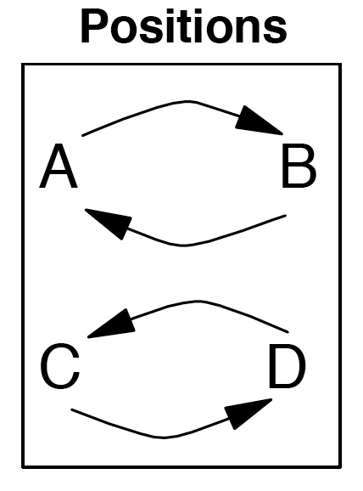
Simple Egg Beater, No Handle
This is like a 4-person version of a synchronous double weave.

Juggler | 1 | 2 | 3 | 4
A | C |  | D
B | D |  | C
C | A |  | B
D | B |  | A
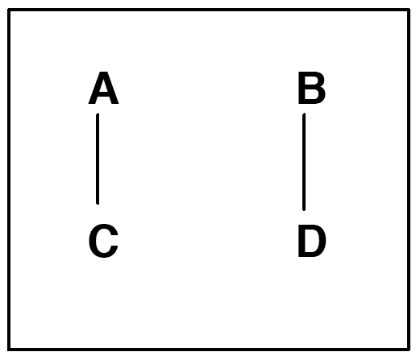Beat One: Pass as indicated
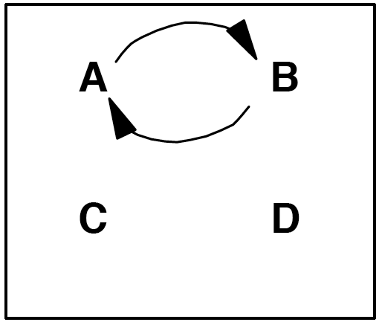Beat Two: A and B switch positions
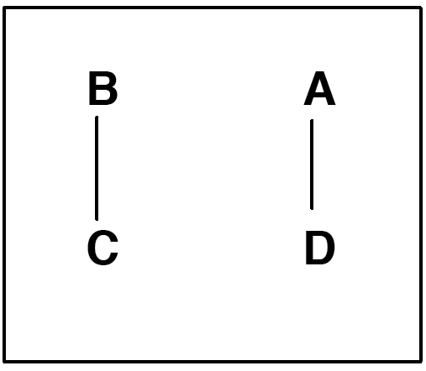Beat Three: Pass as indicated
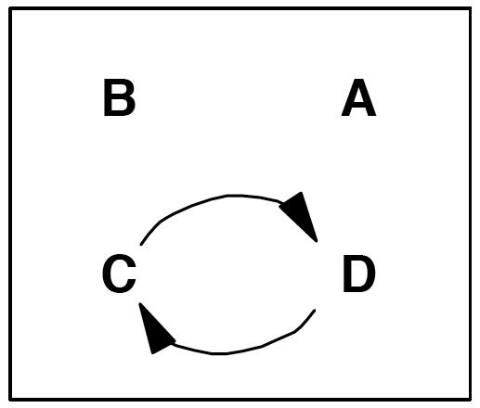Beat Four: C and D switch positions
After the 4th box, the jugglers are inverted, but the passing sequence repeats.
This pattern dates to 1997 by Mike Newton and MAJ.

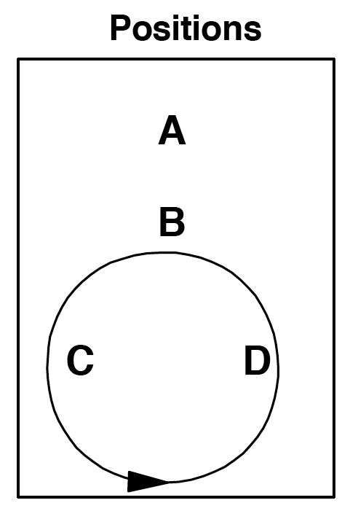
Unicycle
The unicycle is a nice moving pattern in 3-count.
Juggler | 1 | 4 | 7 | 10
A | C | D | D | C
B | A | A | A | A
C | B |  |  | B
D |  | B | B
Both hands counting
Start with right hand

A is the seat, B is the stem, and C and D are the wheel.
A and B face C and D. C and D move around the circle in a counter clockwise direction.
Passes are done on 3-count.
All passes from B to A are drop-backs.
The following table combines the position table and passing table from above.
Also see Extra Club Unicycle and Two Seated Unicycle.
Unicycle dates to 1996 by MAJ.

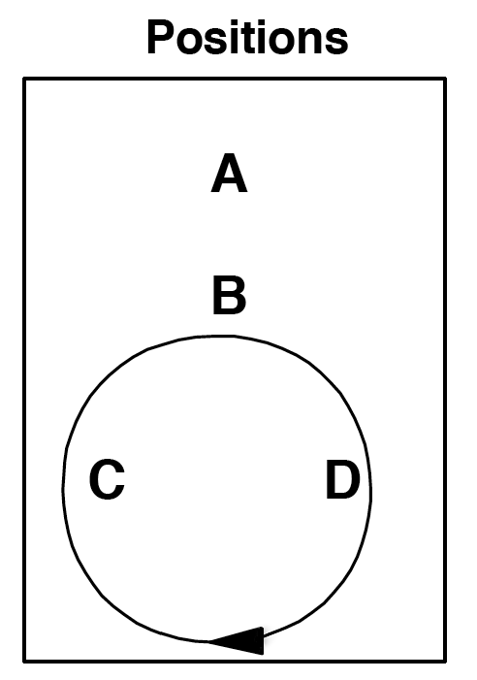
Extra Club Unicycle
The Extra Club Unicycle is a fun moving pattern in 4-count with triple passes, double passes and dropbacks.
A feeds the left and right positions with 4-count triples.
B always throws dropbacks to A in 4-count.
C and D each throw 2 double passes to B in 4-count from the left position and then the right position, and then have 4 right hand counts to move around the back of the circle to the start.

Juggler | 1 | 2 | 3 | 4 | 5 | 6 | 7 | 8 | 9 | 10 | 11 | 12 | 13 | 14 | 15 | 16
A |  |  | T-C |  |  |  | T-D |  |  |  | T-D |  |  |  | T-C
B |  | D-A |  |  |  | D-A |  |  |  | D-A |  |  |  | D-A
C | D-B |  |  |  | D-B
D |  |  |  |  |  |  |  |  | D-B |  |  |  | D-B
Both hands counting – all passes with right hand
C starts with 4 clubs and right hand
B starts with left hand
A and D start with right hand selves

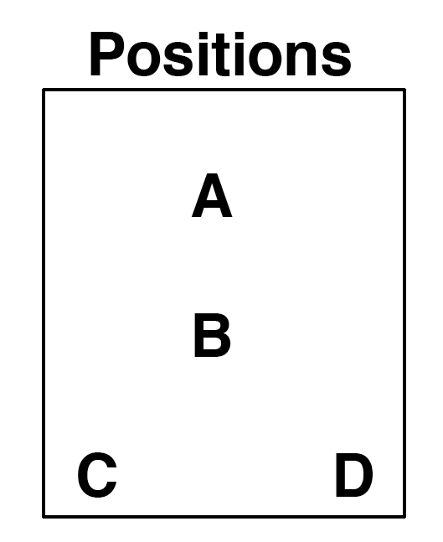
Pattern by Luke Emery.

Y2K
This pattern has synchronous 1-count passes from A and synchronous dropbacks from B to A. A and B throw simultaneously with the left and right hand. It might take some practice to be comfortable catching those crazy passes!
B starts with 4 clubs and passes 2 at a time to A.
A starts with 2 clubs and passes 2 at a time:
Right hand passes to C's left hand.
Left hand passes to D's right hand..

C passes every right hand to the "C" side of B (B's right hand) in right handed 2-count.
D passes every left hand to the "D" side of B (B's left hand) in left handed 2-count.

If B is facing C and D, then B passes simultaneous drop-backs to A, C passes to B's right hand, and D passes to B's left hand.
At B's discretion, B will rotate and face A.
B will now pass 2 at a time straight to A.
C passes drop-forwards to B's left hand.
D passes drop-forwards to B's right hand.

Have B rotate in the pattern until dizzy, then switch positions so that everyone has a chance to experience the problems associated with Y2K.
This pattern was created by Mike Newton on December 31, 1999.

Gorilla for Four
This is one variation on gorilla passing with 4 passers.
Positions
 |  | A
X |  | B
 |  | C

There are 13 clubs. X starts with 4. A, B and C start with 3.
X throws synchronous ultimates. B throws right handed 2 count. A and C throw right handed 4 count. Here is the pattern.
X starts by throwing synchronous ultimates to B's left hand and C's left hand. Then X throws synchronous ultimates to A's left hand and B's left hand. And repeat.
B starts a little after X's first throws, with a right hand throw to X's right hand, then the next right hand throw is to X's left hand. In the steady state, B alternates feeding X's right hand and X's left hand with 2 count right hand throws.
C starts a little after X's first throw (in time with B) and throws to X's right hand. After that, C is always doing 4 count with X's right hand.
A starts a little after X's first throw with a right hand self. After that, A does 4 count with X's left hand.
Pattern by MAJ.

Anklet (for 4 jugglers)
Argyle sock minus 2 jugglers.
Juggler | 1 | 2 | 3 | 4 | 5 | 6
A | B | D |  | C | D
B | C | C |  | A | C
C | A | B |  | B | B
D |  | A |  |  | A
Both hands counting

Variation: Try making D spin.
Pattern by MAJ.

Rush and Rest
Positions
 | A
C |  | D
 | B

This is a four-person pattern using right and left hand passing where each juggler passes four out of six throws.
Classic Rush and Rest

Juggler | 1 | 2 | 3 | 4 | 5 | 6
A | B | C | B |  | D
B | A | D | A |  | C
C |  | A |  | D | B | D
D |  | B |  | C | A | C
Both hands counting

First Variation
This is a Feast pattern with an extra pass across and an extra pass to self.

Juggler | 1 | 2 | 3 | 4 | 5 | 6
A | B | B | C |  |  | D
B | A | A | D |  |  | C
C |  |  | A | D | D | B
D |  |  | B | C | C | A
Both hands counting

Second Variation
A and B repeat the passing rhythm in the classic Rush and Rest. C and D pass for two beats, rest for one beat.
Juggler | 1 | 2 | 3 | 4 | 5 | 6
A | D | D | B |  | C
B | C | C | A |  | D
C | B | B |  | D | A
D | A | A |  | C | B
Both hands counting

Rush and Rest is by Steve Otteson and MAJ from 1998.

Shooting Star
In a Star pattern five jugglers stand in a circle and pass to the second juggler to the right. A Shooting Star is a star with one juggler missing. When each juggler runs out of clubs, they move to the empty space.
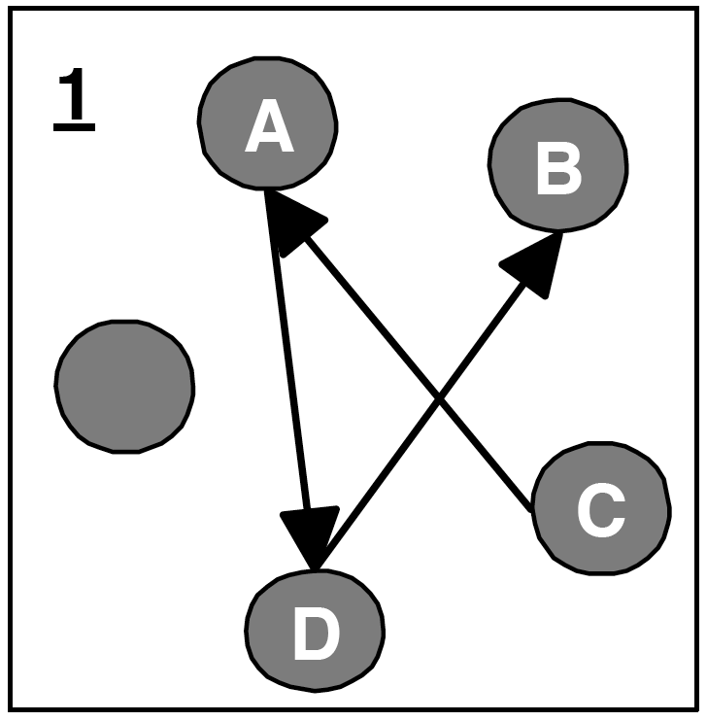
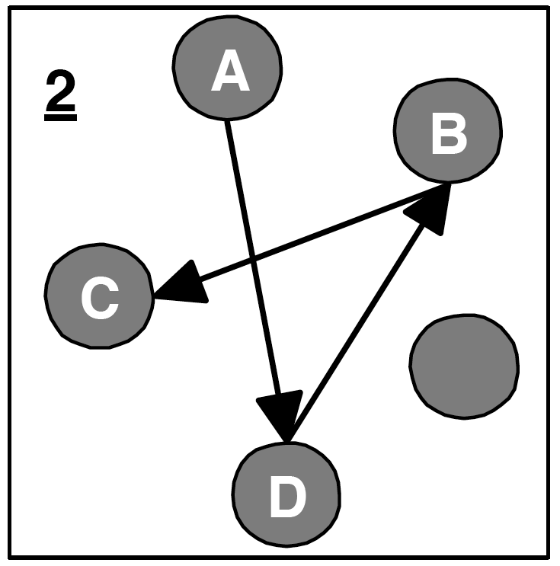

- A, C, and D start with 3 clubs and pass according to diagram one. When C runs out of clubs, C moves to the empty spot.

- A will run out of clubs next and then move to the empty spot. The pattern continues so that each juggler will run out of clubs and move to the empty spot.

Tip: Move to the center as you throw your last club after a club whizzes by the front of your head. Turn around. Move out as the next pass whizzes by the back of your head.
There are many variations on the shooting star. Add multiple clubs and up the passes to doubles and/or triples. Pirouette through the middle
Shooting Star was created by Bryan Olson in 1993.

14 Club Lines (for 4 jugglers)
Positions
A
B
C
D

Here are some of the many 4 juggler line variations we do in Madison. A and B are both facing C and D.
Locked Lines
Juggler | 1 | 2 | 3 | 4
A | D-C |  | D-C
B | D-D |  | D-D
C |  | D-A |  | D-A
D |  | D-B |  | D-B
Both hands counting, right hand passes only
A and B start with 4 and right hand
C and D start with 3 and left hand

To avoid dangerous collisions, A and B should throw at exactly the same time, and C and D should throw at exactly the same time. A and D can control the timing the best since they have the best visibility.

Popcorn Lines
Juggler | 1 | 2 | 3 | 4
A |  | T-self |  | D-C
B | D-D |  | C
C | D-A |  | B
D |  | T-self |  | D-B
Both hands counting, right hand passes only
B and C start with 4 and right hand
A and D start with 3 and left hand

Popcorn Lines 2
Juggler | 1 | 2 | 3 | 4
A |  | T-D |  | D-C
B | D-D |  | C
C | D-A |  | B
D |  | T-D |  | D-B
Both hands counting, right hand passes only
B and C start with 4 and right hand
A and D start with 3 and left hand

You can switch back and forth between the Popcorn Line variations.

Popcorn Dropback Line

The popcorn dropback variations work better if B and C move a little to the side in more of a diamond formation than a line.

Juggler | 1 | 2 | 3 | 4 | 5 | 6
A | D-C |  |  |  | T-self
B |  | T-self |  | D-A
C |  | T-self |  | D-D
D | D-B |  |  |  | T-self
Both hands counting, right hand passes only
A and D start with 4 and right hand
B and C start with 3 and left hand and throw all dropbacks as doubles

Popcorn Dropback Line 2

Now add triple passes over the top!

Juggler | 1 | 2 | 3 | 4 | 5 | 6
A | D-C |  |  |  | T-D
B |  | T-C |  | D-A
C |  | T-B |  | D-D
D | D-B |  |  |  | T-A
Both hands counting, right hand passes only
A and D start with 4 and right hand
B and C start with 3 and left hand and throw all dropbacks as doubles

To start, add one set of triple passes at a time.

Popcorn Dropback Line 3

Ok, add in some more extra passes. Why not?

Juggler | 1 | 2 | 3 | 4 | 5 | 6
A | D-C |  |  |  | T-D
B |  | T-C |  | D-A |  | C
C |  | T-B |  | D-D |  | B
D | D-B |  |  |  | T-A
Both hands counting, right hand passes only
A and D start with 4 and right hand
B and C start with 3 and left hand and throw all dropbacks as doubles

Three Leaf Clover (Mike's Version)
Here's another version of the 4 person clover. However, we juggle the Standard Clover more often (which used to be called the New Clover) because it is easier to remember and has a nicer flow to it.
Juggler | 1 | 2 | 3 | 4 | 5 | 6 | 7 | 8
A | B |  | D |  | C |  | D
B | A |  | C |  | D |  | C
C | D |  | B |  | A |  | B
D | C |  | A |  | B |  | A
Right hand counting

Every juggler is a feeder passing a standard 4-count feed to the other 3 jugglers.
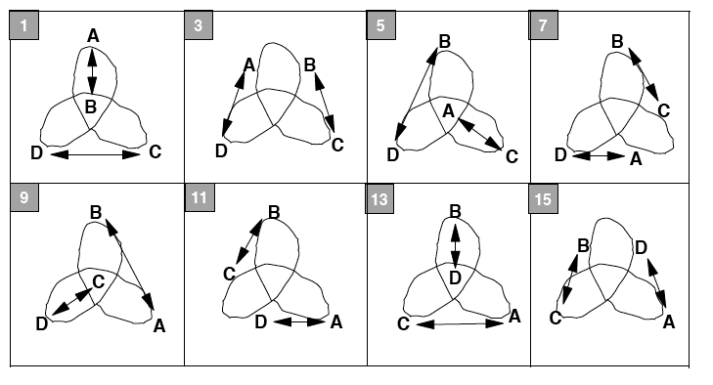
The graph below depicts the movement with the passes. Arrows are passes, and the numbers are the right hand counts from the table above. After 8 passes, or after the 15th right hand throw, all of the jugglers have moved one leaf.
Mike Newton is the creator of this pattern.
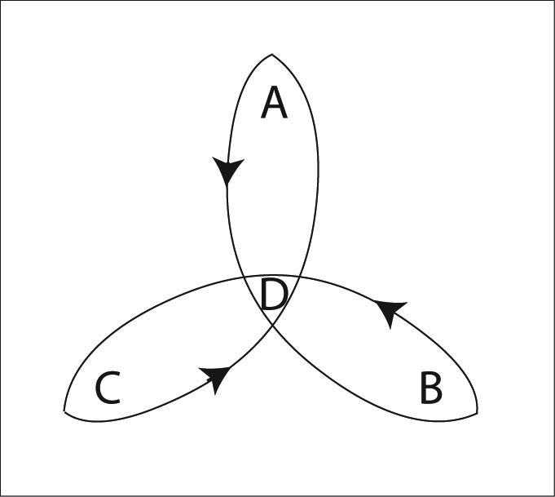
Also see Steve's Clover and Peter's Clover.

Three Leaf Clover (Peter's Version)
The MAJ juggles the Standard Clover more often than this version. This is a nice pattern, if you can remember the passing sequence.

Juggler | 1 | 2 | 3 | 4 | 5 | 6 | 7 | 8 | 9 | 10 | 11 | 12
A | B | C | D | B | D | C | B | C | D | B | D | C
B | A | D | C | A | C | D | A | D | C | A | C | D
C | D | A | B | D | B | A | D | A | B | D | B | A
D | C | B | A | C | A | B | C | B | A | C | A | B
Right handed 4-count

In the graph below, lines indicate passes, and arrows indicate the movement of jugglers after the pass.
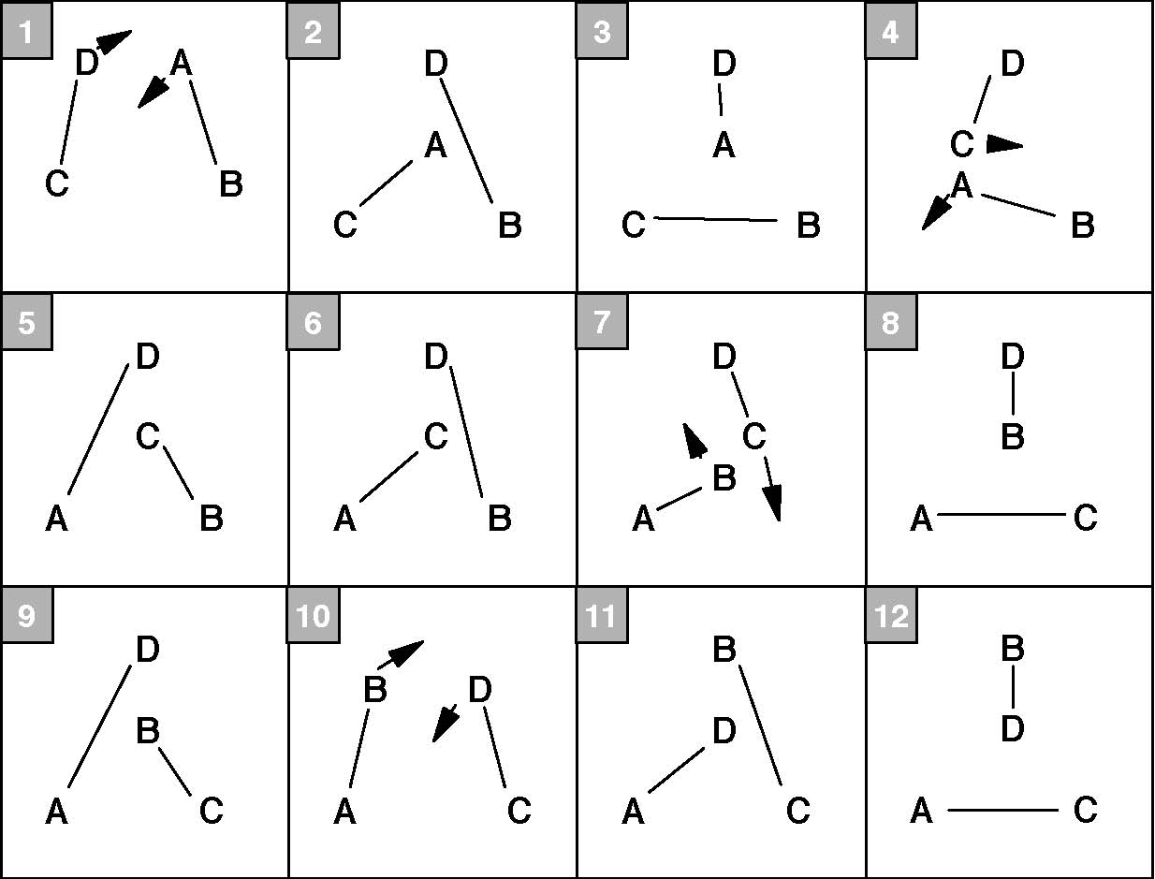
Notice that the movement around the leaves in Peter's version is reversed from Mike's and Steve's version. (The starting positions are also different.) It takes 12 passes for everyone to move to the next leaf.
Every juggler is a feeder in a modified typewriter feed.
Peter Kaseman is the creator of this pattern.

Three-Leaf Clover (Steve's Version)
As above, the MAJ now juggles the standard clover more often than this version, but it's worth exploring this variation too.

Inside Passing Triangles

Juggler | 1 | 2 | 3 | 4 | 5 | 6 | 7 | 8
A | B |  | D |  | C |  | D
B | A |  | C |  | D |  | C
C | D |  | B |  | A |  | B
D | C |  | A |  | B |  | A
Right hand passing 4-count

Outside Passing Triangles

Juggler | 1 | 2 | 3 | 4 | 5 | 6 | 7 | 8
A | B |  | D |  | C |  | D
B | A |  | C |  | D |  | C
C | D |  | B |  | A |  | B
D | C |  | A |  | B |  | A
Right hand passing 4-count

Alternate Inside/Outside Passing Triangles
Juggler | 1 | 2 | 3 | 4 | 5 | 6 | 7 | 8
A | B |  | D |  | C |  | D
B | A |  | C |  | D |  | C
C | D |  | B |  | A |  | B
D | C |  | A |  | B |  | A
Right hand passing 4-count

The movement graph below applies to the three versions above. Lines indicate passes. Arrows indicate movement of jugglers after the pass.
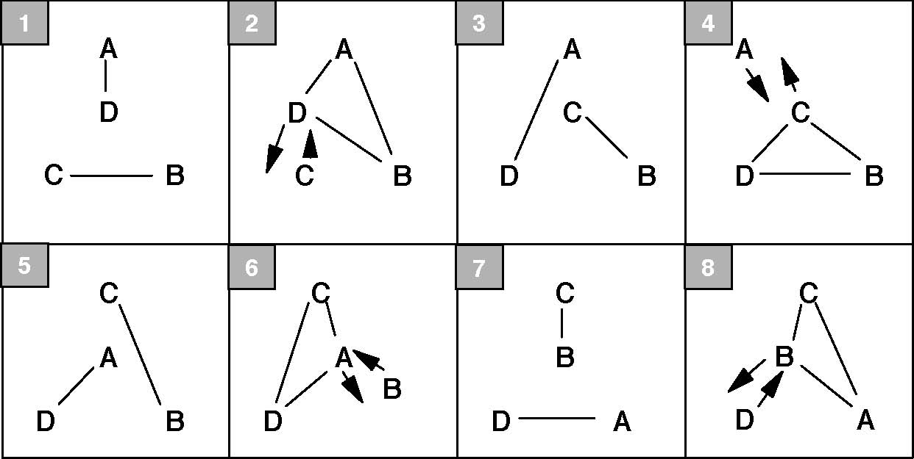
The passing rate and movement along the leaves is the same as in Mike's version (notice the different numberings in the graphs of Steve's and Mike's versions).
In Steve's version, for the odd numbered passes, A and D always pass to each other, and B and C always pass to each other. For the even numbered passes, three jugglers pass to each other in a triangle. The juggler not in the triangle will be bumped off its leaf.
The 1st version of Steve's version has inside passing triangles, the 2nd has outside passing triangles, and the 3rd toggles between outside and inside passing triangles.
Steve Otteson is the creator of this pattern.

5 Person Patterns
Positions
 | A
 | B
C | D | E

Apollo
The standard Apollo (also known as the 1-1-3 Apollo) is a MAJ standard.
Juggler | 1 | 2 | 3 | 4
A | E |  | C
B | C | D | E | D
C | B |  | A
D |  | B |  | B
E | A |  | B
Right hands counting, all passes with right hand

Cockeyed Apollo
Change the outside throws to be in a Y and the Apollo becomes cockeyed...so named because the middle feeder (B) has to throw and catch from opposite directions.
Juggler | 1 | 2 | 3 | 4
A | E |  | C
B | C | D | E | D
C | A |  | B
D |  | B |  | B
E | B |  | A
Right hands counting, all passes with right hand

Apollo Plus
A and D can pass an extra club (triple spin) over the pattern on their right hand self throw. D starts with the extra club.
This variation works well with the standard Apollo, but is hair raising with the Cockeyed Apollo.
If that's not exciting enough, add another club to the inner feed (all those passes are doubles) so it is a 2-count extra club feed.
Apollo Plus Weave
Here's a nice weave pattern. Start with the 1-1-3 Apollo formation and have B feed a standard weave of C, D and E. Then A can add an extra club and throw 4-count triples to the ends. (A starts with 4 and a triple to whichever end B doesn't start with.)
All the weavers will have the following sequence (starting from the outside) B, self, self, B, self, Triple to A, B.
Also see the 1-2-3 Apollo for 6 jugglers and the 1-2-4 Apollo for 7 jugglers.
The Apollo was invented by N.A.S.A. The Apollo juggling pattern was invented by the Gemini Jugglers in 1991.

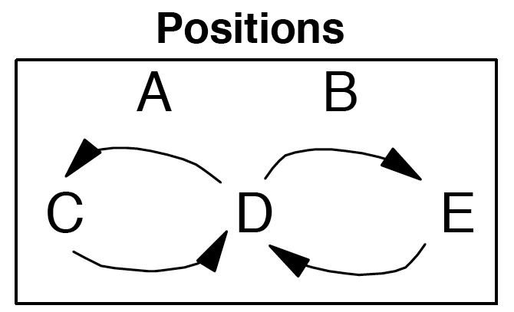
Mr. Inside Mr. Outside Weave
This is a standard weave where the feeder is divided into two feeder (one passing on the inside and one on the outside). This is a good warm up pattern for the Twister Weave. In addition, all of the Twister Weave variations can be applied to this weave too.
Juggler | 1 | 2 | 3 | 4 | 5 | 6
A | C |  | E |  | D
B |  | D |  | C |  | E
C | A |  |  | B
D |  | B |  |  | A
E |  |  | A |  |  | B
Right hand counting

A is Glen Davis (Mr. Outside), and B is Doc Blanchard (Mr. Inside). This pattern is the same as the standard weave with 2 feeders (instead of one). The outside weavers pass to Doc Blanchard, and the inside (middle) weaver passes to Glen Davis. Feeders A and B pass every other right hand throws (4-count).
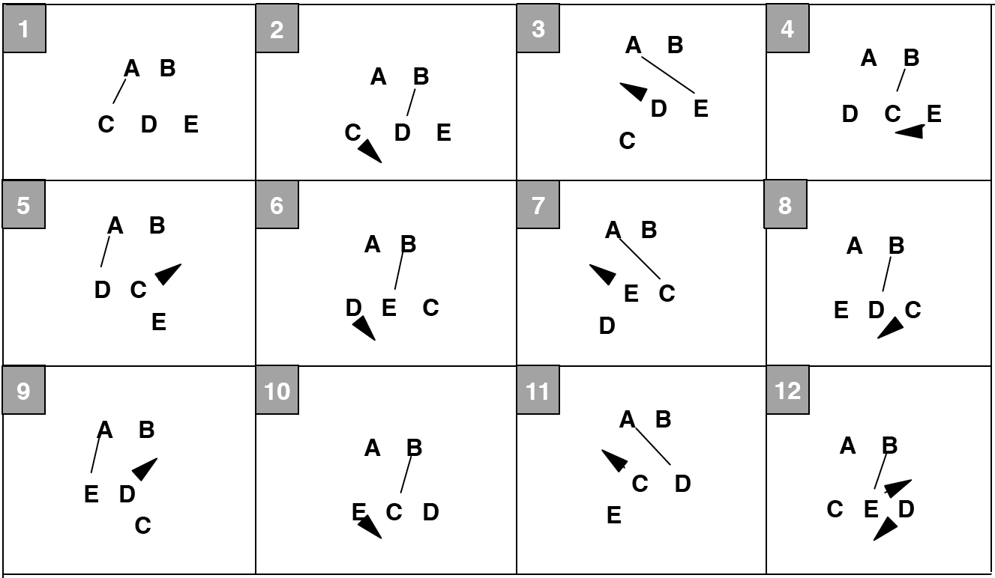
In the graph below, lines indicate passes, and arrows indicate movement.
The same variations for the standard weave and the Twister Weave can be used for this pattern.
When was this pattern created? We have been doing it since 1994.

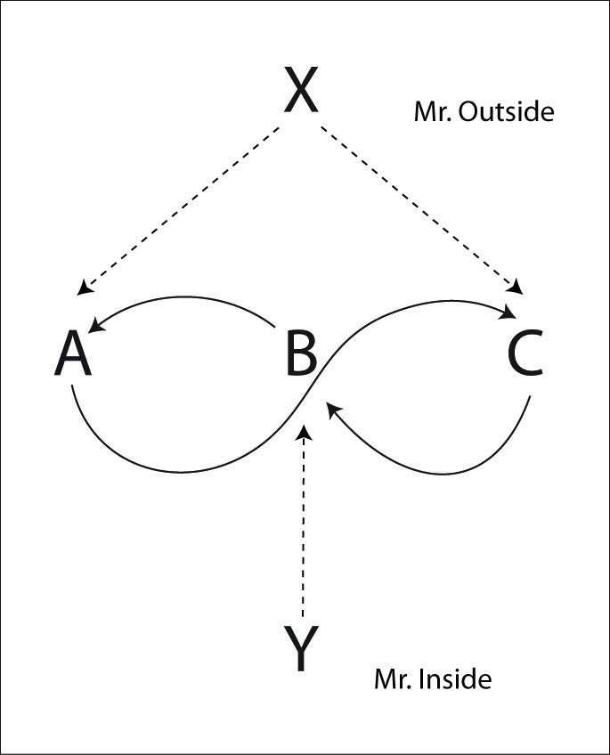
Twister Weave
The Twister Weave has the exact same passes as the Mr. Inside Mr. Outside Weave. However, the Mister Inside Feeder is on the opposite side of the weavers, so the feedees turn around between every pass.
Standard Twister Weave (Feeder 4-Count, Feedees 6-Count)
For the standard twister weave each weaver passes once on the end to Mr. Outside (X), and then has a 6-count (2 right hand selves) to move to the inside and turn around. Then pass once to Mr. Inside (Y) and continue in a 6-count outside and then turning around.

The turns may be done by turning towards the inside or towards the outside. Most people find inside turns easier in the middle and on the ends (i.e. back away from the current feeder and then turn towards the new feeder). However, we suggest that you learn both turns and see which combinations you like best.

Juggler | 1 | 2 | 3 | 4 | 5 | 6 | 7 | 8 | 9 | 10 | 11 | 12
X | A |  |  |  | C |  |  |  | B
Y |  |  | B |  |  |  | A |  |  |  | C
A | X |  |  |  |  |  | Y
B |  |  | Y |  |  |  |  |  | X
C |  |  |  |  | X |  |  |  |  |  | Y
Both hands counting, all passes right hands

Here are some other twister weaves with the feeders in different counts. They get progressively trickier. There are many other possible variations besides these.
PSPSP Twister Weave (Feeders share PSPSP, Feedees 5-Count)
Juggler | 1 | 2 | 3 | 4 | 5 | 6 | 7 | 8 | 9 | 10
X | A |  |  |  | C |  |  | B
Y |  |  | B |  |  | A |  |  |  | C
A | X |  |  |  |  | Y
B |  |  | Y |  |  |  |  | X
C |  |  |  |  | X |  |  |  |  | Y
Both hands counting

3-Count Twister Weave (Feeders 3-Count, Feedees 5/4-Count)
For unbalanced weaves (where the weaver does a different count going inside->out than outside->in) it generally seems easier to do the more challenging count (the smaller one) on the outsides.
Juggler | 1 | 2 | 3 | 4 | 5 | 6 | 7 | 8 | 9
X | A |  |  | C |  |  | B
Y |  |  | B |  |  | A |  |  | C
A | X |  |  |  |  | Y
B |  |  | Y |  |  |  | X
C |  |  |  | X |  |  |  |  | Y
Both hands counting

Fast Twister Weave (Feeders 3 of 8, Feedees 4-Count)
Juggler | 1 | 2 | 3 | 4 | 5 | 6 | 7 | 8
X | A |  | C |  | B
Y | B |  |  |  | A |  | C
A | X |  |  |  | Y
B | Y |  |  |  | X
C |  |  | X |  |  |  | Y
Both hands counting

Twister Weave (Feeders 3 of 7, Feedees 4/3-Count)
Juggler | 1 | 2 | 3 | 4 | 5 | 6 | 7
X | A |  |  | B |  | C
Y | B |  | C |  | A
A | X |  |  |  | Y
B | Y |  |  | X
C |  |  | Y |  |  | X
Both hands counting

Hyper-Twister Weave (Feeders 2-Count, Feedees 3-Count)
Juggler | 1 | 2 | 3 | 4 | 5 | 6
X | A |  | C |  | B
Y |  | B |  | A |  | C
A | X |  |  | Y
B |  | Y |  |  | X
C |  |  | X |  |  | Y
Both hands counting

There are lots of variations on the Twister Weave. See the Twister Plus, Double Time Twister, etc.
We can add 2 clubs to the standard Twister Weave and make the passes from X and Y to the weavers be triples (7 club 4-count between each side of the weave and the feeder), and the return passes triples too.
Another variation is to add 2 extra clubs and have the feeders do 4-count in fast popcorn (534p3).
Try the twister weave in chocolate bar too.
Original Twister Weave suggested by Mike Newton. Variations by MAJ.

Twister Plus
This is a variation of the Twister Weave where the feeders use their right hand selves to add an addition club passed back and forth over the top of the weave in triples like in a 7 club 4-count. The weaving pattern is exactly the same as the Standard Twister Weave.
Juggler | 1 | 2 | 3 | 4 | 5 | 6
X | A | T-Y | C | T-Y | B | T-Y
Y | T-X | B | T-X | A | T-X | C
A | X |  |  | Y
B |  | Y |  |  | X
C |  |  | X |  |  | Y
Right hands counting
Y starts with 4

Another nice variation is for the weavers to do ½ pirouettes under a triple right to left self throw for their turn.
Also see Twister++ and Twister 5.
Pattern by MAJ.

Double Time Twister
The Double-time Twister is the same as the Twister Weave with each weaver passing twice to each feeder before turning around to pass twice to the other feeder. Now each feeder is passing 2-count: passing twice to each weaver as they go by.

Juggler | 1 | 2 | 3 | 4 | 5 | 6
X | A | A | C | C | B | B
Y | C | B | B | A | A | C
A | X | X |  | Y | Y
B |  | Y | Y |  | X
C | Y |  | X | X |  | Y
Right hands counting

For each weaver that A passes to, the first pass is made when the weaver is on the outside. The weaver moves to the inside, following the arrows, for the second pass. A is Mr. Outside In.
For each weaver that B passes to, the first pass is made when the weaver is in the inside. Then the weaver moves to the outside, following the arrows, for the second pass. B is Mr. Inside Out.
To see what the weavers do, lets look at what A does. A passes to X in the outside position and then moves to the inside where the next pass is made to Y. A has one right hand self throw to turn around and make the first throw to Y. The first pass to Y is made when A is on the inside. A then moves to the outside to make the second pass to Y and has one self throw to turn around and repeat the pattern.
All weavers do the same thing two passes out of phase.
Pattern created by MAJ.

Double Time Twister Plus
Here is a twister variation with 2 extra clubs where the passes to and from the weave are all doubles like an extra club feed.
Juggler | 1 | 2 | 3 | 4 | 5 | 6 | 7 | 8 | 9 | 10 | 11 | 12
X |  | D-A |  | D-C |  | D-C |  | D-B |  | D-B |  | D-A
Y |  | D-B |  | D-B |  | D-A |  | D-A |  | D-C |  | D-C
A | D-X |  | D-X |  |  |  | D-Y |  | D-Y
B |  |  | D-Y |  | D-Y |  |  |  | D-X |  | D-X
C | D-Y |  |  |  | D-X |  | D-X |  |  |  | D-Y
Both hands counting
A and C start with 4
A, B and C start with right hand
X and Y start with left hand

Pattern by Luke Emery and MAJ.

Twister Popcorn
The Twister Popcorn is the same as the Popcorn Feed except there are 2 feeders, one on each side, and each popcorn feedee passes to one, turns to pass to the other, and repeats. The feedees do not weave in this pattern. That's the next pattern. In this pattern they just turn in place. The feeders do a Typewriter Feed.
The hardest position is the middle feedee, because he/she cannot cheat as much into the turns. You can either turn fast during the single self, throw a right to left single straight up in the air and do a ½ pirouette underneath it, or throw a behind the back self to turn.
Juggler | 1 | 2 | 3 | 4 | 5 | 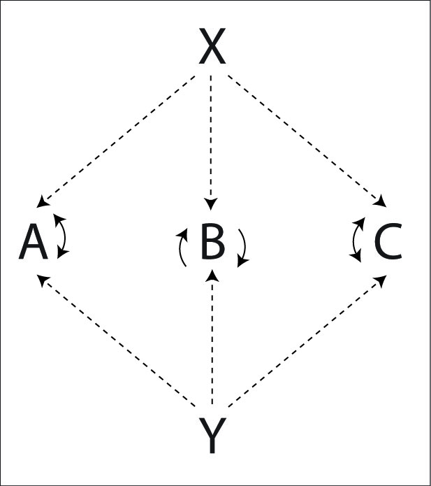  6
X | D-A |  | D-C |  | D-B
Y |  | D-B |  | D-A |  | D-C

A | T-self | D-X |  | T-self | D-Y
B |  | T-self | D-Y |  | T-self | D-X
C | D-Y |  | T-self | D-X |  | T-self
Right hands counting
X and C start with 4
A, B and C are 1 beat after X and Y

It's probably best to be quite comfortable with popcorn feeds before spending a lot of time on this pattern.
Pattern by Luke Emery and MAJ.

Twister Popcorn Weave
As the name implies, this is a standard weave where each feedee does popcorn. The feeders are in 4-count doubles and the weavers are in popcorn.
Juggler | 1 | 2 | 3 | 4 | 5 | 6
X | D-A |  | D-C |  | D-B
Y |  | D-B |  | D-A |  | D-C

A | T-self | D-X |  | T-self | D-Y
B |  | T-self | D-Y |  | T-self | D-X
C | D-Y |  | T-self | D-X |  | T-self
Right hands counting
X and C start with 4
A, B and C are 1 beat after X and Y

Pattern by Luke Emery.

Four Leaf Clover
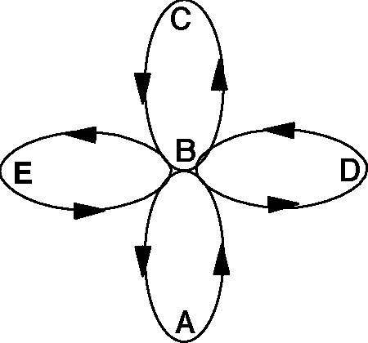
The standard Three Leaf Clover can be extended to any number of jugglers by adding a new leaf for each juggler. Here is the extension for 5 jugglers in a 4 leaf clover.
Juggler | 1 | 2 | 3 | 4 | 5 | 6 | 7 | 8 | 9 | 10
A |  |  | D | C | B |  |  | E | *
B | * |  |  |  | A | D | E |  |  | C
C | D |  |  | A | * |  |  |  | E | B
D | C | E | A |  |  | B | *
E |  | D | * |  |  |  | B | A | C
Right hands counting
* notes when jugglers are in the center

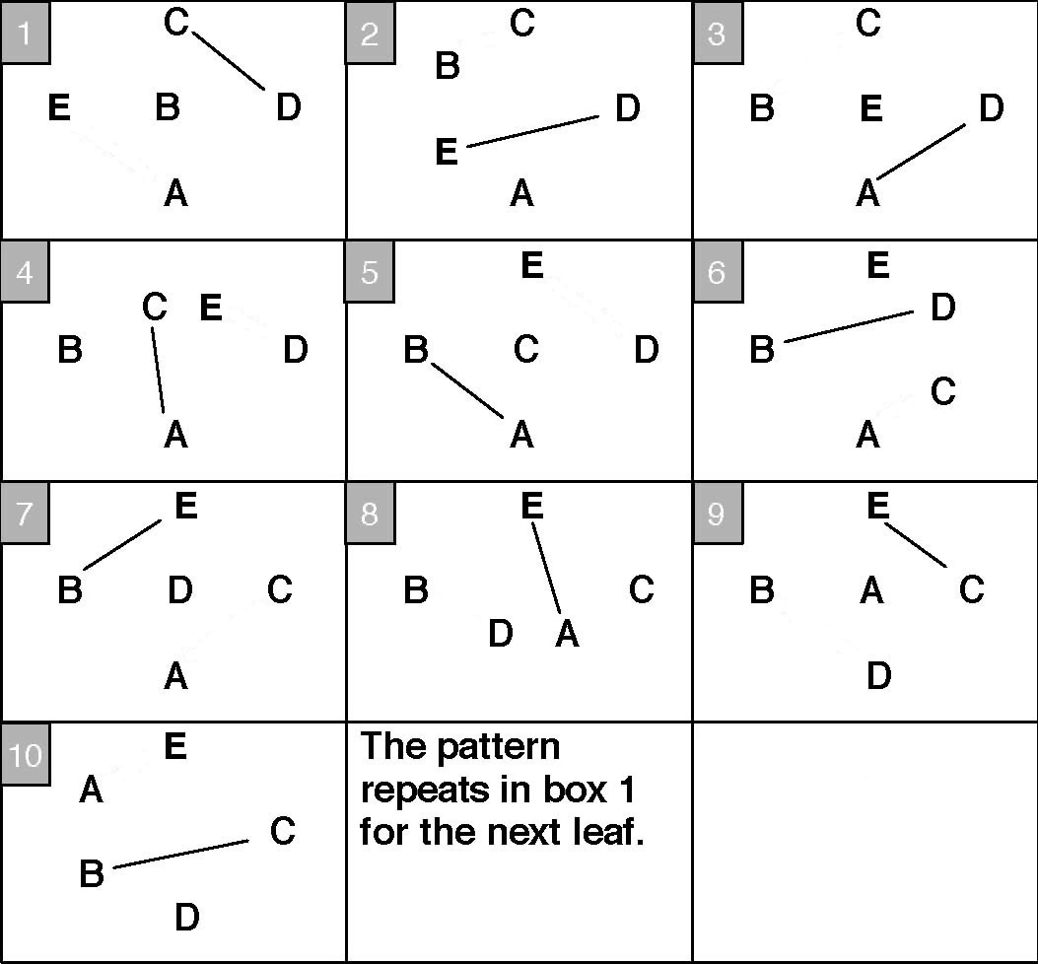
The easy way to remember this is by the count. Feed (3 passes in a row), then 2 right selves in to the middle, pass in the middle and 4 right selves out. Feed, 2 in, 4 out.
See all of those self throws? Well, you can fill some of them in by adding another pass on every beat.
Juggler | 1 | 2 | 3 | 4 | 5 | 6 | 7 | 8 | 9 | 10
A | E |  | D | C | B | C | C | E | * | E
B | * | C | C |  | A | D | E | D | D | C
C | D | B | B | A | * | A | A |  | E | B
D | C | E | A | E | E | B | * | B | B
E | A | D | * | D | D |  | B | A | C | A
Right hands counting

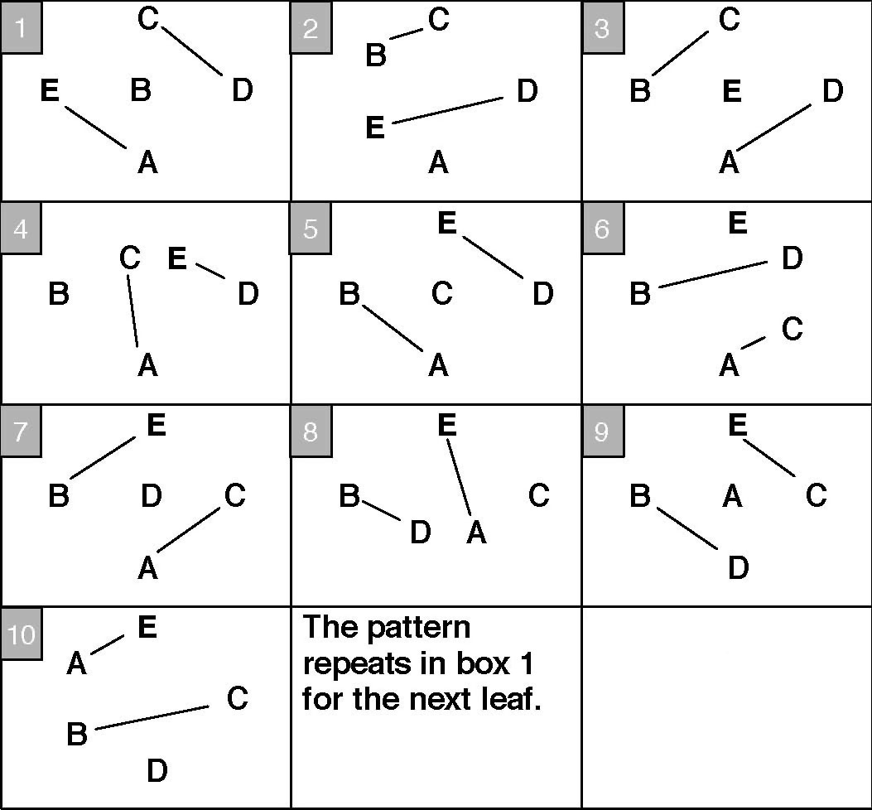
Pattern by MAJ.

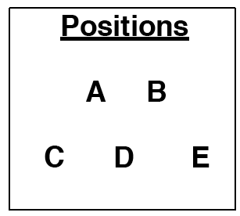
Chocolate Bar 3-Count Feed
The Chocolate Bar feed is shares a 1-Count feed between two feeders. The standard positions are 2 feeders facing 3 feedees. The Wedgee Positions are another alternative pattern layout.
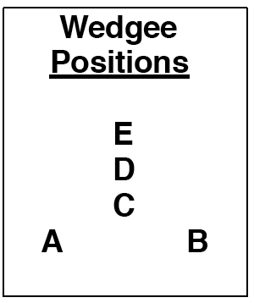
The next 2 Chocolate Bar fields share the same positions.
Juggler | 1 | 2 | 3 | 4 | 5 | 6 | 7 | 8 | 9 | 10 | 11 | 12
A | C | D |  |  | D | E |  |  | E | C
B |  |  | E | C |  |  | C | D |  |  | D | E
C | A |  |  | B |  |  | B |  |  | A
D |  | A |  |  | A |  |  | B |  |  | B
E |  |  | B |  |  | A |  |  | A |  |  | B
Both hands counting, right hand starts

Aidan Quinn worked out an extra club variation of this pattern. See his web site under the Passing Resources section for more information. Basically the feeders share an extra club ultimate feed, alternating two passes as chocolate bar. Feeders pass straight and feedees pass cross.
A version with 2 extra clubs should be theoretically possible, with all passes straight doubles.
Pattern by Steve Otteson and MAJ.

Double Chocolate Double 3-Count Feed
Another pattern using the 2 facing 3 position.

Juggler | 1 | 2 | 3
A | C | C | D
B | E | D | E
C | A | A
D |  | B | A
E | B |  | B
Both hands counting
Right hand starts

Notice that the first 3 throws are R-L-R, and the next 3 throws are to the same people but are L-R-L.
Pattern by Steve Otteson and MAJ.

Semi-Sweet Chocolate 3-Count Feed
As far as the number of passes made by A and B go,the Semi-Sweet pattern is in between the Chocolate Bar and the Double Chocolate Bar patterns. Also uses the 2 facing 3 positions.
Juggler | 1 | 2 | 3 | 4 | 5 | 6
A | E | C |  | E | D
B |  | D | C |  | E | C
C |  | A | B |  |  | B
D |  | B |  |  | A
E | A |  |  | A | B
Both hands counting, right hand starts

Variation
Juggler | 1 | 2 | 3 | 4 | 5 | 6
A | C |  | E |  | D
B |  | D |  | C |  | E
C | A |  |  | B
D |  | B |  |  | A
E |  |  | A |  |  | B
Both hands counting, right hand starts

Pattern by Steve Otteson and MAJ.

Chocolate Swirl
The chocolate swirl is a moving extension of Double Chocolate Double Three Count. It is noteworthy for jugglers moving from one side of the pattern to the other with only a single self throw. That is possible. It is also noteworthy for being hard, both to remember and to juggle.
The table shows a single transition where E moves to the other side.
Juggler | 1 | 2 | 3 | 4 | 5 | 6 | 7 | 8 | 9 | 10 | 11 | 12
A | C | C | D | C | C |  | C | C |  | C | C
B | E | D | E | E | D | C | D |  | C | D |  | C
C | A | A |  | A | A | B | A | A | B | A | A | B
D |  | B | A |  | B | E | B | E | E | B | E | E
E | B |  | B | B | Move | D |  | D | D |  | D | D
Both hands counting, right hand starts

Once you get comfortable with one transition at a time, then you can run the transitions faster. Or so we imagine...we've never been that comfortable...
Pattern by Luke Emery

Mango Swirl / Mangled Squirrel
The Mango Swirl was an attempt to create a change sides pattern for the 2 extra club W pattern. Unfortunately, our first attempts were more mangled than mango, and more squirrelly than swirly and thus its alternate name. There are a couple possible transitions. Although we originally created the pattern with a different transition, this one seems easier (especially if you've practiced the Extra Club Turbo).
Juggler | 1 | 2 | 3 | 4 | 5 | 6 | 7 | 8 | 9 | 10 | 11 | 12
A | D-D |  | D-C |  | D-C | Move |  |  | T-B | Pause |  | D-E
B | (D-E) |  | D-D |  | D-D |  | D-C |  | D-A |  | D-A | Move
C |  |  | T-A | Pause |  | D-B |  | D-B |  | D-E |  | D-D
D |  | D-A |  | D-B |  | D-E |  | D-E | Move |  |  | T-C
E |  | D-B | Move |  |  | T-D | Pause |  | D-C |  | D-C
Juggler | 13 | 14 | 15
A |  | D-E
B |  |  | T-E
C |  | D-D | Move
D | Pause |  | D-A
E | D-A |  | D-B
Both hands counting, right hand passes
A and B start with 4, right hands
C starts with 3, right hand
C, D and E start with 3, left hands
In steady state, B is on a pause for beat 1, but throws D-E at the very start
In steady state, C moves on beat 1, but is in initial position for beat 1 at the very start

E moves first by turning around and passing a triple to D. A moves second by moving to the opposite side and throwing a triple to B, and so on.
The rhythm is move, triple, 2 passes, 1 pass, 2 passes. And repeat. Remember Triple, 2-1-2.
Yeah, it's kind of tricky.
Pattern by Luke Emery

Egg Beater
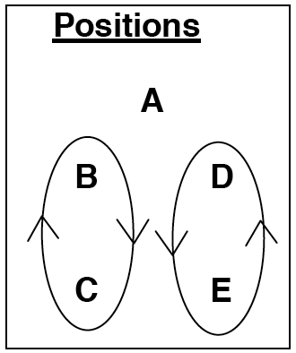
This is another classic MAJ pattern.
Juggler | 1 | 2 | 3 | 4 | 5 | 6 | 7 | 8
A |  | E |  | B |  | D |  | C
B | D |  |  | A |  |  | E
C |  |  | D |  | E |  |  | A
D | B |  | C |  |  | A
E |  | A |  |  | C |  | B
Right hands counting

A is the handle, B and C are one beater, and D and E are the other beater.
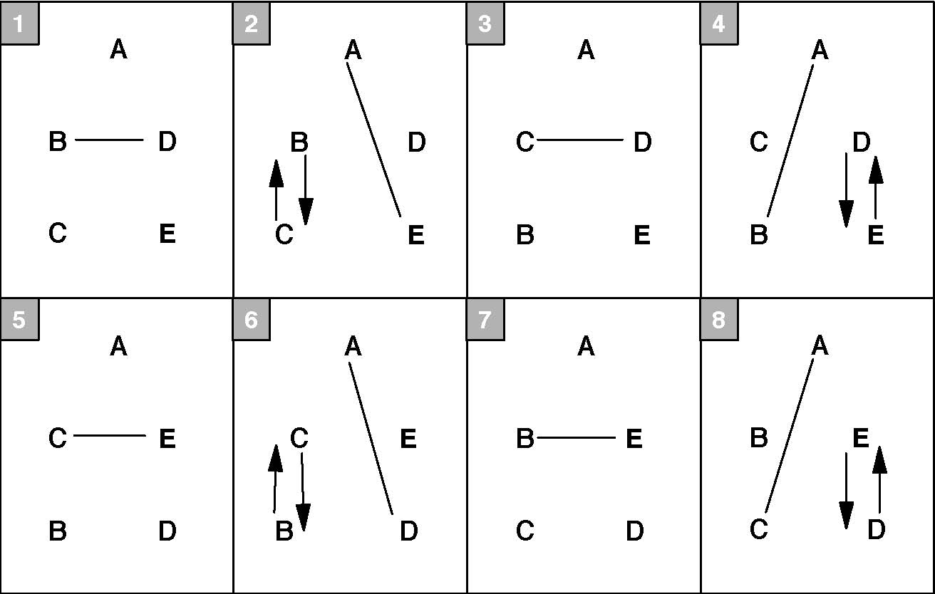
In the graph below, lines indicate passes, and arrows indicate movement.
Variation (by Martin Frost)
Juggler | 1 | 2 | 3 | 4 | 5 | 6 | 7 | 8
A |  | E |  | B |  | D |  | C
B | D |  | E | A | D |  | E
C | E |  | D |  | E |  | D | A
D | B |  | C |  | B | A | C
E | C | A | B |  | C |  | B
Right hands counting

Egg Beater Plus (by Luke Emery)
Change the long passes to and from the feeder to triples to get this impressive looking pattern.

Juggler | 1 | 2 | 3 | 4 | 5 | 6 | 7 | 8
A | T-E |  | T-B |  | T-D |  | T-C
B | D |  | E | T-A | D |  | E
C | E |  | D |  | E |  | D | T-A
D | B |  | C |  | B | T-A | C
E | C | T-A | B |  | C |  | B
Right hands counting
A starts with 4

Egg Beater, Handle in the Batter
This variation moves the feeder to the other side of the pattern.
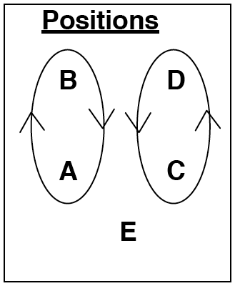
Juggler | 1 | 2 | 3 | 4 | 5 | 6 | 7 | 8
A | C |  | D |  | C |  | D | E
B | D |  | C | E | D |  | C
C | A | E | B |  | A |  | B
D | B |  | A |  | B | E | A
E |  | C |  | B |  | D |  | A
Right hands counting

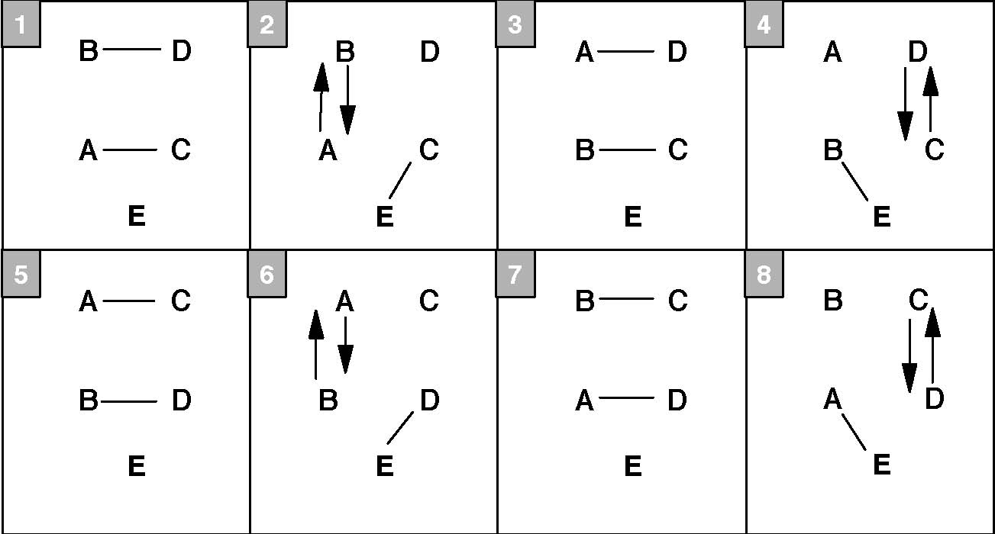
Pattern by Mike Newton and MAJ.

Rotating Feed (for 5 jugglers)
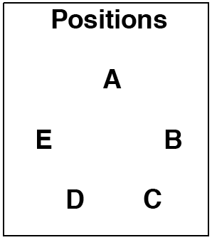
This classic passing pattern has each juggler feed all the others in turn. It can be done with any number of passers.
Juggler | 1 | 2 | 3 | 4 | 5 | 6 | 7 | 8 | 9 | 10 | 11 | 12 | 13 | 14 | 15
A | B | C | D | E |  |  |  | D |  |  |  | C
B | A |  |  |  | E |  |  |  | D |  |  |  | C | D | E
C |  | A |  |  |  | E |  |  |  | D | E | A | B
D |  |  | A |  |  |  | E | A | B | C |  |  |  | B
E |  |  |  | A | B | C | D |  |  |  | C |  |  |  | B
Right handed 2-count

Variation: Add 1 club. The new feeder does not pass to the old feeder. If you want the timings to work out exactly, then make all passes as doubles and follow each pass as a feedee with a right to left self double, and follow each feed sequence (at the very end) with a right to left self double.
Classic pattern. When were these patterns created? We have been doing them since 1992.

Feast (for 5 jugglers)
The Feast is a variation of the Rotating Feed where every juggler in the pattern is a feeder at the same time. There is a self when you feed yourself. A Feast can be done with any number of passers greater than 3, but it is more interesting with around 5.
Passing beat variations for Feasts
- 2-count
- 3-count
- 4-count (slow)
- chocolate bar
- 2 of 3 count
Juggler | 1 | 2 | 3 | 4 | 5
A | B | C | D | E
B | A |  | C | D | E
C | E | A | B |  | D
D |  | E | A | B | C
E | C | D |  | A | B
Right handed 2-count

Classic pattern. When were these patterns created? We have been doing them since 1992.

Extra Club Rotating Feed (for 5 jugglers)
Any feed or feast can be done with an extra club by throwing passes as doubles and following every feedee pass and every feeder cycle with a self double to restore the timing. A right to left self double switches left and rights.
This pattern is also in a star. A is the first feeder. This feed is shown clockwise, but of course it could work either direction.
Juggler | 1 | 2 | 3 | 4 | 5 | 6 | 7 | 8 | 9 | 10 | 11 | 12 | 13 | 14 | 15
A | D-C |  | D-D |  | D-E |  | D-self | Pause |  |  |  | D-D |  | D-self | Pause
B |  | D-self | Pause |  |  |  | D-E |  | D-self | Pause |  |  |  | D-D
C |  | D-A |  | D-self | Pause |  |  |  | D-E |  | D-self | Pause
D |  |  |  | D-A |  | D-self | Pause |  |  |  | D-A |  | D-B |  | D-C
E | D-self | Pause |  |  |  | D-B |  | D-C |  | D-D |  | D-self | Pause
Juggler | 16 | 17 | 18 | 19 | 20 | 21 | 22 | 23 | 24 | 25
A |  |  |  | D-C |  | D-self | Pause
B | D-self | Pause |  |  |  | D-D |  | D-E |  | D-A
C | D-E |  | D-A |  | D-B |  | D-self | Pause
D |  | D-self | Pause |  |  |  | D-B |  | D-self | Pause
E |  | D-C |  | D-self | Pause |  |  |  | D-B
Both hands counting, all right hand passes are doubles
A starts with 4 clubs
A and E start with right hand
B, C and D start with left hand

The steady state right hand sequence is feed 3 passes, double self, then the sequence self, pass, double self, self two times. Repeat.
Pattern by Luke Emery, 1999.

Extra Clubs Feast (for 5 jugglers)
The feast is an extension to the 5 juggler feast and the 5 juggler Extra Club Rotating Feed. The feeders alternate straight across right hand triples and doubles to keep the timing working.
Juggler | 1 | 2 | 3 | 4 | 5
A | Pause |  | D-E |  | T-C
B |  | T-D | Pause |  | D-A
C |  | D-B |  | T-E | Pause
D | T-A | Pause |  | D-C
E | D-D |  | T-B | Pause
Both hands counting, all right hands are double or triple passes
D and E start with 4 clubs and right hands
On the very start only, A skips the pause and starts with a D-C on 1 with right hand
B and C start with left hand

Wow. Remember, if it were easy, then anyone could do it...
If that is just too crazy, then you can do the same pattern idea slower.
Juggler | 1 | 2 | 3 | 4 | 5 | 6 | 7 | 8 | 9 | 10
A | D-C |  | D-C |  | D-D |  | D-E |  | D-E
B |  | D-self | Pause |  | D-C |  | D-D |  | D-D
C |  | D-A |  | D-B |  | D-B |  | D-self | Pause
D |  | D-E |  | D-A |  | D-A |  | D-B |  | D-C
E | D-D |  | D-D |  | D-self | Pause |  | D-A |  | D-B
Juggler | 11 | 12 | 13 | 14 | 15
A | D-self | Pause |  | D-B
B | D-E |  | D-A |  | D-A
C | D-D |  | D-E |  | D-E
D |  | D-C |  | D-self | Pause
E |  | D-B |  | D-C
Both hands counting, all right hands are double passes or double selves
A and E start with 4 clubs and right hands
B,C and D start with left hand

Heres another related pattern that might be easier than the first.

Juggler | 1 | 2 | 3 | 4 | 5
A |  | T-D | Pause |  | D-D
B |  | D-E |  | T-E | Pause
C | T-A | Pause |  | D-A
D | D-B |  | T-B | Pause
E | Pause |  | D-C |  | T-C
Both hands counting, all right hands are double or triple passes
D and C start with 4 clubs and right hands
On the very start only, E does a pause on 1 and then a left self on 2
A and B start with left hand

Patterns by Luke Emery, 1999.

Strange Attractor / Estranged Tractors
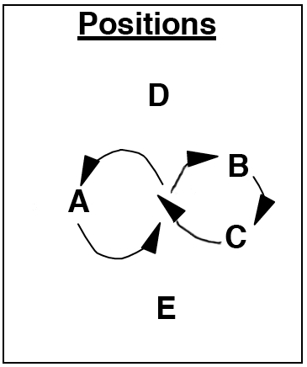
This is an extension of the Turbo with two feeders added on each side.
Juggler | 1 | 2 | 3 | 4 | 5 | 6 | 7 | 8 | 9
A | B | C | E | E | B |  | C | D | D
B | A | D | D | C | A | E | E | C
C | E | A |  | B | D | D | A | B | E
D |  | B | B |  | C | C |  | A | A
E | C |  | A | A |  | B | B |  | C
Right hands counting

A, B, and C are moving in a figure eight as in a Turbo or a 2-leaf Clover pattern. D and E are feeders.
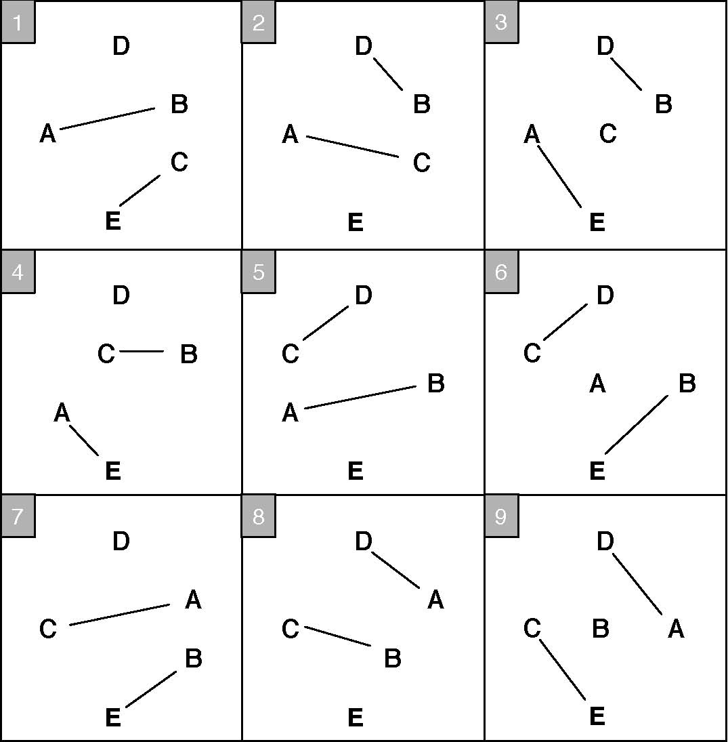
Pattern created by MAJ.

Whirling Melvish
Positions
 | A
D | M | B
 | C

Consider a 14 club box in 4-count. There's room in the middle for one or two jugglers. If they pass with each of the corners while turning slowly in a circle, that's the Whirling Melvish.
To make it easier, the Melvish (the juggler in the middle, who may or may not be named Melonhead), can do 2 passes in a row to each corner.
Juggler | 1 | 2 | 3 | 4 | 5 | 6 | 7 | 8 | 9 | 10 | 11 | 12 | 13 | 14 | 15 | 16
A | T-C |  | M |  | T-C |  | M |  | T-C |  |  |  | T-C
B |  | T-D |  |  |  | T-D |  |  |  | T-D |  | M |  | T-D |  | M
C |  |  | T-A |  |  |  | T-A |  |  |  | T-A |  |  |  | T-A
D |  |  |  | T-B |  |  |  | T-B |  |  |  | T-B |  |  |  | T-B
M |  | D-B | Pause |  |  |  | A |  |  |  | D-B | Pause |  |  |  | M
Both hands counting
A and B start with 4 clubs
A, C and M start with right hand
B and D start on 2 with right hands

A single transition takes from beat 1 through beat 9. At 10 it starts over with the next corner.
The Melvish passes a straight double, pauses and then does a normal 4-count pass to one corner (A in this case), then turns and throws an early straight double in 4-count to the next corner. Wait for 1 beat, then resume the 4-count. Moving after every 2 passes (1 double and 1 single) is a nice timing.
You can add an additional Whirling Melvish juggler in the middle back to back to the original mover. That juggler starts in a 4-count with C and does the same thing as M, 2 beats later.
Pattern by Luke Emery, 2000.

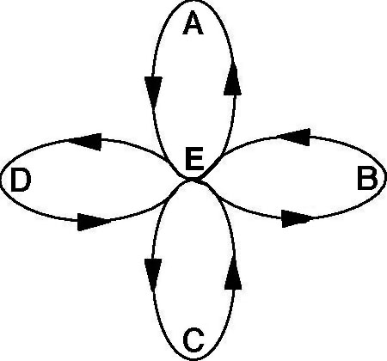
Cathedral
The Cathedral is an extension of the GDP to 5 jugglers. It is a 4 leaf clover with 2 extra clubs and all triple passes over the top. This is a spectacular pattern, but challenging.
The outer box maintains a 14 club box in 4-count triples.
The center juggler passes once with a leaf and then replaces that leaf in a 6-count turn. The table below shows one transition, where E replaces A, and A completes the transition facing B.
Juggler | 1 | 2 | 3 | 4 | 5 | 6 | 7 | 8 | 9 | 10 | 11 | 12 | 13 | 14 | 15 | 16
A | T-C |  | E |  | T-C |  |  |  |  |  | D-B | Pause
B |  | T-D |  |  |  | T-D |  |  |  | T-D |  | A |  | T-D
C |  |  | T-A |  |  |  | T-A |  |  |  | T-E |  |  |  | T-E
D |  |  |  | T-B |  |  |  | T-B |  |  |  | T-B |  |  |  | T-B
E |  | D-A | Pause |  |  |  |  |  | T-C |  |  |  | T-C
Both hands counting

Beats 1 through 9 make up a single transition.
Pattern by Luke Emery, 2000.

Star
Juggler | R | L
A | D | C
B | E | D
C | A | E
D | B | A
E | C | B
3-count or whatever you prefer

All passes are made at the same time. Try this pattern with 5-count, 3-count, 2 of 3 count or 1-count.
Classic pattern.

Selfless Star
This variation on a 3-count star is much more challenging than the standard star.
Juggler | 1 | 2 | 3 | 4
A | B | C | D | E
B | C | D | E | A
C | D | E | A | B
D | E | A | B | C
E | A | B | C | D
3-count

You can extend this pattern to 2 of 3-count or even 1-count if you're feeling ambitious (rights and lefts always go to opposite sides). Good luck with that.
When was this pattern created? We have been doing it since 1992.

Extra Club Stars
There are lots of nice variations on a star with extra clubs. If you're comfortable with 7 and 8 club passing patterns using left and right passes, try these.
4-Count Extra Club Star
In this straight forward variation, each juggler passes in a 4-count across and to the right. This pattern has only right hand passes and right to left double selves.
Juggler | 1 | 2 | 3 | 4 | 5
A | D-D |  | D-self | Pause
B | Pause |  | D-E |  | D-self
C |  | D-self | Pause |  | D-A
D |  | D-B |  | D-self | Pause
E | D-self | Pause |  | D-C
Both hands counting
A starts with 4
A, E start with right
B, C, D start with left (B starts with a Pause, so B actually starts with a right on beat 2)

5-Count Extra Club Star
This is an extension of the 3-count extra club triangle. Each juggler passes doubles in 5 count across and to the right. All passes cross (rights to right, lefts to left).
Juggler | 1 | 2 | 3 | 4 | 5
A | D-D
B |  |  | D-E
C |  |  |  |  | D-A
D |  | D-B
E |  |  |  | D-C
Both hands counting
A starts with 4
All jugglers start with right hand

PSPSS Star
We can continue to add clubs and passes to the 5-Count star, until it is a 1-Count star with 20 clubs and all throws are crossing double passes. However, that is really hard.
Here's a nice variation that is challenging but very doable and looks great. The key to this pattern is precise timing. There are two doubles crossing the circle on every beat and the timing must be exact so they don't collide. If there is any variation, throw the first pass a little late and the second pass a little fast.
Juggler | 1 | 2 | 3 | 4 | 5
A | D-D |  | D-D
B |  |  | D-E |  | D-E
C |  | D-A |  |  | D-A
D |  | D-B |  | D-B
E | D-C |  |  | D-C
Both hands counting
A and E starts with 4
All jugglers start with right hand

Triply Star
In this star a triple pass goes around the pattern. Single passes take up the extra time.
Juggler | 1 | 2 | 3 | 4 | 5
A | T-D |  |  | C | D
B | D | E | T-E
C |  |  | E | A | T-A
D | B | T-B |  |  | A
E |  | B | C | T-C
Right hand counting
A starts with 4

If you want to get crazy, note that each juggler has 2 right selves in a row. That's exactly enough time for each juggler to do a triple self with a pirouette and stay in time.
If you need to mellow it out, you can remove all the single passes and just pass a triple around in 10-count.
Here's another variation with triple selves instead of triple passes.

Juggler | 1 | 2 | 3 | 4 | 5
A | T-self | D |  | C | D
B | D | E | T-self | E
C | A |  | E | A | T-self
D | B | T-self | B |  | A
E |  | B | C | T-self | C
Right hand counting
C starts with 4

There could be many more interesting star variations based on siteswaps that are passed from one star point to the next. I've seen a few demonstrated at European conventions.
Pattern by Luke Emery.

20 Club Star
This classic pattern is just a star where every juggler starts with 4 clubs and does 2-count doubles to the juggler across and to the right.
It's a good study in timing.
Another classic pattern.

Twirly Star
Here's a simple and easy variation on the Shooting Star, but with 5 people and less moving.
Pass a space around a 2-count star and then pirouette every time the space comes around!
Juggler | 1 | 2 | 3 | 4 | 5
A | D | D | Pirouette | D | D
B | E | E | E | E | Pirouette
C | A | Pirouette | A | A | A
D | B | B | B | Pirouette | B
E | Pirouette | C | C | C | C
Right hand counting, 2-count
E starts with 2 clubs

Make sure to keep the count after the pirouette! (At first you can just pause for 2 counts instead of pirouetting.) You'll pirouette holding 2 clubs.
Pattern by Luke Emery.

Quincunx
Ahhh...Quincunx. We don't actually juggle this pattern. We just talk about it. Whenever we can't think of a pattern to try, someone inevitably says, “Let's do Quincunx!” Then we all laugh. Ha, ha! Ok, seriously. What should we do?
With no disrespect for Mike intended, this is kind of a dumb pattern. It's complicated and almost impossible to remember for a full cycle. I haven't done this pattern in at least 8 years, and I don't think anyone else in the MAJ has either. (Melonhead says he still likes it...)
Now that it's a part of the MAJ mythology though, we can't take it out of the pattern book. Maybe you should try it for yourself and see what you think!
Juggler | 1 | 2 | 3 | 4 | 5 | 6 | 7 | 8 | 9 | 10 | 11 | 12 | 13 | 14 | 15 | 16 | 17 | 18 | 19 | 20
A | E | C | C |  |  | D | D | B | B | C |  | B | B | D | C | E | E |  | D | E
B | D | E |  | D | D | C | E | A | A |  | C | A | A | E | E |  |  | C | C | D
C |  | A | A | E | E | B |  | E | E | A | B | D | D |  | A | D | D | B | B
D | B |  | E | B | B | A | A |  |  | E | E | C | C | A |  | C | C | E | A | B
E | A | B | D | C | C |  | B | C | C | D | D |  |  | B | B | A | A | D |  | A
Right handed 4-count

Lines indicate passes; arrows indicate movement.
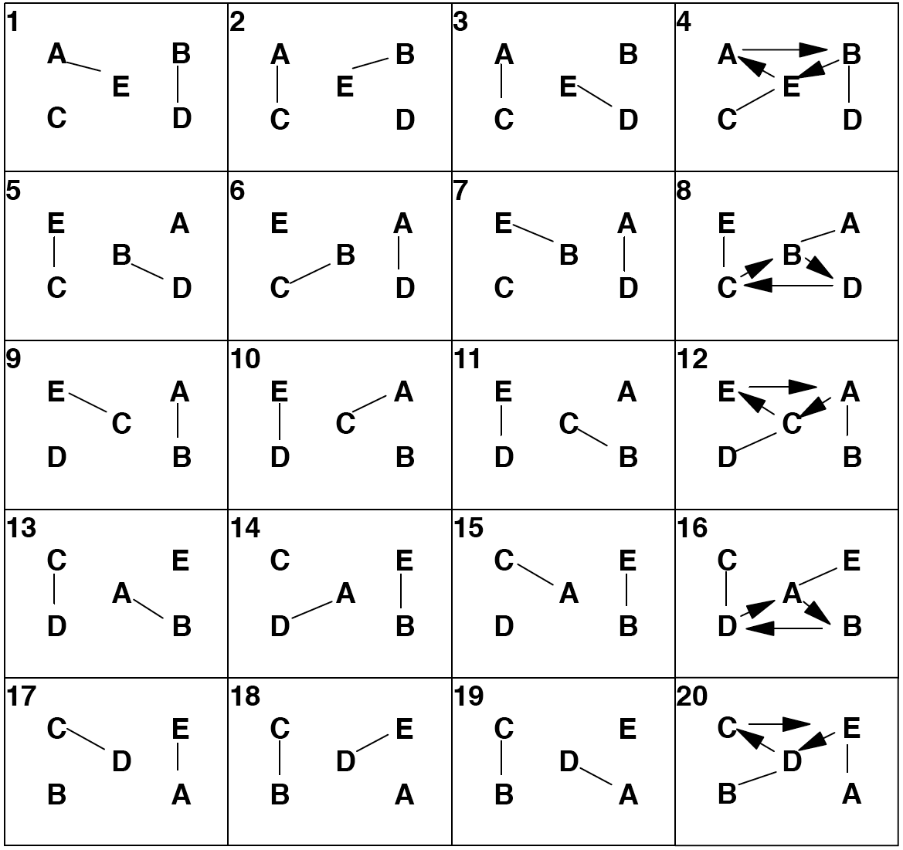
Pattern by Mike Newton.

6 Person Patterns

1-2-3 Apollo for Six
This Apollo for 6 jugglers is another Madison classic. (There are Apollos for all numbers.)
Juggler | 1 | 2 | 3 | 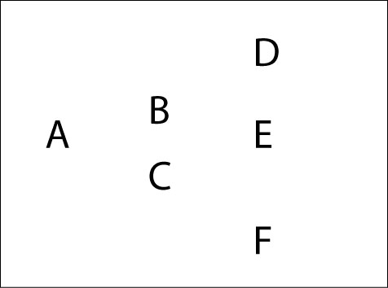  4
A | D |  | F
B | E |  | D
C | F |  | E
D | A |  | B
E | B |  | C
F | C |  | A
Right hand counting

Nice easy 4-count pattern.
Pattern by MAJ.

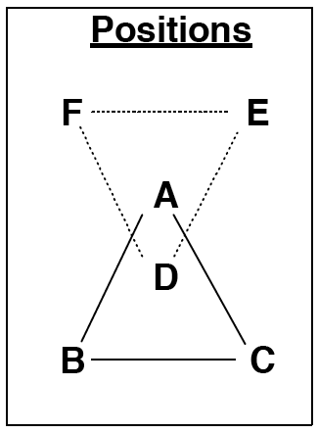
Argyled Triangles
It's trickier than you might think, even if you rock double 3 count.
Juggler | 1 | 2 | 3 | 4 | 5 | 6
A | B | D |  | C | D
B | C |  |  | A
C | A |  |  | B
D |  | A | E |  | A | F
E |  |  | F |  |  | D
F |  |  | D |  |  | E
Both hands counting

A and D face each other, passing double 3-count with the rest. B,C, E, and F pass 3-count.
Pattern by MAJ.

Argyle Sock
More Argyling. Add an extra pass for the corners, in case they're getting bored doing 3-count.
Juggler | 1 | 2 | 3 | 4 | 5 | 6
A | B | D |  | C | D
B | C | C |  | A | C
C | A | B |  | B | B
D |  | A | E |  | A | F
E |  | F | F |  |  | D
F |  | E | D |  | E | E
Both hands counting

See Anklet for a 4 juggler version.
Pattern by MAJ.

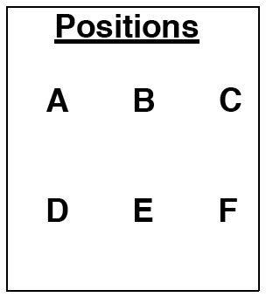
Double Weave
As you've seen, there are a mind boggling variety of possible weaves. Well, any of these weaves can be paired up with any other weave to make a double weave. The permutations are infinite, but here are some that we like.
Standard Double Weave
If A, B and C do a standard weave and pass across to D, E and F in a standard weave, you get the Standard Double Weave.
Juggler | 1 | 2 | 3
A | D
B |  | E
C |  |  | F
D | A
E |  | B
F |  |  | C
Right hand counting

The standard weave has each juggler moving forward in the middle, and back on the ends. Move to the next position after each pass. See the Standard Weave for more details concerning movement.
In this version jugglers pass short throws in the middle and long throws on the ends. As always, watch the lead throws!
Invert Prevert Weave (Equidistant Weave)
One team is inverted (which must mean the other team is preverted). Team DEF does an inverted weave by moving forward on the ends and backwards in the middle. This is an easier weave than the standard weave if all passers are comfortable with both standard and inverted weaves and looks nice because each juggler in a pair stays the same distance from the other.
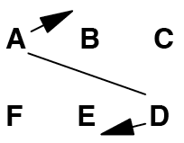
Cross-Corner Weave (Kitty-Korner Weave)
Same as the standard weave, but pass to the opposite corner on the ends.
Dresser Drawers Double Weave
Both teams do the Dresser Drawers weave.
Extra Club Double Weave
All passes are right hand doubles (like 7 2-count). Each weaver passes to only one other weaver (like in standard double weave) in a 6-count. The leads are very important.
Juggler | 1 | 2 | 3 | 4 | 5 | 6
A | D-D
B |  |  | D-E
C |  |  |  |  | D-F
D |  | D-B
E |  |  |  | D-C
F |  |  |  |  |  | D-A
Both hands counting
A, B and C start with right hand
D, E and F start with left hand

Switch Sides Double Weave
Switch sides at each end. For example, after A and D pass at the end, they switch positions so that A, E, and F are weaving, as are D, B, and C.
When was this pattern created? We have been doing it since 1993?

Double Gandini Weave
Positions
A
B
C
D
E
F

The Standard Gandini Weave makes a very nice double weave too. Each weaver passes twice in a row to two different jugglers, and then has 4 selves to move out, around back and into the middle. Next time move out in the opposite direction.
Juggler | 1 | 2 | 3 | 4 | 5 | 6
A |  |  |  | E | F
B |  | D | E
C | D |  |  |  |  | F
D | C | B
E |  |  | B | A
F |  |  |  |  | A | C
Right hands counting

For a good time, call Melonhead. Or try this pattern in chocolate bar.
Another nice variation is to add an extra club and make all the passes in the middle right hand doubles.
Based on Gandini Weaves by Gandini Juggling Project and MAJ.

Double Gandini Weave Plus
Positions
A
B
C
D
E
F

There is so much time at the back end of the Double Gandini Weave! Nine self throws! There must be something to do in all that time. Wait, I know! Let's add another club!
This is the same as the previous pattern with a triple club passed back and forth over the top of the pattern. It's a spectacular pattern and not as hard as you might think (though certainly not easy).
Juggler | 1 | 2 | 3 | 4 | 5 | 6
A |  | T-F |  | E | F
B |  | D | E |  |  | T-E
C | D |  |  | T-D |  | F
D | C | B |  |  | T-B
E | T-A |  | B | A
F |  |  | T-C |  | A | C
Right hands counting

Pattern by Luke Emery.

Stick on the End Double Weave (Synchronous)
Two teams of weavers pass to each other while weaving: moving back on the ends, forward in the middle. Pass straight across from whatever position you are in. "Synchronous" means everyone passes at the same time. In order for this to work, pass twice while in the end positions, and pass once while in the middle. Weavers pass in 6-count.
Juggler | 1 | 4 | 7
A | D | E | F
B | E | F | D
C | F | D | E
D | A | C | B
E | B | A | C
F | C | B | A
Right hands counting

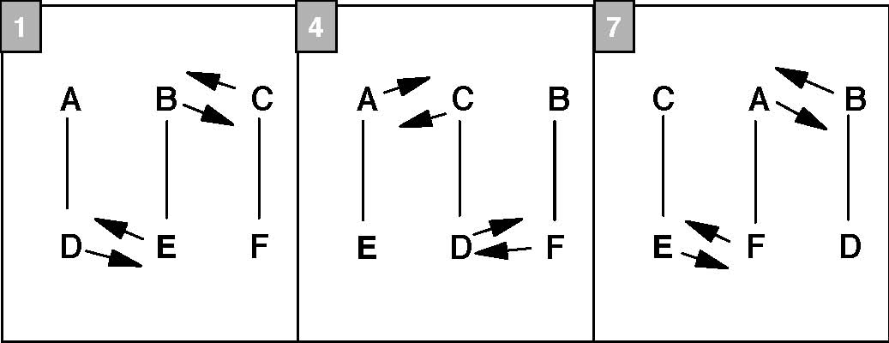
In the graph below, lines indicate passes, numbers indicate the passing beat, and arrows indicate movement after the pass.
Note: If each side moves on the edges and middle of a rectangle, instead of weaving, we have the essence of Han's Delight. [Euro '98'].
When was this pattern created? We have been doing it since 1993.

Five Person Weave (Peter Feeds Five)
Juggler | 1 | 2 | 3 | 4 | 5 | 6 | 7 | 8 | 9 | 10
A | F |  |  |  |  |  |  | F
B |  | F |  |  |  |  |  |  | F
C |  |  | F |  |  | F
D |  |  |  | F |  |  | F |  |  | F
E |  |  |  |  | F
F | A | B | C | D | E | C | D | A | B | D
 | 11 | 12 | 13 | 14 | 15 | 16 | 17 | 18 | 19 | 20
A | F |  |  | F
B |  |  |  |  |  | F |  |  | F
C |  |  | F |  |  |  |  |  |  | F
D |  |  |  |  |  |  | F
E |  | F |  |  | F |  |  | F
F | A | E | C | A | E | B | D | E | B | C
Right hand counting

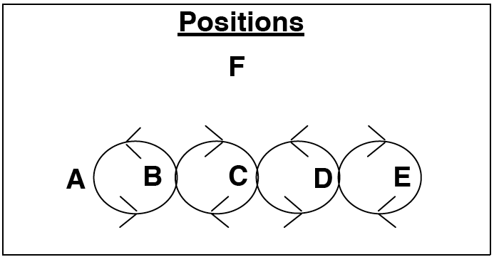
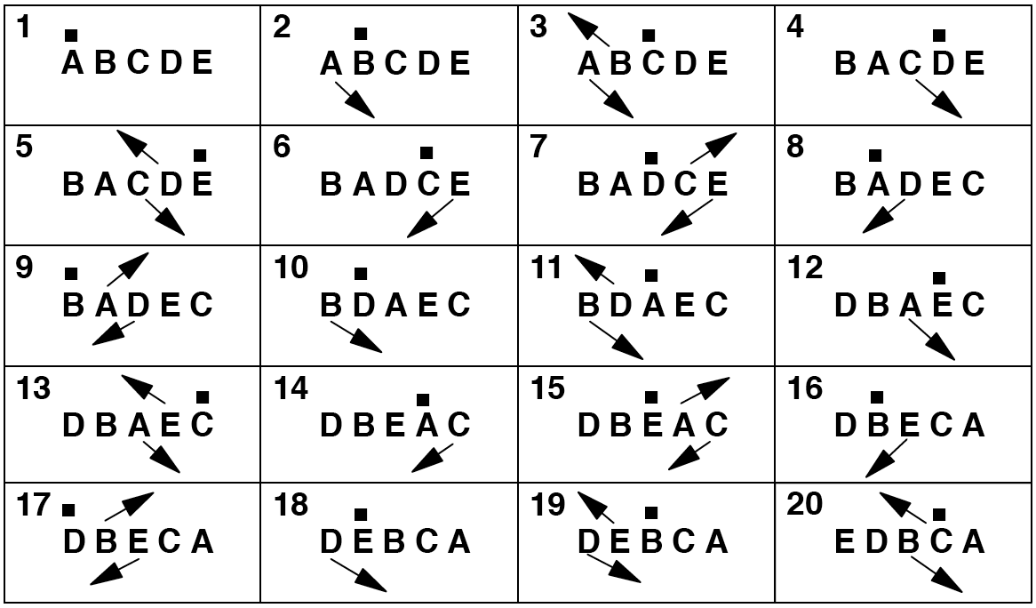
Dot indicates passer; arrows indicate motion; feeder not shown.
When was this pattern created? We have been doing it since 1998.

Spiral
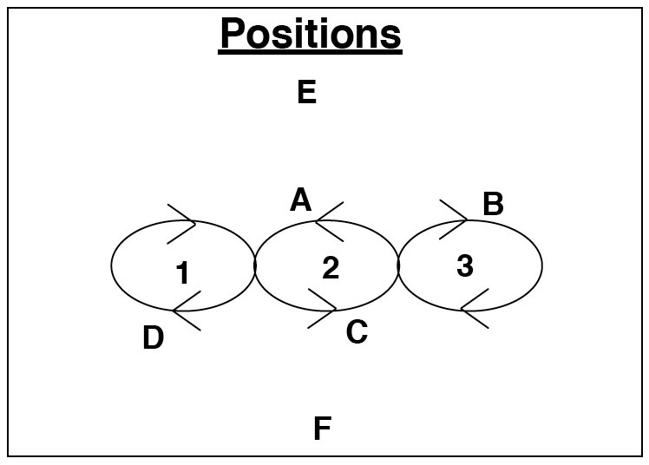
This pattern is a cross between the Twister Weave and the Benzene Ring. Feeders E and F do a typewriter feed to the 3 positions that are on top of the loops in the graph above.
Juggler | 1 | 2 | 3 | 4
A |  | E |  | F
B | E |  | F
C |  | F |  | E
D | F |  | E
E | B | A | D | C
F | D | C | B | A
Right hand counting Fast Spiral Weave
3-Count Standard Spiral Weave
double 3 Count Hyper-Spiral Weave

Refer to the graph above to follow A's path through the pattern. A's first pass is to E. A then turns around and moves to the bottom of loop 1 where a pass is made to F. A turns and moves to the top of loop 1 to pass to E. A turns and moves to the bottom of loop 2 to pass to F. A turns and moves to to the top of loop 3 to pass to E. A turns and moves to the bottom of loop 3 to pass to F. A turns and moves to the top of loop 2 where the pattern started.
Jugglers A, B, C, and D all do the same thing on pass out of phase. If the numbers show right hand counting this is the Fast Spiral and the weavers have a 4-count to move between each position. This is very fast.
To slow the pattern to 3-count, change the column numbers in the table above from 1, 2, 3, 4 to 1, 4, 7, and 10, and change "Right hand counting" to "Both hands counting, right hand starts". The weavers will pass in 6-count (note that 2 weavers, A and C are passing left handed 6-count).
Still too fast? Change the column numbers to 1, 3, 5, and 7 with right hand counting (weavers in 8-count).
Like many patterns, Spirals can be stacked, where one of the feeders is replaced another Spiral with the original feeder moved to the other side of the additional Spiral.
To red line this pattern have the feeders throw double 3 count, but keep the same passing order. Now the weavers are all in 3-count. The Hyper Spiral should be enough to challenge the most jaded of weavers!
Quick poll. Does this look like a spiral to you? Us either.
Pattern by Mike Newton and MAJ.

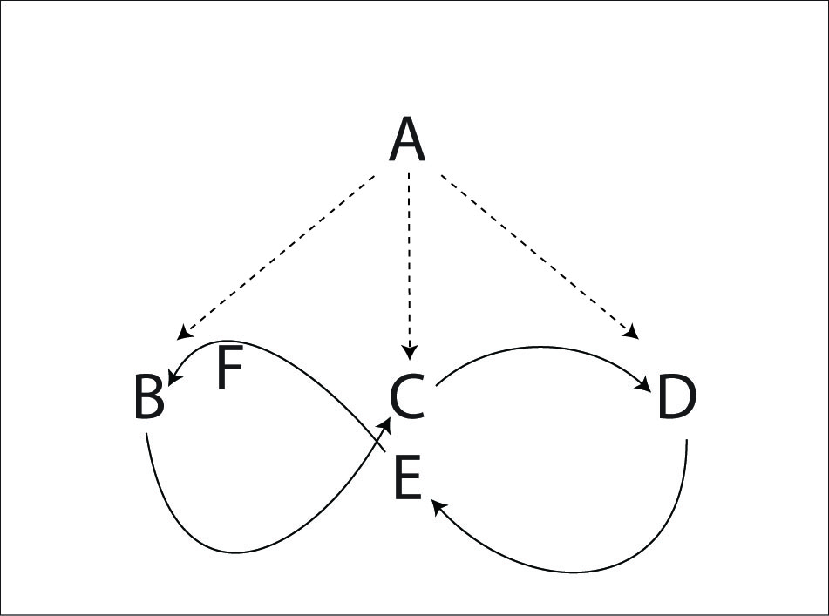
Standard 5 Weave (for 6 jugglers)
The standard weave for 1 feeder and 5 feedees has each feedee in 10-count (every 5th right) and the feeder in 2-count. Each weaver passes once on the end, moves backwards and inside, then passes once in the middle, and moves forwards and outside to the other end. A 10-count sound very slow, but I think you'll find most weavers will not be bored at all trying to keep up.
Once it starts, it's pretty easy to keep going. The start is a bit different from the standard weave for 3. The first weaver who passes in the middle goes to the opposite side of the first outside pass.
A – B end (B goes back on the end)
A – C middle (C move slowly forward and to their right)
A – D end (D goes back on the end)
A – E middle (E moves forward and to their left)
A – F end (F moves slowly left before the pass, then back on the end)
A next passes to B in the middle (as B is moving to their right) and continues passing to each weaver in order, but in the next weave position.
All of the weave variations can be done in a 5 Weave too. For added fun and excitement try a double weave of 2 standard 5 weaves, or 5 weave opposite a 3 weave, or a 5 weave opposite a Gandini Weave and so on.
Also see Twister 5 variations.
Pattern by MAJ.

Gandini 5 Weave
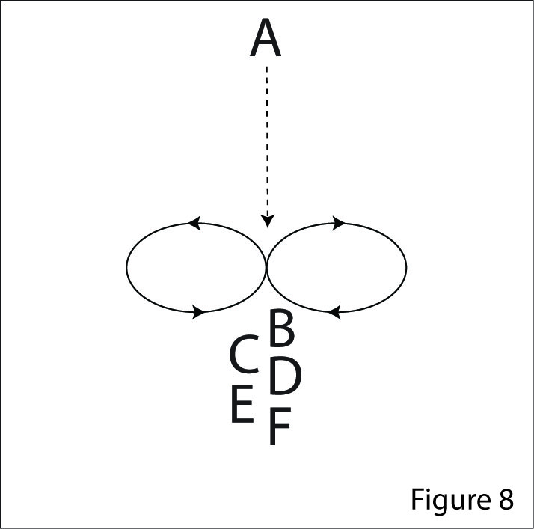
The Gandini 5 Weave is 5 jugglers in a Cascade pattern. Start with the five feedees in a line facing the feeder.
In this weave all the weavers move in a figure 8, but they always pass from the middle instead of the end.
The feeder is in 2-count (every right hand pass), the feedees are in 10-count.
Juggler | 1 | 2 | 3 | 4 | 5
A | B | C | D | E | F
B | A
C |  | A
D |  |  | A
E |  |  |  | A
F |  |  |  |  | A
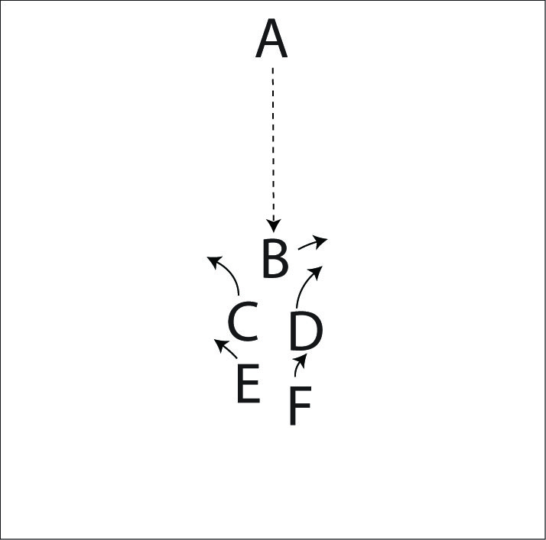
Right hand counting

It's easiest to start with the weavers stacked in a line all facing the feeder. Then each weaver will pass once and move in the opposite direction of the weaver in front of them.
Try all the same variations for the Standard Weave and Gandini Weave, and alternate counts such as 2 of 3 count. You can also invert the weave (reverse cascade). Also see Appendix C.
We learned about this family of weave variations from juggling with Sean Gandini and the Gandini Juggling Project in 2000.

Twister 4 Weave
Twister Weaves can be done with any number of jugglers. Here's a twister weave for 6.
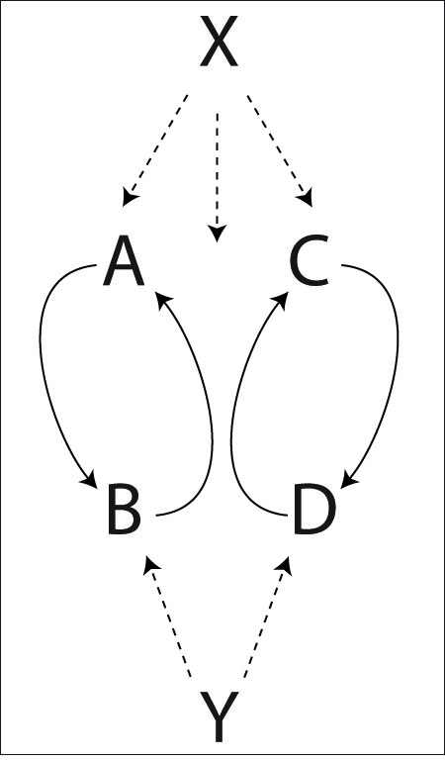
Juggler | 1 | 2 | 3 | 4 | 5 | 6 | 7 | 8
X | A | B | C | D | B | A | D | C
Y |  | D |  | A |  | C |  | B
A | X |  |  | Y |  | X
B |  | X |  |  | X |  |  | Y
C |  |  | X |  |  | Y |  | X
D |  | Y |  | X |  |  | X
Right hand counting

Pattern by Luke Emery.

Interlocking Turbos
The Turbo pattern for 3 jugglers lends itself to lots of variations. This is a pattern of 2 Turbos side by side where during each transition the weaver moves from one of the Turbos to the other.
Three of the jugglers always do an “inside turn” (turning towards their right hand pass). Three of the jugglers do an “outside turn” (turning away from the right hand pass). A, B and C will always go on the outside when they cross with the other Turbo. D, E and F always go on the inside.
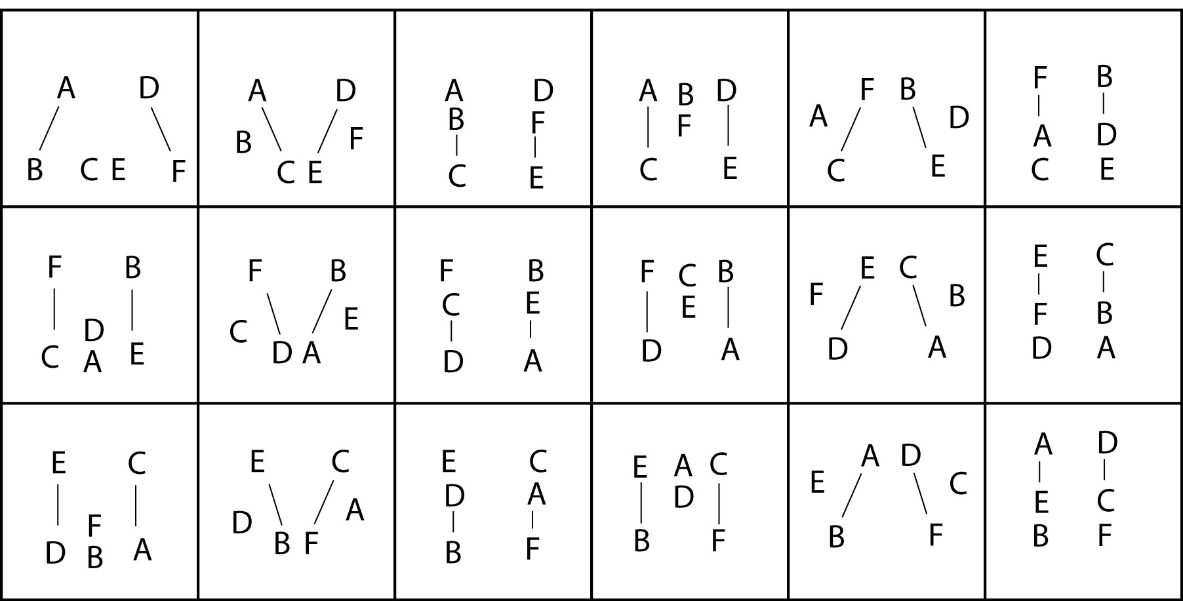
The standard pattern is in a 2-count Turbo. You can do it in 4-count or 3-count to slow it down.
Try in Tom's Turbo for a good challenge. The Interlocking Extra Club Turbos is a formidable challenge for the those with time, talent and hubris.
Pattern by Luke Emery, 1999.

Back to Back Turbos
Two Turbos are back-to-back. There are 2 situations concerning the switching of sides. When you are on one side of a turbo, you weave as you would in the regular turbo. In box 2, B and E switch sides in regular turbo style. When you are on the other side of the turbo, you move to the other turbo. In box 5, A and F switch turbos.
The movement arrows in the graph below are an approximation. In other words, you should move as soon as you can.
Lines indicate passes, and arrows indicate movement.
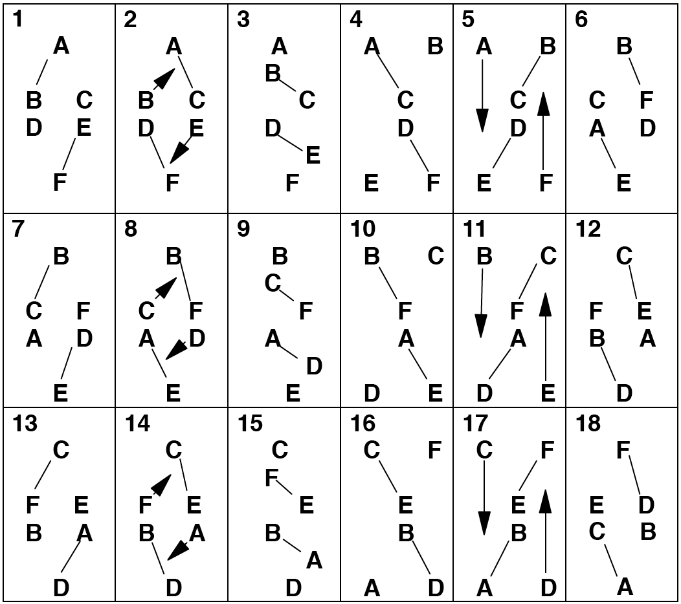
Pattern by Luke Emery, September 1999.

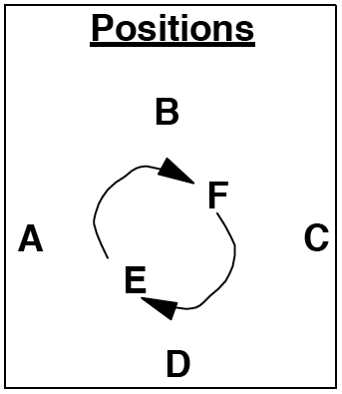
Ball Bearing
A, B, C, and D are doing a Feast (in 4-count), but the self throw is replaced with a pass to one of the movers in the middle. A, B, C, and D are passing 4-count. E and F are passing 8-count.

Juggler | 1 | 2 | 3 | 4 | 5 | 6 | 7 | 8
A | D | E | B | C | D | F | B | C
B | C | D | A | E | C | D | A | F
C | B | F | D | A | B | E | D | A
D | A | B | C | F | A | B | C | E
E |  | A |  | B |  | C |  | D
F |  | C |  | D |  | A |  | B
Right hand 4-count
OR 3-count with left hand start

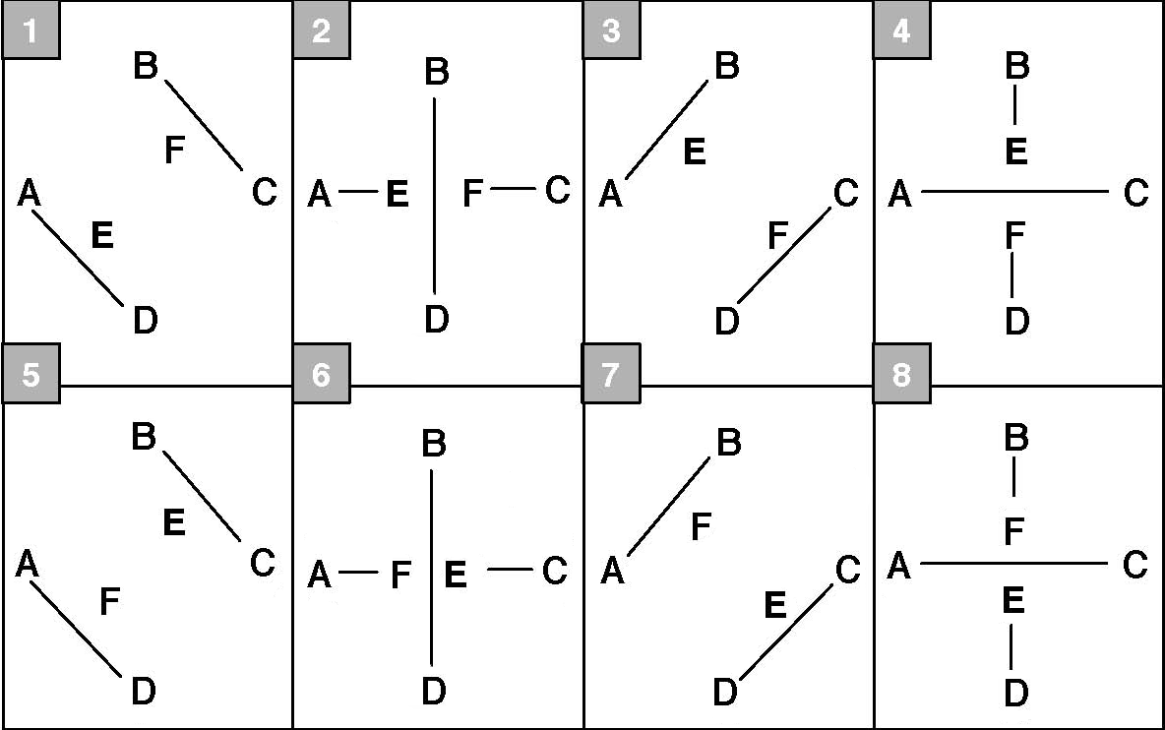
Variation: A,B,C, and D pass 3-count, and E and F pass 6-count. Start the variation with the left hand (or start on 2nd beat).
Pattern by Mike Newton.

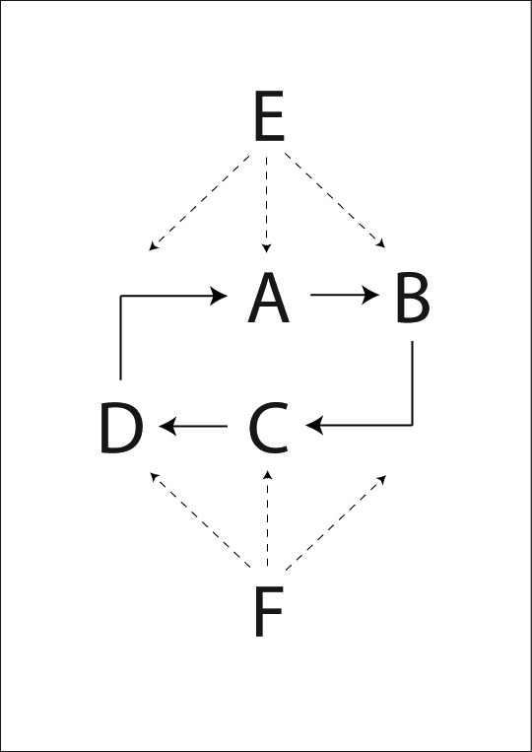
Benzene Ring (for 6 jugglers)
Here's another MAJ standard. E and F are carriage return feeders, feeding to 3 positions: left, middle, right, left, middle, right, etc. The rest of the jugglers move around in a ring, passing to the feeders. They pass 3 times to each feeder and then turn around to pass 3 times to the next feeder.

Juggler | 1 | 2 | 3 | 4 | 5 | 6 | 7 | 8 | 9 | 10 | 11 | 12
A |  | E |  | E |  | F |  | F |  | F |  | E
B | E |  | F |  | F |  | F |  | E |  | E
C |  | F |  | F |  | E |  | E |  | E |  | F
D | F |  | E |  | E |  | E |  | F |  | F
E | B | A | D | A | D | C | D | C | B | C | B | A
F | D | C | B | C | B | A | B | A | D | A | D | C
Right hand counting

Lets look to see what B does. B passes to E on the first beat and then has one right hand self to turn around and make the first pass to F. Then B moves to the middle (to where C is in the graph above). After B passes to F (beat 5 in the above table), B moves to where D is in the graph above. B makes one more pass to F before turning around to repeat the 3-pass cycle with E.
A, B, C, and D pass every other right hand. E and F pass every right hand.
Benzene Ring Plus
A challenging variation is to add two clubs to the pattern so that E and F do a 2-count extra club typewriter feed. All passes are doubles.
Also see Benzene Ring for 8 Jugglers
Benzene Ring Pattern by Mike Newton.

Hex
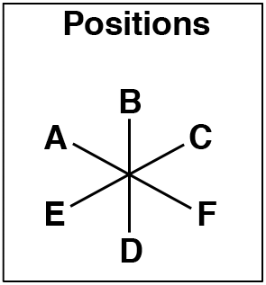
The box can be extended to 6 jugglers in a hexagon. This pattern is really nice in 3-count, but it can be done in other patterns too.
Juggler | 1 | 2 | 3
A | F
B |  | D
C |  |  | E
D |  | B
E |  |  | C
F | A
3-count

7 Club 3-count Hex
For those seeking a challenge, try a Hex where each pair juggles a 3-count 7 club pattern in doubles. It works if the passes are precise.
Pattern by MAJ.

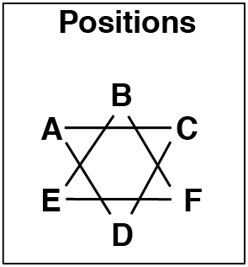
Bubbler of David
The Bubbler is a Star of David with interlocking triangles and extra clubs in 4-count doubles (that's the effervescent part).
A, C and D are in one triangle. They do a 4-count extra club triangle. The pass is a double from right hand to left hand. Each juggler passes to the juggler on their left The timing is a little fast and syncopated (A throws to C, C throws to D 4/3 beats after A, D throws to A 4/3 beats after C).
B, F and E are another triangle. They do a 4-count extra club triangle too. F throws at exactly the same time as A, E throws with C and D is synchronized with B.
Get that pattern smooth first. Now, notice how the juggler across from you is doing a self at the exact same time as you are? Now, just pass the right hand single straight across.
As always, timing is the key.
This pattern doesn't lend itself to a table format because the counts aren't even, but it's easy to figure out.
Pattern by MAJ.

Double Handled Egg Beater
I can't imagine why you would want an egg beater with 2 handlers, but if you did, and it was made of weaving jugglers, it might look like this.
Juggler | 1 | 2 | 3 | 4 | 5 | 6 | 7 | 8
A | C |  | D | F | C |  | D | E
B | D |  | C | E | D |  | C | F
C | A | E | B |  | A | F | B
D | B | F | A |  | B | E | A
E |  | C |  | B |  | D |  | A
F |  | D |  | A |  | C |  | B
Right hand counting

E and F are handles, A and B are one beater, and C and D are the other beater.
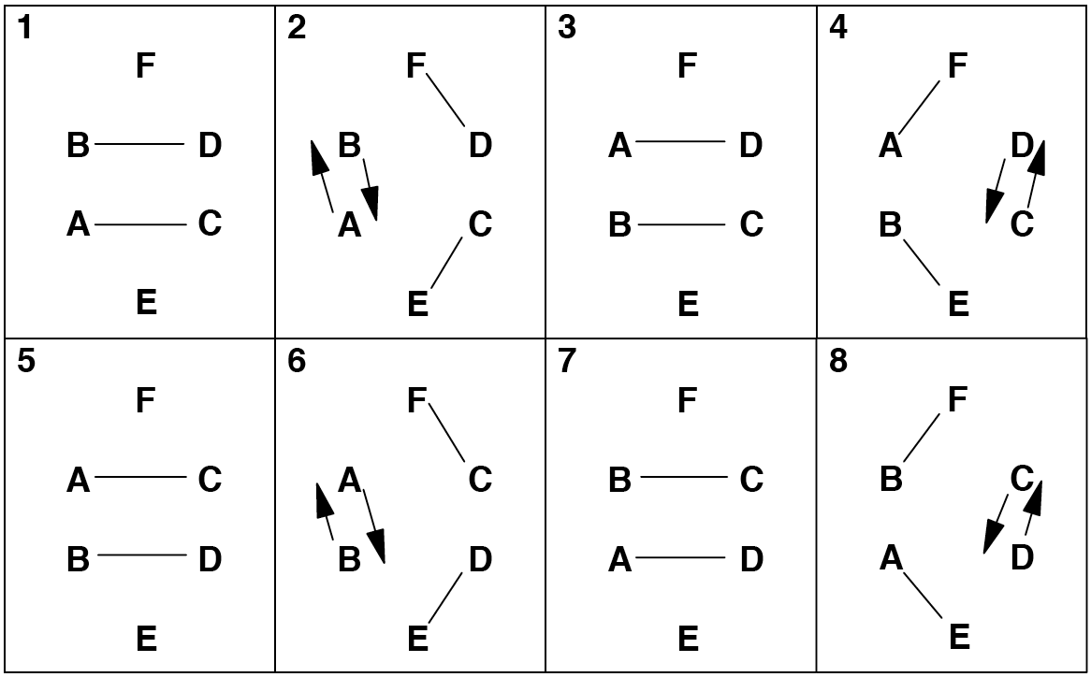
Lines indicate passes; arrows indicate movement.
Pattern by Mike Newton and MAJ.

Razor
A and B move around one circle, and C and D move around another circle. The table below is in 3-count, and is very fast. I recommend 4-count, or even 6-count.
Juggler | 1 | 4 | 7 | 10
A | E | D | D | 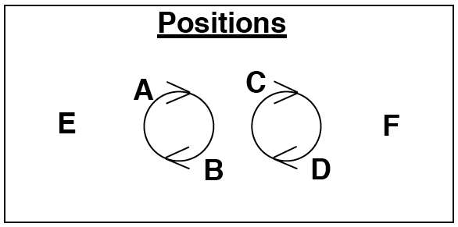  E
B | C | E | E | C
C | B | F | F | B
D | F | A | A | F
E | A | B | B | A
F | D | C | C | D
Both hands counting, right hand starts.

The numbers in the table below count the passes.
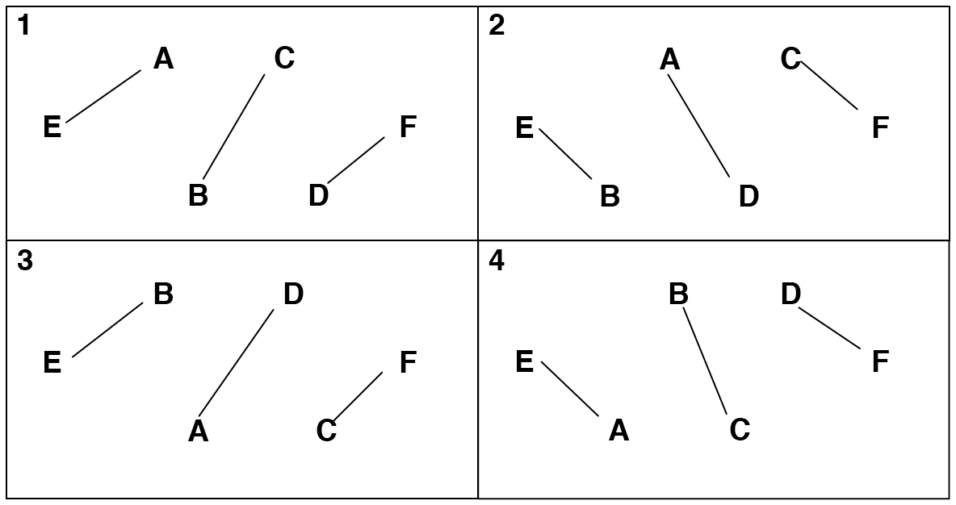
Pattern by Peter Kaseman and the MAJ.

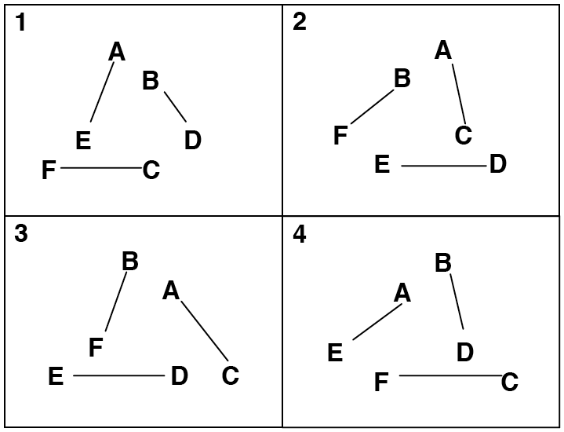
Electric Razor
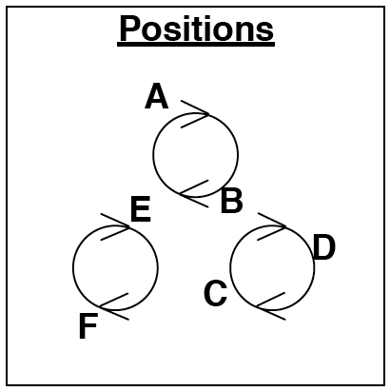
Here's another version of the razor by Peter where all the jugglers spin.
Juggler | 1 | 4 | 7 | 10
A | E | C | C | E
B | D | F | F | D
C | F | A | A | F
D | B | E | E | B
E | A | D | D | A
F | C | B | B | C
Both hands counting, right hand starts.

The Electric Razor is 3 pairs of jugglers. Each pair moves around their own circle.
The numbers in the table above count passes.
The Electric Razor pattern was invented by Peter Kaseman, summer '98.

Two-Seated Unicycle
Juggler | 1 | 4 | 7 | 10
A | C | D | D | C
B | A | A | A | A
C | B | E | E | B
D | E | B | B | E
E | F | F | F | F
F | D | C | C | D
Both hands counting, right hand starts

B does drop-back passes to A.
E does drop-back passes to F.

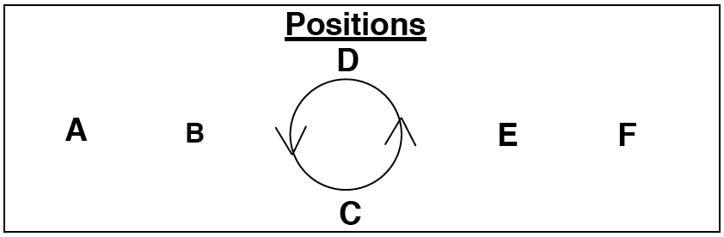
Arrows indicate the direction of pass.
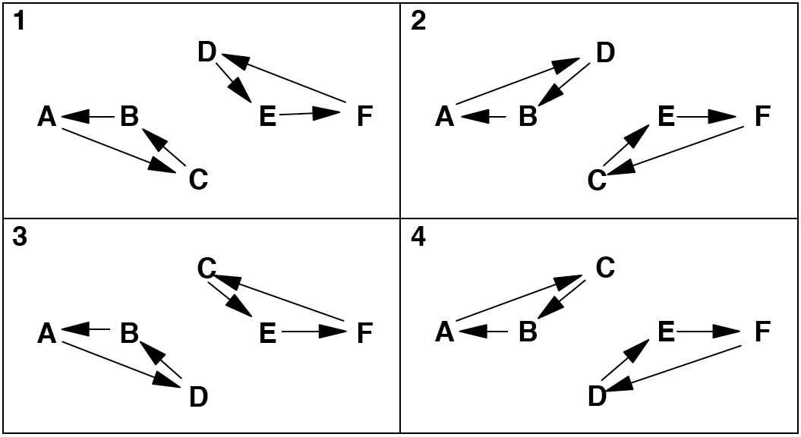
Pattern by MAJ.

Mel's Big Woody
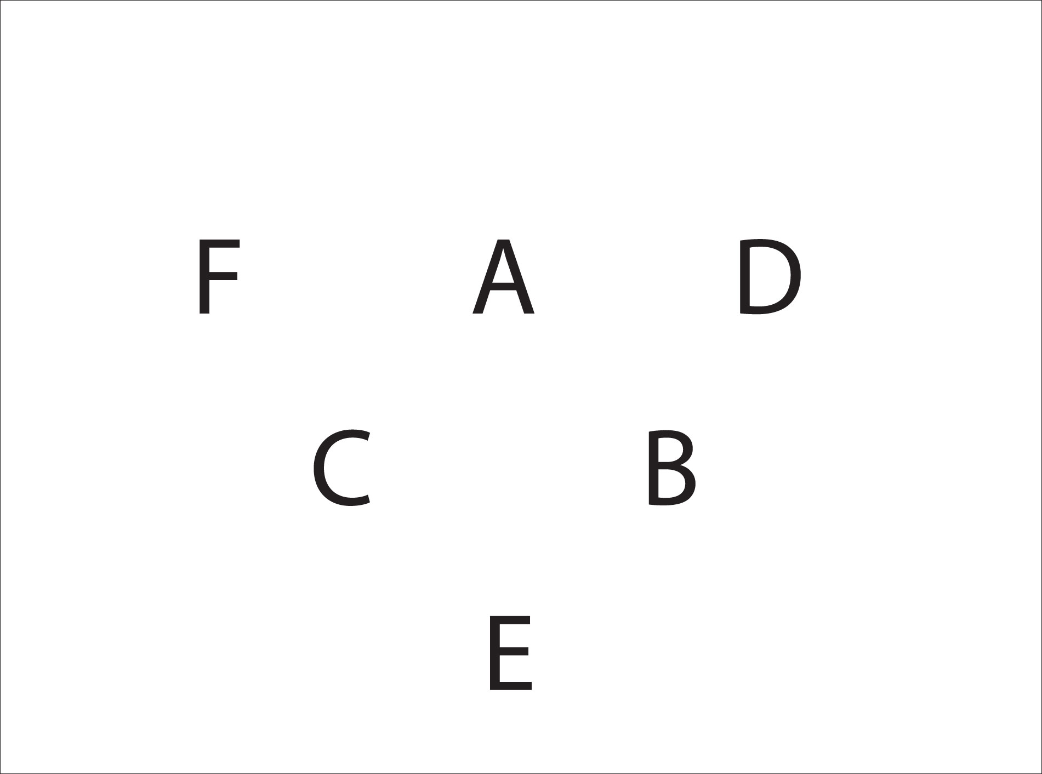
The inner triangle feeders each sweep feed 4 feedees. The outer triangle juggle a 6 count, which gives them plenty of time for tricks or triples.
Standard

Juggler | 1 | 2 | 3 | 4 | 5 | 6
A | D | B | C | F | C | B
B | E | C | A | D | A | C
C | F | A | B | E | B | A
D | A |  |  | B
E | B |  |  | C
F | C |  |  | A
Right hands counting

Now, to make it more interesting, throw early triples from the corners.
Juggler | 1 | 2 | 3 | 4 | 5 | 6
A | D | B | C | F | C | B
B | E | C | A | D | A | C
C | F | A | B | E | B | A
D | A | T-F | Pause | B | T-E | Pause
E | B | T-D | Pause | C | T-F | Pause
F | C | T-E | Pause | A | T-D | Pause
Right hands counting

D, E and F can pirouette in their Pause for some extra showmanship.
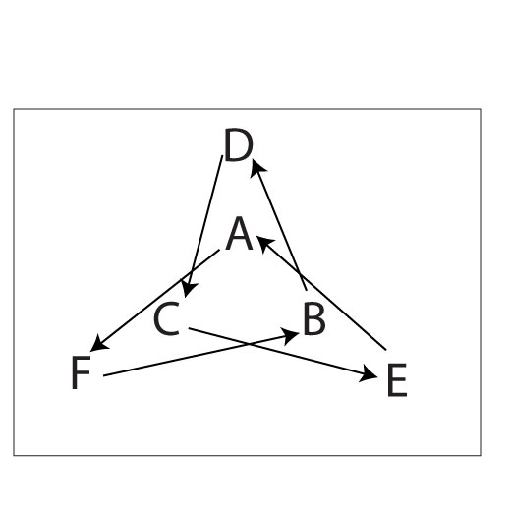
Pattern by Melonhead.

Trompe L'oeil (Concentric Triangles)
Here's an extension of the 4-count extra club triangle to 6 jugglers. All the jugglers should be quite comfortable with 4-count extra club triangles.
A – Double to F, self
D – Double to C, self

C – Double to E, self
F – Double to B, self

B – Double to D, self
E – Double to A, self

All passes right handed. 2 extra clubs (A , and D start with 4).
This is the 4-count version.
There are also nice variations in 6 count doubles (with 1 extra club), 7 club 3-count (2 extra clubs and same pattern a 4-count, just slower), 2-count doubles (3 extra clubs - A, B and C all start with 4), and if you're feeling crazy, chocolate bar (PPSSSS) or 1 – count (2 extra clubs and 6 extra clubs respectively).
This is an extension of a pattern Matt learned at a juggling convention where the same formation juggles without extra clubs in whatever count they choose (4-count being standard).
Pattern by That Matt (Matt Mella).

Overlapping Y's
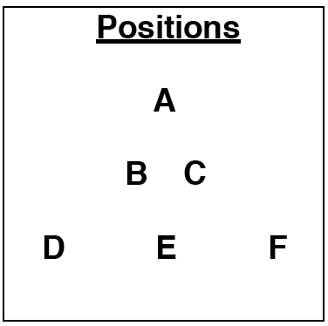
Imagine 2 Oogles mating.
Juggler | 1 | 2 | 3 | 4 | 5 | 6
A | E | E |  | F | D
B |  | D |  |  | E
C | F |  |  | E
D |  | A |  |  | B
E | C | B |  | A | A
F | A |  |  | C
Both hands counting

You can do a nice 1-count variations similar to this too.
Pattern by MAJ.

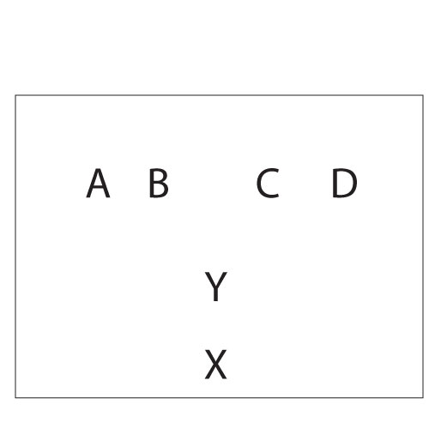
More Mating Oogles
Imagine better looking oogles mating than the previous mating oogles. This is basically a 1-count Oogle variation with a 2-count left handed Y and a 2-count right handed Y superimposed.
Juggler | 1 | 2
X | D | A
Y | B | C
A |  | Y
B | X
C |  | X
D | Y
Both hands counting

X throws rights to D and lefts to A
Y throws rights to B and lefts to C
A throws left hands to Y and does right selves
B throws right hands to X and does left selves
C throws left hands to X and does right selves
D throws right hands to Y and does left selves
Pattern by MAJ.

Fireworks
Do you have nerves of steel? Do you juggle with poise and confidence while bombs explode all around you and other jugglers panic and dive for cover? Good, you'll need all of that for this pattern. It is a right handed pattern with 4 extra clubs and lots of doubles and triples. Sometimes, (maybe even often, for some jugglers), those collide above your heads.
However, if thrown carefully, there is just enough room for all of them.
Positions
A | B | C
D | E | F

Juggler | 1 | 4 | 7 | 10
A | T-D |  | D-E
B |  | D-F |  | D-D
C | D-E |  | T-F
D | D-B |  | T-A
E |  | D-A |  | D-C
F | T-C |  | D-B
Both hands counting
A, C, D and F start with 4 clubs and right hands
B and E start with 3 clubs and left hands

The corners do a 2-count feed of triples to the opposite corner and doubles to the centers.
The centers do a 2-count feed of doubles to the corners.
Pattern by Luke Emery.

Theatre Style Popcorn
Positions
 | A
 | B
 | C
D | E | F

This impressive pattern with 21 clubs is in the same family as the Oogle and the Apollo and is a Madison favorite.
A does a typewriter feed to D, E and F in 8 club 2-count.
B does a typewriter feed to D, E and F in 7 club 2-count.
C does a typewriter feed to D, E and F in 6 club 2-count.
D, E and F do popcorn passing: triple to A, double to B, single to C.
Juggler | 1 | 2 | 3 | 4 | 5 | 6
A | T-D |  | T-E |  | T-F
B |  | D-D |  | D-E |  | D-F
C | E |  | F |  | D
D | T-A |  | D-B |  | C
E | C |  | T-A |  | D-B
F | D-B |  | C |  | T-A
Both hands counting
All passes from right hand
A, C, D, E, F start with right hand
A, D and F start with 4 clubs
B starts with left hand

As you might expect, A is a challenging position. C, less so.

Pattern by Peter Kaseman.

7 Person Patterns

1-2-4 Apollo (for Seven Jugglers)
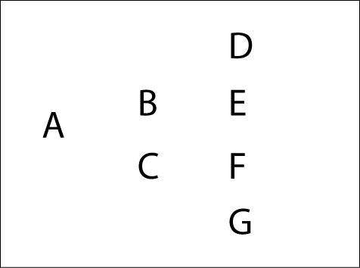
Apollos come in all sizes. Here's one for 7 jugglers.
Juggler | 1 | 2 | 3 | 4
A | D |  | G
B | F | E | D | E
C | G | F | E | F
D | A |  | B
E |  | B | C | B
F | B | C |  | C
G | C |  | A
Right hand counting

A throws long passes in 4-count to the outside edges (D and G)
B and C do sweep feeds of 3 feedees each.
D and G do 4-count between A and the feeder on their side (B and C respectively)
E and F do a sweep feed with a phantom (don't pass to the phantom).

Pattern by MAJ.

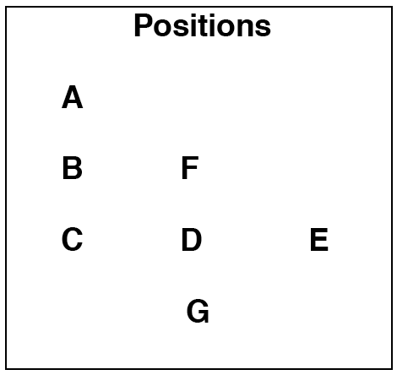
Hinge (for 7)
Easy patterns for lots of people
Juggler | 1 | 2 | 3 | 4
A | F
B |  | F |  | F
C | G |  | F
D |  | G |  | G
E |  |  | G
F | A | B | C | B
G | C | D | E | D
Right hand counting (or whatever count you want)

C is the Hinge, and F and G are feeders.
A Hinge is a juggler who passes to two feeders.
The feeders in a Hinge pattern do a standard feed to 3 jugglers.
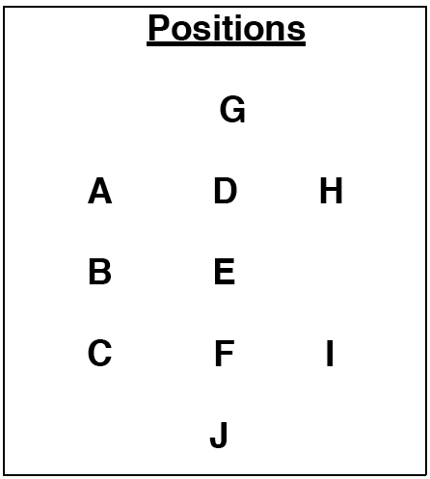
Juggler | 1 | 2 | 3 | 4
A | E |  | G
B |  | E |  | E
C | J |  | E
D |  | G |  | G
E | A | B | C | B
F |  | J |  | J
G | H | D | A | D
H | G
I |  |  | J
J | C | F | I | F
Right hand counting (or whatever count you want)

Hinges: A, C
Feeders: E, G, J
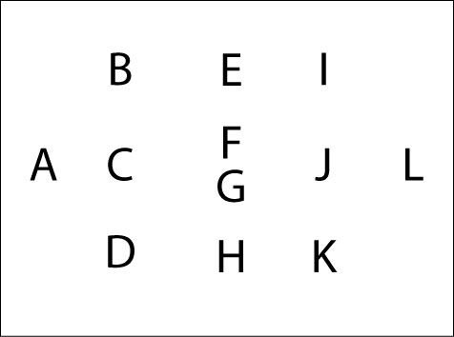
Juggler | 1 | 2 | 3 | 4
A | B | C | D | C
B | A |  | F
C |  | A |  | A
D | G |  | A
E |  | F |  | F
F | I | E | B | E
G | D | H | K | H
H |  | G |  | G
I | F |  | L
J |  | L |  | L
K | L |  | G
L | K | J | I | J
Right hand counting (or whatever count you want)

Hinges: B, D, I, K
Feeders: A, F, G, L

Hinges are great patterns for large numbers of jugglers, but admittedly, that can be rather boring for more advanced passers. One solution is the Precious Metal Hinge.

Precious Metal Hinge
Any line of three can be escalated by adding one or more clubs to the feed. For example, in the 12 person hinge above, A can feed an extra club feed with doubles. In this case:

A – Feeds B, C and D in standard 7 club extra club 2-count doubles feed.
B – Hinge, throws doubles to A and singles to F in 4-count.
D – Hinge throws doubles to A and singles to G in 4-count.
C – Throws doubles to A in 4-count.

That's a Golden Hinge. To start have B start with 4 clubs and A start with a left self).
For a Platinum Hinge, A throws triples and adds 2 clubs. B, C and D throw triple straight passes to A. B starts with a triple to A and A starts with a triple to C. C does a self.
For a Diamond Hinge (diamonds aren't actually a precious metal, I know), there are 4 extra clubs in the line. A throws all triple right hand passes and B, C and D throw triple right hand selves except when they throw triples to A or singles to the other feeder.
You can mix and match precious metals on any side of the hinge, although care must be taken to keep the timing synchronized.
Hinge created by Mike Newton.

The Blast
This pattern became an instant Madison classic. Although the basic pattern is straight forward, there are a vast array of extensions and variations that can easily be tuned for the skill levels and number of available jugglers.
The weavers move in 8-count in the middle and 12-count on the ends. It's not difficult, but certainly not as boring as 8-count and 12-count might seem at first glance.
Dotted lines are passes and solid lines are movement.
Juggler | 1 | 2 | 3 | 4 | 5 | 6 | 7 | 8 | 9 | 10
A | D | E | C | G | E | F | G | D | F | C
B | F | G | D | F | C | D | E | C | G | E
C |  |  | A |  | B |  |  | B |  | A
D | A |  | B |  |  | B |  | A
E |  | A |  |  | A |  | B |  |  | B
F | B |  |  | B |  | A |  |  | A
G |  | B |  | A |  |  | A |  | B
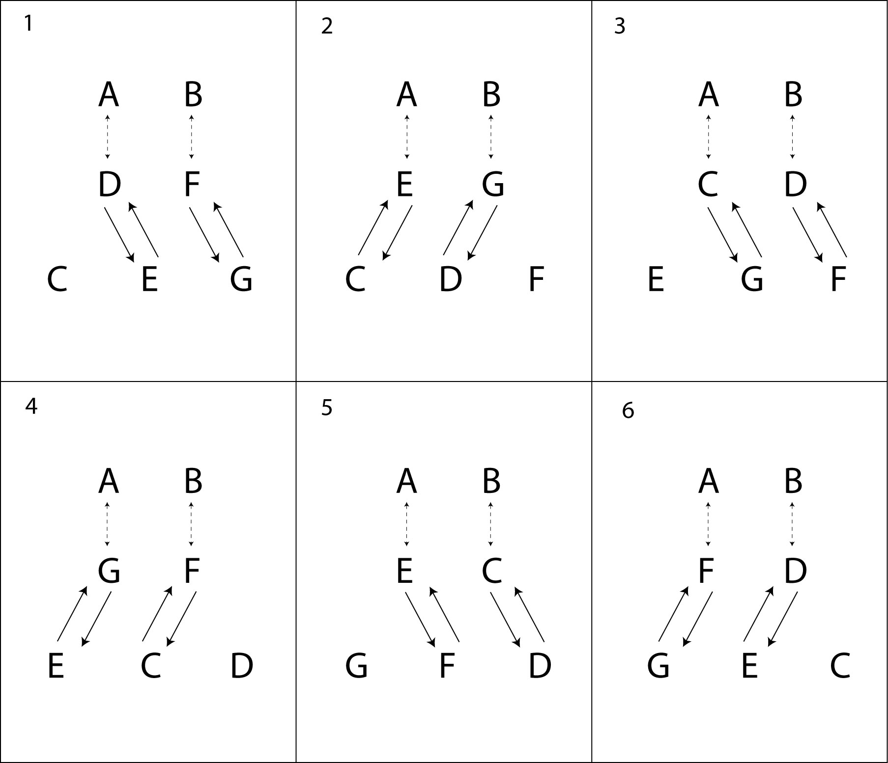
Right hand counting in 4-count.

Try the pattern in chocolate bar, or do a pirouette underneath a self triple while doing 12-count on the ends. See other variations in Fully Loaded Blast underneath Big Patterns, including some very challenging and fun extensions.

This pattern was created by Peter Kaseman and was inspired by a bouncing ball pattern.

Twister 5
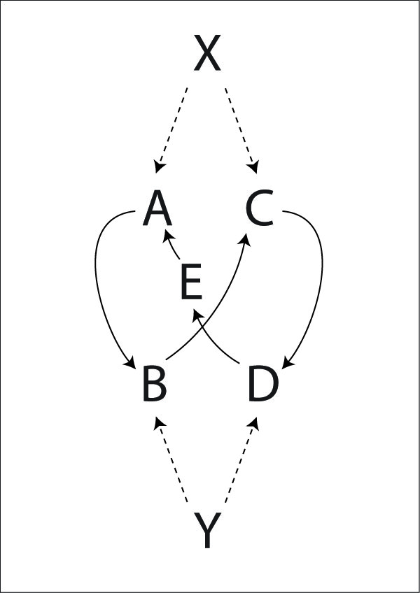
This twister is a particularly nice moving pattern for 7 jugglers.
Juggler | 1 | 2 | 3 | 4 | 5 | 6 | 7 | 8 | 9 | 10
X | A |  | C |  | E |  | B |  | D
Y |  | B |  | D |  | A |  | C |  | E
A | X |  |  |  |  | Y
B |  | Y |  |  |  |  | X
C |  |  | X |  |  |  |  | Y
D |  |  |  | Y |  |  |  |  | X
E |  |  |  |  | X |  |  |  |  | Y
Right hand counting (or whatever count you want)

Double Time Twister 5
The feeders pass twice in a row to each feeder.
Twister 5 Plus
Add an extra club over the top with X and Y passing 7 club 4-count on their self throws.
Twister 5 7/8-Count
The feeders throw 3-count and the weavers pass 7 count on one leg, and 8 count on the other.
Twister 5 5-Count
X throws 2-count right handed. Y throws 2-count left handed. The weavers do 5-count. Fun!
Twister 5 Sandwich
Like the Twister Sandwich in 9 Person Patterns, you can replace one or both of the feeders with a 3 person weave (or any other weave, really). To make it more interesting, try a double time weave where each weaver passes twice to the other weave.
Pattern by MAJ.

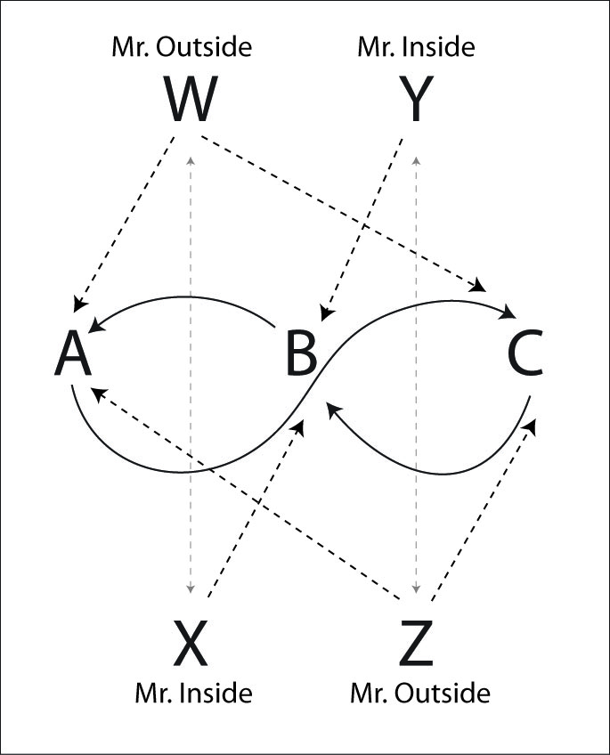
Twister Plus Plus
This amazing pattern is another crown jewel of the MAJ pattern repertoire. It's a combination of Twister Plus and Double Time Twister.
The feeders are all doing Twister Plus, alternating triples all the way across the pattern with singles to the weavers. The weavers are doing a Double Time Twister Weave and pass twice on each side, once to each feeder. Messrs Outside pass to the outsides, and Messrs Inside pass to the inside weaver position.

Juggler | 1 | 2 | 3 | 4 | 5 | 6 | 7 | 8 | 9 | 10 | 11 | 12
W | A | T-X | C | T-X | B | T-X | A | T-X | C | T-X | B | T-X
X | T-W | B | T-W | A | T-W | C | T-W | B | T-W | A | T-W | C
Y | T-Z | A | T-Z | C | T-Z | B | T-Z | A | T-Z | C | T-Z | B
Z | C | T-Y | B | T-Y | A | T-Y | C | T-Y | B | T-Y | A | T-Y
A | W | Y |  | X | Z |  | W | Y |  | X | Z
B |  | X | Z |  | W | Y |  | X | Z |  | W | Y
C | Z |  | W | Y |  | X | Z |  | W | Y |  | X
Right hand counting
X and Y start with 4 clubs

Pattern by MAJ.

Iron Cross Weave
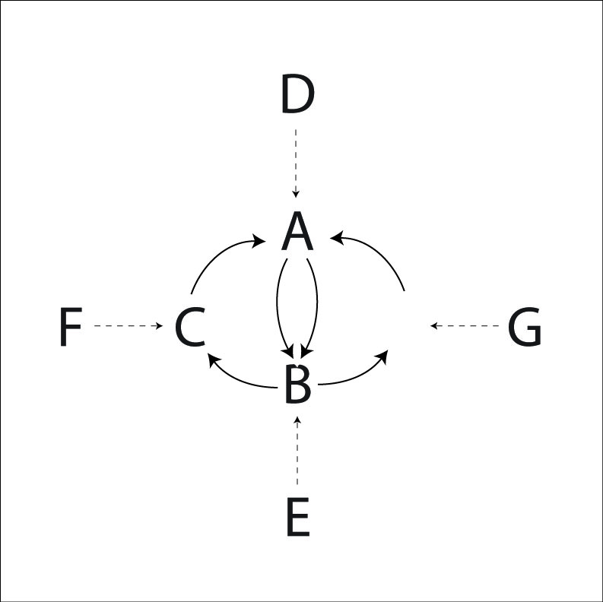
Here's a challenging weave where the weavers are in 4-count. There are 2 harder feeder positions and 2 easier feeder positions.
Juggler | 1 | 2 | 3 | 4 | 5 | 6 | 7 | 8 | 9 | 10 | 11 | 12
A | D |  | E |  | F |  | D |  | E |  | G
B | E |  | G |  | D |  | E |  | F |  | D
C | F |  | D |  | E |  | G |  | D |  | E
D | A |  | C |  | B |  | A |  | C |  | B
E | B |  | A |  | C |  | B |  | A |  | C
F | C |  |  |  | A |  |  |  | B
G |  |  | B |  |  |  | C |  |  |  | A
Right hand counting
See all those selves? Once you're comfortable with this pattern, make life more interesting by adding extra passes in the selves. One variation is for F and G to pick up the passes before and after their normal passes (so they throw pass, pass, pass, self). Another variation is for each E, F and G to all pass twice in a row to the weavers. D can't pass twice in a row without making the turn from D to E rather difficult.
Pattern by Luke Emery.

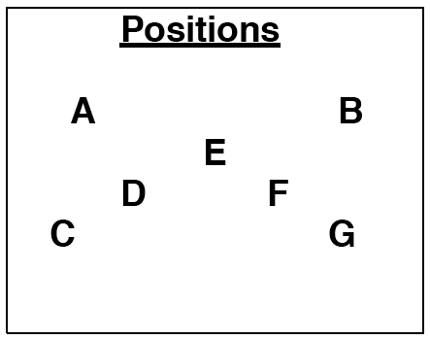
Intersecting Weave
A and B are feeding a standard weave with one position common to both. The weavers do a standard weave until they get between A and B. The weaver then leaves one weave to enter the other. During this transition, the weaver makes 2 passes in a row.

Juggler | 1 | 2 | 3 | 4 | 5 | 6 | 7 | 8 | 9 | 10 | 11 | 12 | 13 | 14 | 15 | 16 | 17 | 18 | 19 | 20
A | C | D | F | C | D | F | G | D | F | G | E | F | G | E | C | G | E | C | D | E
B | E | F | G | E | C | G | E | C | D | E | C | D | F | C | D | F | G | D | F | G
C | A |  |  | A | B |  |  | B |  |  | B |  |  | B | A |  |  | A
D |  | A |  |  | A |  |  | A | B |  |  | B |  |  | B |  |  | B | A
E | B |  |  | B |  |  | B |  |  | B | A |  |  | A |  |  | A |  |  | A
F |  | B | A |  |  | A |  |  | A |  |  | A | B |  |  | B |  |  | B
G |  |  | B |  |  | B | A |  |  | A |  |  | A |  |  | A | B |  |  | B
Right hand counting

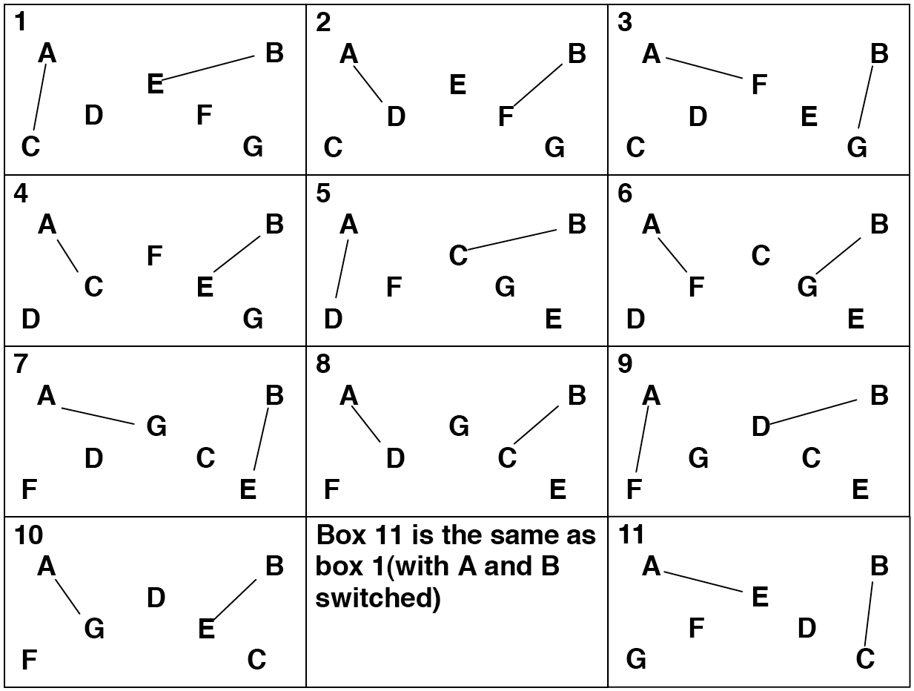
A and B are feeding a standard weave with one position common to both. The weavers do a standard weave until they get between A and B. The weaver then leaves one weave to enter the other. During this transition, the weaver makes 2 passes in a row.
Pattern by Steve Otteson.

Eye of the Needle
A Twister Weave has lots of time and space in the middle.
If your weavers are quite comfortable with outside turns in a Twister Weave, then here is a fun and good looking pattern. This is just a Twister Weave with another passing duo embedded in the center.
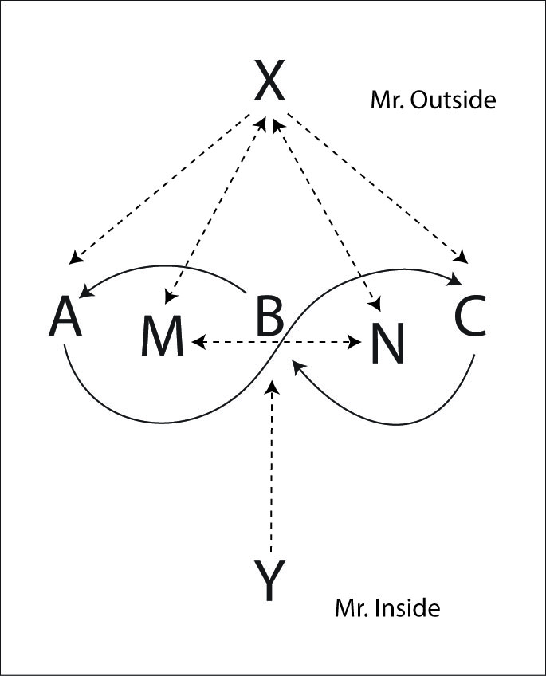
Juggler | 1 | 2 | 3 | 4 | 5 | 6 | 7 | 8 | 9 | 10 | 11 | 12
X | A | N | C | M | B | N | A | M | C | N | B | M
Y |  | B |  | A |  | C |  | B |  | A |  | C
A | X |  |  | Y |  |  | X |  |  | Y
B |  | X |  |  | Y |  |  | X |  |  | Y
C |  |  | X |  |  | Y |  |  | X |  |  | Y
M | N |  | N | X | N |  | N | X | N |  | N | X
N | M | X | M |  | M | X | M |  | M | X | M
Right hand counting

If this pattern is too challenging as written, then start by skipping the passes from M and N to X. Then M and N just do a 4-count in the middle and X does a standard Mr. Outside 4-count.
There are a number of patterns that have enough room to embed other patterns in the middle.
Pattern by MAJ.

8 Person Patterns

Polymer Weave
It's a passing axiom that any 2-count feeder can be replaced by a weave. If this is applied to the traditional W pattern, the result is this crazy pattern. It is called a Polymer Weave because you can add additional weaves to either end of the pattern (just like adding additional passers to a W).
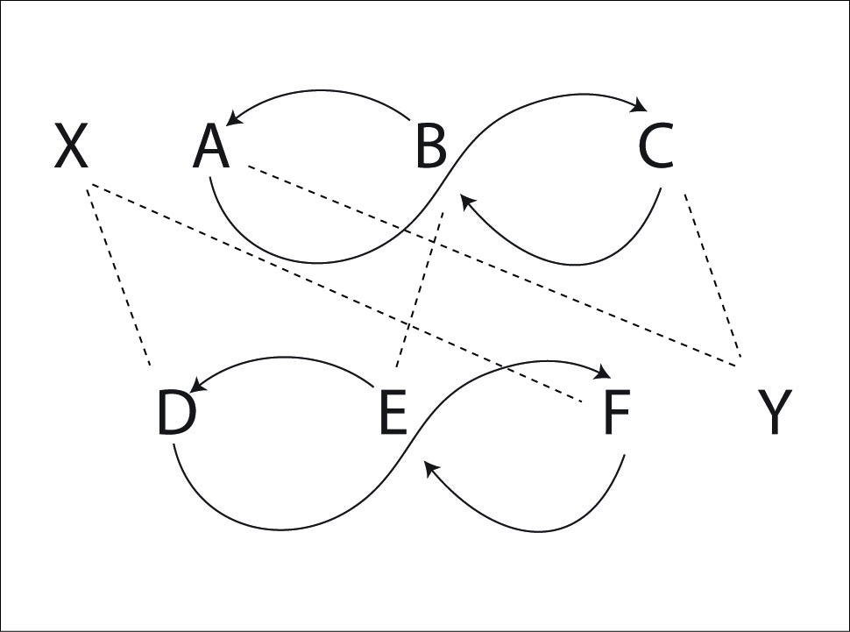
X and Y are stationary and feed as the Mr. Outside position in 4-count. Each weave acts as the other's Mr. Inside for the other pass in the weave. You can move either X or Y to the other side and replace them with another weave. And so on.
Juggler | 1 | 2 | 3 | 4 | 5 | 6 | 7 | 8 | 9 | 10 | 11 | 12
X | D |  | F |  | E |  | D |  | F |  | E
Y | C |  | A |  | B |  | C |  | A |  | B
A |  |  | Y |  |  | F |  |  | Y |  |  | F
B |  | E |  |  | Y |  |  | E |  |  | Y
C | Y |  |  | D |  |  | Y |  |  | D
D | X |  |  | C |  |  | X |  |  | C
E |  | B |  |  | X |  |  | B |  |  | X
F |  |  | X |  |  | A |  |  | X |  |  | A
Right hand counting

Pattern by Mike Newton.

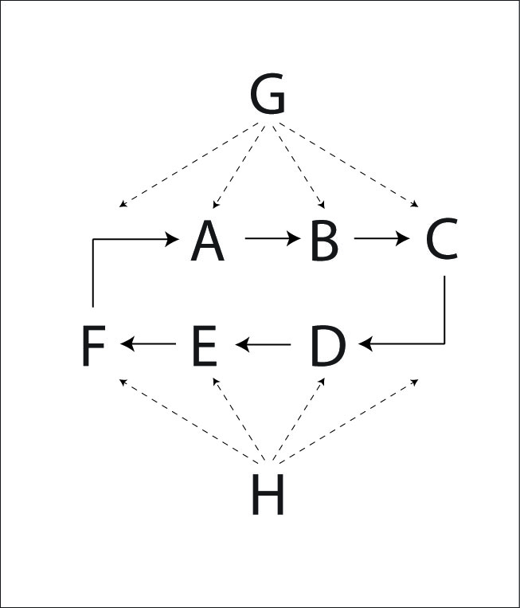
Benzene Ring (for 8 jugglers)
Here's another MAJ standard. E and F are carriage return feeders, feeding to 3 positions: left, middle, right, left, middle, right, etc. The rest of the jugglers move around in a ring, passing to the feeders. They pass 3 times to each feeder and then turn around to pass 3 times to the next feeder.

Juggler | 1 | 2 | 3 | 4 | 5 | 6 | 7 | 8 | 9 | 10 | 11 | 12
A |  |  | G |  |  | G |  |  | G |  |  | H
B |  | G |  |  | G |  |  | H |  |  | H
C | G |  |  | H |  |  | H |  |  | H
D |  |  | H |  |  | H |  |  | H |  |  | G
E |  | H |  |  | H |  |  | G |  |  | G
F | H |  |  | G |  |  | G |  |  | G
G | C | B | A | F | B | A | F | E | A | F | E | D
H | F | E | D | C | E | D | C | B | D | C | B | A
Right hand counting

The feeders G and H feed carriage return to 4 positions (instead of 3 positions in the 6 juggler version). The movers move around the loop passing to each feeder 4 times before turning around to pass to the other feeder. The graph shows half of a full cycle. The pattern will repeat in its mirror image.
Pattern by Mike Newton and MAJ.

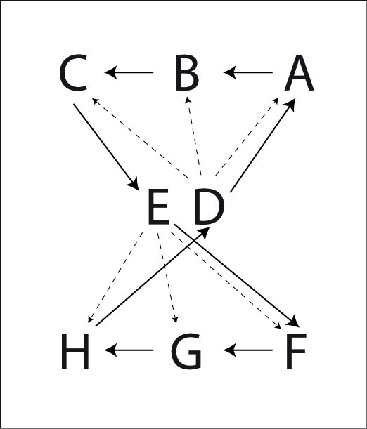
Khaos Butterfly
Kat's Khaos Butterfly is two standard feeds back to back. After each sweep of the feed, each juggler moves to the next position.
Solid lines are movement, dotted lines are passes.

Juggler | 1 | 2 | 3 | 4 | 5 | 6 | 7 | 8 | 9 | 10 | 11 | 12 | 13 | 14 | 15 | 16
A |  |  |  | D | H |  | H |  |  | G |  |  | C | E | C | B
B | D |  | D |  |  | H |  |  | E | F | E | C |  |  |  | A
C |  | D |  |  | F | G | F | E |  |  |  | B | A |  | A
D | B | C | B | A |  |  |  | H | G |  | G |  |  | F
E | G | H | G | F |  |  |  | C | B |  | B |  |  | A
F |  |  |  | E | C |  | C |  |  | B |  |  | H | D | H | G
G | E |  | E |  |  | C |  |  | D | A | D | H |  |  |  | F
H |  | E |  |  | A | B | A | D |  |  |  | G | F |  | F
Right hand counting

Pattern by Kat Girdaukas.

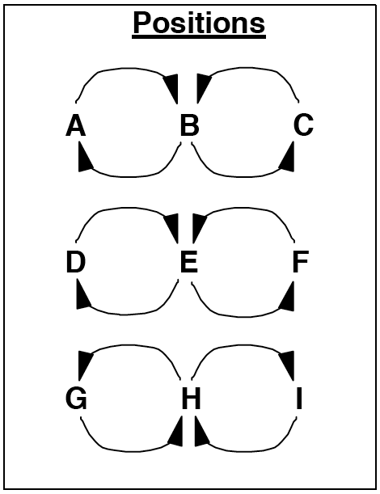
9 Person Patterns

Twister Sandwich
This is a difficult pattern.
Juggler | 1 | 2 | 3 | 4 | 5 | 6
A | D |  |  | F
B |  | D |  |  | E
C |  |  | F |  |  | E
D | A | B |  | I | H
E |  | H | G |  | B | C
F | I |  | C | A |  | G
G |  |  | E |  |  | F
H |  | E |  |  | D
I | F |  |  | D
Right hand counting

D, E, and F are doing the Double-time Twister Weave. The single feeders on the opposite sides of D, E, and F have been replaced with 3 weavers on one side and 3 weavers on the other side.
A, B, and C (and G,H, and I) are doing a standard weave; passing to D,E, and F.
To help you remember to whom you are supposed to pass, just pass straight across from whatever position that you are in. For example, C is in the right side, so when C passes, he or she will pass to who ever is in the right position at that time (in this case, C's first pass is to F). C will then move to the middle and pass to who ever is in the middle.
Variations: (1) Replace either standard weave with one standard feeder or two every-other feeders. If there is one feeder, they are known as the Olive and the sandwich is an Open Faced Sandwich.
(2) After one cycle, rotate the weaves by 90 degrees. For example, after one cycle the positions will be as indicated in the graph above. Run the next cycle with C, F, and I as one standard weave, B, E, and H as the double-time twister weave, and A,D, and G as a standard weave. This version is insane to implement, but it does provide intellectual stimulation.
(3) Add another "slice" to the sandwich: add jugglers J, K, and L below G, H, and I. G, H, and I are also doing the Double-time Twister. This is the Double Decker Sandwich.
(4) If the outside weavers are having trouble keeping up, then you can change any of the weaves to fixed positions where the ends pass in 8-count and the insides pass in 4-count. This is known as Stale Bread.
Pattern by Peter Kaseman and MAJ.

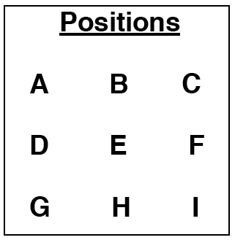
Weaving Canoes
This pattern is a cross between the Asynchronous Double Weave and the Canoe. The Canoe for 3 jugglers is commonly referred to as a drop-back line. We recommend that you can do these before trying the Weaving Canoes.
Juggler | 1 | 2 | 3
A | D
B |  | E
C |  |  | F
D | G
E |  | H
F |  |  | I
G | A
H |  | B
I |  |  | C
Right hand counting

A, B, and C face downward. The rest face upward. Weavers are in rows. Canoes are in columns. D, E, and F pass drop-backs.
A, D, and G start the pattern with the first pass as indicated in the passing graph above. After they pass, they move to the right of their respective weaves. Meanwhile, B, E, and H make their first pass on the second passing beat, and then weave to the left, replacing A, D, and G. C, F, and I pass on the 3rd passing beat and weave to the left.
Variation: Have one of the weaving teams remain stationary.
Pattern dates to September, 1999 by Peter Kaseman.

Weaving Triangles
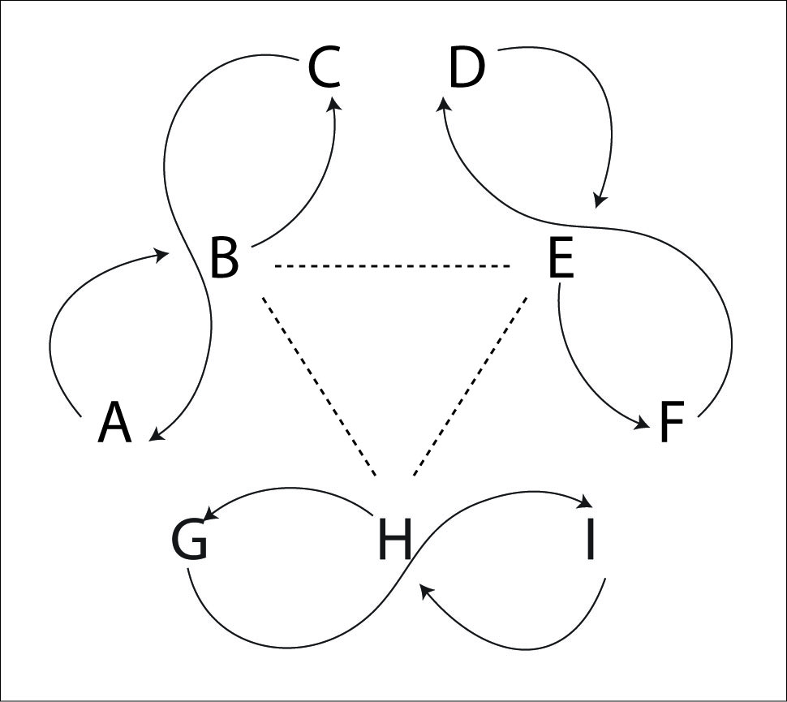
This pattern is three Gandini Weaves all facing each other. The middles of the weave pass first in an outside triangle, then again in an inside triangle. Then they continue moving.

Juggler | 1 | 2 | 3 | 4 | 5 | 6
A |  |  |  |  | I | D
B | H | E
C |  |  | G | F
D |  |  |  |  | A | I
E | B | H
F |  |  | C | G
G |  |  | F | C
H | E | B
I |  |  |  |  | D | A
Right hand counting

Try it with inside outside triangle first then inside triangle.

Pattern by Luke Emery.

10 Person Patterns

Double Weave (with 10 jugglers)
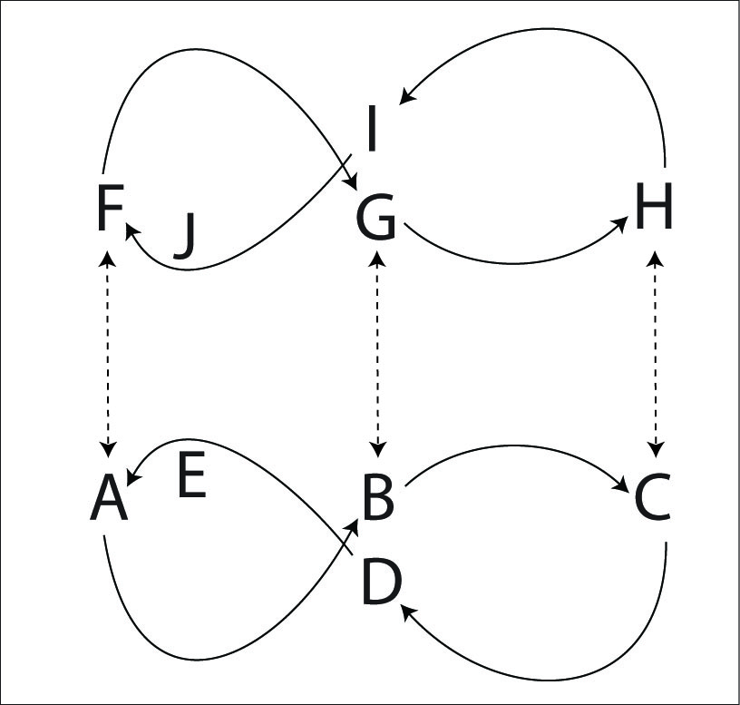
Put 2 Standard 5 Weaves in front of each other to make this big pattern. It's really not too challenging if all the jugglers are comfortable with a standard weave. Each weaver passes only with their counterpart in the other weave. All weavers are in 10-count and pass one on the end, then the middle, etc.
Juggler | 1 | 2 | 3 | 4 | 5
A | F
B |  | G
C |  |  | H
D |  |  |  | I
E |  |  |  |  | J
F | A
G |  | B
H |  |  | C
I |  |  |  | D
J |  |  |  |  | E
Right hand counting, or any other count.

Pattern by MAJ.

Double Gandini 5 Weave
Two mirrored Gandini 5 Weaves face each other and pass in 2-count (or any other count).
Weavers go in alternate directions. It is easiest if both weavers go the same direction (for example A and F start to the pattern's right and B and G start to the pattern's left).
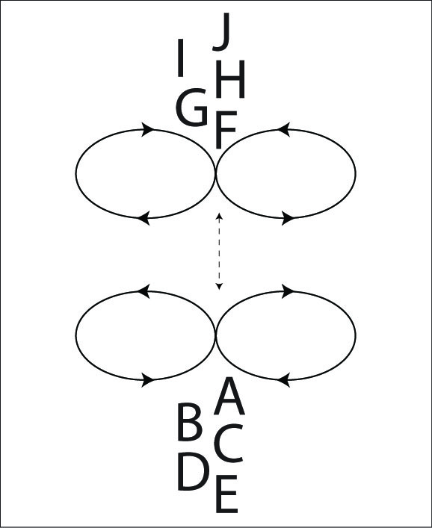  Juggler | 1 | 2 | 3 | 4 | 5
A | F
B |  | G
C |  |  | H
D |  |  |  | I
E |  |  |  |  | J
F | A
G |  | B
H |  |  | C
I |  |  |  | D
J |  |  |  |  | E
Right hand counting or any other count.

If this is too fast, then pass twice in the middle (either to the same weaver or to two different feeders).

Pattern by MAJ and Gandini Juggling Project.

Double Blast
The Double Blast is two mirrored Blast patterns. It is easy.

Juggler | 1 | 2 | 3 | 4 | 5
A |  | H |  | I
B | G |  |  | J
C |  | J |  |  | F
D | I |  | F
E |  |  | G |  | H
F |  |  | D |  | C
G | B |  | E | B
H |  | A |  |  | E
I | D |  |  | A
J |  | C
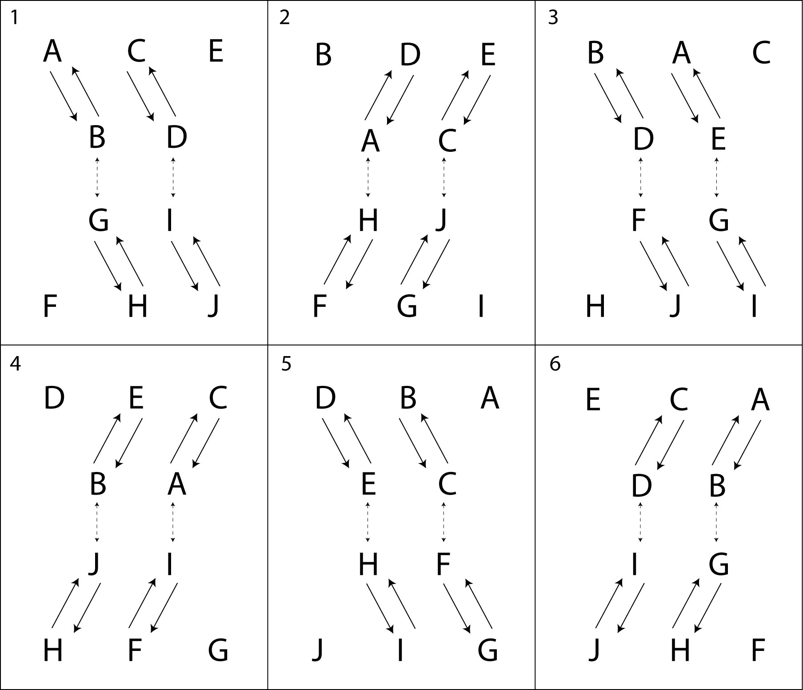
4-count right handed.

Pattern by Peter Kaseman and MAJ.

Big Patterns

Fully Loaded Blast
The Blast has a lot of fun and challenging variations. Here's a Blast loaded up with extra passes and twister weaving for 11 people, but the basic concept works for 7 through 12 people.
The movers (G, H, I, J, and K) move in a typical Blast fashion, except they turn around after every pass to A and B to pass to feeders behind the weave.
The table shows ½ of a full cycle, so the table ends in the mirror image of the start.
Juggler | 1 | 2 | 3 | 4 | 5 | 6 | 7 | 8 | 9 | 10
A | H |  | I |  | G |  | K |  | I
B | J |  | K |  | H |  | J |  | G
C | G |  | G |  | I |  | I |  | K
D | I |  | H |  | K |  | G |  | J
E | K |  | J |  | J |  | H |  | H
F |  | G |  | J |  | I |  | H |  | K
G | C | F | C |  | A |  | D |  | B
H | A |  | D |  | B |  | E | F | E
I | D |  | A |  | C | F | C |  | A
J | B |  | E | F | E |  | B |  | D
K | E |  | B |  | D |  | A |  | C | F
Right handed counting.

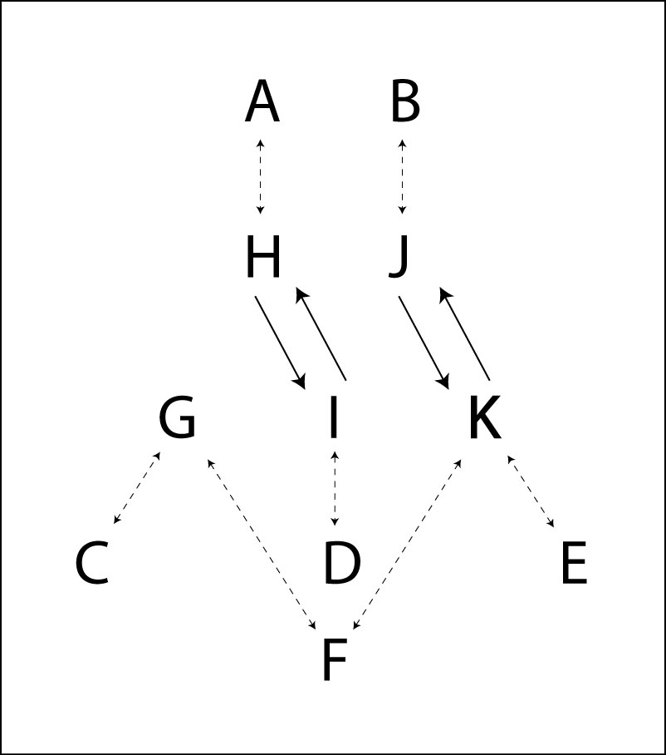
For more variations, replace D and F with a weave or with a single feeder. You can also remove either of the outside feeders C and E for fewer people (and an easier pattern).
Replacing D and F with a weave is called the Blast Toupee (because there is a weave on top).
Pattern by Peter Kaseman and MAJ.

Double Sandwich
A sandwich with two middle layers.
Pattern by MAJ.

Triangle Weave
The Triangle Weave for 15 jugglers consists of 3 standard weaves (9 jugglers) and 6 feeders in 4-count. There is a Mr. Inside feeder for each weave, and then a Mr. Outside feeder in between the weaves who passes in turn to each adjacent weave.
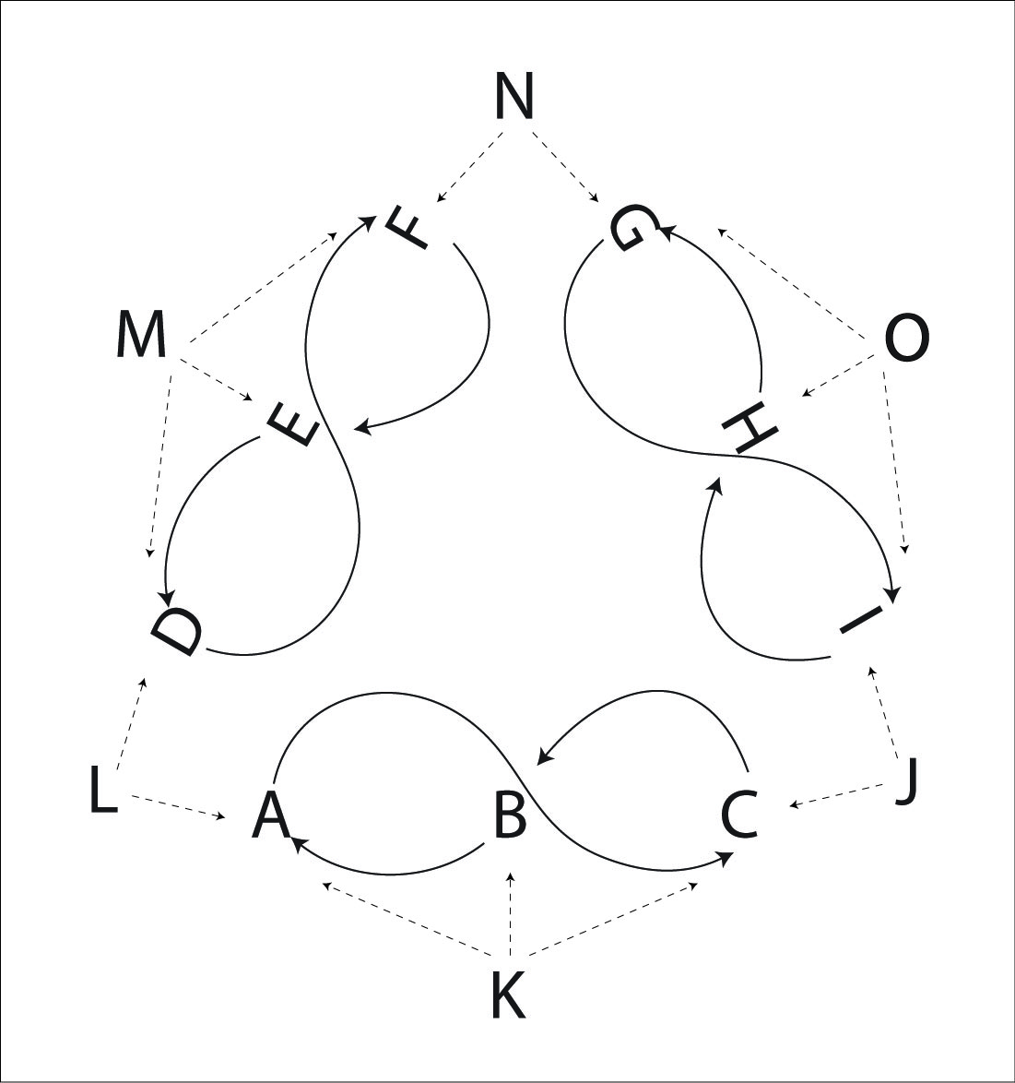
Juggler | 1 | 2 | 3 | 4 | 5 | 6 | 7 | 8 | 9 | 10 | 11 | 12
A | L |  |  | K |  |  | J |  |  | K
B |  | K |  |  | L |  |  | K |  |  | J
C |  |  | J |  |  | K |  |  | L |  |  | K
D |  |  | L |  |  | M |  |  | N |  |  | M
E |  | M |  |  | N |  |  | M |  |  | L
F | N |  |  | M |  |  | L |  |  | M
G |  |  | N |  |  | O |  |  | J |  |  | O
H |  | O |  |  | J |  |  | O |  |  | N
I | J |  |  | O |  |  | N |  |  | O
J | I |  | C |  | H |  | A |  | G |  | B
K |  | B |  | A |  | C |  | B |  | A |  | C
L | A |  | D |  | B |  | F |  | C |  | L
M |  | E |  | F |  | D |  | E |  | F |  | D
N | F |  | G |  | E |  | I |  | D |  | H
O |  | H |  | I |  | G |  | H |  | I |  | G
Right handed counting.
To start, all the Mr. Outside feeders pass to their right, and then feed alternately left and right in 4-count. The Mr. Inside feeders start on beat 2 and pass 4-count to their weave. The weavers pass to alternate Mr. Outside feeders on either end and the Mr. Inside feeder in the middle.
There are all the usual variations of different weave counts, chocolate bars, left handed etc. The pattern design can be any polygon where the side is a weave with a Mr. Inside feeder and the vertices of the polygon are a Mr. Outside feeder who alternates passing between weaves. See also the Octagon Weave. The number of jugglers is 5N were N is the number of sides of the polygon (three for each weave plus 2 feeders).
Pattern by Mike Newton and Luke Emery.

Octagon Weave
Same as the Triangle Weave, except with 8 sides and 40 jugglers instead of 3 sides and 15 jugglers.
Pattern by Mike Newton.

Mandala Weave
Pattern by Kat Girdaukas.

Passing Pattern Philosophy
We're occasionally asked at juggling conventions, where do you come up with all these patterns? Actually, they sort of make themselves once you invite the opportunity. Here are some tips on how to make new passing patterns and have fun doing it.

Start with a classic juggling pattern or any geometric figure (box, triangle, star, Y, W, line, etc.).

Think about everybody juggling 3 or 4 clubs.

Replace any selves with a pass to another juggler doing a self.

Any two jugglers can switch places. Any three jugglers can weave, or turbo.

Replace any 4-count with a Twister Weave, or a 7-club 4-count.

Replace any 2-count with a Weave.

Replace any 3-count with a double 3 count.

Replace any feed with an extra club feed.

Replace any extra club feed with a 2 extra club feed.

The jugglers can move in any pattern (circles, clovers, figure eights, or any juggling siteswap just to name a few).

The clubs can be passed in any juggling pattern or siteswap (admittedly, patterns get challenging quickly once you get past the easier siteswaps).

Try the same movement in a different count, or left handed.

Try the same passing sequence in a different movement.

Many of our favorite patterns are group collaborations where lots of people gave ideas for new ways to move or pass.

Share your favorite club passing patterns with other jugglers and listen to their ideas too.

Random Tips on Passing Patterns
Better Never than Late
If you miss a beat, don't pass on the next throw! Instead, wait for the pass to come around again in the pattern.
Always keep your eye on Mel
Don't pick up the clubs until you're sure the pattern is over, unless you know you can pick up and keep juggling. Even when you're not juggling, it's wise to keep an eye on Mel.
Juggling means never having to say you're sorry
No, really.
Don't say you're sorry unless you draw blood.
(However, if you draw blood then you do have to say you're sorry.)
Beginners often apologize profusely for their lack of skill. It's ok! We already know you're a beginner. But we like passing with other people and passing with beginners too. You'll get better soon and the best way is with lots of passing! If people want to do a hard pattern that is too advanced for beginners then they will, and you'll be left out of that one. Just do a pattern with somebody else. If we're juggling with you it's because we want to, not because we have to. Most patterns have positions of varying skill requirements, so if you're a beginner in a bigger or more advanced pattern, we'll try to put you in the best spot for your level. Just try to do the best you can, and if you drop, try to keep the timing anyway.

Timing
It may already be obvious, but good timing is critical to group passing patterns. One of the best tools to keep timing is your ears. For most patterns, all the catches should happen at the same time. When the timing is perfectly synchronized the sound of catching clubs is a metronome for the pattern.
Otherwise, find a juggler in your field of vision and make sure you throw at exactly the same time as they do (either passes or selves).
Make sure all the passes of the same spin go to the same height.
For many patterns, selecting a juggler to count out loud as a metronome can be very helpful.

Leads
The second most important skill is for the passer to lead the catcher in the direction they are moving. The amount of lead varies based on the height of the throw, the tempo of the juggling, and how fast the weaver is moving.
Outside leads are the easiest, because they are thrown away from the catcher's pattern.
Inside leads are trickier, because they are thrown towards the catcher's pattern, and if the passer is exchanging clubs with the catcher, the two passes are prone to collision. (For some patterns, such as the Cyclone, the weavers are moving so fast that the inside leads go all the way on the other side of the incoming pass.)
One key to throwing good leads is to be able to see where your passes land. That's a difficult skill at first, and especially hard for some patterns with high throws, but your target will certainly appreciate the effort. Otherwise, good communication (especially for dropbacks or other blind passes) helps fine tune lead throws.
Remember that in a feed, the feedee on the same side as the feeder's pass must throw an inside and/or deep pass to give the feeder room to throw underneath to the next feedee.

Turning
Twister weaves are all about turning. In general you can classify how hard a moving pattern is by how many selves are allocated to turn 180 degrees. For example, the Standard Twister Weave has 5 selves (weaving in 6-count). The Fast Spiral has 3 selves (weaving in 4-count). The Chocolate Swirl has 1 self (crossing sides in double 3 count).
In most of these patterns you can turn either to the outside or the inside. One turn is usually easier than the other, but I recommend jugglers learn both turns whenever possible. Learn turning in easy patterns like the Twister Weave and then you can apply those to Clovers or Strange Attractors and other more advanced weaves.
It is also helpful to practice turning while juggling solo. How many selves does it take you to turn 180 degrees while spinning continuously?

Learning
Take advantage of opportunities to pass with jugglers better than you. That's how you'll learn timing.
Take advantage of opportunities to pass with jugglers less skilled than you. That's how you'll learn catching.
Be sure to pass with jugglers at the same level as you. That's how you know how good you really are. :)
Lots of passing patterns benefit from solo skills too. You'll need to be able to juggle 4 clubs comfortably in triple singles, double singles and the fountain to do a lot of the 7 and 8 club based passing patterns.

Internet Passing Resources
Madison Area Jugglers madjuggling.com
Passing DB passingdb.com
IJA site www.juggle.org
Aidan's web site http://www.geocities.com/aidanjburns
Will Murray's site http://www.csulb.edu/~wmurray/

Mark Weston's passing collection?
Martin Frost and Stanford jugglers?

Gandini Juggling Project http://www.gandinijuggling.com/

Appendix A – 7 club patterns
Peter Kaseman and I had an experiment in winter 1999 to think up how many 7 club patterns we could do. The goal was 100, and at first we thought that would be a difficult target. However we soon realized that there are so many possible site swap variations and tempo changes that we easily passed 100. Not of all of them are easy to actually juggle though! Here are a few of the ideas we explored. (Also see Appendices D and E for some more ideas.)

Chocolate Bars

4px4px33 | 3p3p44

A: crossing double pass right, crossing double pass left, self, self.
B: straight single pass right, straight single pass left, straight double self, straight double self (starts with 4)

4p4p33 | 3px3px33

A: straight double pass right, straight double pass left, self, self.
B: crossing single pass left, crossing single pass left, straight double self, straight double self (starts with 4)

4p4p33 | 33px5px3

A: straight double pass right, straight double pass left, self, self.
B: self, crossing single pass right, crossing triple pass left, self

4px4px33 | 33p5p3

A: crossing double right, crossing double left, self, self.
B: right self, straight single pass left, straight triple pass right, self, self.

4-count variations

Here's a nice variation on 4-count triples in 7.

5p333533p3 | 335p33533p

In right hand counting: triple pass, single self, triple self, single pass.

Pass, Pass, Shuffle

5px5px1 | 4p4p1 (2nd juggler starts on beat 2)

A: triple cross, triple cross, shuffle.
B: pause, double straight, triple cross, shuffle.

Another 6-count

5p33334 | 3345p33

Crossing triple right, self, self, self, self, straight self double left

Paired Siteswap Passing Patterns
Any two siteswaps can be turned into passing patterns. For example, consider the 4 club siteswap 534 and the trivial 3 club siteswap 333. There are 12 different passing patterns from combining these two siteswaps. The juggler with the 534 can pass the 5, or the 3, or the 4, or the 5 and 3, 5 and 4, 4 and 3 or all of them. The juggler juggling the 3's just has to throw 1, 2 or 3 passes to match the timing of the first juggler. Then, we can switch all the straights to crosses and the crosses to straights to generate 6 more patterns (although 3 of them don't actually work because the two 3's collide if they are both crossing).
5p34 | 333p
53p4 | 33p3
534p | 3p33 (second juggler starts with 4)
5p3p4 | 33p3p
5p34p | 3p33p (second juggler starts with 4)
5p3p4p | 3p3p3p (second juggler starts with 4)

Crossing versions that work include:

5px34 | 333px
534px | 3px33 (second juggler starts with 4)
5px34px | 3px33px (second juggler starts with 4)

The same idea can be extended to any set of siteswaps with any number of items, such as 561 against 531 or 7441 against 7531. The simple siteswap 444 | 333 has a lot of nice passing variations. More complex siteswaps get challenging very quickly, though.
If the two jugglers have different numbers of clubs (for example 444 | 333), then they can switch sides with each other at almost any point by the first juggler throwing two passes in a row.
There is also a dual passing pattern variation of each of the above, as described in Appendix B.
Popcorns
4-count: 3p353 | 533p3
5-count: 3.5p 3353 | 53 3.5p 33 (slight pause for 2nd juggler)
6-count: 4p33353 | 3534p33 (juggler 2 starts with left on these 6-count popcorn)
or 4p33344 | 3444p33 or 4p44144 | 1444p44 (skip 1 on start)
or 4p53153 | 1534p553 (skip 1 on start)
7-count: 4.5p 333353 | 353 4.5p 333
All even counted popcorns can also be juggled left-handed or with all crossing passes (one juggler left handed and the other right handed).
Now, to make things more interesting, all the popcorns can be juggled against either the next or previous versions in fast/slow. One juggler juggles fast, and the other slowly, so that they each complete a cycle at the same time. The odd count juggler always throws to the same side with alternating left and right passes (also alternating straight and cross passes). The even count juggler throws to each side in turn, also alternating straight and cross passes.
Try 7 club 1-count against 2-count, 2-count against 3-count, 3-count against 4-count, 4-count against 5-count, 5-count against 6-count and 6-count against 7-count.
All of the above patterns have Dual Passing Pattern variations, which tend to have a lot of ultimate single passes and some challenging synchronous variations. Try some and see.
4px5p3p4px5p3px | 3p3p3p3p3p3p (2nd juggler starts with 4)
4px33p3p4px4px | 3p4px4px4px33p (2nd juggler starts with 4)
4px33p3p | 3p4px53p
Three Up
Three Up is a 7 club 8 count popcorn pattern based on the 5551 siteswap with 4 clubs that Peter brought back from somewhere. As an incoming pass comes in, flash 3 crossing doubles (555), catch the incoming club, shuffle it from left to right and then pass it back as a single pass.
55513p333 | 3p3335551
It's technically possible to juggle this pattern with 8 clubs as 55514px | 4p5551 (the fives are doubles and the four is a single) but that's tough.
The 7-club version is more reasonable, and allows opportunity to play with all kinds of 4 club siteswaps. Try replacing the 5551 with 7441, 6631, 7531 and 5641.
See some other nice 7 club synchronous patterns in Appendices D and E.

Appendix B – Dual Passing Patterns
Steve and Mike were playing with the idea of considering the hands of a juggling passing pattern independently of the jugglers, and then moving around which jugglers are attached to which hands. Between every two real jugglers is a phantom or shadow juggler whose left hand is a real person's right hand and their right hand is a different real person's left hand. Every pattern has a corresponding out of phase dual passing pattern.
We discovered a number of new 6 and 7 club patterns and multi person patterns we hadn't tried before. I sent out a bunch of 7 club siteswap passing patterns that come from known 7 club patterns. An interesting corollary is that for every asynchronous passing pattern (left, right, left, right) there is a corresponding synchronous passing pattern (where lefts and rights throw together). This is true for all passing patterns, but especially fun for 7 clubs where collisions aren't as problematic as with 6 club patterns. Some of these patterns are quite difficult, which explains why I don't think I've ever seen any 7 club synchronous patterns in practice except for the basic left double, right single pass.
Yesterday Peter and I worked out some of the "Pod" patterns for 7 club fast/slow variations. Instead of one juggler juggling 2 count against another juggler juggling 3 count, try right hands juggling 2 count against left hands juggling 3 count, etc.
El Nino with phantom jugglers is doable but difficult. The asynchronous 4 person box turns into a very nice and easy synchronous passing pattern (pass 2 to the left, then 2 to the right). Most of the 5 person star patterns turn into either themselves (like the self-less star) or another known 5 person pattern. There's no end in sight!

If 3 jugglers A, B, and C are standing in a triangle formation, define 3 virtual jugglers X, Y, and Z so that X is between A and B, Y is between B and C, and Z is between C and A.
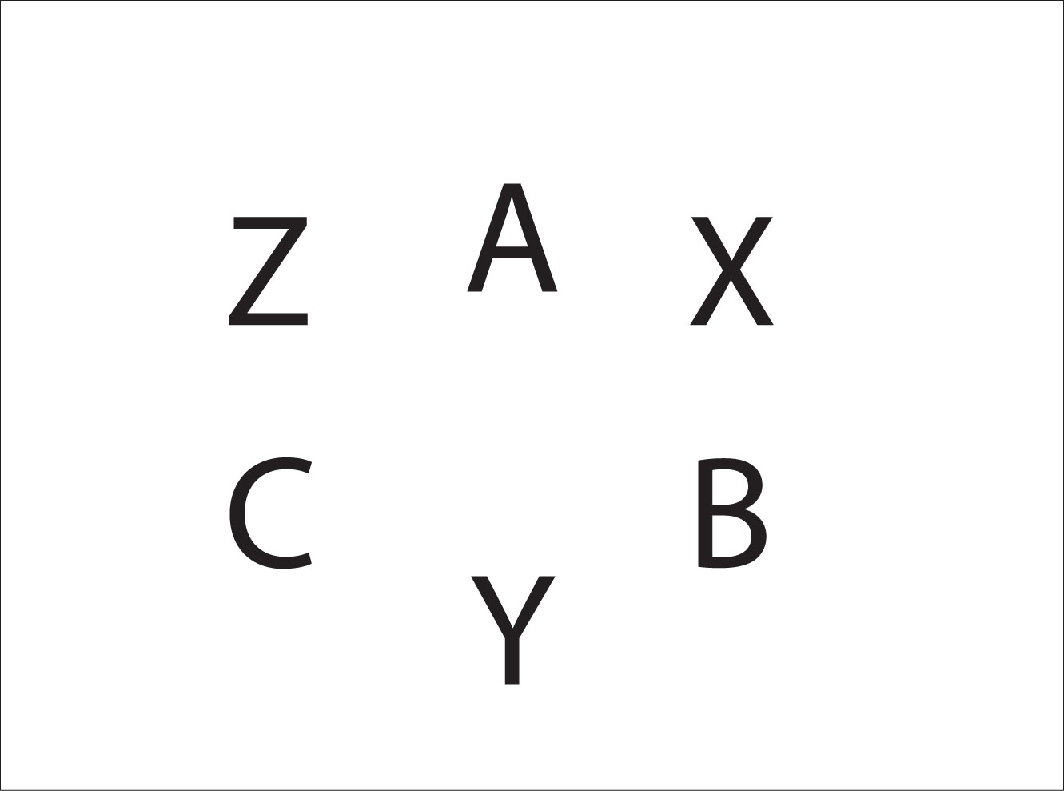
A's left hand is X's right hand, and A's right hand is Z's left hand. Similarly, B's left hand is Y's right, B's right hand is X's left, C's left hand is Z's right, and C's right hand is Y's left.
Any pattern performed by A, B, and C has a dual pattern performed by X, Y, and Z. To generate a new pattern, pick any pattern for X, Y, and Z, and then find out what A, B, and C are doing. In the table below we have X feeding 2-count to Y and Z with the dual pattern for A, B, and C.

Juggler | 1 | 2 | 3 | 4
X | R pass Y | L self | R pass Z | L self
Y | R pass X | L self | R self | L self
Z | R self | L self. | R pass X | L self
A | L pass C | R pass C | L self | R pass C
B | L self | R pass A | L pass C | R pass A
C | L pass A | R pass B | L pass B | R pass B
Both hands counting

The idea of dual passing patterns was conceived by Mike Newton and Steve Otteson in 2001 and applied to many passing patterns by the MAJ.

Dual Passing Pattern for 4
Four jugglers A, B, C, and D stand in a box formation and the virtual jugglers W, X, Y, and Z do a pass-pass-self-self (chocolate bar) box pattern. The dual pattern for A, B, C, and D is shown below. A and C start with 4 clubs each. B and D start with 2 clubs each.
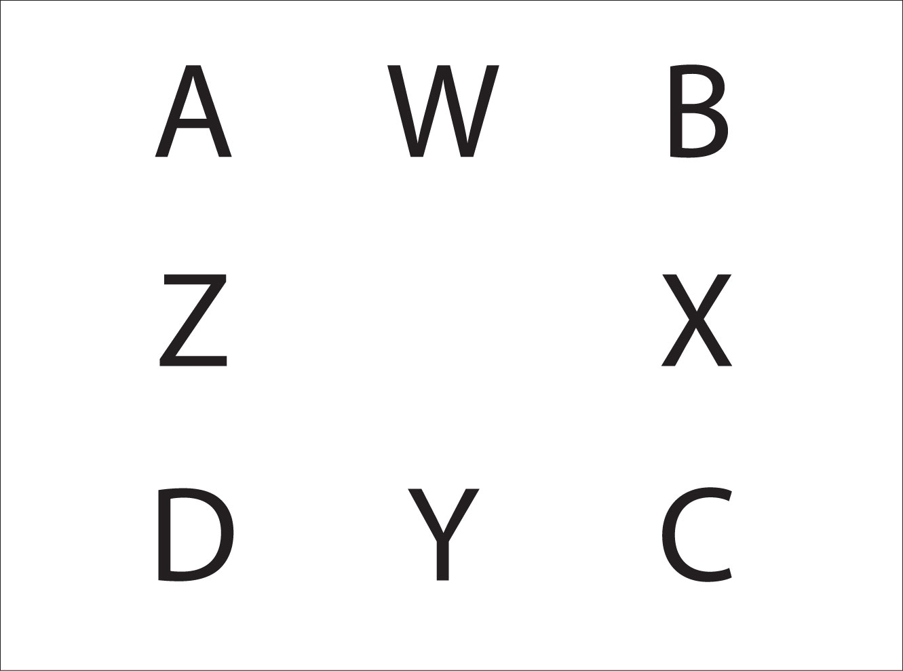
Juggler | 1 | 2 | 3 | 4
W | R pass Y | L self | R self | L pass Y
X | L self | R pass Z | L pass Z | R self
Y | R pass W | L self | R self | L pass W
Z | L self | R pass X | L pass X | R self
A | R,L pass D |  | R, L pass B
B |  | R, L pass A |  | R, L pass C
C | R, L pass B |  | R, L pass D
D |  | R, L pass C |  | R, L pass A

The A, B, C and D square is now doing a synchronous pattern, where the right and left hands throw at the same time.

Dual passing is a good tool for discovering synchronous patterns.

Notice that if beats 1 and 2 are repeated, then W, X, Y, and Z will be doing a 2-count box with right hand passes. If beats 3 and 4 are repeated, then W, X, Y, and Z will be doing a 2-count box with left hand passes.
This pattern was generated by the Madison Area Jugglers March 3, 2001, and was the first dual pattern created.

Dual Passing Pattern for 2
This pattern is for 2 jugglers A and B. The virtual jugglers Y and Z do a 7-club 3-count pattern.
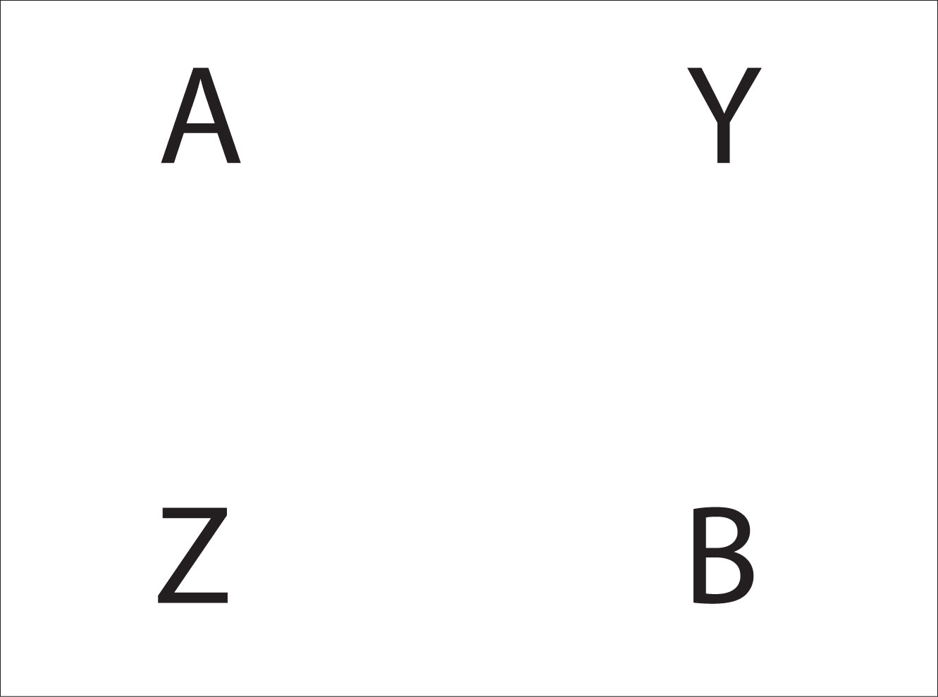
Juggler | 1 | 2 | 3 | 4 | 5 | 6
Y | L self | R D-Z | L self | R self | L D-Z | R self
Z | L D-Y cross | R self | L self | R D-Y cross | L self | R self
A | R D-B cross | L T-self | R B | L S-B | R B | L B
B | R S-A | L S-A | R A | L D-A cross | R T-self | L A

Notice the triple self throw for A and B. We found that the triple spin gave us the time needed to make the pattern work for us.
The pattern for A reads: Right double pass to B crossing (right to right), Left to Right triple self, right single straight pass to B, left single straight pass to B, right single straight pass to B, left single straight pass to B.
In (one form of) pass siteswap notation, you could right that as 4px53p3p3p3p.
The dual pattern for 7-club 3-count was created by the Madison Area Jugglers March 3, 2001.

Appendix C – Gandini Siteswap Weaves
Site-swap is a way to use numbers to determine how high an object is thrown in a pattern, and determines which hand the object lands in. At the IJA festival in Niagara Falls, Sean Gandini showed us that jugglers could weave in a site-swap pattern while being fed passes by a feeder.
Take any valid site-swap string, 741, for example, and find the average: 7 + 4 + 1 = 12, 12/3 = 4. The average of the site-swap string is the number of weavers needed for the pattern. Add one more juggler to feed the weavers and we are ready to go.
The feeder will alternately feed passes to 2 positions. The site-swap numbers will guarantee that only one weaver will be in a feeding spot when it is time to feed that spot a pass. Arrange the weavers so that the start will work. See the example below to see how this is done.
Have the feeder assign the site-swap numbers at the same time that the passes are made, repeating the numbers as they go. When a weaver receives a pass he or she will also receive a number. The number, minus one, is the number of self throws that the weaver will perform before he or she will make the next pass to the feeder. If the given number is even, then the weaver will get his or her next pass at the same feeding spot where the last pass was received. If the given number is odd, then the weaver has to cross over to the other feeding spot for the next pass.
The glossary will show how to test for a valid site-swap.
To save space, the feeder is not pictured in the following example.
741 Site-Swap Weave
Lines indicate passes, arrows indicate movement.
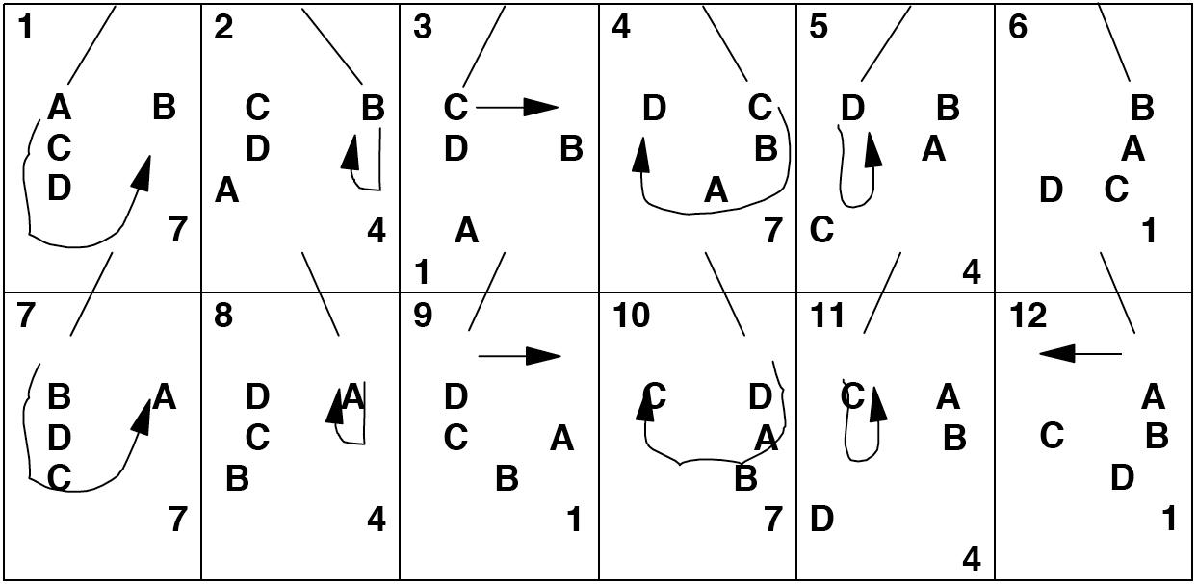
This idea can be extended in many different ways. For example, the weavers and feeders can do patterns like Burke's Barrage or Mill's Mess. A double weave can be any two siteswap weaves passing to each other. For example, try a regular Gandini Weave (333) against a 441 Gandini Weave or a 534 Gandini weave, etc.

Appendix D? – 7 Club 2-Count Exposed
Seven clubs is the playground for the serious club passer. Six clubs is easy. Eight is hard. Seven is just right.
So you know 7 club 2-count? That's great! But, wait, do you really? Let's take a closer look.
The standard 7 club 2-count consists of right handed passes as doubles and left handed single spin selves.
- 4p3 | 34p
This pattern can of course be done with left handed passes too.
- 34p | 4p3 left handed
By changing the height of the throws, the pattern can also be done with single spins.
- 3.5p 3.5 | 3.5p 3.5
- 3.5 3.5p | 3.5 3.5 left handed
Now, speaking of spins, all kinds of spin combinations are possible. One juggler can throw doubles while the other throws singles, or triples versus doubles. Even though the patterns are quite doable, that makes the timing a bit wonky. However, if one juggler throws triples while the other throws singles, then the timing locks in to a new simple siteswap. (Have the juggler passing single passes start with 4 and juggle with their right hands in sync with the juggler throwing triple passes.)
- 5p3 | 3p3
- 35p | 33p left handed
It's a curious and useful fact that any 7 club passing pattern can be modified by changing all the straight passes to crosses and all the cross passes to straights. This is actually applicable to all passing patterns, but for 6 and 8 club passing patterns many such variations lead to collision problems. For 7 club passing, however, a majority of the crossed patterns still work.
Each of the patterns we've discussed so far can also be juggled in a crossed version, where both jugglers cross passes. This means that one juggler will be making left hand passes (in 2-count) and the partner will be making right hand passes.
Crossed versions of above.
- Crossed version of doubles 2-count, both right and left handed: 4px3 | 34p.
- Crossed version of singles 2-count, both right and left handed: 3.5px 3.5 | 3.5 3.5px.
- Crossed version of triple/singles 2-count, both right and left handed: 5px3 | 3px3.
Because of symmetry, there are really only 9 unique patterns so far instead of 12. The left hand versions and the right hand versions turn into the same pattern when the jugglers cross passes.
As we've seen from Appendix B, every passing pattern has a corresponding complementary dual pattern (or shadow pattern) where a juggler's right hand pattern is combined with the left hand pattern off the adjacent juggler. This is really just one permutation of a 4 person 2 handed site swap. Each of the 9 patterns above has a corresponding shadow person pattern, and curiously, they are all 2-count, more or less. Let's look at a couple more closely.
- The shadow pattern for the standard 4p3 is a synchronous juggling pattern where the left and right hands of a juggler throw and catch at exactly the same time. For this pattern the left hand will throw a crossing double self while the right hand throws a straight single pass: (4x, 3p) | (4x, 3p). The second juggler pauses ½ beat before throwing their 2 synchronous throws: one as a pass and the other as a self.
- The same pattern can be done left handed (3p, 4x) | (3p, 4x).
- If we change all the straight passes to crosses, then both 10 and 11 transform into the same pattern: (3px, 4x) | (4x, 3px).
The synchronous versions are very interesting 7 club 2-count patterns in their own right, and are a great foundation for epxloring other synchronous patterns. You can switch back and forth from left handed to right handed throws (still in 2-count, sort of) to make a fantastic 7 club pattern. One juggler will need to throw crosses while the other throws straights.
- Switching sync throws. (4x, 3px) (3px, 4x) | (3p, 4x) (4x, 3p).
This is in the same family as Will Murray's fantastic 7 club Scratch Your Head pattern, which is the same except the double self crosses and straights are switched.
- Scratch Your Head. (4, 3px) (3px, 4) | (4, 3p) (3p, 4).
That's still kind of a 2-count pattern!
The single spin version of seven 2-count doesn't change when you look at the associated dual pattern (7 1-count singles is the same way).
However, the triples/singles version makes an interesting set of dual pattern variations, still in 2-count!
- Fast lop-sided popcorn: 53p | 33p.
- Of course it can be done left handed: 3p5 | 3p3.
- And theoretically, with crossing passes: 53px | 33px. This one doesn't work too well, because there is a collision problem with the 2 crossing singles.
- And 20 again, with left hand self triples: 3px5 | 3px3. This one doesn't work very well either because of collisions.
Had enough? Well, there are more where those come from. Next, we look at combinations where one side does a synchronous pattern and the other does an asynchronous pattern. These are handy patterns when one juggler wants to try synchronous variations, but the other passer isn't ready for that yet.
- Here's the simplest: (3p, 4x) | 4p3.
- Now left handed: (4x, 3p) | 4p3 left handed.
- And, or course, crossing right handed: (3px, 4x) | 4px3.
- And crossing left handed: (4x, 3px) | 4px3 left handed.
Now try some variations where the extra clubs and synchronization are both on one side. They are asymmetric 2-counts, but that can be good if you have a mixture of passing skill levels.
- One juggler throwing both doubles synced (4p, 4x) | 3p3.
- And left handed (4x, 4p) | 33p.
- And crossing (4x, 4px) | 3px3.
- And crossing left handed (4px, 4x) | 33px.
There's a good start, but there are many many more without leaving 7 clubs with only doubles and single passes. Try some of these variations next time your passing partners says they're bored with 7 club 2-count.
So you know 7 club popcorn? That's great! But wait...do you really...?

Appendix E? – Synchronous Passing
Hi Mandy,

Here is the 8 club version of the 7 club sync passing pattern I showed
you and Will at Millstreet. I'm not quite ready for the 8 version at
the moment, but I think it will be a very beautiful pattern and I look
forward to seeing you show it to me next time we're at a convention
together!

Luke

A B

A starts with 5 clubs (3 in right, 2 in left), B with 3 (2 in right, 1
in left). Every throw is a pass and each passer has their left and
right throws synchronized. Here's the text description rather than the
siteswap.

A throws synchronized right triple straight, left single cross
B responds ½ beat later
B throws synchronized right single straight, left triple cross

A throws synchronized right single cross, left triple straight
B throws synchronized right triple cross, left single straight

Repeat until you get bored. :)

Interestingly enough, 3 clubs always do singles and 5 clubs always do
triples, which might make color coordinating the clubs useful.
Technically it seems to work out to be 5 club 1 count with triples
synchronized with a 3 club 1 count as singles.

A number of people wrote to ask me about the 7 club version of that 8 club sync pattern, which I probably should have just included. Anyway, here it is, as well as some others.

The first juggler has the same sequence, while the second responds in synchronous ultimate singles.

A B

A starts with 4 clubs (2 in right, 2 in left), B with 3 (2 in right, 1in left). Every throw is a pass and each passer has their left and right throws synchronized.

A throws synchronized right triple straight, left single crossing
B responds 1/2 beat later
B throws synchronized right single straight, left single straight

A throws synchronized right single crossing, left triple straight
B throws synchronized right single straight, left single straight

I haven't actually tried the 8 club version myself yet, but the 7 club version is challenging enough. Although one side just throws singles, they have to catch a triple and a single pass at the same time on every beat, and that can be tricky...at least for me. As a variation, it
should also work for A to throw the other side of the 8 pattern with crossing triples and straight singles. B would do the same as before, except B would then start with 2 in the left hand and 1 in the right.

If you are interested in 7 club synchronous passing patterns, here are some easier ones to start with.

A B

One sync pattern is just 7 club 3 count in all single spins, which has an interesting, if choppy, sync rhythm.

Basic 7 club synchronous right handed:

A throws synchronous left hand crossing double self, right hand straight single pass.
B responds 1/2 beat later with the same.

Repeat.

Of course, you can do the same pattern with left handed passes and right double selves.

Then, if you're feeling up to it, you can switch back and forth from left handed to right handed sync passing on each cycle to make another fun but challenging pattern, as follows:

A right pass single straight, left self double crossing
B (responds with) right pass single straight, left self double straight

A right self double crossing, left pass single straight
B right self double straight, left pass single straight

I came up with that quite a few years ago when I (with Peter) worked out a list of 100 passing patterns for 7 clubs. It is somewhat similar to Will and Rhonda's Scratch Your Head pattern, which I had never seen, (though I heard rumors about it), until I tried it for the first time in
Millstreet. For some reason it seems to me that the synced crossing self doubles are easier than the synced straight self doubles.

I believe Will already has a good description of the synchronous Scratch Your Head pattern somewhere else, but here it is anyway:

A right pass single straight, left self double straight
B (responds with) right pass single crossing, left self double straight

A right self double straight, left pass single straight
B right self double straight, left pass single crossing

It's nice and I'd like to get the Scratch Your Head pattern down solid now that I've learned how to do it, so I'm planning to work on that here.

Hmmm, the thought occurs to me that you may be able to switch back and forth between Scratch Your Head and the previous pattern (which I think needs a name...) at any time, just by throwing a cross single pass and straight double self instead of a cross double self and straight single pass.

Also, I just noticed that Scratch Your Head has a similar quality to the 8 club sync pattern, in that 4 clubs always do doubles and 3 clubs always do singles. It's a 4 club pattern (all self straight doubles, site swap 4) superimposed on 3 club 1 count instead of a site swap 5 superimposed on a 3. They're sister patterns!

Very cool.

Anyway, I hope that's interesting to anyone who likes 7 club sync passing...

Appendix F? – Passing 43
Here is a further analysis of all the possible 2 person 7 club patterns in the siteswap 43. There appear to be 58 valid patterns.
Within each group of related patterns, you can switch between patterns of the same group at any time. You can switch between the 2 synchronous patterns or between the 2 asynchronous patterns with no effort, but to switch from async to sync requires one of the usual site swap sequences. For example, in standard 7 club 2-count doubles you can switch from 4p 3 to 3px 4 (start with the 4) or switch between (4px 4) and (4x 4p) synced.
Of course there are also site swaps to go between groups. To get from the RL group to the LR group, just change a straight pass to a crossing pass (or vice versa), and both jugglers exchange groups with each other.
To go from right handed patterns to left handed patterns (such as RR to LL) is a little trickier; you need a siteswap like 4p 4p 2 | 3 4p 4p.
To go from RR to RL requires one juggler to switch left and right timing completely, with a throw like (4x, 2) and a siteswap from their partner that give them enough time to do that (such as an early triple or an extra 4).
Each pattern belongs to a group and requires a partner match from a group. For example, there are 4 patterns in the RR group and each of those patterns requires a partner also in the RR group. That means there are 10 possible combinations of 2 jugglers juggling RR on both sides. (From combination theory, combinations with repetitions (n+k-1)!/k!(n-1)! where n = 4 and k = 2).
No Passing Groups: - N3 (with 3), N4 (with 4) The N4 can be synchronous or asynchronous.
Passing Groups: R or L passing to, and then R or L receiving from (followed by number of objects if applicable)

Trivial patterns
N3 requires N4
3 3
N4 requires N3
(4 4) (note: can be in sync with either the left or right hand of the juggler with 3)
4 4

1-count patterns
3p 3p | 4px 4px
3px 3px | 4p 4p

RR requires RR
3 4p
3px 4
(4x 3p)
(3px 4)

LL requires LL
4p 3
4 3px
(3p 4x)
(4 3px)

LR requires RL
3p 4
3 4px
(3p 4)
(4x 3px)

RL requires LR
4 3p
4px 3
(4 3p)
(3px 4x)

Skewed patterns (4 clubs on one side and 3 clubs on the other)
RR3 requires RR4
3 3p

RR4 requires RR3
4px 4
(4px 4)
(4x 4p)

LL3 requires LL4
3p 3

LL4 requires LL3
4 4px
(4 4px)
(4p 4x)

RL3 requires LR4
3px 3

LR4
4p 4
(4p 4)
(4x 4px)

LR3 requires RL4
3 3px

RL4 requires LR3
4 4p
(4 4p)
(4px 4x)

58 total pattern combinations

