# **Problem Context and Description**

QVC is American cable, satellite and broadcast television network with a flagship shopping channel specializing in televised home shopping. The problem domain was to analyze QVC’s data to identify top selling products and product categories, effect of email campaigns and provide a model to forecast sales.

# **Dataset Description**

The dataset consisted of six tables - Customer master (data regarding customers), Product master (data regarding products), Order master (data regarding orders), Product airtime (data regarding airtime of products), Email campaign (data regarding email campaigns for products) and Social (data regarding social media interaction)

# **Key Findings: What are the products and product categories that sell best in the US market?**

* The top 5 highest selling product categories are Home Décor, Health/Beauty, Apparel, Jewelry and Accessories.

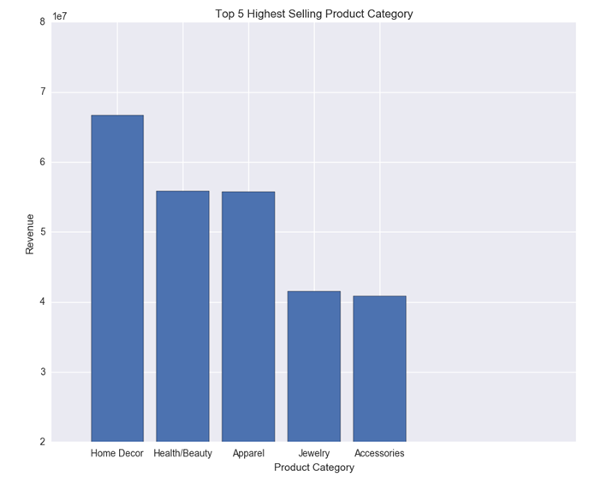

* The top 5 highest selling products are Vitamix Blending System, Sun Joe Electric Telescopic Pole, Bose Wave Music System, Cordless Vacuum and Vitamix Creations GC 48 Oz. 13-in-1 variable.

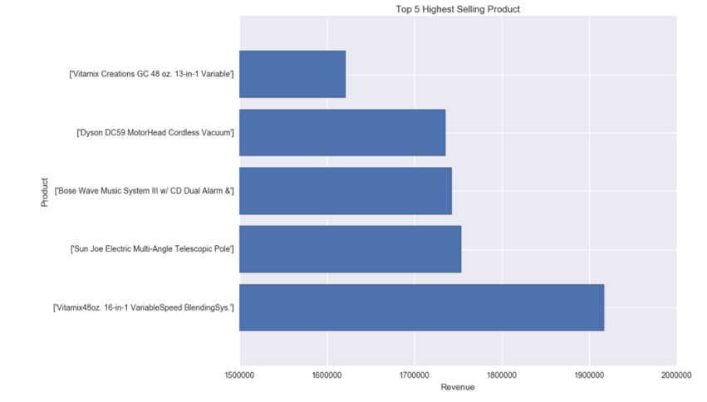

# **Key Findings: How effective are QVC’s email campaigns in driving product sales?**

* Email campaigns are an effective channel in driving product sales. When the email campaigns do not happen then sales dip and when email campaigns happen, sales increases. When sales data is modeled against email campaigns using ARIMAX modeling, high values of coefficient of explanatory variable indicates that sales is directly proportional to email campaigns.

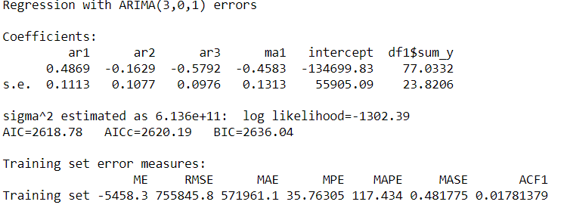

* We also see that for an extra $1 spent in the email campaign, total sales will increase by $77 (keeping other variables constant). Therefore, we can clearly say that the Email Campaign expenditure is effective in driving the total sales.

# **Key Findings: Model for Forecasting Sales**

* Forecasts from ARIMA modeling were not up to the mark
* Plot of Actual Sales Vs Forecast Sales on Test Set using Random Forest Regressor

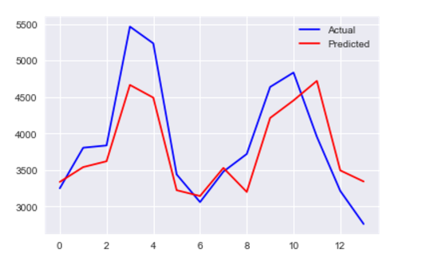

* Plot of Actual Sales Vs Forecast Sales on Test Set using Gradient Boosting Machine Regressor

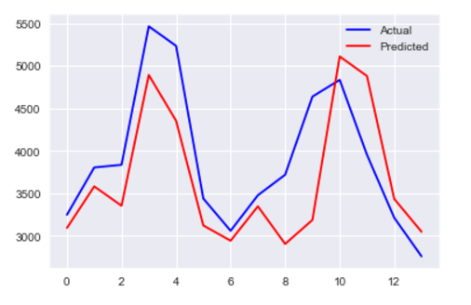

* Random Forest Regressor model’s RMSE is better than Gradient Boosting Machines Regressor model
* Feature Engineering was performed to extract features such as Weekday and Lags

# **Recommendations**

* Looking at the top selling products and product categories, it is clear that items related to basic necessities i.e. food and shelter (home décor category ranked 1st in top selling product category, blending system and cordless vacuum ranked in top 5 best-selling products) are contributing highly to sales. Hence, marketing efforts need to be directed to food and shelter segment.
* Email campaigns should continue as they positively influence sales.
* QVC should focus on sending email advertisements for top selling products and product categories as it would yield the maximum revenue increase for the least dollar spent on email campaigns.
* Though product number can be used to join tables to analyze products, the different data tables do not have a key to join on customer number, which limits the analysis of customer behavior.
* Forecast model can be improved if data related to competitor performance and other market forces is integrated into the current model.