A program contains various sections (in it's object file.):
1) Text Segment.
2) Stack.
3) Heap.
4) Initialized Data segment.
5) Uninitialized Data segment (.bss).
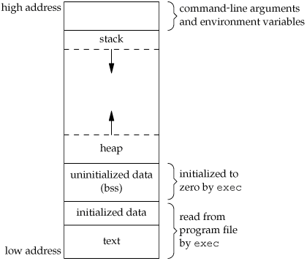
The stack grows from high address to low address. Whenever a function is called in C or C++, it makes it's own stack frame. Initially when 'main' function is called, the stack frame for 'main' is also made. Whenever main calls other function then that function's stack frame is made. It means that a pointer (known as stack pointer) keeps track of the functions which are called. A stack frame typically contains:
1. return address (from where the function is called).
2. input parameters (arguments passed to the function).
3. local variables of the function.
4. Register savings.
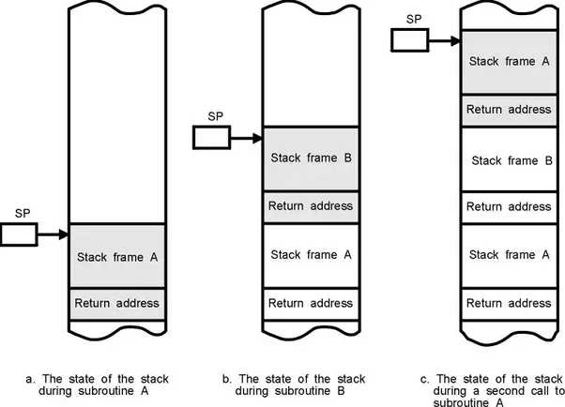
Image source : Google
In this image, function A is called, then A function calls B, then B function again calls A. In turn, this is a stack frame when both functions call each other and stack grows.
Whenever a function is finished, it returns to it's respective return address and stack shrinks. This is why many a time, when we forget to write a right base case in recursion, we get stackOverflow error. Because Stack exceeds it's memory limit and no further memory can be allocated to a function which is called.
[Edit:]
As far as overheads are concerned, It might happen that the calling a function is more expensive for the operating system kernel. Also, the kernel has to keep track of what functions has been called, it has to store their return addresses, function arguments etc. Also, when a program start executing, kernel does not know how much memory it further requires in advance, which, in turn, can cause stack overflow.

