Modern OS - Eyal’s Summary
The operating system performs two basically unrelated functions:
1. Extended Machine: Providing application programmers (and application programs) a clean, abstract set of resources instead of the messy hardware ones.
2. Resource Manager: Managing these resources

1. Introduction

1.3 Computer Hardware Review
Conceptually can be abstracted to a CPU, Memory and IO devices that are all connected by a system bus and communicate with one another over it (today there are multiple busses, multiple CPU, etc...).

1.3.1 Processors
The “brain” of the computer is the CPU, which fetches instructions from memory and executes them. The basic cycle of every CPU is to fetch the first instruction from memory, decode it to determine its type and operands, execute it, and then fetch, decode and execute subsequent instructions. Each CPU has a specific set of instructions that it can execute. Because accessing memory to get an instruction or data word takes longer than executing an instruction, all CPU’s contain some registers inside to hold key variables and temporary results. In addition to these general registers most computers have several special registers that are visible to the programmer:
- Program counter- contains the memory address of the next instruction to be fetched.
- Stack pointer- points to the top of the current stack in memory. Contains one frame for each procedure that has been entered but not yet exited. A frame holds those input parameters, local variables and temporary variables that are not kept in registers.
- PSW (Program Status Word)- contains the condition bits, CPU priority, mode, and other control bits.
Modern CPU’s have facilities for executing more than one instruction at the same time (with separate fetch, decode and execute units). This organization is called a pipeline. More advanced design is called a superscalar CPU where multiple execution units are present (e.g. integer arithmetic, floating point arithmetic).
Most CPUs except very simple ones, have two modes: kernel mode and user mode. In kernel mode, the CPU can execute every instruction in its instruction set and use every feature of the hardware. The OS runs in kernel mode. In contrast, user programs run in user mode, which permits only a subset of the instructions to be executed and a subset of the features to be accessed. Setting the PSW mode bit to enter kernel mode is forbidden. To obtain services from the OS, a user program must make a system call, which traps into the kernel and invokes the operating system. The TRAP instruction switches from user mode to kernel mode. When the work is completed, control is returned to the user program at the instruction following the system call.

1.3.2 Memory
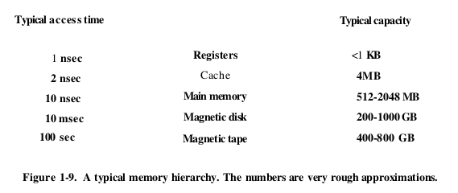
The top layers are more costly. Top layer consists of registers internal to CPU. Typically 32x32-bits on a 32-bit CPU, generally less than 1KB. Programs must manage the registers in software. The cache memory is mostly controlled by the hardware. Main memory is divided up into cache lines, typically 64 bytes. When a program needs a memory word, and the word is located in the cache, its called a cache hit, and no memory request is sent over the bus to main memory. Some machines have two or three levels of cache. L1 cache is always inside the CPU and usually feeds decoded instructions into the CPUs execution engine. A second L1 cache can be used for heavily used data words. In addition there is usually a second cache called L2, that holds several MB of recently used memory words. Main memory is the workspace of the memory system, usually called RAM. All CPU requests that cannot be satisfied out of the cache go to main memory. In some computers the bootstrap loader used to start the computer is contained in ROM (which is nonvolatile). EEPROM, flash are also non-volatile, but can be erased and rewritten.

1.3.3 Disks
It takes more time to randomly access data on the magnetic disk (hard disk) than RAM, yet they are cheaper. The disk is a mechanical device, hence the time difference. At any given arm position, each of the heads can read an annular region of a metal platter called a track. All of the tracks for a given arm position form a cylinder. Each track is divided into some number of sectors. The virtual memory scheme makes it possible to run programs larger than physical memory by placing them on the disk and using main memory as a kind of cache for the most heavily executed parts. The Memory Management Unit (MMU) is responsible for remapping memory addresses on the fly to convert the address the program generated to the physical address in RAM where the word is located. In multiprogramming, performing a context switch (switching from one program to another), might require flushing all modified blocks from the cache and remapping the registers in the MMU, which might be expensive operations.

1.3.4 Tapes
Often used as a backup for disk storage and for holding very large data sets. Cheap, mechanical, slow, but removable so can be stored off-site to survive disasters.

1.3.5 IO Devices
The CPU also manages IO devices, which generally consist of two parts: a controller, and the device itself. The controller is a chip or set of chips that physically control the device. It accepts commands from the OS like read data from the device and carries them out. Because each controller is different, different software is needed to control each one. The software that talks to a controller, giving it commands and accepting responses is called a device driver. The driver must be put into the OS so it can run in kernel mode (or outside the kernel, with ability to allow a user-space driver). Three ways to relink the kernel with the new driver:
1. relink and reboot.
2. make entry in OS file then reboot.
3. accept on the fly without needing reboot.
Every controller has a small number of registers that are used to communicate with it. The collection of all the device registers forms the IO port space. On some computers the device registers are mapped into the OS address space, so they can be read and written like ordinary memory words. On other computers, the device registers are put into a special IO port space with each register having a port address. Input and output can be done by busy waiting, interrupts, Direct Memory Access (DMA). With interrupts, the driver first tells the controller what to do by writing into its device registers. Controller then starts device, reads/write what it should then signals the interrupt controller chip. If controller is prepared to accept the interrupt, it asserts a pin on the CPU chip. Then the interrupt controller puts the number of the device on the bus so CPU can read it and know which device has just finished. When CPU takes the interrupts, the device number may be used as an index into part of memory to find address of the interrupt handler for this device. This part of memory is called the interrupt vector. DMA chip can control the flow of bits between memory and some controller without constant CPU intervention. When the DMA chip is done it causes an interrupt.

1.3.6 Buses
The pentium system has eight buses: cache, local, memory, PCI, SCSI, USB, IDE and ISA. Each bus has different transfer rate and fucntion. The two main buses are the IBM PC ISA bus (Industry Standard Architecture) and its successor, PCI bus (Peripheral Component Interconnect). ISA runs at 8.33 MHz and can transfer 2 bytes at once, for a max speed of 16.67 MB/sec. PCI can run at 66 MHz and transfer 8 bytes at once for a data rate of 528 MB/sec. There is also PCI Express. IDE bus is for attaching peripheral devices such as disks and CDROMS. USB was invented to attach all slow IO devices (keyboard and mouse). SCSI (Small Computer System Interface) bus is a high performance bus intended for fast disks scanners etc.
The OS has to know what peripheral devices are connected and to configure them. This led Intel and Microsoft to design a PC system called plug and play. Before plug and play each IO card had a fixed interrupt request level and fixed addresses for its IO registers. If two cards used the same interrupt level a problem occurred. Plug and play has the system automatically collect information about the IO devices, centrally assign interrupt levels and IO addresses, then tell each card what its numbers are.

1.3.7 Booting the Computer
Every pentium contains a parentboard(aka motherboard). On the motherboard is a program called the system BIOS (Basic Input Output System). The BIOS contains low level IO software, including procedures to read the keyboard, write to the screen, etc. When computer is booted, BIOS is started. First checks to see how much RAM is installed, and scans ISA and PCI to see if basic devices are installed and working. Legacy devices (ones without plug and play capability), are recorded and plug and play devices are recorded. The BIOS then determines the boot device (floppy disk, CDROM, hard disk). The first sector from the boot device is read into memory and executed. This sector contains a program that nomrally examines the partition table at the end of the bott sector to determine which partitions is active. A secondary boot loader is read in from that partition. This loader reads in the operating system from the active partition and starts it. The OS then requires the BIOS to get the configuration information. For each device, it checks to see if it has the device driver. Once it has all drivers (CD ROM internet or god), the OS loads them into the kernel. Then it initializes tables, creates background processes needed and startups the login program or GUI.

1.5 Operating System Concepts

1.5.1 Processes
A process is basically a program in execution. Associated with each process is its address space, which is a list of memory locations from 0 to some maximum, which the process can read and write. The address space contains the executable program, the program’s data, and it’s stack. Also associated with each process is a set of resources, commonly including registers (including program counter and stack pointer), a list of open files, outstanding alarms, lists of related processes, and all other information needed to run the rpogram. A process is fundamentally a container that holds all the information needed to run a program. Periodically, the OS decides to stop running one process and start running another. In many OS’s, when this suspension of a process occurs, all the information about each process, other than the contents of its own address space is stored in an OS table called the process table, which is an array(or linked list) of structures, one for each process currently in existence. A suspended process consists of its address space, usually called the core image, and its process table entry.
The key process management system calls are those dealing with the creation and termination of processes. A parent process can create one or more child processes and so on. The communication between processes is called interprocess communication. Signals are the software analog of hardware interrupts and can be generated by a variety of causes in addition to timers expiring (alarms).
Each person authorized to use a system is assigned a UID by the system administrator. Every process has the UID of the person who started it, which is inherited by child processes also. One UID called the super-user (in UNIX), has special power and may violate many of the protection rules.

1.5.2 Address Spaces
Virtual memory allows the OS to keep part of the address space in main memory (RAM) and part on disk, rather than all in main memory. It then shuttles pieces back and forth between them as needed. This allows a process to have a larger address space than the computer has main memory (RAM). In essence, the OS creates an abstraction of an address space as the set of addresses a process may reference. The address space is decoupled from the machine’s physical memory, and may be either larger or smaller than the physical memory.

1.5.3 Files
Another key concept is the file system. A major function of the operating system is to hide the peculiarities of the disks and other IO devices and present the programmer with a nice, clean abstract model of device-independent files. To provide a place to keep files, most OS have the concept of a directory as a way of grouping files together. Every file within the directory hierarchy can be specified by giving its path name from the top of the directory hierarchy, the root directory. At every instant, each process has a current working directory, in which path names not beginning with a slash are looked for. Before a file can be read or written, it must be opened, at which time the permissions are checked. If access is permitted, the system returns a small integer called a file descriptor. Another important UNIX concept is the mounted file system. The mount system allows a file system to be attached to the root file system (wherever it wants), thus allowing access to content. Another UNIX concept ia the special file, which are provided in order to make IO devices look like files. This way then cay be read and written using the same system calls as are used for reading and writing files. Two kinds of special files exist: block special files and character special files.
A pipe is a sort of pseudofile that can be used to connect two processes. Thus, communication between processes in UNIX looks very much like ordinary file reads and writes. Stronger yet, the only way a process can discover that the output file it is writing on is not really a file, but a pipe is by making a special system call.
The UNIX command interpreter is called the shell.
Virtual memory gives the ability to run programs larger than the machines physical memory by moving pieces back and forth between RAM and disk.

1.6 System Calls
Any single CPU computer can execute only one instruction at a time. If a process is running a user program in user mode and needs a system service, such as reading or writing, it has to execute a trap instruction to transfer control to the operating system. The OS then inspects parameters to determine what the calling process wanted, then it carries out the syytem call and returns control to the instruction following the system call. Steps of ‘read’ system call:
1. Calling program first pushes the parameters onto the stack.
2. Call to the library procedure: read
3. Library procedure puts the system call number in a pre-known register by the OS.
4. Executes a trap instruction to switch from user to kernel mode and start execution at a fixed address within the kernel. The trap instruction cannot jump to an arbitrary address. Depending on architecture, it either jumps to a single fixed location, or uses field in the instruction giving the index into a table in memory containing jump addresses.
5. The kernel code that starts after trap examines the system call number and dispatches to the correct system call handler.
6. System call handler runs
7. Once work is completed, control may be returned to the user-space library procedure at the instruction following the trap instruction. This procedure then returns to the user program in the usual way procedure calls return. To finish, the program cleans the stack as it does after any procedure call.
The read system call may block, preventing the caller from continuing. In this case, the OS will look around to see if some other process can be run next.

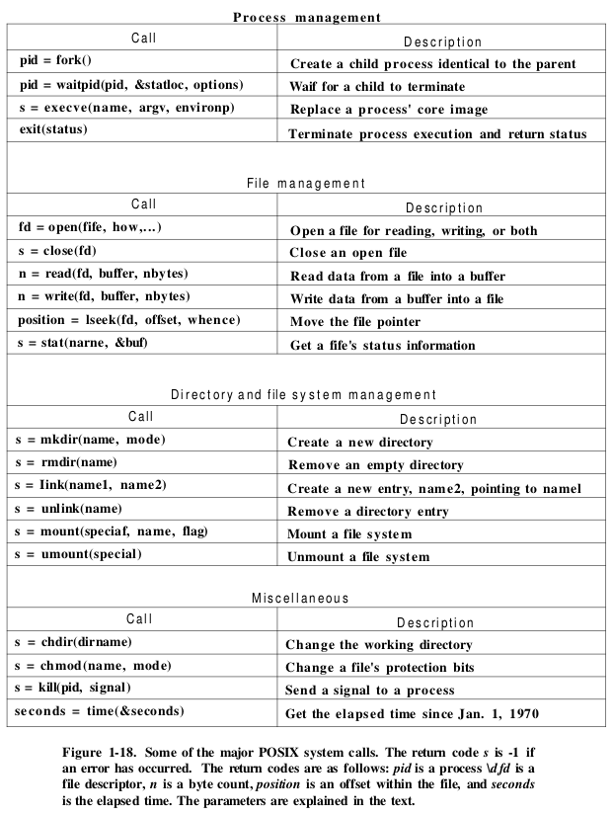

1.6.1 System Calls for Process Management
Fork is the only way to create a new process in POSIX. It creates an exact duplicate of the original process including all the file descriptors, registers, etc. After the fork, the original and copy process go their separate ways. The (unchangeable) program text, is shared between parent and child. To wait for the child to finish, the parent executes a waitpid system call, which waits until any or a specific child terminates. The child process executes the user command by using the execve system call, which causes its entire core image to be replaced by the file named in its first parameter (actually system call is called exec). Processes in UNIX have their memory divided into three segments: text (program code), data (varaibles) and the stack segment. The data segment grows upward and the stack grows downward. Between them is a gap of unused address space. Stack grows into the gap automatically however expansion of the data segment is done explicitly by using a system call brk. Programmers are encouraged to use malloc.

1.6.2 System Calls for File Management
Open, read, write. For each file, UNIX keeps track of file mode (regular, special, directory…), size, time of last modification, etc. Programs can ask to see this via the stat system call.

2. Processes and Threads
The most central concept in every operating system is the process: an abstraction of a running program.

2.1 Processes
In any multiprogramming system, the CPU switches from process to process quickly. While strictly speaking, the CPU is running only one process at any instant in time, over the course of a seocnd it may work on several, giving the illusion of parallelism. This is sometimes known as pseudo-parallelism in contrast with true hardware parallelism of multiprocessor systems.

2.1.1 The Process Model
A process is just an instance of an executing program, including current values of the program counter, registers and variables. The rapid switching back and forth between processes is called multiprogramming. With the CPU switching rapidly, the rate at which a process performs its computation will not be uniform and probably not even reproducible if the same processes are run again. Thus processes must not be programmed with built-in assumptions about timing.
The difference between a process and a program is subtle but crucial. The process is an activity of some kind. It has a program, output and a state. If a program runs twice, it counts as two different processes.

2.1.2 Process Creation
In UNIX there is only one system call to create a new process: fork. This call creates an exact clone of the calling process. After the fork, the two processes, the parent and the child, have the same memory image, the same environment strings, and the same open files. Usually the child process then executes execve or similar to change its memory image and run a new program. After a process is created, the parent and child have their own distinct address spaces. If either process changes a word in its address space, the change is not visible to the other process.

2.1.3 Process Termination
Process will terminate on: normal exit, error exit (no such file exists), fatal error(divide by zero) or if killed by another process.

2.1.5 Process States
When a process blocks it does so because logically it cannot continue, typically because it is waiting for input that is not yet available. It is also possible for a process that is conceptually ready and able to run to be stopped because the operating system has decided to allocate the CPU to another process. A process may be in three states:
- Running (using the CPU at that instant)
- Ready (runnable; temporarily stopped to let another process run)
- Blocked (unable to run until some external event happens)
In some systems, the process can execute a system call such as pause to get into a blocked state. Transitions from ready to running and opposite are caused by the process scheduler, which is part of the OS. Instead of thinking about interrupts, when using the process model we can think about user processes, disk processes, terminal processes, etc.

2.1.6 Implementation of Processes
To implement the process model, the OS maintains a table, called the process table, with one entry per process (entries are also known as process control blocks). This entry contains important information about the process’s state, including its program counter, stack pointer, memory allocation, status of its open files, its accounting and scheduling information, and everything else about the process that must be saved when the process is switched from running to ready or blocked state so that it can be restarted later.
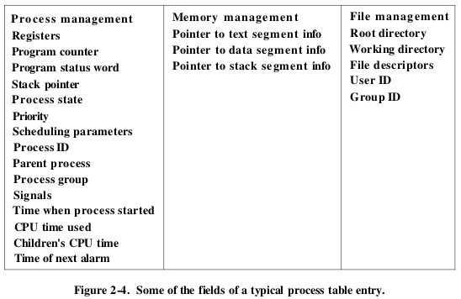
Associated with each IO class is a location (typically at a fixed location near the bottom of memory) called the interrupt vector. It contains the address of the interrupt service procedure. Upon an interrupt (e.g. disk interrupt) the process’s program counter, program status word and sometimes more registers are push onto the current stack by the interrupt hardware. The computer then jumps to the address specified in the interrupt vector. The hardware’s job ends here.
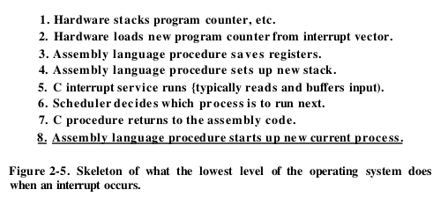
If processes spend 80% of their time waiting for IO, at least 10 processes mut be in memory at once to get the CPU waste below 10%. When you realize that an interactive process waiting for a user to type something at a terminal is in IO wait state, it should be clear that IO wait times of 80% and more are not unusual.

2.2 Threads
In traditional OS, each process has an address space and a single thread of control. There are frequent situations in which it is desirable to have multiple threads of control in the same address space running in quasi-parallel.

2.2.1 Thread Usage
In many applications, different activities might block. Being able to run multiple processes make the programming model simpler. Instead of thinking about interrupts, timers and context switches, we can think about parallel processes. The same applies for threads but with an additional element: the ability for parallel entities to share an address space and all of its data among themselves. Another argument for threads is that since they are lighter weight than processes, they are easier (faster) to create and destroy. In many systems, creating a thread goes 10-100 times faster than creating a process. A third reason is a performance argument due to threads allowing computing and IO activities to overlap, thus speeding up the application. Finally, threads are useful on systems with multiple CPU’s where real parallelism is possible.
In a word processor, there might be one thread handling user interaction, a second thread reformats the document when told to, and the third thread writes the contens of RAM to disk periodically. It should be clear that by having three threads instead of three processes, they share a common memory and thus all have access to the document being edited. This would not work with processes. A design in which each computation has a saved state, and there exists some set of events that can occur to change the state is called a finite-state machine.

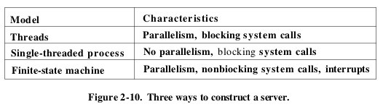
2.2.2 The Classical Thread Model
The process model is based on two independent concepts: resource grouping and execution. A process has an address space containing program text, data, and others including open files, child processes, pending alarms, signal handlers, etc. BY putting them together in the form of a process, they can be managed with more ease. The second concept of a process is the thread of execution. The thread has a program counter, registers, a stack (with execution history and one frame for each procedure called but not yet returned from). Although a thread must execute in some process, the thread and its process can be treated separately. Processes are used to group resources together, threads are entities schedule for execution on the CPU. Threads are also sometimes called lightweight processes. With three compute-bound threads in a process, the threads would appear to be running in parallel, each one on a CPU with one-third the speed of the real CPU.

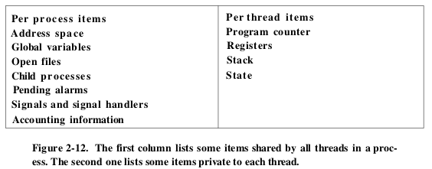
Like traditional processes, a thread can be running, blocked, ready or terminated state. It is important to realize that each thread has its own stack, which contains one frame for each procedure called but not yet returned from. Threads can also introduce a number of complications into the programming model: fork from a parent process→does the child process inherit all the threads of the parent? If not, the program might not run properly, if so, what happens with a thread that blocks for keyboard input? Do both thread in parent and thread in child block wating for the input? These types of problems can be solved with some effort, but careful thought and design are needed to make multi threaded programs work correctly.
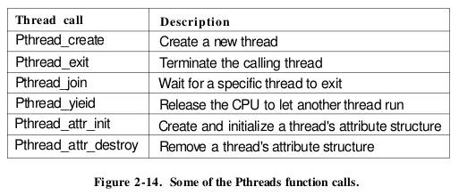
Sometimes it happens that a thread is not logically blocked, but feels that it has run long enough and wants to give another thread a chance to run. This can be achieved by calling pthread-yield. There is no such call for processes because the assumption there is that processes are fiercely competitive and each wants all the CPU time it can get.
There are two main ways to implement a threads package and also a third hybrid: in user-space and in the kernel. The first method is to put the threads package entirely in the user space. As far as the kernel is concerned, it is managing ordinary, single threaded processes.

2.3 InterProcess Communication
Processes frequently needs to communicate with other processes. Generally there are three issues:
- How does one process pass information to another process.
- How to stop processes from interfering with each other.
- Sequencing when dependencies between processes exist.

2.3.1 Race Conditions
In some OS, processes that are working together may share some common storage that each one can read and write. Situations for example where two or more processes are reading or writing some shared data and the final result depends on who runs precisely when, are called race conditions.

2.3.2 Critical Regions
The key to preventing trouble with race conditions is to find a way to prohibit more than one process from reading and writing the shared data at the same time. What we need is mutual exclusion. The part of the program where the shared memory is accessed is called the critical region or critical section. We avoid races by assuring that no two processes ever are in the critical section at the same time. This solution is not sufficient for having parallel processes cooperate correctly and efficiently using shared data so we need four conditions to hold in order to have a good solution:
- No two processes may be simultaneously inside their critical region.
- No assumptions may be made about the speeds or number of CPU.
- No process running outside its critical region may block other processes.
- No process should have to wait forever to enter its critical region.

2.3.3 Mutual Exclusion with Busy Waiting
- Disabling Interrupts
On a single processor system, the simplest solution is to have each process disable all interrupts just after entering its critical region and re-enable them just before leaving it. The CPU is only switched from process to process as a result of clock or other interrupts. This approach is generally unattractive because it gives the user process the power to turn off interrupts which could mean the end of the system. Either way this is not relevant for multiprocessor systems.
- Lock Variables
A single, shared (lock) variable could be used, but still race condition occurs.
- The TSL instruction
Instruction looks like: TSL RX, LOCK. Test and Set Lock reads the content of the memory word LOCK into register RX and then stores a nonzero value at the memory address lock. The operations of reading the word and storing into it are guaranteed to be indivisible (atomic) – no other processor can access the memory word until the instruction is finished. The CPU executing the TSL instruction locks the memory bust to prohibit other CPU’s from accessing memory until it is done. An alternative to TSL is XCHG which exchanges the contents of two locations atomically.

2.3.4 Sleep and Wakeup
The solutions above are correct but have the defect of requiring busy waiting. This approach wastes CPU time but can also have unexpected effects. Producer – Consumer problem: Two processes share a common, fixed-size buffer. The producer puts information into the buffer, and the consumer takes it out. Trouble arises when the producer wants to put a new item in the buffer but it is already full or the consumer wants to take but its empty. The solution is for either side to go to sleep to be awakened at the appropriate time. This still leads to race conditions.

2.3.5 Semaphores
A new variable type to count the number of wakeups called a semaphore was introduced by Dijkstra. It could have the value 0, indicating that no wakeups were saved, or some positive value if one or more wakeups were pending. Two operations were suggested, down and up. The down operation checks to see if the value is greater than zero, if so, it decrements the value and continues. If the value is 0, the process is put to sleep without completing the down for the moment. Checking the value, changing it and possibly going to sleep are all done atomically. Semaphores are thus also used for synchronization. In this case, they ensure that the producer stops running when the buffer is full, and that the consumer stops running when it is empty. Semaphores that are initialized to 1 and used by two or more processes to ensure that only one of them can enter its critical region at the same time are called binary semaphores.

2.3.6 Mutex
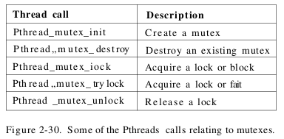
A simplified version of a semaphore. A mutex is a variable that can be in one of two states: unlocked or locked.

Condition variables allow threads to block due to some condition not being met.
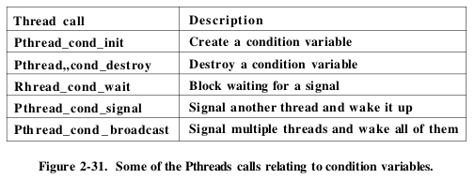
Condition variables and mutexes are always used together. It is worth noting, that conditional variables (unlike semaphores) have no memory. If a signal is sent to a condition variable on which no thread is waiting, the signal is lost.

2.3.9 Barriers
Some applications ared divided into phases and have the rules that no process may procedd into the next phase until all processes are ready to proceed to the next phase. This behaviour may be achieved by placing a barrier ath the end of each phase.

2.4 Scheduling
When a computer is multiprogrammed, it frequently has multiple processes or threads competing for the CPU simultaneously. This occurs whenever two or more of them are simultaneously in the ready state. If only one CPU is available, achoice has to be made which process to run next. The part of the OS that makes the choice is called the scheduler, and the algorithm it uses is called the scheduling algorithm. In addition to picking the right process to run, the scheduler also has to make efficient use of the CPU because process switching is expensive: switch from user to kernel mode, save the state of the current process including storing its registers in the process table and the memory might need to be saved as well. Then the scheduling algorithm is ran to select the new process to run followed by reloading the MMU with the memory map of the new process. Finally, the new process must be started, but on top of this, the entire memory cache might need to be dynamically reloaded from the main memory twice (upon entering the kernel and upon leaving it), since a process switch usually invalidates the entire memory cache.
- Process Behaviour
Process that spend most of their time computing are called compute-bound, while those that spend most of their time waiting for IO are called IO-bound. Compute-bopund usually have long CPU bursts and thus infrequent IO waits, whereas IO-bound have short CPU bursts and thus infrequent IO waits.
- When to Schedule
There are a variety of situations where scheduling is needed:
- When a new process is created. Since both process are in ready state, it is a normal scheduling decision, so the scheduler can legitimately choose to run either the parent or the child next.
- When a process exits. A different process must be chosen from the set of ready processes. If no process is ready, a system supplied idle process is normally run.
- When a process blocks (IO, semaphore, etc…). Generally, the scheduler does not have the necessary information to take any dependencies (e.g. shared memory) between processes into account.
- When an IO interrupt occurs. It is up to the scheduler to decide wether to run a newly ready process (that changed to ready because of the interrupt), the process that was running at interrupt time or a different process.
If a hardware clock provides periodic interrupts at e.g. 60 Hz, then a scheduling decision can be made at every k-th clock interrupt. A non preemptive scheduling algorithm picks a process to run and then lets it run until it blocks or voluntarily releases the CPU. In effect no scheduling decisions are made during clock interrupts like this. In contrast, a preemptive scheduling algorithm picks a process and lets it run for a maximum of some fixed time. If it is still running at the end of the time interval, it is suspended and the scheduler picks another process to run (if one is available). Preemptive scheduling requires a clock interrupt at the end of the time interval to give control of the CPU back to the scheduler.
- Categories
In batch systems, non-preemptive or preemptive with long time periods for each process, are often acceptable. With interactive systems, preemption is essential to keep one process form hogging the CPU and denying service to the others. In real-time systems, preemption is not always needed.
- Scheduling Algorithm Goals
Under all system types, fairness is important. Comparable processes should get comparable service. In addition, the algorithm should enforce the system’s policies, and keep all parts of the system busy when possible. If CPU and all IO devices can be kept running, more work gets done per second than if some of the components are idle. Users have an inherent idea of how long things should take. When a request that is perceived as simple, takes a long time, users get irritated. This is related to the concept of proportionality. The foremost need in real-time is meeting all (or most) of the deadlines.

2.4.2 Scheduling in Batch Systems
- First-Come First-Served
Non-preemptive first-come first-served. Processes are assigned the CPU in the order they request it. A single queue of ready processes. When the running process blocks, the first process on the queue is run next. When a blocked process becomes ready it is put on the end of the queue. With this algorithm, a single linked lists keeps track of all ready processes. Easy to program and work with, but unfortunately has disadvantages.
- Shortest Job First
This non-preemptive batch algorithm assumes that run times are known in advance. This algorithm is provably optimal in terms of mean turnaround time. Worth noting that this is only optimal when all the jobs are available simultaneously.
- Shortest Remaining Time Next
A preemptive version of the shortest job first. The run time has to be known in advance. This allows new short jobs to get good service.

2.4.3 Scheduling in Interactive Systems
- Round Robin Scheduling
One of the oldest, simplest, fairest and most widely used algorithms. Each process is assigned its time interval, called a quantum, during which it is allowed to run. The scheduler needs to maintain a list of runnable processes, When the process uses up its quantum it is put on the end of the list. The interesting thing about round robin is the length of the quantum. Switching from one process to another requires a certain amount of time for doing the administration. This switch is known as a process switch or context switch. Adjusting the quantum to the particular system can improve performance. Setting the quantum too short causes too many context switches and lowers the CPU efficiency, but setting it too long may cause poor response to short interactive requests.
- Priority Scheduling
Each process is assigned a priority and the runnable process with the highest priority is allowed to run. To prevent high-priority processes from running indefinitely, the scheduler may decrease the priority of the currently running process at each clock interrupt. Alternatively, each process may be assigned a maximum time quantum that it is allowed to run. Priorities can be assigned to processes statically or dynamically.
- Guaranteed Scheduling
One realistic promise that can be made: If there are n users logged in while you are working, you will receive about 1/n of the CPU power. Similarly, on a single-user system with n processes running, all things being equal, each one should get 1/n of the CPU cycles. To make good of promise, the system must keep track of how much CPU each process has had since its creation.
- Lottery Scheduling
The basic idea is to give processes lottery tickets for various system resources, such as CPU time. Whenever a scheduling decision has to be made, a lottery ticket is chosen at random, and the process holding that lottery ticket gets the resource. More important processes can be given extra tickets, to increase their odds of winning. A process holding a fraction of the tickets will get about the same fraction of the resource in question. Cooperating processes may exchange tickets (client giving tickets to server so that it runs next).
- Fair-Share Scheduling
Some systems take into account who owns a process before scheduling it. Each user is allocated some fraction of the CPU and the scheduler picks processes in such a way as to enforce it.

2.4.4 Scheduling in Real-Time Systems
When an external event is detected it is the job of the scheduler to schedule the processes in such a way that all deadlines are met. The events that a real-time system may have to respond to can be periodic or aperiodic. A system might have to respond to multiple periodic event streams, and depending on how much time each event requires for processing, it may not even be possible to handle them all. A static real-time scheduling algorithm makes decision prior to run-time. A dynamic one, makes scheduling decisions at run-time.

2.4.6 Thread Scheduling
A major difference between user-level threads and kernel-level threads is the performance. Doing a thread switch with user-level threads takes a handful of machine instructions. With kernel-level threads it requires a full context switch, changing the memory map and invalidating the cache. On the other hand, with kernel-level threads, having a thread block on IO does not suspend the entire process as it does with user-level threads. The scheduler could take this into account to make better scheduling decisions. User-level threads can employ an application specific thread scheduler.

2.5 Classical IPC Problems
The Dining Philosophers problem. A situation in which all the programs continue to run ideifnitely but fail to make any progress is called starvation. The solution which is deadlock free and allows the maximum parallelism for an arbitrary number of philosophers uses an array to keep track of whether a philosopher is eating, thinking or hungry. A philosopher mau move into eating state if neither neighbor is eating. The program uses an array of semaphores, one per philosopher so hungry philosophers can block if the needed forks are busy.

3. Memory Management
Main memory (RAM) is an important resource that must be carefully managed. Over the years, the concept of memory hierarchy has developed in which computer have a few megabytes of very fast, expensive volatile cache memory, a few gigabytes of medium-speed medium priced volatile main memory and a few terrabytes of slow, cheap, nonvolatile disk storage, not to mention removable storage as DVD;s and USB sticks. It is the job of the OS to abstract this hierarchy into a useful model and then manage the abstraction. The part of the OS that manages (part of) the memory hierarchy is called the memory manager. It keeps track of which parts of memory are in use, allocate memory to processes when they need it, and deallocate when they are done.

3.1 No Memory Abstraction
The simplest memory abstraction is no abstraction at all. The model presented to the programmer was simply physical memory, a set of addresses from 0 to some maximum, each address corresponding to a cell containing some number of bits, commonly eight. Under these conditions, it was not possible to have two running programs in memory at the same time. Even with this model of memory being just physical memory, several options are possible: placing OS at bottom of memory (RAM), or in ROM at top of memory, or device drivers may be at top of memory in ROM and the rest of system in RAM down below. When the system is organized this way, generally only one process at a time can be running.
- Running Multiple Programs Without a Memory Abstraction
What the OS must do is save the entire contents of memory to a disk file, then bring in and run the next program. As long as there is only one program at a time in memory, there are no conflicts (swapping). With the addition of some hardware it is possible to run multiple programs concurrently, even without swapping. A problem here is that two programs both reference absolute physical memory. We actually want each program to reference a private set of addresses local to it.

3.2 A Memory Abstraction: Address Spaces
Exposing physical memory to processes has several major drawbacks. First, user programs that address every byte of memory can easily trash the operating system. Second, it is difficult to have multiple programs running at once (taking turns, if there is only one CPU).

3.2.1 The Notion of an Address Space
Two problems have to be solved to allow multiple applications to be in memory at the same time without their interfering with each other: protection and relocation. As the process concept creates a kind of abstract CPU to run programs, the address space creates a kind of abstract memory for programs to live in. An address space is the set of addresses that a process can use to address memory. Each process has its own address space. Address spaces do not have to be numeric (the set of .com internet domains is also an address space). How does one give each program its own address space so address 28 in one program means a different physical location than address 28 in another program.
- Base and Limit Registers
This is a simple version of dynamic relocation. This maps each process’s address space onto a different part of physical memory in a simple way. For the intel 8088, the solution was to equip each CPU with two special hardware registers called base and limit registers.
..
..

3.2.2 Swapping
In practice, the total amount of RAM needed by all the processes is often much more than can fit in memory. Two general approaches to dealing with memory overload have been developed. Swapping consists of bringing in each process in its entirety, running it for a while, then putting it back on disk. The other strategy, called virtual memory, allows programs to run even when they are only partially in main memory. Swapping and the memory holes is illustrated below:
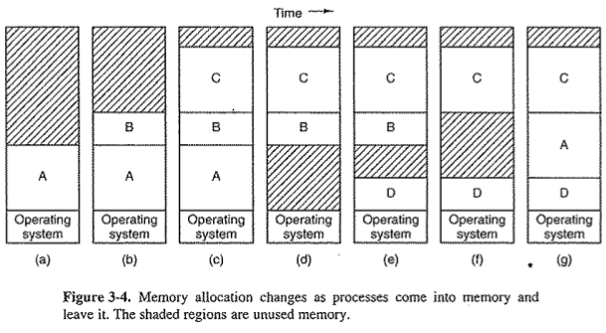
Aprocess can have two growing segments, a stack at the top of its allocated memory that grows downward and a data segment just beyond the program text that is growing upward.

3.2.3 Managing Free Memory
When memory is assigned dynamically, the OS must manage it. Generally, there are two ways to keep track of memory usage: bitmaps and free lists.
- Memory Management with Bitmaps
With a bitmap, memory is divided into allocation units as small as a few words and as large as serveral kilobytes. Corresponding to each allocation unit is a bit in the bitmap, which is 0 if the unit is free and 1 if it is occupied (or opposite).
- Memory Management with Linked Lists
Here a segment either contains a process or is an empty hole between two processes/ Each entry in the list specifies a hole (H) or a process (P), the address at which it starts, the length, and a pointer to the next entry. Segment lists can be kept sorted by address. When sorted by address, there are several algorithms that can be used to allocate memory for a created process (or an existing process being swapped in from disk), assuming that the memory manager knows how much memory to allocate. The simplest algorithm is first fit. A minor variation on first fit is next fit. Another well-known algorithm is best fit. When holes re kept on a separate list from the processes, a small optimization is possible. Another allocation algorithm is quickfit.

3.3 Virtual Memory
There is a need to run programs that are too large to fit in memory, and there is also a need to have systems that can support multiple programs running simultaneously, each of which fits in memory but which collectively exceed memory. A solution adopted in the 60’s was to split programs into little pieces called overlays. When a program started, all that was loaded into memory was the overlay manager, which immediately loaded and ran overlay 0. Although the actual work of swapping overlays in and out was done by the OS, the work of splitting the program into pieces had to be done manually by the programmer. The method devised to turn the whole job over to the computer has come to be known as virtual memory. The basic idea is that each program has its own address space, which is broken up into chunks called pages. Each page is a continuous range of addresses. These pages are mapped onto physical memory, but not all pages have to be in physical memory to run the program. When the program references a part of its address space that is not in physical memory, the OS is alerted to go get the missing piece and re-execute the instruction that failed. Virtual memory works fine in a multiprogramming system, with bits and pieces of many programs in memory at once. While a program is waiting for piece of itself to be read in, the CPU can be given to another process.

3.3.1 Paging
Programs reference a set of memory addresses. With an instruction like: MOV REG, 1000 , the computer copies contents of memory address 1000 to REG (or vice versa depending on the computer). Addresses can be generated using indexing, base registers, segment registers, and other ways. These program-generated addresses are called virtual addresses and form the virtual address space. On computers without virtual memory, the virtual address is put directly onto the memory bus and causes the physical memory word with the same address to be read or written. With virtual memory, the addresses go to an MMU (Memory Management Unit), that maps the virtual addresses onto the physical memory addresses.
The virtual address space is divided into fixed-size units called pages. The corresponding units in the physical memory are called page frames. The pages and page frames are generally the same size. With 64 KB of virtual address space and 32 KB of physical memory, we get 16 virutal pages and 8 page frames. Transfers between RAM and disk are always in whole pages.
In the example below, we have a computer that generates 16-bit addresses, from 0 – 64k. These are the virtual addresses. This computer, however has only 32KB of physical memory, so although 64KB programs can be written, they cannot be loaded into memory in their entirety and run.

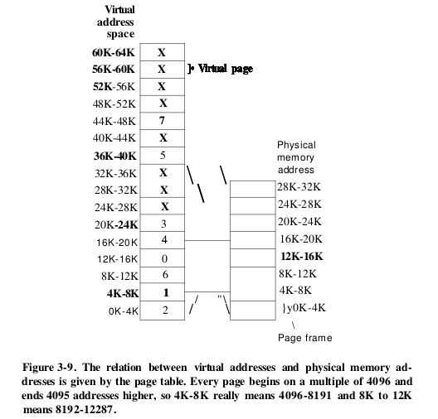
The instruction MOV REG.8192, is effectively transgormed into MOV REG.24576, because virtual address 8192 (in virtual page 2) is mapped onto 24576 (in physical page frame 6). Since we only have eight physical page frames, only eight of the virtual pages are mapped onto physical memory while the others (shown as a cross) are not. If a program references an unmapped address, the MMU notices this and causes the CPU to trap the operating system. This trap is called a page fault. The OS picks a little used page frame and writes its contents back to disk (if not already there) and then fetches the page just referenced into the page frame just freed, changes the map and restarts the trapped instruction.
The incoming 16-bit virtual address is split into a 4-bit page number (for 16 pages) and 12-bits for offset (to address all 4096 bytes within a page). The page number is used as an index into the page table, yielding the number of the page frame corresponding to that virtual page. If the present/absent bit is 0, a trap to the OS is caused, if the bit is 1, the page number is copied to the high order 3 bits of the output register along with the 12-bit offset which is copied unmodifed, making a 15-bit physical address. The output register is then put onto the memory bus as the physical memory address.

3.3.2 Page Tables
The purpose of the page table is to map virtual pages onto page frames. In a simple implementation, the mapping of virtual addresses onto physical addresses can be summarized as follows: the virtual address is split into a virtual page number(high-order bits) and an offset(low-order bits). Other splits are possible which imply different page sizes. The virtual page number is used as an index into the page table to find the entry for that virtual page. From the page table entry, the page frame number is found.
- Structure of page table entry
Highly machine dependent. Most important field is the page frame number. Next to it is the present/absent bit. If the bit is 1, the entry is valid and can be used. If it is 0, the virtual page to which the entry belongs is not currently in memory. This causes a page fault. The protections bits tell what kind of access are permited. The modified and referenced bits keep track of page usage. The modified bit is sometimes called the dirty bit. Since it reflects the page’s state. The referenced bit is et whenever a page is referenced for reading or writing. Its value is to help the OS choose a page to evict when a page fault occurs. The last bit allows caching to be disabled for the page (important for pages that map onto device registers rather than memory. The address space is thus an abstraction of physical memory just as a process is an abstraction of the CPU.

3.3.3 Speeding Up Paging
Two major issues must be addressed: The mapping of virtual address to physical address must be fast. If the virtual address space is large, the page table will be large. With say a 4KB page size, a 32-bit address space has 1 million pages. This means that the page table must have 1 million entires, keeping in mind that each process needs its own page table (because it has its own virtual address space).
- Translate Lookaside Buffers
The starting point for most optimization techniques is that the page table is in memory. Based on the observation that most programs tend to make a large number of references to a small number of pages, thus only a small fraction of the page table entries are heavily read, the rest barely read at all. The TLB (aka an associative memory) is a small hardware device for mapping virtual address to physical address without going through the page table. It is usually inside the MMU and consists of a small number of entries. Each entry contains information about one page, including the virtual page number, a modified bit, protection(permission) code, and the physical page frame in which the page is located. Another bit indicates whether the page is in use or not (valid or not). If the virtual page number (found from the virtual address presented to the MMU for translation) is not in the TLB, the MMU detects the miss and does an ordinary page table lookup. It then evicts one of the entries from the TLB and replaces it with the page table entry just looked up. Software TLB management can be used and might be prefereable.

3.3.4 Page Tables for Large Memories
- Multilevel Page Tables
In a simple example, a 32-bit virtual address that is partitioned into a 10-bit PageTable1 field, a 10-bit PageTable2 field, and a 12-bit Offset field. Since offsets are 12 bits, pages are 4KB and there are a total of 2^20 of them. When a virtual address is presented to the MMU it first extracts the PT1 field and uses this value as an index into the top-level page table. Each of these 1024 entires represents 4M because the entire 4GB(32-bit) virtual address space is chopped into chunks of 4096 bits. The entry located by indexing into the top-level page table yields the address or the page frame number of a second-level page table. The PT2 field is now used as an index into the selected second-level page table to find the page frame number for the page itself.
- Inverted Page Tables
A different solution than multilevel page table is needed for 64-bit paged virtual address spaces. If the address space is 2^64 bytes with 4KB pages we need a page table with 2^52 entries. If each entry is 8 bytes, if each entry is 8 bytes, the table is over 30 million GB Just for the page table! One solution is the inverted page table. In this design there is one entry per page frame in real memory, rather than one entry per page of virtual address space. FO rexample with 64-bit virtual addresses, a 4KB page and 1GB of RAM, an inverted page table only requires 262,144 entries. The entry keeps track of which (process, virtual page) is located in the page frame. Downside: virtual to physical translation becomes harder. Using the TLB can improve this. There are other approaches to handling large virtual memories.

3.4 Replacement Algorithms
While it would be possible to pick a random page to evict at each page fault, system performance is much better if a page that is not heavily used is chosen. Find the page that will be referenced after the most amount of upcoming instructions. This is optimal but not realizable! Not recently used page replacement algorithm: when a page fault occurs, the OS inspects all the pages and divides them into 4 categories based on the referenced and modified bits:
- Class 0: not referenced, not modified.
- Class 1: not referenced, modified.
- Class 2: referenced, not modified.
- Class 3: referenced, modified.
The NRU removes a page at random from the lowest-numbered nonempty class. FIFO, the second chance replacement, the clock page replacement are also options. A good approximation to the optimal algorithm is the least recently used (LRU) algorithm, though its not cheap.

3.4.8 The Working Set Page Replacement Algorithm
Demand paging means that pages are loaded on demand. Most processes during any phase of their execution reference only a relatively small fraction of its pages. The set of pages that a process is currently using is known as its working set. Many paging systems try to keep track of each processe’s working set and make sure that it is in memory before letting the process run. This approach is called the working set model, and is designed to greatly reduce the page fault rate. Loading pages before letting processes run is also called prepaging. The working set changes over time. The basic working set algorithm is cumbersome since the entire page table has to be scanned at each page fault until a suitable candidate is located. The WSClock page replacement algorithm is better and uses a circular list of page frames.
..
..

3.7 Segmentation
The virtual memory discussed so far is one-dimensional because the virtual addresses go from 0 to some maximum address. In some cases, having two or more seperate address spaces may be much better than having only one (e.g. a compiler has many tables built up as compilation proceeds). We need a way of freeing the programmer from having to manage the expanding and contracting tables, in the same way that virtual memory eliminates the worry of organizing the program into overlays. A straightforward and general solution is to provide the machine with many completely independent address spaces, called segments. Each segment consists of a linear sequence of addresses from 0 to some maximum. Different segments may have different lengths. To specify an address in this segmented (two-dimensional memory) the program must supply a two-part address, a segment number, and an address within the segment. Besides simplifying the handling of data structures that are growing or shinking, segmented memory also greatly simplifies the linking of procedures compiled seperately. If the procedure in segment n is subsequently modified and recompiled, no other procedures need be changed (because no starting addresses have been modified).
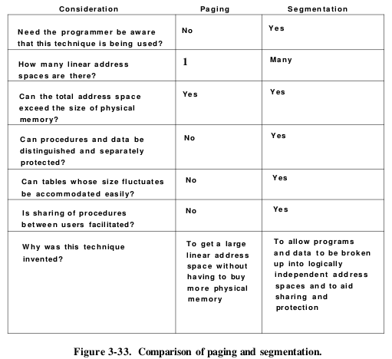

After a segmented memory system has been running for a while, memory will be divided up into a number of chunks, some containing segments and others containing holes. This phenomenon, called checker-boarding or external fragmentation, wastes memory in the holes, but can be dealt with by compaction.

3.7.2 Segmentation with Paging
If segments are large it may be inconvenient or even impossible to keep them in main memory in their entirety, which leads to the idea of paging them, so that only those pages that are actually needed have to be around. Several significant systems have support paged segments, like MULTICS. … look into this more online.

