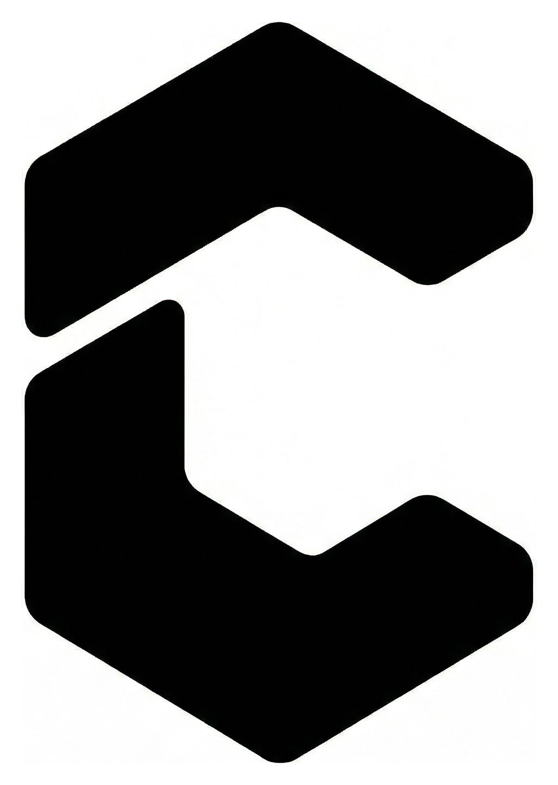
Creator Hive FZE
User Agreement
Terms governing access to and use of Creator Hive FZE websites, talent network, client services and related platform or managed offerings.
Last updated: 17 March 2026
Sharjah Research, Technology and Innovation Park, Block B - B53-050, Sharjah, United Arab Emirates

1. Acceptance of Terms
This User Agreement ("Agreement") is a legally binding agreement between Creator Hive FZE ("Creator Hive", "we", "our" or "us") and the person or entity accessing or using Creator Hive ("you" or "User"). By accessing, using, registering with, submitting information to, or accepting services through Creator Hive, you agree to this Agreement.
If you are accepting this Agreement on behalf of a company or other entity, you represent that you have authority to bind that entity. If you do not agree to this Agreement, you must not use Creator Hive.
2. Eligibility and User Responsibilities
You must be at least 18 years old and legally capable of entering into binding agreements. You agree to provide accurate, current and complete information, keep your account and credentials secure, and use Creator Hive only for lawful business purposes.
You are responsible for all activity conducted through your account or on your behalf. You must not impersonate another person, misrepresent your authority, submit misleading information, or interfere with the operation or security of Creator Hive.
3. Role of Creator Hive
Creator Hive operates as a platform, network and managed service that may introduce, source, coordinate or facilitate work between clients, creators, freelancers, contractors and other service providers. Unless expressly agreed in writing, Creator Hive is not the employer of independent talent and is not a party to contracts formed directly between users.
Creator Hive may review applications, shortlist talent, manage communications, coordinate deliverables, oversee workflow, invoice clients, process payments, and set or collect service fees where applicable. We may refuse, suspend or remove access to our services at our discretion where permitted by law.
4. Services, Bookings and Payments
All project scopes, rates, fees, timelines, deliverables, revisions and payment terms must be confirmed by Creator Hive or documented in a separate written proposal, statement of work, booking confirmation or service order. Creator Hive may require payment in advance, milestone payments, deposits or other commercial terms before work starts.
Where Creator Hive collects payment, you agree to pay all agreed fees, taxes, expenses, chargebacks, recovery costs and other amounts due under the applicable commercial terms. Late payment may result in suspension of services, withholding of deliverables, cancellation of bookings, recovery action or additional charges where allowed by law.
5. User Content and Intellectual Property
You retain ownership of content, materials and intellectual property you lawfully provide to Creator Hive, subject to any rights needed for Creator Hive to host, review, reproduce, adapt, transmit, publish or share that content solely to operate the services, evaluate opportunities, present talent, coordinate projects and fulfil our contractual obligations.
Except as otherwise agreed in writing, work product created for a client will be governed by the applicable project terms between the relevant parties. You represent that you have all rights needed to provide any material you submit and that your content does not infringe the rights of any third party.
6. Confidentiality
Each party may receive non-public business, commercial, creative, financial or technical information from the other in connection with Creator Hive. The receiving party must use such information only for the relevant purpose, protect it with reasonable care, and not disclose it to third parties except where disclosure is required to operate the services, is authorised by the disclosing party, or is required by law.
7. Acceptable Use
You must not use Creator Hive to engage in unlawful, abusive, fraudulent, deceptive, infringing, defamatory or harmful conduct. You must not scrape data, reverse engineer systems, bypass security, upload malware, interfere with any workflow, spam users, exploit confidential information, or use Creator Hive in a way that damages our network, reputation or relationships.
8. No Direct Contact with Creator Hive Talent / Non-Circumvention
For the purpose of this section, "Creator Hive Talent" means any creator, freelancer, contractor, consultant, producer, editor, strategist, influencer, operator or other talent that Creator Hive introduces, recommends, shortlists, manages, represents, submits, books or otherwise makes available to you.
You agree that during your use of Creator Hive and for a period of 12 months after the later of (a) your last use of Creator Hive in relation to the relevant talent, or (b) the last introduction, meeting, proposal, shortlist, briefing, booking, communication or project activity arranged by Creator Hive involving that talent, you will not directly or indirectly contact, solicit, contract with, hire, pay, engage or attempt to engage any Creator Hive Talent outside Creator Hive without Creator Hive's prior written consent.
This restriction applies whether contact or engagement is attempted by you directly or through an affiliate, employee, agent, recruiter, subcontractor, family member, associated company or any third party acting for your benefit. You must not encourage, request or permit Creator Hive Talent to bypass Creator Hive, share off-platform commercial terms, or move a relationship outside Creator Hive during the restricted period.
This section does not apply to a relationship that clearly and demonstrably existed before Creator Hive introduced the relevant talent to you, provided that you disclosed that prior relationship to Creator Hive in writing before any engagement through Creator Hive. In the event of breach or threatened breach, Creator Hive may seek injunctive relief, damages, recovery of lost fees, and reimbursement of reasonable enforcement costs to the fullest extent permitted by law.
9. Suspension and Termination
Creator Hive may suspend, restrict or terminate your access immediately if you breach this Agreement, fail to pay amounts due, create legal or reputational risk, interfere with the services, misuse Creator Hive Talent relationships or if we reasonably consider such action necessary to protect Creator Hive, our users or third parties.
Termination does not affect rights or obligations that accrued before termination, including payment obligations, confidentiality, intellectual property, non-circumvention, limitation of liability and dispute provisions.
10. Disclaimers
Creator Hive provides its website, platform, network and services on an "as available" basis unless we expressly agree otherwise in writing. To the fullest extent permitted by law, Creator Hive disclaims warranties of uninterrupted availability, merchantability, fitness for a particular purpose, non-infringement and any guarantee that a particular talent, booking, campaign result or commercial outcome will be achieved.
11. Limitation of Liability
To the fullest extent permitted by law, Creator Hive will not be liable for indirect, incidental, consequential, special or punitive damages, or for loss of profits, revenue, business opportunity, goodwill, anticipated savings, data or reputation arising out of or in connection with Creator Hive or this Agreement.
To the fullest extent permitted by law, Creator Hive's aggregate liability arising out of or in connection with this Agreement will not exceed the total fees paid by you to Creator Hive in the 3 months immediately preceding the event giving rise to the claim. Nothing in this Agreement excludes liability that cannot lawfully be excluded.
12. Indemnity
You agree to indemnify and hold harmless Creator Hive, its affiliates, directors, officers, employees and representatives from claims, losses, liabilities, damages, costs and expenses arising from your breach of this Agreement, your misuse of Creator Hive, your content, your violation of law, or your infringement of any third-party rights.
13. Governing Law and Disputes
This Agreement is governed by the laws of the United Arab Emirates, as applicable in the Emirate of Sharjah, unless mandatory law requires otherwise. The courts of Sharjah shall have exclusive jurisdiction over disputes arising out of or in connection with this Agreement, unless the parties agree in writing to another dispute process.
14. Changes and Notices
Creator Hive may update this Agreement from time to time. The updated version will apply from the stated effective date. Continued use of Creator Hive after the effective date constitutes acceptance of the updated Agreement.
Formal notices relating to this Agreement should be sent to Creator Hive FZE, Sharjah Research, Technology and Innovation Park, Block B - B53-050, Sharjah, United Arab Emirates, and to hello@creatorhive.ae, or to any updated contact details published by Creator Hive.

Acceptance
By signing below, the User confirms that they have read, understood, and agree to this User Agreement.
User / Company Name
Authorized Signatory
Signature
Date

