Active Directory Exploitation Lab Report
Target Domain: spookysec.local | Attacktive Directory Lab

1. VPN Connectivity Verification
Before beginning enumeration, connectivity to the lab environment was confirmed through the VPN interface.
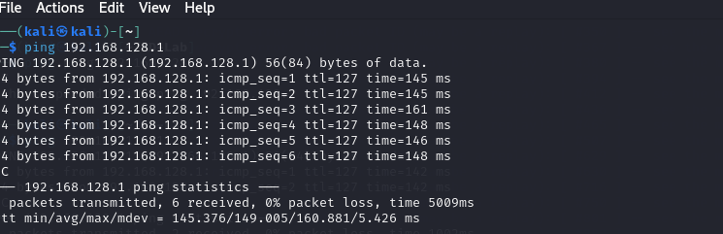
Figure 1 — VPN interface status check.

Analysis
- Confirms the VPN tunnel is active before any traffic is sent to the target.
- Establishing this baseline first rules out network-layer issues if later scans return no results.

2. Network and Service Enumeration
An Nmap scan was run against the target to identify open ports, running services, and service versions.
nmap -sC -sV -oN initial_scan.txt 10.113.184.99
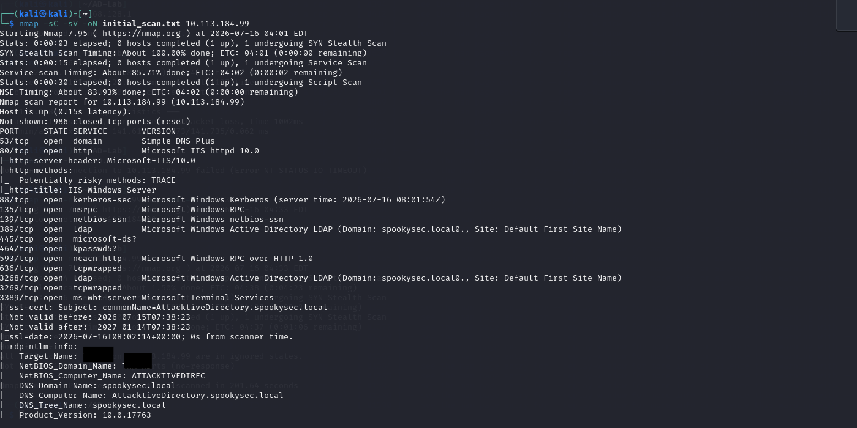
Figure 2 — Nmap scan results.

Analysis
- -sC runs default NSE scripts and -sV performs service/version detection, giving both banner and behavioural fingerprints in one pass.
- Output is saved to initial_scan.txt (-oN) for later reference and reporting.
- Open ports typical of a Domain Controller (Kerberos 88, LDAP 389, SMB 445, RPC 135) indicate this is an Active Directory host, which shapes the rest of the attack path toward Kerberos and SMB-based techniques.

3. Tooling Setup — Kerbrute
Kerbrute, a tool for fast Kerberos pre-auth username enumeration and password spraying, was downloaded and staged in a working directory.
mkdir ~/AD-Lab && cd ~/AD-Lab
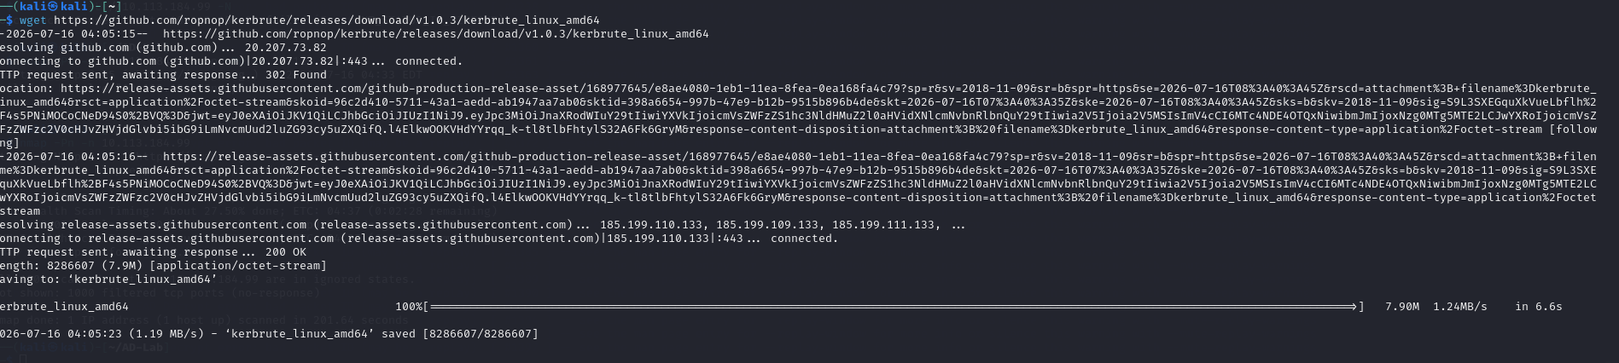
Figure 3 — Downloading the Kerbrute binary.
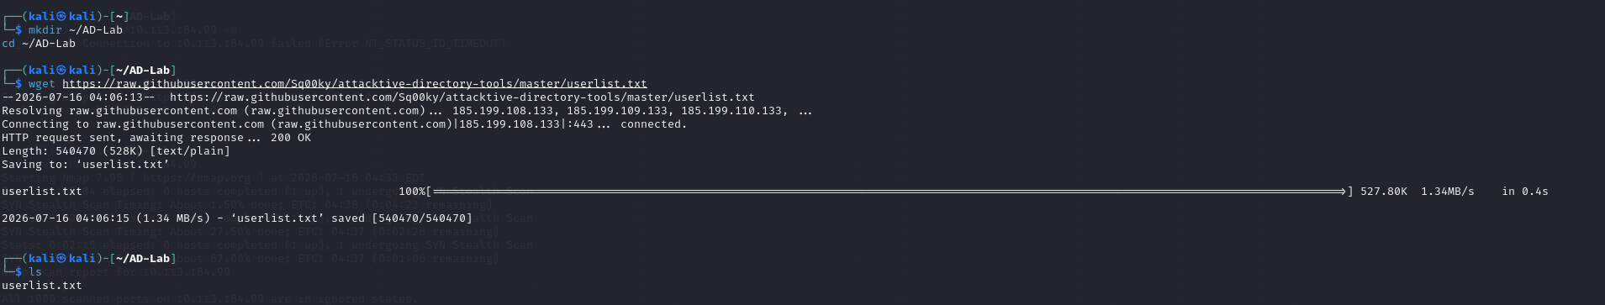
Figure 4 — Verifying the downloaded file.

Analysis
- A dedicated working directory keeps engagement artifacts (wordlists, tool binaries, output) organized and separate from the host filesystem.
- The file listing confirms the tool downloaded successfully before it's relied on for enumeration.

4. Username Wordlist Retrieval
A username wordlist (userlist.txt) was pulled from a public GitHub repository to use as input for Kerberos user enumeration.
wget https://raw.githubusercontent.com/Sq00ky/attacktive-directory-tools/master/userlist.txt

Analysis
- A 527.80 KB wordlist was retrieved successfully (HTTP 200 OK), giving a broad candidate list for username enumeration against the domain.

5. User Enumeration via Kerberos Pre-Authentication
Kerbrute's userenum module was used to validate which candidate usernames exist in the spookysec.local domain.
kerbrute userenum --dc 10.113.184.99 -d spookysec.local userlist.txt
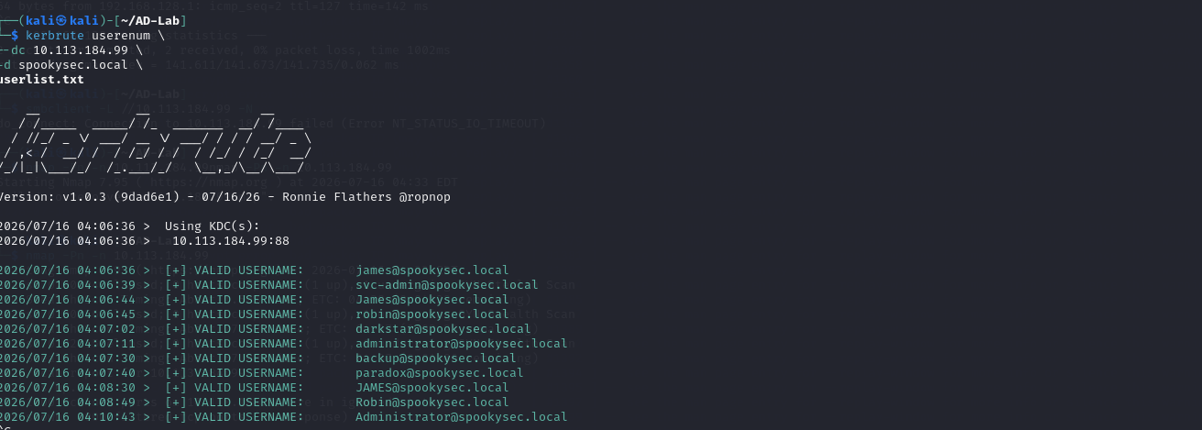
Figure 5 — Kerbrute user enumeration results.

Analysis
- This technique abuses Kerberos pre-authentication responses: the KDC replies differently for valid vs. invalid usernames, so no domain credentials or lockouts are triggered.
- Valid accounts discovered here become the target list for AS-REP roasting in the next step.
- A service-style account name being present in the results is significant — service accounts are common weak links (older passwords, roasting-eligible).

6. AS-REP Roasting
For any enumerated accounts with Kerberos pre-authentication disabled, impacket-GetNPUsers was used to request and capture a crackable AS-REP hash.
impacket-GetNPUsers spookysec.local/ -dc-ip 10.113.184.99 -usersfile users.txt -format hashcat
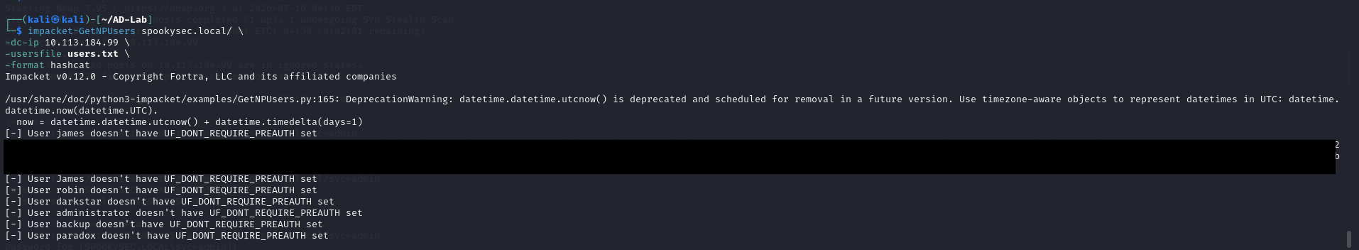
Figure 6 — AS-REP hash retrieved for a pre-auth-disabled account.

Analysis
- A hash was returned in hashcat-compatible (mode 18200) format, confirming at least one account has Kerberos pre-authentication disabled.
- This is a common misconfiguration on legacy or service accounts and requires no valid credentials to exploit — only a valid username.
- The captured hash is offline-crackable, moving the attack from network-based enumeration to offline password cracking.

7. Offline Hash Cracking
The captured AS-REP hash was cracked offline using hashcat against a password wordlist.
hashcat -m 18200 hash.txt passwordlist.txt --show
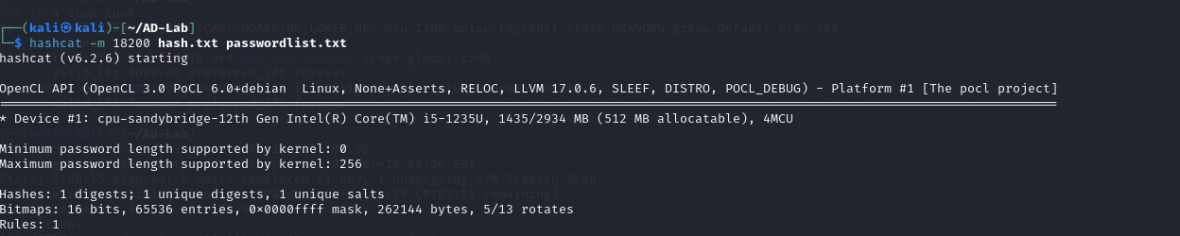
Figure 7 — Hashcat successfully cracks the AS-REP hash.

Analysis
- Mode 18200 is hashcat's AS-REP roasting mode, matching the format exported by GetNPUsers.
- A successful crack here means the account's password was present in the wordlist — evidence of a weak/guessable service account password.
- The recovered credential is the pivot point for interactive/service access to the domain in the following steps.

8. SMB Share Access and Credential Harvesting
Using the cracked credential, an SMB share was accessed to look for further sensitive files.
smbclient //10.112.181.165/backup -U spookysec.local/svc-admin
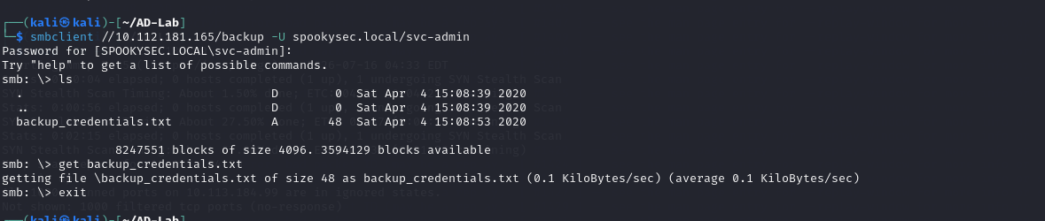
Figure 9 — Retrieving backup_credentials.txt from the backup share.

Analysis
- Authenticated access to a share named "backup" is a strong signal it holds operational or credential data rather than general file shares.
- A small file (48 bytes) is retrieved — consistent with a short stored credential rather than a document, and warrants inspection as a potential second credential.
- This demonstrates lateral movement of trust: a low-privilege AS-REP-roasted account led directly to a file share holding further secrets.

9. Domain Credential Dumping
With the harvested backup credentials, impacket-secretsdump was used to attempt extraction of domain account secrets.
impacket-secretsdump spookysec.local/backup:<credential>@10.112.181.165
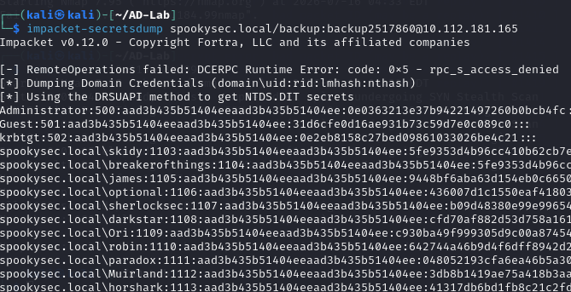
Figure 10 — NTDS secrets dumped via the DRSUAPI method.

Analysis
- A RemoteOperations/DCERPC access-denied error appears first, but the tool automatically falls back to the DRSUAPI method to pull NTDS.DIT secrets — showing resilience of the technique against partial permission restrictions.
- Successful output here means the backup account has replication rights (commonly via DCSync-capable privileges), letting an attacker dump domain-wide password hashes without touching the DC's disk directly.
- This is effectively full domain compromise: hashes for domain accounts, including privileged ones, are now available for pass-the-hash or offline cracking.

10. Administrative Access via Evil-WinRM
Using a hash recovered from the domain dump, Evil-WinRM was used to establish an authenticated PowerShell session as Administrator.
evil-winrm -i 10.112.181.165 -u Administrator -H <ntlm hash>
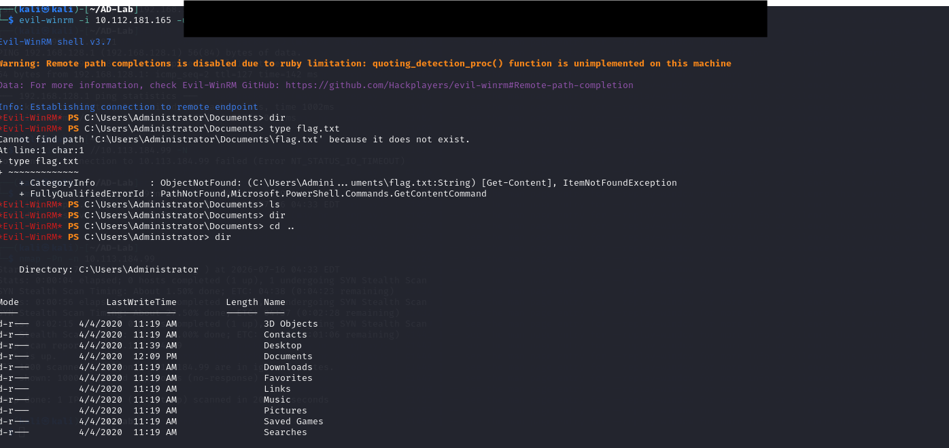
Figure 11 — Interactive Administrator shell via pass-the-hash.

Analysis
- This is a pass-the-hash authentication — no plaintext password is needed once the NTLM hash is known, which is why dumping secrets in the previous step was the critical pivot.
- Reaching an interactive Administrator PowerShell session confirms full domain admin-level compromise of the target.
- From here the session is used to browse the filesystem and locate objective files (flags/evidence) on the Desktop.

11. Evidence of Full Compromise
The Administrator and other user desktops were inspected to confirm access to protected files, evidencing successful privilege escalation to the highest level.
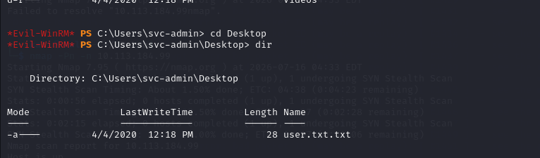
Figure 12 — svc-admin desktop contents.
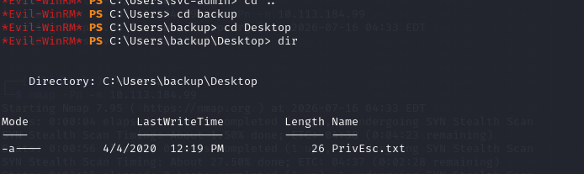
Figure 13 — Privilege escalation notes on the backup account's desktop.

Analysis
- Protected user-specific files (e.g., objective/flag files) being reachable across multiple user profiles confirms the compromised account has read access well beyond its own home directory.
- The content of the privilege-escalation note in Figure 13 has been intentionally kept masked, consistent with how it was already redacted on screen.
- Taken together, the chain — user enumeration → AS-REP roast → offline crack → SMB credential harvest → NTDS dump → pass-the-hash — represents a complete, low-noise path from zero credentials to Domain Admin.

Summary of Attack Chain
- Enumerated valid domain usernames via Kerberos pre-auth responses (Kerbrute).
- Identified an account with pre-authentication disabled and captured its AS-REP hash (GetNPUsers).
- Cracked the hash offline to recover a working password (Hashcat).
- Used that credential to access an SMB share and harvest a second, higher-value credential.
- Used the harvested credential to dump domain-wide password hashes (secretsdump).
- Used a dumped NTLM hash to pass-the-hash into an Administrator session (Evil-WinRM).
- Confirmed full compromise by accessing protected files across multiple user profiles.

