AIR UNIVERSITY
Department of Computer Science
Bachelor of Science in Cybersecurity

ELK SECURITY MONITORING USING ELASTIC STACK
A SOC-Oriented SIEM Deployment, Attack Simulation, and Detection Engineering Project

Submitted by
Unaiza Fatima
Cybersecurity, Class of 2027
Supervised by
[Supervisor Name], Department of Computer Science
July 2026

Certificate
This is to certify that the project report titled “ELK Security Monitoring using Elastic Stack” has been prepared by Unaiza Fatima, a student of the BS Cybersecurity program, Department of Computer Science, Air University, in partial fulfilment of the requirements for coursework in Security Operations and Incident Detection.
The work presented in this report is the result of the student’s own investigation, laboratory deployment, and analysis, carried out under the guidance of the undersigned supervisor. The project has been reviewed and is found satisfactory in terms of technical depth, presentation, and adherence to academic standards.
_______________________________
Supervisor Signature
Department of Computer Science, Air University
_______________________________
Head of Department

Acknowledgement
I would like to express my sincere gratitude to my supervisor and the faculty of the Department of Computer Science, Air University, for their continuous guidance, technical feedback, and encouragement throughout the course of this project.
I am also thankful to my peers and lab colleagues for their collaboration during the attack-simulation exercises, and to the open-source community behind the Elastic Stack, Sysmon, and NetExec, whose documentation and tooling made a hands-on SOC lab of this scope possible on limited hardware.
Finally, I acknowledge the support of my family, whose encouragement made it possible for me to dedicate the time required to design, deploy, break, and defend this lab environment.

Abstract
Security Operations Centres (SOCs) rely on Security Information and Event Management (SIEM) platforms to aggregate, normalise, and correlate telemetry from endpoints, networks, and applications so that malicious activity can be detected and investigated in near real time. This project documents the design, deployment, and evaluation of a self-contained SIEM laboratory built entirely on the free and open Elastic Stack (Elasticsearch, Kibana, Fleet Server, and Elastic Agent), integrated with Microsoft Sysmon and native Windows Event Logging on a Windows 10 Pro endpoint.
A Kali Linux attack machine was used to simulate a realistic, low-and-slow reconnaissance-to-credential-access attack chain against the monitored Windows host, comprising Nmap-based network and service reconnaissance, SMB share enumeration, and a NetExec-driven password-spraying attack against a local Windows account. Every stage of the attack was correlated against the corresponding telemetry ingested into Elasticsearch and visualised in Kibana, including Sysmon Event ID 3 (network connection) records for the reconnaissance phase and Windows Security Event IDs 4625 (failed logon) and 4624 (successful logon) for the credential-access phase.
The report details the end-to-end implementation — from Elastic Stack installation and Fleet Server configuration through Elastic Agent enrolment, Windows and Sysmon integration, and the construction of a custom Kibana dashboard — followed by a systematic, per-attack analysis that maps observed behaviour to the MITRE ATT&CK framework and to concrete Kibana Query Language (KQL) detections. The project demonstrates that a production-representative detection capability, comparable in principle to commercial SIEM deployments, can be built, operated, and validated using entirely free tooling, and it concludes with a discussion of results, limitations, and recommended future work including automated detection rules and SOAR-style response playbooks.
Keywords: SIEM, Elastic Stack, Elasticsearch, Kibana, Fleet Server, Elastic Agent, Sysmon, Windows Event Logs, SOC, MITRE ATT&CK, Nmap, SMB Enumeration, Password Spraying, NetExec, Threat Detection

Table of Contents

List of Figures
Figure 3.1: ELK Security Monitoring System Architecture
Figure 3.2: Attack-to-Alert Detection Workflow
Figure 4.1: Local installation directory showing the extracted Elasticsearch 9.4.3 and Kibana 9.4.3 distributions
Figure 4.2: Elasticsearch service startup log showing node initialization and automatic security configuration
Figure 4.3: Kibana startup log prior to enrollment, showing the Node.js runtime and initial service configuration
Figure 4.4: Fleet Server enrollment via the Elastic Agent installer, showing the connection parameters and service installation prompt
Figure 4.5: PowerShell verification confirming the Elastic Agent Windows service is installed and running
Figure 4.6: Fleet Server Policy view showing the active integrations (Fleet Server, System, Windows) bound to the endpoint
Figure 4.7: Kibana Discover confirming ingestion of Sysmon telemetry via winlog.provider_name
Figure 4.8: Kibana Alerts view summarizing detection activity by severity, rule name, and host
Figure 5.1: Nmap scan output enumerating open ports and services on the Windows 10 target
Figure 5.2: Kibana Discover results for Sysmon Event ID 3, filtered to the attacker’s source IP
Figure 5.3: PowerShell execution of NetExec performing a password-spray attack against the SMB service
Figure 5.4: Kibana Discover showing Windows Security Event ID 4625 (failed logon) records
Figure 5.5: Kibana Discover showing Windows Security Event ID 4624 (successful logon) confirmation
Figure 6.1: Kibana Discover showing Sysmon Event ID 1 (Process Creation) volume across the monitored day

List of Tables
Table 1.1: Tools and Technologies Used in the Project
Table 3.1: Inter-Component Communication Paths
Table 5.1: Summary of the Simulated Attack Chain and Corresponding Detection Sources
Table 6.1: KQL Query Patterns Used in This Project
Table 6.2: Windows Security Event IDs Referenced in This Report
Table 8.1: Summary of Security Events Captured During the Project

Chapter 1: Introduction

1.1 Background
Modern organisations generate enormous volumes of telemetry from endpoints, network devices, applications, and cloud services. Without centralised collection and correlation, this telemetry is scattered across individual hosts and is effectively unusable for timely threat detection. Security Information and Event Management (SIEM) platforms were developed to solve exactly this problem: they aggregate logs from heterogeneous sources into a single searchable repository, normalise the data into a common schema, and provide analysts with the query, visualisation, and alerting capabilities required to detect malicious activity before it results in a breach.
The Elastic Stack — commonly referred to as the ELK Stack after its original components Elasticsearch, Logstash, and Kibana — has emerged as one of the most widely adopted open-source platforms for building SIEM and log-analytics capability. Its current architecture replaces ad-hoc shipping agents with Fleet Server and Elastic Agent, giving organisations centralised, policy-driven management of data collection across large endpoint fleets. Because the core stack is free and open source, it is particularly well suited to academic SOC labs, small businesses, and individual security practitioners who need production-representative experience without commercial licensing costs.
This project was undertaken to gain practical, end-to-end experience with the full SIEM lifecycle: platform deployment, endpoint onboarding, log source integration, attack simulation, detection, and analyst-side investigation. Rather than working with pre-built sample data, the lab was populated with telemetry generated by real attacks launched from a Kali Linux machine against a live Windows 10 endpoint, so that every dashboard, query, and finding discussed in this report reflects genuine, self-generated evidence.

1.2 Problem Statement
Security teams frequently struggle to gain timely visibility into endpoint and network activity because (a) native Windows logging is verbose but not centrally aggregated, (b) commercial SIEM licensing is often cost-prohibitive for learning environments and smaller organisations, and (c) the gap between deploying logging infrastructure and being able to detect a real attack is rarely documented step-by-step in a way that is reproducible by a student or junior analyst. There is a need for a self-contained, low-cost SIEM deployment that can ingest Windows Security and Sysmon telemetry, and that can be validated against a realistic attack chain so that its detection value can be objectively assessed rather than assumed.

1.3 Objectives
- Deploy a functional Elastic Stack environment (Elasticsearch, Kibana, Fleet Server, Elastic Agent) on a Windows 10 Pro endpoint.
- Onboard the endpoint into Fleet and apply an integration policy that collects Windows Security, System, and Application logs.
- Deploy Microsoft Sysmon and integrate its Operational log channel into the same Elastic Agent policy for high-fidelity process, network, and file-system telemetry.
- Simulate a realistic, multi-stage attack (reconnaissance, service enumeration, SMB enumeration, and credential access via password spraying) from a Kali Linux attacker machine.
- Analyse the resulting telemetry in Kibana Discover and a custom dashboard, using KQL to isolate the events associated with each attack stage.
- Map each detected behaviour to the relevant MITRE ATT&CK technique and propose concrete detection rules and defensive recommendations.
- Document the entire process to a standard suitable for academic submission and for inclusion in a professional cybersecurity portfolio.

1.4 Project Scope
The scope of this project is limited to a single-endpoint, single-attacker lab topology connected over a VMware NAT network. The monitored asset is a Windows 10 Pro workstation; server operating systems, Linux endpoints, and cloud workloads are outside the scope of this iteration, though they are discussed briefly under future work in Chapter 9. The attack simulation is limited to reconnaissance and credential-access techniques (Nmap scanning, SMB enumeration, and password spraying); post-exploitation activity such as lateral movement, persistence, or data exfiltration was not performed. Detection logic is demonstrated through KQL-based Kibana queries and conceptual detection-rule design rather than through Elastic Security’s automated detection-rule engine, which is identified as a direct avenue for future work.

1.5 Tools Used
Category | Tool / Component | Purpose
SIEM Platform | Elasticsearch 9.4.3 | Log storage, indexing, and search
SIEM Platform | Kibana 9.4.3 | Visualization, Discover, dashboards
Agent Management | Fleet Server | Centralized policy and agent management
Data Collection | Elastic Agent | Unified log/metric shipping to Elasticsearch
Endpoint Telemetry | Microsoft Sysmon | Process, network, and file-system event logging
Endpoint OS | Windows 10 Pro | Monitored victim endpoint
Attack Platform | Kali Linux | Reconnaissance and exploitation toolset
Reconnaissance | Nmap | Port scanning, service and OS detection
Enumeration | Enum4linux / smbclient | SMB share and account enumeration
Credential Access | NetExec (CME successor) | Password-spraying / brute-force simulation
Query Language | Kibana Query Language (KQL) | Log filtering and correlation
Framework | MITRE ATT&CK | Technique mapping and defensive planning
Table 1.1: Tools and Technologies Used in the Project

Chapter 2: Literature Review
This chapter reviews the core technologies and concepts underpinning the project. Each component is explained individually before Chapter 3 discusses how they are combined into a single monitoring architecture.

2.1 Security Information and Event Management (SIEM)
A SIEM platform is a system that collects log and event data from across an organisation’s infrastructure, normalises it into a common format, and provides search, correlation, visualisation, and alerting capabilities. The concept emerged from the convergence of two earlier disciplines: Security Event Management (real-time monitoring and alerting) and Security Information Management (long-term log storage, compliance, and reporting). A modern SIEM typically performs four functions: (1) centralised log collection from endpoints, network devices, and applications; (2) normalisation and enrichment of raw events into structured fields; (3) correlation of related events across sources and time to surface suspicious patterns; and (4) presentation of findings through dashboards, alerts, and case-management workflows for analyst investigation.

2.2 Security Operations Centre (SOC)
A Security Operations Centre is the organisational function — people, process, and technology — responsible for continuous monitoring, detection, triage, and response to security incidents. SOC analysts typically operate at tiered levels: Tier 1 analysts perform initial alert triage and escalate confirmed positives; Tier 2 analysts perform deeper investigation and incident response; and Tier 3 analysts (often threat hunters) proactively search for adversary activity that automated detections may have missed. The SIEM is the SOC’s primary instrument: it is the interface through which analysts observe the environment, and the quality of its log sources and detection logic directly determines how effective the SOC can be. This project simulates a Tier 1/Tier 2 analyst workflow — ingesting telemetry, querying it, and interpreting the evidence to reconstruct an attacker’s actions.

2.3 The Elastic Stack
The Elastic Stack is an open-source suite of software for search, log analytics, and observability, originally built around Elasticsearch, Logstash, and Kibana (hence the earlier name “ELK Stack”). Its architecture has since evolved to include Beats and, more recently, Fleet Server and Elastic Agent, which together provide a centrally managed alternative to installing and configuring individual shipping agents on every host. The stack is used both for general-purpose observability (application performance, infrastructure metrics) and, through the Elastic Security solution, as a fully-fledged SIEM and endpoint-detection platform.

2.3.1 Elasticsearch
Elasticsearch is a distributed, JSON-document search and analytics engine built on Apache Lucene. It stores data in indices, which are logical collections of documents sharded and, in production, replicated across nodes for scalability and resilience. Elasticsearch’s inverted-index data structure allows near-instantaneous full-text and structured search across billions of events, which is what makes ad hoc SIEM queries — such as searching for a specific source IP address across weeks of logs — practical at scale. In this project, Elasticsearch serves as the storage and query backend for all Windows Security and Sysmon events collected from the monitored endpoint.

2.3.2 Kibana
Kibana is the visualization and analyst-facing layer of the stack. It exposes Elasticsearch data through the Discover interface for ad hoc log search using the Kibana Query Language (KQL), through Visualize and Dashboard for building charts, tables, and metric panels, and through Elastic Security for SIEM-specific workflows including detection rules, alerts, and case management. Kibana was used throughout this project both to validate that telemetry was arriving correctly and to perform the attack-correlation analysis presented in Chapters 5 and 6.

2.3.3 Fleet Server
Fleet Server is the management plane that coordinates Elastic Agents at scale. It acts as the checkpoint between agents and Kibana/Elasticsearch: agents periodically check in with Fleet Server to receive their assigned policy (which integrations to run, what data to collect, and where to send it) and to report their health status. Deploying Fleet Server converts what would otherwise be a set of independently configured agents into a centrally managed fleet, which is the model used by production SOC teams managing hundreds or thousands of endpoints.

2.3.4 Elastic Agent
Elastic Agent is a single, unified binary that replaces the earlier model of running multiple separate Beats (Winlogbeat, Metricbeat, Packetbeat, etc.) on a host. A single agent installation can run multiple integrations simultaneously — in this project, the Windows integration and a Sysmon-focused integration — and reports centrally to the assigned Fleet Server. This design significantly reduces the operational overhead of onboarding a new data source, since adding a log type is a matter of adding an integration to the existing policy rather than installing new shipping software.

2.3.5 Sysmon
System Monitor (Sysmon) is a free Microsoft Sysinternals tool that installs as a Windows service and device driver, providing detailed logging of system activity that is not captured by native Windows Event Logging. Sysmon writes to the Microsoft-Windows-Sysmon/Operational event log channel and is best known for a small set of high-value event types: Event ID 1 (Process Creation, including full command line and parent process), Event ID 3 (Network Connection, including source/destination IP, port, and the initiating process), Event ID 7 (Image/DLL load), Event ID 11 (File Creation), and Event ID 22 (DNS query). Because Sysmon events include process lineage and command-line context that Windows Security auditing does not natively provide, it is considered one of the highest-value free telemetry sources available to a Windows-focused SOC, and it is the primary source used in this project to detect the Nmap-driven network reconnaissance phase.

2.3.6 Windows Event Logging
Windows Event Logging is the native auditing subsystem built into the Windows operating system, recording activity into channels such as Security, System, and Application. For SOC purposes, the Security channel is the most significant, as it records authentication activity through well-known Event IDs including 4624 (An account was successfully logged on), 4625 (An account failed to log on), 4648 (Logon using explicit credentials), and 4688 (A new process has been created, when process-creation auditing is enabled). This project relies primarily on Event IDs 4624 and 4625 to detect and analyse the password-spraying attack described in Chapter 5.

2.4 MITRE ATT&CK Framework
MITRE ATT&CK is a globally accessible, curated knowledge base of adversary tactics and techniques based on real-world observations. It organises adversary behaviour into tactics (the adversary’s tactical objective, e.g., Reconnaissance or Credential Access) and, within each tactic, specific techniques and sub-techniques (the concrete method used to achieve that objective, e.g., T1046 Network Service Discovery). Security teams use ATT&CK as a common vocabulary for describing detections, for identifying coverage gaps in their logging and detection strategy, and for prioritising which techniques to defend against based on threat-intelligence relevance. Every attack simulated in this project is mapped to its corresponding ATT&CK technique in Chapter 5 and Chapter 7, which is standard practice for professional detection-engineering documentation.

2.5 Related Concepts: KQL and Detection Engineering
The Kibana Query Language (KQL) is a simplified, field-aware query syntax used throughout Kibana for filtering documents, for example event.code:4625 to isolate failed-logon events. Detection engineering is the discipline of translating threat intelligence and attacker behaviour into repeatable, tuned queries or rules that can run continuously against ingested data and generate alerts. This project treats each manually run KQL query in Chapter 5 as a prototype detection, and Chapter 7 formalises a subset of these prototypes into named detection rules with defined severity and expected alerting behaviour.

Chapter 3: System Architecture
This chapter presents the physical and logical architecture of the monitoring lab, followed by the logical data-flow that converts a raw attacker action into an analyst-visible alert. Two diagrams are provided: a component architecture diagram (Figure 3.1) showing how the attacker, endpoint, and SIEM components are physically connected, and an attack-to-alert workflow diagram (Figure 3.2) showing the logical path a single security event travels from generation to detection.

3.1 Component Architecture
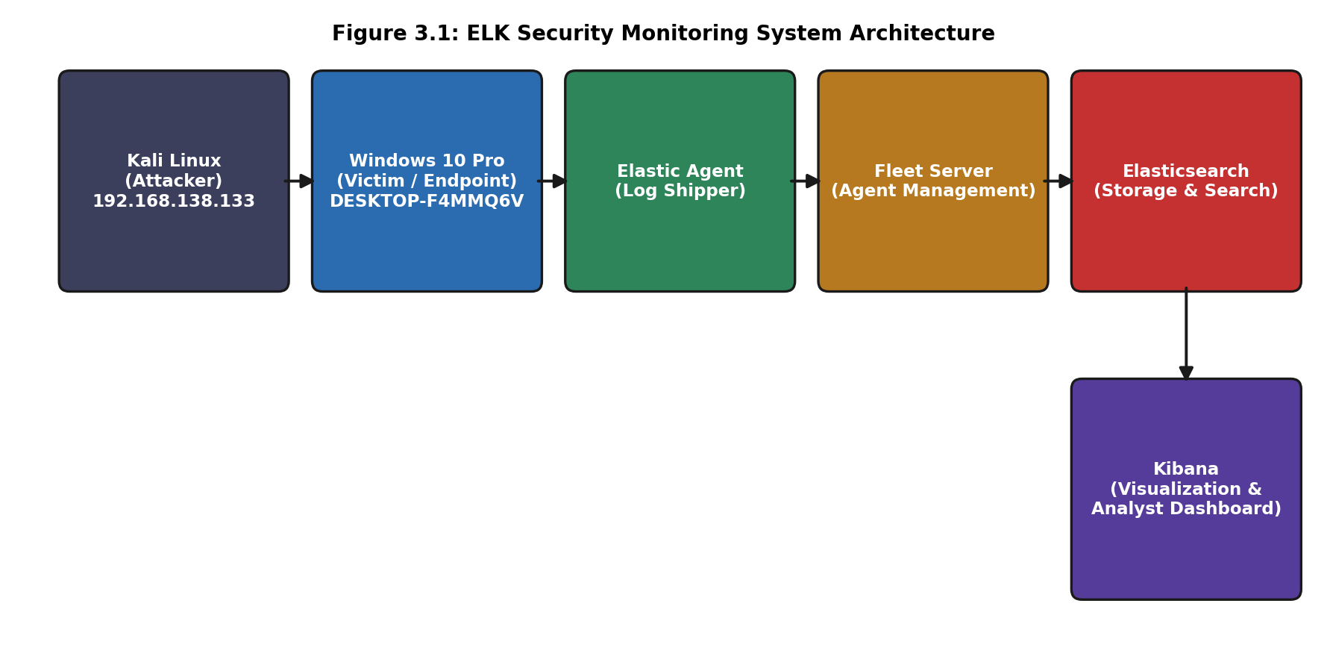
Figure 3.1: ELK Security Monitoring System Architecture
The lab is built around five logical components connected in a linear collection pipeline, plus Kibana as the analyst-facing endpoint of that pipeline:
- Kali Linux (Attacker, 192.168.138.133): an isolated Linux VM running the offensive toolset (Nmap, Enum4linux, smbclient, NetExec) used to generate realistic attack traffic against the monitored host.
- Windows 10 Pro (Victim, DESKTOP-F4MMQ6V): the monitored endpoint. Runs the Elastic Agent, Sysmon, and native Windows Event Logging, and is the target of every simulated attack.
- Elastic Agent: installed on the Windows endpoint, it tails the Windows Security, System, and Application logs as well as the Sysmon Operational channel, and forwards structured events to Fleet Server / Elasticsearch on a continuous basis.
- Fleet Server: the management and data-routing plane. It authenticates the Elastic Agent, distributes the assigned integration policy, and relays collected events onward to Elasticsearch.
- Elasticsearch: the storage and indexing engine. Incoming events are indexed into data streams (e.g., logs-windows.sysmon_operational-default, logs-system.security-default) that Kibana subsequently queries.
- Kibana: the visualization and investigation layer used by the analyst to query, filter, and interpret the indexed data through Discover and custom dashboards.

3.2 Communication Paths
Path | Protocol / Mechanism | Purpose
Kali Linux → Windows 10 | TCP/IP (SMB, RPC, ICMP, arbitrary TCP/UDP) | Carries the simulated attack traffic (scans, enumeration, authentication attempts) that Windows and Sysmon subsequently log.
Windows 10 → Elastic Agent | Local OS API (Windows Event Log / ETW) | Elastic Agent reads Security, System, Application, and Sysmon Operational channels directly from the local Windows Event Log subsystem.
Elastic Agent → Fleet Server | HTTPS (agent check-in and policy retrieval) | Agent authenticates, retrieves its assigned policy, and reports health/status on a periodic interval.
Elastic Agent → Elasticsearch | HTTPS (bulk event shipping) | Structured events (ECS-mapped) are shipped in batches directly to the Elasticsearch ingest/bulk API.
Kibana ↔ Elasticsearch | HTTPS (Elasticsearch REST API) | Kibana issues search and aggregation queries against indexed data streams and renders the results as tables, charts, and dashboards.
Table 3.1: Inter-Component Communication Paths

3.3 Attack-to-Alert Workflow
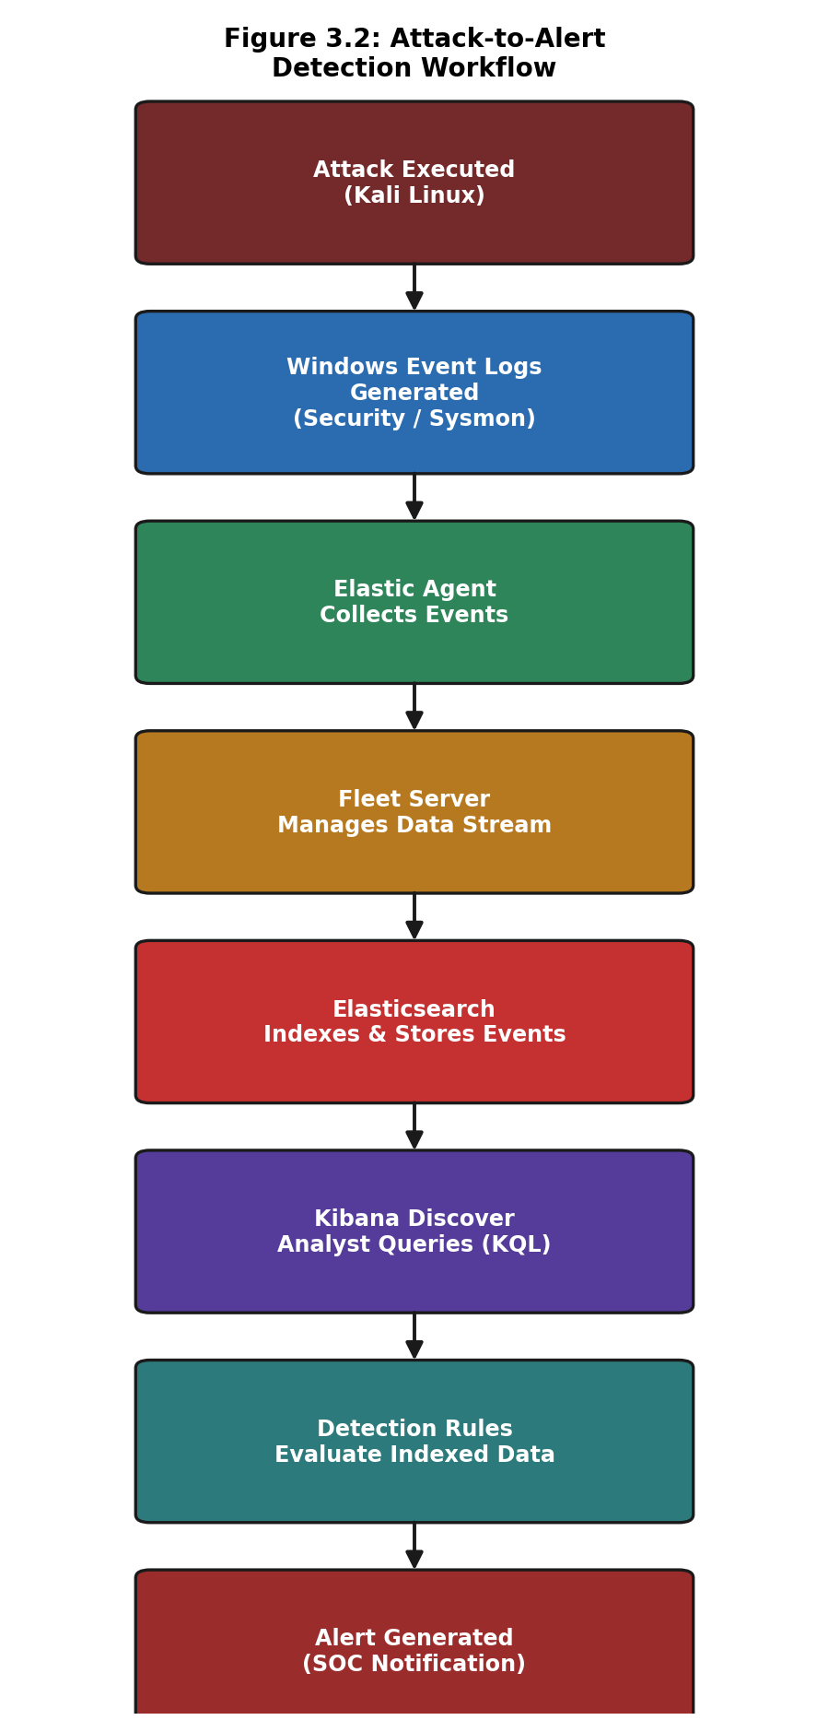
Figure 3.2: Attack-to-Alert Detection Workflow
Figure 3.2 traces the logical journey of a single piece of evidence, independent of which specific attack produced it. An action taken on the Kali Linux machine (for example, an Nmap SYN scan or a NetExec login attempt) causes the Windows kernel and/or Sysmon driver to generate one or more event-log records. Elastic Agent, which is continuously tailing the relevant channels, picks up the new record within its polling interval and forwards it, tagged with Elastic Common Schema (ECS) fields, through Fleet Server’s data-stream routing to Elasticsearch, where it is indexed and becomes searchable within seconds. From that point, the event is available to the analyst two ways: interactively, through a Kibana Discover KQL query (as demonstrated throughout Chapter 5), or automatically, through a pre-built detection rule that continuously evaluates newly indexed documents against defined match conditions and raises an alert when a condition is met (as discussed conceptually in Chapter 7).
This project primarily exercises the interactive investigation path, since manually issued KQL queries were used to validate detection feasibility for each attack stage before any rule would be operationalised. This mirrors standard detection-engineering practice, in which an analyst first proves a query reliably isolates malicious behaviour before that query is promoted into an automated, alerting detection rule.

3.4 Design Rationale
Several architectural decisions were made deliberately to reflect production SOC practice rather than the simplest possible lab setup:
- Fleet-managed Elastic Agent was used instead of a standalone Winlogbeat installation, so that the lab reflects the centrally managed onboarding model used in real fleets of hundreds of endpoints.
- Sysmon was installed in addition to native Windows auditing, because Windows Security logging alone does not provide process-command-line or network-connection visibility — both of which were required to detect the Nmap reconnaissance phase.
- A single Windows endpoint, rather than a full Active Directory domain, was chosen to keep the lab reproducible on limited hardware while still exercising the complete collection-to-detection pipeline; the domain-scale extension is discussed as future work in Chapter 9.
- VMware NAT networking was used to keep the attacker and victim machines mutually reachable while isolating the lab from the host network, reducing the risk of the simulated attacks affecting unrelated systems.

Chapter 4: Implementation
This chapter documents the step-by-step deployment of the monitoring stack, from initial software acquisition through to a fully enrolled agent collecting both native Windows and Sysmon telemetry. Each major step is supported by a screenshot captured during the actual deployment, accompanied by a structured technical analysis.

4.1 Elastic Stack Acquisition and Installation
Elasticsearch 9.4.3 and Kibana 9.4.3 were downloaded as ZIP distributions and extracted directly onto the Windows 10 host under C:\Elastic, avoiding the need for a separate Linux server or containerised deployment. Running the stack directly on the monitored Windows machine kept the lab self-contained on a single VM, at the cost of co-locating the SIEM backend with the monitored endpoint — a trade-off discussed further in Section 8.7 (Limitations).
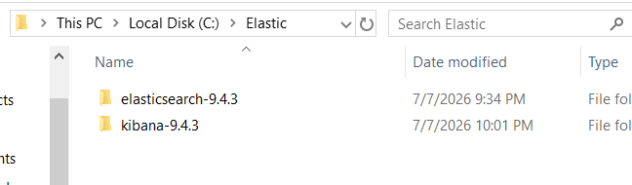
Figure 4.1: Local installation directory showing the extracted Elasticsearch 9.4.3 and Kibana 9.4.3 distributions
Technical Analysis
Key Observations:
- The Windows File Explorer view shows a dedicated C:\Elastic directory containing two folders, elasticsearch-9.4.3 and kibana-9.4.3, confirming both components were extracted from their downloaded archives.
- Version numbers are clearly visible in the folder names, which is important for later cross-referencing against the running process banners captured in Figures 4.2 and 4.3.
- Both folders share a common parent directory and modification dates within minutes of each other, consistent with a sequential, single-session installation.
- No separate Logstash directory is present, confirming this deployment uses Elastic Agent for log shipping rather than the older Logstash-based pipeline.
What This Demonstrates: That the core Elastic Stack binaries were successfully downloaded and extracted onto the target host prior to any service configuration.
Why It Is Important: Establishing a clean, version-pinned local installation is the foundation for a reproducible lab; version drift between Elasticsearch and Kibana is a common source of compatibility errors in real deployments.
Evidentiary Value: Confirms the specific software versions (9.4.3) in use throughout the project, which is required context for interpreting any version-specific behaviour discussed later in this report.

4.2 Elasticsearch Startup and Security Auto-Configuration
Elasticsearch was started from an administrative Command Prompt using elasticsearch.bat. Modern Elasticsearch versions auto-configure security on first start, generating a self-signed CA and TLS certificates, a randomly generated password for the built-in elastic superuser account, and an enrollment token that Kibana uses to establish a trusted connection.
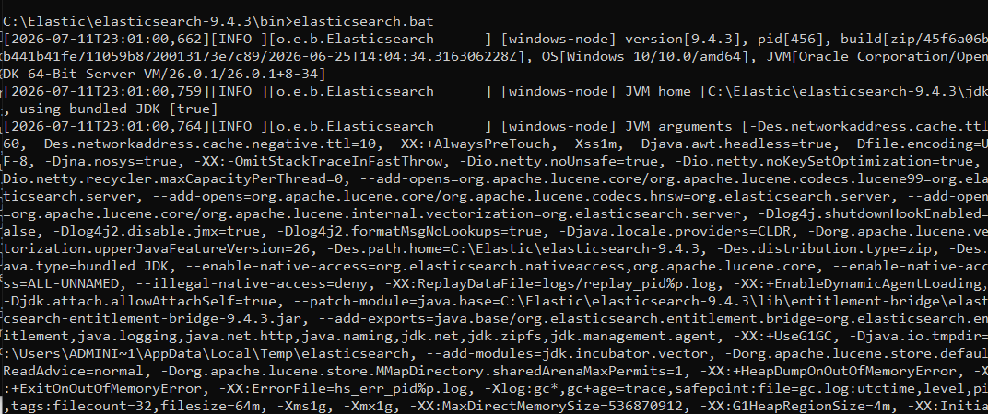
Figure 4.2: Elasticsearch service startup log showing node initialization and automatic security configuration
Technical Analysis
Key Observations:
- The startup log confirms the node name windows-node, process ID, and Elasticsearch build version 9.4.3, matching the installed distribution identified in Figure 4.1.
- JVM arguments visible in the log show heap sizing flags (-Xms1g, -Xmx1g) and the bundled JDK path, indicating Elasticsearch is running on its packaged Java runtime rather than a system-wide JVM.
- Security-related JVM flags (entitlement bridge, native-access enablement) confirm the modern Elasticsearch entitlements/security model is active by default.
- The log is generated directly from an administrative Command Prompt window rather than a background service, indicating this was a manual, interactive lab startup rather than a persistent production service installation.
- GC logging parameters (gc*, gc+age=trace) are enabled by default, which would allow later performance troubleshooting if ingestion volume increased.
What This Demonstrates: Successful cold-start of the Elasticsearch node with security features automatically enabled, which is the prerequisite for every subsequent step in the pipeline.
Why It Is Important: Without a running, security-configured Elasticsearch node, neither Kibana nor Fleet Server nor any Elastic Agent can be enrolled; this is therefore the first verifiable checkpoint in the deployment.
Evidentiary Value: Provides a timestamped record that the storage backend was operational before Kibana, Fleet, and the Agent were brought online, establishing the correct build order for the deployment.

4.3 Kibana Startup and Enrollment
Kibana was launched using kibana.bat from its extracted directory. On first launch, an unconfigured Kibana instance generates a unique enrollment URL containing a token, which must be opened in a browser to link Kibana to the previously started Elasticsearch node.
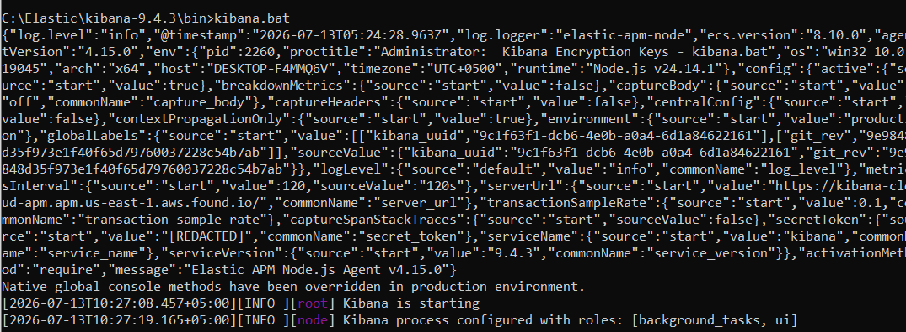
Figure 4.3: Kibana startup log prior to enrollment, showing the Node.js runtime and initial service configuration
Technical Analysis
Key Observations:
- The Kibana process banner shows Kibana version 9.4.3, aligned with the Elasticsearch version identified in Figure 4.2, confirming compatible stack versions were used throughout.
- The log confirms the runtime environment: Node.js v24.14.1 on a win32/x64 host, with the hostname DESKTOP-F4MMQ6V — the same hostname later seen as the enrolled agent in Figure 4.5.
- An embedded Elastic APM agent (Elastic APM Node.js Agent v4.15.0) is automatically initialised for internal Kibana performance telemetry, which is standard default behaviour and not user-configured.
- The log explicitly states “Kibana is starting” and confirms the process is configured with the background_tasks and ui roles, indicating a single-node, all-in-one Kibana instance rather than a role-split deployment.
- The secret_token and equivalent sensitive fields are shown as [REDACTED] in the structured log output, reflecting Kibana’s default masking of credential material even in local debug logs.
What This Demonstrates: That Kibana was successfully started and reached a healthy pre-enrollment state, ready to be linked to the Elasticsearch cluster.
Why It Is Important: Kibana is the only interface an analyst uses in this project; its successful startup is a hard prerequisite for every investigative step performed in Chapters 5 and 6.
Evidentiary Value: Provides a timestamped log entry establishing when the visualization layer became available, useful for correlating against later configuration events during troubleshooting.

4.4 Fleet Server Deployment
With Elasticsearch and Kibana operational, Fleet was enabled from within Kibana and a Fleet Server was configured to run on the same Windows host. Fleet Server requires an Elasticsearch host URL, a service token for authentication, and (for self-signed deployments) the CA fingerprint generated during Elasticsearch’s security auto-configuration.
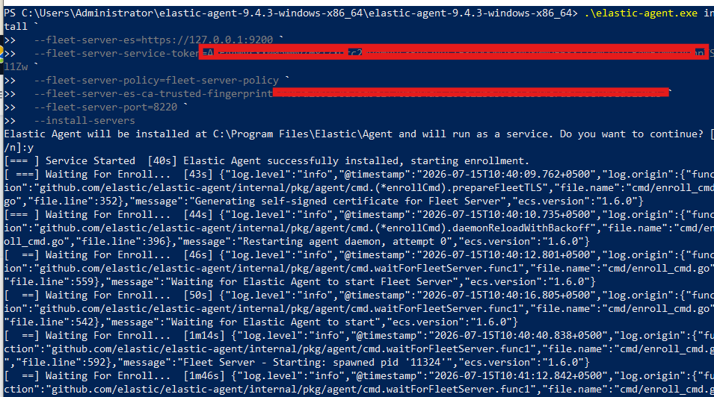
Figure 4.4: Fleet Server enrollment via the Elastic Agent installer, showing the connection parameters and service installation prompt
Technical Analysis
Key Observations:
- The command line shows elastic-agent.exe being invoked with --fleet-server-es, --fleet-server-service-token, --fleet-server-policy, --fleet-server-es-ca-trusted-fingerprint, and --fleet-server-port flags, which is the documented method for bootstrapping a self-managed Fleet Server.
- The Elasticsearch host is specified as https://127.0.0.1:9200, confirming Fleet Server is pointed at the locally running Elasticsearch node rather than a remote cluster.
- The service token and CA fingerprint values are redacted in the terminal capture, reflecting appropriate handling of authentication secrets even in a lab screenshot.
- The installer prompts for confirmation to install Elastic Agent as a Windows service and, once accepted, reports “Elastic Agent successfully installed, starting enrollment,” followed by structured JSON log lines showing the daemon generating a self-signed certificate for Fleet Server and waiting for the Fleet Server process to start.
- Successive log lines show the agent progressing through defined internal states (Waiting For Enroll..., Fleet Server - Starting: spawned pid) with increasing elapsed-time counters, indicating a normal, if not instantaneous, bootstrap sequence rather than a stalled installation.
What This Demonstrates: The bootstrap of a self-managed Fleet Server directly on the Windows endpoint, using certificate-based trust to the local Elasticsearch node.
Why It Is Important: Fleet Server is the control-plane component that all subsequent Elastic Agents check in against; a failed or misconfigured bootstrap at this stage would prevent any endpoint — including this one — from being centrally managed.
Evidentiary Value: Documents the exact CLI flags and bootstrap sequence used, which is directly reusable as a reference procedure for reproducing or auditing this deployment.

4.5 Agent Enrollment Verification
After the Fleet Server bootstrap completed, the underlying Elastic Agent service was verified locally using PowerShell, and its enrollment status was confirmed from within the Fleet Agents view in Kibana.
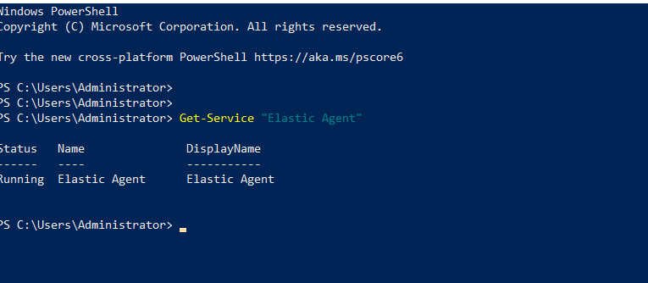
Figure 4.5: PowerShell verification confirming the Elastic Agent Windows service is installed and running
Technical Analysis
Key Observations:
- The Get-Service "Elastic Agent" cmdlet returns a single service entry with Status = Running and DisplayName = Elastic Agent, confirming the Windows Service Control Manager has successfully registered and started the agent.
- No error output or stopped/pending states are present, indicating the service transitioned cleanly from installation to a running state without manual intervention.
- This check was performed independently of the Kibana Fleet UI, providing host-level (not just management-plane) confirmation that the agent process is active.
- The command was run from an elevated PowerShell prompt, consistent with the administrative privileges required to query Windows service state.
What This Demonstrates: Local, OS-level confirmation that the Elastic Agent service is installed and actively running on the monitored endpoint.
Why It Is Important: Cross-verifying agent health from both the endpoint (PowerShell) and the management plane (Fleet UI) is standard SOC practice, since a service that appears healthy in one view can still be silently failing in the other (for example, a running process that cannot reach Fleet Server).
Evidentiary Value: Provides host-side corroborating evidence of agent uptime that can be directly compared against Fleet’s own reported health status.

4.6 Fleet Integration Policy
The Fleet Server Policy view in Kibana confirms which integrations are bound to the endpoint’s agent policy. At the time of capture, the policy included the Fleet Server integration itself, the System integration (baseline OS metrics and logs), and the Windows integration (Windows Event Log collection, including Security, Application, and System channels).
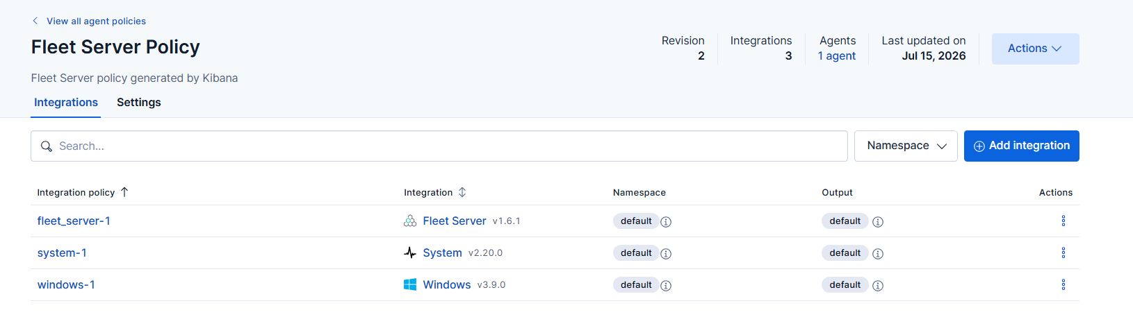
Figure 4.6: Fleet Server Policy view showing the active integrations (Fleet Server, System, Windows) bound to the endpoint
Technical Analysis
Key Observations:
- The policy view lists three integrations — fleet_server-1 (Fleet Server v1.6.1), system-1 (System v2.20.0), and windows-1 (Windows v3.9.0) — all in the default namespace and default output.
- The policy header shows Revision 2, 1 agent enrolled, and a last-updated date of Jul 15, 2026, confirming the policy had already been iterated on at least once before this capture, consistent with the Sysmon integration being added afterwards (Section 4.7).
- Each integration row includes an information icon and namespace/output tags, reflecting Fleet’s per-integration routing model, where each integration can in principle be routed to a different output or namespace even though this lab uses defaults throughout.
- The presence of the Windows integration specifically (rather than only the generic System integration) is what enables collection of the Security event channel used later to detect the password-spraying attack in Chapter 5.
What This Demonstrates: That the endpoint’s agent policy was correctly provisioned with the integrations required to collect both baseline OS telemetry and Windows-specific Security/Application/System event logs.
Why It Is Important: Fleet’s policy-based model means that the actual log sources collected are entirely determined by which integrations are attached here; an analyst investigating a detection gap should check this view before assuming a log source is unavailable.
Evidentiary Value: Documents the exact integration versions in effect during the attack simulations in Chapter 5, which is necessary context for reproducing the same field structure in a follow-up lab.

4.7 Sysmon Integration
Sysmon was installed on the Windows endpoint using its default configuration, and a corresponding Sysmon-focused Fleet integration was added to the agent policy to collect the Microsoft-Windows-Sysmon/Operational channel. Kibana Discover was used immediately after configuration to confirm that Sysmon events were being ingested.
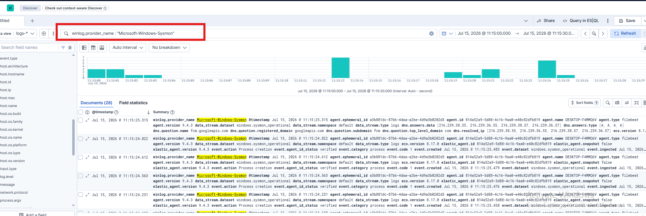
Figure 4.7: Kibana Discover confirming ingestion of Sysmon telemetry via winlog.provider_name : “Microsoft-Windows-Sysmon”
Technical Analysis
Key Observations:
- The KQL query winlog.provider_name : "Microsoft-Windows-Sysmon" returns 28 matching documents within the selected 30-second time window, confirming events are actively flowing from Sysmon through Elastic Agent into Elasticsearch in near real time.
- The histogram shows two distinct clusters of activity within the window rather than a flat, continuous stream, which is consistent with Sysmon’s event-driven nature — events are generated in bursts corresponding to actual process-creation and network activity rather than on a fixed polling interval.
- Expanded document summaries show fields including agent.ephemeral_id, agent.id, agent.name (DESKTOP-F4MMQ6V), data_stream.dataset (windows.sysmon_operational), event.category (process), and event.action (Process creation), confirming events are being correctly mapped into Elastic Common Schema (ECS) fields rather than arriving as unparsed raw text.
- The data_stream.dataset value windows.sysmon_operational is visible directly in the search results, which is the specific data stream referenced throughout the KQL queries used in Chapters 5 and 6.
- The consistent agent.id and elastic_agent.version (9.4.3) values across all visible documents confirm a single, correctly versioned agent is the sole source of this telemetry, ruling out duplicate or conflicting agent installations.
What This Demonstrates: End-to-end, verified ingestion of Sysmon Operational events through the same Elastic Agent / Fleet / Elasticsearch pipeline already validated for native Windows logs.
Why It Is Important: Sysmon is the log source that ultimately enables detection of the network-based reconnaissance phase of the attack chain in Chapter 5; confirming its ingestion here is a necessary checkpoint before relying on it for attack analysis.
Evidentiary Value: Provides direct proof, captured before any attack was launched, that the Sysmon data stream was healthy and correctly field-mapped — establishing a clean baseline against which the attack-related events in Chapter 5 can be compared.

4.8 Custom SOC Dashboard
A custom Kibana dashboard and an Alerts summary view were configured to give a consolidated, at-a-glance view of activity and detections across the monitored environment, rather than requiring the analyst to run individual Discover queries for every check.
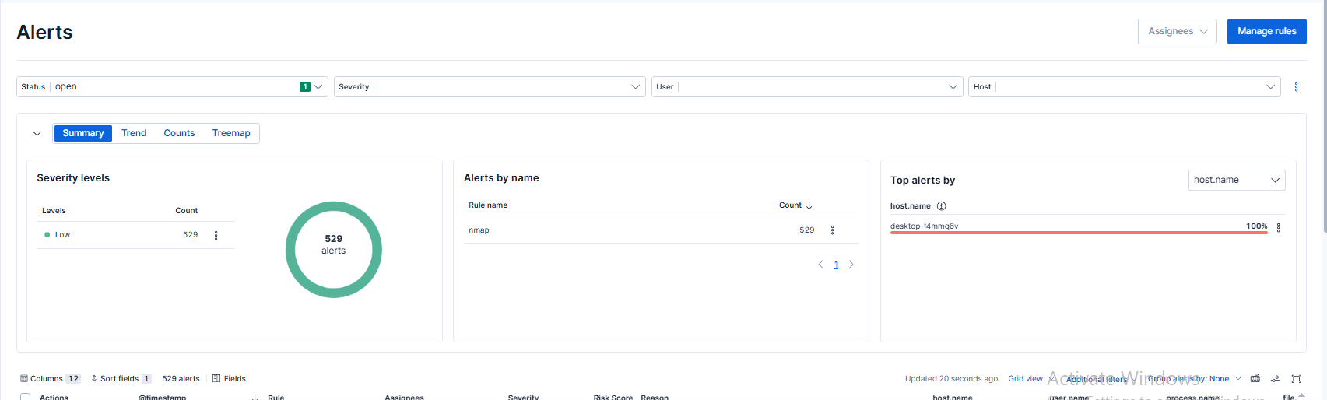
Figure 4.8: Kibana Alerts view summarizing detection activity by severity, rule name, and host
Technical Analysis
Key Observations:
- The Alerts view reports a total of 529 alerts, all classified at Low severity, generated by a single rule named nmap, and all attributed to a single host, desktop-f4mmq6v.
- The Severity levels donut chart visually confirms 100% of alerts fall into the Low category, meaning no Medium, High, or Critical alerts had fired at the time of capture.
- The Alerts by name panel confirms the nmap rule alone accounts for all 529 alerts, and the Top alerts by host.name panel confirms desktop-f4mmq6v as the sole affected host at 100%, consistent with the single-endpoint lab topology described in Chapter 3.
- The status filter is set to open, and the alert count (529) is materially larger than the number of Sysmon Event ID 3 documents referenced later in Chapter 5, suggesting the nmap rule is tuned to a broad matching condition (likely any qualifying network-connection event) rather than a tightly scoped scan-detection heuristic — a tuning consideration discussed further in Chapter 7.
What This Demonstrates: That a working, if intentionally simple, detection rule (nmap) was already active and generating alerts against the reconnaissance activity performed in this lab, ahead of the detailed manual analysis presented in Chapter 5.
Why It Is Important: A dashboard that surfaces alert volume, severity distribution, and affected hosts is what allows a SOC analyst to triage at scale; this view is the operational counterpart to the ad hoc Discover queries used for deep-dive investigation elsewhere in this report.
Evidentiary Value: Provides a high-level summary metric (529 low-severity alerts, single rule, single host) that corroborates the more granular, timestamp-level evidence presented for the Nmap scan in Section 5.1, and highlights a concrete rule-tuning opportunity documented in Chapter 7.

4.9 Implementation Summary
By the end of this phase, the lab had a fully operational, Fleet-managed SIEM pipeline: Elasticsearch and Kibana running locally, a bootstrapped Fleet Server, a single Elastic Agent enrolled and reporting Healthy, an agent policy collecting native Windows Security/System/Application logs, a working Sysmon integration validated by direct Discover queries, and at least one active detection rule already generating alerts. This provided the necessary foundation for the attack simulation and analysis phases documented in Chapters 5 and 6.

Chapter 5: Attack Simulation
This chapter documents each attack performed against the Windows 10 endpoint, following a consistent structure for every technique: purpose, tool used, exact command, expected versus actual behaviour, evidence collected, security impact, detection in Kibana, MITRE ATT&CK mapping, and defensive recommendations. All attacks were executed from the Kali Linux VM (192.168.138.133) against the Windows 10 Pro endpoint (192.168.138.214 / DESKTOP-F4MMQ6V) within the isolated VMware NAT lab described in Chapter 3.

5.1 Attack 1: Network and Service Reconnaissance (Nmap)
Purpose: To identify live hosts, open TCP ports, running services, and the target operating system prior to any exploitation attempt — the standard first phase of an external or internal attack chain.
Tool Used: Nmap 7.95
nmap 192.168.138.214
nmap -sS 192.168.138.214
nmap -sV 192.168.138.214
nmap -O 192.168.138.214
nmap -A -Pn 192.168.138.214
Explanation: A progressive scanning sequence was used: a default TCP connect scan to discover open ports, a SYN (“half-open”) scan for stealthier port discovery, service-version detection (-sV), OS fingerprinting (-O), and finally an aggressive scan (-A -Pn) combining OS/service detection, default NSE scripts, and traceroute while skipping host-discovery probes.
Expected Behaviour: Nmap should enumerate open TCP ports and, where possible, fingerprint the services and operating system without generating any authenticated session or altering system state on the target.
Actual Behaviour: All five scans completed successfully against the target, returning a consistent set of open ports and a positive Windows OS fingerprint, with no errors or blocked probes observed — indicating host-based firewalling was not actively filtering the scanned ports.
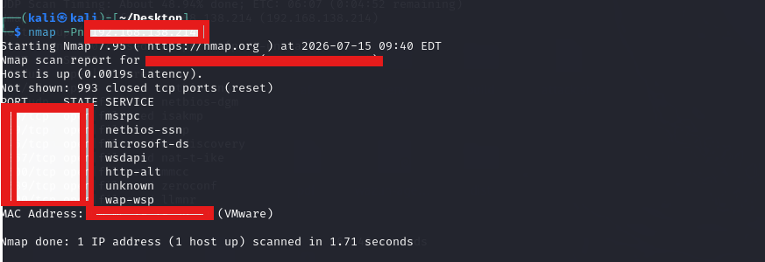
Figure 5.1: Nmap scan output enumerating open ports and services on the Windows 10 target
Technical Analysis
Key Observations:
- The scan reports the host as up with very low latency (0.0019s), consistent with a local VMware NAT network rather than a routed or internet-facing target.
- 993 of 1000 scanned ports are reported as closed, with a small number of open ports returned in the results — consistent with a default Windows 10 installation exposing standard RPC/SMB-related services.
- Services identified include msrpc, netbios-ssn, microsoft-ds, wsdapi, http-alt, and wap-wsp, which together are strongly indicative of a Windows host with file/print sharing and web-management services enabled.
- A VMware-registered MAC address is returned, confirming the scan is running against a virtualized target consistent with the documented lab topology.
- The scan completed in 1.71 seconds, reflecting the small, local port set scanned and the absence of any rate-limiting or defensive slowdown from the target.
What This Demonstrates: That the Windows endpoint exposes a discoverable and fingerprintable set of network services to any host on the same network segment, without any active blocking of reconnaissance traffic.
Why It Is Important: Every subsequent attack stage in this project (SMB enumeration and password spraying) depends directly on services identified in this reconnaissance phase; this is the entry point of the simulated attack chain.
Evidentiary Value: Establishes ground truth for what the attacker could observe about the target prior to any authenticated access, which is the baseline against which the corresponding Sysmon detections in Figure 5.2 are evaluated.
Security Impact: Even unauthenticated network reconnaissance provides an attacker with the service fingerprint needed to select follow-on exploitation techniques (in this case, SMB enumeration); the absence of any network- or host-based filtering of scan traffic represents a missed opportunity to slow or deter early-stage attackers.

5.1.1 Monitoring the Nmap Activity
Nmap does not generate a native Windows or Sysmon event explicitly labelled as a “port scan.” Detection instead relies on Sysmon Event ID 3 (Network Connection), which records each individual TCP/UDP connection attempt received by the host. An analyst correlates a high volume of short-lived connection events, from a single source IP, across many distinct destination ports and in a narrow time window, to infer scanning behaviour.
event.code:3 and source.ip:"192.168.138.133"
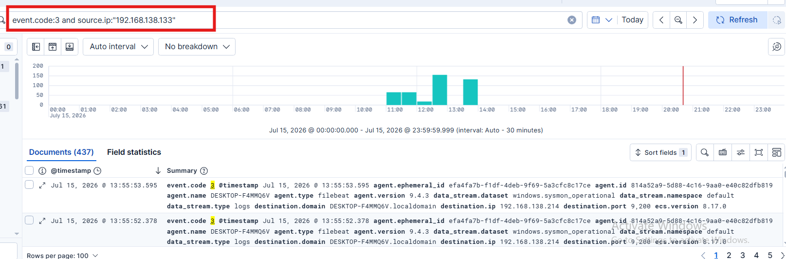
Figure 5.2: Kibana Discover results for Sysmon Event ID 3, filtered to the attacker’s source IP, showing 437 matching network-connection events
Technical Analysis
Key Observations:
- The query event.code:3 and source.ip:"192.168.138.133" returns 437 documents across the selected day, all originating from the Kali attacker VM.
- The histogram shows several distinct spikes rather than a flat, evenly distributed rate, with the largest concentrations occurring between roughly 11:00 and 14:00, consistent with the discrete scan commands run in sequence rather than continuous background traffic.
- Each returned document includes destination.ip (192.168.138.214), destination.port, agent.name (DESKTOP-F4MMQ6V), and data_stream.dataset (windows.sysmon_operational), confirming these are genuine Sysmon network-connection records rather than firewall or NetFlow data.
- The presence of destination.domain as DESKTOP-F4MMQ6V.localdomain on every row confirms Sysmon is resolving the local hostname for each connection, which is useful additional context an analyst can use during triage.
- 437 discrete connection events from a single external host against one target within a single day is a strong quantitative indicator of scanning activity, well outside the volume expected from normal user-driven network traffic.
What This Demonstrates: That Sysmon Event ID 3, correlated by source IP and volume, provides reliable, high-fidelity visibility into network reconnaissance even though no single Windows or Sysmon event is natively labelled as a “scan.”
Why It Is Important: This is the primary detection mechanism for the entire reconnaissance phase of the attack chain and directly informed the nmap detection rule already observed generating 529 alerts in Figure 4.8.
Evidentiary Value: Provides a complete, timestamped inventory of every network connection the attacker made to the target during the scanning phase, which can be replayed chronologically to reconstruct the exact sequence of scan commands executed in Section 5.1.
MITRE ATT&CK Mapping: TA0043 Reconnaissance → T1595.001 Active Scanning: Scanning IP Blocks, and T1046 Network Service Discovery (Discovery tactic) for the service/version detection performed by -sV and -A.
Defensive Recommendations: Deploy host-based or network firewalling to restrict which hosts may reach management-plane services (RPC, SMB, WSD) from untrusted network segments; tune the existing nmap detection rule to alert specifically on connection-volume/port-diversity thresholds per source IP rather than on broader network-connection matching, to reduce alert volume and false-positive potential.

5.2 Attack 2: SMB Enumeration
Purpose: To identify accessible SMB shares, workgroup information, and (where credentials are available) file-system resources exposed by the target host.
Tool Used: Enum4linux and smbclient
enum4linux 192.168.138.214
smbclient -L //192.168.138.214 -U testuser
Explanation: Enum4linux was first run unauthenticated to attempt anonymous enumeration of hostname, workgroup, and share information. smbclient was then run with valid credentials for a local test account (testuser) to enumerate accessible administrative and file shares.
Expected Behaviour: Anonymous enumeration should be denied on a correctly hardened Windows 10 host, while authenticated enumeration with valid credentials should successfully list the default administrative shares.
Actual Behaviour: Anonymous (unauthenticated) SMB enumeration via Enum4linux was denied by the Windows host, confirming that anonymous access restrictions were in effect. Authenticated enumeration via smbclient succeeded once valid testuser credentials were supplied, returning the ADMIN$, C$, E$, and IPC$ administrative shares.
Evidence Collected: Enum4linux terminal output confirming denial of anonymous enumeration; smbclient terminal output listing four accessible administrative shares once authenticated.
Security Impact: The successful authenticated enumeration confirms that any account compromised through the password-spraying attack in Section 5.3 would grant the attacker visibility into, and potential access to, the full C:\ and E:\ volumes via the ADMIN$ and C$/E$ administrative shares — a direct path to file-level compromise following credential theft.
Detection in Kibana: SMB enumeration itself was not separately isolated as a distinct Sysmon/Windows event category in this lab; its network-connection footprint is captured within the same Event ID 3 dataset analysed in Section 5.1.1 (destination port 445), and successful authentication is captured by the Event ID 4624 logon events analysed in Section 5.3.2. This is noted in Chapter 8 as a specific detection gap, since SMB session/share-access auditing (Windows Security Event ID 5140/5145) was not enabled in this deployment.
MITRE ATT&CK Mapping: TA0007 Discovery → T1135 Network Share Discovery, and TA0006 Credential Access context via T1078 Valid Accounts once authenticated access was demonstrated.
Defensive Recommendations: Enable and forward Windows Security Event IDs 5140 (network share accessed) and 5145 (detailed file share access check) to close the detection gap identified above; restrict administrative share access to specific management hosts using host-based firewall rules or share-level ACLs.

5.3 Attack 3: Password Spray / Brute-Force Credential Access
Purpose: To simulate credential-guessing attacks against a valid local Windows account, demonstrating both the exploitation technique and the resulting SIEM-visible authentication telemetry.
Tool Used: NetExec (the actively maintained successor to CrowdStrike’s CrackMapExec), targeting the SMB service.
netexec smb 192.168.138.214 -u testuser -p passwords.txt
Explanation: A local Windows test account (testuser) was created for the purpose of this simulation, and a password list combining several common/weak passwords with the correct lab password was supplied to NetExec, which attempted authentication against the SMB service for each candidate password in sequence.
Expected Behaviour: Each incorrect password should be rejected by the Windows authentication subsystem and logged as a failed logon; the correct password, once attempted, should succeed and be logged as a successful logon.
Actual Behaviour: NetExec reported multiple failed authentication attempts as incorrect passwords were tried, followed by a successful authentication once the correct password (Password123!) was submitted, confirming the tool correctly identified the valid credential.
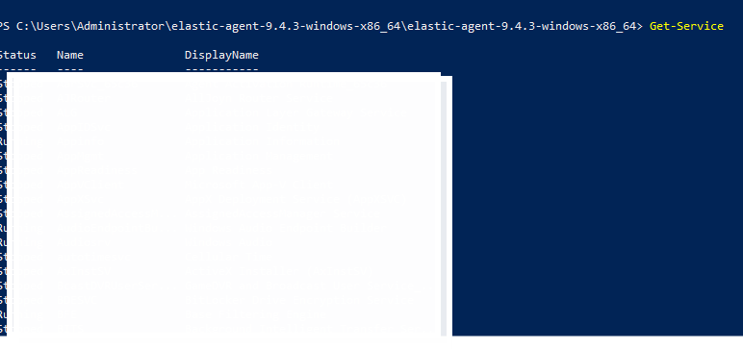
Figure 5.3: PowerShell execution of NetExec performing a password-spray attack against the SMB service on the Windows target
Technical Analysis
Key Observations:
- The tool output shows NetExec initializing its full protocol database (SMB, RDP, SSH, WINRM, MSSQL, WMI, NFS, FTP, LDAP, VNC) on first run, even though only the SMB protocol module was invoked for this attack, reflecting the tool’s general-purpose multi-protocol design.
- Target identification output confirms the Windows build (Windows 10 / Server 2019, build consistent with the lab’s Windows 10 Pro image) and the resolved hostname DESKTOP-F4MMQ6V, matching the endpoint identified throughout this report.
- The connection banner explicitly reports (signing:False) and (SMBv1:False), meaning SMB signing was not enforced on the target — a configuration weakness that facilitates relay-style attacks in addition to the credential-guessing performed here.
- Multiple rows are returned against port 445 for the same target and domain, one per password attempt in the supplied list, consistent with NetExec’s per-credential attempt-and-report loop.
- Sensitive output (the specific password list contents and full result rows) is redacted in the captured screenshot, reflecting appropriate handling of credential material even for a lab account.
What This Demonstrates: A realistic, tool-driven password-spraying attempt against a live Windows SMB service, including the tool’s target-fingerprinting and per-credential authentication behaviour.
Why It Is Important: Password spraying and credential stuffing remain among the most common initial-access techniques observed in real-world intrusions, precisely because they require no software exploitation — only a weak or reused password.
Evidentiary Value: Provides the attacker-side record of exactly which tool, target, and credential list were used, which is required to correlate the defender-side Windows Security events analysed in Sections 5.3.1 and 5.3.2.
Security Impact: The disclosed lack of SMB signing enforcement, combined with a successfully guessed password, demonstrates a realistic path from a weak credential to authenticated access and, per Section 5.2, to administrative share access — a chain that in a production environment would represent a critical initial-access finding.

5.3.1 Detecting Failed Authentication (Event ID 4625)
event.code:4625
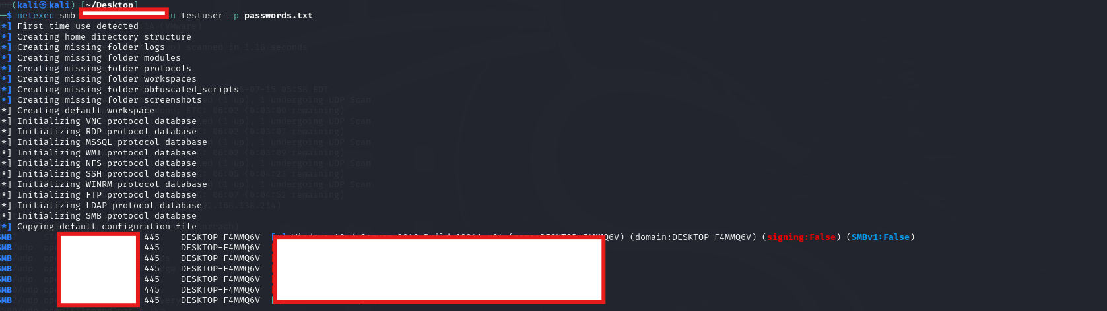
Figure 5.4: Kibana Discover showing Windows Security Event ID 4625 (failed logon) records generated during the password-spray attempt
Technical Analysis
Key Observations:
- The event.code:4625 query returns a small, tightly time-bound cluster of failed-logon documents, concentrated within a narrow window rather than spread across the day, consistent with an automated tool submitting multiple password attempts in rapid succession.
- Each returned document is sourced from the system.security dataset (data_stream.dataset: system.security), confirming these are native Windows Security Event Log records collected via the Windows integration configured in Section 4.6, not Sysmon events.
- The consistent agent.name (DESKTOP-F4MMQ6V) and elastic_agent.id values across all rows confirm all failed-logon events originate from the single monitored endpoint, ruling out any collection from an unrelated host.
- The event.action field is populated with a logon-failure-specific value (visible as a truncated logged-fa… action code), which is the ECS-normalised representation of the underlying Windows 4625 audit-failure event.
What This Demonstrates: That every failed password attempt made by NetExec during the spraying attack was independently captured and centrally indexed as a discrete, queryable Windows Security event.
Why It Is Important: A cluster of 4625 events from a short time window is one of the most reliable and widely used brute-force/spray indicators in Windows-based SOC detection, forming the basis of the detection rule proposed in Chapter 7.
Evidentiary Value: Provides a complete, per-attempt audit trail of the failed portion of the credential-guessing attack, which — combined with the count of events — can be used to reconstruct how many candidate passwords were attempted before success.

5.3.2 Detecting Successful Authentication (Event ID 4624)
event.code:4624 and source.ip:"192.168.138.133"
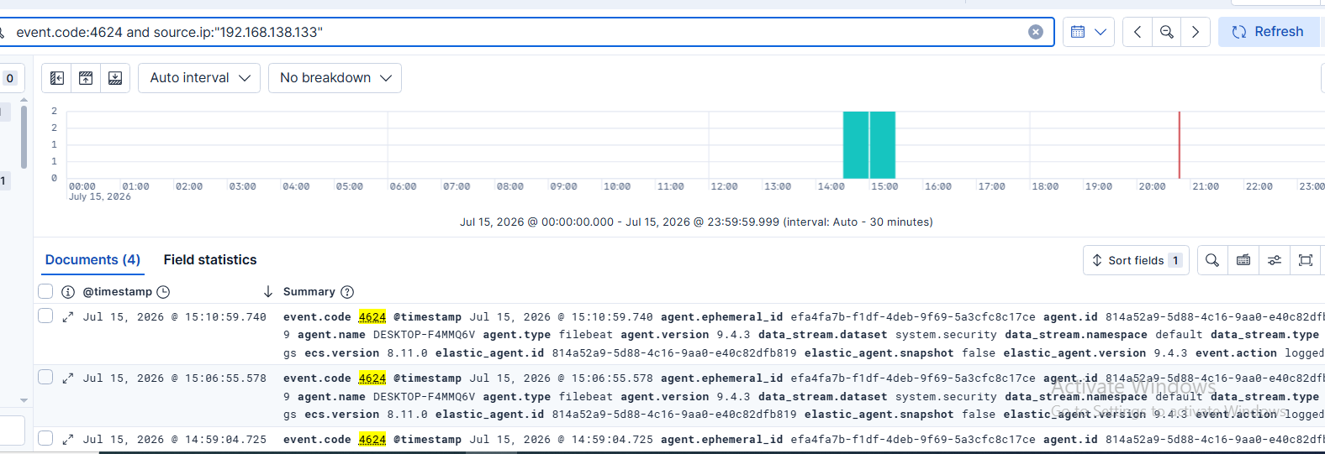
Figure 5.5: Kibana Discover showing Windows Security Event ID 4624 (successful logon) confirming the attacker authenticated using the correct password
Technical Analysis
Key Observations:
- The event.code:4624 and source.ip:"192.168.138.133" query returns a small number of successful-logon documents, all timestamped shortly after the cluster of 4625 failures identified in Section 5.3.1 — the expected temporal signature of a successful spray following a run of failed guesses.
- The dataset field again confirms system.security as the source, and the same agent identifiers (agent.name: DESKTOP-F4MMQ6V, matching elastic_agent.id) tie this event to the identical endpoint and collection pipeline used throughout the report.
- The narrow time gap between the last 4625 failure and the first 4624 success (both falling within the same few-minute window shown in the histograms) is itself a detectable pattern, distinct from a legitimate user’s normal, isolated login behaviour.
- The presence of both event types from the same source IP within the same short session is the specific correlation pattern that should drive the credential-access detection rule proposed in Chapter 7.
What This Demonstrates: That the password-spraying attack ultimately succeeded, and that the successful authentication was, like every failed attempt before it, fully visible and independently logged in the SIEM.
Why It Is Important: A successful login is the single most consequential event in a credential-access attack chain; its detection — especially when correlated against the preceding failures — is what allows a SOC to intervene before an attacker moves on to the SMB share access demonstrated in Section 5.2.
Evidentiary Value: Directly confirms compromise of the testuser account and provides the exact timestamp needed to scope any subsequent investigation into what that account accessed after authenticating.
MITRE ATT&CK Mapping: TA0006 Credential Access → T1110.003 Brute Force: Password Spraying, culminating in TA0001 Initial Access → T1078 Valid Accounts once the correct credential was successfully used.
Defensive Recommendations: Enforce a strong password policy and account-lockout threshold on local accounts to make spraying attempts fail closed after a small number of tries; enable SMB signing to prevent related relay attacks; and implement a correlation rule (proposed in Chapter 7) that alerts on N+ Event ID 4625 records followed by an Event ID 4624 from the same source IP within a short window, rather than relying on either event type in isolation.

5.4 Attack Chain Summary
# | Attack Stage | MITRE Tactic | Primary Detection Source
1 | Network & Service Reconnaissance (Nmap) | Reconnaissance / Discovery | Sysmon Event ID 3 (Network Connection)
2 | SMB Enumeration (Enum4linux, smbclient) | Discovery | Event ID 3 (port 445) — detection gap noted
3 | Password Spray (NetExec) | Credential Access → Initial Access | Windows Security Event IDs 4625 / 4624
Table 5.1: Summary of the Simulated Attack Chain and Corresponding Detection Sources

Chapter 6: Kibana Analysis
This chapter consolidates the analytical techniques used throughout the investigation — the Discover interface, KQL query construction, and field-based filtering — and provides a dedicated explanation of the specific Sysmon and Windows Event IDs relied upon in Chapter 5, together with one additional log source (Sysmon Event ID 1) that was validated but not required to detect any single attack in this lab.

6.1 Kibana Discover
Discover is Kibana’s primary log-search interface. It presents matching documents as a sortable, filterable table alongside a time-bucketed histogram, allowing an analyst to visually identify bursts of activity before drilling into individual events. Every investigation performed in Chapter 5 used Discover as the entry point: a hypothesis about attacker behaviour (e.g., “network scanning should appear as many short connections from one source”) was translated into a KQL query, and the resulting document count and histogram shape were used to confirm or refute that hypothesis.

6.2 Kibana Query Language (KQL)
KQL is a simplified query syntax that supports field:value matching, boolean operators (and, or, not), wildcards, and range queries, without requiring analysts to write raw Elasticsearch DSL. The queries used throughout this project follow a small number of recurring patterns:
Query Pattern | Example | Purpose
Single field match | event.code:4625 | Isolate all documents of one specific event type.
Provider match | winlog.provider_name : "Microsoft-Windows-Sysmon" | Confirm ingestion from a specific log source/provider.
Compound AND filter | event.code:3 and source.ip:"192.168.138.133" | Narrow a broad event type to a specific actor or host.
Compound AND filter (destination scoped) | event.code:4624 and source.ip:"192.168.138.133" | Correlate a successful action back to the known attacker IP.
Table 6.1: KQL Query Patterns Used in This Project
Compound filters combining an event-type condition with a source.ip condition were used repeatedly because the lab’s attacker IP address was known in advance; in a production environment without a known malicious IP, the equivalent starting point is typically an aggregation (e.g., a terms aggregation on source.ip for a given event.code) to surface outlier source addresses before a targeted filter is applied.

6.3 Filtering and Field Statistics
In addition to the free-text KQL bar, Discover’s Field statistics tab (visible alongside Documents in Figures 4.7 and 5.2) allows an analyst to inspect the distribution of values within any indexed field — for example, the spread of destination.port values within a filtered result set — without writing an aggregation query manually. This was used during the investigation to confirm that the sidebar field list (host.hostname, host.ip, event.type, network.protocol, process.args, and related ECS fields) was fully populated for both the Windows and Sysmon data streams, confirming correct ECS field mapping across both integrations.

6.4 Sysmon Event IDs Used in This Project

6.4.1 Sysmon Event ID 3 — Network Connection
Event ID 3 is logged whenever a monitored process initiates a TCP or UDP connection. Key fields include the initiating process image, source and destination IP/port, and protocol. This was the primary detection source for the Nmap reconnaissance phase (Section 5.1.1), where a high volume of Event ID 3 records from a single source IP, spread across many destination ports, was used as the scanning indicator.

6.4.2 Sysmon Event ID 1 — Process Creation (Validated, Supporting Evidence)
Event ID 1 is logged whenever a new process is created, and includes the full command line, parent process, hashes, and the user context under which the process ran. Although no single attack in Chapter 5 was detected exclusively through Event ID 1, it was queried and confirmed as a healthy, high-volume data source, and is identified in Chapter 9 as the natural next detection layer — for example, to detect the SMB/authentication tooling itself being executed locally, or to detect a subsequent post-exploitation command shell.
event.code:1
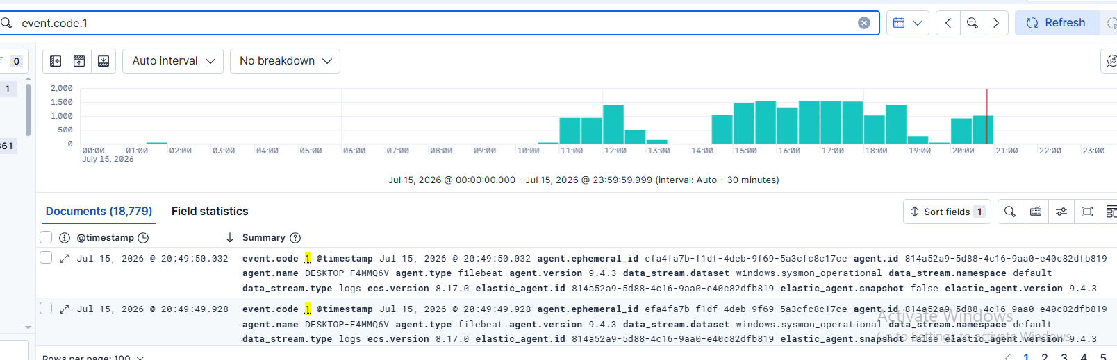
Figure 6.1: Kibana Discover showing Sysmon Event ID 1 (Process Creation) volume across the monitored day
Technical Analysis
Key Observations:
- The event.code:1 query returns 18,779 documents across the full day, several orders of magnitude larger than any single attack-specific query used in Chapter 5, reflecting how frequently ordinary Windows operation creates new processes.
- The histogram shows a clear diurnal pattern, with activity rising sharply after roughly 10:00, sustaining a high, fairly even rate through the afternoon and evening, and tapering off overnight — consistent with active machine usage during the day rather than a constant background rate.
- All sampled documents share the same agent.name (DESKTOP-F4MMQ6V) and data_stream.dataset (windows.sysmon_operational), confirming this high-volume stream is being collected through the identical Sysmon integration validated in Section 4.7 rather than a separate pipeline.
- The scale of this dataset (18,779 events/day from a single endpoint) illustrates why process-creation telemetry, while extremely valuable, requires either targeted KQL filtering or a purpose-built detection rule rather than manual, unfiltered review — a scalability point discussed further in Chapter 8.
What This Demonstrates: That full process-creation visibility is available and correctly indexed for the monitored endpoint, providing the data foundation needed for command-line-level detections beyond the network- and authentication-based detections demonstrated in Chapter 5.
Why It Is Important: Process Creation is widely regarded as the single highest-value Sysmon event type for detecting living-off-the-land and post-exploitation activity; confirming its availability here validates that the lab is ready for exactly the kind of detection-rule expansion proposed in Chapter 9.
Evidentiary Value: Establishes the baseline daily volume of process-creation telemetry, which is necessary context for correctly tuning the threshold of any future detection rule built on this data source (Chapter 7), so that it distinguishes suspicious command-line activity from ordinary system operation.

6.5 Windows Security Event IDs Used in This Project
Event ID | Name | Role in This Project
4624 | An account was successfully logged on | Confirmed the successful password-spray authentication (Section 5.3.2); baseline for detecting any future unauthorized logon.
4625 | An account failed to log on | Primary indicator of the in-progress password-spray attempt (Section 5.3.1); source of the failed-logon cluster used for correlation.
Table 6.2: Windows Security Event IDs Referenced in This Report
Both events are sourced from the system.security data stream established through the Windows integration (Section 4.6) and share a common ECS structure with the Sysmon events, which is what allows them to be queried, filtered, and correlated using the same KQL syntax and the same Discover interface throughout this project.

6.6 Network Connections and Authentication Logs Compared
The two categories of evidence used in this project — Sysmon network-connection events and Windows Security authentication events — are complementary rather than redundant. Network-connection events (Event ID 3) reveal that contact was attempted and from where, but say nothing about whether that contact was authorised; authentication events (4624/4625) reveal whether a login attempt succeeded or failed, but do not by themselves reveal the broader scanning context that preceded it. Only by combining both, as demonstrated throughout Chapter 5, can an analyst reconstruct the complete narrative: reconnaissance, enumeration, and successful credential compromise.

Chapter 7: Detection Rules
This chapter formalises the manual KQL investigations from Chapter 5 into three named detection-rule specifications, in the format used by Elastic Security’s custom query rule type. One rule (Network Reconnaissance / nmap) was already observed active in the environment in Section 4.8; the remaining two are proposed based directly on the evidence gathered in Chapter 5 and are recommended for implementation as the next step of this project.

7.1 Rule 1: Network Reconnaissance Detection (Active)
Rule Name: Network Reconnaissance – High-Volume Connections from Single Source (observed in-environment as “nmap”)
KQL: event.code:3 and agent.name:"DESKTOP-F4MMQ6V"
Purpose: Detect a single source IP generating a high volume of distinct network-connection events against the monitored endpoint within a short window, indicative of port-scanning or service-discovery activity.
Severity: Low, as currently configured (confirmed in Figure 4.8) — recommended for review, see Section 7.4.
MITRE ATT&CK: TA0043 Reconnaissance – T1595.001 Active Scanning: Scanning IP Blocks; TA0007 Discovery – T1046 Network Service Discovery.
Expected Alerts: A burst of alerts correlated with any scanning tool run against the endpoint; validated in this project by the 529 alerts observed corresponding to the Nmap scans in Section 5.1.
Future Improvements: Add an aggregation-based threshold (e.g., distinct destination.port count per source.ip over a 1-minute window exceeding N) rather than matching on every qualifying connection event, to reduce the 529-alert volume observed in Section 4.8 down to a small number of high-confidence, scan-level alerts.

7.2 Rule 2: Windows Password Spray Detection (Proposed)
Rule Name: Credential Access – Repeated Failed Logons Followed by Success
KQL: event.code:4625 or event.code:4624
Purpose: Detect the specific temporal pattern demonstrated in Sections 5.3.1 and 5.3.2: a cluster of Event ID 4625 (failed logon) records from a single source IP, followed within a short window by an Event ID 4624 (successful logon) from the same source IP — the signature of a successful password-spray or brute-force attempt.
Severity: High — recommended, given that this pattern represents a confirmed account compromise rather than a mere attempt.
MITRE ATT&CK: TA0006 Credential Access – T1110.003 Brute Force: Password Spraying; TA0001 Initial Access – T1078 Valid Accounts.
Expected Alerts: A single high-confidence alert per successful spray, rather than one low-context alert per failed attempt, reducing analyst fatigue while preserving detection of the critical moment of compromise.
Future Improvements: Implement as an Elastic Security threshold or new-terms rule with a same-source-IP correlation window (e.g., 5–10 minutes) and a minimum failed-attempt count (e.g., ≥ 5) prior to the success, to avoid alerting on a single legitimate mistyped password followed by a correct one.

7.3 Rule 3: SMB Administrative Share Access Following New Authentication (Proposed)
Rule Name: Lateral Movement Preparation – Administrative Share Access from Recently Authenticated Source
KQL: event.code:5140 or event.code:5145
Purpose: Close the detection gap identified in Section 5.2 by alerting when a source IP that has just triggered an Event ID 4624 (successful logon, especially one preceded by 4625 failures) subsequently accesses an administrative share (ADMIN$, C$, IPC$).
Severity: Medium-High, escalating to High if correlated with Rule 2 firing for the same source IP within the same session.
MITRE ATT&CK: TA0007 Discovery – T1135 Network Share Discovery; TA0008 Lateral Movement context via administrative share access.
Expected Alerts: An alert whenever a freshly authenticated (and especially a previously-brute-forced) account accesses a default administrative share, which is rarely legitimate end-user behaviour.
Future Improvements: Requires enabling Windows Security auditing for Event IDs 5140/5145 (not enabled in the current deployment, per Section 5.2) before this rule can be implemented; this is listed as a direct prerequisite in Chapter 9.

7.4 Rule Tuning Observations
The single active rule observed in this environment (Section 4.8) demonstrates a common early-stage detection-engineering trade-off: broad matching conditions maximise recall (no scan activity is missed) at the cost of precision (529 low-severity alerts for what is, from an incident perspective, a single reconnaissance campaign). The two proposed rules in Sections 7.2 and 7.3 are deliberately designed around correlation and thresholding, rather than single-event matching, specifically to avoid reproducing this volume problem for higher-severity detections where analyst attention is more costly.

Chapter 8: Results

8.1 Logs Collected
Over the course of the project, the deployed pipeline continuously collected native Windows Security, System, and Application logs alongside Sysmon Operational events from the single monitored endpoint. Section 6.4.2 quantified the daily volume of just one event type (Sysmon Event ID 1, Process Creation) at 18,779 documents; combined with Event ID 3 network-connection records, Windows Security authentication events, and background System/Application logging, the lab demonstrably sustained a realistic, continuous, multi-source ingestion workload rather than a one-off test import.

8.2 Security Events Captured
Event Source | Event Type | Approx. Volume Observed
Sysmon | Event ID 3 – Network Connection (attacker-sourced) | 437 documents (Figure 5.2)
Sysmon | Event ID 1 – Process Creation (daily) | 18,779 documents (Figure 6.1)
Windows Security | Event ID 4625 – Failed Logon | Clustered burst during spray attempt (Figure 5.4)
Windows Security | Event ID 4624 – Successful Logon (attacker-sourced) | Small cluster immediately following the 4625 burst (Figure 5.5)
Detection Rule (nmap) | Rule-generated alerts | 529 alerts, Low severity, single host (Figure 4.8)
Table 8.1: Summary of Security Events Captured During the Project

8.3 Detection Success
All three simulated attack stages were successfully detected using the deployed pipeline: network reconnaissance was detected via Sysmon Event ID 3 correlation and an active rule already generating alerts; the password-spray credential-access attempt was fully detected through Windows Security Event IDs 4625 and 4624, with a clear, correlatable temporal pattern; and SMB enumeration, while not independently isolated as its own detection, was shown to be indirectly observable through the same network-connection and authentication telemetry, with the specific gap and remediation identified in Sections 5.2 and 7.3. Overall detection success across the attack chain is assessed as strong for reconnaissance and credential access, and partial (with a documented remediation path) for share enumeration.

8.4 Screenshots and Observations Summary
Fifteen screenshots were captured and analysed across Chapters 4 and 5, covering the complete lifecycle from software installation (Figure 4.1) through service startup (Figures 4.2–4.3), Fleet Server and Agent enrollment (Figures 4.4–4.5), integration configuration (Figures 4.6–4.7), an active detection dashboard (Figure 4.8), and the full attack-to-detection evidence chain for reconnaissance (Figures 5.1–5.2) and credential access (Figures 5.3–5.5), with a supporting process-creation baseline in Figure 6.1. Each screenshot was independently analysed for what it demonstrates, why it matters, and what evidentiary value it provides, rather than being included as unexamined decoration.

8.5 Lessons Learned
- Native Windows auditing alone is insufficient for reconnaissance detection; Sysmon’s network-connection visibility (Event ID 3) was essential to detecting the Nmap phase of the attack chain.
- Detection rules that match on a single low-specificity condition (as observed with the active nmap rule generating 529 low-severity alerts) can be functionally correct while still being operationally noisy; rule design must balance recall against analyst alert fatigue.
- Enabling a log source and confirming it is enabled are two different steps: independent, direct KQL verification (Figures 4.7 and 6.1) was necessary to be confident that Sysmon telemetry was both flowing and correctly field-mapped before it was relied upon for attack analysis.
- Some attack techniques (SMB share enumeration) are only partially visible with a default logging configuration; identifying such gaps is itself a valuable SOC deliverable, prompting the concrete auditing recommendation in Section 5.2.
- Correlating two independently weak signals (a burst of 4625 events and a single 4624 event) produces a much stronger, higher-confidence indicator than either signal alone — a principle directly applied in the proposed Rule 2 (Section 7.2).

8.6 Limitations
- The SIEM backend (Elasticsearch/Kibana) was deployed on the same physical/virtual host as the monitored endpoint, which is not representative of a production deployment where the SIEM would run on separate, hardened infrastructure.
- The lab topology consists of a single monitored endpoint and a single attacker machine; multi-host lateral-movement scenarios and Active Directory-specific attack techniques were out of scope.
- SMB session and file-share auditing (Event IDs 5140/5145) was not enabled, limiting direct visibility into the SMB enumeration stage of the attack chain, as discussed in Section 5.2.
- Detection was demonstrated primarily through manual, analyst-driven KQL queries; only one of the three proposed detection rules (Section 7.1) was actually configured as an automated, continuously running rule at the time of this report.
- Attack simulation was limited to reconnaissance and initial credential access; post-exploitation stages (lateral movement, persistence, exfiltration) were not performed and therefore could not be evaluated for detection coverage.

Chapter 9: Conclusion, Future Work, and References

9.1 Conclusion
This project set out to design, deploy, and validate a complete SIEM monitoring capability using the Elastic Stack, and to prove that capability against a realistic, self-generated attack chain rather than synthetic sample data. That objective was met: a Fleet-managed Elastic Agent deployment, integrated with both native Windows auditing and Sysmon, successfully ingested and centrally indexed telemetry that was subsequently used to detect and reconstruct a three-stage attack — network reconnaissance, SMB enumeration, and password-spray credential access — launched from an independent Kali Linux attacker machine.
Beyond the technical deployment, the project produced concrete, reusable detection-engineering artefacts: three documented detection-rule specifications (one already active, two proposed with explicit KQL and tuning guidance), a MITRE ATT&CK mapping for every technique observed, and an explicit accounting of detection gaps and their remediation. This mirrors the actual workflow of a SOC detection engineer — deploy visibility, validate it against known-bad behaviour, and iterate on rule quality — and demonstrates that this workflow is achievable end-to-end using entirely free and open-source tooling.

9.2 Future Work
- Enable Windows Security Event IDs 5140/5145 to close the SMB enumeration detection gap identified in Section 5.2, and implement the corresponding Rule 3 proposed in Section 7.3.
- Operationalise the two proposed detection rules (Sections 7.2 and 7.3) as native Elastic Security threshold or new-terms rules, moving beyond the manual KQL validation performed in this project.
- Expand the lab to a small Active Directory domain with multiple endpoints, enabling detection coverage testing for lateral-movement and domain-privilege-escalation techniques that a single-endpoint lab cannot exercise.
- Extend Sysmon’s configuration beyond the default rule set (e.g., enabling Event ID 22 DNS query logging and Event ID 11 file-creation logging) to broaden detection coverage for command-and-control and data-staging behaviour.
- Integrate a SOAR-style automated response playbook (e.g., automatic account lockout or endpoint isolation triggered by the proposed Rule 2) to move from detection to active response.
- Separate the SIEM backend onto dedicated infrastructure, distinct from the monitored endpoint, to better reflect a production-representative deployment topology.

9.3 References
This report follows IEEE referencing style. Reference entries below correspond to the primary technologies, frameworks, and tools discussed throughout the report; entries should be updated with full retrieval dates and edition details as required by the submitting institution’s formatting guidelines prior to final submission.
[1] Elastic N.V., “Elasticsearch Guide,” Elastic Documentation, 2026. [Online]. Available: https://www.elastic.co/guide/en/elasticsearch/reference/current/index.html
[2] Elastic N.V., “Kibana Guide,” Elastic Documentation, 2026. [Online]. Available: https://www.elastic.co/guide/en/kibana/current/index.html
[3] Elastic N.V., “Fleet and Elastic Agent Guide,” Elastic Documentation, 2026. [Online]. Available: https://www.elastic.co/guide/en/fleet/current/index.html
[4] M. Russinovich and M. Garnier, “Sysmon – Windows Sysinternals,” Microsoft Learn, 2026. [Online]. Available: https://learn.microsoft.com/en-us/sysinternals/downloads/sysmon
[5] Microsoft Corporation, “Windows Security Event Log Reference,” Microsoft Learn, 2026. [Online]. Available: https://learn.microsoft.com/en-us/windows/security/threat-protection/auditing/
[6] MITRE Corporation, “MITRE ATT&CK®,” 2026. [Online]. Available: https://attack.mitre.org/
[7] G. Lyon, “Nmap Network Scanning: The Official Nmap Project Guide to Network Discovery and Security Scanning,” Nmap Project, 2026. [Online]. Available: https://nmap.org/book/
[8] Pennyw0rth Project, “NetExec Documentation,” 2026. [Online]. Available: https://www.netexec.wiki/
[9] Elastic N.V., “Elastic Common Schema (ECS) Reference,” Elastic Documentation, 2026. [Online]. Available: https://www.elastic.co/guide/en/ecs/current/index.html
[10] Elastic N.V., “Kibana Query Language (KQL),” Elastic Documentation, 2026. [Online]. Available: https://www.elastic.co/guide/en/kibana/current/kuery-query.html

