CYBERSTER
Blue Team Internship

PHASE ONE — WEEK 1 SUBMISSION REPORT
SOC Foundations and Lab Setup

Submitted by: Unaiza Fatima
Track: Blue Team | Program: Cyberster Blue Team Internship
Submission Date: 3/7/2026

Overview & Personal Reflection

Coming into Week 1, I knew this would be a foundational week but I didn't fully appreciate just how much it would shift the way I think about networks and security tooling until I was knee-deep in it. This report documents everything I worked through across Days 1 to 7: the networking theory, the VirtualBox lab build, the Wazuh installation, agent deployment, and finally getting my hands on the dashboard as an analyst rather than an installer.

I want to be upfront that not everything went perfectly. There were adapter misconfigurations, a moment where I thought the Wazuh Indexer had completely crashed, and one agent that refused to show as Active for longer than it should have. Each of those problems taught me more than the steps that worked smoothly. I've documented those moments honestly rather than pretending the week was clean.

Day 1 — Networking Fundamentals for SOC

What I Did
Day 1 was fully focused on understanding the networking layer before touching any tools. My approach was to work through each topic methodically rather than just skim documentation because if I'm going to be reading packet captures and triaging alerts later, I need to understand what I'm actually looking at.

TCP/IP and OSI Model
I traced a full web request from browser to server and back, mapping each stage to both the OSI and TCP/IP models. The exercise that really helped was thinking about what actually happens when I type a URL the DNS lookup at the Application layer, the TCP handshake establishing a connection at the Transport layer, the IP routing at the Network layer, and eventually the frame going out at the Data Link layer. Rather than memorizing layers in isolation, thinking of them as stages of a real journey made it stick.

Subnetting and CIDR
I worked through subnetting practically. A /24 subnet has 256 addresses (254 usable), and two machines in the same /24 block can communicate directly without routing through a gateway. For example, 192.168.56.10 and 192.168.56.50 are both on the same /24 and can reach each other directly. This mattered directly for my lab setup since all three VMs needed to communicate on the Host-Only /24 subnet.

Ports and Protocols Reference
Port | Protocol | What It Does / SOC Relevance
22 | SSH | Encrypted remote access. Brute force and suspicious login attempts are common detection targets.
25 | SMTP | Email transmission. Used in phishing infrastructure and spam relay detection.
53 | DNS | Domain resolution. DNS tunnelling and suspicious query volumes are key alert types.
80 | HTTP | Unencrypted web traffic. Can carry malware downloads and C2 communication in plaintext.
443 | HTTPS | Encrypted web traffic. Harder to inspect but still generates useful metadata.
445 | SMB | Windows file sharing. Classic lateral movement and ransomware propagation vector.
3389 | RDP | Remote Desktop. High-value attack target; brute force attempts are frequent.
8080 | HTTP-alt | Alternative HTTP. Often used for proxy traffic or developer tools; can be abused.

Protocol Deep Dive: ARP, DNS, HTTP, HTTPS, ICMP
For each protocol I tried to think about two things: what a normal exchange looks like, and what a suspicious version would look like. ARP is fascinating because it has no authentication — an attacker on a local network can simply send gratuitous ARP replies to redirect traffic, and nothing in the protocol stops them. DNS is similarly abusable: queries should mostly go to known resolvers and return sensible TTLs. A host doing thousands of queries per minute or resolving unusually long domain names is worth a second look. ICMP is used for diagnostics (ping being the obvious one), but large ICMP payloads or high-volume ICMP traffic can indicate covert channel communication or reconnaissance.

Wireshark Capture
I ran a ten-minute Wireshark capture on my host while browsing normally. I identified DNS queries and responses going out before each HTTP/S connection, TCP handshakes establishing connections, TLS Client Hello packets initiating HTTPS sessions, ICMP echo requests from a ping I ran mid-session, and ARP broadcasts from the local network. What surprised me was how much DNS traffic there is just from normal browser activity — multiple queries per page load, including third-party domains I hadn't consciously visited.

Lab Topology Diagram
Below is my planned network diagram showing the three VMs, their adapters, and which network each connects to.
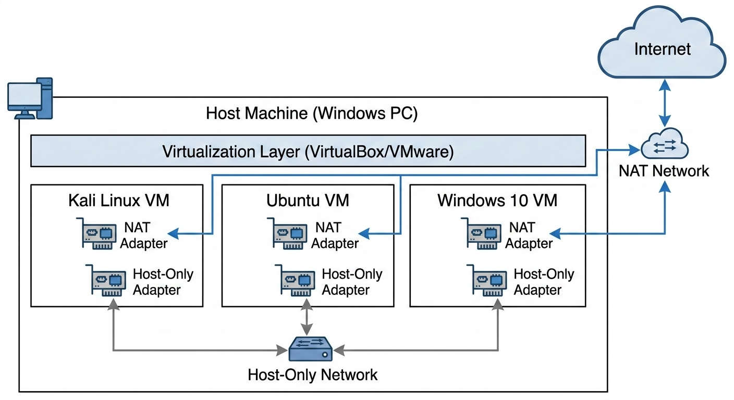

SCREENSHOT: Network Topology Diagram — 3 VMs with Host-Only and NAT adapters labelled

Wireshark Capture
Capture file showing five identified protocols: DNS, TCP, TLS/HTTPS, NTP, and ARP
NTP (Network Time Protocol)
NTP is used to synchronize the time between computers on a network.
It ensures all systems have the same clock so logs, security events, and transactions stay accurate.
ARP (Address Resolution Protocol)
ARP helps a device find the physical MAC address of another device using its IP address.
It acts like asking the network, “Who has this IP?” so devices can communicate locally.
DNS (Domain Name System)
DNS translates human-friendly domain names into IP addresses that computers understand.
For example, when you type a website name, DNS finds the server’s actual IP address.
TLS (Transport Layer Security)
TLS encrypts data sent between a client and a server to keep it private and secure.
It protects sensitive information like passwords and credit card details during online communication.
TCP (Transmission Control Protocol)
TCP is a reliable communication protocol that ensures data is delivered correctly and in order.
If any packets are lost during transmission, TCP automatically retransmits them.

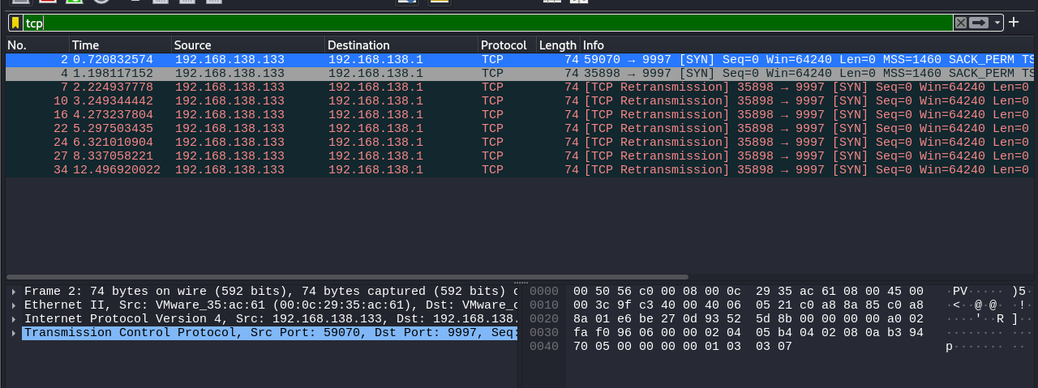

SCREENSHOT: Wireshark capture — TCP protocol

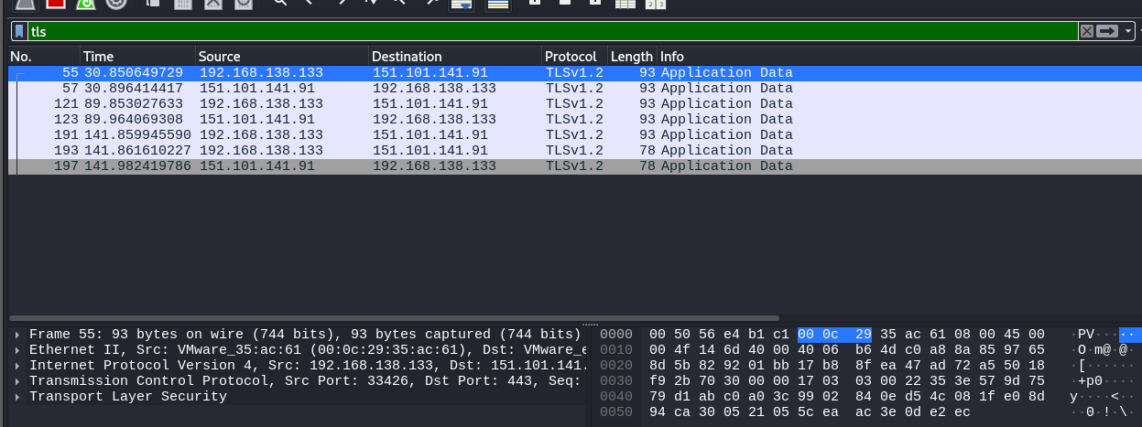

SCREENSHOT: Wireshark capture — TLS protocol

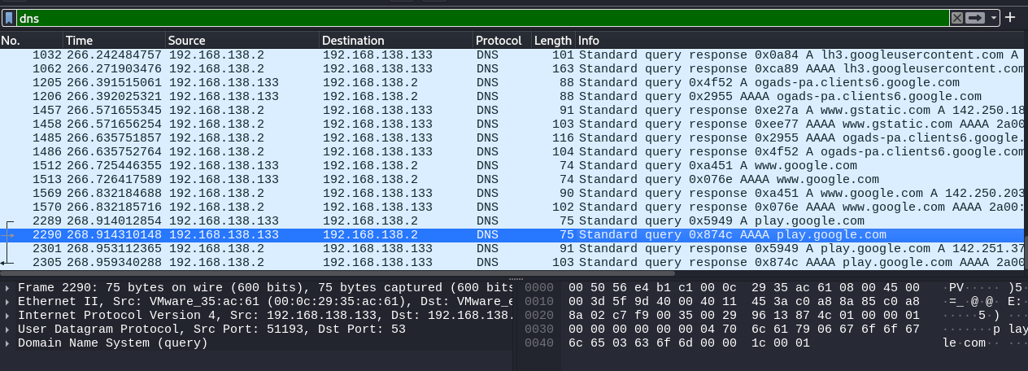

SCREENSHOT: Wireshark capture — DNS protocol

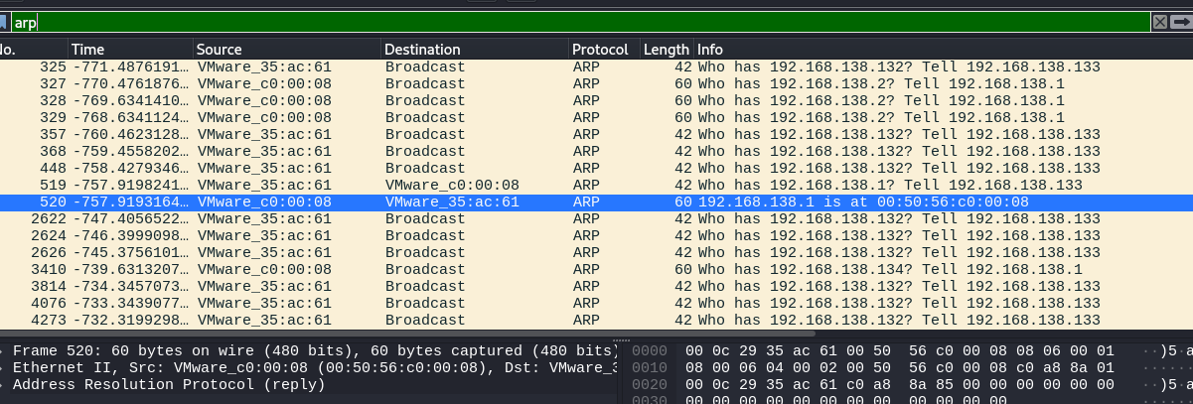

SCREENSHOT: Wireshark capture — ARP protocol

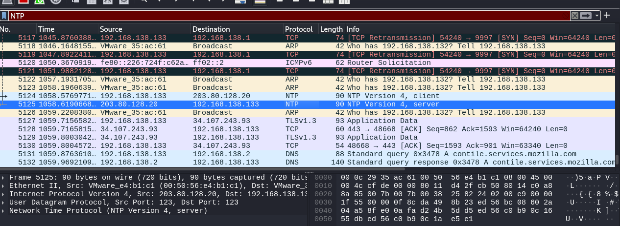

SCREENSHOT: Wireshark capture — NTP protocol

Day 2 — VirtualBox Lab Setup

What I Did
Today was hands-on from the start. The objective was three VMs, each with dual adapters, all able to talk to each other on the Host-Only network while still reaching the internet on NAT. Simple in principle, but getting it right took more careful attention than I expected.

VM Specifications
VM | Role | CPU | RAM | Storage
Kali Linux | Attacker / Testing | 2 cores | 4 GB | 60 GB
Ubuntu Server | Wazuh Server (SIEM) | 2 cores | 8 GB | 50 GB
Windows 10 | Monitored Endpoint | 2 cores | 4 GB | 50 GB

Network Adapter Configuration
Each VM received two network adapters: Adapter 1 on the default Host-Only network (vboxnet0 or equivalent) so the machines can communicate directly with each other and with the host, and Adapter 2 on NAT so they can access the internet for downloads and updates. The reason for this dual-adapter setup is that a Host-Only-only configuration isolates the machines completely, making internet access impossible. A NAT-only configuration would give internet access but break direct VM-to-VM communication. Both adapters together solve both requirements cleanly.

A Problem I Hit
When I first booted Ubuntu Server, it only showed one IP address. After checking the VirtualBox Host Network Manager, I found that the DHCP server for the Host-Only network had not been enabled. I enabled it, rebooted the VM, and both addresses appeared correctly. This is worth flagging because it's an easy thing to miss and it will block the rest of the week if not caught here.

Connectivity Testing
Once all three VMs were up, I ran ping tests between every pair over the Host-Only subnet and verified internet connectivity from each. All tests passed. I then took labelled snapshots of each VM before moving on this proved valuable later during the Wazuh installation.

Screenshots

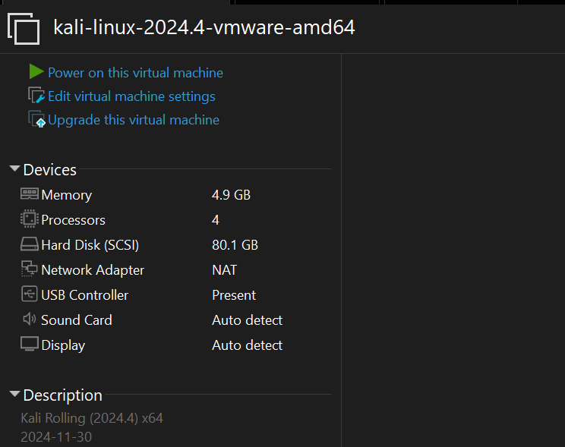

📸 SCREENSHOT: VirtualBox Adapter Settings — Kali Linux:

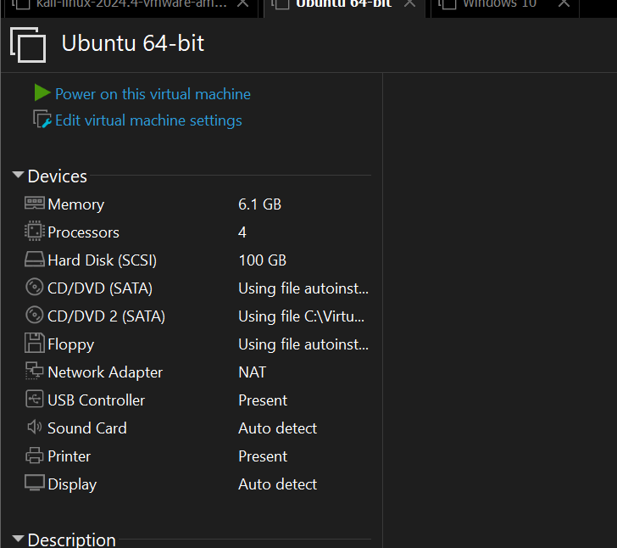

📸 SCREENSHOT: VirtualBox Adapter Settings — Ubuntu Server

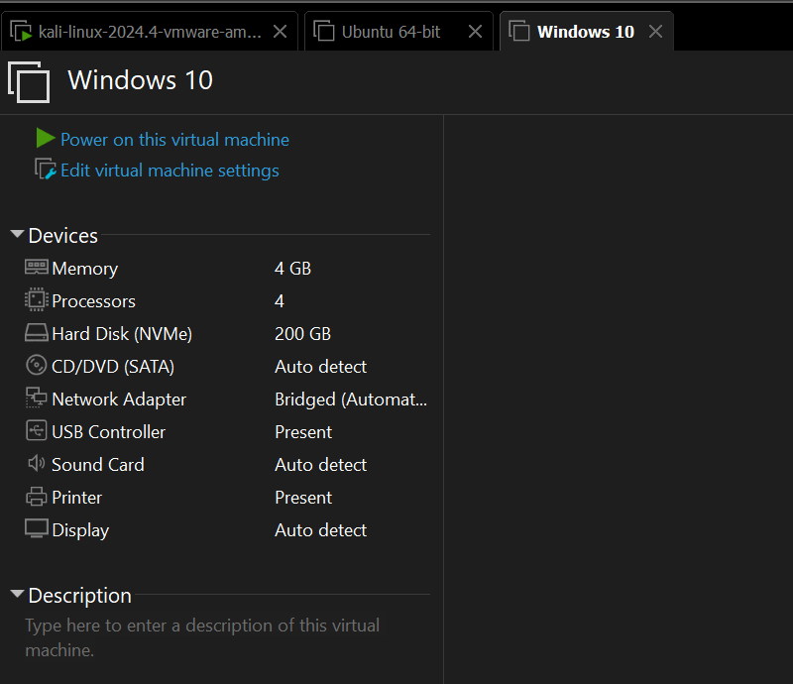

SCREENSHOT: VirtualBox Adapter Settings — Windows 10

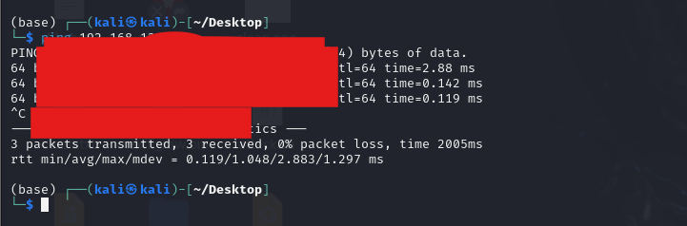

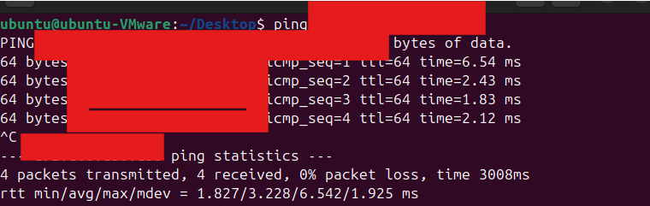
📸 SCREENSHOT: Ping test results — each VM successfully pinging

Days 3 & 4 — Wazuh Manager Installation

What I Did
Days 3 and 4 were dedicated to installing Wazuh on the Ubuntu Server VM. Wazuh has three components that all need to be running together: the Manager (which receives log data from agents and runs detection rules), the Indexer (which stores everything in a searchable format), and the Dashboard (the web interface analysts use day to day). None of them is optional — if one fails, the whole system doesn't work.

Pre-Installation: Setting a Static IP
Before running any installation command, I assigned a static IP to the Host-Only interface on Ubuntu Server. This step is critical: agents will be configured to point at this address, and if it changes, every agent loses its connection. I chose 192.168.56.10 as the static address and configured it via Netplan, Ubuntu's default network configuration tool.
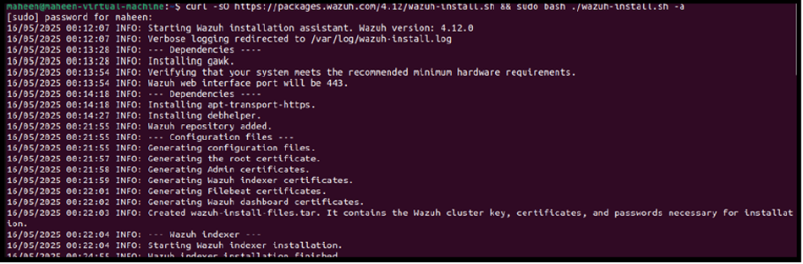

Running the Quickstart Installation
I followed the official Wazuh documentation and used the quickstart installation script, which handles all three components in a single run. The command pulled the installer script from Wazuh's servers and executed it. The process took about 22 minutes end-to-end. I left it running with the other VMs shut down to free up as much host memory as possible — which turned out to be a good decision.

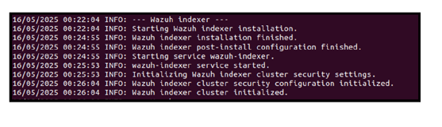
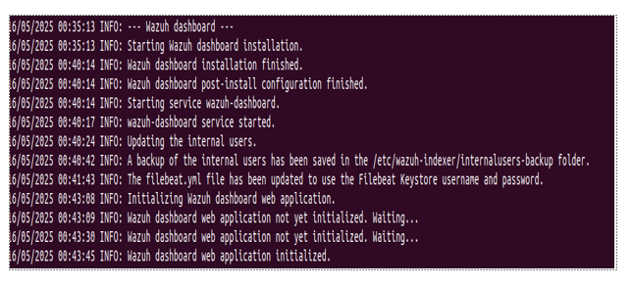

Service Status Verification
Once the script finished, I verified each component using systemctl. All three should show as active (running). The Indexer was the one I was most nervous about given its memory requirements — but with 8GB allocated to the VM, it came up without issues.

Accessing the Dashboard
I navigated to https://192.168.56.10 in a browser on my host machine. The browser threw a certificate warning (Wazuh uses a self-signed certificate by default) which I proceeded past. I logged in with the auto-generated credentials, immediately changed the password, and spent time exploring the overview screen, the Agents section, and the Security Events tab to get familiar with the layout before agent deployment.
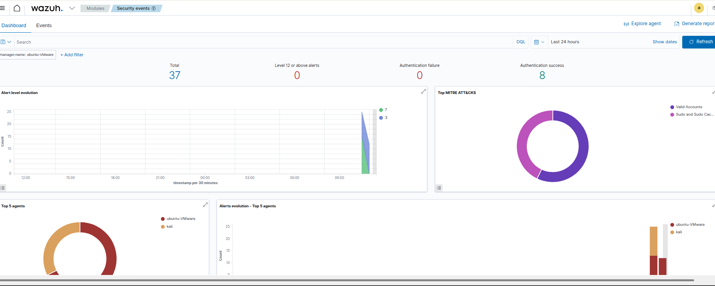
📸 SCREENSHOT: Wazuh Dashboard loaded in browser — Overview screen visible after successful login

Days 5 & 6 — Wazuh Agent Deployment

What I Did
With the Wazuh server running and verified, the next step was connecting the other two machines to it as agents. An agent is a lightweight service that runs on an endpoint, collects log data and system events, and sends them back to the Manager. Without agents, the SIEM has no visibility into anything except the server itself.

Using the Deployment Wizard
The Wazuh dashboard includes a deployment wizard under the Agents section. I used this rather than building the installation command manually. The wizard asks for the target OS and the Manager IP, then generates the correct installation command for that platform. This is the recommended approach because it pre-fills the Manager address and selects the right package format automatically.

Kali Linux Agent
I ran the generated command on the Kali VM, started the wazuh-agent service, and waited. It appeared in the dashboard as Active within about two minutes. I confirmed the connection from the dashboard view and noted the agent ID assigned by the Manager.
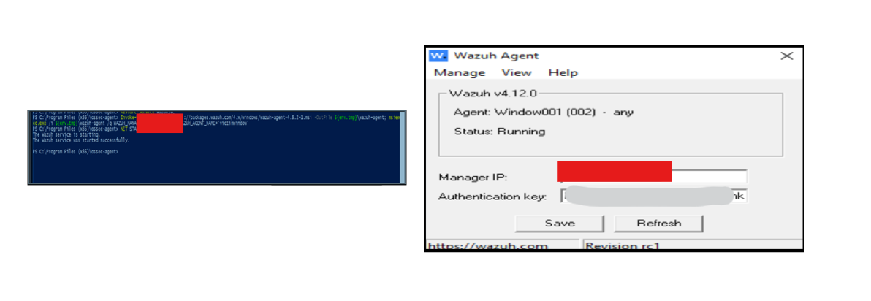
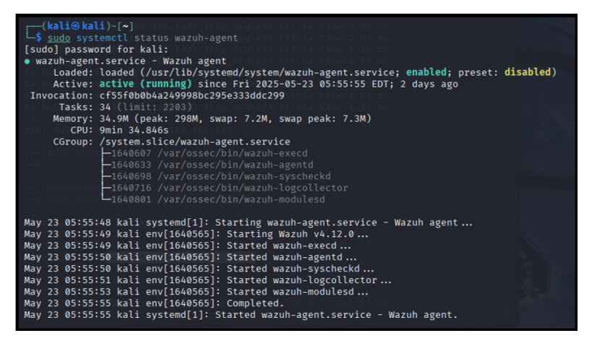

Windows 10 Agent
For Windows, the wizard generated a PowerShell command. I ran it in an elevated PowerShell session (right-click, Run as Administrator). The agent installed, the service started, and it appeared as Active in the dashboard. This was the smoother of the two deployments, ironically — Windows is a well-tested target for Wazuh.

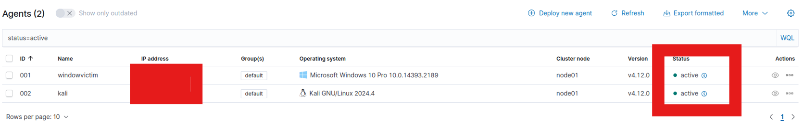
📸 SCREENSHOT: Wazuh Dashboard — Both agents (Kali Linux and Windows 10) showing as Active simultaneously

Day 7 — Dashboard Navigation and Alert Triage

Shifting from Setup to Analysis
Day 7 felt different from the previous six. Instead of building and configuring, the task was to sit with the environment and understand what it's telling me. Alert triage is the process of reviewing security alerts and making a judgement call on each one: is this a genuine concern, a false positive, or normal system behaviour that I should note as baseline? The skill develops over time, but it starts with paying attention to what your environment generates at rest.

I spent over an hour in the Security Alerts view without scrolling past anything, clicking into individual alerts and reading the detail panel for each one. The combination of rule ID, rule level, triggered condition, and agent name tells a more complete story than any single field alone.

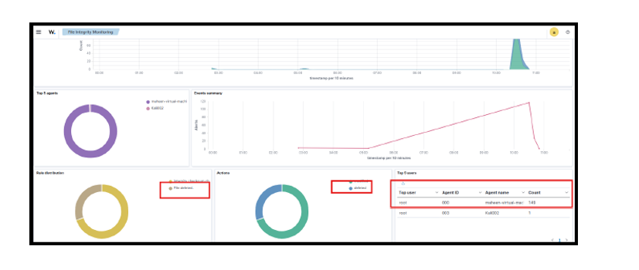
SCREENSHOT: Wazuh Security Alerts view — alerts list visible with various rule levels and agent names

Alert Triage Report — Top 10 Alert Types
Below are the ten most frequently occurring alert types I identified in my environment, with my assessment of each. Rule levels run from 0 (informational) to 15 (critical). A level alone doesn't tell the full story — frequency and context matter just as much.

Rule ID | Level | Trigger | What It Means | My Assessment
5710 | 5 | SSH failed login | Someone or something attempted to log in via SSH with wrong credentials. | Low concern in isolation. Worth watching if frequency spikes or if it comes from an unexpected source IP.
5715 | 3 | SSH authentication success | Successful SSH login recorded. | Expected — I log in to Ubuntu Server during setup. Baseline event but should only come from known IPs.
550 | 7 | File integrity check changed | Syscheck detected a file that changed since last scan. | Depends heavily on which file. System package updates will trigger this. Worth noting path and timestamp.
554 | 5 | New file found in monitored directory | Syscheck found a file that wasn't in the baseline scan. | Could be legitimate (software install) or unexpected. Needs context from the path and agent name.
530 | 3 | Syscheck: file date changed | A monitored file's modification timestamp changed. | Normal in active systems. Only worth escalating if the file path is unusual or system-critical.
1002 | 2 | Unknown problem in log | An error message in a log file that didn't match any known rule. | Informational. Worth reading the raw log message to check whether it's an application error.
51003 | 3 | Windows audit event | An audit policy event generated by the Windows 10 endpoint. | Generally routine. Windows generates a lot of audit events during normal operation.
18104 | 3 | Wazuh agent started | An agent service started or restarted. | Expected event when VMs boot. Only notable if an agent restarts at an unexpected time.
5701 | 8 | SSH brute force attempt | Multiple failed SSH logins from the same source within a short window, indicating automated guessing. | This is the one I generated intentionally during pipeline testing. In a real environment, this level-8 alert would warrant immediate investigation.
100001 | 5 | Custom rule test alert | A rule I observed triggered during the Wazuh default rule scan on the agent host. | Still investigating what exactly triggered this. Will follow up in Week 2.

Key Takeaway on Triage
Rule level is a starting point, not a verdict. A level-3 alert that fires ten thousand times in one hour is more interesting than a single level-8 alert triggered by a scheduled task. Looking at frequency and context alongside severity is the habit I'm building from day one.

Working through MITRE ATT&CK as a mapping framework for these alerts was genuinely useful — it's one thing to know that a rule fired, and another to know that it corresponds to a specific technique in a taxonomy used across the entire industry. The SSH brute force attempt maps cleanly to T1110 (Brute Force), which puts it in context and helps frame what a realistic response would look like.

Week 1 Summary

By the end of Day 7, I had three VMs running and communicating with each other, Wazuh fully installed with two active agents, and a working understanding of how log data moves from an endpoint through to a SIEM dashboard — because I'd actually built every part of that pipeline myself.

The most valuable learning came from the things that didn't work immediately: the Host-Only DHCP that wasn't enabled, the agent that took longer than expected to appear as Active, reading actual error messages instead of just trying commands again. These moments forced a deeper level of understanding than a clean run would have.

Going into Week 2, I have a functioning lab environment and enough familiarity with the Wazuh dashboard to use it as an analyst rather than just navigate it. The triage work on Day 7 gave me a baseline sense of what normal activity looks like in this environment — and that baseline is what will eventually let me spot things that aren't normal.

Cyberster Blue Team Internship — Week 1 Submission — UNAIZA FATIMA

