Applewood Computers
Incomplete Records System

User Manual and
System Guide

This document forms part of the System Specification for AC-IRS (Applewood Computers Incomplete Records System) which is in part ACAS (Applewood Computers Accounting System) and is

Copyright © Applewood Computers

Applewood House
Epping Road
Roydon
Essex
CM19 5DA

Phone: 44-1279-793009
or in UK 01279-793009

Support email: vbcoen@btconnect.com

Rewritten/Copied to OOo: 2nd February 2009

1 3 5 7 9 0 2 4 6 8

Release 2.00 (OC) Migration

Rel. 3.00 (Open Source for Open Cobol) Migration

Rel. 3.01 OS) update.

Latest update: 7. May 2013 23:44:06
Doc. Version 31
Table of Contents
1 System Overview 5
1.1 Introduction 5
1.2 Support and problem reporting. 6
2 The physical structure of IRS 7
2.1 Files used by the system 7
2.2 IRS Programs 8
2.3 Processing Flow 9
2.4 Program file usage 10
3 General Information 11
3.1 The importance of backup 11
3.2 Backup Recovery 12
3.3 A Glimpse at double entry book keeping and the detection of errors 13
4 System Set-up & Maintenance 16
4.1 The system menu - IRS 16
5 Chart of Accounts Set-up & Maintenance 18
5.1 Account Overview 18
5.2 Set-up Chart of Accounts 21
5.3 Amend the Chart of Accounts 23
5.3.1 Amendments 23
5.3.2 Addition 23
5.3.3 Deletion 23
5.3.4 Print the Chart of Accounts 23
5.3.5 Display the Chart of Accounts 23
5.3.6 Export the Chart 24
5.3.7 Import the Chart 24
5.3.8 Return to System Menu 24
6 Default Accounts Set-up & Maintenance 26
6.1 Default Accounts - IRS020 26
6.1.1 An Account Number 26
6.1.2 The Transaction Code 26
6.1.3 The VAT type 26
6.2 Set-up Default Accounts 28
6.2.1 VAT Accounts and Defaults 28
6.2.2 Suspense Account 28
6.3 Amend Default Accounts 29
6.4 Display Default Accounts 30
6.5 Print the Defaults 30
6.6 Set-up Final Accounts 31
7 Posting – IRS030 32
7.1 Enter run option 32
7.2 Enter Default Number 32
7.3 Correct Account (Y/N) 32
7.4 Enter Run Characteristics (DR) or (CR) 33
8 Trial Balance - IRS040 35
9 The Audit Trail - IRS050 36
10 The Final Accounts - IRS060 37
11 Amend Postings - IRS070 38
12 Nominal File Fix up - IRS080 39
13 Analysis Report - IRS090 40
14. Update or Conversion programs – IRSCONVERT etc 41
Appendix A IRS Set-up 42
A.1 IRS Executable Programs 42
A.2 IRS Source Programs 43
A.3 Open Cobol Compiler v1.1 or later 44
A.4 Building IRS from sources 45
A.5 Running IRS and its requirements 46
Appendix B Sample Charts of Account 47
B.1 Limited Company 47
Appendix C Posting Methods 50
Appendix D Introduction to Double Entry Book Keeping 51
D1 Double entry book keeping as applied to IRS. 51

1 System Overview

1.1 Introduction

For 'the I want to get it going now people', see Appendix A for instructions. The Incomplete Records System (IRS) has been designed as a tool to be used by an accountant or book keeper to aid him/her in the production of a set of accounts for a company or business where a full set of books have not been kept and where a client has provided the accountant with boxes containing bundles of bank statements, cheque stubs (if used) for each bank account, all sales invoices & receipts and again purchase invoices & receipts etc. This is often referred to brown bag (or brown box) accounting. They can then, be input into IRS in batches of work eg, all bank statements together, all purchase invoices and all sales invoices. This speeds up the work flow where behalf of many small businesses the whole process can easily be done within a day and often considerably less.

Final accounts printed and/or transferred to the online filing systems for Companies House and/or HMRC and all completed in under a working day and usually less than four hours. As such, it provides the maximum flexibility consistent with ease of use. The facilities provided are those required to complete a job from its source documents through to the final accounts.

In addition it has been kept as simple as possible so that any business may use it in their day to day operations also in conjunction with the ACAS ledger system.

It has been designed to be run on any computer platform that the Open Cobol (TM) compiler can be run on, which includes Linux, BSD, Unix, Windows, Mac, mini's and mainframes running Linux all of which need to have installed the development tools including GNU gcc compiler suite as well as Open Cobol and any other tools that it requires. Many of the Linux distributions have most of these tools already installed or available on the DVD that makes up the distribution although not all of them have the latest version of Open Cobol available so it is always worthwhile to check on the sourceforge website at http://sourceforge.net/projects/open-cobol to see what the current version is. The remainder can be easily obtained via the internet. See Appendix A for more information on setting up IRS and the tools needed to get it working. Other compiler's can and will present problems due to lack of functionality regarding 2002 and other Cobol standards. Versions for the use of other branded compilers may well also be available such as for Micro Focus Visual Cobol, Net Express etc. However they may not be the most current available so contact us for details.

These IRS facilities can be split into three distinct groups:-
- Environmental - Those facilities which are used to describe the job to IRS
- Posting - The entry and maintenance of transactions
- Reporting - Trial Balance, Audit Trail, Final Accounts, etc.

Other features of the system include:-
- Interactive menu-driven programs
- Password control
- Automatic postings to contra accounts
- Report displays and printing
- Automatic calculation of VAT with manual override
- Main and sub-nominal accounts
- VAT day book
- Support for amounts up to 9 millions for entries and 99 millions for totals.

This manual has been modified for the Open Source version which uses Open Cobol and some functionality (e.g., usage of extra search facilities via the F3 key) has been removed mostly due to missing functionality within the Cobol compiler but which forms part of the commercial version that is offered for those users that require support and/or maintenance during their usage of IRS.

1.2 Support and problem reporting.

Support for the open source version is also available.

For extra details, refer to the contact information inside the front cover of this document for access to a company representative in support of this product.

If you find any errors or missing topics etc, please report them using the contact details shown on inside front cover of this manual along with the manual and software versions.

Do not “assume” that it has been previously reported. Not everyone will spot it.

The same applies if you think you have found a bug in the software eg, where the program is not doing what you think it should or in relation to what is specified in the manual but please be aware that many problems relate to using the system in a directory that has:

- Enough unused disk space and usually over 10% of the total for the hard drive & partition.
- Correct access controls for the directory you are using eg, you own it or that you have full access permissions.

Note That you should never use a Linux (or for that matter Windows) system as root or administrator for other than to administer the system and never to run any application.

2 The physical structure of IRS

2.1 Files used by the system

This section briefly describes the files used by IRS. Although not necessary for the use of the system, an insight into the way IRS works may prove invaluable should any problems occur. IRS stores all the data relating to a particular job in only five primary files. The programs themselves are in no way modified by use. These files are described below. The program names shown here are all in upper case for ease of reading, but they are in fact, supplied in lower case, e.g., IRS010 is supplied as irs010.
All files are in lower case as shown.

The System File - system.dat

Contains user and client information. It also holds the encrypted system password, the current date, the VAT rate, and the next posting number as well as other system information.

The Chart of Accounts File - acnts.dat

This file contains the records of each nominal ledger account. This consists of the account number and type, its name, and the two current balances - one for credit and one for debit plus cumulative totals.

The Defaults File - dflt.dat

This file contains information about contra-accounts. It is used when posting transactions to the Nominal Ledger.

The Postings File - post.dat

Holds one record for each posting made. This record contains the debit and credit accounts, the net amount, and the VAT amount and type.

The Final Accounts File - final.dat

Contains the descriptions to be printed at the end of each account group on the Profit and Loss Report and the Balance Sheet.

2.2 IRS Programs

Note that program and module names used here are shown in upper case for clarity but are in fact in lower case eg, IRS is irs. On reports and displays the module/program name along with its version number is always shown. This helps in providing support in the rare case of suspecting a program fault (bug). The name and version number must always be given along with any fault found. Do not assume that the fault has been previously reported. Updates of any fixes are always made available for users of the various systems that Applewood Computers provide.

IRS - System File Maintenance and Main Menu

Allows the user to set-up and maintain the System File. It also displays the main menu so that the user may select which facility is required.

IRS010 - Chart of Accounts Maintenance

This program allows the user to set-up, maintain and report on the Chart of Accounts.

IRS020 - Default Accounts Maintenance

Allows the user to set-up, maintain and report upon the contra accounts and the organisation of the final accounts i.e. the Profit and Loss Report and the Balance Sheet.

IRS030 - Postings

This program allows the user to make postings to the Chart of Accounts. It is the primary data entry program.

IRS040 - Trial Balance

Displays or prints the trial balance.

IRS050 - Audit Trail, Day Book / VAT report as well as the Ledgers

Displays or prints the audit trail in three forms.

As an audit report showing postings
As a ledger report showing the ledger details for either an individual account or all accounts
As a day book giving full VAT details including the statistics required for the VAT return.

IRS060 - Final Accounts

Produces the Profit and Loss Report, the Balance Sheet, and a report on sales ratios.

IRS070 – Postings Amendments

Allows the user to amend any feature of any posting that has been made or to totally delete it. Furthermore, it has a renumber facility that will sort and reorganise the audit trail.

IRS080 - Nominal File Fix Up

This program will repost all postings to the accounts file.

IRS090 - Analysis Report

Produces a monthly analysis by account number of all postings.

2.3 Processing Flow

The basic flow in order, when first starting out with irs is:

Run irs (option 1 which is automatic on a new and empty directory) which is used to set up the various system settings into a parameter file. Please note that the IRS system must not be run in the same user directory as ACAS as the parameter file names are the same.

IRS010 and set up or import your chart of accounts and print them off for reference.
IRS020 and set up the Default accounts and print them off for reference.
IRS030 Entry of posting transactions.

All the others as needed.

Note that you can copy an existing chart of accounts, Default accounts and the final account files but do not transfer over the posting file or the system file, as this should be created for each client / directory as it will know if your CoA (Chart of Accounts) was freshly created or copied from another client and this can also apply if you run export and import a CoA from another client. If this is the case it will offer to clear down all totals that exist for all accounts.

2.4 Program file usage

system acnts post dflt final

IRS X
IRS010 X X
IRS020 X X X
IRS030 X X X X
IRS040 X X
IRS050 X X X X
IRS060 X X X X X*
IRS070 X X X X
IRS080 X X X X
IRS090 X X X X
+IRS055 X X
+IRS065 X X
+IRS085 X X

* Not used in open source version

+ The sort programs may not be present if using a database such as MySQL. These use temporary files (in addition to the above) that are deleted or cleared to zero length after processing in the same directory as the main data files.

3 General Information

3.1 The importance of backup

The importance of adequate back-up cannot be over-emphasised. Should your current data and program files be damaged in any way, it is essential that you have recent alternate files from which to recover. This will allow you to continue processing with a minimum loss of time and data. A copy of the IRS master disk or archive should be made immediately upon receipt, and the master disk or archive should then be stored in a safe place.

The operating system you are using, will provide you with utility programs for copying data files from one directory to another or to a USB memory stick or hard drive. This back-up procedure should be performed at the end of each working day, or more often if the volume of data entered, warrants it. Remember that every entry in your data file without back-up, is a potential loss resulting in you having to re-enter all the lost information. The printing of your daily, or all entries for the year will also help protect you in the event of a major hardware failure. (see section 9. Audit Trail & 8. Trial Balance).

For Linux a suitable backup script is included*

This should be modified to reflect the directory you wish to backup to having created it. It is recommended that this is on a removable drive as mentioned above. The name of the archive file created by the script is based on the date and time that it is created, e.g., irs-bkup-yyyymmddhhmmss where

yyyy = Current year
mm = Month
dd = Day of month
hh = Hour based on 24 hour clock
mm = Minutes
ss = Seconds

*The name of the script is also inbuilt into the IRS main menu program and is called just before shutting down (via the x function) so you need to ensure that your backup medium is loaded, installed and available to the user running IRS prior to pressing 'x'. If you do not wish to use this function use a dummy script that just exit's. The names for this scripts are:

Under Linux, Unix or Mac OS/X: irsbakup.sh
Under Windows or Dos: irsbakup.bat
Under OS/2: irsbakup.cmd

3.2 Backup Recovery

For Linux; to recover one or more files is fairly straight forward but it is best to go to a command prompt via a terminal or terminal program such as konsole:

At the prompt, change to your working irs directory, create a temporary directory (to hold the restored files in) then list the online back up directory and decide which back up you wish to use which normally will be the one with the latest date and time and here is how, command by command:

cd IRS (go to the directory used when running irs)
mkdir tmp-restored (create directory to temporarily hold recovered files)
cd tmp-restored (move the that directory)
ls -la ../temp-backups (listing with date/times of all back ups and displayed)
tar xvfz irs-bkup-20090228145032.tar.gz (ie, select file name to be used)
ls -la (for list of all of files with date/times)
cp -vpf *.dat .. (restore all files, forcing overwrite of existing files)
cd ~/irs (return to the directory you use, to run irs)
rm -fR tmp-restored (to remove the temporary directory holding the files from
the back up)

You are now ready to run irs

So enter irs and check that the lost data has indeed been restored. If not exit from irs and start over from the beginning of the recovery procedure above but picking the next latest file, than the one used last time and keep doing this until you have the correct data.

That said, doing this once is usually enough.

You may have to re-enter data, depending on where in processing you had the problem

3.3 A Glimpse at double entry book keeping and the detection of errors

Many of those who will use this software to maintain their accounting records will have had no previous experience of double-entry book keeping. A manual such as this cannot and does not provide a full study of this subject. [Some versions include a more in depth study.]

Even the most experienced book keeper makes mistakes in book keeping entries and it is important for the reliability and accuracy of the financial information that these can be readily detected and easily corrected.

The correction of errors within IRS is a simple matter and is dealt with fully in Section 11.

The detection of errors is more difficult but can be assisted by a basic understanding of double entry book keeping and by constant verification of your records against external sources whenever these become available to you.

If you consider the use of this accounting software merely as a means of recording transactions to be passed to your Accountant for the preparation of annual accounts then it is likely that many of your errors will remain undetected until the annual audit and this can be expensive in terms of fee's.

Those users who rely on the system for their financial information, to control their bank accounts, to collect outstanding debts and to pay their suppliers will verify the transactions and will detect and correct any errors.

The enthusiastic book keeper, using IRS, will enjoy and take pride in her/his work and will be eager to receive the daily post to verify and update transactions.

It is essential that bank statements are received (or examined via the internet) on a regular basis and that these are checked against the bank account held on IRS. (It is also possible to download the data from your statements via your bank and the internet in a form that can be input directly to IRS). Entries may need to be made or adjusted for bank charges and interest and for any other direct debits or items which had not been previously entered on IRS.

From a practical viewpoint it is better if these items are entered on their due dates in advance of receiving the bank statement, even though the amounts may not be known with accuracy and may need to be estimated. Any subsequent adjustment to the amount when finally determined can be made through Posting Amendments.

The reason that this method can be considered as best practice is that it will enable IRS to portray a closer proximity to the correct bank balance and thus not deceive the user as to the bank position.

Many IRS users in fact enter the standing orders and direct debits for the entire month, in advance, in order that they can more easily estimate available funds.

Reconciliation of the bank statement to IRS is of prime importance and cannot be over emphasised.

Returning to the receipt of the daily mail the other items which should be verified against IRS, as soon as is possible, are demands and statements from suppliers and remittances from customers.

In respect of suppliers the statements or demands should be checked against IRS and any discrepancies investigated. Any errors in IRS entries should be corrected. IRS can be used to record sales or purchase invoices as well as their payments by use of the main and sub nominal accounts and the allocation of one account per supplier or customer. The usage of manual paper books I.e., day books, Petty cash, VAT ledger etc, should always be maintained during the early days of a computerised system. Many insist on both, used by separate parties (staff) as a checks and balances system to help safeguard accuracy, again once procedures are in place and well tested, it is possible to remove the need for many of the paper, book recording requirements but always when reports are produced daily or more often and examined for correctness and filed.

If invoices or credit notes appear on suppliers statements and are not entered on IRS then duplicates should be requested from the supplier. Unless there are exceptional circumstances, payment should not be made to a supplier for an invoice which has not been received and verified.

Turning now to remittances from customers these should be checked against the customer's ledger account. If the full outstanding amount is not being paid it should be seen whether the remittance clears specific invoices and whether any prior invoices remain unpaid, in which event, this should be queried with the customer. It may be that certain invoices have not been received by the customer or are in dispute and if so then the quicker these matters are resolved the quicker payment may be received.

Of course, if you are also running ACAS (Applewood Computers Accounting System) along with the Purchase and Sales Ledgers they they will pass Sales and Purchase data directly to IRS so that these are not required to be entered manually, see the manuals for each system to for the correct way to allow the ledgers to do this as it will have a considerable amount of time and reduce the risk of any posting errors. The data that will be automatically transferred over to IRS include but not limited to,

for Sales Ledger:
Invoices to your credit sales account and if using Stock Control updating stock status as items are sold.
Analysis of products invoiced assuming you have set this up in S/L and irs.
Payments including (late fee's if used)

for Purchase Ledger
Purchases to your Purchase ledger accounts including materials used to build items for sale eg, WIP (Work in Progress) that can in turn be transferred to Stock Control.
Payments against your purchase orders/ inbound invoices to Purchase Control account etc,

Let us now consider double-entry book keeping and how a basic understanding of this subject will help you to detect errors.

When any posting is made through IRS the double-entry is automatically completed and the trial balance should always agree. If at any time the trial balance is seen not to agree then this would indicate that the files have become corrupt. This can be caused by an interruption to the power supply whilst posting and can be corrected by running the file correction program provided with the software and explained in Section 13 (Nominal File Fix up).

Periodically a detailed Day Book should be printed and examined in some depth. It will be seen that there are four columns of figures and the first check to be made is whether the figures appear to be in the correct columns. Columns two and four are the VAT elements of the transactions.

The first column represents the expenses of your business including the cost of goods and materials used in generating the sales.

The third column is the income of the business, that is sales and any interest or rents received. If a profit was made on the disposal of an asset this would also be in the second column.

If you can see that there are items in the first column which should be in the third column, or conversely items in the third which should be in the first column this would indicate that the chart of accounts may have been set-up incorrectly in respect of the letter which designates the account type. Refer to Section 5.3 (Chart of Account Amendment), which explains how to amend this. Also see section 6. (Default account set up and amendment) with emphasis on VAT code i.e., Input or Output or None

Also if items appear in column one which should normally be in column three or vice-versa, this is possibly, but again not definitely, due to posting errors. Refer to Section 11. (Posting Amendments), which explains how to amend this. If this is happening check that you have set up the Chart of Accounts correctly, then check the Defaults are set up properly and then if the posting was to the correct side i.e., DR run and not CR. Remember CR is the same as From and DR is the same as To, or monies/payments going To (DR) or monies received, From or CR account .

For example, if money owed to you by a customer (trade debtor) is in column one and not in column three this would indicate that you owe your customer money. You may well know whether or not this is correct, if for instance you recall that the customer has overpaid, if not then you should examine the transactions in the ledger account to see whether they are correct and how the credit balance has arisen. It is possible that cash may have been posted to the wrong customers account, or that an invoice has not been posted or has been posted to the wrong customer. Alternatively may have been posted as a credit which should be a debit. Cash and credit notes should appear on the credit of your customers account and sales invoices on the debit.. The entries will of course be reversed when looking at a suppliers account..

Having considered whether each figure seems to be in the correct column and investigated any anomalies it is as well to check through each column and give thought to whether the amount seems reasonable in relation to each account.

For instance, if you know that your bank overdraft is say 20,000 and the trial balance shows it as being 50,000 then something is obviously wrong and must be investigated and corrected. Likewise if you know that the business owns two vehicles which, in total, cost 18,000 and the trial balance shows Motor Vehicles at cost 6,000 then again you know that something is wrong and that it should be investigated and put right.

By adopting this approach to your book keeping you will find that the figures will become more meaningful and, in all likelihood, more accurate.

One last point, having set up accounts for a company do not forget to process OTB (Opening Trial Balance) transactions for the (beginning of the) year.

[adjusted for 2 cols OS from 4 cols]

4 System Set-up & Maintenance

4.1 The system menu - IRS

In order to run IRS, enter the command: irs

The menu will be displayed.
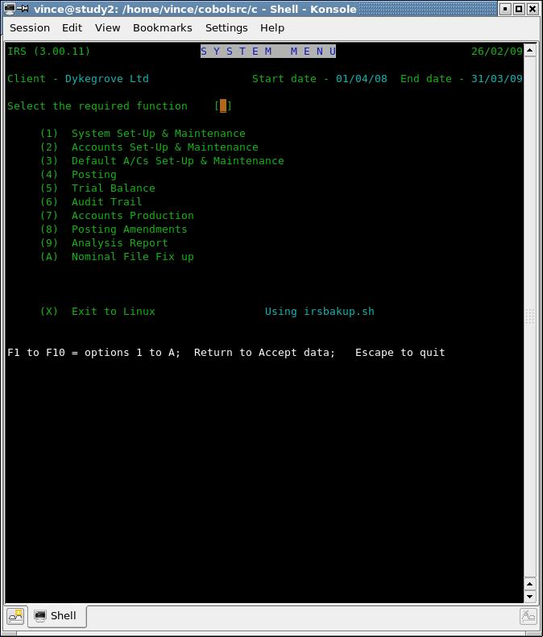
Fig 4.1 System Menu

To run the option you require, simply enter the number. These functions are now described. Option X causes a return to the operating system, and run the shell script / batch command shown, in this case it is irsbakup.sh (stored in the same directory/folder as the programs and the data by the install procedure) which will make a backup of your data. It is up to you to ensure that the drive you are backing up to is set-up and loaded for writing to. There is no recovery if this not in place, however the user may run the script manually at any time. If the system can not find this script or batch file, a message will be displayed in place of the usual 'using script name' message displayed to the right of the menu (x) option, see fig 4.1.

If this is the first time that IRS has been run, option 1 - System Set-up & Maintenance - will be run automatically.

This function will normally be used to change the date only, but may be used to update the system parameters. Upon entry the user must enter or verify today's date in the form "dd/mm/yy" if the date has changed since last running. The cursor will next be positioned over the field marked pass word. If the correct pass word is entered the user will be given access to the other system parameters. If an incorrect pass word is entered or only the return key is struck then the system will return to the main menu.

The first parameter which may be altered is the password itself. As released, the password is "Hit space bar 4 times", e.g. four spaces. This may be changed to any four character value required, or left as it is by hitting the return key. If changed, you must make a note of the password because it is encrypted and therefore it is not possible to re-create it without special processing. [The encryption level has been simplified for the OS version while still being protected]. See fig 4.2.

The other parameters which may be changed are as follows:-

- The user name - up to twenty four alphabetic characters.
- Client's name and address as five lines of twenty-four characters each.
- The VAT rate - entered as two integer and two decimal places e.g. "1500" for 15.00%
- The client's financial year start and end dates - should be entered as dd/mm/yy
- Name of the operating system in use

Use tab or cursor down to skip to the next field, or cursor up to the previous. Use enter when finished. Using Escape will quit back to the main menu. These functions can be used throughout the program in addition, the function keys F1 through F12 where indicated on the bottom of the screen, can be used to select a menu option in addition to the displayed number, i.e., for option 3 you can use number 3 or the F3 key at the top of your keyboard. Use of the keys: delete, back space, home and end will depend on the way your system is set up.

Note that dates are normally entered in the form dd/mm/yy where . , can be entered in place of / in any combination.

If, during the input of the system parameters, there are already characters between the square brackets, pressing return only, will accept the displayed data in its entirety.

When entering the VAT rate, enter all four digits i.e., not say just '20' for 20.00%. The result, may not be what you expect. Some versions of IRS offers 3 – 5 different Vat rates.

Now you are asked for the name of the operating system you are running under, i.e., Linux, Windows etc. After responding to (iv) above the program will return to the system menu for the next option.

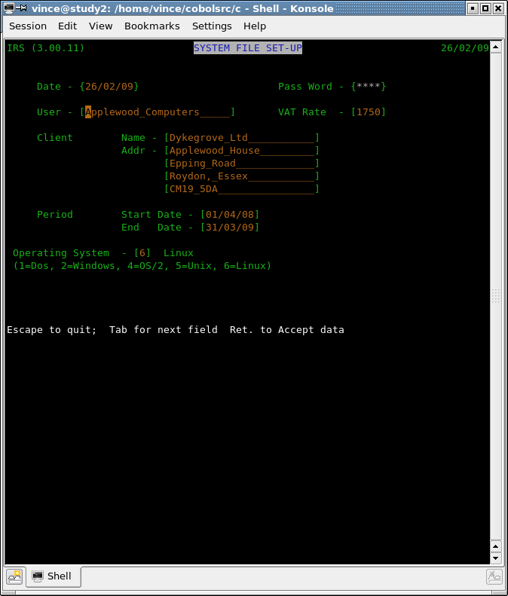
Fig 4.2 System File Set Up

5 Chart of Accounts Set-up & Maintenance

Chart of Accounts Set-up and Maintenance - IRS010

5.1 Account Overview

Before you can start entering transactions you must set-up a 'Chart of Accounts'. & default accounts.

Examples of CoA (Chart of Accounts) for your guidance are provided and set out in Appendix B. If you decide to use one of the supplied sample charts this may be selected from the Chart of Accounts menu and will not need to be manually entered.

If you wish to use an existing CoA perhaps from another client or from a sample set (see above) then just copy the acnts.dat file to the new directory, setup for this client and if not previously done, set up the irs parameter file via main menu option 1. This should be automatically selected.

Now when entering CoA set-up for the first time you will be offered an option to clear down the accounts, see fig 5.1 and you should respond to this by Y having made sure that you ARE in the directory for the new client. The system will then clear all totals for each of the accounts ready for you to enter any amendments to the CoA and start adding posting, see Chapter 7 Posting.

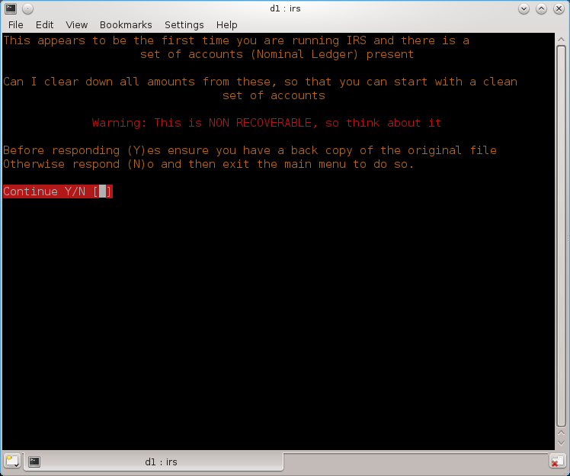
Fig 5.1 Account clear down on first entry

The remainder of this section explains the Chart of Accounts for the better understanding of those who select a sample chart and in particular for those who intend to set-up a new chart.

On the ledger for a main account the sub-nominal balances, if any, are shown. Account numbers are five digits for both the main account and the sub-nominal account. IRS can support up to 99,999 accounts. For large Companies that require 10 digit main and sub nominal accounts contact us for a more suitable product. If however you have the source code you can amend it to allow for larger accounts or for that matter larger monitory values above 9 millions for entry and 99 millions for totals (display and printing).

For normal operations, main accounts are numbered 101 to 199 and are used to group and sub-total sub-accounts of a particular type. For example a main account may be set-up for 'Light and Heat' as say 115 with sub-accounts 215 as 'Electricity' and 315 as 'Gas'. On a 'Detailed Trial Balance' you would see individual totals for 'Electricity' and for 'Gas' whereas on a 'Summary Trial Balance' it would add these items together and show only one total as 'Light and Heat'.

Each main account can have up to 998 sub-accounts which will automatically be set-up in order. This will allow you to run the same number of customers you give credit to and invoice or suppliers you get credit from. If you have more, just allocate more main accounts for the purpose.

The first sub-account to 101 will be 201, the next 301 etc., up to 99901.

To set-up a chart select (2) from the main menu for 'Accounts Set-up and Maintenance' and then (1) from the sub-menu .

When you enter this routine for the first time, certain accounts must be set-up as follows although the numbers are not cast in stone (see the examples in Appendix B for more details) :-

Main Sub
a/c a/c

177 VAT. Control account
277 VAT. Input Tax
377 VAT. Output Tax
199 Suspense account
299 Journal Control account
399 Opening Trial Balance account

To continue, enter the number of the first main account you want to set-up, e.g.'101', give it a description, e.g.'Sales'.

The accounts structure is such that the nature of an account (e.g. revenue or capital, income or expenditure) is defined by a single character rather than by the account number. You are now asked to stipulate the account type, which is a letter from A to Z. The significance of these letters will only become fully apparent to those users who intend to produce final accounts or those that pass their data files on to their accountants who also run IRS.

The first decision to be made is whether the account will affect profit, i.e. whether it is a 'profit and loss' or 'income and expenditure' account in which event use a letter from A to N or, if the account is a balance sheet account use a letter for O to Z.

Within the groups A - N and O - Z IRS recognises eight different account types and allocates various groups of letters to them. The sample chart/s at Appendix B show example/s of which account type to use and a greater understanding can also be obtained by reference to the section on double-entry book keeping at Section 3.2. The accounts structure is such that the nature of an account (e.g. revenue or capital, income or expenditure) is defined by a single character rather than by the account number. IRS recognises eight different account types and allocates various groups of letters to them. The account types have groups of letters associated with them in order to increase flexibility when defining the layout of the final accounts (see section 6.6). The account types and their associated letters are shown below:-

Income Accounts A to D

Direct Cost Accounts E to H

Sundry Income Accounts I to J

Indirect Cost Accounts K to N

Fixed Assets O to Q

Current Assets R to T

Current Liabilities U to V

Capital Accounts W to Z

As a review and that can be seen, letters A to N relate to the Profit and Loss Account, and letters O to Z to the Balance Sheet.

For 'Sales Invoicing' you would enter 'A' (or any letter from A to D). The accounts structure supports sub-nominal accounts such that accounts may be divided into main (or owning) accounts and sub-accounts. On the final accounts, only main accounts are reported and they show the cumulative balance on themselves and their sub-nominals.

If at this juncture you want to add sub-accounts (which can be done now or later) then enter 'Y' to 'Add Subs' and then a description for the first Sub-account e.g. 'Sales – A. N. Company Ltd'.

Continue entering sub-accounts until complete and then press <Return> where the sub-account is zero to allow you to enter the next main account number. Using this method you can continue adding all your customers that you give credit to and invoice. Similarly, do the same for your suppliers that invoice you.

When you have entered your chart this can be displayed by selecting (3) from the 'Chart of Accounts Set-up and Maintenance' menu, or printed by selecting (4) from the same menu.

If you discover any errors in the chart these can be amended by selecting (2) from the Sub Menu, which selection is also used to add subs to a Main Account which has already been set-up. If you do not know the account number which needs to be amended you can use function key 'F3' and enter any part of the account name. If the entry is ambiguous you will be given a list of the relevant accounts from which you may choose.

Upon entry to this function the user will be presented with a group menu containing five functions, each of which is now fully described., see fig. 5.2.

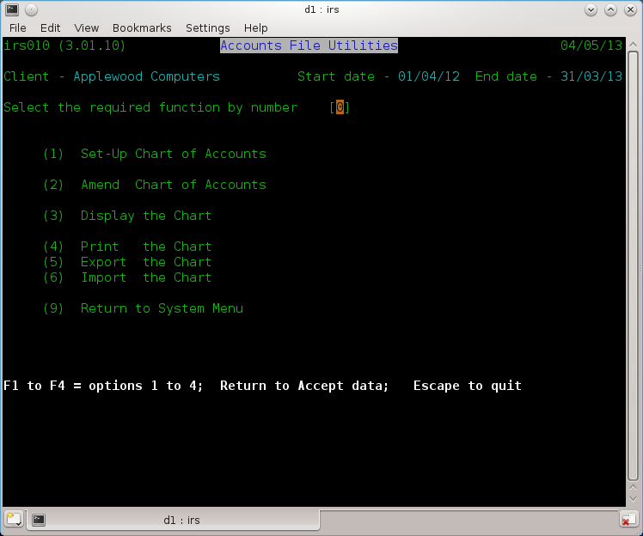
Fig 5.2 Account file Utilities

5.2 Set-up Chart of Accounts

This function allows a new Chart of Accounts to be created, and also allows new accounts to be added to an existing Chart. Note that this function will only add sub-nominals to the chart at the same time as the owning account is created. To add sub-nominals at any other time, use function 2. Amend.

Upon entry, the you are asked if you wish to add to an existing chart? The answer to the question is of crucial importance. Answering "N" (for no) erases the current chart. However before doing so, the user is asked for the pass word, which must be entered correctly in order to erase the chart.. This is so important that additional warnings are also displayed in Red to help force you to think about this question before answering.

Thereafter, the next screen is displayed for the input of information. The first item keyed in is the main account number which is checked, and rejected if already in use on this chart, see fig. 5.3.

The next item to enter is headed "Sub-Nominal" to which the response is either "Y" for yes or "N" for no. Answering "Y" implies that the account being set-up is an owning account and the user will be given an opportunity to enter sub-nominal accounts to the owning account.

Answering "N" or just hitting return implies that the account is a main account without sub-nominals.

Regardless of the answer to the above question the user will next be asked for the name of the account. Twenty-four characters are allowed.

Following this, the last item to be entered is the Account Type. Enter a letter in the range A to Z, to specify where you wish it to appear in the final accounts.

At this point, the response to the sub-nominal question determines the information that is entered on the next line.

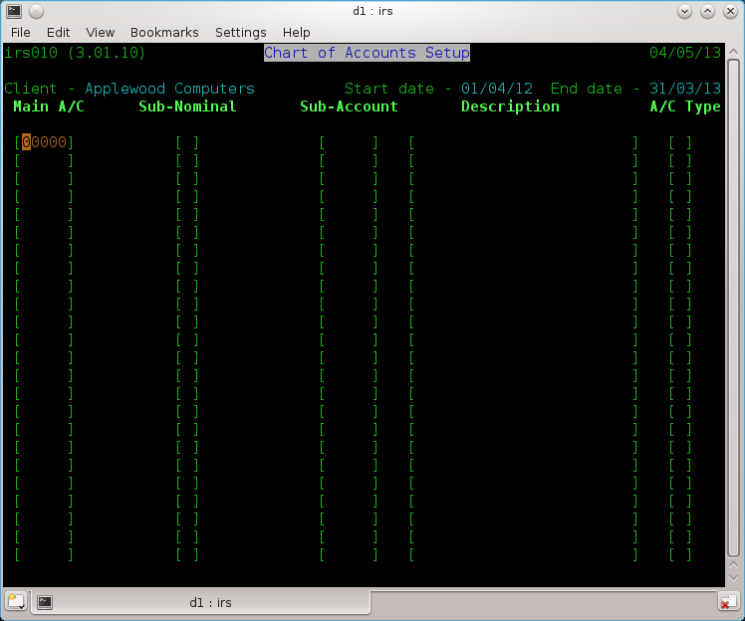
Fig. 5.3 Chart of Account Setup

If the response was no, the user will be prompted for the main account number required, and the input process for a main account is repeated. Note that typing return to this question (i.e. entering no value whatsoever) causes the system to exit from the function and return to the group menu.

If the response was yes to the sub-nominal question, the input on the line below will be for a sub-nominal account number followed by its description only. Note that a sub-nominal account automatically takes the same account type as its owning account. This input cycle of sub-account followed by its description continues until a return only is entered for the sub-account number, which terminates the entry of sub-nominal accounts and allows a new owning account to be entered.

The simple rule to remember is that a blank sub-account number i.e. return allows another main account to be input and a blank main account number allows the user to exit to the group menu. After each group of entries the screen clears and entry starts again from the top.

5.3 Amend the Chart of Accounts

This function is provided to permit the following:-

i. Amendment of a main or sub-nominal account.

ii. Addition of a sub-nominal account when its main account already exists.

iii. Deletion of an owning account and all its sub-nominal accounts (if any).

The screen displayed is identical to the screen shown in figure 5.3. In actual usage there are functional differences, the major difference being that for all data to be entered the main account number must be entered first and must exist. The function is now discussed in terms of its three sub-functions.

5.3.1 Amendments

By definition the account to be amended must be present within the chart. On entering the main account number the description will be displayed in the appropriate area. The cursor will be positioned in the Sub-Nominal field. If the main account is to be updated enter "N" (for no). If the sub-nominal account is to be updated enter "Y" (for yes). This will cause a request for the sub-nominal account number to be entered. At this point the name of the account to be amended will be displayed. The name may then be updated as required, or accepted by hitting the return key, following which the account type may be similarly changed or accepted.

The cursor will next be positioned in the main account field, and a main account may be entered for update. Just hitting the return key will exit to the group menu.

5.3.2 Addition

Initially proceed as above for amending an existing sub-nominal but enter the account number for the new sub-nominal account as a sub-account. The description may then be entered and the new account will be stored in the chart.

5.3.3 Deletion

The user may only delete main accounts. Doing so will cause the deletion of any associated sub-nominals accounts. To delete a main account enter its number as previously described and then "D" to the sub-nominals question.

5.3.4 Print the Chart of Accounts

On selection, this function first prompts the user to ensure that the printer is ready and then prints the entire chart of accounts in the same format as the display.

5.3.5 Display the Chart of Accounts

This function displays the chart on the screen. The display is in ascending main account sequence with sub-nominals shown immediately after their owning account.

On each screen fifteen or more (depending on screen size) accounts are displayed, after which the user may enter "X" to exit or "N" to display the next screen. After displaying the last screen the user enters any key to return to the group menu. The "X" facility is provided to allow the user to terminate the display and return to the group menu at any time.

5.3.6 Export the Chart

This function allows you to save a copy of the current chart to a text or comma delimited file. The text file is the default option, see fig 5.4.

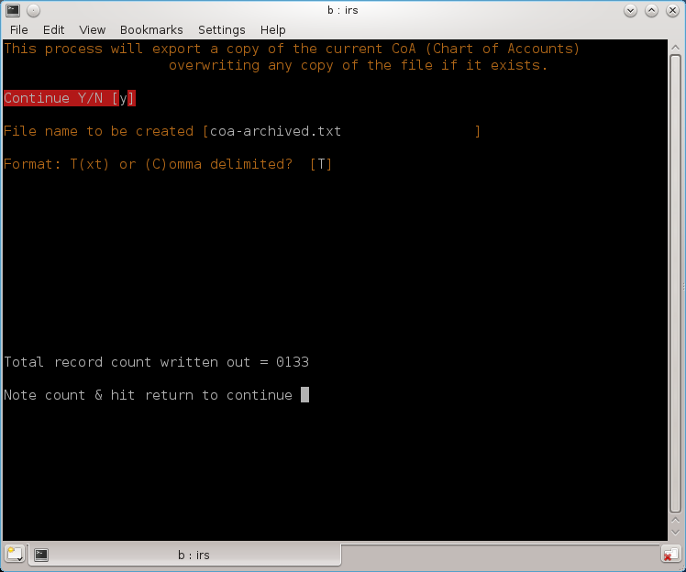
Fig 5.4 Exporting the Chart

On entry, you will be asked to confirm selection, file name and file type default is T (for Text) that can be imported using option 6 (see the next function) as well as a comma delimited file which can be imported into a spreadsheet or word processor eg, the open source LibreOffice.

5.3.7 Import the Chart

You can import a copy of a Chart that was previously exported (see 5.3.6).
On entry you will be asked to confirm the process as this will overwrite any accounts file present and this is not recoverable so make sure you have backed it up. Next you will need to enter the name of the file to be imported that is in the current directory or a path/filename not exceeding 32 characters, see Fig 5.5). Any existing chart will be deleted and the new one created. All totals etc are cleared down to zeros ready for you to use or amend as needed.

Fig 5.5 Import the Chart

5.3.8 Return to System Menu

This function returns the user to the main system menu.

Note The Chart of Accounts must be created before using any program other than System Set up, and then followed by the Default Accounts, see chapter 6.

6 Default Accounts Set-up & Maintenance

6.1 Default Accounts - IRS020

Default accounts are a central feature of IRS and should be clearly understood. IRS will not permit single entry posting, entering both the debit and credit for each posting is time consuming and prone to error. VAT accounting requires that, for each posting, the user knows (a) whether the posting is VAT related and (b) if the VAT is input or output. It is also necessary to apply to each posting a simple code for reporting purposes. The final consideration is the desirability of having a single input format for all postings which will automatically build up a VAT Day Book providing both VAT and statistical totals. The solution to all of the above is Default Posting. The user, by setting up the defaults, defines the contra-accounts which are to be used. The system supports 32 contra-accounts at any given time. To set-up the defaults the user must supply three pieces of information for each default account. These are:-

6.1.1 An Account Number

This can only be a number of an account which already exists in the chart of accounts. In most cases the following accounts should be used as defaults:-

Bank Account
Cash Account
Journal Control

6.1.2 The Transaction Code

This two letter code will be printed on all detailed transaction reports and using the accounts mentioned above could be:-

BE = Bank expenditure VAT Input
BI = Bank income VAT Output
BK = Bank income or ex non VAT
CE = Cash expenditure VAT Input
etc,

6.1.3 The VAT type

As (I) input, (O) output or (N) none.

Defaults 30, 31 & 32 are dedicated to:-

30 Opening Trial Balance
31 VAT Inputs (Purchases)
32 VAT Outputs (Sales)

All of which must be VAT type coded "N" for None.

During postings it is vital that you use the correct default, taking into account the settings for VAT and on what side i.e., Input or Output.

Defaults 1 to 29 inclusive are available for any account the user requires. All accounts used for default accounts must already exist in the chart of accounts. While the user is able to utilise the accounts and defaults at his/her own discretion the following advice may prove useful.

During posting it is only necessary to specify the number of the default account and whether the batch is a debit (To) or credit (From) batch for IRS to meet the criteria outlined above. The user then, for any transaction, only has to input the date, contra-account, narrative, amount and, if necessary, the VAT code.

It should be noted that a single account may be used in several defaults e.g. the Cash and Bank Accounts would normally be found in at least three default accounts with one each of input, output and none as the associated VAT types. Likewise the associated default codes could be BI, BE and BK for Bank Income, Bank Expenditure and Bankings respectively.

By using this system, restrictions on the number of Bank or Cash accounts within the 29 default parameters are removed, journals are also created by setting up and defining as a default a Journal Control Account. The two character default codes can later be used at the reporting stage as a retrieval parameter.

On entry to this function the user will be shown and prompted to select one of the six options as discussed below.

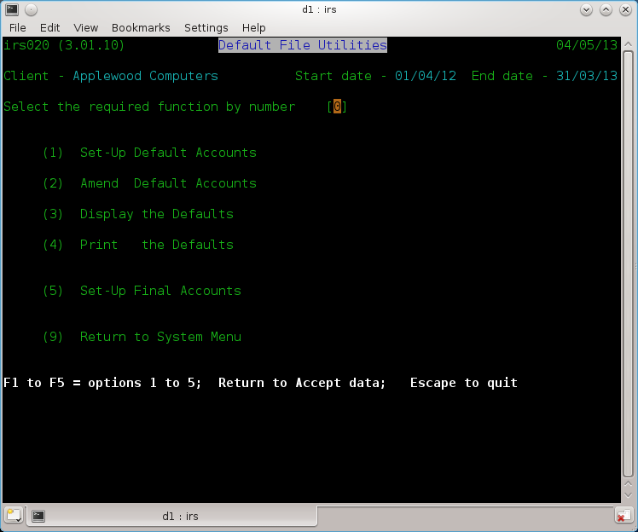
Fig. 6.1 Default Accounts Setup

6.2 Set-up Default Accounts

6.2.1 VAT Accounts and Defaults

It is suggested that a main account say 177 is designated as a VAT Control Account and sub-accounts 277 VAT Inputs and 377 VAT Outputs are created, sub-accounts 477 for payments and refunds and sub-account 577 for Direct VAT Postings, this latter account being useful for dealing with correcting invoices rendered or received for VAT only and other similar infrequent transactions.

6.2.2 Suspense Account

This should always be a main account say 199 and may have numerous sub-accounts i.e. cash sales control 299, journal control 399, petty cash 499 and 599 say for directors A and B, general suspense 699, petty cash for staff & others 799 and Opening Trial Balance (or OTB) 99999, all of which should never produce a balance but in the event of an erroneous balance being generated, it would appear in Suspense Account..

Upon entry the question "Add to existing defaults?" is asked. Entering "N" (for no) deletes the existing file whilst "Y" (for yes) permits a speedy update to existing defaults.

Each default is numbered, and for each one the user must supply the number of an account which exists within the chart of accounts, a two character code, and the VAT type which must be either "I" for input tax, "O" for output tax or "N" for no VAT.

Default entry is terminated with an account code of zero, which can be achieved simply by hitting return only to the input account code prompt..

Once done the system will prompt for defaults 30, 31 and 32 which must be the opening trial balance, Input and Output VAT accounts respectively. This function does not terminate to the group menu but automatically loads the amendment routine.

6.3 Amend Default Accounts

This function allows one or more defaults to be amended. The default is amended in the same way as it was added in section 6.2. The difference is that each default to be amended has to be specified by number. The default number is entered at the bottom of the screen in the space provided. A screen is shown in figure 6.2.

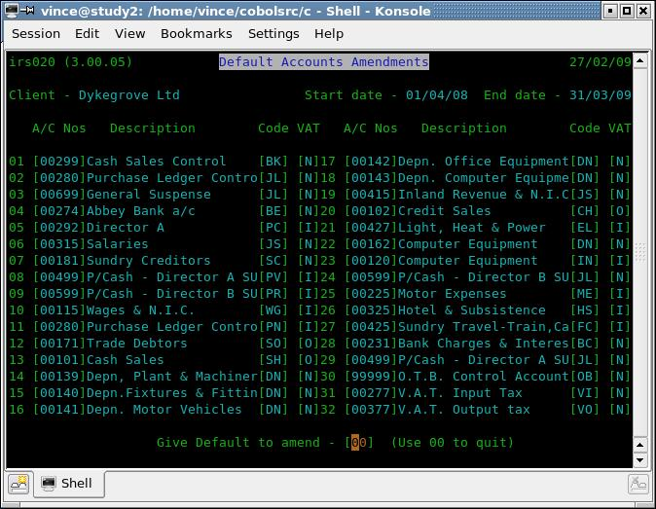
Fig 6.2 Amend Defaults

6.4 Display Default Accounts

This function produces a simple display of the defaults as held on the Defaults file. This function is also implemented in the posting procedure to allow the defaults to be displayed at the time they are actually used. See figure 6.2.

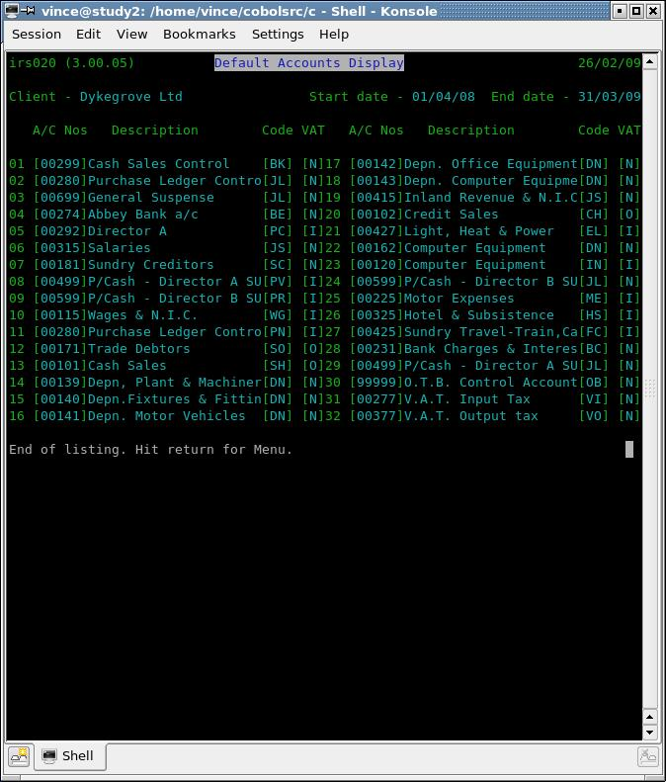
Fig 6.2 Defaults Display

6.5 Print the Defaults

This function is provided to allow a print-out of the defaults to be produced.

6.6 Set-up Final Accounts

A single function is implemented for setting-up the final accounts. Screen example is shown in figure 6.3. At the present time, please ignore the column marked sign as this is provided for possible future use although you can enter values '+' or '-' now. These headings will be automatically used in place of the default ones. If in doubt, leave these all blank.

For the Profit and Loss Account, enter it or the Capital account that will be used to transfer profit or loss for next years accounting using the Final account production and end of year processing, (see 10 Final Accounts). This account will be checked that it exists in the CoA.

Use the various arrow keys to travel around the screen (figure 6.4) and only enter heading narratives against those letters which are actively used in the chart of accounts. At this point enter or return to complete input.

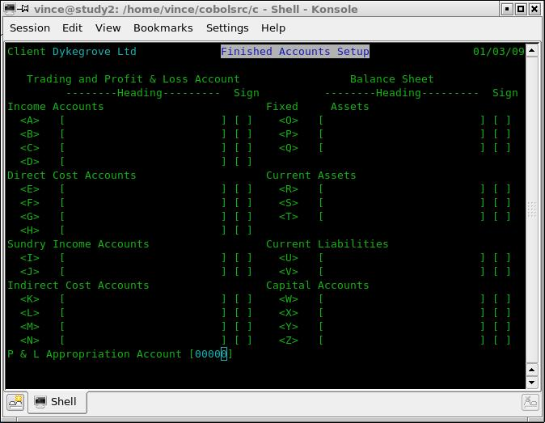
Fig 6.3 Set up Final Accounts

Return Sends all data on screen to program
Home Moves cursor to start of first field
^ Moves cursor to start of previous field
v Moves cursor to start of next field
<-- Moves cursor left one position
--> Moves cursor right one position
. (stop char) Inserts leading zeros into field (Note this may differ using the Open Cobol version)

Fig 6.4 Cursor Movement keys

7 Posting – IRS030

Although IRS is not a true batch system, transactions are entered in what are effectively batches. Each batch relates to a particular default account. Upon entry to this part of IRS and before actually making the postings, it is necessary to identify to the system the type of postings that will be made.

This is done by answering the following four questions:-

7.1 Enter run option

This has four possible responses as follows:-

a) "99" displays the existing defaults The same way as in 6.3.
b) "88" adds the batch to be entered to the current file of postings.
c) "77" clears the existing file of postings and starts the file anew with the postings to be entered, under
pass word control.
d) “66” Add PL or SL Postings from file.
e) <Return> exits to the Main Menu.

Selecting option “77” should only be done after final accounts have been produced and end of year processing completed. Of course it is recommended that a back up of your data must be completed prior to running final account (see 10) or selecting “77”. Both functions are otherwise not recoverable.

Selecting option “66” will post transactions from Sales and/or Purchase ledgers to the posting file so that they are merged with transaction entered through IRS. There are some error message that can appear that will show that system setting within P/L or S/L are incorrect but this should not happen.
At the end of processing a display will provide you will a record count along with a request to clear down the temporary file. You will normally enter “Y” as otherwise they will be reposted, the next time you run this function.

7.2 Enter Default Number
or
Posting from which account?

This allows selection of the default to be used. Pick the right one with VAT in mind and is the default account to which the total of each posting will default.

e.g. If you were posting cheque payments you would enter the account number which you have set-up to be the bank account.

Whenever you are asked for an account number you can use function key 'F3' and enter any part of the account name. If the entry is ambiguous you will be given a list of the relevant accounts from which you may choose.

It's description will be displayed and you have to confirm that it is the correct account..

Please note that here and in 7.4 the question can differ depending on software version used.

7.3 Correct Account (Y/N)

The account description and VAT type associated with the default are displayed, and this question is used to allow confirmation that the correct default has been selected.

7.4 Enter Run Characteristics (DR) or (CR)
or
Debit or Credit?

"DR" if the accounts to be entered are debited and the default account credited.
"CR" if the accounts to be entered are credited and the default account debited.

Payments made to others by cheque or cash would be debit 'DR', monies received would be credit 'CR'.

If the series of transactions which you are about to enter are mainly payments then enter <DR>, if during the run you want to enter an occasional receipt this can still be done by preceding the amount with a minus sign '-'. Having entered the answer, the main posting screen will appear. A split screen is used with all entries being kept to the bottom four lines of the screen, with one exception which is discussed later. The entries to be made are as follows:-

(1) Date - Should be entered as dd/mm/yy. i.e., day as 01 to 31, Month as 01 to 12 and the year.

(2) Account - The account number of the main or sub-nominal account of the posting.

(3) Narrative - Thirty-two characters are provided for a legend. On the screen only this is contracted to sixteen characters.

(4) Amount - This is the net or gross amount of the transaction according to the VAT type. A zero amount will abort the posting.

Mistakes during posting

If you make a mistake whilst posting, before you have accepted the amount, enter a nil amount and the transaction will not be entered into the system.

If you have accepted the amount before you notice the error then make a note of the posting number and correct the mistake through Posting Amendments. (See 11.)

(5) VAT Code - This is only requested if an input or output tax default account has been used, and should be entered as:-

If "P" is inserted, the system will calculate the amount of VAT to be added to the transaction amount entered and will display the VAT calculated, you may either accept the amount by hitting Return or delete the integer of the amount and enter an amended figure. You may also use the arrow keys to move then modify an incorrect character. This also works with 'M' as discussed below. This function is useful for checking the VAT shown on input documents.

If "M" is used the system will calculate the amount of VAT to be deducted from the transaction amount entered, amend the transaction and insert the VAT. You may either accept or alter the amount as for "P". If you alter the VAT amount the Net will be adjusted automatically, with Net and VAT redisplayed.

If Space is used then the VAT amount can be entered manually or return can be used for Non VAT (Zero Rated) items.

Entering Zero Rated items through the medium of either Input or Output Default Accounts, ensures that they appear in the statistics columns of the VAT day book.

Entry of transactions outside the scope of VAT should be via ("N"/Non Vat Defaults), these entries will not then appear on the VAT day book.

A minimum of fourteen postings (the maximum will depend on your screen size) can be entered on each screen. When the screen is full, the last transaction will be moved to the top of the next screen.

To exit once a batch has been entered type return only to the Account prompt.

As items are input the current balance on both the default account and the VAT account is displayed along with a running batch total. A transaction number is allocated to each posting that is entered.

NB: The transaction number will be required when utilising the Posting Amendments facility.
Also, A minus sign following the amount reverses the default posting convention for that
transaction only. eg. When in a debit run a minus sign will credit the posting.

Important:
Under Open Cobol and when entering or amending numbers and amounts you will have to key in the full number including the full stop and the pence, i.e., 000000029.45 and not 29.45. The full stop and pence must be keyed even for 0.00. This is because the code produced by the compiler for editing accepting numeric amounts from the keyboard is very weak. When this is corrected you should be able to use the full stop in the same way as you do with a calculator. You can, use the left and right arrow keys to position to the digit you wish to change.

Changing the Default Account whilst posting transactions

If you are entering purchase invoices, you will possibly be defaulting through the suppliers account. The next invoice to be entered may be for a different supplier.

To prevent your having to come out of the posting screen to change the account from which you are posting, there is a facility to press function key F3 when asked for the date in order to change the default. Please note that there is a short delay (.5 to 2 seconds) when pressing a function key or the escape key for the program to respond, again due to the current version of Open Cobol (v1.1) running under Linux. Hopefully this problem will be fixed in a later release. Its is recommended that user has a print out of the defaults to hand.

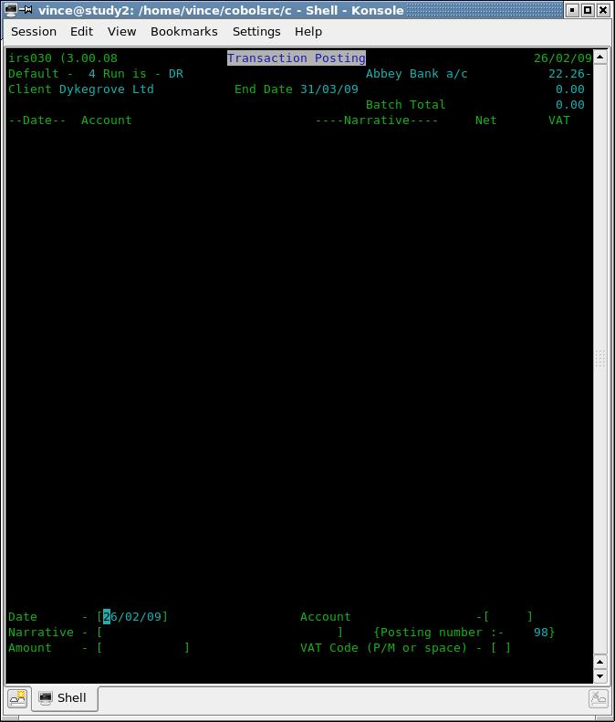
Fig 7.1 Transaction Posting

8 Trial Balance - IRS040

Selected from the Main Menu as Function 5 or F5.

You can select a detailed or summary trial balance that can either be displayed or printed. In either case accounts with zero balances may be included or omitted. The Trial Balance order is ascending by Main Account Number with sub-nominals immediately after their owning accounts (if detailed trial balance has been selected). A summary trial balance will accumulate all postings to 'sub' accounts into the respective 'main' account and will display 'main' account totals only. When displaying the Trial Balance, at the end of each page the user is asked whether the next page is required or not so that the display may be aborted if no further information is required.

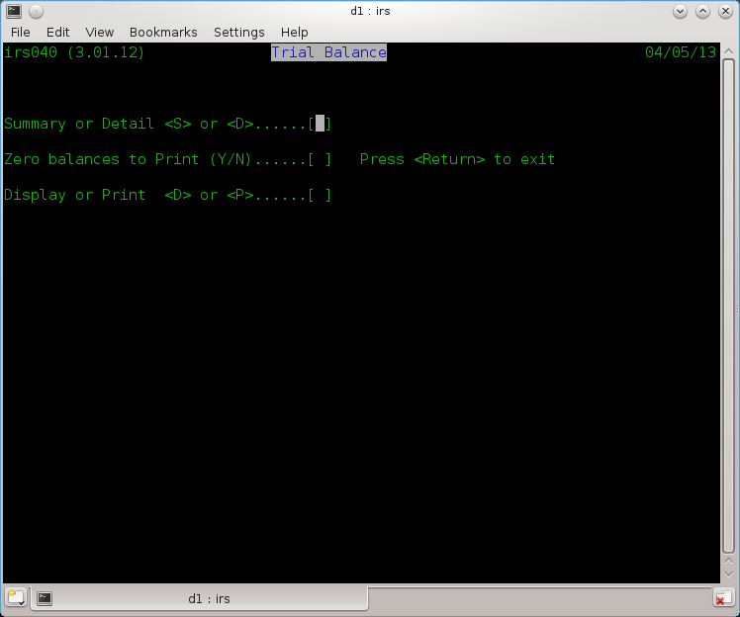
Fig 8.1 Trial Balance Reports

9 The Audit Trail - IRS050

Selected from the main menu as function 6 or F6.

There are three primary reports or displays available. Fig 9.1 These are:-

- A - Audit Report
- L - Ledgers
- D - Day Book

(1) Audit Trail

The Audit Report is a listing of postings entered into the system. It can be used to list all postings or may be used selectively to list only those postings having a given code. e.g. "BE" (Bank Expenditure Input VAT), "JE" (Journal debits Input VAT) etc.

(2) Ledgers

The Ledger Report produces either the ledger page for an individual account or a report for all accounts. Sub-nominal balances are also shown. Entering zero or just return as the account number will produce all accounts which is particularly useful at the year end in order to obtain full hard copy print out.

(3) Day Book

The Day Book produces a VAT listing of all transactions entered against VAT "I", "O" or “N” default accounts. When this selection is made, start and end dates for the report must also be entered, as this will produce quarterly reports which provide the totals for insertion in the VAT returns, both for tax and statistics.

All the above reports can be produced in one of three sequences:-

- Code Order Sequence
- Date Order Sequence
- Transaction Order Sequence

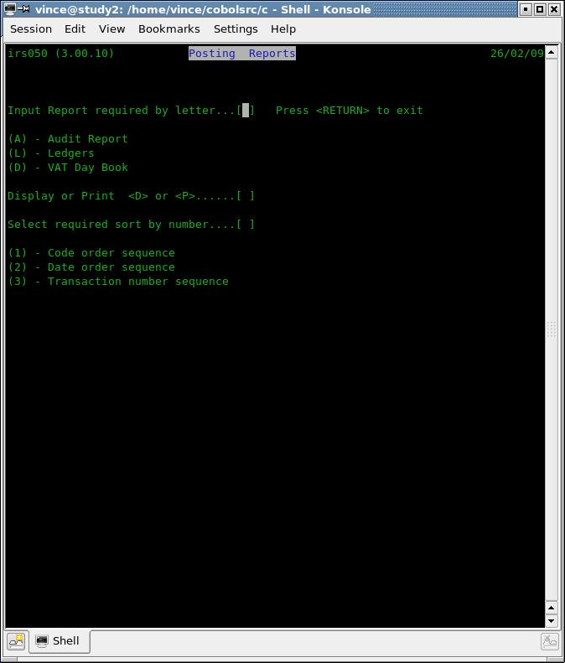
Fig 9.1 Audit Trail menu

10 The Final Accounts - IRS060

Selected from the Main Menu as Function 7 or F7.

This function prints the Profit & Loss Report, Balance Sheet and optionally, processes the end of year cycle.

Gross and Net Profit %s are expressed in the same way i.e. as a percentage of Sales.

To initiate the production of the accounts, select the comparative field which contains last year's figures. If there is no requirement for comparative figures (or none exist as this is the first year using IRS for this client), select 0 (zero). The comparatives are from one to four, I.e., the last four years prior to current.

After printing the accounts and balances the system will ask:-

"Do you require end of year processing?"

Before saying Yes to this you should make a backup of your data files in case of any problems, as this does change accounts and this is not recoverable using the Fix-up function (12).

The user should answer "Y" for yes or "N" for no. If the answer is no, the main menu will be shown, otherwise the system will ask for the comparative area (1-4) in which to store the figures and a profit and loss appropriation account in which to carry forward the profit or loss. The comparatives must be between one and four inclusive and the profit and Loss Account must exist within the chart of accounts. This is discussed twice for a good reason.

End of year processing copies all the balances to the comparative selected. The current balance for all revenue accounts are set to zero, but those for capital accounts are unchanged except that the account nominated for the Profit and Loss Appropriation has it's balance updated by the Profit or Loss. The system is now ready to accept the new year or period inputs.

A back up at this point is recommended eg, exit the system and then rerun IRS to allow the automatic back up to occur assuming you have the backup script in place.

11 Amend Postings - IRS070

Use this procedure to correct any errors you have made when posting a transaction.

Selected from the Main Menu as Function 8 or F8. This function is provided to allow previously entered postings to be amended or deleted. Postings are referenced by their IRS transaction numbers. It is useful, therefore, to produce an audit report before attempting to use this facility.

On entering the transaction number the posting is retrieved while a message

"Reversing posting - Please wait" is displayed.

The posting has now been effectively deleted. It is then displayed along with the message "Correct the transaction". At this point any or all fields may be amended. To leave a field as it is, simply hit return only. Please note that negative amounts may not be entered. After entering the VAT, the transaction is restored to the file suitably updated.

To leave this function enter a transaction number of zero.
To delete the displayed transaction, enter a code of "**" (star star).

On exit from this function the user will be given the opportunity to renumber the transactions. If the transactions are renumbered, they are sorted into date order at the same time. This will of course mean that any previous numbering will no longer be correct. If a transaction number is entered which does not exist an error message is given and the prompt for transaction number is repeated.

Using the renumbering function will remove the ability of an audit trail. For a company, the correct and recommended way of correcting a posting to say the wrong account, is to enter a posting to contra it off and add it to the correct account. However the facility might be handy for accountants and their book keepers in certain conditions.

The Amend Postings facility is more commonly used to correct entries made when posting rather than making additional correcting entries. Before exiting from the posting mode, note the current transaction number displayed and calculate the transaction number you wish to amend or delete.

Errors observed whilst checking printouts are easily corrected in this mode as all printout entries record the transaction numbers.

12 Nominal File Fix up - IRS080

Selected from the main menu as function A or F10.

Sometimes, due either to misuse of posting VAT, during Posting Amendments or hardware failure the Trail Balance goes out of balance compared to the individual balances on the ledgers. This program, after requesting the pass word, will repair the General (Nominal) Ledger Accounts File by clearing current balances and reposting all entries from the Post File. This process will sometimes become needed if using Posting Amendments where the VAT element is changed from None to I or O or O to I etc. It is suggested that any time such an amendment is made this program is run before the end of the day just as a safeguard.

NOTE – It is recommended to make a back up copy of ALL data files prior to running, in case of hardware or power failure.

13 Analysis Report - IRS090

Selected from the main menu as function 9 or F9.

This function will produce a monthly analysis by account number of all postings. This can be used for budgeting purposes.

Before starting, the system will request the month your tax year starts, i.e. New financial year starts April (common for the UK), then enter 04 (fourth month).

As this process will read every posting it can take some time depending on the number of transactions and the speed of your computer. That noted, on the test system running a Intel E6600 with a Sata2 hard disk, 1,000 postings takes less than a second.

14. Update or Conversion programs – IRSCONVERT etc

These can have various names but usually called irsconvert1, irsconvert2 etc.

Supplied with a new version of the software, if needed. After installing the new version but before compiling it using the Cobol Compiler (if using the Open Source version):

- Read the documentation supplied with the update which can be called Changelog or readme.now etc, for information regarding the nature of the updates and any conversion programs and how or when to run them.
- Make a complete back up of all data files I.e., all with names ending with .dat.
- Run any programs specified in (1) as needed. This is usually a one time process for each set of accounts in each data directory. Make sure you do not forget to run against any clients directories as serious and unrecoverable errors could and probably will, occur.
If this does happen, the only solution is to restore from the last back up prior to upgrading.

Appendix A IRS Set-up

A.1 IRS Executable Programs

Only supplied if you have purchased a licence:

The IRS issue binary archive should contain the following files:-

Open Cobol version.

irs irs040.so irs065.so irs090.so irsub4.so
irs010.so irs050.so irs070.so irsub1.so irsub5.so
irs020.so irs055.so irs080.so irsub2.so irsubp.so
irs030.so irs060.so irs085.so irsub3.so

The file name extensions eg '.so' will not be the same if you have the version for the Microfocus Cobol system such as Net Express or Visual Cobol.

In addition, these two data files reflecting limited company accounts as an example which you may use as a basis to create your own (a complete set of data files may be supplied contain limited company data that is used during testing):

acnts.dat dflt.dat

Note that before using them, you must run the set up procedure as detailed in 4.1. to create the system file (system.dat) but this is not needed if you are playing with the sample test data). We would recommend that you place the test data in a separate directory just for the purpose of you using them for testing or getting used to the various functions of IRS. The same applies to the sample Limited company files I.e., acnts.dat and dflt.dat but for these two you must create the system file as described above in a fresh directory.

In addition you will also have the Cobol compiler runtime system that must be installed.

Please see the README file and other notes included, as this will be different depending on the compiler used eg, Open Cobol, Micro Focus Visual Cobol, Net Express etc.

A.2 IRS Source Programs

If you have obtained the OS version (Open Source) you will have the Cobol source code instead (but also with the sample data files indicated in A.1 and possibly a complete set that was a part of the test data suite) so they will need to be compiled using the current version of Open Cobol so the archive contains the same file names but with the extension of .cbl instead of .so (irs will be irs.cbl). In addition there will be various additional source files with an extension of .cob or .cpy that are included as copybook files for the programs, i.e., used during the compiling process only.

A complete list of source files is shown below:

Changelog irs040.cbl irs-manual-v2.odt selpost-irs.cob
comp-irs.sh irs050.cbl irsub1.cbl TODO
COPYING irs055.cbl irsub2.cbl wsdflt.cob
envdiv.cob irs060.cbl irsub3.cbl wsfinal.cob
fdl-1.2.txt irs065.cbl irsub4.cbl wsfnctn.cob
fdpost-irs.cob irs070.cbl irsub5.cbl wsfsrply.cob
fdwsnl.cob irs080.cbl irsubp.cbl wsirs020.cob
fsdispfe.cob irs085.cbl print-spool-command.cob wsnl.cob
irs010.cbl irs090.cbl print-spool-command-p.cob wspost.cob
irs020.cbl irsbakup.sh readme wssystem.cob
irs030.cbl irs.cbl screenio.cpy install-irs.sh
install-irs-preinstalled.sh
The two shell scripts, one to compile them and then the other to place them into ~/bin directory is also included along with other scripts, batch & command files (used in Windows and Dos only).

If items are missing or you suspect they are, contact us at vbcoen@btconnect.com for advise and a possible updated version.

To compile use compile-all.sh
To install use install-irs.sh and if you have previously run this for a specific user run instead
install-irs-preinstalled.sh. The later will not set up the environment variables again.

It is very strongly recommended that you read any and all files that may be named Changelog, TODO, upgrade, readme (and any variants, e.g., readme.first, readme.now etc) prior to doing any work whatsoever with the IRS package in order to get the most up to date information. If you have any problems not discussed relating to the Open Cobol system, please make use of the help forums at the http://www.add1tocobol.com web site or at http://sourceforge.net/projects/open-cobol or
http://sourceforge.net/p/open-cobol/discussion/?source=navbar

A.3 Open Cobol Compiler v1.1 or later

Of course you must have installed the Open Cobol compiler prior to this. Current versions should be available via the web site at http://sourceforge.net/projects/open-cobol or via the older site at http://www.opencobol.org/modules/mydownloads/ make sure you select the latest version. Also check out http://www.add1tocobol.com. After you have downloaded it, say in to your primary directory which I will assume to be /home/user-name where user-name is your login name, then create 3 new directories so the instructions are:

mkdir cobolcompiler (Creates directories for holding the cobol compiler sources)
mkdir -p cobolsrc/irs (and the IRS Cobol source code)
cd cobolcompiler
tar xfvz ../open-cobol-1.n.y.tar.gz (unpacks the compiler sources but change n.y to the filename)
cd open-cobol-1.1 (created by the tar command)
( and assuming 1.1 is the current version)

There are instructions for compiling the compiler which you should read and follow, which may include installing some other development packages. If you need help go to the forum where you found the Cobol compiler for help. Note that building the compiler with tests can take 10 – 20 minutes depending on the speed of your computer.

But simply just type:
./configure && make && make check

It is strongly recommended you also install the NIST validation test pack and copy it to the tests/cobol85 subdirectory below open-cobol-1.1 by doing:

1. Download the test archive `newcob.val.Z' from http://www.itl.nist.gov/div897/ctg/cobol_form.htm
and store it in the open-cobol-n-y directory where the compiler is.

2. Uncompress it by running 'uncompress newcob.val.Z' coping the file to the tests/cobol85 directory.

Then run from the same directory, 'make test'. I suggest you then run 'cmp summary.txt summary.log' to verify that all tests worked but please also read the README file in the cobol85 directory.

Assuming that all works then (you may have to change this next one to):
su -c “make install” and provide the root login password:

sudo make install and provide your login password

This will fully install the Cobol compiler on your system ready for use.

A.4 Building IRS from sources

Once you have installed the compiler you are ready to build IRS or any other packages within the ACAS range. So move to the IRS directory you created above and run tar xfvz ~/irs-package-filename, and cd to the created directory and now you can run the build script that comes with irs, i.e., comp-irs.sh then install-irs.sh.

You are now ready to start using your new application of IRS by returning to your home directory and creating a directory for running irs.

Note that install-irs.sh will create a IRS directory under your home directory ready for you to use as well as setting up all the environment variables needed. This you can check by:

Leave the terminal program you used to build the IRS system and reload it so that the changes made by running install-irs.sh will take effect. Then to check that it is set up correctly, do 'set | grep ACAS' and you should see something like:

ACAS_BIN=/home/vince/bin
ACAS_IRS=/home/vince/IRS
ACAS_LEDGERS=/home/vince/ACAS This one if you also installed ACAS.
COBCPY=/home/vince/cobolsrc/ACAS/copybooks
COB_COPY_DIR=/home/vince/cobolsrc/ACAS/copybooks

The name vince should be your user name.

Also see A.2 for more information.

A.5 Running IRS and its requirements

Usage of IRS will create the following files:

Primary files: system.dat acnts.dat post.dat dflt.dat final.dat
Temporary files: worksort.tmp work2.tmp postsort.dat workpost.tmp

All files must be on-line simultaneously in order for the software to function. All data files (those with an extension of .dat) must be regularly backed-up. Each set of data files relates to a single client only. It is up to the user to organise his data. All files with the extension of .tmp are temporary files and will normally be deleted or of zero length after processing.

Add the path name containing the programs to the system path parameter. Your current directory must contain the data files to be used. If running under Linux a shell script is supplied to do this for you to place the programs in your local folder at /home/(login name)/bin (Also referred to as: ~/bin). See the script install-irs.sh and again see A.1.

Note that some version of the IRS and ACAS systems use rdbms systems such as mysql and these files are not needed with the possible exception of temporary files and/or the system.dat file.

Appendix B Sample Charts of Account

B.1 Limited Company

Main Sub Description Type

101 Cash Sales A
201 Books A
301 Hardware A
401 Software A
501 Manuals A
601 Postage and Packing A
701 Miscellaneous & Overpaid A
801 Cash Refunds Control A
102 Credit Sales A
202 Computer Consultancy A
302 Computer Rentals (SW,HW) A
402 Agency Fee's (Intro's) A
502 Aviation A
602 Dispersements (Exps) A
103 Opening Stock E
104 Purchases E
204 Software and Manuals E
304 Books E
404 Hardware E
105 Freight (Input) E
110 Closing Stock E
111 Bank Deposit Interest I
114 Consultancy Fee's K
115 Wages & N.I.C. K
215 Agency Fee's & Staff K
315 Salaries K
415 Inland Revenue & N.I.C. K
116 Office use of Home K
117 Rent and Rates K
217 Rent K
317 Rates K
417 Water Rates K
517 Council Tax (Property) K
617 Bldg service charges K
121 Telephone, Fax, Internet K
221 Telephone K
123 Printing, Post & Statry K
223 Stationery K
323 Printing K
423 Book,Manuals,Magazines K
523 Postage/Courier K
124 Advertising & Exhibitions K
125 Travel & Subsistence K
225 Motor Expenses K
325 Hotel & Subsistence K
425 Sundry Travel-Train,Cab K
525 Foreign Business Trips K
126 Entertainment K
127 Sundry Expenses K
227 Staff Welfare K
327 Training K
427 Light, Heat & Power K
527 Subscriptions K
627 Conference Fee's K
727 Computer Maint'c Costs K
827 Insurance K
128 Hire of Equipment K
131 Finance Charges K
231 Bank Charges & Interest K
331 Debt Collection Fees K
431 Credit card Charges K
133 Bad Debts K
134 Legal Fees K
135 Book-keeping Fees K
137 Audit and Accountancy K
138 Hire Purchase Interest K
139 Depn. Plant & Machinery L
140 Depn. Fixtures & Fittings L
141 Depn. Motor Vehicles L
142 Depn. Office Equipment L
143 Depn. Computer Equipment L
144 Computer Consumables K
244 Software K
344 Computer Consumables K
145 Directors remuneration K
245 A - Dividends K
345 B - Dividends K
148 Pension Scheme K
154 Plant & Machinery O
155 Depn. Plant & Machinery O
156 Fixtures & Fittings O
157 Depn. Fixtures & Fittings O
158 Motor Vehicles O
159 Depn. Motor Vehicles O
160 Office Equipment O
161 Depn. Office Equipment O
162 Computer Equipment O
163 Depn. Computer Equipment O
169 Loans made by Company R
170 Stock on hand R
171 Trade Debtors R
172 SDY. DRS & Prepayments R
174 Cash at bank and in hand R
274 Cash at bank R
374 Cash in hand R
176 Hire Purchase U
177 V.A.T. Control Account U
277 V.A.T. Input Tax U
377 V.A.T. Output tax U
477 V.A.T. Payments to HMRC U
577 V.A.T. Paid to suppliers U
178 Inland Revenue-Corp Tax U
179 Credit Cards U
279 Barclaycard - A U
379 Barclaycard - B U
180 Trade Creditors U
280 Purchase Ledger Control U
181 Sundry Creditors U
182 Bank Loans U
282 Bank Loan - #1 U
382 Bank Loan - #2 U
186 Share Capital W
189 Profit and Loss Account X
192 Directors Loan Account W
292 A W
392 B W
193 Loans by Directors W
293 Loans by A W
393 Loans by B W
195 Capital Account W
295 Capital a/c - B/Fwd W
395 Capital a/c - Cap Intro W
495 Capital a/c - Profit W
595 Capital a/c - Drawings W
199 Suspense Z
299 Cash Sales Control Z
399 Journal Control Account Z
499 P/Cash - A Z
599 P/Cash - B Z
699 General Suspense Z
799 P/Cash - Staff & Others Z
99999 O.T.B. Control Account Z

See the sample data directory s it may have a more up to date copy of this as well as more examples for different business types such as partnership, sole, charity etc.

If you create others not included, please consider offering them to us for redistribution.

Appendix C Posting Methods

United Kingdom:

There are two main methods of processing VAT whether on a manual or computerised system.

Method (1) Cash Basis and by arrangement with HMRC

Only enter transactions when you spend or receive monies.

Method (2) Credit Basis

Enter purchase invoices when received, whether or not you have paid them.

Enter sales when you have invoiced them, whether or not you have received the money.

You could have a combination of the two methods, e.g. credit basis for purchases and cash basis for sales.

See section 3.2 for more information.

Appendix D Introduction to Double Entry Book Keeping

D1 Double entry book keeping as applied to IRS.

Currently a separate document due to size.

