Convolution is a important concept in a lot of different fields aswell in the field of signal processing and analysis. Convolution is able to create an output out of any input signal and an impulse response.

Convolution definition comes out of the mathematical domain.   
The equation is as follows:  
Definition of 1D Convolution   
x[n] is an input signal  
h[n] is the impulse response  
y[n] is output  
\* is the notation for convolution.  
  
Important is that we multiply x[k] by the terms of time-shifted h[n] and add them up.

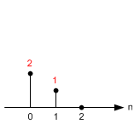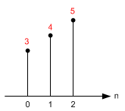Key to understanding convolution is understanding the way the impulses are being handled.  
 

Input: x[n]

Impulse Response: h[n]

Y[0] =

*y*[0] = *x*[0]·*h*[0]  y[0] = 3·2 =6  
*y*[1] = *x*[1]·*h*[0] + *x*[0]·*h*[1] y[1] = 4·2 + 3·1 =11  
*y*[2] = *x*[2]·*h*[0] + *x*[1]·*h*[1]  y[2] = 5·2 + 4·1 =14  
*y*[3] = *x*[3]·*h*[0] + *x*[2]·*h*[1] y[3] = 0·2 + 5·1 =5

Lowpass =  
1 1 1  
1 1 1   
1 1 1   
------  
 9  
  
Highpass  
-1 -1 -1  
-1 8 -1  
-1 -1 -1