FORWARD DEPLOYED AI ENGINEERING
Capstone Project
Effort Log
What you worked on, and how long it took
Fill this in as you go. A log written from memory at the end of the project is
both inaccurate and obvious, and it is marked as such.
FILL IN EVERY SECOND DAY

Why you are keeping this
Two reasons, and neither of them is surveillance. The first is that estimating your own work is a professional skill you will be asked to exercise constantly, and the only way to get better at it is to compare what you predicted against what actually happened. The second is that the reflection section of your report needs material, and a log that shows discovery took half the time you expected while evaluation took twice as long gives you something genuinely worth writing about.
Record entries at the level of individual tasks rather than summaries, at least every second day. Record the hours you actually worked, including the ones that produced nothing useful. A task that took four hours and ended in a dead end is a real cost and belongs here.
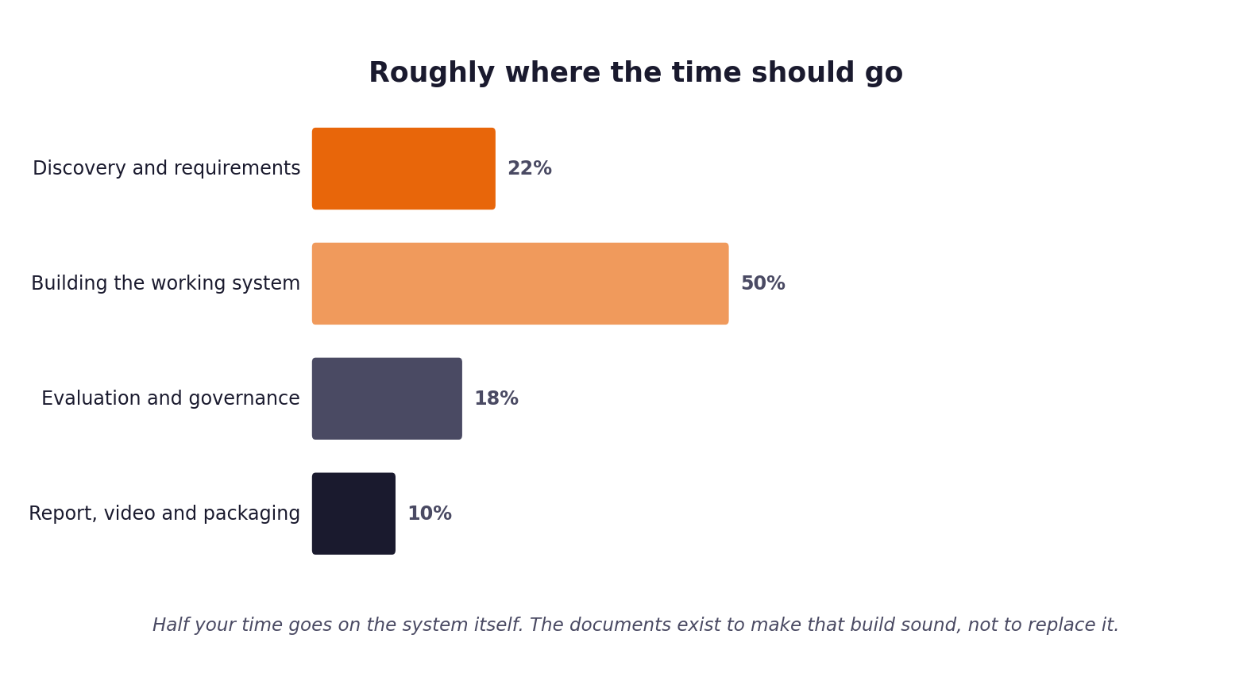
Figure 1. Roughly how the hours are expected to distribute. Compare yours against this at the end of each week.
1 Your details
Field | Value
Full name | Balakumaran SV
Project start date | [YOUR START DATE]
Target submission date | 21 September 2026
Hours available per week | [YOUR HOURS] — alongside full-time employment

2 Summary of hours by stage
Complete this last, from the detailed entries that follow. The totals must reconcile with your daily records.
Stage | Planned hours | Actual hours | Difference | Why the difference
1. Discovery | [ ] | [ ] | [ ]
2. Requirements | [ ] | [ ] | [ ]
3. Prompt library | [ ] | [ ] | [ ]
4. Sprint plan | [ ] | [ ] | [ ]
5. Build and revision | [ ] | [ ] | [ ]
6. Report, video, packaging | [ ] | [ ] | [ ]
Total | [ ] | [ ] | [ ]

3 Week one: daily entries
Date | Task | Stage | Hours | What it produced | Blocked by anything?
[DATE] | Read the pack: brief, build specification, submission guide | 1 | [ ] | Understanding of the twelve acceptance criteria and the gate
[DATE] | Environment setup; Python, dependencies, model provider account | 1 | [ ] | Working local environment | Free-tier model availability
[DATE] | Read five stakeholder transcripts | 1 | [ ] | Interview notes; five points of disagreement identified
[DATE] | Analyse 500 development tickets: volume, effort, outcomes by group | 1 | [ ] | 71.4% answerable; 107 avoidable escalations consuming 36.8% of agent hours
[DATE] | Settle the interview disagreements against the ticket data | 1 | [ ] | Three interview claims found to be contradicted by the data
[DATE] | Complete the Stage 1 discovery workbook and problem statement | 1 | [ ] | Stage 1 workbook; every claim traced to evidence
[DATE] | Derive the intent taxonomy from the labels | 1 | [ ] | 22 categories matching the evaluation labels
[DATE] | Recover the routing policy from expected_route | 1 | [ ] | Three-clause rule reproducing 500/500 dev and 80/80 validation
[DATE] | Write PRD v1 with evidence traceability | 2 | [ ] | 16 functional and 10 non-functional requirements, each with an evidence id
[DATE] | Build ingest: four channels, tolerant field mapping, never raises | 5 | [ ] | src/ingest.py; test_a2_* passing
[DATE] | Build retrieval: chunking, hybrid scoring, relevance floor | 5 | [ ] | src/retrieve.py; expected document ranked first 94.3%
[DATE] | Build classification with calibration and a rule fallback | 5 | [ ] | src/classify.py, src/calibration.py
[DATE] | Externalise the prompt library as versioned files | 3 | [ ] | prompts/*.json; Stage 3 register
[DATE] | Build generation, citation resolution and four guardrails | 5 | [ ] | src/generate.py, src/guardrails.py; test_a7_* passing
[DATE] | Build the decision log with reconciliation | 5 | [ ] | src/decision_log.py; log reconciles 80/80
[DATE] | Build the evaluation harness and metrics | 5 | [ ] | One documented command; six metric groups computed by code
[DATE] | Build the answerability model and tune its threshold | 5 | [ ] | src/answerability.py; AUC 0.76 from the intent prior against 0.58 from retrieval alone
[DATE] | FIRST LIVE RUN — 80 validation tickets, 983 seconds | 5 | [ ] | metrics.json, metrics.md, decision log; two defects surfaced | OpenRouter retired the free Llama model mid-project
[DATE] | Diagnose and fix the cosine rescaling defect | 5 | [ ] | Relevance floor works; scripts/tune_retrieval_floor.py added | Caught by a test that had been passing only because embeddings were unavailable
[DATE] | Diagnose and fix the fitted-artefacts loading defect | 5 | [ ] | fitted/ committed and used as fallback; taxonomy now loads on a clean checkout | Silent failure — 15% intent accuracy with no crash and no clear warning
[DATE] | Model provider migration: OpenRouter to Groq to gpt-oss-120b | 5 | [ ] | scripts/list_models.py; verify_setup points at it on model_not_found | Both providers' published documentation was wrong at the moment it mattered
[DATE] | Re-run the evaluation on the corrected system | 5 | [ ] | [YOUR FINAL METRICS]
[DATE] | Write the governance framework: risks, fairness, incident procedure, kill switch | 6 | [ ] | Risk register with 12 risks, owners and residual ratings
[DATE] | Complete the Stage 5 revision log | 5 | [ ] | Six requirement changes, each traced to what prompted it
[DATE] | Repository structure, CI, clean-checkout rehearsal | 6 | [ ] | Mandated four-folder layout; build_submission.py; rehearsal passed
[DATE] | Write the report | 6 | [ ] | [N] pages
[DATE] | Record the video | 6 | [ ] | [N] minutes
[DATE] | Complete the workbooks, effort log and packaging | 6 | [ ] | Submission archive built and checked

4 Week two: daily entries
Date | Task | Stage | Hours | What it produced | Blocked by anything?

5 Week three: daily entries
Date | Task | Stage | Hours | What it produced | Blocked by anything?

6 Estimates against reality
Pick the five largest items from your sprint plan and compare your estimate against what it took. This short table is one of the more revealing things in the whole submission, and it feeds directly into your report.
Item | Estimated hours | Actual hours | Why the difference
Discovery and data analysis | [ ] | [ ] | Settling the interview disagreements against the data took longer than reading the transcripts, and was worth more.
Retrieval | [ ] | [ ] | The scoring scale problem was invisible until embeddings worked on a different machine.
Debugging the two defects | [ ] | [ ] | Not estimated at all. Neither was foreseeable from the code; both needed a live run.
Model provider migration | [ ] | [ ] | Not estimated. Two providers retired the free models named in the pack, and both sets of published documentation were wrong.
Report, video and packaging | [ ] | [ ]

7 Where the time went unexpectedly
Answer these in full sentences. They are short, and they will save you writing the reflection section from a blank page in your final week.
Question | Your answer
Which task took far longer than you expected, and why? | Getting a model to answer at all. Two providers retired the free Llama models the pack names, and in both cases their own documentation still listed the model as available. I lost an evening to it before writing a script that queries the provider's models endpoint instead of trusting a web page.
Which task was easier than you expected, and why? | Recovering the routing policy. I expected to spend hours defending a chosen threshold and instead found that treating expected_route as a target and searching for the simplest rule reproduced it exactly on both sets. That turned the hardest thing to justify into the easiest.
What would you allocate differently if you started again on Monday? | Run the system end to end on the real data far earlier, even badly. Both defects I found were invisible until a live run with working embeddings, and neither would have been caught by any amount of further reading.
What did you spend time on that turned out not to matter? | Tuning thresholds against a score scale that turned out to be wrong. Every number derived before the cosine fix had to be re-derived. The wasted effort was not the tuning itself but doing it before validating the scale it rested on.

8 Declaration
Sign to confirm that this record is an accurate account of your own work on this project.
Full name | Signature | Date | Total hours recorded
Balakumaran SV |  | 21 September 2026 | [ ]

