FORWARD DEPLOYED AI ENGINEERING
Capstone Project
Stage Four: Sprint Plan
Deciding who does what, in what order, and what finished means
A plan is not a list of tasks. It is a statement of sequence, ownership and
completion that the team has actually agreed to.
WEEK TWO · DAY ONE

How to plan three weeks of work
You have already lost a third of the project to discovery and requirements, which is as it should be. What remains has to be sequenced carefully, because several parts of the build depend on others and the dependencies are not always obvious until you hit them.
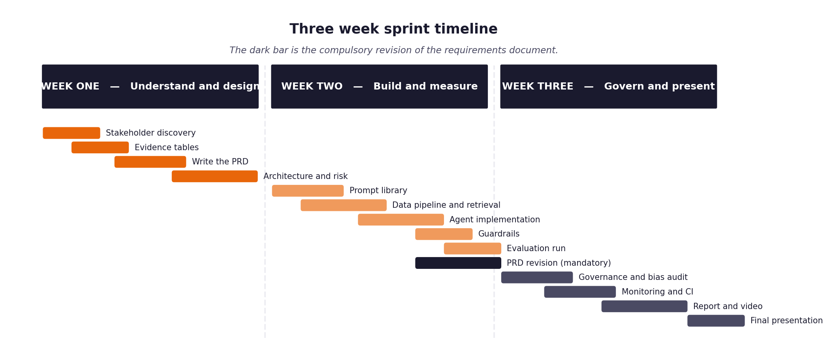
Figure 1. The shape of the three weeks, including the compulsory requirements revision.
Three rules that make the difference
- Every item has an estimate in hours and a priority. When you run short of time, and you will, the priority column is what decides for you rather than whatever felt urgent that morning.
- Every item has a definition of done written before work starts. Written afterwards, it describes whatever happened to be produced.
- The retrieval layer and the evaluation harness come early, not late. Almost everything else depends on one or the other, and leaving the harness until the end means discovering your results too late to act on them.
- The full unattended run over the hidden evaluation set happens in week two, not week three. It is the gate the project turns on, and it always exposes problems that never appear when you are testing one ticket at a time.

1 Section one: your capacity
Before you plan anything, work out honestly how much time you actually have. Plans built on optimistic capacity fail in week two rather than week three, which is worse, because by then you have committed to an architecture that assumed the time existed.
Week | Hours realistically available | Other commitments that week | Days you cannot work
Week one | [YOUR HOURS] | Full-time employment; this ran alongside it | [YOUR DAYS]
Week two | [YOUR HOURS] | Full-time employment | [YOUR DAYS]
Week three | [YOUR HOURS] | Full-time employment | [YOUR DAYS]

On working alone
Working individually removes the coordination overhead and replaces it with a different problem: nobody will notice when you have been stuck for six hours. Set yourself a rule that anything blocking you for more than an hour gets written down and either escalated or worked around, and check that list at the end of each day.

2 Section two: the backlog
List every item of work. Estimate in hours rather than in vague sizes, because hours can be compared against the capacity you recorded above. Mark dependencies explicitly, because the order matters more when there is only one of you.
ID | Item | Est. hours | Priority | Depends on | Definition of done
B-01 | Read the pack; set up the environment and model access | 2 | Must | — | verify_setup passes; a model provider answers
B-02 | Discovery: read five transcripts, analyse 500 development tickets, settle the disagreements against the data | 6 | Must | B-01 | Stage 1 workbook complete; every claim traced to an interview or a computed figure
B-03 | Derive the intent taxonomy from the labels | 1 | Must | B-02 | storage/taxonomy.json holds the 22 categories present in the data
B-04 | Recover the routing policy from expected_route | 2 | Must | B-02 | A rule reproduces expected_route on dev and held-out validation; script reproduces it
B-05 | PRD v1 with traceability from evidence to requirement | 3 | Must | B-02 | Every requirement carries an evidence id and a verification method
B-06 | Ingest: four channels into one representation, never raises | 2 | Must | B-01 | Hostile input produces warnings, not exceptions; test_a2_* pass
B-07 | Retrieval: chunking, hybrid dense + lexical, relevance floor | 4 | Must | B-06 | Expected document ranked first >= 85%; irrelevant query returns nothing
B-08 | Classification with calibrated confidence and a rule fallback | 4 | Must | B-03, B-06 | Confidence calibrated; fallback capped below the routing threshold
B-09 | Prompt library as versioned files | 2 | Must | B-08 | prompts/*.json loaded at import; register emits the Stage 3 table
B-10 | Generation with resolved citations and the insufficient-context path | 3 | Must | B-07 | Citations resolve to retrieved passages; dangling markers discarded
B-11 | Four guardrails that block | 3 | Must | B-10 | Each demonstrably blocks; each records what it checked even when it passes
B-12 | Routing: ordered rules, pure function, human-readable reasons | 2 | Must | B-04, B-08 | Same input, same decision; test_a5_* pass
B-13 | Decision log with reconciliation | 2 | Must | B-12 | Logged decisions reconcile against tickets processed
B-14 | Evaluation harness: one command, --input/--output, unattended | 4 | Must | B-13 | Full validation set processed with no intervention; metrics written
B-15 | Metrics: volume, business, technical, governance, fairness, doc gaps | 4 | Must | B-14 | Every figure computed by code and reported with its denominator
 | Answerability model and threshold tuning | 3 | Should | B-07, B-08 | Fitted on development data only; threshold chosen from a sweep, not by eye
 | FastAPI interface, /health, /metrics, kill switch | 2 | Should | B-12 | Endpoints respond
 | CI: tests with no API key, credential scan, unattended run | 2 | Should | B-14 | Green on push; fails the build on a committed credential
 | Governance pack: risk register, fairness method, incident procedure | 3 | Must | B-13 | Every risk has a named mitigation and an owner
 | Report, video, workbooks, packaging | 8 | Must | all | build_submission.py reports no mechanical failures

3 Section three: the week two plan in detail
Day | What will be finished by the end of the day | Hours | Risk to this
Monday | Ingest working; a ticket from each channel normalised | [ ] | None — no external dependencies
Tuesday | Retrieval: corpus embedded, expected documents found | [ ] | Embedding model download; mitigated by a lexical fallback
Wednesday | Classification and routing; decisions logged with reasons | [ ] | Model provider availability
Thursday | Generation and guardrails; at least one demonstrably blocking | [ ] | Prompt iteration can take longer than planned
Friday | THE GATE: full validation set processed unattended, metrics produced | [ ] | Highest-risk day. If behind, cut scope rather than the end-to-end run.

4 Section four: the week three plan in detail
Day | What will be finished by the end of the day | Hours | Risk to this
Monday | Governance framework and fairness audit complete | [ ] | None
Tuesday | Monitoring and CI configured | [ ] | None
Wednesday | First video take recorded | [ ] | Always overruns; budget a second take
Thursday | Report drafted; second video take | [ ] | Evaluation numbers must be final first
Friday | Packaging, clean-checkout rehearsal, final checklist | [ ] | The rehearsal usually finds a missing README step

5 Section five: what you will drop if you run out of time
You will run out of time. Every student does. Deciding now what gets cut is far better than deciding in a panic on the final Wednesday, and it protects the parts that carry the most marks.
Item | Cut order | Consequence of cutting it | What you will say about it in the report
Prometheus/Grafana dashboards | 1 | Metrics endpoint still exposed; no visualisation. | Stated as not implemented in the governance framework, with the alert rules that would be needed listed.
Response-quality scoring against the 200 reference answers | 2 | Answer quality measured by grounding and citation resolution only — both proxies. | Named as a limitation in the report's evaluation section: no human or reference-based quality score was produced.
Per-group answer-quality fairness (beyond automation rate) | 3 | Equal automation rates could mask unequal answer quality. | Listed under what the fairness audit does not cover.
Log retention and redaction job | 4 | Customer text accumulates indefinitely; a compliance obligation, not a preference. | Listed first under 'what is not implemented' in the governance framework.
Human review queue for sampled sent answers | 5 | A wrong answer is found by complaint rather than by audit. | Named as the operational control that would close risk R11.

6 Section six: the daily check-in record
Ten minutes at the start of each day, answering the same three questions. Keeping this record is what makes your effort log accurate rather than reconstructed, and it is where you will notice a blocker that has quietly consumed two days.
Date | Finished since yesterday | Doing today | Blocked by
[DATE] | [what you finished] | [what you are doing] | [blockers]
[DATE]
[DATE]
[DATE]
[DATE]
[DATE]
[DATE]
[DATE]
[DATE]

