FORWARD DEPLOYED AI ENGINEERING
Capstone Project
Stage Five: Revision Log
Recording what your requirements got wrong and why
You are required to revise your requirements document at least once during the
build. This is where you record what changed and what prompted the change.
WEEK TWO INTO WEEK THREE · COMPULSORY

Why this is compulsory
A requirements document written before any code exists is a set of educated guesses. Some of those guesses will be wrong, and building is how you find out which ones. A student that reaches the end of three weeks with an unchanged PRD has either been extraordinarily lucky or has stopped consulting the document, and the second is far more common than the first.
This log is not a confession. It is evidence that you were paying attention. The students who score well here are the ones who can point to a specific thing they discovered while building, explain how it contradicted an assumption they had written down, and show what they changed as a result.
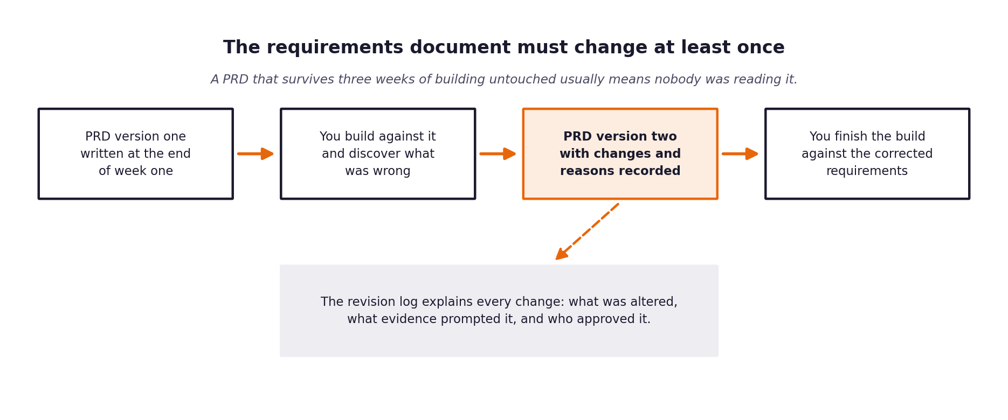
Figure 1. The revision sits in the middle of the build, not at the end.
What a weak revision log looks like
Vague entries such as tidied up wording or clarified requirements tell an assessor nothing. A strong entry names the requirement, states what it said before, states what it says now, identifies the specific thing that prompted the change, and says who agreed to it.

1 Section one: revision summary
Field | Value
New version number | 1.1
Date of revision | 21 September 2026
Who carried out the revision | Balakumaran SV
Who reviewed and agreed it | Individual project — no second reviewer
Number of requirements changed | 6
Number of requirements added | 2 (FR-14 documentation gaps, FR-15 fairness)
Number of requirements removed | 0

2 Section two: the changes
One row per change. Be specific about the trigger; that column is what distinguishes a considered revision from a tidying exercise.
Requirement ID | What it said in version one | What it says now | What prompted the change | Agreed by
 | Did not exist. FR-02 required only 'a numeric confidence'. | Stated confidence must fall within five percentage points of observed accuracy, measured as expected calibration error and reported every run. | The model returned 0.9 or higher for nearly every ticket, including ones it got wrong. Since routing compares against that number, a threshold of 0.70 was no threshold at all. | Self-agreed (individual project)
 | 'Answers grounded in the retrieved passages.' | Adds: states plainly when the documentation is insufficient, rather than filling the gap. | The model strongly preferred answering thinly to declining, and vague hedged replies passed a naive grounding check because they were similar to almost anything retrieved. | Self-agreed
 | 'Continue operating when the model provider is unavailable.' | Adds: degrade rather than merely continue — automated replies are suspended while degraded. | It did continue, and that was the problem. The rule-based fallback could clear the routing threshold and auto-answer on keyword evidence alone, at exactly the moment nobody was watching. | Self-agreed
 | Did not exist. Documentation gaps were an implicit by-product of retrieval failing. | The system must produce a prioritised list of questions the documentation cannot answer. | Those tickets turned out to be the most informative output the system produces, and the only one that reduces future volume rather than handling it faster. As a by-product it was invisible. | Self-agreed
 | Wording unchanged; the design beneath it changed from dense-only to hybrid. | Hybrid dense plus lexical scoring, with an absolute rather than per-query score scale. | Pure dense retrieval missed tickets quoting exact tokens — error codes, header names, endpoint paths. Then the score scaling itself proved wrong: see the assumptions table. | Self-agreed
 | 'Free tiers only; the project is designed to cost nothing.' | Free tier where available; otherwise the cheapest adequate model, with the deviation reported. | Both providers named in the pack retired their free Llama models mid-project. OpenRouter returned 404 pointing at the paid model; Groq returned model_not_found for a model its own documentation still listed as in production. | Self-agreed

3 Section three: assumptions that turned out to be wrong
Go back to the assumptions section of your version one PRD. For each assumption, say whether it held. The ones that did not are the most interesting part of your report.
Assumption from version one | Did it hold? | What you found instead | What you changed because of it
Free-tier model capacity from the providers named in the pack. | NO | OpenRouter retired the free Llama 3.3 70B; Groq had no Llama chat models available to the key at all. Published documentation was wrong for both at the moment it mattered. | Moved to openai/gpt-oss-120b, and wrote scripts/list_models.py so the provider is asked what it can run rather than a web page. verify_setup now points at it on a model-not-found error.
A model's stated confidence approximates a probability. | NO | Near-constant 0.9 regardless of correctness. Expected calibration error 0.545 uncalibrated. | Added isotonic calibration fitted on development data, and NFR-08 as an explicit condition.
Thresholding the retrieval score predicts whether the documentation can answer a ticket. | NO | AUC 0.58 — barely better than chance. A feature request is not unanswerable for want of a topically similar passage; no documentation could answer it. | Built a small logistic model over the retrieval score and the intent's historical answerable rate. Intent alone reaches 0.76.
Rescaling cosine similarity into [0,1] is harmless. | NO | (cos+1)/2 gives unrelated text a floor of ~0.55, so the relevance floor could never reject anything. Retrieval returned passages for 100% of tickets labelled not answerable, and the documentation gap list came out empty. | Clamped cosine at zero and wrote scripts/tune_retrieval_floor.py so the floor is set against the answerability label rather than by eye.
Committing the code is enough for a clean checkout to behave correctly. | NO | storage/ is gitignored, so the taxonomy, calibration mapping and answerability model were absent on a fresh clone. The system fell back to placeholder intent categories and scored 15% accuracy without crashing or warning loudly enough. | Committed the fitted artefacts to fitted/ and made them the fallback source, so a clean checkout works without anyone running the fitting scripts.
A substantial share of tickets are answerable from existing documentation. | YES | 71.4%, closely matching the tier one agent's estimate of seven in ten. | Nothing.

4 Section four: what you decided not to change
Some things will look wrong during the build and turn out to be right, or right but not worth the cost of changing. Recording those decisions is as valuable as recording the changes.
What looked wrong | Why you left it | What it would have cost to change | Revisit when?
The routing threshold produced a higher escalation rate than targeted. | It was set from a cost argument on the development set. Moving it after seeing validation results is fitting to the validation set, which is the one thing the split exists to prevent. | Nothing technically — one config value. The cost is to the integrity of the evaluation. | When there is agreement on what a wrong automated answer actually costs CloudServe.
Per-channel routing thresholds would raise the automation rate. | Customers who use different channels are not randomly distributed, so a channel-varying threshold is an outcome difference by another name, and the fairness audit would then have to disentangle it. | About an hour to implement, considerably more to defend. | If the fairness audit shows no group correlation with channel.
Several intent categories have too few examples to measure. | Adding finer categories would make the classifier look more sophisticated and every per-class figure less reliable. | Low, but it would mislead. The thin categories are labelled as noise in the report instead. | With a larger labelled sample.
The 95th-percentile latency target is missed. | It is dominated by per-call model latency on a free tier, with two or three sequential calls per ticket. A faster model closes part of it; the architecture is not the cause. | Restructuring to parallel calls would break the ordering that makes grounding-aware routing possible. | If latency becomes a deployment blocker rather than a reported miss.
Grounding measures similarity rather than entailment. | Entailment checking needs a second model call per sentence, which triples cost and latency on a target already missed. | Significant — a redesign of the validation step. | Before any production rollout. It is the largest residual risk in the design.

5 Section five: the reflection
Answer these in full sentences. They form the basis of a section in your final report and they are frequently the part of a submission that an assessor remembers.
Question | Your answer
What did you most misunderstand about the problem when you wrote version one? | That the client's request named the deliverable. CloudServe asked for a chatbot and I initially framed the problem as 'answer tickets well'. The evidence says the expensive failure is not unanswered tickets but escalations that did not need to happen — 107 per 500, consuming 36.8% of agent hours. A chatbot does nothing for those.
Which piece of discovery work would have caught it earlier? | Cross-referencing the history block against the labels, which took about twenty minutes. I did the volume analysis first and the effort analysis second; reversed, I would have seen immediately that 96.8% of agent time sits in escalated tickets.
What would you do differently if you started this project again on Monday? | Add a column to the requirements table headed 'and when it cannot?'. Four of my six revisions came from specifying what the system should do and omitting what it should do when that was impossible — retrieval finding nothing, a model that will not decline, a provider that disappears, a confidence that means nothing. All four would have been caught in an hour in week one.
What is still uncertain, and what would you need to resolve it? | Whether the answers the system sends are actually correct. Grounding and citation resolution are proxies: a sentence can score well against a passage that does not support it. Resolving it needs a human to read a sample of sent replies against the 200 reference answers, which I have not done.

