Supplementary Material
Terminology: resistance in retained plot labels denotes the NDVI-based resistance proxy, not physiological resistance. Recovery follows the clock and eligibility stated for each analysis.
Reviewer colours: yellow (Reviewer 1), pale green (Reviewer 2), light turquoise (Reviewer 3). Tables S1-S24 and Figures S1-S14 are historical sensitivities under their earlier cohorts, references and response definitions. Primary fixed-reference lagged/censored results appear in Tables S25-S28 and Figure S15; sensor/ecological diagnostics in Tables S29-S39 and Figures S16-S17; trend and censoring summaries in Tables S40-S41. Different cohorts, clocks and weights are not pooled. Missing source NDVI remains NA.

Supplementary Note S1: Rationale for focusing modelling on hot–dry events
Hot–wet (HW) compound extremes were retained in the descriptive analysis (frequency, resistance proxy, recovery) but were not used for the historical modelling component because HW occurrence was too sparse under the adopted month-of-year percentile definition to support stable, generalisable inference. Across all elevation bands, the median HW event frequency was 0 and the 75th percentile was also 0, indicating that at least 75% of pixels experienced no HW events over 1985–2025. Consequently, HW response metrics are estimated from a restricted subset of locations and are sensitive to localised hydroclimatic regimes. Consistent with this, the number of pixels with non-missing HW resistance proxy represents only 13.8% of pixels in <500 m and 21.4% in 500–1500 m but declines sharply to 3.1% (1500–2500 m), 3.0% (2500–3500 m), and 3.7% (≥3500 m). Given this sparsity, particularly in the high-elevation belts where compound extremes are of greatest ecological interest, flexible models (e.g., random forest with SHAP prediction contributions) and spatial prediction would be disproportionately influenced by a small number of locations and would provide limited national generality. Modelling therefore focused on hot–dry events, which occurred widely across Pakistan and yielded sufficient sample sizes for grouped cross-validation, model contribution analysis, and conditional predictive-dispersion mapping, while HW results are reported as spatially constrained patterns within the descriptive framework.
Table S1. Hot–dry (HD) exposure and vegetation response metrics by elevation band.
Reported as median and interquartile range (IQR) of pixel-level summaries: event frequency (count), mean event duration (months), resistance proxy (minimum NDVI anomaly; z-score), and recovery time (months).
Elevation zone | Elevation band (m a.s.l.) | Median hot–dry frequency (events) | Median mean duration (months) | Median resistance proxy (unitless) | Median recovery (months)
1 | <500 | 3 | 1 | 0.059 | 1.00
2 | 500–1500 | 2 | 1 | 0.232 | 1.00
3 | 1500–2500 | 4 | 1 | 0.231 | 1.83
4 | 2500–3500 | 4 | 1 | 0.272 | 1.75
5 | ≥3500 | 3 | 1 | −0.275 | 3.75
Table S2. Hot–wet (HW) exposure and vegetation response by elevation band (median values).
Elevation zone | Elevation band (m a.s.l.) | Median HW frequency (events) | Median mean duration (months) | Median resistance proxy (z-score) | Median recovery (months)
1 | <500 | 0 | 1 | 0.715 | 1
2 | 500–1500 | 0 | 1 | 0.036 | 1
3 | 1500–2500 | 0 | 1 | −0.438 | 1
4 | 2500–3500 | 0 | 1 | 0.948 | 1
5 | ≥3500 | 0 | 1 | 0.398 | 1
Table S3. Descriptive resistance proxy contrast for hot–dry (HD) impacts relative to single-driver extremes by elevation band.
Elevation zone | Elevation band (m a.s.l.) | n (pixels) | Mean | SD | Median | Q25 | Q75
1 | <500 | 13,361 | 0.087 | 0.860 | 0.115 | −0.606 | 0.712
2 | 500–1500 | 7,277 | 0.415 | 0.592 | 0.392 | 0.044 | 0.727
3 | 1500–2500 | 3,644 | 0.367 | 0.454 | 0.375 | 0.035 | 0.676
4 | 2500–3500 | 911 | 0.429 | 0.586 | 0.514 | 0.107 | 0.855
5 | ≥3500 | 2,039 | −0.000 | 0.858 | −0.036 | −0.622 | 0.586
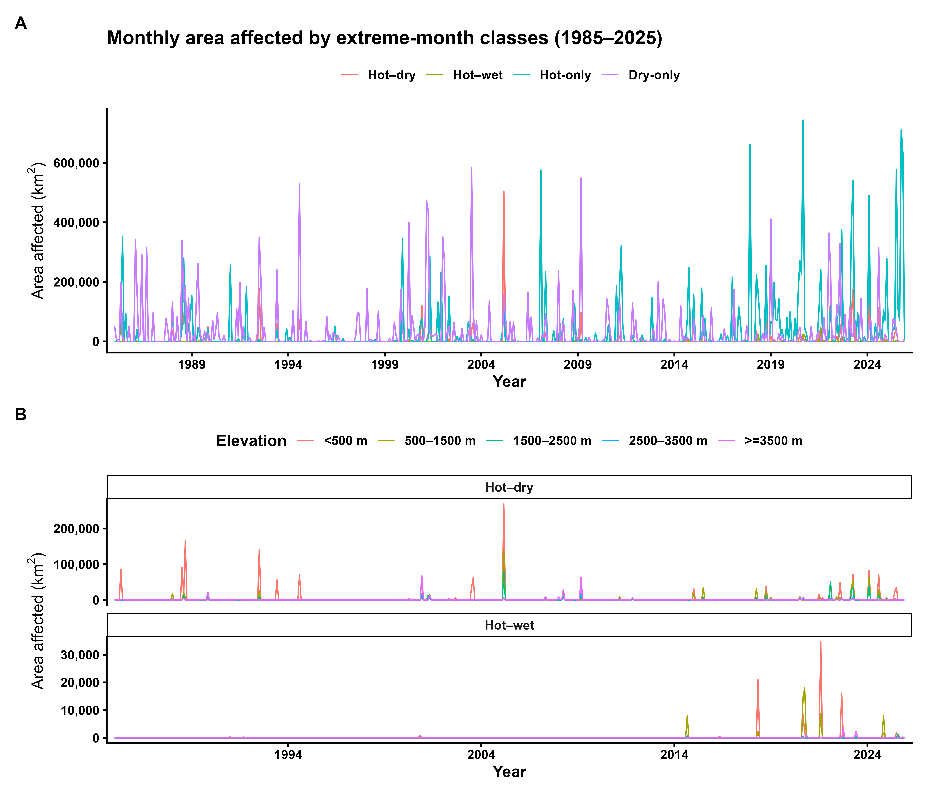
Figure S1. Area affected by extreme-month classes across Pakistan (1985–2025).
(A) National monthly area affected (km²) by hot–dry (HD), hot–wet (HW), hot-only, and dry-only months, computed by summing grid-cell surface area flagged each month.
(B) Elevation-zone monthly area affected (km²) for HD and HW months across five elevation regimes (<500, 500–1500, 1500–2500, 2500–3500, ≥3500 m a.s.l.). Areas are calculated on the analysis grid using cell-wise surface area to account for geographic distortion.
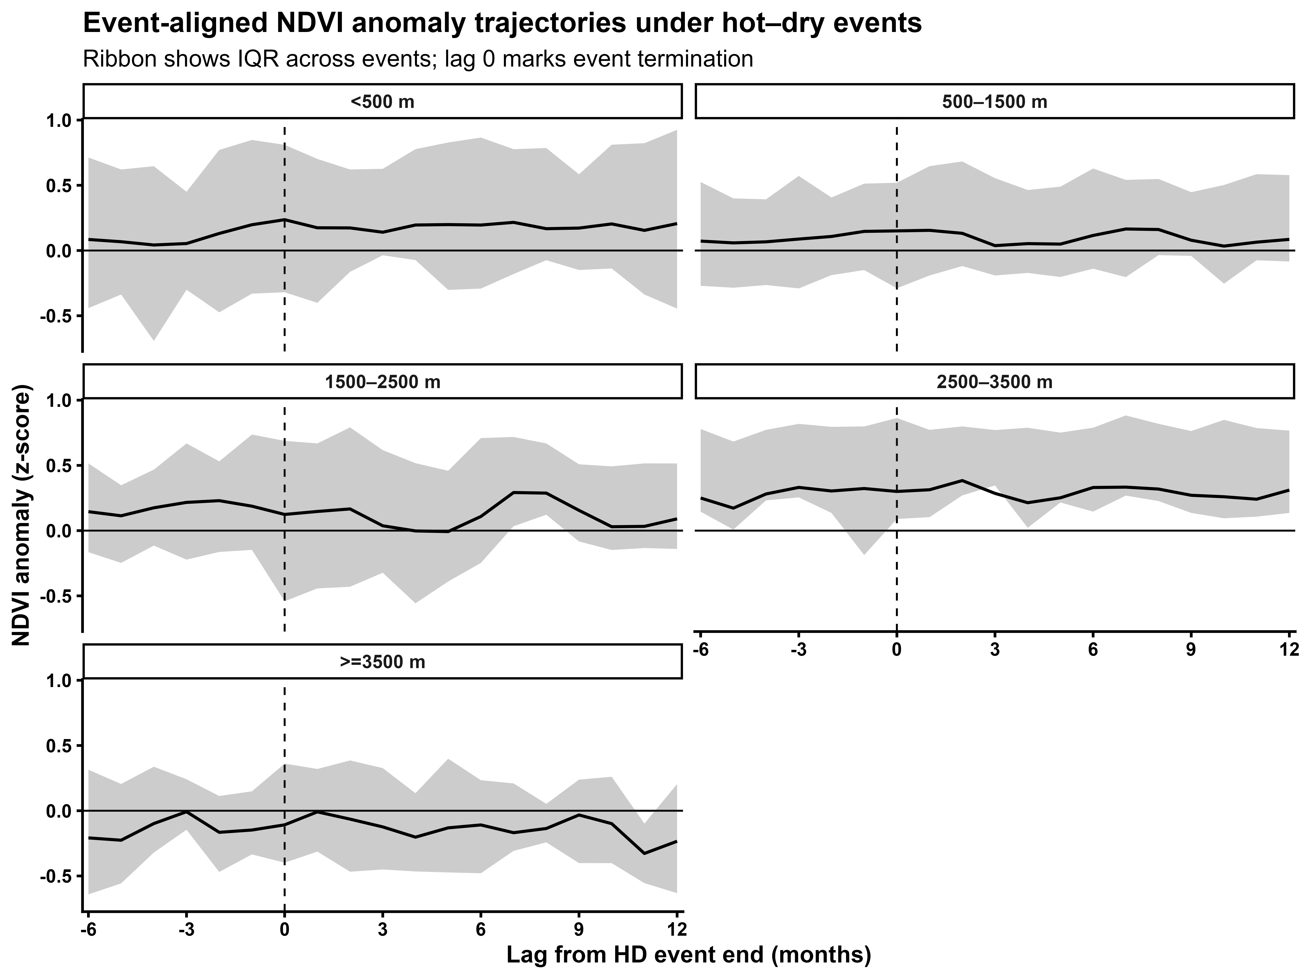
Figure S2. Event-aligned NDVI′ trajectories under hot–dry events by elevation regime.
NDVI anomalies (calendar-month z-scores) are aligned to HD event termination (lag 0) and summarised for each elevation band over a fixed pre-event (−6 months) and post-event (+12 months) window. Solid lines indicate the mean trajectory across events; shaded ribbons indicate the interquartile range (IQR). The horizontal reference line denotes baseline conditions (z = 0).
Table S4. Grouped cross-validation performance for event-level prediction of hot–dry (HD) resistance proxy. Model skill was evaluated using k-fold cross-validation grouped by pixel ID, such that all events from a given pixel were held out together. The environment-only Random Forest achieved R² = 0.9416, RMSE = 0.2608, and MAE = 0.1566 (n = 109,734 events), while the spatially augmented model (environmental predictors plus x–y coordinates) improved performance to R² = 0.9542, RMSE = 0.2309, and MAE = 0.1322 (n = 109,734). Values are reported in NDVI anomaly z-score units.
Model | n (events) | RMSE (z-score) | MAE (z-score) | R²
RF (environment-only) | 109,734 | 0.261 | 0.157 | 0.9416
RF (environment + x–y) | 109,734 | 0.231 | 0.132 | 0.9542
Note: Grouped k-fold cross-validation was performed by pixel ID, such that all events from a given pixel were assigned to the same fold. Error metrics are reported in NDVI anomaly z-score units.
Table S5. Elevation-stratified grouped cross-validation performance for predicting hot–dry (HD) resistance proxy (event level). Elevation bands are reported as m a.s.l.; error metrics are in NDVI anomaly z-score units.
Elevation band (m a.s.l.) | n (events) | RMSE (RF env) | MAE (RF env) | R² (RF env) | RMSE (RF env + x–y) | MAE (RF env + x–y) | R² (RF env + x–y)
<500 | 61,437 | 0.256 | 0.155 | 0.9535 | 0.226 | 0.131 | 0.9636
500–1500 | 26,238 | 0.239 | 0.144 | 0.9334 | 0.198 | 0.115 | 0.9543
1500–2500 | 14,998 | 0.204 | 0.126 | 0.9456 | 0.177 | 0.107 | 0.9589
2500–3500 | 3,297 | 0.315 | 0.199 | 0.8686 | 0.303 | 0.185 | 0.8787
≥3500 | 3,764 | 0.515 | 0.351 | 0.7412 | 0.489 | 0.325 | 0.7671
Note:
Grouped k-fold cross-validation was performed by pixel ID, ensuring that all events from the same pixel were assigned to the same fold. Performance is summarised by elevation band, showing increasing error and reduced explained variance at higher elevations, with consistent (but modest) gains from adding spatial coordinates (x–y) to the environmental predictor set.
Table S6. Permutation importance of predictors for the environment-only RF model of HD resistance proxy. Permutation importance was computed for the environment-only Random Forest predicting hot–dry (HD) resistance proxy (NDVI anomaly z-score). Values represent the decrease in predictive skill after randomly permuting each predictor; larger values indicate greater contribution to model performance.
Rank | Predictor (label) | Variable name | Permutation importance
1 | Antecedent vegetation state | ndvi_pre | 1.743
2 | Climatic water balance during HD months (pr − PET) | wb_mean | 0.543
3 | Maximum temperature during HD months | tmax_mean | 0.492
4 | Elevation (m a.s.l.) | elev_m | 0.435
5 | Vapour pressure deficit during HD months | vpd_mean | 0.392
6 | Precipitation during HD months | pr_mean | 0.306
7 | Soil moisture constraint (event minimum) | soil_min | 0.304
8 | Event duration (months) | dur | 0.005
Note: Permutation importance ranking for the environment-only Random Forest predicting HD resistance proxy (NDVI anomaly z-score). Importance values quantify the reduction in predictive performance when each predictor is permuted, with larger values indicating stronger contribution. Antecedent NDVI (ndvi_pre) dominated, followed by climatic water balance (wb_mean) and thermal stress (tmax_mean), while event duration contributed negligibly at monthly resolution.
Table S7. Permutation importance for the spatially augmented Random Forest predicting hot–dry (HD) resistance proxy (NDVI anomaly z-score).
Rank | Predictor (label) | Variable name | Permutation importance
1 | Antecedent vegetation state | ndvi_pre | 1.795
2 | Climatic water balance during HD months (pr − PET) | wb_mean | 0.489
3 | Maximum temperature during HD months | tmax_mean | 0.413
4 | Northing / latitude coordinate | y | 0.374
5 | Elevation (m a.s.l.) | elev_m | 0.355
6 | Easting / longitude coordinate | x | 0.308
7 | Vapour pressure deficit during HD months | vpd_mean | 0.306
8 | Precipitation during HD months | pr_mean | 0.231
9 | Soil moisture constraint (event minimum) | soil_min | 0.226
10 | Event duration (months) | dur | 0.003
Note. Permutation importance quantifies the reduction in predictive skill when each predictor is randomly permuted; larger values indicate stronger contribution to model performance.

Table S8. Global SHAP importance for the environment-only Random Forest predicting hot–dry (HD) resistance proxy.
Rank | Predictor (label) | Variable name | Mean |SHAP|
1 | Antecedent vegetation state | ndvi_pre | 0.672
2 | Climatic water balance during HD months (pr − PET) | wb_mean | 0.111
3 | Elevation (m a.s.l.) | elev_m | 0.078
4 | Maximum temperature during HD months | tmax_mean | 0.071
5 | Vapour pressure deficit during HD months | vpd_mean | 0.064
6 | Soil moisture constraint (event minimum) | soil_min | 0.055
7 | Precipitation during HD months | pr_mean | 0.052
8 | Event duration (months) | dur | 0.002
Note: Global SHAP importance (mean absolute SHAP value) for the environment-only Random Forest model predicting HD resistance proxy (NDVI anomaly z-score). Mean |SHAP| summarises the average magnitude of each predictor’s contribution to model predictions across the SHAP attribution sample; larger values indicate stronger overall influence, irrespective of sign.
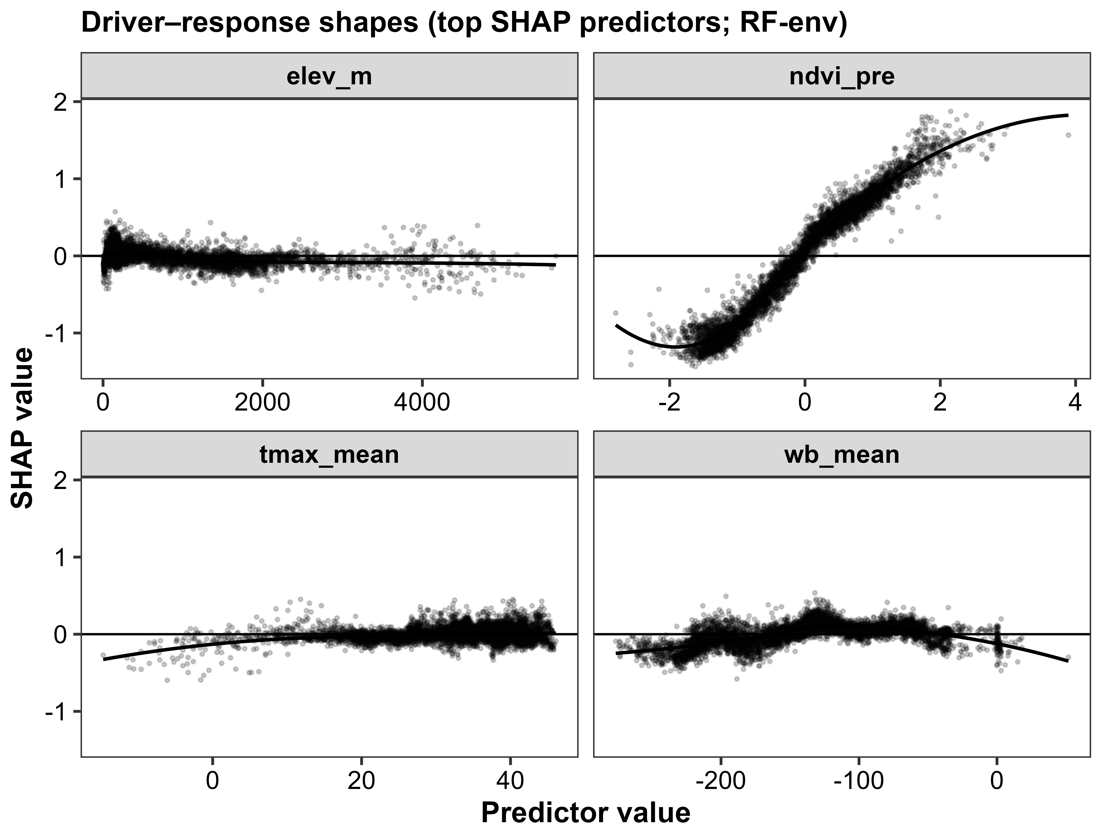
Figure S3. Historical model contribution patterns for the leading SHAP predictors in the environment-only Random Forest model of hot–dry (HD) resistance proxy. Panels show SHAP dependence relationships between each predictor and its SHAP contribution to predicted HD resistance proxy (NDVI anomaly z-score), based on the SHAP prediction contributions sample. Points represent individual HD events (or event-sampled records), and the smoothed curve summarises the average fitted-model contribution across the predictor range. Positive SHAP values indicate an increase in predicted resistance proxy (less NDVI suppression), whereas negative values indicate a lower fitted resistance proxy value. Predictors shown are elevation (elev_m), antecedent vegetation state (ndvi_pre), maximum temperature during HD months (tmax_mean), and climatic water balance during HD months (wb_mean).
Table S9. Elevation-stratified sensitivity of hot-dry exposure and NDVI response metrics across alternative event definitions (1985-2025). Values are reported by elevation belt as the median and interquartile range (Q25-Q75) for events per pixel, the NDVI-based resistance proxy, and months to recovery. Scenario codes are HD95/PR10 (baseline), HD90/PR10, HD95/PR05, HD95/WB10, and HD95/VPD90+SM10.
Scenario | Elevation (m a.s.l.) | Pixels (n) | HD events per pixel | Resistance proxy (NDVI′ z) | Recovery (months)
HD95/PR10 (baseline) | <500 | 16126 | 3 [1–6] | 0.059 [-0.632–0.578] | 1.00 [1.00–2.17]
HD95/PR10 (baseline) | 500–1500 | 9099 | 2 [1–4] | 0.232 [-0.142–0.586] | 1.00 [1.00–2.00]
HD95/PR10 (baseline) | 1500–2500 | 3690 | 4 [3–5] | 0.231 [-0.143–0.530] | 1.83 [1.00–3.00]
HD95/PR10 (baseline) | 2500–3500 | 946 | 4 [3–5] | 0.272 [-0.037–0.471] | 1.75 [1.00–2.67]
HD95/PR10 (baseline) | ≥3500 | 3060 | 3 [3–4] | -0.275 [-0.792–0.100] | 3.75 [3.00–4.75]
HD90/PR10 | <500 | 16126 | 7 [2–11] | 0.064 [-0.293–0.424] | 1.78 [1.17–3.00]
HD90/PR10 | 500–1500 | 9099 | 5 [2–8] | 0.156 [-0.167–0.443] | 2.00 [1.00–3.00]
HD90/PR10 | 1500–2500 | 3690 | 6 [5–8] | 0.100 [-0.209–0.407] | 2.60 [1.40–3.75]
HD90/PR10 | 2500–3500 | 946 | 8 [6–11] | 0.191 [-0.020–0.421] | 1.95 [1.20–2.80]
HD90/PR10 | ≥3500 | 3060 | 6 [5–9] | -0.108 [-0.332–0.202] | 3.50 [2.67–4.33]
HD95/PR05 | <500 | 16126 | 2 [0–3] | -0.032 [-0.666–0.557] | 1.00 [1.00–2.00]
HD95/PR05 | 500–1500 | 9099 | 0 [0–2] | 0.267 [-0.146–0.643] | 1.00 [1.00–2.00]
HD95/PR05 | 1500–2500 | 3690 | 2 [1–3] | 0.208 [-0.057–0.423] | 2.00 [1.00–3.50]
HD95/PR05 | 2500–3500 | 946 | 2 [2–3] | 0.170 [-0.154–0.388] | 1.50 [1.00–2.50]
HD95/PR05 | ≥3500 | 3060 | 2 [2–2] | -0.648 [-1.198–-0.101] | 3.67 [2.50–5.00]
HD95/WB10 | <500 | 16126 | 7 [5–9] | 0.023 [-0.344–0.446] | 1.62 [1.00–2.75]
HD95/WB10 | 500–1500 | 9099 | 5 [3–8] | 0.246 [-0.174–0.594] | 1.50 [1.00–2.50]
HD95/WB10 | 1500–2500 | 3690 | 7 [6–9] | 0.198 [-0.088–0.451] | 2.00 [1.17–2.88]
HD95/WB10 | 2500–3500 | 946 | 7 [6–8] | 0.295 [0.058–0.468] | 2.00 [1.33–3.24]
HD95/WB10 | ≥3500 | 3060 | 7 [6–9] | 0.175 [-0.175–0.330] | 4.62 [3.57–5.43]
HD95/VPD90+SM10 | <500 | 16126 | 0 [0–1] | 0.128 [-0.452–0.729] | 1.00 [1.00–2.27]
HD95/VPD90+SM10 | 500–1500 | 9099 | 0 [0–0] | 0.643 [0.018–0.955] | 1.00 [1.00–1.00]
HD95/VPD90+SM10 | 1500–2500 | 3690 | 1 [0–2] | 0.298 [-0.233–0.752] | 1.00 [1.00–2.00]
HD95/VPD90+SM10 | 2500–3500 | 946 | 0 [0–1] | 0.753 [0.163–0.936] | 1.00 [1.00–1.33]
HD95/VPD90+SM10 | ≥3500 | 3060 | 0 [0–0] | 0.770 [-0.237–1.036] | 1.00 [1.00–6.00]
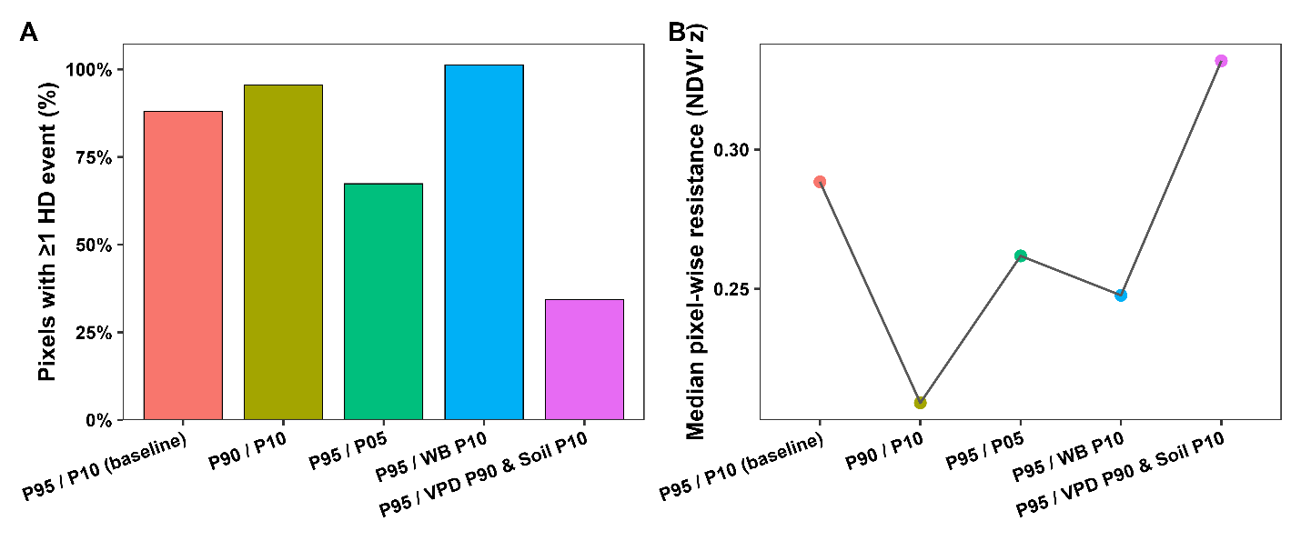
Figure S4. Sensitivity of pixel-wise hot–dry (HD) exposure and resistance proxy to alternative event definitions. (A) Fraction of valid pixels experiencing ≥1 HD event under each scenario. (B) Median pixel-wise resistance proxy (NDVI′ z-score; mean within-event minimum per pixel) across scenarios. Scenarios vary the hot/dry percentile thresholds and the dryness proxy (precipitation, climatic water balance, or combined VPD–soil limitation).

Supplementary validation analyses
The following historical validation analyses retain their earlier definitions. Primary estimates are reported in Tables S25-S28 and S40-S41.
Table S10. Detrended hot-dry resistance proxy by elevation.
elevation band | n original | median original | median detrended | median difference | prop negative original | prop negative detrended
>=3500 | 2039 | -0.320 | -0.048 | 0.156 | 0.633 | 0.514
2500-3500 | 911 | 0.271 | -0.030 | -0.227 | 0.291 | 0.523
1500-2500 | 3644 | 0.230 | -0.150 | -0.359 | 0.336 | 0.654
500-1500 | 7277 | 0.232 | -0.026 | -0.216 | 0.346 | 0.522
<500 | 13362 | 0.061 | 0.191 | 0.233 | 0.473 | 0.361
Table S11. Temporal holdout validation and antecedent-NDVI sensitivity.
model | train period | test period | n | RMSE | MAE | R2
Environment + antecedent NDVI | 1985-2014 | 2015-2025 | 43720 | 0.961 | 0.691 | -0.436
Environment without antecedent NDVI | 1985-2014 | 2015-2025 | 43720 | 1.566 | 1.295 | -2.811
Environment + spatial + antecedent NDVI | 1985-2014 | 2015-2025 | 43720 | 0.953 | 0.682 | -0.412
Environment + spatial without antecedent NDVI | 1985-2014 | 2015-2025 | 43720 | 1.561 | 1.295 | -2.788
Table S12. Mann-Kendall and Theil-Sen trend tests.
metric | n | tau | p value | sen slope per year
Annual HD area-months (km2-months) | 41 | 0.140 | 0.215 | 166.517
Annual mean monthly HD area (km2) | 41 | 0.140 | 0.215 | 13.876
Annual maximum monthly HD area (km2) | 41 | 0.104 | 0.356 | 3.249
Table S13. Continuous Gaussian-copula severity trend.
n | tau | p value | sen slope per year | sen p value
41 | 0.127 | 0.247 | 0.006 | 0.247
Table S14. NDVI and GOSIF recovery by elevation.
elevation band | n cells | median NDVI recovery | median SIF recovery | median SIF minus NDVI | proportion cells SIF slower
>=3500 | 2221 | 3.500 | 4.333 | 0.500 | 0.557
2500-3500 | 861 | 3.333 | 3.500 | 0 | 0.472
1500-2500 | 3587 | 2 | 2 | 0 | 0.316
500-1500 | 6699 | 1.333 | 1.800 | 0 | 0.400
<500 | 9889 | 1.500 | 1.667 | 0 | 0.326
Table S15. High-elevation SWE proxy and recovery association.
n complete | spearman rho | spearman p | r2 | adj r2
3164 | -0.010 | 0.562 | 0.047 | 0.046

Table S16. NDVI sensor-era residual step diagnostics.
transition | median step | q25 step | q75 step | median abs standardized step
1999: TM-only to TM+ETM+ | 0.003 | -0.013 | 0.065 | 0.911
2013: TM/ETM+ to OLI era | -0.007 | -0.016 | -0.000 | 0.355
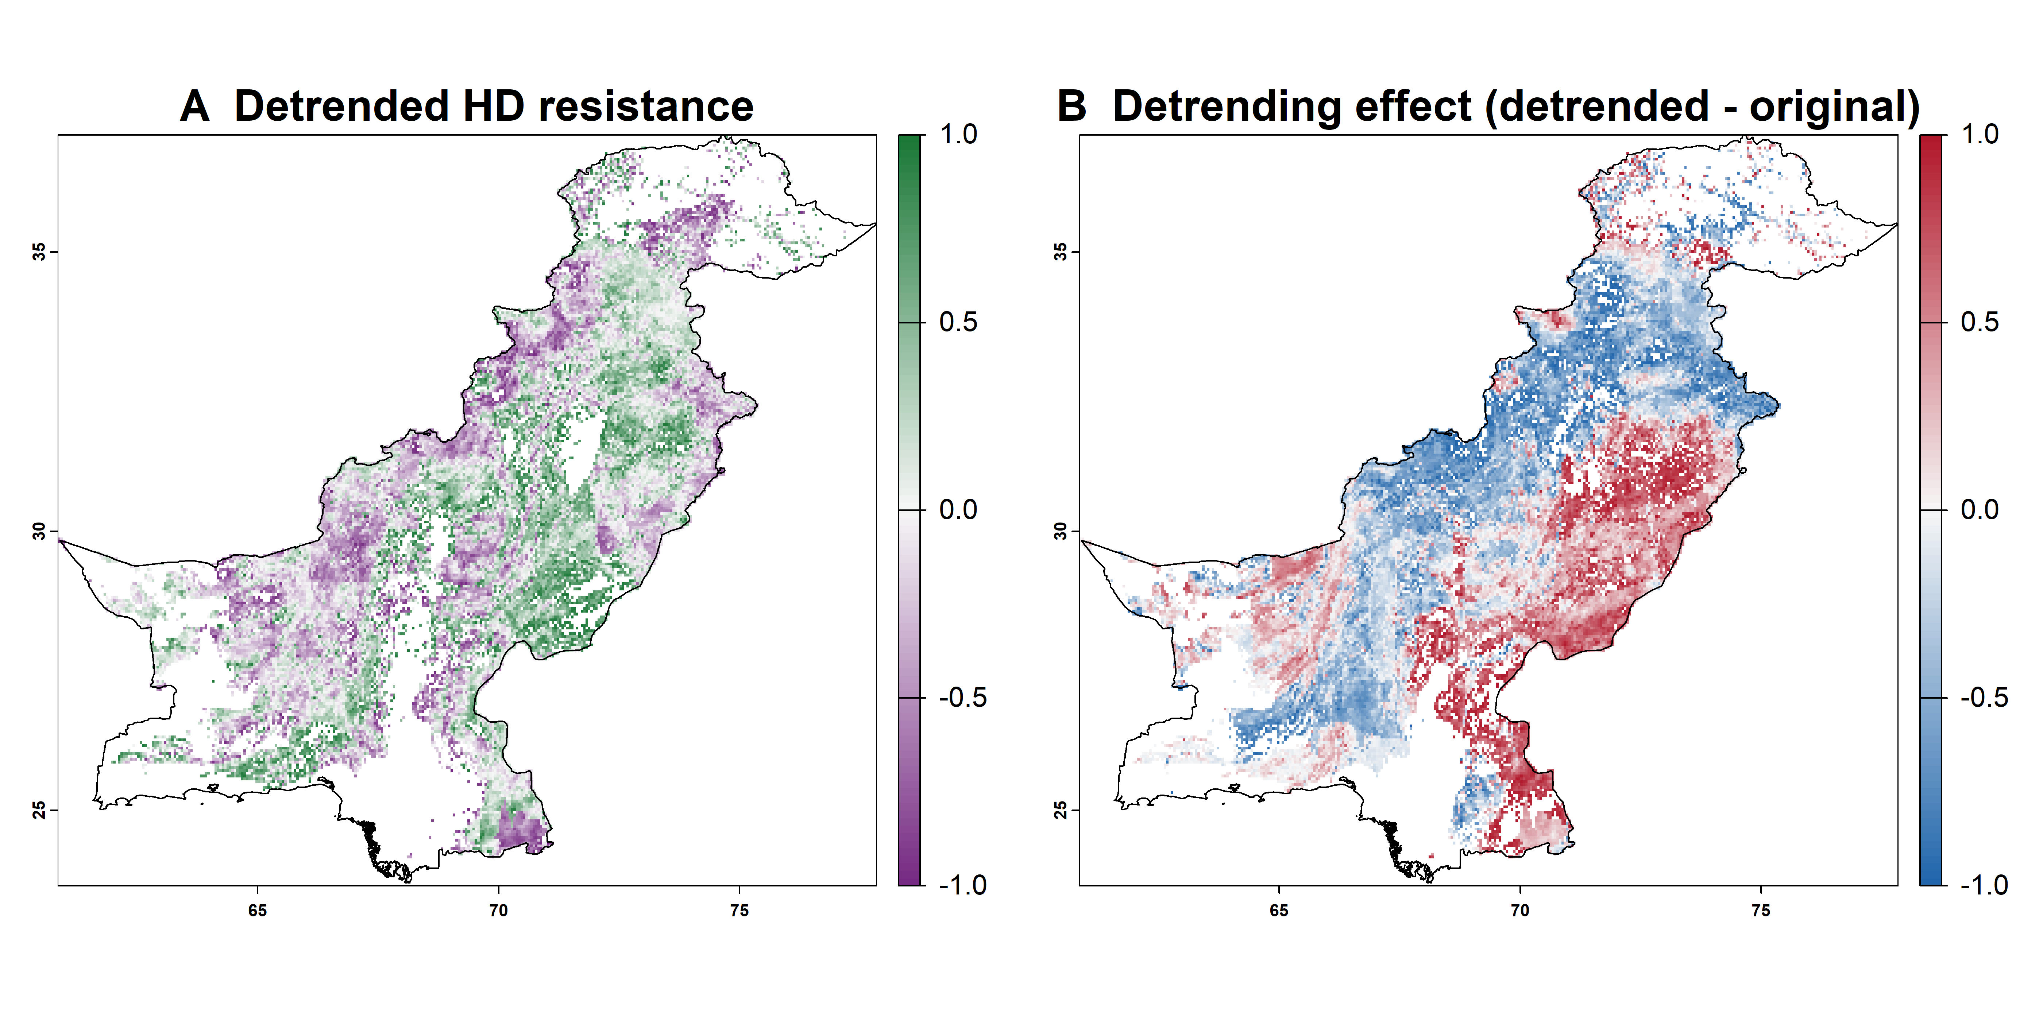
Figure S5. Detrended hot-dry resistance proxy and the spatial effect of detrending.

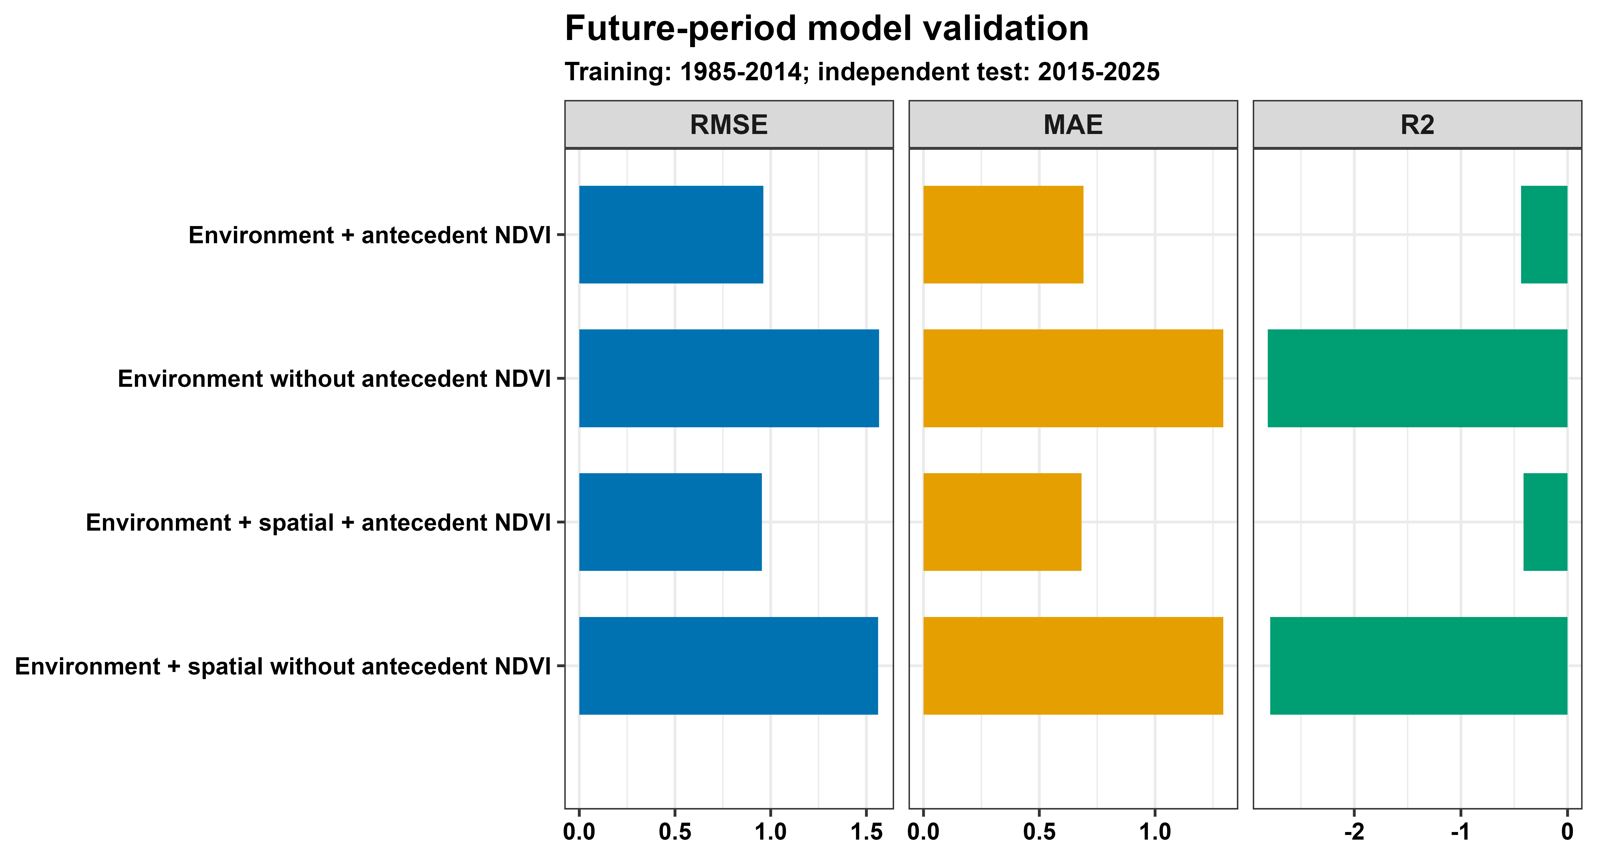
Figure S6. Temporal holdout validation of historical hot-dry resistance-proxy models trained on 1985–2014 and tested on 2015–2025, with and without antecedent NDVI for environment-only and spatially augmented Random Forests. All models use the same 43,720 test events. Negative R² means poorer performance than the test-period mean.

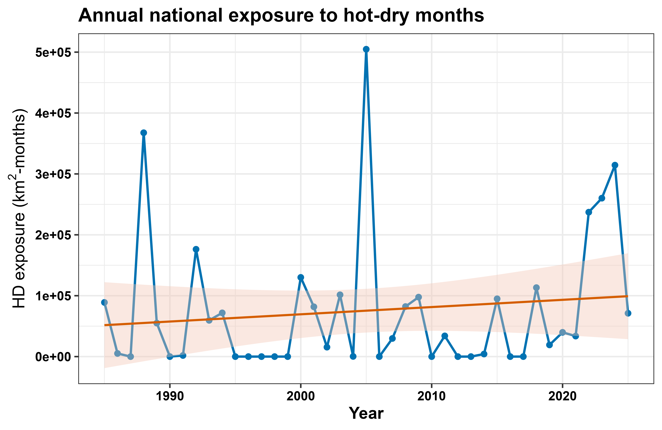
Figure S7. National hot-dry affected-area trend.

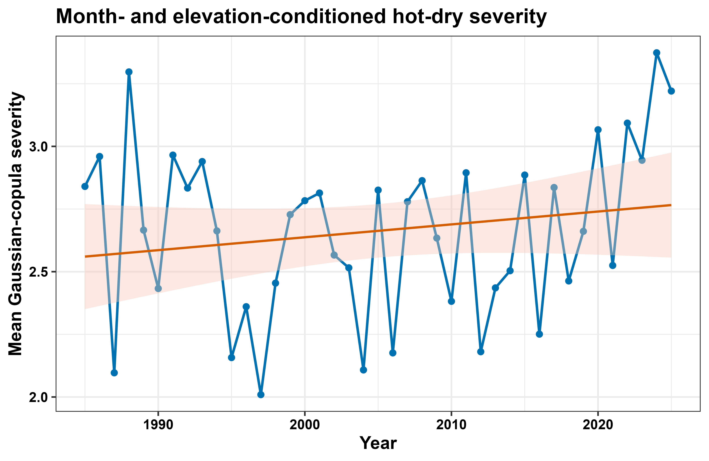
Figure S8. Continuous Gaussian-copula severity trend.

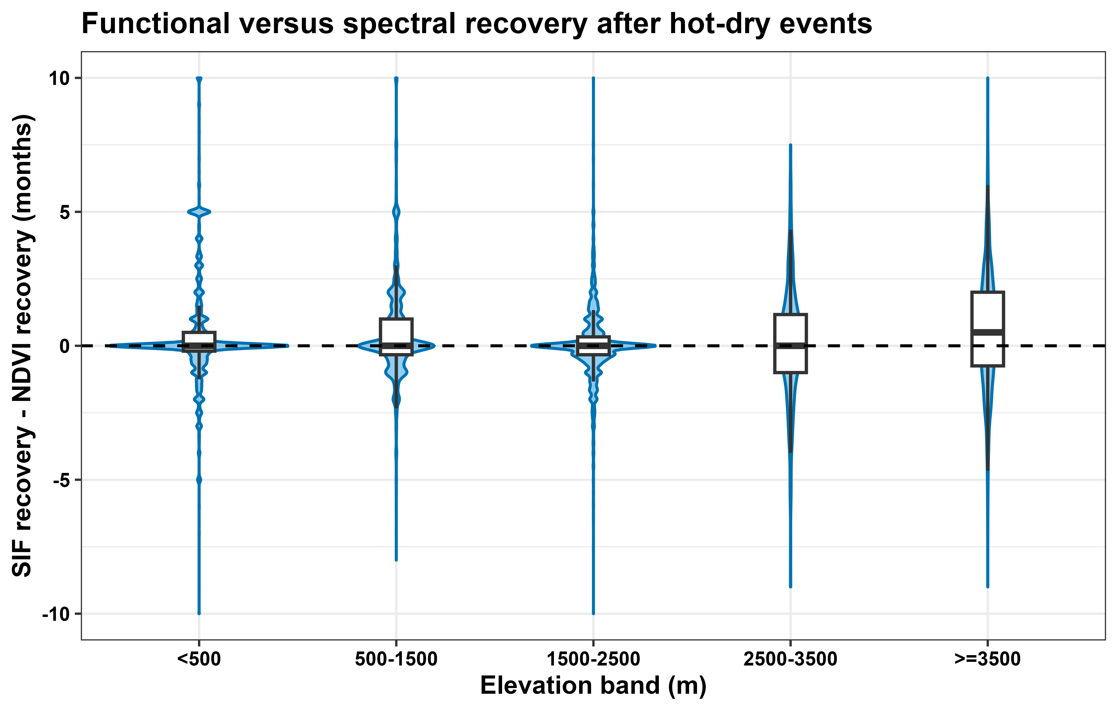
Figure S9. Functional-minus-spectral recovery across elevation belts.

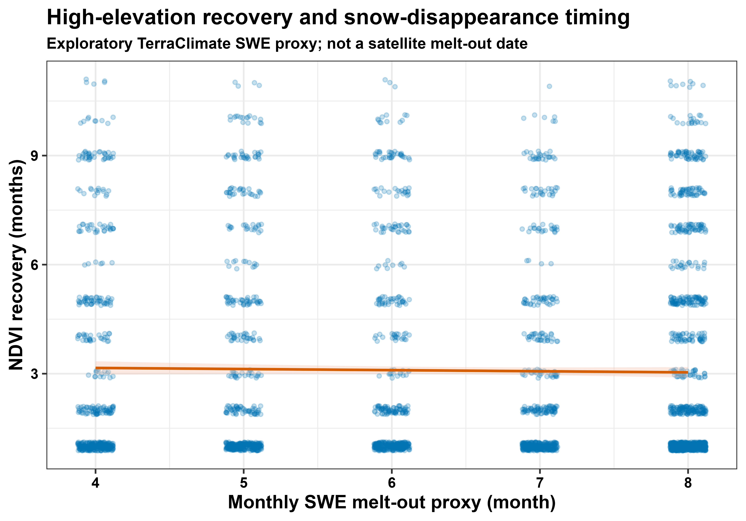
Figure S10. Monthly SWE disappearance proxy and high-elevation recovery.

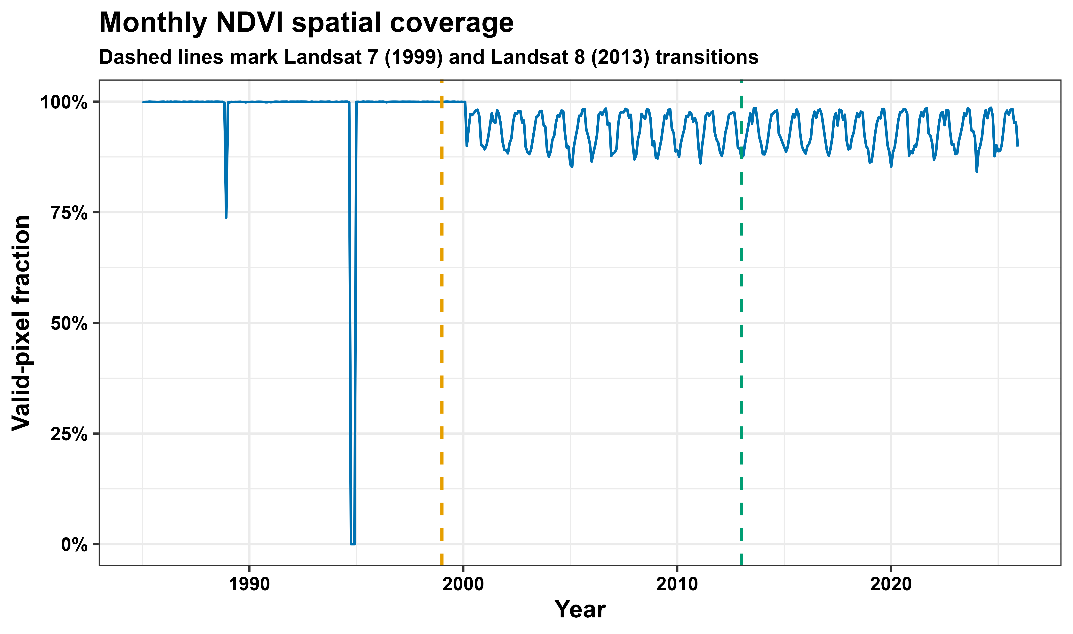
Figure S11. Monthly NDVI valid-pixel coverage and sensor-era transitions.
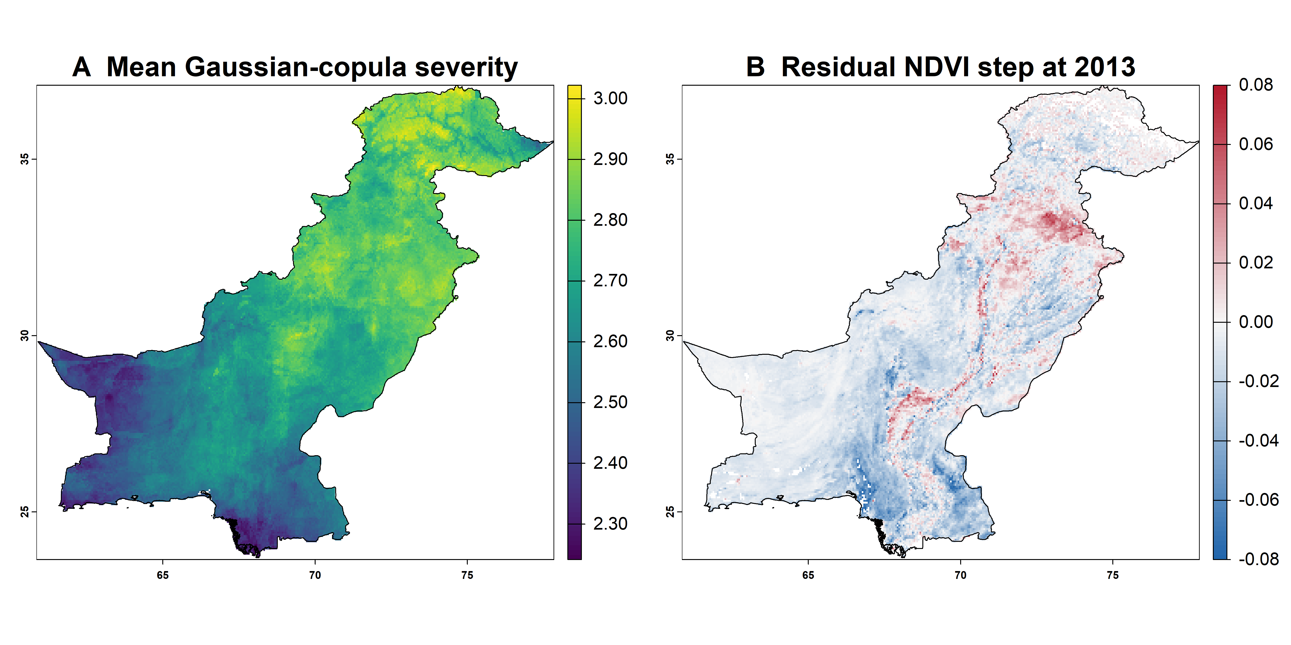
Figure S12. Continuous severity and residual 2013 sensor-era step maps.

Supplementary major-revision analyses
The following common-grid and event-sample summaries use earlier baselines, outcome definitions and recovery clocks, as specified above.
Table S17. Exact common-grid inventory.
dataset | nrow | ncol | layers | xres_deg | yres_deg | valid_cells
Landsat monthly NDVI | 269 | 340 | 492 | 0.050 | 0.050 | 33520
TerraClimate tmax | 269 | 340 | 492 | 0.050 | 0.050 | 33624
TerraClimate precipitation | 269 | 340 | 492 | 0.050 | 0.050 | 33624
Elevation | 269 | 340 | 1 | 0.050 | 0.050 | 32921
NDVI z score | 269 | 340 | 492 | 0.050 | 0.050 | 33520
Table S18. Fixed-baseline hot-dry trend tests.
baseline | metric | tau | p_value | sen_slope_per_year
1985-2014 | annual_affected_area_percent | 0.249 | 0.022 | 0.802
1985-2004 | annual_affected_area_percent | 0.290 | 0.008 | 1.096
1985-2014 | event_area_months_km2 | 0.327 | 0.003 | 15879.708
1985-2004 | event_area_months_km2 | 0.410 | 0.000 | 23843.256
Table S19. Event inventory.
quantity | value
valid_analysis_cells | 32829
sampled_pixels | 28786
model_events | 110157
complete_model_events | 109734
holdout_events_2015_2025 | 43744
suppressed_model_events | 44922
Table S20. Suppression and recovery by elevation (full grid).
elevation_zone | mean | metric | elevation_label
1 | 20.243 | events | <500 m
2 | 24.056 | events | 500-1499 m
3 | 16.909 | events | 1500-2499 m
4 | 11.240 | events | 2500-3499 m
5 | 10.227 | events | >=3500 m
1 | 7.485 | suppressed_events | <500 m
2 | 12.975 | suppressed_events | 500-1499 m
3 | 7.687 | suppressed_events | 1500-2499 m
4 | 3.416 | suppressed_events | 2500-3499 m
5 | 2.845 | suppressed_events | >=3500 m
1 | 0.368 | suppression_probability | <500 m
2 | 0.475 | suppression_probability | 500-1499 m
3 | 0.412 | suppression_probability | 1500-2499 m
4 | 0.305 | suppression_probability | 2500-3499 m
5 | 0.273 | suppression_probability | >=3500 m
1 | 0.899 | suppression_magnitude | <500 m
2 | 0.701 | suppression_magnitude | 500-1499 m
3 | 0.840 | suppression_magnitude | 1500-2499 m
4 | 0.892 | suppression_magnitude | 2500-3499 m
5 | 0.929 | suppression_magnitude | >=3500 m
1 | 1.969 | recovery_all | <500 m
2 | 2.217 | recovery_all | 500-1499 m
3 | 2.169 | recovery_all | 1500-2499 m
4 | 2.129 | recovery_all | 2500-3499 m
5 | 3.920 | recovery_all | >=3500 m
1 | 4.064 | recovery_suppressed | <500 m
2 | 3.813 | recovery_suppressed | 500-1499 m
3 | 3.870 | recovery_suppressed | 1500-2499 m
4 | 3.653 | recovery_suppressed | 2500-3499 m
5 | 3.812 | recovery_suppressed | >=3500 m
1 | 3.656 | recovery_suppressed_censored | <500 m
2 | 3.159 | recovery_suppressed_censored | 500-1499 m
3 | 3.382 | recovery_suppressed_censored | 1500-2499 m
4 | 3.517 | recovery_suppressed_censored | 2500-3499 m
5 | 3.613 | recovery_suppressed_censored | >=3500 m
This earlier recovery summary truncates follow-up at the next hot-dry event. It is not the revised landmark-based, missingness-censored Kaplan-Meier estimate.
Table S21. Event-sample suppression and recovery by elevation.
Belt code | Events | Suppression probability | Median suppression magnitude | Median recovery: all | Median recovery: suppressed | Observed return fraction: all | Observed return fraction: suppressed
2 | 26,239 | 0.328 | 0.799 | 1.000 | 2.000 | 0.755 | 0.338
1 | 61,438 | 0.452 | 1.084 | 1.000 | 4.000 | 0.597 | 0.163
5 | 4,171 | 0.603 | 0.895 | 2.000 | 2.000 | 0.759 | 0.642
3 | 14,998 | 0.338 | 0.698 | 1.000 | 2.000 | 0.832 | 0.539
4 | 3,311 | 0.299 | 1.133 | 1.000 | 2.000 | 0.831 | 0.441
Table S22. Descriptive resistance proxy contrast statistics.
Zone code | Elevation | Cells | Median | Q25 | Q75 | Negative (%) | Positive (%) | Zero (%)
1 | <500 m | 13,858 | 0.121 | -0.596 | 0.705 | 44.855 | 55.145 | 0
2 | 500-1499 m | 7,774 | 0.378 | 0.029 | 0.716 | 23.103 | 76.897 | 0
3 | 1500-2499 m | 4,141 | 0.352 | 0.009 | 0.664 | 24.342 | 75.658 | 0
4 | 2500-3499 m | 1,408 | 0.392 | -0.011 | 0.776 | 25.852 | 74.148 | 0
5 | >=3500 m | 2,536 | 0.017 | -0.585 | 0.565 | 48.778 | 51.222 | 0
0 | National | 27,729 | 0.269 | -0.256 | 0.708 | 35.634 | 64.366 | 0
Table S23. Spatial-block cross-validation.
validation | n_events | n_pixels | n_blocks | RMSE | MAE | R2
2-degree spatial-block 5-fold CV | 109734 | 28639 | 38 | 0.491 | 0.333 | 0.793
Events in each 2° × 2° geographic block were assigned to a single fold.
Table S24. Temporal QRF calibration.
Training events | Test events | Below p10 | Below p90 | p10-p90 coverage | Median RMSE | Median MAE | Median R2 | Mean interval width
66,014 | 43,720 | 0.042 | 0.699 | 0.657 | 0.957 | 0.665 | -0.424 | 1.527
The p10-p90 interval has nominal 80% coverage; empirical temporal coverage was 65.7%, so interval width is predictive dispersion rather than total uncertainty.

Supplementary figures: driver associations and model transferability
Figure S13. Colour-coded predictor importance and SHAP prediction contributions for hot-dry resistance proxy models. (A) Environment-only permutation importance. (B) Spatial-model permutation importance. (C) Global mean absolute SHAP importance. (D) SHAP contribution distributions. These are descriptive associations and are not interpreted as temporally transferable prediction.
Figure S14. Spatial prediction and driver diagnostics for hot–dry resistance proxy under typical hot–dry conditions across Pakistan. (A) Median predicted resistance proxy (p50; NDVI anomaly z-score) from the quantile regression forest. (B) Predictive dispersion quantified as the interdecile width (p90–p10; z-score units). (C) Largest model contribution defined as the predictor with the largest absolute SHAP contribution (max |SHAP|) for the attribution sample (n ≈ 6000), mapped to sampled pixels. (D) Typical hot–dry climatic water balance (pr − PET; mm month⁻¹) summarised over HD months and used as a key predictor layer. Blank areas denote masked or missing grid cells.

Primary results and supporting sensitivities

Supplementary Note S2 Source processing and missingness
Monthly P75 and monthly-maximum NDVI are distinct temporal summaries; spatial averaging to 0.05 degrees is a separate step. The primary numerical analysis uses the existing monthly archive, while Landsat overlap and harmonization tests are reported as sensor-processing sensitivities. These tests assess processing dependence and do not establish uniform equivalence throughout the record. Landsat context includes scan-line-corrector failure (Andréfouët et al., 2003), Collection 1 documentation (Sayler, 2020) and gap-filling methods (Yin et al., 2017); the revised analysis retains NA.
Missing source observations are retained as NA, including October-December 1994. The supplied July example is one author-provided series of unspecified location; its zero-scene interpolated values are replaced by NA in the cleaned display. This does not imply that July 1994 is missing nationally. Remaining observed anomalies are supplied values and have not been re-estimated after removing interpolation. Seasonal sensitivity results are labelled explicitly by their growing-season clock.

Supplementary Note S3 Cohorts clocks and ecological interpretation
The primary analysis uses observed original NDVI with fixed 1985-2014 seasonal references. Reported harmonization, land-cover and seasonal sensitivities retain their own earlier cohorts and do not overwrite the primary results. A recovery median among observed returns differs from a censored Kaplan-Meier median; calendar-month and growing-season clocks also differ. Static irrigation masks and stable land cover restrict comparison but do not establish independent altitude effects. In the weighted check, cell shares weight category summaries; these are not necessarily national event weights, and an average of subgroup medians is not a pooled median. Small differences can reflect supplied rounding or weighting definitions. Stable-cover sensitivity uses the annual 1992–2020 ESA CCI/Copernicus map series (European Space Agency, n.d.).
Table S25. Matched primary response-lag comparison.
Post-event extension (months) | Shared assessable events | Suppressed (%)
0 | 186,132 | 35.9
1 | 186,132 | 40.5
2 | 186,132 | 44.5
3 | 186,132 | 48.3
Source: primary V2 Suppression_lag_comparison_by_elevation.csv. The same 186,132 events are used for every lag. A wider window detects more below-reference anomalies but does not establish causation.
Table S26. Primary three-month response coverage and censored recovery.
Elevation | Climate events | Complete response | Recovery eligible | Confirmed recovery | Censored | 6-month KM % [95% interval] | KM median (months)
National | 220,924 | 186,132 | 101,231 | 38,484 | 62,747 | 37.1 [36.7, 37.5] | NR
<500 m | 102,926 | 91,711 | 48,725 | 14,617 | 34,108 | 32.4 [31.9, 32.9] | NR
500-1499 m | 63,034 | 60,916 | 32,192 | 13,795 | 18,397 | 36.8 [36.0, 37.5] | NR
1500-2499 m | 28,760 | 27,241 | 13,993 | 8,723 | 5,270 | 48.6 [47.6, 49.5] | 7
2500-3499 m | 7,281 | 3,606 | 1,963 | 579 | 1,384 | 47.5 [43.7, 51.1] | 7
>=3500 m | 18,923 | 2,658 | 4,358 | 770 | 3,588 | 78.1 [73.7, 81.8] | 3
NR: median not reached. Recovery cohort includes observed suppression in partial windows when the landmark is assessable. Confirmation is the second of two consecutive observed nonnegative months. At >=3500 m only 60 events remain at risk at month six; censoring may be strongly informative, so the high KM probability/short median is not representative year-round recovery. Kaplan-Meier estimation follows Kaplan and Meier (1958).
Table S27. Framework event and response summaries.
Framework | Climate ref. | NDVI ref. / processing | Events | Matched windows | Suppressed (%) | 6-month KM (%)
Primary | 1985-2014 | 1985-2014; original | 220,924 | 186,132 | 48.3 | 37.1
Climate full | 1985-2025 | 1985-2014; original | 112,158 | 94,664 | 45.4 | 33.9
Climate 1985-2004 | 1985-2004 | 1985-2014; original | 271,581 | 232,847 | 46.8 | 43.6
NDVI detrended | 1985-2014 | 1985-2014; detrended | 220,924 | 186,132 | 76.3 | 50.3
Matched full detrended | 1985-2025 | 1985-2025; detrended | 112,158 | 94,339 | 71.7 | 51.4
Matched full | 1985-2025 | 1985-2025; original | 112,158 | 94,339 | 53.2 | 38.0
Matched 1985-2004 detrended | 1985-2004 | 1985-2004; detrended | 271,581 | 235,590 | 72.4 | 57.0
Matched 1985-2004 | 1985-2004 | 1985-2004; original | 271,581 | 236,317 | 42.0 | 43.2
NDVI full | 1985-2014 | 1985-2025; original | 220,924 | 185,414 | 55.4 | 39.5
NDVI 1985-2004 | 1985-2014 | 1985-2004; original | 220,924 | 189,257 | 43.6 | 37.8
Within-framework matched lag windows and eligible suppressed cohorts differ across climate references. Paired NDVI comparisons in the manuscript use a separate explicitly shared cohort. Source: National_framework_comparison.csv.
Table S28. Primary and sensitivity specifications.
Framework | Climate years | NDVI reference years | NDVI processing
Primary | 1985-2014 | 1985-2014 | original
NDVI detrended | 1985-2014 | 1985-2014 | detrended
Matched 1985-2004 | 1985-2004 | 1985-2004 | original
Matched 1985-2004 detrended | 1985-2004 | 1985-2004 | detrended
Matched full | 1985-2025 | 1985-2025 | original
Matched full detrended | 1985-2025 | 1985-2025 | detrended
Climate 1985-2004 | 1985-2004 | 1985-2014 | original
Climate full | 1985-2025 | 1985-2014 | original
NDVI 1985-2004 | 1985-2014 | 1985-2004 | original
NDVI full | 1985-2014 | 1985-2025 | original
H14 = 1985-2014; H04 = 1985-2004; full = 1985-2025. Primary uses original NDVI. Adequate monthly references require at least 80% of their years and usable variance; climate flags do not depend on NDVI availability. All variants share the revised response/recovery rules.
Table S29. Reported scene-density diagnostic.
Era | Sensors | Mean scenes mountains | Mean scenes plains | Historical single-scene or interpolated mountains (%) | Historical single-scene or interpolated plains (%)
1985-1998 | TM | 0.6 | 1.1 | 38 | 24
1999-May 2003 | TM + ETM+ | 2.1 | 3.0 | 9 | 5
June 2003-2011 | TM + ETM+ SLC-off | 1.7 | 2.4 | 14 | 8
2012 | ETM+ SLC-off | 0.5 | 0.8 | 52 | 41
2013-2021 | OLI + ETM+ | 2.8 | 3.4 | 5 | 3
2022-2025 | OLI + OLI-2 | 3.9 | 4.6 | 3 | 2
This historical category combines single-scene observations and interpolated values; it cannot quantify observation coverage under the revised NA-only policy.
Table S30. Reported sensor offsets and standardized shifts.
Stratum / belt | Valid-cell share (%) | Peak NDVI | SD | Raw offset | 2013 step | Raw z shift | Gridded z shift
Irrigated cropland; <500 m | 22 | 0.55 | 0.070 | 0.0083 | -0.018 | +0.12 | -0.26
Desert / sparse; <500 m | 30 | 0.12 | 0.015 | 0.0202 | +0.006 | +1.35 | +0.40
Rain-fed cropland and rangeland; 500-1499 m | 26 | 0.25 | 0.040 | 0.0166 | -0.009 | +0.42 | -0.22
Chir pine and lower temperate forest; 1500-2499 m | 6 | 0.50 | 0.030 | 0.0096 | -0.007 | +0.32 | -0.23
Moist temperate conifer forest; 2500-3499 m | 4 | 0.45 | 0.035 | 0.0110 | +0.002 | +0.31 | +0.06
Alpine pasture and sparse cover; >=3500 m | 12 | 0.18 | 0.025 | 0.0185 | +0.012 | +0.74 | +0.48
z shift = offset / supplied interannual SD; arithmetic verified to displayed rounding. Shares sum to 100% across supplied strata. Raw offset and the gridded 2013 step are distinct diagnostics; the reported signs are retained for each diagnostic. This table is not a sensor-equivalence test.
Table S31. Additional Landsat harmonization and subset results.
Analysis / cohort | Suppression (%)
Earlier original within-event sample | 40.8
Same reported sample after harmonization | 46.5
Reported pre-2013 subset | 47.9
Current primary matched event-plus-three-month cohort | 48.3
The first three values are calculated sensor sensitivities. The last is independently traced to primary V2 output. Cohort and response definitions differ and the values are not pooled. Roy et al. (2016) addresses Landsat 7/8 continuity; the sensor-pair transformation is a distinct sensitivity from the primary archive analysis.
Table S32. July example with interpolated entries retained as NA.
Year | Sensor era | Scenes | Raw NDVI | Harmonized NDVI | Raw z | Harmonized z | HD event
1985 | TM | 1 | 0.195 | 0.214 | 0.02 | 0.13 | Not specified
1986 | TM | 0 | NA | NA | NA | NA | Not specified
1987 | TM | 1 | 0.193 | 0.212 | -0.06 | 0.05 | Not specified
1988 | TM | 1 | 0.188 | 0.207 | -0.25 | -0.14 | Not specified
1989 | TM | 0 | NA | NA | NA | NA | Not specified
1990 | TM | 1 | 0.188 | 0.206 | -0.27 | -0.16 | Not specified
1991 | TM | 0 | NA | NA | NA | NA | Not specified
1992 | TM | 1 | 0.206 | 0.225 | 0.48 | 0.59 | Not specified
1993 | TM | 1 | 0.192 | 0.210 | -0.10 | 0.01 | Not specified
1994 | TM | 0 | NA | NA | NA | NA | Not specified
1995 | TM | 1 | 0.200 | 0.218 | 0.22 | 0.33 | Not specified
1996 | TM | 0 | NA | NA | NA | NA | Not specified
1997 | TM | 1 | 0.197 | 0.216 | 0.11 | 0.21 | Not specified
1998 | TM | 1 | 0.189 | 0.207 | -0.22 | -0.11 | Not specified
1999 | TM + ETM+ | 2 | 0.199 | 0.215 | 0.19 | 0.18 | Not specified
2000 | TM + ETM+ | 2 | 0.205 | 0.221 | 0.43 | 0.42 | Not specified
2001 | TM + ETM+ | 2 | 0.167 | 0.182 | -1.10 | -1.11 | Yes
2002 | TM + ETM+ | 2 | 0.196 | 0.212 | 0.07 | 0.05 | Not specified
2003 | TM + ETM+ SLC-off | 2 | 0.185 | 0.200 | -0.39 | -0.40 | Not specified
2004 | TM + ETM+ SLC-off | 2 | 0.190 | 0.205 | -0.19 | -0.20 | Not specified
2005 | TM + ETM+ SLC-off | 2 | 0.185 | 0.201 | -0.37 | -0.38 | Not specified
2006 | TM + ETM+ SLC-off | 2 | 0.198 | 0.214 | 0.15 | 0.14 | Not specified
2007 | TM + ETM+ SLC-off | 2 | 0.190 | 0.206 | -0.17 | -0.18 | Not specified
2008 | TM + ETM+ SLC-off | 2 | 0.202 | 0.218 | 0.32 | 0.31 | Not specified
2009 | TM + ETM+ SLC-off | 2 | 0.182 | 0.197 | -0.51 | -0.52 | Yes
2010 | TM + ETM+ SLC-off | 2 | 0.199 | 0.215 | 0.18 | 0.17 | Not specified
2011 | TM + ETM+ SLC-off | 2 | 0.180 | 0.196 | -0.56 | -0.57 | Not specified
2012 | ETM+ SLC-off | 1 | 0.187 | 0.212 | -0.28 | 0.07 | Not specified
2013 | OLI + ETM+ | 3 | 0.222 | 0.216 | 1.10 | 0.23 | Not specified
2014 | OLI + ETM+ | 3 | 0.223 | 0.217 | 1.16 | 0.29 | Not specified
2015 | OLI + ETM+ | 3 | 0.210 | 0.204 | 0.63 | -0.24 | Not specified
2016 | OLI + ETM+ | 3 | 0.219 | 0.213 | 0.97 | 0.10 | Not specified
2017 | OLI + ETM+ | 3 | 0.215 | 0.209 | 0.82 | -0.05 | Not specified
2018 | OLI + ETM+ | 3 | 0.196 | 0.190 | 0.08 | -0.79 | Yes
2019 | OLI + ETM+ | 3 | 0.231 | 0.225 | 1.48 | 0.61 | Not specified
2020 | OLI + ETM+ | 3 | 0.217 | 0.211 | 0.89 | 0.01 | Not specified
2021 | OLI + ETM+ | 3 | 0.223 | 0.217 | 1.14 | 0.27 | Not specified
2022 | OLI + OLI-2 | 4 | 0.230 | 0.224 | 1.43 | 0.56 | Not specified
2023 | OLI + OLI-2 | 4 | 0.219 | 0.213 | 0.97 | 0.10 | Not specified
2024 | OLI + OLI-2 | 4 | 0.223 | 0.217 | 1.12 | 0.25 | Not specified
2025 | OLI + OLI-2 | 4 | 0.224 | 0.218 | 1.20 | 0.33 | Not specified
Zero-scene years 1986, 1989, 1991, 1994 and 1996 have raw/harmonized NDVI and anomalies recorded as NA. Blank event flags mean Not specified, not No. The series location is unspecified; remaining observed anomalies were not re-estimated after removing interpolation.
Table S33. Additional recovery sensitivities with distinct clocks.
Elevation | All-event mean calendar | All-event median calendar | Suppressed summary calendar | Next-event-truncated summary calendar | Suppressed summary growing-season | All-event median growing-season
<500 m | 1.97 | 1.00 | 3.65 | 3.16 | 3.62 | 1.00
500-1499 m | 2.08 | 1.50 | 3.72 | 3.25 | 3.66 | 1.50
1500-2499 m | 2.22 | 1.80 | 3.80 | 3.38 | 3.40 | 1.60
2500-3499 m | 2.15 | 1.50 | 3.88 | 3.47 | 2.80 | 1.20
>=3500 m | 3.92 | 3.75 | 4.06 | 3.66 | 2.50 | 1.90
Units: months under the stated clock. Growing-season columns contain calculated seasonal-clock sensitivities. They are not Kaplan-Meier estimates and do not replace Table S26. Suppressed-event columns retain the recovery-summary statistic used in the corresponding sensitivity design.
Table S34. Additional resistance proxy preprocessing sensitivities.
Elevation | Original | Detrended | Harmonized | Harmonized + detrended
<500 m | +0.312 | +0.191 | +0.290 | +0.180
500-1499 m | +0.104 | -0.026 | +0.088 | -0.035
1500-2499 m | +0.052 | -0.150 | +0.030 | -0.142
2500-3499 m | +0.061 | -0.030 | +0.035 | -0.030
>=3500 m | -0.320 | -0.048 | -0.166 | -0.048
Units: NDVI anomaly z-score. At >=3500 m the difference between original and detrended summaries is 0.272, and between harmonized and harmonized-detrended summaries is 0.118. These reported summaries retain their own cohort and references. This processing sensitivity is reported separately from historical Table S10 and from the primary response cohort.
Table S35. Additional land-cover stratification.
Elevation | Land cover | Belt cells (%) | Suppression probability | Detrended resistance proxy | Median observed recovery (months)
<500 m | Irrigated cropland | 40 | 0.27 | +0.400 | 0.5
<500 m | Desert / sparse | 48 | 0.43 | +0.065 | 1.0
<500 m | Rangeland / grassland | 12 | 0.48 | -0.050 | 1.5
500-1499 m | Rain-fed cropland | 30 | 0.52 | -0.060 | 1.5
500-1499 m | Rangeland / grassland | 52 | 0.51 | -0.040 | 1.5
500-1499 m | Irrigated cropland | 10 | 0.24 | +0.300 | 0.5
500-1499 m | Forest | 8 | 0.40 | +0.000 | 1.0
1500-2499 m | Forest | 38 | 0.38 | -0.170 | 1.5
1500-2499 m | Rangeland / grassland | 40 | 0.48 | -0.200 | 2.0
1500-2499 m | Irrigated cropland | 9 | 0.22 | +0.150 | 0.5
1500-2499 m | Desert / sparse | 13 | 0.40 | -0.120 | 2.0
2500-3499 m | Forest | 35 | 0.27 | -0.010 | 1.9
2500-3499 m | Rangeland / grassland | 40 | 0.32 | -0.040 | 1.5
2500-3499 m | Desert / sparse | 20 | 0.33 | -0.050 | 1.5
2500-3499 m | Irrigated cropland | 5 | 0.20 | +0.100 | 0.5
>=3500 m | Alpine pasture | 55 | 0.28 | -0.050 | 4.0
>=3500 m | Desert / sparse | 45 | 0.26 | -0.045 | 3.5
Cell shares sum to 100% within each belt. Shares are expressed within elevation belts, while response metrics describe the corresponding land-cover strata. Observed recovery medians are not censored primary medians. Irrigation and stable land cover contextualize elevation; this table does not identify causal altitude effects.
Table S36. Cell-weighted arithmetic check from displayed land-cover values.
Elevation | Recomputed suppression | Supplied weighted suppression | Earlier manuscript suppression | Recomputed resistance proxy | Supplied weighted resistance proxy | Earlier detrended resistance proxy
<500 m | 0.3720 | 0.372 | 0.368 | +0.18520 | +0.185 | +0.191
500-1499 m | 0.4772 | 0.477 | 0.475 | -0.00880 | -0.009 | -0.026
1500-2499 m | 0.4082 | 0.408 | 0.412 | -0.14670 | -0.147 | -0.150
2500-3499 m | 0.2985 | 0.298 | 0.305 | -0.02450 | -0.024 | -0.030
>=3500 m | 0.2710 | 0.271 | 0.273 | -0.04775 | -0.048 | -0.048
Recomputed values use the displayed cell shares and category values in Table S35. At 2500-3499 m they are 0.2985 and -0.02450, compared with supplied 0.298 and -0.024. Small differences can arise from rounding. Cell-weighted suppression differs from event-weighted suppression when event frequency varies; averaging subgroup medians does not yield a pooled median.
Table S37. Targeted GEE sensor comparison summaries.
Design | Pair / year | Assessable / planned | Mean bias B-A | Mean RMSE | Median spatial r
monthly P75 | L5/L7; 2001 | 6/40 | -0.0002 | 0.0200 | 0.719
monthly P75 | L7/L8; 2014 | 15/40 | +0.0502 | 0.0633 | 0.888
monthly P75 | L8/L9; 2022 | 13/40 | +0.0070 | 0.0316 | 0.968
near time scenes | L5/L7; 2001 | 14/40 | +0.0328 | 0.0824 | 0.622
near time scenes | L7/L8; 2014 | 23/40 | +0.0551 | 0.0669 | 0.895
near time scenes | L8/L9; 2022 | 17/40 | -0.0084 | 0.0367 | 0.955
Ten purposive grid-cell chips; monthly checks cover January, April, July and October in 2001, 2014 and 2022. Monthly 34/120 and near-time 54/120 comparisons pass the shared-support rules; at >=3500 m monthly 0/24 and near-time 3/24 pass. Near-time dates are approximately eight days apart. Mean bias and RMSE are unweighted comparison summaries, not national calibration coefficients or equivalence tests.
Table S38. High-elevation first unassessable follow-up causes.
Cause | Eligible suppressed events | Share of eligible (%)
Missing source NDVI | 851 | 19.5
Raw observed NDVI; monthly reference inadequate | 2,577 | 59.1
Total first unassessable follow-up | 3,428 | 78.7
Denominator: 4,358 primary event-plus-three-month recovery-eligible suppressed events at >=3500 m. The two causes are mutually exclusive first-gap classifications. They do not assign the physical cause of missing source observations.
Figure S15. Primary matched response-lag suppression and national censored recovery. Panel A holds events constant across lag windows. Panel B shows Kaplan-Meier confirmed-recovery probability with pixel-clustered 95% intervals from the later of event end and the NDVI minimum. Censoring may be informative; this curve is not a guarantee of representative recovery for every ecological context.
Figure S16. Reported raw offsets and gridded sensor-era steps expressed relative to interannual NDVI SD. Standardized shifts illustrate variance sensitivity. Signs and magnitudes refer to the supplied diagnostic, not the targeted-chip B-A convention in Table S37.

Table S39. Selected-year P75 versus P50 compositing sensitivity by elevation belt.
Elevation belt | Diagnostic cells | Paired cell-months across six years | Range of yearly mean P75-P50 (NDVI) | Range of missing cell-months (%)
<500 m | 13,788 | 885,198 | 0.0043 to 0.0139 | 2.8 to 25.7
500-1499 m | 9,192 | 552,771 | 0.0027 to 0.0084 | 6.3 to 34.3
1500-2499 m | 4,596 | 239,846 | 0.0018 to 0.0055 | 14.9 to 47.9
2500-3499 m | 2,298 | 95,192 | 0.0017 to 0.0054 | 30.6 to 61.0
>=3500 m | 2,955 | 68,468 | 0.0024 to 0.0075 | 60.6 to 78.8
Years: 1990, 2001, 2009, 2012, 2018 and 2024. Means use cos(latitude) cell-area weights. P75-P50 was computed from common valid observations at 30 m and spatially averaged over common valid pixels within each 0.05-degree cell. Cell-months with no valid observation or less than 10% valid-pixel coverage remain NA; interpolated months were excluded. Diagnostic cell allocations define this comparison and do not replace primary event-analysis denominators. Paired counts include repeated observations through time. Ranges describe variation among yearly means, not confidence intervals. Raw differences are reported in NDVI units; no missing observations were filled.
Figure S17. Selected-year sensitivity of monthly NDVI to P75 versus P50 compositing. (A) Cell-area-weighted yearly mean raw NDVI differences by elevation belt, in 0.001 NDVI units. (B) Missing cell-month percentages for the same years and belts; rows share the elevation labels in panel A. (C) Cell-area-weighted monthly mean raw NDVI differences in 2018. (D) Percentage of diagnostic cells meeting the observation and 10% valid-pixel coverage criteria in each month of 2018, calculated from the reported cell and NA counts. Differences describe available observations. Missing observations remain NA.

Table S40. Climate-reference sensitivity of national hot-dry exposure trends.
Climate reference | OLS slope (pp/year) | 95% HAC interval (pp/year) | p value | Theil-Sen slope (pp/year)
1985-2004 | +0.639 | +0.105 to +1.173 | 0.019 | +0.334
1985-2014 (primary) | +0.335 | -0.137 to +0.807 | 0.165 | +0.260
1985-2025 | +0.116 | -0.184 to +0.417 | 0.448 | +0.018
All trends use the same 1985-2025 analysis years and common spatial footprint. The annual affected-area fraction is the cell-area-weighted area with at least one hot-dry month, divided by area with complete climatic status for that year. Slopes are percentage points per year; uncertainty uses Newey-West HAC lag 3 (Newey & West, 1987) and normal 95% intervals. Theil-Sen slopes are descriptive summaries, not separate significance tests. Only the 1985-2004 OLS interval excludes zero. These exposure trends do not use NDVI values and are distinct from annual area-month totals. Source: Exposure_trend_comparison.csv, metric hd_area_fraction_complete.
Among the tested references, 1985-2014 is preferred here for Pakistan long-term exposure comparisons: it supplies a fixed 30-year historical benchmark that precedes the 2015-2025 model holdout. The shorter 1985-2004 reference samples fewer years for percentile estimation. Full-period thresholds include later conditions and answer a retrospective, period-relative question. This study reference is not presented as an official current climatological normal or a validated early-warning trigger.

Table S41. Non-observed recovery and censoring by elevation.
Elevation belt | Eligible suppressed events | No observed return n (%) | 12-month limit n (%) | Next hot-dry event n (%) | Observation/reference gap n (%) | Dataset end n (%)
National | 101,231 | 62,747 (62.0%) | 40,155 (39.7%) | 10,158 (10.0%) | 11,820 (11.7%) | 614 (0.6%)
<500 m | 48,725 | 34,108 (70.0%) | 22,648 (46.5%) | 5,364 (11.0%) | 6,029 (12.4%) | 67 (0.1%)
500-1499 m | 32,192 | 18,397 (57.1%) | 13,160 (40.9%) | 3,666 (11.4%) | 1,043 (3.2%) | 528 (1.6%)
1500-2499 m | 13,993 | 5,270 (37.7%) | 4,074 (29.1%) | 909 (6.5%) | 268 (1.9%) | 19 (0.1%)
2500-3499 m | 1,963 | 1,384 (70.5%) | 245 (12.5%) | 87 (4.4%) | 1,052 (53.6%) | 0 (0.0%)
>=3500 m | 4,358 | 3,588 (82.3%) | 28 (0.6%) | 132 (3.0%) | 3,428 (78.7%) | 0 (0.0%)
Primary framework: fixed 1985-2014 climate and original-NDVI references, event-plus-three-month response window, all_suppressed recovery cohort. Percentages use recovery-eligible suppressed events in each belt as denominators. Unsuppressed events do not require recovery; unassessable suppression/landmarks are reported separately in Table S26. No observed return means that two consecutive nonnegative observed anomalies were not confirmed before available follow-up ended. It is not evidence of permanent damage, and these crude fractions are not Kaplan-Meier failure probabilities.
The last four columns partition the no-observed-return column. Events reaching the administrative limit without confirmation remain censored at 12 months after climatic event termination, not assigned a recovery time of 12 months. Earlier censoring occurs before another hot-dry event, an unassessable anomaly or dataset end. No unknown-climate censoring occurred in this cohort. Observation/reference gaps include missing source NDVI or an inadequate monthly anomaly reference; missing values remain NA and are not bridged. At >=3500 m, 3,428 of 4,358 eligible events encounter such a gap (Table S38), limiting interpretation of the mountain curve. Source: primary framework Recovery_censoring_by_elevation.csv, response_lag=3 and cohort=all_suppressed.

Supplementary Note S4 Interpretation of historical contrasts model transfer and spectral-functional recovery

Historical hot-dry versus single-event contrasts
Equation 8 compares average NDVI resistance proxy in separately occurring event classes at each pixel. Negative values describe lower hot-dry resistance proxy relative to the more suppressive single-event class. The historical negative shares are 44.9% below 500 m and 48.8% at >=3500 m, compared with 23.1-25.9% in the intervening belts (Table S22). They do not establish spatially varying synergistic interaction. In irrigated plains, crop calendars and water deliveries may place compound and single events in different phenological or management contexts; irrigation buffering of one event class need not carry over to the other. In high terrain, short growing seasons, low NDVI variance, snow-season observation/reference limitations and event timing can alter sampled standardized minima. Atmospheric demand and soil-water interactions remain plausible ecological mechanisms, but neither irrigation nor snowmelt was isolated as the cause of these contrasts. Event severity, timing, antecedent state and observed support are unmatched, and the historical contrast uses its original cohort rather than the primary delayed-response cohort.

Antecedent NDVI and temporal transfer
SHAP ranks contributions within the fitted historical RF; it is not a temporal stability test and should not be read as feature-specific future skill. Antecedent NDVI and the response are derived from the same vegetation series, so persistence, phenology and the anomaly reference can produce a strong historical association. In the existing 2015-2025 RF ablation, retaining antecedent NDVI gives R-squared=-0.436, versus -2.811 without it; spatial variants give -0.412 and -2.788. Thus antecedent information is not wholly lost, but it does not restore successful transfer. The QRF median holdout R-squared=-0.424 is a separate model statistic (Tables S11 and S24). Changes in greening, management, land-cover composition, sensor/preprocessing characteristics or the frequency/severity of later events could shift the predictor-target relationship or place observations outside well-sampled training combinations. These are possible explanations; the present ablations do not identify their individual contributions. Grouped validation can retain shared historical conditions and nearby spatial similarity, whereas the temporal holdout changes period. No causal interpretation, stable future SHAP ranking or operational forecasting skill is inferred.

Unequal record lengths in the NDVI-GOSIF comparison
The existing comparison restricts NDVI and hot-dry flags to January 2001-December 2024, matching 288 monthly GOSIF layers on the 0.05-degree grid. Both indices are standardized by calendar month against 2001-2014. It therefore compares overlapping periods directly; it does not compare a 41-year NDVI mean with a 24-year SIF mean. Nevertheless, exclusion of 1985-2000 and 2025 changes the sampled event and climate/management/sensor-era mix relative to the primary analysis. The 14-year reference has fewer years for estimating monthly means and standard deviations than the primary 30-year reference. Monthly averaging and the coarse grid can smooth short-lived or localized differences, and modelled GOSIF is not independent of all MODIS and meteorological inputs (Li & Xiao, 2019).
The earlier algorithm shares event flags but averages finite observed returns separately for NDVI and SIF; the contributing observed-return subsets can differ. Non-observed return remains unavailable rather than an observed recovery duration. Consequently the difference between cell-level average returns may reflect selection as well as spectral/functional behavior, and the comparison is not a paired-event causal estimate. It retains the earlier observed-return definition rather than the revised suppressed-event, missingness-censored primary recovery clock. Table S14 and Figure 5 are therefore supporting overlap-period diagnostics, not independent validation of full-record recovery, and their uncertainty cannot be reduced to record length alone. No extension of GOSIF beyond its available study period or filling of missing observations is implied.

References
Andréfouët, S., Bindschadler, R., Brown de Colstoun, E., Choate, M., Chomentowski, W., Christopherson, J., … Wylie, B. (2003). Preliminary assessment of the value of Landsat-7 ETM+ data following scan line corrector malfunction. U.S. Geological Survey, EROS Data Center, Sioux Falls, SD.
European Space Agency. (n.d.). Land Cover: ESA Climate Change Initiative. https://climate.esa.int/en/projects/land-cover/
Kaplan, E. L., & Meier, P. (1958). Nonparametric estimation from incomplete observations. Journal of the American Statistical Association, 53(282), 457-481. https://doi.org/10.1080/01621459.1958.10501452
Li, X., & Xiao, J. (2019). A Global, 0.05-Degree Product of Solar-Induced Chlorophyll Fluorescence Derived from OCO-2, MODIS, and Reanalysis Data. Remote Sensing, 11(5), 517. https://doi.org/10.3390/rs11050517
Newey, W. K., & West, K. D. (1987). A simple, positive semi-definite, heteroskedasticity and autocorrelation consistent covariance matrix. Econometrica, 55(3), 703-708. https://doi.org/10.2307/1913610
Roy, D. P., Kovalskyy, V., Zhang, H. K., Vermote, E. F., Yan, L., Kumar, S. S., & Egorov, A. (2016). Characterization of Landsat-7 to Landsat-8 reflective wavelength and normalized difference vegetation index continuity. Remote Sensing of Environment, 185, 57-70. https://doi.org/10.1016/j.rse.2015.12.024
Sayler, K. (2020). Landsat 4–7 Collection 1 (C1) Surface Reflectance (LEDAPS) Product Guide (LSDS-1370, Version 3.0). U.S. Geological Survey, EROS, Sioux Falls, SD.
Yin, G., Mariethoz, G., & McCabe, M. F. (2017). Gap-Filling of Landsat 7 Imagery Using the Direct Sampling Method. Remote Sensing, 9(1), 12. https://doi.org/10.3390/rs9010012

