Compound Heat–Drought Extremes and Vegetation Response: Separating Climatic Exposure from Ecosystem Impact — A National Landsat NDVI Assessment for Pakistan (1985–2025)

Muhammad Adnanᵃᵇ, Ayman Alrehailiᶜ, Saad Alhumidanᵈ, Mohammed Meshl Alotaibiᶜ, Muhammad Mubusharᵉ, Fahad Shahzadᶠ, Zhengping Duᵃ, TianXiang Yueᵃᵇ*
*Corresponding yue@lreis.ac.cn

ᵃ State Key Laboratory of Resources and Environmental Information System, Institute of Geographical Sciences and Natural Resources Research, Chinese Academy of Sciences, Beijing 100101, China
ᵇ University of Chinese Academy of Sciences, Beijing 101499, China
ᶜ King Abdulaziz City for Science and Technology (KACST), Saudi Arabia
ᵈ Geology and Geophysics Department, College of Science, King Saud University, Riyadh, Saudi Arabia
ᵉ Department of Plant Production, College of Food and Agriculture Sciences, King Saud University, Riyadh 11451, Saudi Arabia
ᶠ Precision Forestry Key Laboratory of Beijing, Beijing Forestry University, Beijing 100083, China

*Corresponding author: TianXiang Yue
Email: yue@lreis.ac.cn

Abstract
Climatic hot-dry exposure alone does not establish vegetation impact. We analysed monthly NDVI and TerraClimate data across Pakistan during 1985-2025 using fixed 1985-2014 calendar-month references, delayed response windows and censored recovery after observed suppression, retaining missing observations as NA. Among matched events, suppression increased from 35.9% during the event to 48.3% with a three-month extension. National six-month recovery probability was 37.1%, and median recovery was not reached. These results highlight the value of monitoring vegetation beyond climatic event termination and assessing recovery only after observed suppression. The primary national exposure trend was positive but statistically uncertain; alternative baselines and NDVI processing changed estimated magnitudes. Elevation patterns require ecological, management and observation-coverage context, and RF/QRF outputs describe historical associations because temporal transfer to 2015-2025 was poor. The framework links climatic exposure, observed suppression and subsequent recovery to support landscape-specific monitoring. In data-limited South Asian mountains, exposure alerts can prioritize precautionary action and targeted follow-up observations, while missing observations leave impact status unresolved.
Keywords: Ecosystem resilience; Remote sensing; Compound stress; Phenology; Temporal transferability

1. Introduction
Heat and drought threaten terrestrial ecosystems: heat raises atmospheric moisture demand, while drought restricts evaporative cooling and plant functioning (Zscheischler et al., 2020; Zscheischler & Fischer, 2020; Jha et al., 2023; Wu & Jiang, 2022). Together, they can reduce vegetation activity, increase forest mortality (Gazol & Camarero, 2022) and delay recovery (Schwalm et al., 2017), with compound extremes projected to become more frequent under warming (Li et al., 2024). Crop studies link drought to photosynthetic and yield losses and motivate resistant breeding and phenotyping (He et al., 2024; Raza et al., 2026; Deng et al., 2026). Heat-responsive stress-granule regulation provides a mechanistic perspective on thermotolerance (Liu & Jin, 2025). These findings motivate distinguishing climatic exposure from observed response; satellite greenness does not directly measure physiological injury or crop yield.
Remote sensing and ecosystem scenarios support large-scale vegetation assessment, while probabilistic analyses quantify compound-event risks to crop yields (Pettorelli et al., 2005; Fan et al., 2019; Feng et al., 2019; Feng & Hao, 2020; Zhang et al., 2024). Pakistan applications include drought monitoring, land degradation and forest-fire susceptibility (Khan et al., 2018; Chen et al., 2023; Shahzad et al., 2025); crop and adaptation studies demonstrate management heterogeneity (Azmat et al., 2021; Irshad Ahmad et al., 2024). The monsoon, irrigated Indus Basin and Hindu Kush–Karakoram–Himalaya headwaters make a national framework linking multi-decadal observations, seasonal event detection, response and elevation particularly valuable.
The unresolved issue is whether climatic exposure, delayed greenness suppression and recovery can be distinguished consistently when observation support and analytical references differ (Zscheischler et al., 2020). An exposure count alone does not establish vegetation damage, and unsuppressed events do not require recovery. Baseline selection and NDVI preprocessing can alter event-response estimates, while grouped validation does not establish temporal transfer (Roberts et al., 2017). Greenness and functional recovery also represent different responses. Our national framework therefore separates exposure from observed suppression and censored recovery, evaluates reference and processing sensitivities, and tests temporal transfer across Pakistan's contrasting landscapes. In data-limited South Asian mountains, climate-based exposure alerts can prioritize precautionary preparedness and scarce field or satellite monitoring resources (Bouwer et al., 2022). Follow-up observations should continue after event termination to assess delayed greenness suppression and recovery. Missing vegetation observations leave impact status unresolved and should not be interpreted as evidence of no impact.
Accordingly, this national assessment addresses three linked research questions:
1. How often does hot-dry exposure coincide with below-reference greenness, and how does allowing delayed responses change suppression probability and magnitude?
2. How does recovery after suppression vary across elevation belts, and what do overlapping NDVI and GOSIF records reveal about spectral versus functional recovery?
3. How sensitive are exposure-response conclusions to climate references and NDVI processing, and do historical model associations transfer to a later period?

2. Methodology

2.1 Study area
Pakistan spans approximately 24–37°N and 61–78°E, adjoining the Arabian Sea; Figure 1 defines the national analysis boundary. The Indus alluvial plains form the main agricultural belt, the Thar and Cholistan deserts occupy arid lowlands, the Balochistan Plateau dominates the west, and the Hindu Kush–Karakoram–Himalaya mountains rise in the north. The Indus and its tributaries connect these headwaters, plains and coastal delta.
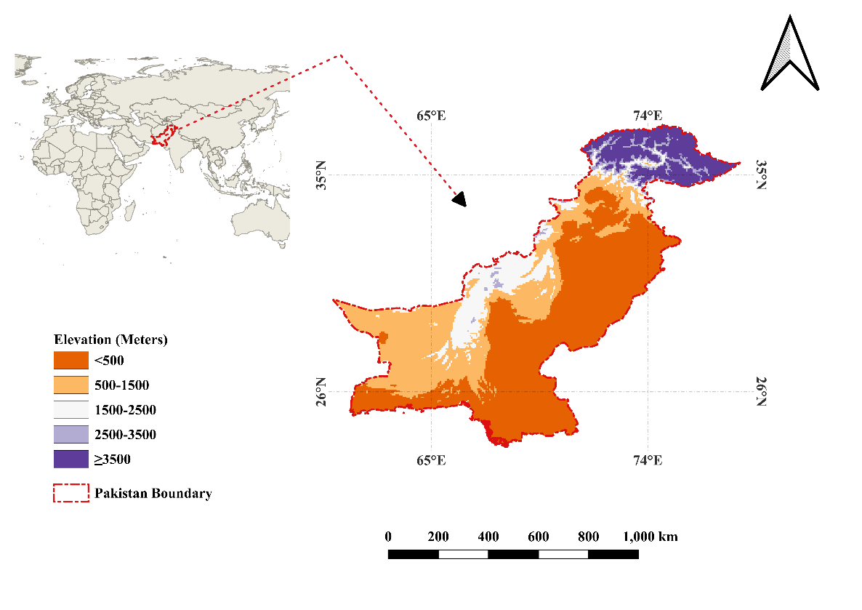
Figure 1. Study area and elevation stratification of Pakistan. Belt boundaries are 500, 1500, 2500 and 3500 m; each boundary belongs to the higher belt. The national boundary defines the analysis domain.
Topography, the summer monsoon and winter western disturbances create strong seasonal and spatial contrasts in temperature and moisture. Irrigation in the Indus Basin can partly decouple greenness from local rainfall, whereas rangelands and desert margins depend more directly on water supply and atmospheric demand. Rainfall–NDVI relationships also vary across ecological zones (Al-Bakri & Suleiman, 2004). These differences motivate separating climatic exposure from vegetation response across Pakistan’s contrasting landscapes (Adnan et al., 2024; Chen et al., 2023). Severe flooding and climate-related crop-production risks provide additional regional context (Shehzad, 2023; Chaudhry et al., 2021).

2.2 Datasets and preprocessing
The primary analysis uses an existing monthly gridded NDVI archive for January 1985–December 2025 (492 months). Landsat Collection 2 Level-2 TM, ETM+, OLI and OLI-2 reflectance supports separate sensor diagnostics and harmonization sensitivities. Reflectance uses scale 0.0000275 and offset -0.2; Equation 1 defines NDVI. Landsat context includes ETM+ scan-line-corrector failure (Andréfouët et al., 2003), legacy Collection 1 processing (Sayler, 2020) and gap-filling alternatives (Yin et al., 2017); these do not replace Collection 2 processing or the revised NA-retention rule.
$NDVI=\frac{ρ_{NIR}-ρ_{Red}}{ρ_{NIR}+ρ_{Red}}$ (1)
In Equation 1, red and near-infrared reflectance correspond to TM/ETM+ bands 3 and 4 and OLI/OLI-2 bands 4 and 5. For the targeted Collection 2 diagnostics, QA masks exclude fill, dilated cloud, cloud, cloud shadow, snow and saturation, with cirrus screened for OLI sensors. NDVI is calculated explicitly with a nonzero-denominator guard and restricted to [-1, 1]. These checks follow Collection 2 documentation (Google Earth Engine, n.d.). Sensor-specific processing also matters in comparative spectral-index applications (Konkathi & Shetty, 2021).

2.2.1 Monthly compositing and handling of missing months
Monthly P75 and monthly-maximum NDVI are distinct temporal summaries; spatial averaging is separate. Missing observations remain NA without interpolation, including October-December 1994 and zero-scene July entries (Supplementary Note S2; Tables S29-S32). P75 and P50 were computed jointly at 30 m from identical QA-screened observations; differences were averaged to 0.05-degree cells over common valid pixels. Cell-months without observations or with <10% valid-pixel coverage remained NA; interpolated months were excluded. Six sensor-era years (1990, 2001, 2009, 2012, 2018, 2024) were summarized by belt/month within the 32,829-cell joint mask using cos(latitude)-weighted means (Table S39; Figure S17).

2.2.2 Spatial harmonisation and anomaly standardisation
The common analysis support is a 0.05 degree WGS84 grid (EPSG:4326), with 269 rows by 340 columns and a fixed 32,829-cell NDVI-elevation footprint. Continuous climate and elevation fields are aligned to this grid; categorical masks use nearest-neighbour alignment. Spatial averaging of NDVI and temporal compositing are separate operations. Original NDVI is standardized by its 1985-2014 calendar-month mean and sample standard deviation (Equation 2). Each monthly reference requires observations in at least 80% of its reference years and a standard deviation greater than 0.000001. An inadequate winter reference does not remove a usable summer month from the same cell. Raw missing NDVI remains NA; an observed raw value may nevertheless have an unassessable anomaly when its reference is inadequate. Resampling does not increase the effective information content of the climate fields (Zscheischler & Fischer, 2020; Bastos et al., 2021).

$NDVI_{t}^{'}=\frac{NDVI_{t}-μ_{m}}{σ_{m}},m=month(t)$ (2)
The primary anomaly expresses departure from a fixed historical seasonal reference. The full 1985-2025 analysis period does not set the primary mean or standard deviation. Detrended residual anomalies answer a different question, departure from a fitted trajectory, and are used only as sensitivity analyses. Reference eligibility is assessed by pixel and calendar month rather than by requiring every month of a cell to be complete (Table S28).
Monthly hydroclimatic fields were obtained from TerraClimate (Abatzoglou et al., 2018) on the same grid. Maximum temperature and precipitation defined the compound extremes, while vapour pressure deficit, soil moisture, potential and actual evapotranspiration, and climatic water balance served as covariates for interpretation and modelling; scale factors and unit conventions were applied so that all predictors were in physical units, and continuous fields were resampled bilinearly. Elevation from the Copernicus GLO-30 Digital Elevation Model (30 m; European Space Agency & Airbus Defence and Space, n.d.), accessed through Google Earth Engine and resampled to the analysis grid, supported regime stratification and represented topographic control. The datasets, with their sources, resolutions, and uses, are summarised in Table 1.
Table 1. Datasets used in this study
Data | Product / Source | Temporal coverage | Temporal resolution | Key variables used | Nominal spatial resolution | Primary use
Vegetation | Monthly gridded NDVI archive for primary analysis; Landsat Collection 2 Level 2 Surface Reflectance (L5 TM, L7 ETM+, L8/9 OLI/OLI-2) processed in Google Earth Engine for sensor diagnostics and harmonization (monthly P75 and monthly-maximum summaries); missing observations retained as NA in the revised analysis | 1985–2025 | Monthly | NDVI | 0.05 degree analysis grid; 30 m Landsat sensor diagnostics | NDVI anomalies; event responses
Climate | TerraClimate (IDAHO_EPSCOR/TERRACLIMATE) | 1985–2025 | Monthly | tmmx, pr, VPD, soil moisture, PET, AET, climatic water balance | ~4 km native (resampled to analysis grid) | Extreme definition; driver modelling
Topography | Copernicus GLO-30 DEM via Google Earth Engine (European Space Agency & Airbus Defence and Space, n.d.) | Static | — | Elevation | 30 m native (resampled to analysis grid) | Elevation stratification; modelling covariate
Note: All datasets were harmonised to the common analysis grid used for statistics and mapping.

2.3 Event definitions, response lags, censored recovery and descriptive contrasts
Primary hot and dry thresholds are estimated separately for every pixel and calendar month using 1985-2014 observations. A hot month has maximum temperature strictly above its reference 95th percentile, and a dry month has precipitation strictly below its reference 10th percentile (Equation 3). Quantiles use type 7 interpolation. Consecutive qualifying months form an event. Climate exposure is evaluated independently of NDVI availability. The month-of-year index is $m$.

${\text{Hot}}_{t}: tmmx_{t}>P_{95}(tmmx∣m),{\text{Dry}}_{t}: pr_{t}<P_{10}(pr∣m),{\text{Wet}}_{t}: pr_{t}>P_{95}(pr∣m)$ (3)
Hot–dry (HD) and hot–wet (HW) months were then defined as conjunctions of the corresponding single conditions (Eq.4).

$HD_{t}={\text{Hot}}_{t}∧{\text{Dry}}_{t},HW_{t}={\text{Hot}}_{t}∧{\text{Wet}}_{t},$ (4)
with single-driver months retained for comparison as hot-only and dry-only (Eq.5).

$HotOnly_{t}={\text{Hot}}_{t}∧¬{\text{Dry}}_{t},DryOnly_{t}={\text{Dry}}_{t}∧¬{\text{Hot}}_{t}$ (5)
The NDVI response window includes the climatic event and L subsequent months, with L = 0, 1, 2 or 3; attribution stops before the next hot-dry event. The three-month extension is the main delayed-response specification, and the other windows are sensitivities. In Equation 6, W_jk denotes this response window. The minimum observed standardized NDVI is an NDVI-based resistance proxy, not a physiological measure. Suppression requires a negative minimum. A fully assessable response window is used for suppression-probability denominators; partial windows may establish observed suppression but cannot establish absence of suppression. Paired lag comparisons use the same events assessable in all windows. Negative anomalies indicate below-reference greenness; NDVI cannot distinguish physiological damage, phenological shifts or irrigation-driven signals, or establish climatic causation. Short resistance labels in figures denote this NDVI-based proxy.
$R_{jk} = \underset{t∈W_{jk}}{min⁡}\left(NDVI_{j,t}^{'}\right)$ (6)
Pixel summaries average the event-level resistance proxy only across assessable events (Equation 7). Censored follow-up is not assigned a recovery duration of zero or twelve months. Event counts, complete response windows and recovery-eligible suppressed cohorts are reported separately, because they have different denominators (Tables S25-S27).

$R_{j} = \frac{1}{K_{j}}\sum_{k=1}^{K_{j}}{R_{jk}}$ (7)
Recovery is evaluated only for suppressed events with an assessable clock. Its landmark is the later of event termination and the NDVI minimum within the response window. Recovery is confirmed on the second of two consecutive observed months with nonnegative anomalies. Follow-up is censored before a missing NDVI month, a new hot-dry event or unknown climate status, and at dataset end or the twelve-month limit after climatic event termination. Both confirmation months must precede that limit. Kaplan-Meier probabilities retain censored observations (Kaplan & Meier, 1958); intervals based on pixel-clustered robust standard errors describe sampling uncertainty. A competing-event sensitivity treats the next hot-dry event as a competing outcome. Seasonal or reference-dependent censoring may be informative. Missing values are never interpreted as no impact or recovery.
The historical hot-dry versus single-event resistance proxy contrast is defined as hot-dry resistance proxy minus the more suppressive hot-only or dry-only resistance proxy at the same pixel (Equation 8). It compares separately occurring event categories and is retained as a descriptive sensitivity. Events are not matched for timing, duration, severity or antecedent conditions, and the contrast is not a test of additivity or synergistic interaction.

$A_{j} = R_{HD,j} - min⁡\left(R_{HotOnly,j} , R_{DryOnly,j}\right)$ (8)
A negative contrast denotes lower average resistance proxy for hot-dry events than for the more suppressive single-event category; a positive contrast denotes higher resistance proxy. These signs describe category differences rather than causal compound-event effects. Shared geography alone does not make separately occurring events comparable. The contrast $A_{j}$ is descriptive.
Summaries use five elevation belts: <500 m, 500-1499 m, 1500-2499 m, 2500-3499 m and >=3500 m. Primary suppression is event-weighted within assessable windows; land-cover-weighted cell summaries are separate descriptive diagnostics. National exposure is area-weighted on the common footprint. Recovery probabilities and times are measured from the stated landmark; calendar-month and growing-season clocks are reported separately.

2.4 Historical association modelling, spatial validation, and conditional dispersion
Historical event-level models relate the NDVI-based resistance proxy to event climate, antecedent NDVI, elevation and location. Coordinates proxy unmeasured spatial structure. These fits retain their earlier within-event cohort, rather than the primary delayed-response cohort; their mapped surfaces describe historical associations under typical hot-dry conditions.

$NDVI_{jk}^{pre} = \frac{1}{L}\sum_{t=s_{jk}-L}^{s_{jk}-1}{NDV}I_{j,t}^{'},L=6$ (9)
Equation 9 defines antecedent NDVI for the existing historical model fits. Event duration is included as a covariate. Elevation and coordinates provide ecological and spatial context; their importance does not identify an independent altitude effect or a causal mechanism. In Equation 9, $s_{jk}$ is the start month of event $k$ at pixel $j$.
Pixel-grouped folds kept events from the same pixel together but could retain similarity among nearby pixels (Tables S4-S5). Five-fold validation with indivisible 2° spatial blocks and a 2015–2025 holdout provided stricter tests (Tables S11, S23-S24; Figure S6). Spatial validation does not establish temporal transfer.
A Quantile Regression Forest (QRF; Meinshausen, 2006) estimated conditional p10, p50, and p90 values of the NDVI-based resistance proxy. Their p90-p10 width is termed conditional predictive dispersion. It is not total uncertainty because it excludes sensor, compositing, climate-input, threshold, land-cover, irrigation, and structural uncertainty. Empirical p10-p90 coverage was tested in the temporal holdout before interpretation.

$X_{j}^{HD} = \frac{\sum_{t}{X_{j,t}} I(HD_{j,t}=1)}{\sum_{t}{I(H}D_{j,t}=1)}$ (10)
Typical-HD predictor rasters, including conditional soil-moisture minima where appropriate, and static covariates supplied QRF quantile and dispersion maps. Permutation importance and SHAP contributions were evaluated on a stratified event subset (Tables S6-S8; Figures S3 and S13-S14). Contributions describe fitted historical associations, not causal effects or validated forecasts (Wu & Jiang, 2022; Lundberg & Lee, 2017).

2.5 Primary framework and sensitivity analyses
One primary framework combines fixed 1985-2014 climate thresholds with original NDVI anomalies referenced to the same period. Nine alternatives vary matched 1985-2004 and full-period climate/NDVI references, detrending, or one reference component at a time. All use the same lag, suppression, recovery and censoring rules (Table S28). Detrending fits a separate pixel/calendar-month linear model to observed 1985-2025 values, requiring at least twenty years, then standardizes residuals using the named reference. It is a descriptive full-record sensitivity. Reference adequacy requires 24/30, 16/20 or 33/41 observed years, as appropriate. Exposure trends (Table S40) use OLS with Newey-West lag-3 intervals and p-values (Newey & West, 1987); Theil-Sen slopes are descriptive sensitivity summaries (Mann, 1945; Sen, 1968).

2.5.1 Sensitivity to hot and dry threshold choices
A baseline hot–dry (HD) definition was specified using a hot threshold at the 95th percentile of monthly maximum temperature ($tmmx$) and a dry threshold at the 10th percentile of precipitation ($pr$), both estimated pixel-wise and separately for each calendar month $m$. Sensitivity to threshold selection was examined by (i) relaxing the hot threshold to $P_{90}$ while retaining the precipitation $P_{10}$ dryness criterion, and (ii) strengthening dryness by adopting $P_{05}$ for precipitation while keeping the hot threshold at $P_{95}$. For each scenario, hot and dry conditions were defined as (Eq.11).
${\text{Hot}}_{t}: tmmx_{t}>P_{p_{h}}(tmmx∣m),{\text{Dry}}_{t}: Z_{t}<P_{p_{d}}(Z∣m)$ (11)
The hot percentile was set to either 0.90 or 0.95, and the dry percentile to either 0.05 or 0.10. The moisture variable was precipitation, climatic water balance, or the combined VPD-soil moisture criterion. A hot-dry month required both the selected hot and dry conditions. These are historical threshold/proxy sensitivities under their original preprocessing, rather than alternative primary results.

2.5.2 Sensitivity to the choice of moisture limitation proxy
Because precipitation extremes may not fully represent plant-available water or evaporative demand, dryness was additionally defined using alternative hydroclimatic constraints. Two complementary alternatives were considered: (i) climatic water balance ($WB=pr-PET$), using a low-percentile criterion analogous to precipitation (i.e., $WB_{t}<P_{p_{d}}(WB∣m)$); and (ii) a combined atmospheric–soil moisture limitation definition, where dryness is flagged when vapour pressure deficit is anomalously high and soil moisture is anomalously low within the calendar month (Eq.12).

${\text{Dry}}_{t}^{VPD\&SM}: VPD_{t}>P_{0.90}(VPD∣m) ∧ SM_{t}<P_{0.10}(SM∣m)$ (12)
Percentile alternatives probe statistical choices, not universal biological damage limits. Crop physiology and heat-stress regulation motivate comparing water-supply and atmospheric-demand proxies (He et al., 2024; Raza et al., 2026; Liu & Jin, 2025), while flash-drought projections emphasize humidity and soil moisture (Black, 2024). These historical sensitivities retain their earlier cohorts.

2.5.3 Pixel-wise event metrics and response stability
For each robustness scenario, consecutive flagged months were grouped into events. Pixel-level exposure included event frequency, event-month count, and mean duration. Response was calculated from standardized NDVI anomalies, with the NDVI-based resistance proxy defined as the minimum anomaly during each event. This historical within-event definition differs from the primary lagged-response window.

$R_{jk}=\underset{t∈E_{jk}}{min⁡}NDVI_{j,t}^{'}$ (13)
Pixel-level resistance proxy was the mean event minimum. Recovery was the first of two consecutive post-event months with a standardized NDVI anomaly of at least zero within 12 months. Suppression probability was the fraction of events with a negative event minimum. Scenario-minus-baseline rasters and elevation-stratified medians and interquartile ranges were used for comparison. These earlier observed-return summaries are historical sensitivities; primary recovery instead requires suppression and uses the landmark-based censoring rules in Section 2.3.

2.6 Additional validation and functional-recovery analyses
Supporting analyses retain their earlier cohorts and references. A Gaussian copula pooled pixel-year empirical temperature and negative-precipitation probabilities separately by calendar month and elevation belt. Severity is the negative logarithm of joint upper-tail exceedance probability. Annual area and severity trends used Mann-Kendall and Theil-Sen procedures (Mann, 1945; Sen, 1968; Tables S12-S13, S18; Figures S7-S8 and S12). Calendar-month detrending preceded anomaly standardisation; unchanged climate flags isolated its effect on the resistance proxy (Table S10; Figure S5). Grouped and 2° spatial-block validation assessed historical performance, while 1985–2014 training and 2015–2025 testing assessed transfer. Empirical p10–p90 coverage was compared with nominal 80% coverage. Coordinates and SHAP remain association descriptors.
GOSIF v2 monthly fluorescence was restricted to 2001–2024, excluding fill values 32766–32767 and applying scale 0.0001 (Li & Xiao, 2019). NDVI and hot-dry flags used the same period and 0.05° grid; both indices used 2001–2014 calendar-month references, but finite observed-return subsets could differ (Table S14; Figure S9). An exploratory monthly TerraClimate SWE-disappearance proxy was assessed above 3500 m (Table S15; Figure S10). Monthly NDVI completeness and residual 1999/2013 steps were evaluated controlling for month and linear trend (Table S16; Figure S11). Additional sensitivities considered Landsat harmonization (Roy et al., 2016), pre-2013 outcomes, WorldCover/GMIA land-cover and irrigation context (ESA WorldCover Consortium, n.d.; Siebert et al., 2013), and growing-season recovery, including May–October above 2500 m (Tables S29-S36; Supplementary Note S3). Static masks do not reconstruct annual management. Stable-cover sensitivity uses annual ESA CCI/Copernicus maps for 1992–2020 (European Space Agency, n.d.).

3. Results

3.1 Hot–dry exposure, vegetation response, and recovery
The primary framework identifies 220,924 hot-dry events on the common footprint. On the same 186,132 events assessable across all lag windows, suppression is 35.9% during the event, 40.5% with one subsequent month, 44.5% with two and 48.3% with three (Table S25; Figure S15). Extending the window detects delayed below-reference greenness but also increases the opportunity to observe unrelated negative anomalies. The primary three-month analysis includes 101,231 recovery-eligible suppressed events, with 38,484 confirmed recoveries and 62,747 without observed recovery (62.0%); elevation-specific fractions and censoring reasons are in Table S41. National six-month recovery probability is 37.1% (95% interval 36.7-37.5%), and the median is not reached (Table S26). At or above 3500 m, only 2,658 of 18,923 events (14.0%) have complete three-month response windows, from 1,362 cells. Follow-up is truncated by an observation/reference gap for 3,428 of 4,358 eligible suppressed events, so the resulting mountain recovery curve does not establish representative year-round recovery. Hot-wet and earlier pixel-level maps are retained as historical sensitivities with their original definitions (Figure 2; Tables S1-S2, S17, S19-S21; Figures S1-S2).
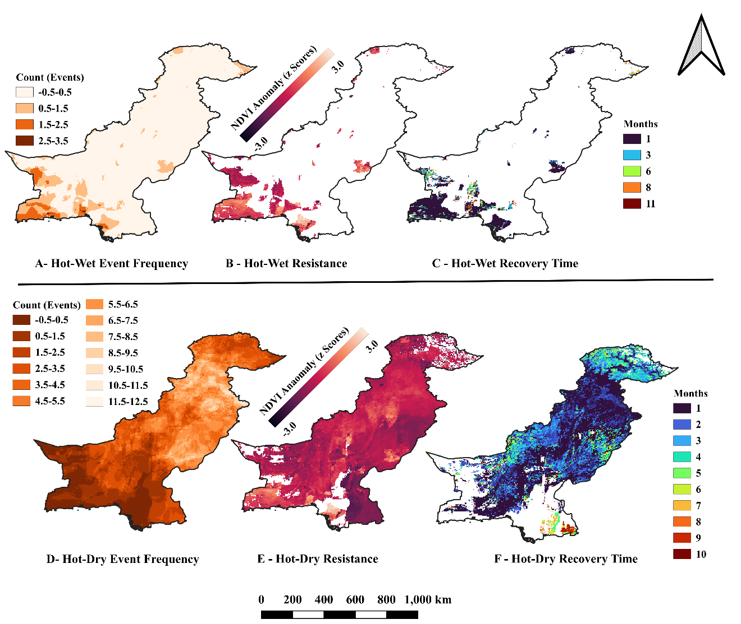
Figure 2. Historical pixel-level hot-wet (A-C) and hot-dry (D-F) summaries under the earlier event and reference definitions. Frequency, within-event NDVI-based resistance proxy and observed-return recovery are retained for context. The recovery panels do not display the revised suppressed-event Kaplan-Meier estimates, and visual elevation differences are not independent altitude effects. Current primary results are reported in Tables S25-S27 and Figure S15.
Original, detrended and harmonized resistance proxy summaries differ across elevation belts. In the processing sensitivity, the >=3500 m resistance proxy values are -0.320 for original NDVI, -0.048 for detrended NDVI, -0.166 after harmonization and -0.048 after harmonization plus detrending (Table S34). These are sensitivity summaries, not interchangeable estimates under the primary lagged-response cohort. The earlier category-contrast surface is retained as a descriptive hot-dry versus single-event resistance proxy contrast (Figure 3; Tables S3 and S22).
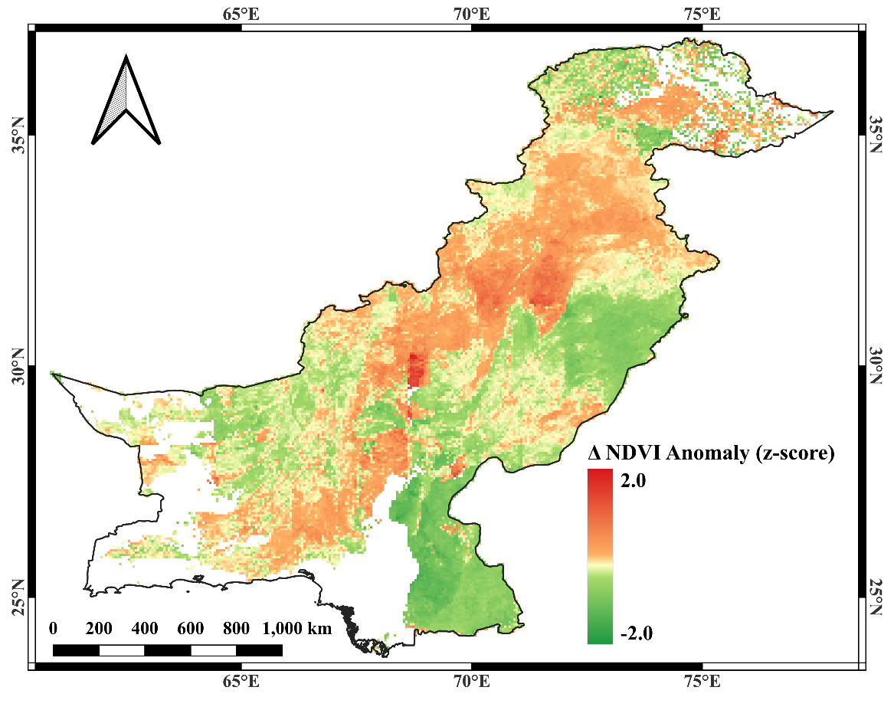
Figure 3. Historical hot-dry versus single-event resistance proxy contrast, defined by Equation 8. Negative values indicate lower average resistance proxy for hot-dry events than for the more suppressive single-event category at that pixel. Event categories are unmatched for timing, severity and antecedent conditions; the map does not demonstrate synergistic interaction.

3.2 Robustness and sensitivity of hot–dry exposure and response metrics
The ten-framework comparison depends on reference period and NDVI preprocessing (Table 2; Tables S27-S28). Climate thresholds for 1985-2014, 1985-2004 and 1985-2025 identify 220,924, 271,581 and 112,158 events, respectively. Table S40 consolidates their national trends and uncertainty: a significant increase is reference-dependent. For Pakistan planning, 1985-2014 supplies a fixed 30-year historical benchmark; full-period thresholds incorporate later conditions. This supports historical monitoring, not validated operational warnings. Older threshold/proxy maps remain historical sensitivities (Figure 4; Figure S4; Table S9).
Moisture definitions answer different biological questions (Table S9; Figure S4). Precipitation measures supply; water balance adds potential demand. Vegetation–water relationships can also be nonlinear (Araki et al., 2025). Joint high VPD/low soil moisture is conceptually closer to simultaneous atmospheric demand and soil-water limitation, but its stricter conjunction selects fewer events. Modelled soil moisture may miss local irrigation, so none is a validated universal stress measure; precipitation remains the transparent primary exposure definition.
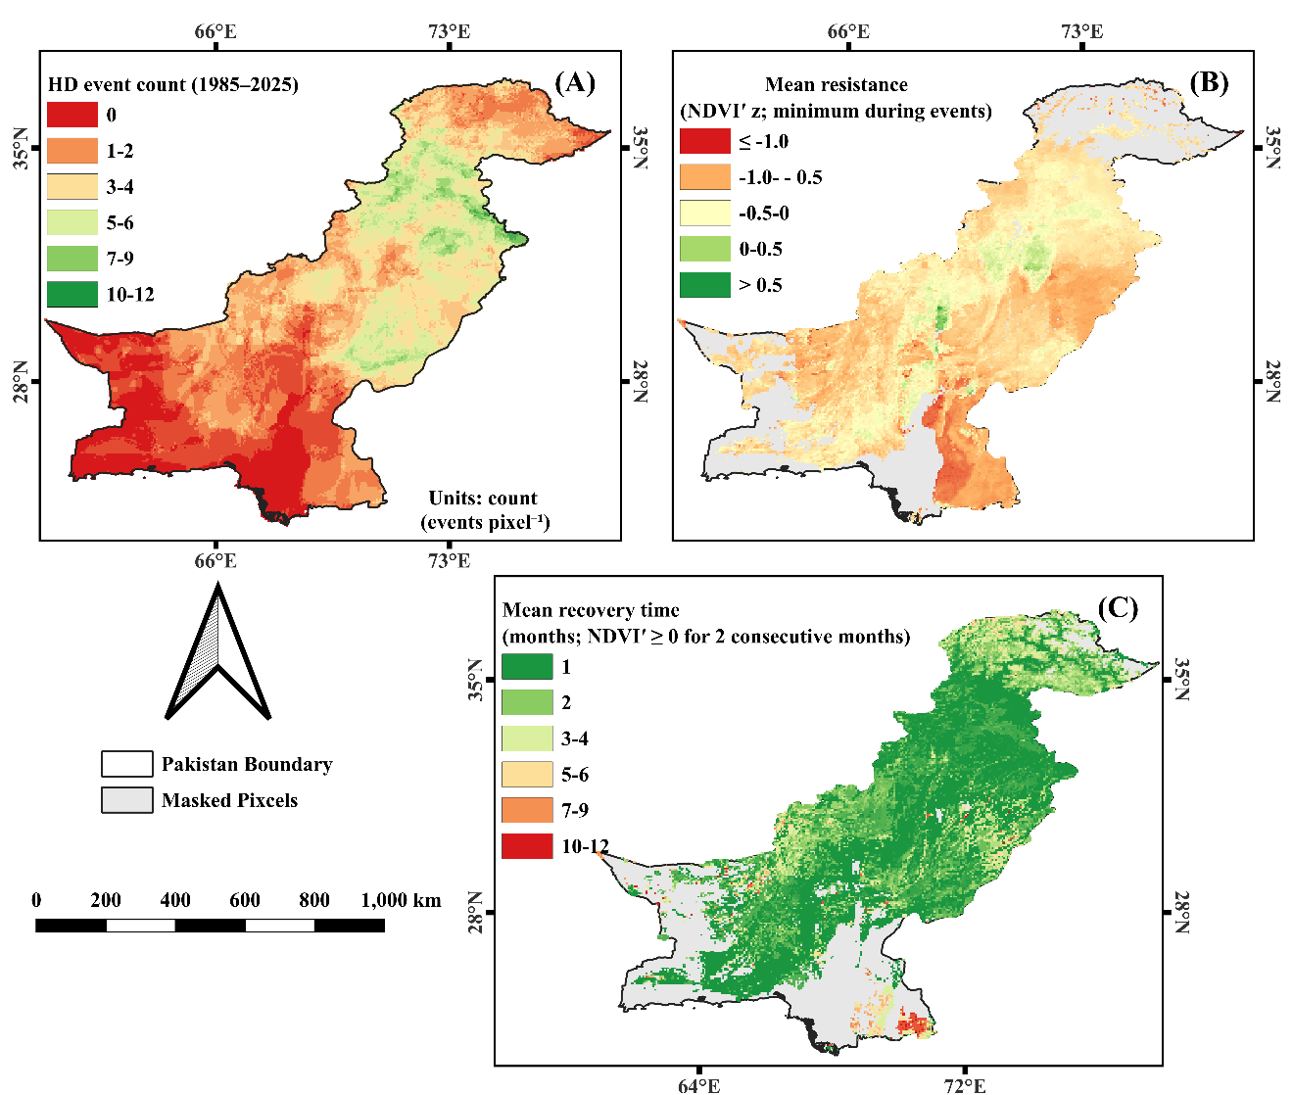
Figure 4. Historical precipitation-threshold pixel summaries retained from the earlier analysis. Frequency, within-event NDVI-based resistance proxy and observed-return recovery use that analysis definition. The recovery panel is not a censored primary estimate and does not demonstrate uniformly rapid recovery. Updated primary and baseline sensitivities are tabulated in Table 2 and Tables S25-S28.
On 185,304 shared complete event-plus-three-month windows with primary climate events, suppression is 48.2% using original NDVI and 76.3% after detrending. Changing only the original-NDVI reference gives 43.1% for 1985-2004 and 55.4% for the full period. National six-month recovery probability is 37.1% under the primary framework and 50.3% after detrending, but the suppressed cohorts differ. On 80,712 events suppressed and recovery-eligible in all four NDVI alternatives sharing primary climate events, the corresponding estimates are 30.1% and 45.9%. These are operational-definition sensitivities and do not establish faster physical recovery after detrending.
Table 2. Primary framework and nine baseline/preprocessing sensitivities. Event counts reflect the specified climate reference. Suppression percentages use each framework's cohort assessable across the four response-lag windows, and six-month Kaplan-Meier probabilities use its recovery-eligible suppressed cohort. These denominators differ from the explicitly paired NDVI comparison in Section 3.2. NR denotes a median not reached; NA denotes unavailable values.
Framework | Climate reference | NDVI reference / processing | Events | Suppression (%) | 6-month recovery (%)
Primary | 1985-2014 | 1985-2014; original | 220,924 | 48.3 | 37.1
Climate full | 1985-2025 | 1985-2014; original | 112,158 | 45.4 | 33.9
Climate 1985-2004 | 1985-2004 | 1985-2014; original | 271,581 | 46.8 | 43.6
NDVI detrended | 1985-2014 | 1985-2014; detrended | 220,924 | 76.3 | 50.3
Matched full detrended | 1985-2025 | 1985-2025; detrended | 112,158 | 71.7 | 51.4
Matched full | 1985-2025 | 1985-2025; original | 112,158 | 53.2 | 38.0
Matched 1985-2004 detrended | 1985-2004 | 1985-2004; detrended | 271,581 | 72.4 | 57.0
Matched 1985-2004 | 1985-2004 | 1985-2004; original | 271,581 | 42.0 | 43.2
NDVI full | 1985-2014 | 1985-2025; original | 220,924 | 55.4 | 39.5
NDVI 1985-2004 | 1985-2014 | 1985-2004; original | 220,924 | 43.6 | 37.8

Calendar-month eligibility improves use of observed mountain data without filling gaps. Of 3,060 footprint cells at or above 3500 m, 2,869 have at least one adequate primary-reference month. This does not imply complete annual records or complete event follow-up. Of 3,428 first unassessable follow-up cases in this belt, 851 involve missing source NDVI and 2,577 involve observed raw NDVI with an inadequate monthly reference (Table S38). The cause of individual source gaps cannot be assigned to clouds, snow or satellite faults from the monthly stack alone.

3.3 Sensor consistency, ecological context and historical model diagnostics
Landsat analyses report suppression of 46.5% after harmonization, compared with 40.8% in the earlier within-event sample; the pre-2013 subset gives 47.9% (Table S31). These sensitivities retain their stated original event cohorts and are not replacements for the primary delayed-response estimate of 48.3%. Observation density varies by era and terrain (Table S29). In the stratum diagnostic, an absolute offset of 0.0202 with interannual standard deviation 0.015 corresponds to a raw shift of 1.35 z units in desert/sparse cover. This shows why small NDVI differences can affect low-variance anomalies, without proving uniform sensor equivalence (Table S30; Figure S16). In the targeted comparisons, no monthly P75 comparison above 3500 m met the shared-support rules (0/24): in 15 cases one sensor had fewer than two scenes in the month, and in the other 9 no pixel kept two clear observations from both sensors after cloud, shadow and snow screening. Three October near-time scene pairs at 3514 m qualified, with differences of +0.072 (L7 minus L5, 2001), +0.099 (L8 minus L7, 2014) and -0.044 NDVI (L9 minus L8, 2022) and spatial correlations of 0.86-0.95; none qualified at the 4370 m chip. Their signs match the overall near-time means, but three pairs from one site and month cannot establish sensor consistency above 3500 m (Table S37). The July example changes a 2018 event anomaly from +0.08 to -0.79 after harmonization; interpolated entries are reported as NA (Table S32). The selected-year comparison yielded pooled cell-area-weighted mean P75-minus-P50 NDVI differences of 0.0034 to 0.0104. Across the five belts, cell-area-weighted yearly mean differences ranged from 0.0043 to 0.0139 (<500 m), 0.0027 to 0.0084 (500-1499 m), 0.0018 to 0.0055 (1500-2499 m), 0.0017 to 0.0054 (2500-3499 m), and 0.0024 to 0.0075 (>=3500 m) (Table S39; Figure S17). Missing cell-months above 3500 m represented 60.6-78.8% of that belt in the selected years, restricting the comparison to observable conditions.
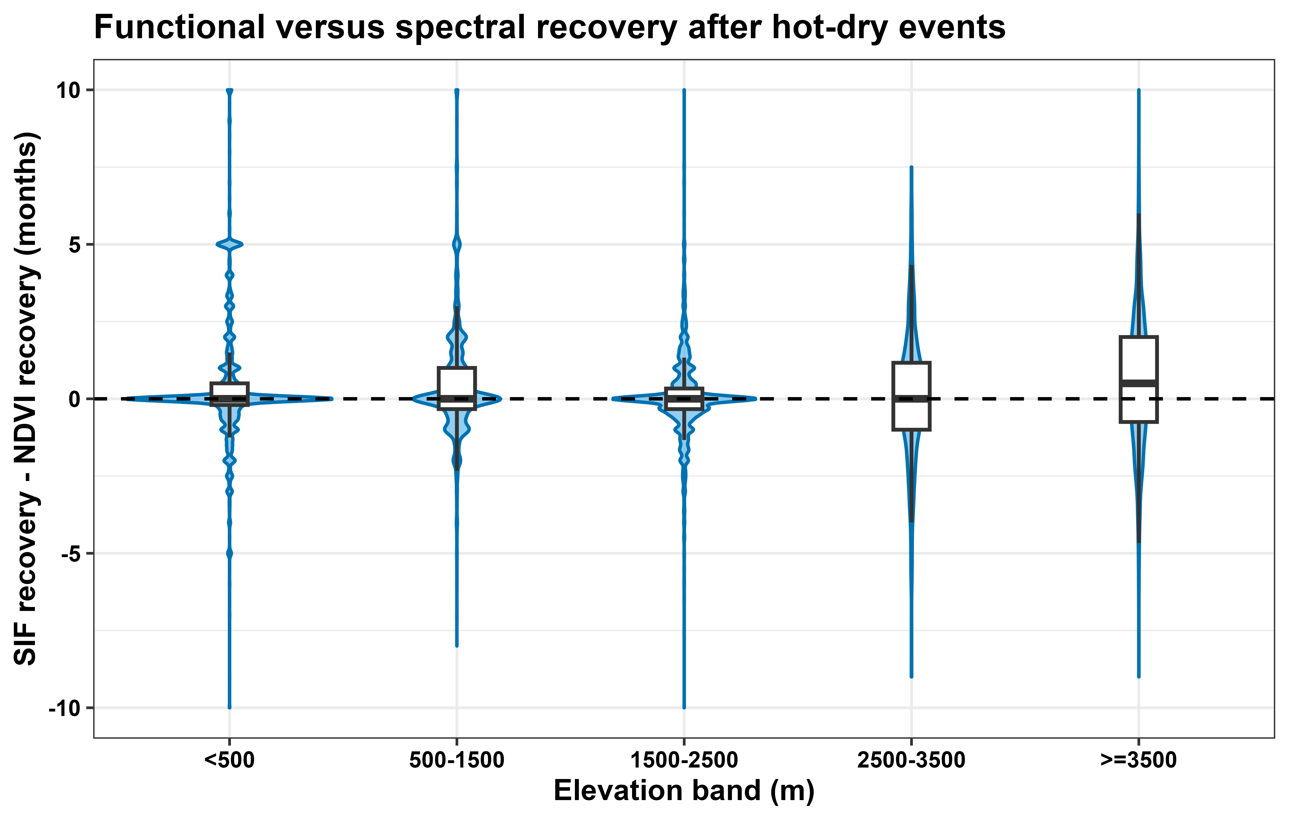
Figure 5. Historical GOSIF-minus-NDVI observed-return recovery comparison for common-grid events in 2001-2024. Positive values indicate a longer functional than spectral return under that earlier definition. This supporting comparison uses a separate cohort and seasonal reference and is not an independent validation of the revised primary censored recovery estimate (Table S14).
Land-cover and irrigation stratification show differing contexts across elevation belts (Table S35). The land-cover categories have suppression probabilities of 0.27 in irrigated cropland, 0.43 in desert/sparse cover and 0.48 in grassland/rangeland. Cell-weighted checks are arithmetic diagnostics, not pooled event probabilities or medians (Table S36). Growing-season sensitivities differ from calendar-month recovery summaries (Table S33); a separate forest-stratified analysis reports a residual difference of 0.9 months, with no independent altitude attribution. Targeted GEE checks provide additional limited-site evidence: 34/120 monthly sensor comparisons and 54/120 near-time pairs meet coverage rules; no monthly comparison at or above 3500 m is assessable (Table S37). Existing historical QRF transfer to 2015-2025 has median R-squared = -0.424 and 65.7% coverage of the nominal 80% interval (Table S24). These models explain fitted historical associations, not transferable predictions (Lundberg & Lee, 2017).

4. Discussion
The national framework shows why climatic exposure, observed suppression and recovery need separate assessment. Allowing delayed responses identifies below-reference greenness beyond climatic event termination, while censored follow-up distinguishes confirmed recovery from incomplete observation. This distinction connects compound-event detection to vegetation monitoring and clarifies which exposed events require recovery assessment. Compound heat and moisture limitation have plausible ecological mechanisms (Zhou et al., 2025; H. Liu et al., 2024; Min et al., 2023). The present estimates describe spectral greenness response rather than physiological damage, carbon loss or causal effects.

4.1 Hot–dry dominance and the scarcity of hot–wet compounds

A plausible climatic contribution to hot-wet scarcity is monsoon cloud/rain cooling, but simultaneous exceedance of both calendar-month 95th percentiles also restricts detections. Monthly aggregation misses shorter or sequential combinations, whose ecological effects can include altered pathogen dynamics (Sasso et al., 2024). Scarcity therefore applies to this definition; climatic and threshold contributions were not separately quantified. Sparse, spatially restricted samples motivate focusing historical modelling on hot-dry events (Supplementary Note S1).

4.2 Seasonally conditioned anomalies and the role of timing
Water limitation depends on phenology, crop calendars, snowmelt timing and antecedent conditions, so identical monthly anomalies can have different seasonal consequences. Winter-wheat experiments found that moderate intermittent water-deficit priming improved biomass/grain water-use efficiency and alleviated subsequent drought-induced yield losses (Ru et al., 2025). This illustrates context-dependent acclimation, not a rule that drought benefits vegetation. Such physiology helps explain why exposure need not produce greenness suppression; improved water-use efficiency or post-stress performance is not equivalent to NDVI recovery. The national analysis does not measure these mechanisms; recovery remains observed greenness return.

4.3 Resistance proxy and recovery as complementary dimensions of vulnerability

Suppression and recovery capture complementary aspects of vegetation response. Restricting recovery assessment to suppressed events gives the return probability a defined denominator; retaining censored follow-up distinguishes confirmed return from incomplete observation. Earlier all-event summaries and complete-return averages answer different questions. The national recovery median is not reached, and high-elevation estimates depend strongly on raw gaps and monthly reference adequacy. Interpretation remains conditional on observable follow-up and sufficiently independent censoring; seasonal data loss can violate this assumption.

4.4 Elevation associations, land cover, irrigation and seasonal coverage
Elevation stratification places vegetation-response patterns in their ecological context (Leonelli et al., 2009; Zheng, Shi, et al., 2021). The most negative original resistance proxy occurred above 3500 m; detrending made several middle/high belts negative while the >=3500 m median approached zero. GOSIF provides a separate functional comparison, whereas the monthly SWE proxy showed no significant recovery association. Seasonal, hydrological and atmospheric-demand mechanisms remain plausible context, not demonstrated causes. Evidence of prolonged dryland recovery after compound events (Yao et al., 2024) supports this ecological context. Eligibility, management, seasonal clocks and observation gaps require landscape-specific interpretation and prevent isolating an independent altitude effect here.
Snow and glacier melt can buffer drought propagation, with spatially and temporally variable effects in the Indus Basin (van den Bos et al., 2025). Such hydrological buffering does not guarantee protection from atmospheric vegetation stress. Tree-growth sensitivity (Leonelli et al., 2009; Zheng, Gaire, et al., 2021) and mountain aquatic vulnerability (Niedrist & Füreder, 2023) likewise depend on ecological context. These mechanisms provide context; our diagnostics do not identify snowmelt as the cause of observed vegetation recovery patterns.

4.5 Descriptive compound-versus-single-event contrasts
The resistance proxy contrast in Equation 8 compares unmatched event categories: its national median is 0.269 NDVI-z units (IQR -0.256 to 0.708), with 35.6% negative values. Negative shares are 44.9% below 500 m and 48.8% at >=3500 m (Table S22). Irrigation and crop timing may differentiate lowland event samples; highland seasonality, low NDVI variance and observation gaps may alter sampled minima. These are possible contexts, not identified causes (Supplementary Note S4). Timing, intensity and antecedent differences prevent interpreting the pattern as synergy. Atmospheric demand and soil-water interactions remain hypotheses (X. Liu et al., 2023; Yu et al., 2023).

4.6 Historical model associations and temporal transfer
Antecedent NDVI retains information about vegetation state in the later holdout: RF R-squared is -0.436 with it and -2.811 without it. Both estimates remain below the test-period mean benchmark, distinguishing useful state information from a transferable forecasting model. These results concern the original model cohort. Historical SHAP rank therefore does not establish stable future predictive value. Antecedent NDVI and the NDVI-based target share persistence and reference effects; shifts in greening, management, sensor composition or event severity may change that relationship (Supplementary Note S4). These possible explanations are not isolated causes. Correlated predictors and coordinates can encode historical ecological/spatial structure without temporal stability (Roberts et al., 2017). Maps remain historical associations.

4.7 Limitations and implications
GOSIF depends on meteorological and MODIS inputs. Its 2001–2024 overlap, shorter 2001–2014 reference and unequal finite-return subsets limit comparison with full-record recovery (Supplementary Note S4). Monthly SWE can miss local melt-out and sub-monthly controls; a nonsignificant association does not exclude snowmelt effects. Hydrological covariates can depend on storage and model structure, as illustrated in karst-flood modelling (Dai et al., 2022). Month/elevation-pooled copulas avoid unstable 41-year pixel fits but smooth local dependence. Sensor-era steps do not substitute for reflectance-level calibration. Cross-sensor consistency could not be verified above 3500 m, where scene scarcity and snow and cloud screening left no assessable monthly comparison; estimates in this belt are therefore lower-confidence and are interpreted with their harmonization and detrending sensitivities (Table S34). A dedicated high-elevation validation using all overlapping snow-free acquisitions remains needed. Mixing irrigated croplands, rainfed systems, forests and rangelands can mask ecosystem-specific drought responses. Indus irrigation may lower suppression during rainfall deficits; delivery or crop-timing changes may also generate negative anomalies (Maina et al., 2022). National metrics describe landscape mixtures, with ecological interpretation strongest in water-limited, non-irrigated systems. Static stratification cannot reconstruct 1985–2025 management; future comparisons need consistent land-cover/irrigation histories and matched growing seasons (Tables S35-S36). Negative holdout R² precludes forecasting without treatment of non-stationarity and independent temporal validation (Roberts et al., 2017). References, response windows and suppression eligibility affect estimates. Missing observations and inadequate monthly references can produce selective inclusion and informative censoring, especially in mountains. Sensor/seasonal sensitivities retain distinct cohorts; chip tests do not establish national equivalence. July-example anomalies were not recalculated after interpolated entries became NA. P75 can mask short declines. Because event months and their calendar-month references are both P75 composites, a stable P75–P50 offset largely cancels in the standardized anomaly; only changes in the offset during events affect the resistance proxy and recovery. Year-to-year changes in belt-mean offsets (0.0037-0.0096 NDVI; Table S39) are smaller than the interannual NDVI standard deviations of the diagnostic strata (0.015-0.070; Table S30), although low-variance desert cover is most sensitive and cell- and event-level offsets may be larger. By favouring greener observations, P75 is expected to understate suppression and resistance proxy magnitudes and to favour earlier detected greenness return; the reported suppression is therefore likely conservative and the six-month recovery probability an upper estimate. Recomputing resistance and recovery from P50 composites remains future work.
Dryness-proxy sensitivity (Table S9) cautions against equating rainfall deficits with plant water stress in arid or irrigated landscapes. Irrigation modifies water supply, while evaporative demand can remain high despite rainfall. Regional studies should compare precipitation, water balance and combined VPD-soil-moisture definitions, considering irrigation and phenology when interpreting stress.
Future work should pair satellite anomalies with field physiological measurements (gas exchange, water status) and phenotyping to distinguish injury, phenology and recovery. Multi-omics could identify mechanisms for testing in climate-resilient crop improvement, informed by systems-design and sugarcane-breeding perspectives (Yao et al., 2026; Wang et al., 2026). Thermal management of protected cultivation is another context-specific adaptation (Heyat Jilani et al., 2024). Complementary priorities include percentile-based VPD/soil-moisture early warning, HKH headwater and rangeland/forest management, and warming-scenario projections of hot-dry exposure with interaction and state-dependence tests for adaptation planning. Operational prediction requires independent temporal validation. Cross-border cooperation also has political contexts outside this ecological assessment (Tasleem, 2022).

5. Conclusion
This Pakistan-wide assessment demonstrates the importance of separating climatic hot-dry exposure from observed greenness suppression and subsequent recovery. Under the fixed 1985-2014 reference framework, suppression increases from 35.9% during climatic events to 48.3% when three subsequent months are considered, highlighting the importance of monitoring delayed vegetation responses. Among recovery-eligible suppressed events, the estimated six-month recovery probability is 37.1%, while median recovery is not reached during available follow-up. These findings show why event occurrence, vegetation suppression and recovery should be assessed separately when characterizing ecosystem resilience. Differences across elevation belts require interpretation alongside vegetation type, irrigation, seasonal conditions and observation coverage. Baseline and processing sensitivities qualify the estimated magnitudes, while model outputs describe historical associations. The framework provides a basis for linking climate-based exposure alerts with continued vegetation monitoring in data-limited South Asian landscapes, directing attention to observed impacts and recovery needs.

Authorship contribution statement
Muhammad Adnan: Conceptualization, Methodology, Software, Formal Analysis, Visualization, Data Curation, Original Draft Writing, Investigation, Validation, Review & Editing.
Ayman Alrehaili: Visualization, Review & Editing, Supervision.
Saad Alhumidan: Data Curation, Formal Analysis
Mohammed Meshl Alotaibi: Formal Investigation, Review & Editing.
Muhammad Mubushar: Review & Editing
Fahad Shahzad: Formal Analysis, Investigation, Review & Editing
Zhengping Du: Formal Analysis, Investigation, Review & Editing
Tian Xiang Yue: Review & Editing, Supervision.

Declaration of competing interest
The authors declare no competing financial interests or personal relationships that could have influenced this work.

Data availability
Code and derived data are archived in Zenodo (Version v1.1.0; Adnan et al., 2026); this version retains the originally submitted v1.0.1 files and adds the revised scripts, result and diagnostic tables, figures, run metadata and execution instructions. The revised files are also available in the revision_2026_10_18 folder of the project GitHub repository (https://github.com/madnankhan336/Compound-Extremes-and-Vegetation-Resilience-Across-Pakistan/tree/main/revision_2026_10_18). Prepared monthly input rasters and per-event output catalogues are not included because of their size. Elevation-stratified tables therefore cannot be reproduced from the scripts alone; they require the prepared monthly inputs, an aligned elevation grid and configured paths and R packages (code/README_Elevation_Table_Reproduction.md). Tables S40 and S41 can be regenerated directly from the included result tables. Raw Landsat Collection 2, TerraClimate and GOSIF products are publicly available from their providers and require acquisition and preprocessing (Abatzoglou et al., 2018; Google Earth Engine, n.d.; Li & Xiao, 2019).

Acknowledgements
The authors gratefully acknowledge the support of the National Natural Science Foundation of China, the National Key Research and Development Program of China, and the Strategic Priority Research Program of the Chinese Academy of Sciences in carrying out this work.

Funding
This work was supported by the National Natural Science Foundation of China (42330707), The National Key Research and Development Program of China (2024YFD1700904), the Science Fund for Creative Research Groups of the National Natural Science Foundation of China (72221002), the Strategic Priority Research Program of the Chinese Academy of Sciences (XDB0740100).

References
Abatzoglou, J. T., Dobrowski, S. Z., Parks, S. A., & Hegewisch, K. C. (2018). TerraClimate, a high-resolution global dataset of monthly climate and climatic water balance from 1958–2015. Scientific Data, 5(1), 170191. https://doi.org/10.1038/sdata.2017.191
Adnan, M., Alrehaili, A., Alhumidan, S., Alotaibi, M. M., Mubushar, M., Shahzad, F., Du, Z., & Yue, T. (2026). Compound-Extremes-and-Vegetation-Resilience-Across-Pakistan: Revised data and code for compound heat–drought extremes and vegetation response across Pakistan (1985–2025) (Version v1.1.0) [Software and data set]. Zenodo. https://doi.org/10.5281/zenodo.23453248
Adnan, M., Xiao, B., Bibi, S., Xiao, P., Zhao, P., & Wang, H. (2024). Addressing current climate issues in Pakistan: An opportunity for a sustainable future. Environmental Challenges, 15, 100887. https://doi.org/10.1016/j.envc.2024.100887
Al-Bakri, J. T., & Suleiman, A. S. (2004). NDVI response to rainfall in different ecological zones in Jordan. International Journal of Remote Sensing, 25(19), 3897-3912. https://doi.org/10.1080/01431160310001654428
Andréfouët, S., Bindschadler, R., Brown de Colstoun, E., Choate, M., Chomentowski, W., Christopherson, J., … Wylie, B. (2003). Preliminary assessment of the value of Landsat-7 ETM+ data following scan line corrector malfunction. U.S. Geological Survey, EROS Data Center, Sioux Falls, SD.
Araki, R., Morgan, B. E., McMillan, H. K., & Caylor, K. K. (2025). Nonlinear Soil Moisture Loss Function Reveals Vegetation Responses to Water Availability. Geophysical Research Letters, 52(11), e2024GL111403. https://doi.org/10.1029/2024GL111403
Azmat, M., Ilyas, F., Sarwar, A., Huggel, C., Vaghefi, S. A., Hui, T., Qamar, M. U., Bilal, M., & Ahmed, Z. (2021). Impacts of climate change on wheat phenology and yield in Indus Basin, Pakistan. Science of The Total Environment, 790, 148221. https://doi.org/10.1016/j.scitotenv.2021.148221
Bastos, A., Orth, R., Reichstein, M., Ciais, P., Viovy, N., Zaehle, S., Anthoni, P., Arneth, A., Gentine, P., Joetzjer, E., Lienert, S., Loughran, T., McGuire, P. C., Sungmin, O., Pongratz, J., & Sitch, S. (2021). Vulnerability of European ecosystems to two compound dry and hot summers in 2018 and 2019. Earth System Dynamics, 12(4), 1015-1035. https://doi.org/10.5194/esd-12-1015-2021
Black, E. (2024). Global Change in Agricultural Flash Drought over the 21st Century. Advances in Atmospheric Sciences, 41(2), 209-220. https://doi.org/10.1007/s00376-023-2366-5
Bouwer, L. M., Cheong, S. M., Jacot Des Combes, H., Frölicher, T. L., McInnes, K. L., Ratter, B. M. W., & Rivera-Arriaga, E. (2022). Risk Management and Adaptation for Extremes and Abrupt Changes in Climate and Oceans: Current Knowledge Gaps. Frontiers in Climate, 3, 785641. https://doi.org/10.3389/fclim.2021.785641
Chaudhry, I. S., Aslam, A. R., Farooq, F., & Faheem, M. (2021). How do Climate Change, Environmental Degradation and Economic Growth affect CropsProduction in Pakistan?. Review of Applied Management and Social Sciences, 4(4), 921-932. https://doi.org/10.47067/ramss.v4i4.199
Chen, X., Wang, Y., Chen, Y., Fu, S., & Zhou, N. (2023). NDVI-Based Assessment of Land Degradation Trends in Balochistan, Pakistan, and Analysis of the Drivers. Remote Sensing, 15(9), 2388. https://doi.org/10.3390/rs15092388
Dai, J., Rad, S., Xu, J., Wan, Z., Li, Z., Pan, L., & Shahab, A. (2022). Influence of Karst Reservoir Capacity on Flood in Lijiang Basin Based on Modified HEC-HMS through Soil Moisture Accounting Loss. Atmosphere, 13(10), 1544. https://doi.org/10.3390/atmos13101544
Deng, H., Li, G., Pan, X., Wang, Q., & Xiao, Z. (2026). Quantifying the impact of extreme climatic compound events and adaptation strategies on seed maize yield: Insights from a six-year field experiment in the Hexi Corridor Oasis, China. European Journal of Agronomy, 172, 127864. https://doi.org/10.1016/j.eja.2025.127864
ESA WorldCover Consortium. (n.d.). WorldCover products and data access. https://esa-worldcover.org/en/data-access
European Space Agency. (n.d.). Land Cover: ESA Climate Change Initiative. https://climate.esa.int/en/projects/land-cover/
European Space Agency & Airbus Defence and Space. (n.d.). Copernicus DEM GLO-30: Global 30 m digital elevation model [Data set]. Accessed through Google Earth Engine. https://doi.org/10.5270/ESA-c5d3d65
Fan, Z., Fan, B., & Yue, T. (2019). Terrestrial ecosystem scenarios and their response to climate change in Eurasia. Science China Earth Sciences, 62(10), 1607-1618.
Feng, S., & Hao, Z. (2020). Quantifying likelihoods of extreme occurrences causing maize yield reduction at the global scale. Science of The Total Environment, 704, 135250. https://doi.org/10.1016/j.scitotenv.2019.135250
Feng, S., Hao, Z., Zhang, X., & Hao, F. (2019). Probabilistic evaluation of the impact of compound dry-hot events on global maize yields. Science of The Total Environment, 689, 1228-1234. https://doi.org/10.1016/j.scitotenv.2019.06.373
Gazol, A., & Camarero, J. J. (2022). Compound climate events increase tree drought mortality across European forests. Science of The Total Environment, 816, 151604. https://doi.org/10.1016/j.scitotenv.2021.151604
Google Earth Engine. (n.d.). USGS Landsat 8 Level 2, Collection 2, Tier 1. Earth Engine Data Catalog. https://developers.google.com/earth-engine/datasets/catalog/LANDSAT_LC08_C02_T1_L2
He, Z., Zhang, P., Jia, H., Zhang, S., Nishawy, E., Sun, X., & Dai, M. (2024). Regulatory mechanisms and breeding strategies for crop drought resistance. New Crops, 1, 100029. https://doi.org/10.1016/j.ncrops.2024.100029
Heyat Jilani, M. N., Yadav, S., Panda, S. K., Mohapatra, P. K., Tiwari, G. N., & Hachem-Vermette, C. (2024). Assessment of annual performance of quonset GiPVT system combined with an earth-air heat exchanger (EAHE) for hot and dry climatic conditions. Renewable Energy, 223, 119990. https://doi.org/10.1016/j.renene.2024.119990
Irshad Ahmad, M., Ma, H., Shen, Q., Rehman, A., & Oxley, L. (2024). Climate change variability adaptation and farmers decisions of farm exit and survival in Pakistan. Climate Services, 33, 100437. https://doi.org/10.1016/j.cliser.2023.100437
Jha, S., Gudmundsson, L., & Seneviratne, S. I. (2023). Partitioning the Uncertainties in Compound Hot and Dry Precipitation, Soil Moisture, and Runoff Extremes Projections in CMIP6. Earth's Future, 11(3), e2022EF003315. https://doi.org/10.1029/2022EF003315
Kaplan, E. L., & Meier, P. (1958). Nonparametric estimation from incomplete observations. Journal of the American Statistical Association, 53(282), 457-481. https://doi.org/10.1080/01621459.1958.10501452
Khan, J., Wang, P., Xie, Y., Wang, L., & Li, L. (2018). Mapping MODIS LST NDVI Imagery for Drought Monitoring in Punjab Pakistan. IEEE Access, 6, 19898-19911. https://doi.org/10.1109/ACCESS.2018.2821717
Konkathi, P., & Shetty, A. (2021). Inter comparison of post-fire burn severity indices of Landsat-8 and Sentinel-2 imagery using Google Earth Engine. Earth Science Informatics, 14(2), 645-653. https://doi.org/10.1007/s12145-020-00566-2
Leonelli, G., Pelfini, M., Battipaglia, G., & Cherubini, P. (2009). Site-aspect influence on climate sensitivity over time of a high-altitude Pinus cembra tree-ring network. Climatic Change, 96(1-2), 185-201. https://doi.org/10.1007/s10584-009-9574-6
Li, J., Zhang, Y., Bevacqua, E., Zscheischler, J., Keenan, T. F., Lian, X., Zhou, S., Zhang, H., He, M., & Piao, S. (2024). Future increase in compound soil drought-heat extremes exacerbated by vegetation greening. Nature Communications, 15(1), 10875. https://doi.org/10.1038/s41467-024-55175-0
Li, X., & Xiao, J. (2019). A Global, 0.05-Degree Product of Solar-Induced Chlorophyll Fluorescence Derived from OCO-2, MODIS, and Reanalysis Data. Remote Sensing, 11(5), 517. https://doi.org/10.3390/rs11050517
Liu, H., Xiao, P., Zhang, X., Liang, Y., Tang, B., Chen, S., & Liu, Y. (2024). Winter snowpack loss increases warm-season compound hot-dry extremes. Communications Earth & Environment, 5(1), 567. https://doi.org/10.1038/s43247-024-01734-8
Liu, J., & Jin, W. (2025). Molecular underpinnings of plant stress granule dynamics in response to high-temperature stress. New Crops, 2, 100069. https://doi.org/10.1016/j.ncrops.2025.100069
Liu, X., Sun, G., Fu, Z., Ciais, P., Feng, X., Li, J., & Fu, B. (2023). Compound droughts slow down the greening of the Earth. Global Change Biology, 29(11), 3072-3084. https://doi.org/10.1111/gcb.16657
Lundberg, S. M., & Lee, S.-I. (2017). A unified approach to interpreting model predictions. Advances in Neural Information Processing Systems, 30.
Maina, F. Z., Kumar, S. V., Albergel, C., & Mahanama, S. P. (2022). Warming, increase in precipitation, and irrigation enhance greening in High Mountain Asia. Communications Earth & Environment, 3(1), 43. https://doi.org/10.1038/s43247-022-00374-0
Mann, H. B. (1945). Nonparametric tests against trend. Econometrica, 13, 245-259.
Meinshausen, N. (2006). Quantile regression forests. Journal of Machine Learning Research, 7, 983-999.
Min, R., Gu, X., Guan, Y., & Zhang, X. (2023). Increasing likelihood of global compound hot-dry extremes from temperature and runoff during the past 120 years. Journal of Hydrology, 621, 129553. https://doi.org/10.1016/j.jhydrol.2023.129553
Newey, W. K., & West, K. D. (1987). A simple, positive semi-definite, heteroskedasticity and autocorrelation consistent covariance matrix. Econometrica, 55(3), 703-708. https://doi.org/10.2307/1913610
Niedrist, G. H., & Füreder, L. (2023). Disproportional vulnerability of mountain aquatic invertebrates to climate change effects. Arctic, Antarctic, and Alpine Research, 55(1), 2181298. https://doi.org/10.1080/15230430.2023.2181298
Pettorelli, N., Vik, J. O., Mysterud, A., Gaillard, J.-M., Tucker, C. J., & Stenseth, N. C. (2005). Using the satellite-derived NDVI to assess ecological responses to environmental change. Trends in Ecology & Evolution, 20(9), 503-510. https://doi.org/10.1016/j.tree.2005.05.011
Raza, A., Charagh, S., Siddique, K. H. M., Prakash, C. S., Prasad, P. V. V., Harper, R. J., Fotopoulos, V., Hu, Z., & Varshney, R. K. (2026). Breeding drought-tolerant crops for sustainable agriculture. Agriculture & Food Security, 15(1), 6. https://doi.org/10.1186/s40066-025-00587-4
Roberts, D. R., Bahn, V., Ciuti, S., Boyce, M. S., Elith, J., Guillera-Arroita, G., Hauenstein, S., Lahoz-Monfort, J. J., Schröder, B., Thuiller, W., Warton, D. I., Wintle, B. A., Hartig, F., & Dormann, C. F. (2017). Cross‐validation strategies for data with temporal, spatial, hierarchical, or phylogenetic structure. Ecography, 40(8), 913-929. https://doi.org/10.1111/ecog.02881
Roy, D. P., Kovalskyy, V., Zhang, H. K., Vermote, E. F., Yan, L., Kumar, S. S., & Egorov, A. (2016). Characterization of Landsat-7 to Landsat-8 reflective wavelength and normalized difference vegetation index continuity. Remote Sensing of Environment, 185, 57-70. https://doi.org/10.1016/j.rse.2015.12.024
Ru, C., Liu, Y., Wang, W., & Hu, X. (2025). Moderate intermittent water deficit enhances dry matter remobilization, nitrogen uptake, and water and nitrogen use efficiency in winter wheat. Agriculture Communications, 3(3), 100098. https://doi.org/10.1016/j.agrcom.2025.100098
Sasso, T., McCallum, H., Newell, D., & Grogan, L. (2024). Extreme climatic events modulate chytrid infection across the landscape. Biological Conservation, 296, 110702. https://doi.org/10.1016/j.biocon.2024.110702
Sayler, K. (2020). Landsat 4–7 Collection 1 (C1) Surface Reflectance (LEDAPS) Product Guide (LSDS-1370, Version 3.0). U.S. Geological Survey, EROS, Sioux Falls, SD.
Schwalm, C. R., Anderegg, W. R. L., Michalak, A. M., Fisher, J. B., Biondi, F., Koch, G., … Tian, H. (2017). Global patterns of drought recovery. Nature, 548(7666), 202-205. https://doi.org/10.1038/nature23021
Sen, P. K. (1968). Estimates of the regression coefficient based on Kendall's tau. Journal of the American Statistical Association, 63, 1379-1389.
Shahzad, F., Mehmood, K., Anees, S. A., Adnan, M., Muhammad, S., Haidar, I., ... & Khan, W. R. (2025). Advancing forest fire prediction: A multi-layer stacking ensemble model approach. Earth Science Informatics, 18(3), 270. https://doi.org/10.1007/s12145-025-01782-4
Shehzad, K. (2023). Extreme flood in Pakistan: Is Pakistan paying the cost of climate change? A short communication. Science of The Total Environment, 880, 162973. https://doi.org/10.1016/j.scitotenv.2023.162973
Siebert, S., Henrich, V., Frenken, K., & Burke, J. (2013). Global Map of Irrigation Areas version 5. University of Bonn / Food and Agriculture Organization of the United Nations. https://www.fao.org/aquastat/en/geospatial-information/global-maps-irrigated-areas/latest-version/
Tasleem, S. (2022). Internal Drivers – The Nexus between Domestic Politics and Bilateral Relations: Exploring India-Pakistan, Pakistan-China, and China-India Dynamics. Journal for Peace and Nuclear Disarmament, 5(2), 315-335. https://doi.org/10.1080/25751654.2022.2158705
van den Bos, L. J., Lutz, A. F., Biemans, H., Khanal, S., & Immerzeel, W. W. (2025). Drought propagation in the Indus Basin and the importance of snow and glacier melt in drought mitigation. Journal of Hydrology: Regional Studies, 60, 102581. https://doi.org/10.1016/j.ejrh.2025.102581
Wang, P., Wu, Q., Wang, W., Wang, D., Wang, J., Sun, T., … Que, Y. (2026). Three-chain empowered sugarcane bio-breeding in China. The Innovation Life, 4(2), 100207. https://doi.org/10.59717/j.xinn-life.2026.100207
Wu, X., & Jiang, D. (2022). Probabilistic impacts of compound dry and hot events on global gross primary production. Environmental Research Letters, 17(3), 034049. https://doi.org/10.1088/1748-9326/ac4c5b
Yao, Y., Fu, B., Liu, Y., Zhang, Y., Ding, J., Li, Y., Zhou, S., Song, J., Wang, S., Li, C., & Zhao, W. (2024). Compound hot–dry events greatly prolong the recovery time of dryland ecosystems. National Science Review, 11(10), nwae274. https://doi.org/10.1093/nsr/nwae274
Yao, Y., Xiao, W., Qi, S., Xu, K., & Yin, Y. (2026). From gene editing to system design: Reprogramming agriculture for resilience and sustainability. The Innovation Life, 4(2), 100216. https://doi.org/10.59717/j.xinn-life.2026.100216
Yin, G., Mariethoz, G., & McCabe, M. F. (2017). Gap-Filling of Landsat 7 Imagery Using the Direct Sampling Method. Remote Sensing, 9(1), 12. https://doi.org/10.3390/rs9010012
Yu, J., Kumar, A., Pattnayak, K. C., Obbard, J., & Moise, A. F. (2023). Characteristics of Compound Climate Extremes and Impacts in Singapore, 1985–2020. Climate, 11(3), 58. https://doi.org/10.3390/cli11030058
Zhang, G., Zhang, S., Wang, H., Yew Gan, T., Su, X., Wu, H., Shi, L., Xu, P., & Fu, X. (2024). Evaluating vegetation vulnerability under compound dry and hot conditions using vine copula across global lands. Journal of Hydrology, 631, 130775. https://doi.org/10.1016/j.jhydrol.2024.130775
Zheng, L., Gaire, N. P., & Shi, P. (2021). High-altitude tree growth responses to climate change across the Hindu Kush Himalaya. Journal of Plant Ecology, 14(5), 829-842. https://doi.org/10.1093/jpe/rtab035
Zheng, L., Shi, P., Song, M., Zhou, T., Zong, N., & Zhang, X. (2021). Climate sensitivity of high altitude tree growth across the Hindu Kush Himalaya. Forest Ecology and Management, 486, 118963. https://doi.org/10.1016/j.foreco.2021.118963
Zhou, C., Wang, G., Jiang, H., Li, S., Shi, X., Hu, Y., & Cabral, P. (2025). Spatio-temporal patterns of compound dry-hot extremes in China. Atmospheric Research, 314, 107795. https://doi.org/10.1016/j.atmosres.2024.107795
Zscheischler, J., & Fischer, E. M. (2020). The record-breaking compound hot and dry 2018 growing season in Germany. Weather and Climate Extremes, 29, 100270. https://doi.org/10.1016/j.wace.2020.100270
Zscheischler, J., Martius, O., Westra, S., Bevacqua, E., Raymond, C., Horton, R. M., van den Hurk, B., AghaKouchak, A., Jézéquel, A., Mahecha, M. D., Maraun, D., Ramos, A. M., Ridder, N. N., Thiery, W., & Vignotto, E. (2020). A typology of compound weather and climate events. Nature Reviews Earth & Environment, 1(7), 333-347. https://doi.org/10.1038/s43017-020-0060-z

