Mohamed Amr Emad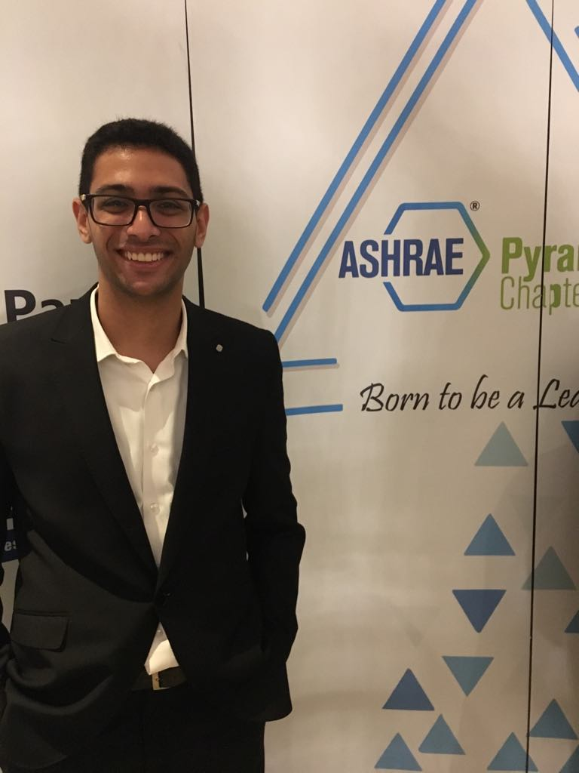  CONTACT  Address:  12A Zahraa St. , Dokki, Giza  Phone:  01285326789  Email:  Mohamedamremad@gmail.com  LANGUAGES  Arabic – Native  English – B2  French – B2 |  | OBJECTIVE  Seeking an internship in mechanical engineering field.  EDUCATION  2016- 2021 (expected)  Cairo university, faculty of engineering.  Bachelor of Science in Mechanical Engineering  2002 – 2016  College De La Salle  ADDITIONAL SKILLS  Microsoft Office Word, PowerPoint and Excel  SolidWorks  MATLAB  EXTRACURRICULAR ACTIVITIES  Jan 2019 – Present  American Society of Heating, Refrigeration, and Air-Conditioning Engineers. (ASHRAE) – Member  TRAININGS  8 – 2018  Repairing airplane’s frames and motors – Egypt Air  7 – 2018  Repairing car motors – The Arab Contractors

